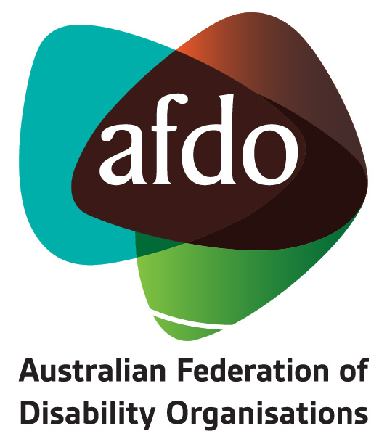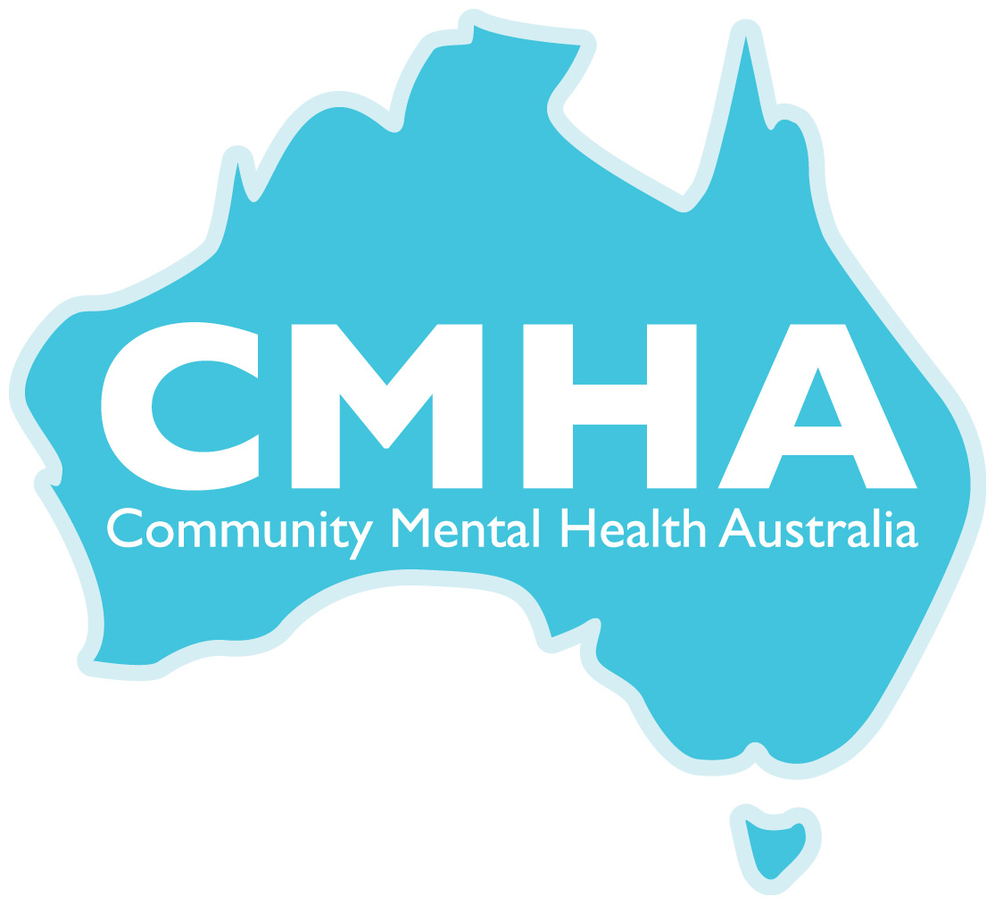
Australian Federation of Disability Organisations
&
Community Mental Health Australia Submission
to
The Australian National Audit Office Follow On Audit
27th July 2018
Contents
Australian Federation of Disability Organisations 3
Community Mental Health Australia 4
Introduction 5
Key principles for a sustainable DSP 7
Pathways onto the DSP 8
Pathways off the DSP 12
Responses to Specific Audit Criteria 14
Recommendations: 17

Australian Federation of Disability Organisations
The Australian Federation of Disability Organisations (AFDO) is the peak organisation in the disability sector representing people with lived experience of disability. AFDO and its member organisations are run by and for people with lived experience of disability.
AFDO’s mission is to champion the rights of people with disability in Australia and support them to participate fully in Australian life. AFDO has strong relationships not just with its member organisations, but across the disability sector including peaks representing service providers as well as those representing families and carers.
As a founding member of the National Disability and Carer Alliance, AFDO played a key role in the campaign for the introduction of the National Disability Insurance Scheme (NDIS). As the NDIS has moved through the trial phase and begun the transition to full scheme, AFDO and its members have continued to work constructively with the National Disability Insurance Agency (NDIA) as well as Commonwealth and State and Territory governments to provide critical feedback and address implementation issues as they arise.
AFDO’s members include:

Blind Citizens Australia
Brain Injury Australia
Deaf Australia
Deafblind Australia
Autism Aspergers Advocacy Australia
Down Syndrome Australia
Physical Disability Australia
Disability Advocacy Network Australia
Disability Justice Advocacy
People with Disability WA
Disability Resources Centre
Inclusion Australia (NCID)
People with Disabilities ACT
Women with Disabilities Victoria
Enhanced Lifestyles
Deafness Forum of Australia
Women with Disabilities ACT

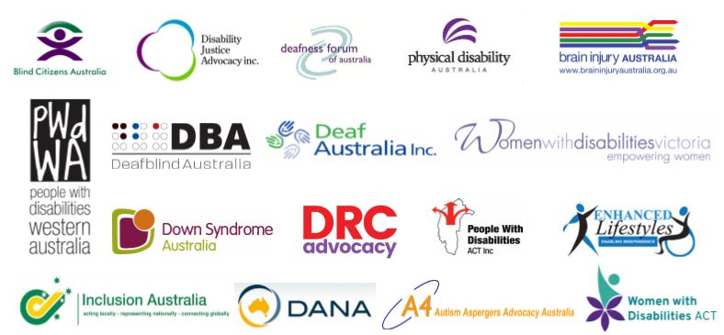

Community Mental Health Australia
Community Mental Health Australia (CMHA) is a coalition of the eight peak community mental health organisations from each State and Territory and was established to provide leadership and direction to promote the importance and benefits of community mental health and recovery services across Australia.
CMHA provides a unified voice for over 800 community-based, non-government organisations who work with mental health consumers and carers across the nation and who are members of, or affiliated with, the various coalition members.
Coalition members of Community Mental Health Australia
Representing the peak community mental health organisations from each State and Territory;
Mental Health Coalition of South Australia
Mental Health Community Coalition of the ACT
Mental Health Coordinating Council NSW
Mental Health Council of Tasmania
Northern Territory Mental Health Coalition
Psychiatric Disability Services of Victoria (VICSERV)
Queensland Alliance for Mental Health
Western Australian Association for Mental Health

Introduction
AFDO and CMHA would like to acknowledge the contribution of Dr Yvette Maker, Melbourne Social Equity Institute of Melbourne University for her advice and assistance with this submission.
Disability Support Pension and the International Convention on the Rights of People with Disability
Article 28 of the Convention on the Rights of Persons with Disability - Adequate standard of living and social protection
1. State Parties recognize the right of persons with disabilities to an adequate standard of living for themselves and their families, including adequate food, clothing and housing, and to the continuous improvement of living conditions, and shall take appropriate steps to safeguard and promote the realization of this right without discrimination on the basis of disability.
2. State Parties recognize the right of persons with disabilities to social protection and to the enjoyment of that right without discrimination on the basis of disability, and shall take appropriate steps to safeguard and promote the realization of this right, including measures:
(a) To ensure equal access by persons with disabilities to clean water services, and to ensure access to appropriate and affordable services, devices and other assistance for disability-related needs;
(b) To ensure access by persons with disabilities, in particular women and girls with disabilities and older persons with disabilities, to social protection programmes and poverty reduction programmes;
(c) To ensure access by persons with disabilities and their families living in situations of poverty to assistance from the State with disability-related expenses, including adequate training, counselling, financial assistance and respite care;
(d) To ensure access by persons with disabilities to public housing programmes;
(e) To ensure equal access by persons with disabilities to retirement benefits and programmes.
Australia is a party to the United Nations Convention on the Rights of Persons with Disabilities. Under article 28 of the Convention, Australia is obliged to ensure that all persons with disabilities have access to social protection and an adequate standard of living. Our social security system is crucial to the realisation of this right, particularly through the payment of Disability Support Pension (DSP) to people who cannot achieve economic security through paid work participation. Access to income support is especially important given the ongoing inaccessibility of meaningful, secure and appropriately remunerated employment for many persons with disabilities.
We are concerned that the Disability Support Pension is not achieving this purpose. As outlined later in this submission, we are also concerned that staff guidance and training; review processes; and monitoring, evaluation and reporting on program delivery, are compounding the problems that exist within the social security legislation and policy.

Real cases;
“I am Joe, a man with an intellectual disability and schizophrenia. I am in regular contact with the criminal justice system as my behaviour often brings me to the attention of the police. In 1997 I was in Prison at Long Bay Jail in the Disability Unit. When I got out of jail I was informed that I owed a debt to Centrelink on the basis that they had not been advised that I was detained in jail on remand.
The process of advising Centrelink that I am detained begins with me filling in an inmate notification form. A Corrections Officer helps to fill it in. The jail then sends the form to Centrelink. I am never given a copy and because of my disability I can never remember the name of the person who helped me fill in the form. I am also never aware of whether the form is sent off or received by Centrelink as there is no correspondence about this from either the jail or Centrelink. The first time I become aware of whether the form that halts my Centrelink payment was not sent or received is when I am informed by Centrelink that I have a debt with them. Often my debts with Centrelink can take many months to pay off.
In March of 2018 I was again detained at the Metropolitan Reception and Remand Centre. Eventually I was transferred to Long Bay Jail and finally released back into the community in June. As in 1997 I learned at the end of my detention that Centrelink did not receive the inmate notification form from MRRC in March. I now have another debt with Centrelink that I am required to pay off. I believe I fulfilled my obligations to notify Centrelink that I was detained but again I have no proof of whether the inmate notification form was sent or received. Once again I now have a debt to Centrelink.”

Key principles for a sustainable DSP
We would advance the following ten principles to ensure the sustainable and fair operation of the DSP;
- People with disability who are unable to work due to disability have a right to access the Disability Support Pension.
- Eligibility requirements for the DSP should not be burdensome for people with disability.
- The evaluation and assessment of those who qualify for the DSP must be based upon merit of need.
- Information about all aspects of the DSP claim process for people with disability must be in accessible formats and in a manner they can understand.
- Co-occurring conditions must be recognised and acknowledged across the impairment tables.
- Government and non-government medical professionals involved in DSP assessments must communicate with each other about a person with a disability who is claiming DSP.
- Doctors will properly assess disabilities and coherently communicate their diagnoses to claimants.
- There should be a pathway from the DSP to allow for access to high performing employment support.
- Newstart is not an appropriate income support option for people with disability who may be eligible for the DSP, whilst they await their claim outcome.
- DSS must publish regular and comprehensive data about the DSP program including regular and independent reviews.

Pathways onto the DSP
Real case;
“DA is an Indigenous man with a number of complex mental health issues. His Centrelink file had vulnerability indicators of homelessness, mental health and childhood trauma history. He applied for DSP in early 2016. He had a diagnosis of Complex Post-Traumatic Stress Disorder, Major Depressive Disorder, Substance Dependency, and Bi-polar disorder. His claim was assessed against Table 5 – Mental Health. He provided medical evidence from his GP and Psychiatrist. The medical evidence indicated that he had no capacity to work. The JCA was conducted by telephone. The JCA Assessor determined that DA had a baseline work capacity of 8-14 hours that may increase to 15-22 hours, contrary to the THPs opinions. This was affirmed by the ARO.
On appeal to the AAT, the tribunal accepted the opinion of the THPs that DA had a continued incapacity to work. (We note that DA’s original DSP claim was rejected on the basis that his mental health conditions were not FDT&S at the time of claim. However, on appeal, the AAT found otherwise”1.

“Disability Benefits play an important role in ensuring income security for persons with disabilities and therefore, in realising their rights and aspirations as productive members of society”
In Australia, successive governments have implemented policies to tighten access to the Disability Support Pension which supports those with a physical or intellectual impairment that hampers their ability to work.
Declining rates of access to the Disability Support Pension may be perceived by some as an achievement but given the rates of poverty amongst people with disability (36.2% of people with disability were living below the poverty line) the falling rate is of concern to AFDO.
Further, the Australian Council of Social Services (ACOSS) says the policies are driving people with a limited capacity to work either into poverty or onto the poverty-level.
People with disability already experience barriers to social and economic participation that restrict their access to the community and leave them vulnerable to isolation and marginalisation – key markers of poverty.
The decline of access to the Disability Support Pension from 63% in 2010 to 30% in 2018 is a dramatic cut in income support for people who are largely unable to work due to their impairments and for whom there are few secure employment opportunities. The lowest rates of approvals were in 2015 / 2016 when just 26,842 of the 106,000 applications were approved.
AFDO remains concerned that people who are eligible for the Disability Support Pension, due to their disability, are no longer guaranteed access to the appropriate level of income support needed, a right guaranteed by both the Convention on the Rights of Persons with Disability and the National Disability Strategy. The barriers mean that people with disability can no longer count on the Disability Support Pension as a means of true economic participation in the community.
The concern regarding the declining rates of access sits alongside the belief held by the AFDO that the onerous and burdensome nature of claiming the Disability Support Pension is also having an impact on the ability of people to access the Disability Support Pension. Given the fact that many people with disability experience trauma in their lives, by allowing the process of claiming income support as a result of their disability to become more complex and difficult only reinforces the experience of trauma for people with disability.
The levels of trauma people with disability experience is just one factor in the context of the burdensome and onerous nature of the claimant process. Another important consideration is the cost of disability.
The cost of disability is particularly worrying given that AFDO believes that many people who are eligible for the Disability Support Pension but have been unsuccessful in their applications are existing on Newstart allowance.
A similar group for whom AFDO is concerned are those that are waiting on Provisional Newstart for the outcome of their Disability Support Pension application or appeal. Surveys reveal that the cost of disability is significant each fortnight. This is reflected in the fact that the amount provided for in the Disability Support Pension is greater than that provided via allowances such as Newstart (which has a completely different policy approach and purpose)
Blind Citizens of Australia, the Physical Disability Council of Australia and the Chronic Illness Alliance have all conducted surveys into the costs of disability. Blind Citizens of Australia survey covered costs associated with education, employment, job seeking, the impact of degenerative eye conditions, housing, mobility, domestic life, children personal care, communication, shopping, banking/financial and leisure and social activities.
On behalf of the Commonwealth Department of Family and Community Services, in 1999, Cooper and Lybrand also conducted a survey based on interviews with one thousand people on Disability Support Pension found that the aggregate costs of disabilities including health, travel, aids and equipment, care consumables, home task, housing modifications etc range from $24.75 per fortnight to $73.18 per fortnight. This was the costing in 1999 nearly twenty years ago.
National Social Security Rights Network NSSRN believe that the 2015 changes to the DSP medical assessment process have made it more difficult for claimants to obtain the information they need to demonstrate that they meet the criteria to qualify medically for DSP. Recent NSSRN research found that the majority of their member centre clients find the DSP claims process complex and difficult to navigate.
AFDO is aware through its members and sector colleagues, of the increasing numbers of people with disability seeking advocacy support from disability advocacy agencies.
People with Disability WA cite a 20% increase in people with disability seeking advocacy support for issues regarding the Disability Support Pension which is consistent with advocacy agencies across the country. AFDO support the statement by ACOSS that, “We must ensure people who need the DSP receive it. And we must do better in employing people with a disability.”
Particular examples of the onerous and burdensome nature of the process include:
General complexity of the claims process:
“The key thing for anybody who is very ill is to understand what is required and the process. Being unwell and unable to absorb what is going medically with you...it is very hard to cope with anything else. Even the GP could not understand what was required for DSP,”
Lack of information, guides or checklists available to claimants to give to their Treating Health Professional (THP) about DSP medical eligibility requirements following on from the phasing out of the Treating Doctors Report.

This results in confusion for the claimant and the doctor and leads to delays in claims or claims being rejected. It has been found that 71% of claimants did not pass on any information to their doctors.
Timeliness of the claimant and review process remains of concern
  - The Joint Committee’s inquiry report found that “the time to complete assessments and reviews had increased, despite the new processes [introduced in 2015].”

  - The 22 cases included in the snapshot indicate that the time involved in a DSP claim assessment could vary from less than 2 months to almost 6 months. In our snapshot, a period of 2 to 4 months was common for the claim assessment.
A consistent problem concerns people with lived experience of disability, who want to work but have a tendency to become unwell quite suddenly and then are unable to work. They then find themselves unable to quickly access the income support system, or advocate for themselves.
The scheme needs to be able to accommodate the episodic nature of mental illness and not inadvertently keep people on a pension when they would rather be working, for fear of being left without any income support. The scheme needs to have flexibility built in that acknowledges that mental health conditions do not follow a linear trajectory. The system states that it makes such accommodations for episodic illness, but in reality, this does not work well on the ground.
Lack of understanding of the Program of Support (POS) requirements which is a compulsory DSP eligibility requirement for individuals who do not meet the definition of severely impaired under the legislation (83% had not heard of POS when they claimed for DSP).
Medical criteria for the DSP are in conflict with a Recovery Oriented Approach to mental health, including the following:
    - Diagnosis can be an inexact science
    - Despite what is written in the impairment tables, assessment on the day is often the main evidence utilised
    - Many people are treatment resistant or have coexisting medical conditions that made treatment and stabilisation problematic
Access to information about the Disability Support Pension, the application process, the obligations on the claimant, correspondence between the Department of Human Services and the claimant and information in the context of internal reviews or appeals to the Administrative Appeals Tribunal are currently not available in accessible formats and provided in a manner that people with disability can understand in a range of formats including print and media.

Pathways off the DSP
Real Case;
“I work very hard to stay on top of my mental illness. Some days are good and some are bad but those bad days are coming up more often. I have worked in the past in retail and for the Human Rights Commission so I can do good work and have enjoyed those areas. I enjoyed working in small retail stores that offer more of a personal touch to assisting people. My issues with the anxiety is that I can't work in busy places that requires speed because I get nervous and start to panic easily, it's always been like that for me as long as I can remember.
My Job network service recently with full knowing of my conditions decided to put me in a busy bar running around and picking up glasses with a big crowd of people and noisy music. I feel like now for the first time in four years that my mental illness is starting to go backwards and it's very hard to not listen to the "bad thoughts" in my head.
My job network never think of a real suitable job for me and tend to try to put me in anything that they can find and it's not the first time they have done this. They promote themselves as people who value their clients dignity and self-confidence but they only been stripping those aspects from me. I feel like I'm alone and there's nothing to do to try to solve this. I now need to reapply for the DSP. Because I have worked recently and can take care of myself, I doubt that I will get the points necessary. I’m likely to have to become more unwell before I secure a pension.”

“The exclusion of people with disabilities from the labour market is a significant contributor to their disproportionate levels of poverty”
AFDO believes that there is a misunderstanding that the Disability Support Pension is the same as Newstart – that being on the Disability Support Pension is income support for people with disability whilst they look for work.
We are concerned that the fundamental right to social protection through the provision of income support is being distorted by the current political discussion focused on Centrelink participants including those on the Disability Support Pension.
This misunderstanding sits alongside the lack of oversight or evidence from DSS on whether the recent changes to the Disability Support Pension has made it harder to access or even streamlined the process. The ANAO observed “to date, DSS has not undertaken any formal review or evaluation of the eligibility changes”.
People with disability want to be able to go to work, contribute to society and feel a sense of worth and belonging that comes from working and contributing. The most significant barrier to that occurring is the lack of employment opportunities that exist in the open labour market for people with disability. In the context of a significant lack of employment opportunities for people with disability continuing access to the Disability Support Pension must be maintained and the access process simplified.
AFDO supports a focus on pathways being developed whereby people with disability are assisted to transition off the Disability Support Pension and into secure employment in a manner that is appropriate to the circumstances of their disability. AFDO knows this based on direct feedback from people with disability through its national and state/territory member organisations. However, they also say that the opportunities to work in the Labour Market are almost non-existent. We believe there is a need for an effective labour market assistance program for those who choose or want or have to seek work. AFDO well-funded labour market programs with specific and targeted disability support is one of the answers to assisting people with disability off the DSP and into open employment.
“There is no doubt that this is a group of jobseekers with exceptionally high needs who face considerable odds in the open labour market. What appears to set them apart is the body of evidence of their potential to succeed given the right type of service.”
AFDO would like to see a comprehensive analysis of how people can transition off the Disability Support Pension and into employment. A first step is to review the limit on the amount of hours people with disability can work whilst on the Disability Support Pension. If the Disability Support Pension is your only source of secure income then people with disability have stated that they are unwilling to give up that security for the insecurity that is attached to gaining employment in the open labour market.
Community Mental Health Australia comments:
“Another issue is the 15 hour work requirement as determining eligibility. Some people living with a mental health condition can work 2 or 3 days a week but the jobs they are able to secure are poorly paid and may represent less than the income support for the hours worked. The income support scheme should be supporting people to work and acknowledge how work contributes to wellbeing and recovery. The DSP should be available to supplement earnings where they fall below income support, in other words a part-support payment.”

Responses to Specific Audit Criteria

Human Services provide and regularly update training for staff and contractors involved in DSP assessments and/or review processes

As with Inclusion Australia, AFDO and CMHA remain concerned about the level of understanding of disability by the staff and contractors of the Department of Human Services.
A lack of understanding by Centrelink staff about specific forms of disability and how they impact on claiming the DSP, for example how manifest eligibility applied to recent reforms for people with intellectual disability.

“Inclusion Australia know that a young person with an intellectual disability will invariably do poorly on an assessment of current/future job capacity - largely due to the nature of their impairment. Yet we also know that the capacity to work of people with intellectual disability is highly related to a presumption of work capacity followed by the opportunity to try work with explicit on the job training and ongoing support. This is discussed briefly in the DES Evaluation report - and this has been the research finding for people with ID since at least the 1950s,” Paul Cain CEO, Inclusion Australia
We would like to see involvement by disability persons organisations, such as AFDO and its members, in the development of disability awareness training for both the Department of Social Services and the Department of Human Services.

DSS and Human Services effectively select existing DSP recipients for review using evidence-based risk profiles that are regularly assessed for efficacy

“DSS reports little information about the efficiency, effectiveness and economy of the program or its service delivery”
AFDO remains unaware and uninformed of how DHS effectively select existing DSP recipients for review and what evidence based profiles they are using.

DSS and Human Services effectively monitor, evaluate and report on program delivery
“Nothing about us without us” is an expression adopted by the disability rights movement in the 1990s, which succinctly expresses a desire by people with disability to have control in regards to economic, social and political matters that concern them, breaking historical patterns of dependency and paternalism born from powerlessness, poverty, degradation and institutionalisation. It is a call for people with disability to determine the course of their destinies, against formidable economic, social and political barriers.
“Nothing about us without us” achieved broad international relevancy during the formulation of the 2006 United Nations Convention on the Rights of Persons with Disabilities (CRPD), the first human rights convention specifically pertaining to persons with disabilities. Whilst the 1948 Universal Declaration of Human Rights provides that people with disabilities have a right to welfare, prior to the CRPD people with disabilities were not specifically entitled to be free from the discrimination, prejudice and impoverishment which contributes to this need for welfare in the first place. The CRPD does not create new rights for people with disabilities, but posits disability-specific interpretations of existing human rights, such as the rights to life, health, education and employment.
The CRPD was drafted over five years by the United Nations Ad Hoc Committee on a Comprehensive and Integral International Convention on the Protection and Promotion of the Rights and Dignitary of Persons with Disabilities. Formed in 2001, the Ad Hoc Committee facilitated an unprecedented level of inclusion of people with disabilities in governing public policy models. This was achieved through the inclusion of over 80 disability person organisations – representative organisations controlled by people with disabilities - to have a central role in the United Nations debates.
As a result of this influence by people with disabilities and their representative organisations, the CRPD recognises that people with disabilities should have the opportunity to be actively involved in the decision-making processes about policies and programmes concerning them. When formulating policies, CRPD signatory states like Australia are obliged to closely consult with and actively involve people with disabilities, including children with disabilities, through their representative organisations. The CRPD monitoring body, the Committee on the Rights of Persons with Disabilities, similarly requires state parties to try to involve the participation of people with disabilities on the committee.
AFDO and CMHA request the involvement of People with Disability in the monitoring, evaluating and reporting on program delivery concerning the Disability Support Pension. AFDO would extend this by adding that the there is no strategic advisory committee providing advice to the Department of Social Services and the Department of Human Services on issues relating to the Disability Support Pension. In the context of support and choice being at the heart of the Federal Government’s commitment to the National Disability Insurance Scheme and the National Disability Strategy this is now an oversight
“It is difficult to evaluate the DSP program as data is not readily available. In our submission to the Joint Committee’s inquiry, the NSSRN argued for improved collection and publication of data about the DSP program. We supported the recommendations made in the ANAO report that DSS and DHS develop comprehensive external and internal performance measures. We reiterate these endorsements here, as comprehensive data may address misunderstandings about the DSP program. It will also equip organisations, such as the NSSRN, to make informed assessments and comments about the mechanisms of the program and any unintended consequences.”

Recommendations:
AFDO and CMHA propose the following;
- The DSP must be made available and accessible to individuals with a disability who need financial support through a more direct, straightforward, and less time-consuming eligibility process.
- More accurate and accessible information must be made available to claimants in a manner they can understand.
- Improvement to Medical Assessments including a review of the impairment tables and a restructuring of the point system.
- Changes to legislation and policy to allow individuals who appeal decisions to be deemed eligible for DSP on any date between the time of claim and a review determination
- Removal of the Programs of Support Obligation prior to application for the Disability Pension and consideration of providing a program of support whilst receiving the DSP
- A requirement for DSS and DHS to regularly publish comprehensive data about the DSP programs and have any changes regularly and independently reviewed by an independent body.

Catalina Devandas Aguilar, “Social Protection and Persons with Disabilities” International Social Security Review Vol 70 Issue 4 December 2017
Social Policy Research Centre, “Poverty in Australia 2016” 5th Edition
Eric Wilson, Nicole Oke, Lorien Vecellio, “Economic Hardship and Social Participation” Disability and Society 2005 (pre-print of article submitted)
National Social Security Rights Network, Disability Support Pension (DSP) Project: A Snapshot of DSP Client Experiences of Claims and Assessments since the 2015 Changes January 2018
ibid
National Social Security Rights Network, Client Experiences of Claiming for Disability Support Pension January 2018
Joint Committee of Public Accounts and Audit, above n 9, 24 [3.5].
National Social Security Rights Network, Disability Support Pension (DSP) Project: A Snapshot of DSP Client Experiences of Claims and Assessments since the 2015 Changes January 2018
National Social Security Rights Network, Client Experiences of Claiming for Disability Support Pension January 2018
Catalina Devandas Aguilar, “Social Protection and Persons with Disabilities” International Social Security Review Vol 70 Issue 4 December 2017
Department of Social Services, Submission No 28 to Joint Committee of Public Accounts and Audit, Inquiry based on Auditor-General’s report 18 (2015-16), May 2017
Inclusion Australia, “We Can Work with the Right Support” Supplementary Submission to Disability Employment Framework Issues Paper July 2015
Department of Social Services, Submission No 28 to Joint Committee of Public Accounts and Audit, Inquiry based on Auditor-General’s report 18 (2015-16), May 2017
National Social Security Rights Network, Disability Support Pension (DSP) Project: A Snapshot of DSP Client Experiences of Claims and Assessments since the 2015 Changes January 2018

