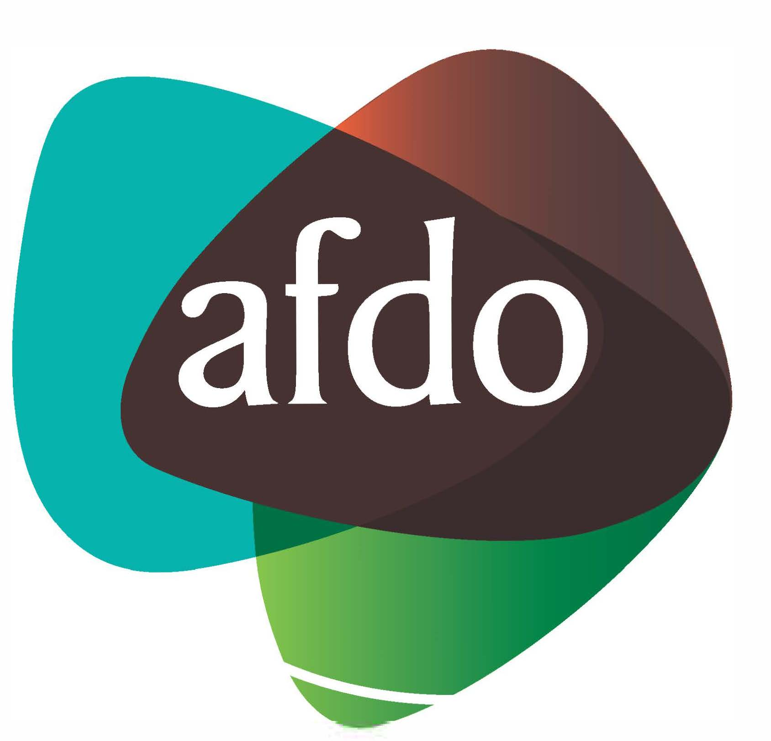

Australian Federation of Disability Organisations

Paper: The future of supported employment in Australia

March 2018

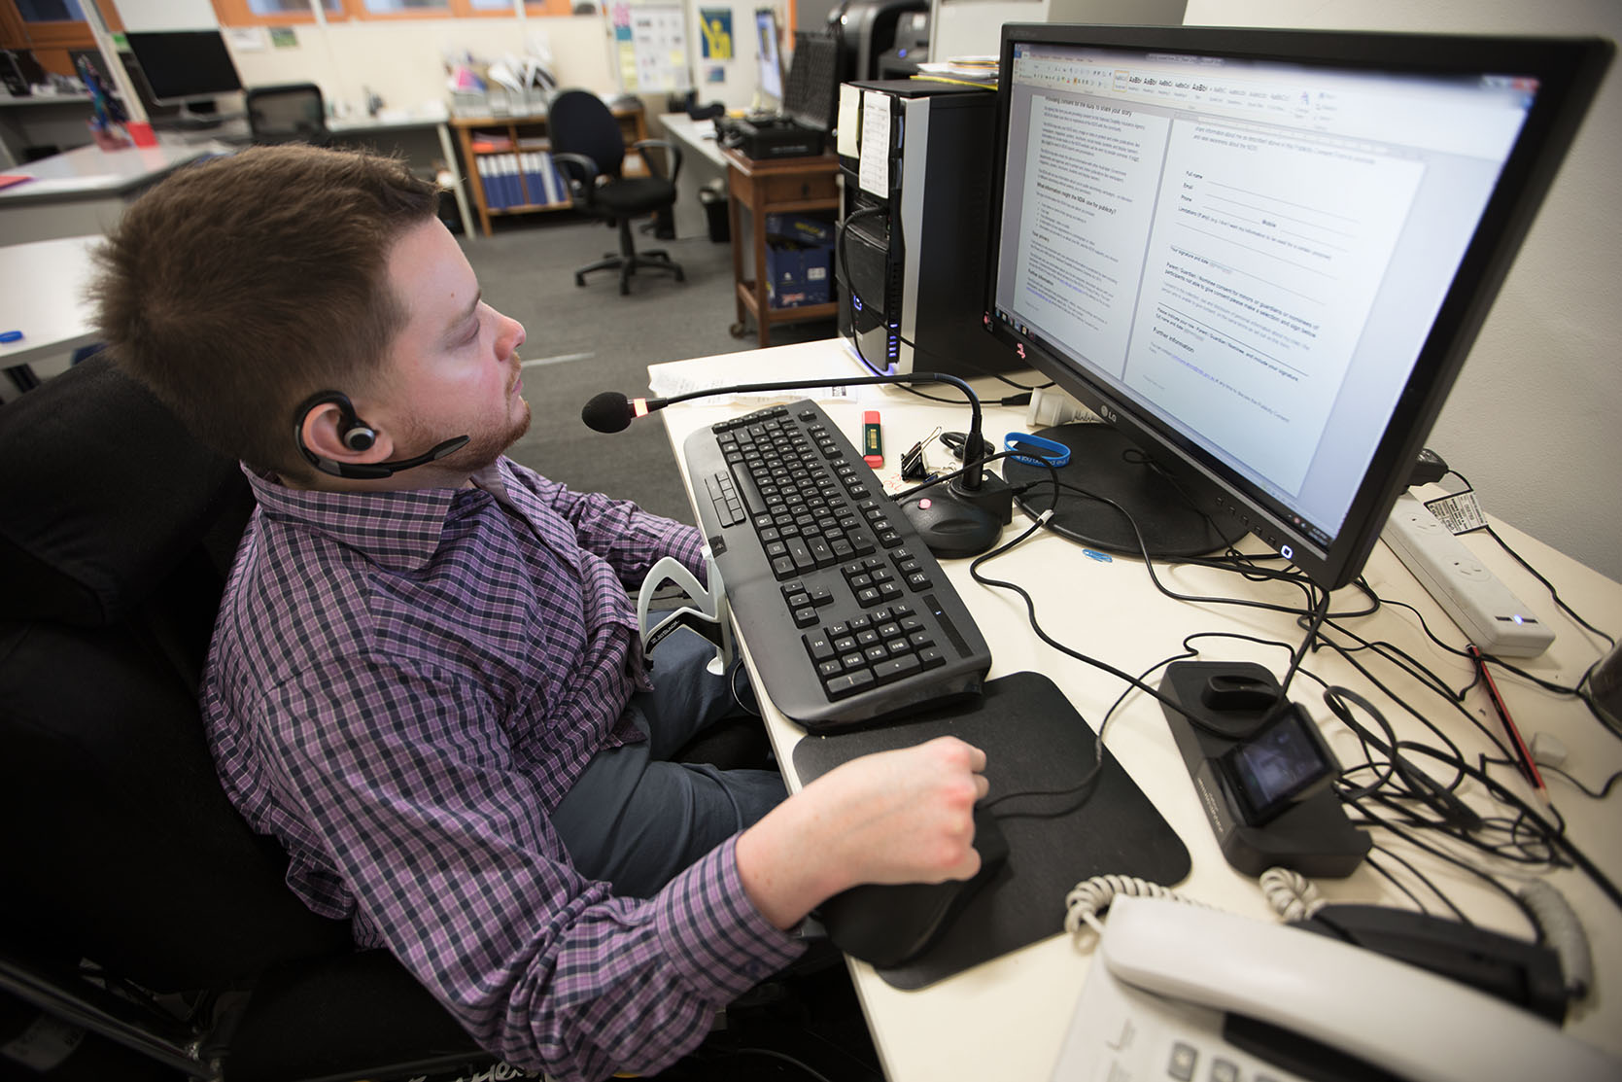
What is AFDO?

The Australian Federation of Disability Organisations (AFDO) is the peak organisation in the disability sector representing people with lived experience of disability. AFDO and its member organisations are run by and for people with lived experience of disability.

AFDO’s mission is to champion the rights of people with disability in Australia and support them to participate fully in Australian life. AFDO has strong relationships not just with its member organisations, but across the disability sector including peaks representing service providers as well as those representing families and carers.

As a founding member of the National Disability and Carer Alliance, AFDO played a key role in the campaign for the introduction of the National Disability Insurance Scheme (NDIS). As the NDIS has moved through the trial phase and begun the transition to full scheme, AFDO and its members have continued to work constructively with the National Disability Insurance Agency (NDIA) as well as Commonwealth and State and Territory governments to provide critical feedback and address implementation issues as they arise.

AFDO’s members include:

Blind Citizens Australia
Brain Injury Australia
Deaf Australia
Deafblind Australia
Autism Aspergers Advocacy Australia
Down Syndrome Australia
Physical Disability Australia
Disability Advocacy Network Australia
Disability Justice Advocacy
People with Disability WA
Disability Resources Centre
Inclusion Australia (NCID)
People with Disabilities ACT
Women with Disabilities Victoria
Enhanced Lifestyles
Deafness Forum of Australia
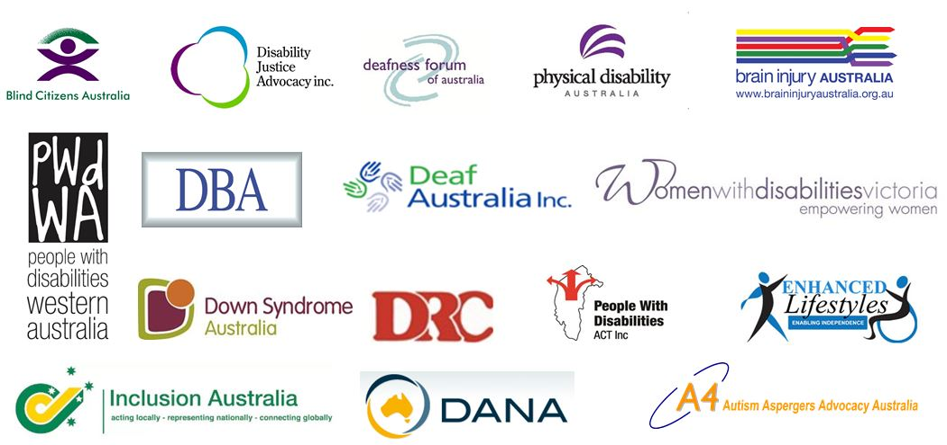

Introduction

The Australian Federation of Disability Organisations (AFDO) and its member organisations welcome the opportunity to work with the Australian Government to shape the future of supported employment for people with disability.
This reform is of critical importance. To date, the direction of supported employment has failed to deliver on the promise of the objects, principles and objectives of the Disability Services Act 1986 (DSA), which stated;
“Services should have as their focus the achievement of positive outcomes for people with disabilities, such as increased independence, employment opportunities and integration into the community.”
Over the last 30 years, there has been a failure to develop evidence based integrated “supported employment” models for people with disability who need specialist and ongoing support to be successful in the open labour market. In its place, Commonwealth policy has resulted in an increase of the number of people with disability in institutionalised and congregate settings over time. These settings have been internationally recognised as incoherent with stated legislative objects of integration or full inclusion and misaligned with the rights of people with disability.
Congregate settings, such as Australian Disability Enterprises (ADEs), where people with disability mostly work with people with other people with disabilities, are contrary to the objectives of the National Disability Insurance Scheme (NDIS) (which focuses on the object of “full inclusion” and an ordinary life as a part of the community), the DSA which sought a change from ‘closed settings’ to integrated settings and our international obligations under Article 27 of the United Nations Convention on the Rights of Persons with Disabilities (UNCRPD).
The advice provided by the consumer sector – people with disability themselves – has often been viewed by the Commonwealth as solely focused on human rights, rather than pragmatic and evidence based. Information presented by people with disability and family led organisations outlining that people with intellectual and developmental disabilities are able to work in open employment is often seen to be lofty, idealistic or relevant to only a certain group of people with disability rather than based on decades of solid evidence.
This includes evidence that people with IQs ranging between 40-70 (approximately 95% of people with intellectual and developmental disabilities) can successfully work in open employment with the right ongoing support, with open employment presenting a better value for money proposition.
Arguments have also been made by proponents of ADEs that promotion of open employment is often by people with a disability who have a much higher functional capacity than ‘real’ people working in ADEs. Our members, representing hundreds of thousands of people with disability across Australia, include people with a range of disability and capacity, including people with intellectual disabilities who have and do work in ADEs. People in ADEs are not other people – they are us too.
Reform that has led to improved rights for women, Australian indigenous people, LGBTI communities and the rights of children did not occur unanimously. Reforms banning child labour, slavery and less pay to Indigenous workers are now not only seen as the right thing to do, but consistent with our community values. This is also true for the closure of large institutions that housed people with disability. This is why the discussion regarding the future of supported employment and its future policy direction is critical.
The following paper presents a number of strategies to address how supported employment can be successfully delivered in the future to maximise employment outcomes for people with disability and achieve the full inclusion the Commonwealth has significantly invested to address through the NDIS. The paper also includes a number of principles and approaches based on evidence of what works and how these practices can be scaled, as well as where innovation might be needed to ensure more successful transition outcomes for people currently working in ADEs.
An inclusive vision for supported employment
It is AFDO’s view that we can do much better than congregate settings for people with disability and aspire to much better outcomes for people with disability that are inclusive, integrated and lead to an ordinary life – outcomes that are consistent with the goals of the NDIS. At present there is no clear vision for supported employment with binding goals and strategies to achieve inclusive open employment outcomes.
Without a clear vision for the future of supported employment, any reform that is made will always be piecemeal, addressing siloed components of a problem or failing to work towards an overarching goal.
Supported employment and ADEs are two distinct concepts. Supported employment recognises the capacity of people with disability to work with the right ongoing supports in a variety of settings that include open (mainstream) employment, mobile crews, social enterprises and small businesses. Supported employment is defined by the DSA by the level of support an individual requires and doesn’t give authority to group people with disability in congregate employment settings.
“supported employment services means services to support the paid employment of persons with disabilities, being persons:
- for whom competitive employment at or above the relevant award wage is unlikely; and
- who, because of their disabilities, need substantial ongoing support to obtain or retain paid employment.”
The Act envisaged supported employment services would assist people with significant disability who would require ongoing support, and who may not be able to work at full award wage to work in integrated settings. Congregate settings in Australia have taken the form of ADEs (previously known as sheltered workshops and business services) which are the least inclusive of all employment options and far removed from the intent of the DSA.
The discussion paper specifically references the economic gains that could be realised if more people with disability were to enter the workforce, with reference to ADEs as a potential solution. The discussion paper itself notes that approximately $11,000 is spent on each placement per year, with employees themselves only realising income of approximately $5500. This low income does not minimise Disability Support Pension payments to any significant extent.
It does not enable people with disability to earn enough income to have an ordinary life that might include living out of home and participating in the community with appropriate support. It also does not contribute to tax revenue and would have questionable impact on economic gains.
By the Government’s own account, employees of ADEs earn on average $5 per hour. If the Commonwealth seeks to increase economic productivity as well as meet the tenets of the UNCRPD and the NDIS Act, this approach is inconsistent with these objectives. This is particularly relevant to the actuarial objects of the NDIS which require the Commonwealth to consider alternative employment strategies for this cohort that produce higher outcomes of inclusion and wages which produce long term savings.
The way to increase economic gains, as well as inclusion is not through a focus on ADEs, but an investment in supported employment that enables people with disability to try and succeed in open (mainstream) employment first (for school leavers/people new to employment) and to transition into open employment with evidence based support for existing employees in ADEs.
There are many examples internationally of how this could be successfully achieved. The success of Washington State in the US, which heralded a move from congregated settings (that mirror the current practice of ADEs) to customised open employment for people with greater barriers to work involved a paradigm, policy and funding shift.
The paradigm shift was a commitment to open employment over other forms of employment (congregate settings) and recreation (day programs) for people with disability. This paradigm shift turned the focus from supporting a system of service providers to continue to provide ‘employment like’ work, to working with and supporting individual people with disability to identify employment opportunities in the open labour market where each could work with the right support. The policy shift focused on prioritising open employment over other policy programs, with an associated funding shift to support this policy objective.
Customised, supported open employment of people with disability has been successful in international contexts such as Washington State due to a conscious re-adjustment of government priorities and spending. This included higher proportional funding into the development of an open employment first framework, with diminishing funding to congregate settings as more people with disability gained jobs in the labour market. This approach recognised that continuing to fund the existing model without greater investment to build the capability of people to enter open employment would not lead to genuine inclusive reform.
Other states in the US, such as Vermont, have also led the way in moving people from congregate settings to more inclusive forms of employment. Investment in open employment and transition planning, resulting in employment outcomes, led to a significant change in attitudes and aspirations of parents and families who initially feared the closure of institutions and had been conditioned to low expectations of their adult children. If the Commonwealth wishes to increase employment outcomes of people who are most likely to enter ADEs, there needs to be a commitment, in both funding and action to do so.
Recommendation 1: AFDO recommends:
- Genuine co-design with people with disability, their representative organisations and other key stakeholders to develop a five (5) year plan, with clearly articulated goals and measures that enable
  - open employment of people with disability entering employment for the first time and
  - transition pathways for people currently working at an ADE.
contingent on the following:
- A line in the sand - no new entrants into Australian Disability Enterprises
- Re-alignment of government priorities (of policy, programs and funding) to preference open employment, with funding of programs that are demonstrated to maximise inclusion or integration
- Development of an open employment first framework, drawing on domestic and international best practice of how to support people with intellectual disabilities, autism and/or complex behaviour, with appropriate resourcing to enable its implementation Australia-wide.
- An investment approach to support individuals to transition to open employment
- Age-appropriate planning and support to assist people with disability and their families to identify appropriate employment pathways (open employment, social enterprises, micro businesses and other pathways such as work experience)
- Resource employment sampling (the ability to try different jobs in different sectors) for all people with disability that can be demonstrated to support people into mainstream employment (not sampling for sampling sake)
- Build the capability and availability of employment professionals equipped to support people with more complex barriers to mainstream employment to explore and successfully gain open employment (see Principle 6 in this paper)
- A transition pathway established for older employees of ADEs, including retirement options and support
- Independent information available to people with disability and families to make informed choices about their future, address fears of transition and navigate appropriate employment options
Measures within the five year plan should include:
- Target for the number of people to enter open employment (school leavers or those seeking a job for the first time)
- Target for the number of people to transition into more inclusive employment options (current employees of ADEs)
- Growing expectations of employment, with people actively choosing and succeeding in open employment. This should be measured by inclusion of open employment in NDIS plans and clear actions to achieve open employment (growing 10% per year) and in employment data
- Consistent measures relating to placement and retention to monitor ‘churn’ (short term placements to meet outcome payments rather than support for the individual to maintain longer term employment)/unsustainable placements
- A minimum of two specialist disability employment support providers with contemporary practice of supporting people in open employment operating in each state and territory to maximise employment outcomes and successful transition
- Clear evidence-based practice identified to support cohorts with very low employment participation rates (eg. people with autism), with customised approaches developed
- Diminishing funding to ADEs as open employment outcomes increase and the development framework is implemented, leading to staged closure of ADEs
- Diminishing expenditure by the Commonwealth as open employment outcomes increase

Pathway to open employment (new participants)
AFDO proposes a future pathway for school leavers with significant disability to open employment that is effective. This is a pathway;
- with demonstrated practice, evaluation, and published results;
- which is much more powerful in achieving open employment outcomes when compared to the same cohort pursuing open employment via an ADE pathway.
The majority of ADE participants currently in “supported employment” are people with intellectual and developmental disabilities (67.5%). The most effective school to work pathway for people with intellectual and developmental disabilities, based on achieving open employment outcomes, is a school to work pathway that involves a presumption of work capacity; transition support that is focused primarily on work experience in the open labour market to address low expectations and other barriers to work; and seamless, concurrent linkages with skilled DES-ESS providers.
This pathway was demonstrated by the NSW Government from 2004 as part of its Transition to Work program. The NDIS School Leaver Employment Supports (NDIS-SLES) is broadly based on this model of support. This pathway was developed due the vast majority of school leavers with intellectual and developmental disability moving from school to non-work day programs. The NSW government found that few, if any, day program participants moved from day programs to employment. This highlighted the need to intervene before school leavers moved to day programs and offer discrete transition to work support that was “risk free”.
Features of open employment first pathway
Critical to the success of open employment for people with significant disability is an initial presumption of the capacity to work in the open labour market. The research indicates that conducting work capacity assessments on young people with disabilities will invariably focus on their current inexperience of work and limited vocational development. The core research finding is that the initial capacity to work of youth with significant disability has little relationship with the level achieved after on the job training in actual workplaces. More investment is needed in this area, including:
- Building the employment aspiration of young people with disability via early conversations about employment in NDIS planning meetings, career exploration aspirations and skills via transition education (age 14 and above)
- Independent information and advice to families about employment pathways to build employment aspiration
- Avoid using assessments to predict capacity – start with the person first and build skills, rather than presume what the person can’t do.
Support at secondary school
- Build employment aspiration (Year 10 and above), including through role modelling
- Transition assessment and planning. “Transition planning should begin early enough to make sure that when a student exits school, he or she has developed some important skills to function as a responsible adult in society. The plan should include measurable goals that are based on assessments related to training, education, employment and, where appropriate, independent living skills. It should also include a description of the transition services the student needs to reach the goals.” (Handbook of Adolescent Transition Education)
Acting on plans - Coordination between school and post-school employment supports
- Based on principles of starting early. “Transition planning should begin no later than age 14, and students should be encouraged, to the full extent of their capabilities, to assume a maximum amount of responsibility for such planning. (Handbook of Adolescent Transition Education)
- Person-centred, capacity building to address personal goals, student and family involvement and leadership in the planning process
- Authentic work experiences (unpaid or paid) in the open labour market with explicit training and support
School Leaver Employment Support (Post School Transition to Work)
For school leavers who are not ready for DES-ESS, due to low expectations, or the need to address barriers
- Extended work experience in the open labour market to address barriers to entering paid work in open employment
- On-site training from employment providers skilled in on-site systematic job training and support
- Training and support to address associated needs such as travel training, and adaptive work behaviour development, e.g. appropriate language and communication, dress, hygiene, following instructions, response to correction, staying on task, checking with supervisor, contact with customers, etc.
- Effective engagement with employers
- Effective relationships with participant and their families
Movement from SLES/Post School Transition to Work — to DES-ESS
- When participant ready to attempt paid work
- Seamless and concurrent movement between transition to work and DES-ESS
- Link to skilled DES-ESS providers with the competences of evidence based open employment support for this cohort (i.e. customised employment, on-site job training, ongoing support)
This model of support from school to work in open employment for people with significant disability (shown pictorially in Diagram 1) is used by the top NDIS and DES-ESS providers.
For example; Jobsupport and Nova, according to the NSW Government’s published results, were responsible for 59% of open employment job placements for 2013 school leavers entering post school transition to work (NSW-TTW) support, Two providers out of 24 Sydney NSW-TTW metropolitan providers were responsible for more than half of the employment outcomes. Jobsupport and Nova are also responsible for 63% of DES-ESS indicative 52-week outcomes for participants with intellectual disability in Sydney, according to DES outcomes by disability type for June 2017. This external independent outcome data indicates that there are employment practices that correlate with successful employment outcomes for school leavers with significant disability. It is important that a future supported (open) employment system is built on these successful practices of open employment.

Pathway to open employment for ADE employees
AFDO recognises that closure of ADEs cannot happen overnight without a significant impact on up to 20,000 employees. In recognition of this, the five year period proposed provides appropriate time to develop a robust framework that has a skilled workforce to transition people into more inclusive employment and participation options.
For current ADE participants, the pathway to open employment must first of all require a raised awareness that placement or employment in an ADE as a step to achieving open employment is typically ineffective based on decades of research and data. This is largely due to the poor capacity of this cohort to transfer skills from one setting to another. The research and demonstration of effective practice indicates that a provider should;
- seek to find a job in the open labour market
- provide on the job training for an individual to learn the job tasks
- provide ongoing support
Alternatively, any employment preparation to develop readiness to address barriers that may be preventing a participant pursue a goal of open employment can include extended unpaid work experience — but needs to be in open employment. This is an employment preparation option that school leavers with disability have via School Leavers Employment Support (SLES).
This would require a provider with the skills in working with this cohort in conducting work experience, addressing barriers, and movement to a paid open employment position. This pathway and processes would need to occur ‘outside’ of the ADE setting. This pathway would require modelling as there has been no demonstration of such a model of support, with current transition efforts by ADEs producing very poor results (less than 1% successfully transition from ADEs into open employment).
ADE participants with a goal of open employment could be referred to a provider with transition to work and open employment skills, and a track record of outcomes, for people with intellectual and developmental disabilities, and other significant disabilities.
A secondary option is for the ADE employment provider to convert its operations to a “supported open employment” provider on a gradual basis. This would require a significant re-orientation of operations, as well as training and technical assistance to make such change and gain a new set of competencies. The proposed model is outlined in detail in Diagram 2.
The success of these pathways is dependent on the adoption of key principles which are outlined in the next section as well as co-investment and collaborative working relationships between employment programs, the NDIS and education systems.
Recommendation 2: AFDO recommends that the pathways outlined for new participants and current ADE employees are used as the basis for future funding of supported employment programs.
Diagram 1: Pathway to open employment (new participants)
Presume that people with disability can work in mainstream employment with the right supports
- Early conversations about employment, aspirations and talents with young people with disability (via NDIS planning, 14 years and above)
- Independent information and advice to families about employment pathways
- Start with a person first approach, with the view of building skills, rather than presume what a person can or can’t do
Provide support at school (mainstream or specialist)
- Based on principles of starting early, person-centred, capacity building, student and family involvement and leadership
- Build employment aspiration (14 years+), including role modelling of people with intellectual and developmental disability in employment
- Transition assessment and planning
- Acting on plans
- Coordination between school & post-school employment supports
- Authentic work experiences with explicit training and support
Implement School Leaver Employment Support / Post School Transition to Work programs
For school leavers who are not ready for DES-ESS due to low expectations or the need to address barriers
- Work experience in the open labour market
- On site job training and support
- Travel training and adaptive work skills development
- Effective engagement with employers
- Effective relationships with participant & families
Move from SLES/Post School Transition to Work to DES-ESS
When participants are ready to try paid work
- Seamless and concurrent movement between NDIS School Leaver Employment Supports and DES-ESS
- Link to skilled DES-ESS providers with experience in providing evidence- based open employment support (i.e. customised employment, on-site job training, ongoing support)
Job identified and participants supported in a job
- Customisation of the role
- ‘On the job’ skills training
- Regular ‘check in’ for both the employee and employer

Ongoing support to ensure that the relationship remains effective
- Regular ‘check in’ for both the employee and employer throughout the life of the job and/or as circumstances change (changes in the workplace, location of the workplace, management, tasks or the need to develop new skills etc.)
- Customised support when and as needed
Diagram 2: Pathway to open employment (current ADE employees)
Presume that people with disability working in ADEs can work in the open labour market with the right support
- Goal is to achieve open employment
- Start with a person first approach, with the view of building skills, rather than presume what a person can or can’t do
- Look at interests, what the person likes and where skills can be built
Independent information and support to address fears of moving from an ADE and to build employment aspiration and goals
- Independent information provided to people with disability and their families to move to more inclusive forms of employment, including support to maintain friendships made through ADEs, and community participation and/or respite support for families due to changes in work hours (resourced in NDIS plans)
- Role modelling of people with intellectual and developmental disability in employment to build employment aspirations among people with disability
Transition to open employment support
For participants not ready for DES-ESS due to low expectations or the need to address barriers (similar to SLES). Occurs outside of an ADE.
- Work experience in the open labour market
- On site job training and support
- Travel training and adaptive work skills development
- Effective engagement built by provider with employer
- Effective relationship built by provider with participant & families
- Maintenance of ADE position should continue if this is the participant’s choice - with primary focus on transition and open employment support activities.
Move from Transition to Work support to DES-ESS
When participants are ready to try paid work
- Seamless and concurrent movement between NDIS Employment Supports and DES-ESS
- Link to skilled DES-ESS providers with experience in providing evidence- based open employment support (i.e. customised employment, on-site job training, ongoing support)
Participants supported in a job in the open labour market
- Customisation of the role
- ‘On the job’ skills training
- Regular ‘check in’ for both the employee and employer

Ongoing support to ensure that the relationship remains effective
- Regular ‘check in’ for both the employee and employer throughout the life of the job and/or as circumstances change (changes in the workplace, location of the workplace, management, tasks or the need to develop new skills etc)
- Customised support when and as needed
Key principles
AFDO supports the first two principles proposed (page 19 of the discussion paper) which are ‘an employment first approach for all NDIS participants of working age’ (more comment is provided in Principle x) and ‘a diversity of employers providing employment supports’, with the proviso that these must be inclusive options and not congregate arrangements.
AFDO have identified the following key principles as central to the future of supported employment that underpin the two models proposed in Diagram 1 and 2.
Recommendation 3: AFDO recommends that the following principles are adopted as features of the future of supported employment.
Principle 1: Open employment should be trialled first for all people with disability, irrespective of their type of disability or perceived level of capacity
This is a significant ideological and policy shift to current practice which presumes that people with intellectual and multiple disabilities are largely unable to work in open employment settings. AFDO proposes that this “old” thinking be removed from policy. Such a change in policy in turn requires a plan to build provider capacity in evidence based support for this group of jobseekers.
The success of this principle is reliant on a shift in how government programs are prioritised and how they are funded. While ADEs will cease to be block funded with the full rollout of the NDIS, there is currently very little investment, and no consistent investment Australia wide, in programs that enable people with disability to trial open employment first, and to be able to sample different types of work and work settings, until the best fit is found.
It is common place for people without disability to try many jobs before a ‘good fit’ is found. Where open employment is trialled for people with disability most likely to enter an ADE, it is often the trial of one job or placement. When it falls over due to inadequate knowledge and availability of trained staff to provide customisation, on site job training, and ongoing job support, the assumption is made that open employment does not work, rather than that the right fit has not yet been found. The latitude that is largely provided to people without a disability to try and fail until they find success is not available, thereby reinforcing the notion that open employment cannot work. Our goal should to be to maximise and optimise the chance and success of a person gaining a job with good support.
Resourcing the time for people with disability to find out what can be achieved, with the support of a customised employment professional, is critical. While open employment cannot be guaranteed for every person with disability, the evidence indicates that people can work with the right support. This is evidenced by thousands of people with a range of cognitive disability working in open employment settings.
Proponents of ADEs note that ADEs cater for people with disability who will never be able to work in open employment, yet best practice for people with significant intellectual disability indicates that approximately 90% can achieve job placement. Where people are unsuccessful in achieving work in the open labour market, other options could be explored, which might include more intensively supported work settings such as social enterprises and other ways to meaningfully contribute to the community, such as volunteering.
Principle 2: Supported employment is employment that offers the right support to a person with disability, founded on principles of integration and value (value as an individual and valuable work)
Research released by the Department of Social Services indicates that less than 1% of ADE employees transition to DES, indicating clearly that ADEs are not a pathway to open employment. Australian and international evidence has repeatedly shown that grouped based services such as ADEs, or community participation programs, are an ineffectual model or pathway for people with significant disability to achieve open employment.
The research and demonstration over several decades has repeatedly indicated that “place and train” models of employment assistance (i.e. place a participant directly in an open employment job together with explicit job training instruction, and subsequent ongoing support) is the most successful strategy for people with intellectual and developmental disability, or other significant disabilities.
This means that the skills learned within an ADE are unlikely to be transferrable to other work settings, explaining lower transition outcomes and poor take up of concurrency programs that enable support to trial DES while working within an ADE. The lack of providers who have the skills to do “place and train” well has exacerbated the issue.
A conflict to supporting transition also exists for many ADEs. Every business, ADE or otherwise, seeks to keep its most skilled employees, with employees transitioning into open employment contrary to the survival of the operation. Segregated employment where people with disability only work with other people with disability over a long period of time diminishes the confidence to work in a new setting, ADE or otherwise; another barrier to transition.
There is no doubt that there are some people with disability who enjoy working with an ADE and gain value from their work. These experiences should not inhibit the development of a concrete plan that actively works to support the achievement of supported open employment. ADEs should not be the first point of employment for young students who have no experience of work when opportunities to develop capacity exist, nor should they be the first and final job for people with disability who have the capacity to contribute in the open labour market.
To maximise the intent (and spending) on the NDIS, it is critical that the future of supported employment has at its heart a focus on work that is of value and is inclusive – real work for real wages in real mainstream settings where the products or services are genuinely valued by the market, the business is commercially viable in its own right, people work with people with and without disability and are valued for their contributions, and people are paid fair wages for fair work undertaken.
Principle 3: Presume that people with disability can work if given the right support through a focus on individual capability rather than use of assessment tools
We do not know what we are capable of doing until we try with the right training – something that we hold true for people without disability but dismiss for people with disability, particularly intellectual disability. Capacity is currently assessed through assessment tools, rather than starting with the individual, finding work and focusing on how to teach job skills and behaviours.
Research from the 1950s to 2018 has repeatedly shown that predicting future work capacity in the open labour market is invalid. Predictive work capacity assessments, however, have a particular harsh impact on people with intellectual and development disability who often experience, and are the subject of, low expectations.
Current assessments do not take into account the skills that can be learned, do not take into consideration the potential for customised employment and are ineffectual when applied to young people who may have little or no experience of work. Furthermore, it is difficult to predict how much a person is able to work, and the type of work they can do, without trialling work. Predictive work capacity assessments feed into a deficit model and are inconsistent with the parameters of the NDIS which seeks to enhance what a person can achieve.
Recommendation 4: AFDO recommends that the new framework
a. enables people with disability to explore the world of work first rather than arbitrarily assess work capacity – by working with individuals with disability over time, a person’s strengths and the capacity for skills to be developed will become apparent
b. seeks to minimise the boundaries between DES and NDIS, including building employment aspiration and assessing the readiness of participants. The NDIS, and SLES in particular, provide a vital pathway for people who will eventually be assisted by a DES. Some better questions to assess the readiness of candidates could look at:
- whether the person is interested in working
- readiness for transition programs and support to explore employment
- readiness to move to DES
- the barriers that need to be addressed to maximise employment success.
Principle 4: Fair pay for fair work
AFDO agrees that there should be clear parameters regarding industrial wage setting for people working in ADEs, including for businesses that hire them and in open employment. AFDO supports the position advocated by AED Legal, People with Disabilities Australia and Inclusion Australia for the adoption of the Supported Wage System as the primary wage assessment tool where a pro-rata Award wage is necessary.
Principle 5: Work is a means to an end, not an end in itself
The third principle outlined in the discussion paper makes reference to how the viability of the ADE sector can be secured into the future. AFDO strongly maintains that the viability of ADEs should not be a principle in the delivery of supported employment in the future, when more robust, evidenced based approaches for open employment can be scaled. The purpose of this reform should not be to secure existing models, but to scale models that are demonstrated to provide better outcomes, in terms of quality of life, inclusion and wages.
Work is a means to an end and not an end in itself and this is also true for how ADEs should be viewed. It is imperative that individuals with disability are supported to work in the open labour market with optimal support, rather than support a system (ADEs) that promote congregate, separate employment.
Principle 6: Invest in sharing best practice and mentoring to build a skilled workforce
The knowledge of how to support people with disability, including people with intellectual disability, in open employment exists in Australia. However its application is limited to just a handful of providers successfully working to assist people with more complex barriers to gain and keep open employment. The success of these providers has been through applying evidence based employment support practices, with a customised employment approach to engaging employers to support each individual and each employer to develop and sustain a good job match, together with on-site job training and ongoing support.
Due to a lack of investment in prioritising specialist supported open employment, many young people with significant disability have been limited to choices of ADEs and non-work support options, reinforcing the notion that open employment couldn’t possibly work for all people with disability.
Extending this knowledge so that these pockets of excellence become a skilled workforce across Australia requires investment of financial resources and expertise, with a focus on building capability via channels such as mentoring, training and technical assistance. Critical elements include sharing practice knowledge of how to:
- identify barriers and behaviour that needs to be corrected to enable open employment to be successful, such as building up skills to work multiple hours per day, completing tasks to a consistent standard and learning how to socialise in a workplace
- work flexibly and responsively to address the needs of individuals who may have a number of barriers to employment
- locate employers within a region that have job tasks that match the needs of specific individuals
- engage employers via customised employment strategies
- do on-the-job training
- deal with behavioural issues as they arise
- provide long-term ongoing support for both employee and the employer
This does not have to be a new program. There is opportunity within the scope of Disability Employment Services Employment Support Service (DES-ESS) which has as its objective to assist people with permanent disability who require ongoing support to find and maintain a job in the open labour market. The DES-ESS program could develop a package of training and technical assistance to encourage providers committed to specialising in supporting people with disability who would normally enter ADEs or non-work support programs. Likewise an opportunity exists for ADEs themselves who are committed to inclusion to re-orient operations and gain the technical know-how and skills required to generate supported open employment
Principle 7: Be clear on what good participation outcomes are for people with disability in supported employment
Good participation outcomes are more than just successfully gaining a job. Potential measures that could apply to supported employment overall could include:
I like my job (a lot, quite a bit, a little, not much, not at all – applied to all of the below, following by more exploratory questions)
I like coming to work at (insert name)
I am bored
I would like to do new things in my job.
I would like to learn new skills in my job.
I would like to work with new people
I would like to work with people who do not have a disability as well
I would like to do another job
I would like to work somewhere else
In one year, I would like to…. (could be new tasks, new job etc)
Developing an understanding of an individual’s goals, employment satisfaction and career aspirations is central to the focus on NDIS planning.
Recommendation 5: AFDO recommends that measurement of employment satisfaction, particularly for current employees of ADEs, is included within NDIS planning reviews.
Principle 8: Successful supported employment relies on building expectations early by working with other systems, including the NDIS and the education system
Significantly increasing mainstream employment rates of people likely to enter ADEs relies on building up expectations of work from a young age. The reform that is needed spans beyond changes to supported employment, but also considers the NDIS and education settings which have a critical role to play.
Reforms by the NDIA
The object of the NDIS Act 2013 seek to;
“promote the provision of high quality and innovative supports that enable people with disability to maximise independent lifestyles and full inclusion in the mainstream community; and”
The general principles guiding actions under the NDIS Act state that;
(11) Reasonable and necessary supports for people with disability should:
(a) support people with disability to pursue their goals and maximise their independence; and
(b) support people with disability to live independently and to be included in the community as fully participating citizens; and
(c) develop and support the capacity of people with disability to undertake activities that enable them to participate in the mainstream community and in employment.
A number of reforms are necessary to enable the vision of open employment first.
Start the conversation and goal setting about employment early
We cannot change the expectation of employment without building that expectation early in both young people with disability and their families. At present, many students attending schools may only discuss employment in their final year of school, and often, the only options presented are an ADE or non-work activities.
This is not genuine choice and control. One conversation in one year of schooling is not enough, particularly where low expectations of what can be achieved have been instilled over years of schooling. When compared with students without disability who begin conversations about employment in early secondary school, the contrast becomes even more apparent. If we want to change the employment outcomes of people with disability, the conversation – and building of expectations of students with disability – needs to start earlier and with purpose.
Recommendation 6: AFDO recommends:
a. employment supports are included as part of the development of NDIS plans with an ‘opt out’ provision. This will enable employment planning to commence as early as possible and also has applicability to people currently working in ADEs to transition. This could also include support to maintain social connections with friends made in ADEs and respite and support options for families due to changes in work hours.
b. the NDIS assessment process require young people aged 14 and above to attend at least one NDIS planning meeting per year, to develop employment aspirations and identify potential employment opportunities and areas for skill development. This provides important information that can assist families, the NDIA and connected providers to identify opportunities and what the young person might like to do.
At present, young people under the age of 18 are not required to attend a planning meeting, with parents often directing the conversation regarding the types of support needed and goal setting. The low expectations of what their child might be able to achieve (often exacerbated over many years through the school system) may be inconsistent with what a young person might be able to successfully achieve with the right support and encouragement, or in fact the views of the young person themselves.
As an example, a consumer led organisation in Victoria recently presented to a group of students in their final year of school, of which 12 of 13 students were recipients of the NDIS. Each of 12 students was unaware that they were receiving an NDIS package. It is important that young people have their own voice and are part of decision making regarding their own life to the best of their ability. Where a young person feels comfortable, AFDO recommends that one-to-one chats with a planner are encouraged to begin to unpack likes and interests.
c. ensure that plans are approved in a timely manner to maximise the momentum for open employment
Where plans are developed for school based transition, or for SLES, plans have not been approved early enough, creating anxiety for young people and parents to be able to get on with their lives and address employment aspirations.
d. raise expectations and build awareness of people with disability and their families of a wide range of opportunities that are available to people with disability
Parents and young people who aspire for more than employment in an ADE often have limited genuine alternatives. A lack of genuine choice to explore other options, due to a lack of sufficient resourcing and quality providers who understand how to make customised employment work well, result in people with disability staying with what they know or gravitating to the only options available. Access to independent information to make informed choices goes hand with hand with skilled providers who can make open employment work.
One of the questions asked within the discussion paper is what will attract people with disability to open employment. Building awareness among people with disability and their families of the supports available is critical, with independent information to make informed choices about the opportunities available. At present, young people and families do not have consistently available access to independent support and advice to make informed decisions about employment and other pathways. This had led to an over-reliance on providers and education settings shaping the direction of young adults. To balance this, it is important that people with disability and families are equipped with independent information to work collaboratively with teachers and providers to maximise outcomes for students.
For people with disability currently working in ADEs, it is imperative that this information is provided in a neutral space (outside of ADEs) so that people with disability do not feel dissuaded from attending, or disloyal for asking questions and seeking to transition to more inclusive pathways. Access to this support should be included within an NDIS plan.
e. funding within NDIS packages is provided to work one on one with families to build employment aspiration and knowledge of the employment pathways that are possible and where to access support. AFDO recommends that a line item is created within the NDIS to support the purchase of independent support and that this is encouraged of parents of children with intellectual and multiple disabilities in planning meetings. This is a critical shift to elevating expectations and employment uptake.
f. Increase awareness and expectations of successful open employment of NDIS staff, including Local Areas Co-ordinators and planners
Planners and Local Area Co-ordinators are a front line resource for people with disability and their families. The experience of working with Local Area Coordinators can vary greatly depending on the training and expertise of individual co-ordinators and their exposure to open employment practices.
Similar to teachers, they can have significant influence in directing young people to open employment or dissuading them based on their own preconceived notions of whether a person is suited to open employment (which may be before the person has sampled work), lack of local providers to support open employment or lack of knowledge of how open employment can work for people with more significant barriers to employment. AFDO recommends that tailored training and development is funded for front line NDIA staff focused on evidence based information about open employment and potential outcomes.
We need all stakeholders and players to have high expectations of people with disability, with a focus on possibility. It is imperative that the NDIS, in particular planners and LACs, work hand in hand with families, schools and providers to begin the process of exploring open employment. LACS and Regional Employment Champions can play a pivotal role in assisting people with disability and families to explore local employment supports and to support families to maximise their NDIS planning session to obtain employment focused supports.
g. Invest in the expansion of successful transition to work programs, including SLES
To increase the numbers of school leavers entering mainstream supported employment, it is critical that the SLES program is re-oriented to employment pathways that lead to open supported employment only. SLES should not be used for pathways into ADEs.
The success of the expansion of the SLES program, and the expansion of transition to work programs, is dependent on successful sector development and the skill of providers. The NSW state-wide transition to work program is one of a few programs that has been successful in demonstrating what is possible through evaluating the practices of high performing providers. The evaluation of this program identified critical success factors:
Young people need extensive exposure to diverse workplace settings in order to expand their occupational horizons, to gain vocational experience and to further develop vocational skills and aptitudes.
- “Providers need strong, professional links with employer networks in order to design work experience placements and to locate and/or create ongoing work roles. In some situations this can be achieved through partnering with a DES provider. However, TTW staff will still require a strong awareness of the contemporary labour market and the needs of employers. Employers need deep confidence in the capacity of the service provider to provide appropriate support to the employer, the young person and their colleagues. A strong, balanced and inclusive relationship needs to exist between the young person, their parents/carers, and the service provider in order to achieve the goal of finding and keeping a job. Partnership and close integration with a DES has a positive impact on achieving employment outcomes. Partnership and close integration with a Community Participation program has a negative impact on achieving employment outcomes.”
Sector development is crucial, with training and mentoring needed in other regions and states. We believe this is a critical role that the NDIS can play.
Reform by state and territory education systems, in particular schools
To counter low expectations and increase the likelihood of young people with disability entering employment, it is imperative that the five year framework includes a focus on increasing expectations of open employment in school settings where children with disability form their views of work and a future outside of school.
In addition to independent information provided to young people with disability and families, it is critical that young people are exposed to examples of successful open employment while at school so that aspirations can be built. As per our recommendations above, it is critical that this starts as early as possible and from the age of 14 at a minimum.
Recommendation 7: AFDO recommends that
a. funding is allocated for sessions to be held at each specialist school across Australia to begin to build employment aspiration and increase expectations for students, parents and teachers.
The sessions should provide evidence of how open employment works in principle and showcase successful employment outcomes with ongoing support. These sessions should be co-delivered by consumer organisations and providers who have expertise in developing successful employment outcomes, with people with disability themselves who have been employed in open supported employment presenting at each session. At minimum, sessions should be held once per year, with LAC support after the session to assist families to connect with local support and begin to think about strategies that can be incorporated into NDIS plans.
Teachers in specialist settings can significantly influence the goal setting and direction of young people and their families. They can be the champions of open employment and aspiration or can view open employment as a risk that is ‘not suitable’, which in turn can moderate, stifle or shift the expectations of parents of what their child can realistically achieve.
b. AFDO recommends that teachers attend the same sessions that are offered to parents and students, with specialist teachers supported and encouraged to work with skilled providers to learn about how students can transition from school to work.
In closing, AFDO reiterates its position that we can do much better than congregate settings for people with disability and should aspire to much better outcomes for people with disability that are inclusive, integrated and lead to an ordinary life. AFDO welcomes the opportunity to work as partner with the Australian Government to develop a vision for supported employment that is inclusive, fair and values the contribution each person with disability can make with the right support.
Video Resources
Jessica
Video: https://youtu.be/rv6XuowgcHA
“I have been working for the ABC for 11 years. I like working with my work colleagues and I enjoy all of the tasks and jobs I do. I think employers should give people with disability a chance. We’ve got abilities, we can do anything”
Sarah
Video: https://www.youtube.com/watch?v=glKCicC8P6I
“It’s coming up my 25th year at Harris Farms Market. I love it”
Russell
Video: https://www.youtube.com/watch?v=vX9Zu5Kqzcs
“We’ve got Russell here at Northmead (McDonalds) and we have people who come and ask for him specifically and from time to time if he is not on they actually won’t come in to visit us because they are really keen to see him”.

Principles and Objectives of the Disability Services Act 1986. Commonwealth of Australia Gazette, No.S 118, Tuesday 9 June 1987.
United Nations High Commissioner for Human Rights. (2012). Thematic Study on the work and employment of persons with disabilities. See page 17, paragraph 17. “Submissions to this study highlighted a wide range of efforts undertaken by States parties to promote employment of persons with disabilities. Nevertheless, such efforts often focus on creating jobs or training opportunities in separate settings and fail to respect the principle of inclusion provided for in the Convention. It is imperative that States parties move away from sheltered employment schemes and promote equal access for persons with disabilities in the open labour market.” - See integration objects, and objects and principles of the Disability Services Act 1986. - See “full inclusion” objects of the NDIS Act
Commonwealth of Australia, Evaluation of Disability Employment Services. 2010-2013. Final Report. Centre for International Economics. (2017). Securing savings from open employment. The case of persons with moderate intellectual disability
Developed in 2004, with implementation beginning in 2006, Washington’s Working Age Adult Policy was the first “employment first policy” established in the USA. Built upon the community values and practices of more than three decades, the policy firmly establishes open employment as the primary goal and establishes employment supports as the primary use of program funds for all persons with developmental disabilities of working age. Since its implementation other states have looked to Washington State for leadership and guidance, using us as a model as they define their priorities of services and resource investment.
AIHW DSS 2015-2016
There is not enough time and resources to undertake both extensive unpaid work experience to work on barriers to open employment AND undertake the explicit job search support and on the job training that DES-ESS resources provide. A combination of NDIS-SLES resources and DES-ESS resources has demonstrated high rates of open employment outcomes by skilled providers.
Commonwealth of Australia, Evaluation of Disability Employment Services. 2010-2013. Final Report, Chapter 7.
Commonwealth of Australia. (2015). National Disability Employment Framework - Issues Paper. “In 2014, 159 ADE supported employees left ADEs to move into open employment.” (p. 12)
The United States Senate Committee on Health, Education, Labor and Pensions. The United States House of Representatives Committee on Education and the Workforce. September 15, 2016. Advisory Committee on Increasing Competitive Integrated Employment for Individuals with Disabilities. Final Report “For people with I/DD or other significant disabilities, center-based employment, also called sheltered workshops, have long been used as a place to provide “prevocational” services for people deemed as either unemployable in CIE [community integrated employment] or as “needing training” to prepare them for eventual CIE in their communities. However, center-based employment has been shown to rarely result in CIE.
A.D.B.Clarke(1958).TheAbilitiesandTrainabilityofImbeciles.p.309-333.InA.M. Clarke, & A.D.B. Clarke (Eds.). (1958). Mental Deficiency. The Changing Outlook. The Free Press. Dyson, M, Brown M & Canobi, S. Critical Literature Review: Instruments Assessing Work Capacity. 2016, Melbourne: Dyson Consulting Group for Department of Social Services. “Overall, our searches confirm the observations of Cronin et al.4 regarding a world-wide interest in work capacity assessments and the concerns of Serra et al.5, that is in spite of such an interest, there is a scarcity of evidence based work capacity (fitness for work) assessments validated by empirical data.” (p. 9)
From Protection to Productivity. An Evaluation of the Transition to Work Program. Ageing, Disability and Home Care Department of Family and Community Services NSW November 2009

