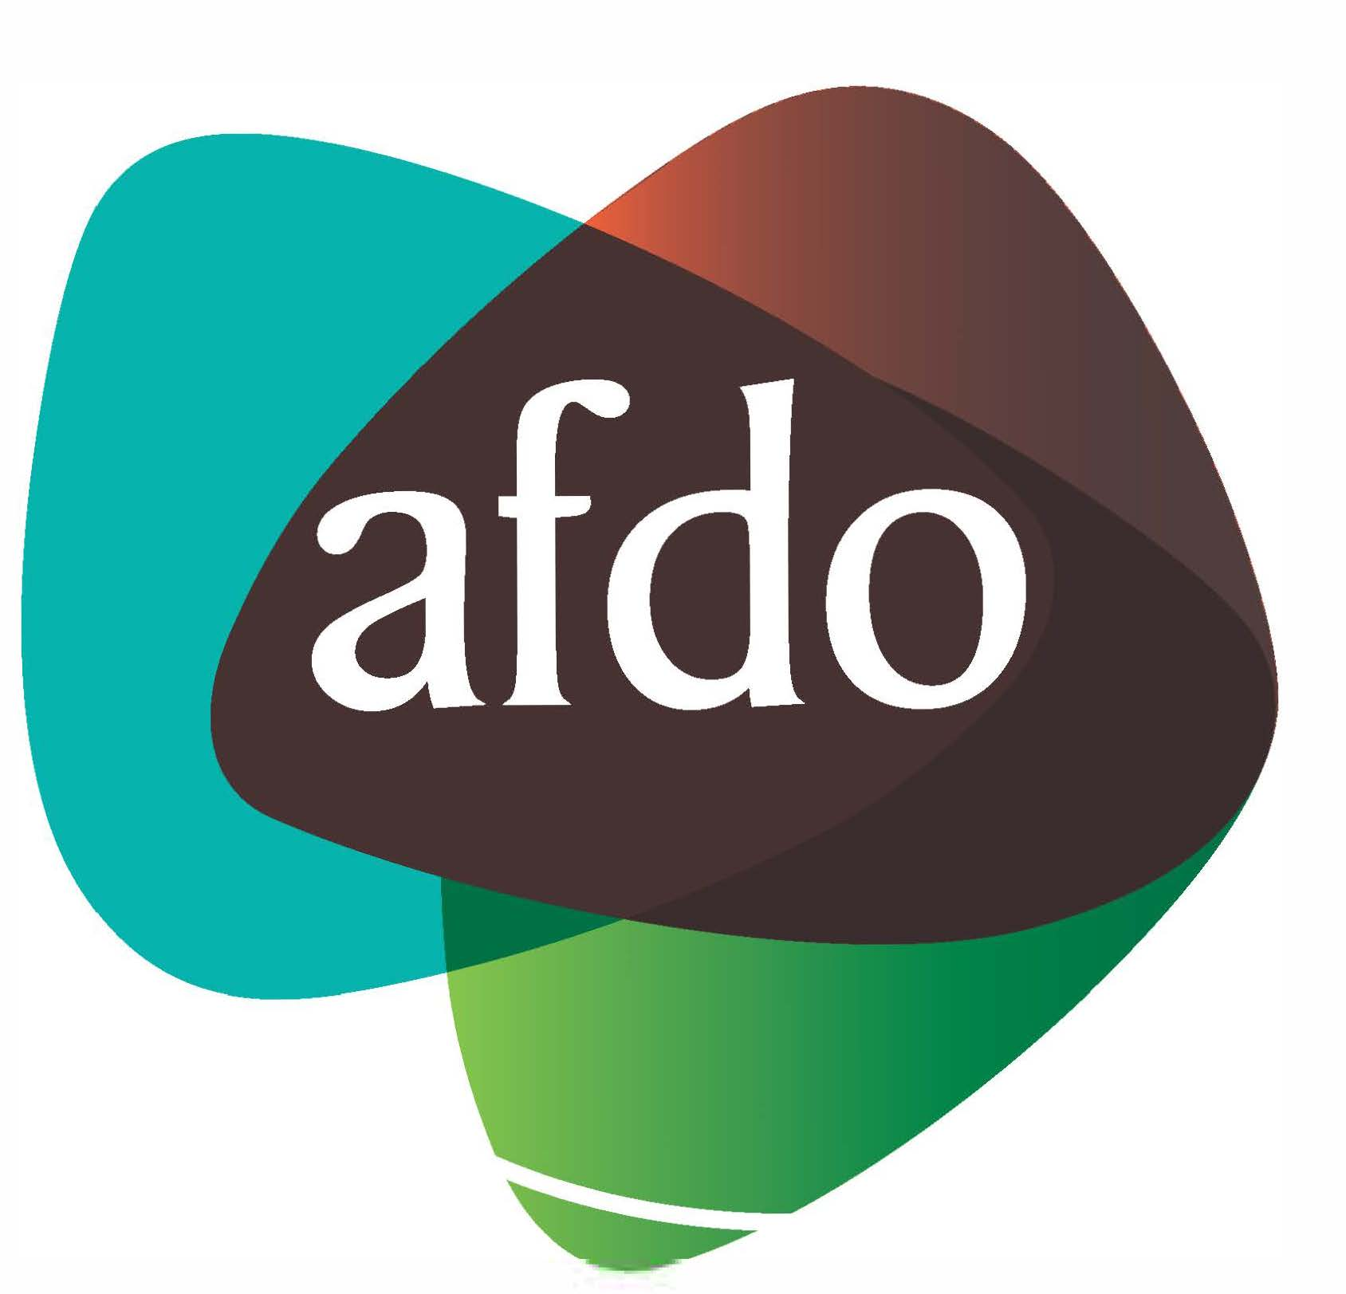

Australian Federation of Disability Organisations

Strategic Plan 2018 – 2021

Table of Contents
Table of Contents 2
About us 3
Our Values 3
Our Vision 3
Our Mission 3
Our Members 3
Our Strategic Objectives 4
Our Strategic Projects 4
Strategic Objective A: 4
Represent the united voice of our members & people with disability 4
Strategic Objective B: 5
Enhance the profile, respect and reputation for AFDO through our members 5
Strategic Objective C: 5
Build the capacity and sustainability of AFDO and our members 5
Strategic Objective E: 6
connection & influence in international disability initiatives – Asia Pacific region 6

About us
Formed in 2003, the Australian Federation of Disability Organisations (AFDO)
is the peak organisation in the disability sector representing people with disability and lived experience of disability.

AFDO and its member organisations are run by and for people with lived experience of disability.

We work to develop a community where people with disability can participate in all aspects of social, economic, political and cultural life. This includes genuine participation in mainstream community life, the development of respectful and valued relationships, social and economic participation, and the opportunity to contribute as valued citizens.

Our Values
Respect, Responsibility, Transparency, Trust and Resiliency This is seen as a dynamic document which will evolve over the life of the Strategic Plan in response to external and/or internal changes or issues that arise.

Our Vision
All people with disability are involved equally in all aspects of social, economic, political, and cultural life.

Our Mission
Using the strength of our membership based organisations to harness the collective power of uniting people with disability to change society into a community where everyone is equal.

Our Members

Blind Citizens Australia
Brain Injury Australia
Deaf Australia
Deafblind Australia
Autism Aspergers Advocacy Australia
Down Syndrome Australia
Physical Disability Australia
Disability Advocacy Network Australia
Disability Justice Advocacy
People with Disability WA
Disability Resources Centre
Inclusion Australia (NCID)
People with Disabilities ACT
Women with Disabilities Victoria
Enhanced Lifestyles
Deafness Forum of Australia
Women with Disabilities ACT

Our Strategic Objectives
- Represent the united voice of our members and people with disability in national initiatives and policy debate
- Enhance the profile, respect and reputation for AFDO through our members
- Build the capacity and sustainability of AFDO and our members
- Foster strong collaboration and engagement between our members
- Enhance the connection & influence of AFDO in international disability initiatives by policy, advocacy & engagement, focussed on the Asia Pacific region

Our Strategic Projects
- In order to deliver on the five key Strategic Objectives for AFDO and its Members a number of Strategic Projects have been devised for implementation
- These will be regularly reviewed, reported and monitored by the Board & Management with full reporting of outcomes to our Members and Stake-holders
- It is envisaged that additional Strategic Projects will be added as required over the life of the Strategic Plan

Strategic Objective A:

Represent the united voice of our members & people with disability
A1 Develop a policy, advocacy & research team, Oct 2018 + Ongoing
A2 NDIS roll-out monitor, review and advise, Federal political & stakeholder engagement strategy for AFDO & members, Ongoing
A3 National Disability Strategy (NDS) 2020 – 2030 – Advocacy, Oct 2018 + Ongoing
A4 Develop Advocacy Master Plan, Sept 2018
A5 Federal political & stakeholder engagement strategy for AFDO & members, Dec 2018
A6 Improve employment outcomes of PWD in Australia, May 2019
A7 Develop an action plan for PWD that are <65 non NDIS, Aug 2019
A8 Develop an action plan for PWD that are 65+ non NDIS, Oct 2019
A9 Develop a partnership strategy with non-AFDO members & key disability sector organisations, Nov 2019

Strategic Objective B:

Enhance the profile, respect and reputation for AFDO through our members
B.1 Develop a strategy to build AFDO’s profile, branding & increase media exposure, Feb 2018 & Ongoing
B.2 New AFDO Website launched, Aug 2018
B.3 CRM System for AFDO + Members, Nov 2018 + Ongoing
B.4 Develop a strategy to build member’s profile & increase media exposure, May 2019
B.5 Develop a Digital Strategy to utilise suitable platforms, Sept 2019

Strategic Objective C:

Build the capacity and sustainability of AFDO and our members
C.1 AFDO Constitution review – membership & Board structure, Completed
C.2 AFDO & Members Sustainability Strategy, Aug 2018
C.3 Develop a fee for service strategy for AFDO & its Members, Nov 2018
C.4 Raise funds to establish fundraising resources, June 2019
C.5 Develop portfolio of funded projects, March 2019
C.6 Develop a Digital Strategy to utilise suitable platforms, March 2020

Strategic Objective D:
Strong collaboration, engagement between members & stakeholders
D.1 Strategic capacity development workshops for members, Sept 2017 & Ongoing
D.2 Members meetings - Information sharing & funding opportunities, Oct 2018 & Ongoing
D.3 Disability Australia Hub website - Members engagement & cross news feed, Oct 2018 & Ongoing
D.4 Developing the internal capability & resource to coordinate applications for funding, Oct 2018 & Ongoing
D.5 Consolidated events management calendar – all Members, Dec 2019

Strategic Objective E:

connection & influence in international disability initiatives – Asia Pacific region
E.1 Develop an International Master Plan, Jan 2019 + Ongoing

Australian Federation of Disability Organisations
Head Office: 02 6198 3361 Level 1, The Realm
18 National Cct, Barton ACT 2600
Phone: +61 3 9662 3324
Email: office@afdo.org.au
Website: www.afdo.org.au

