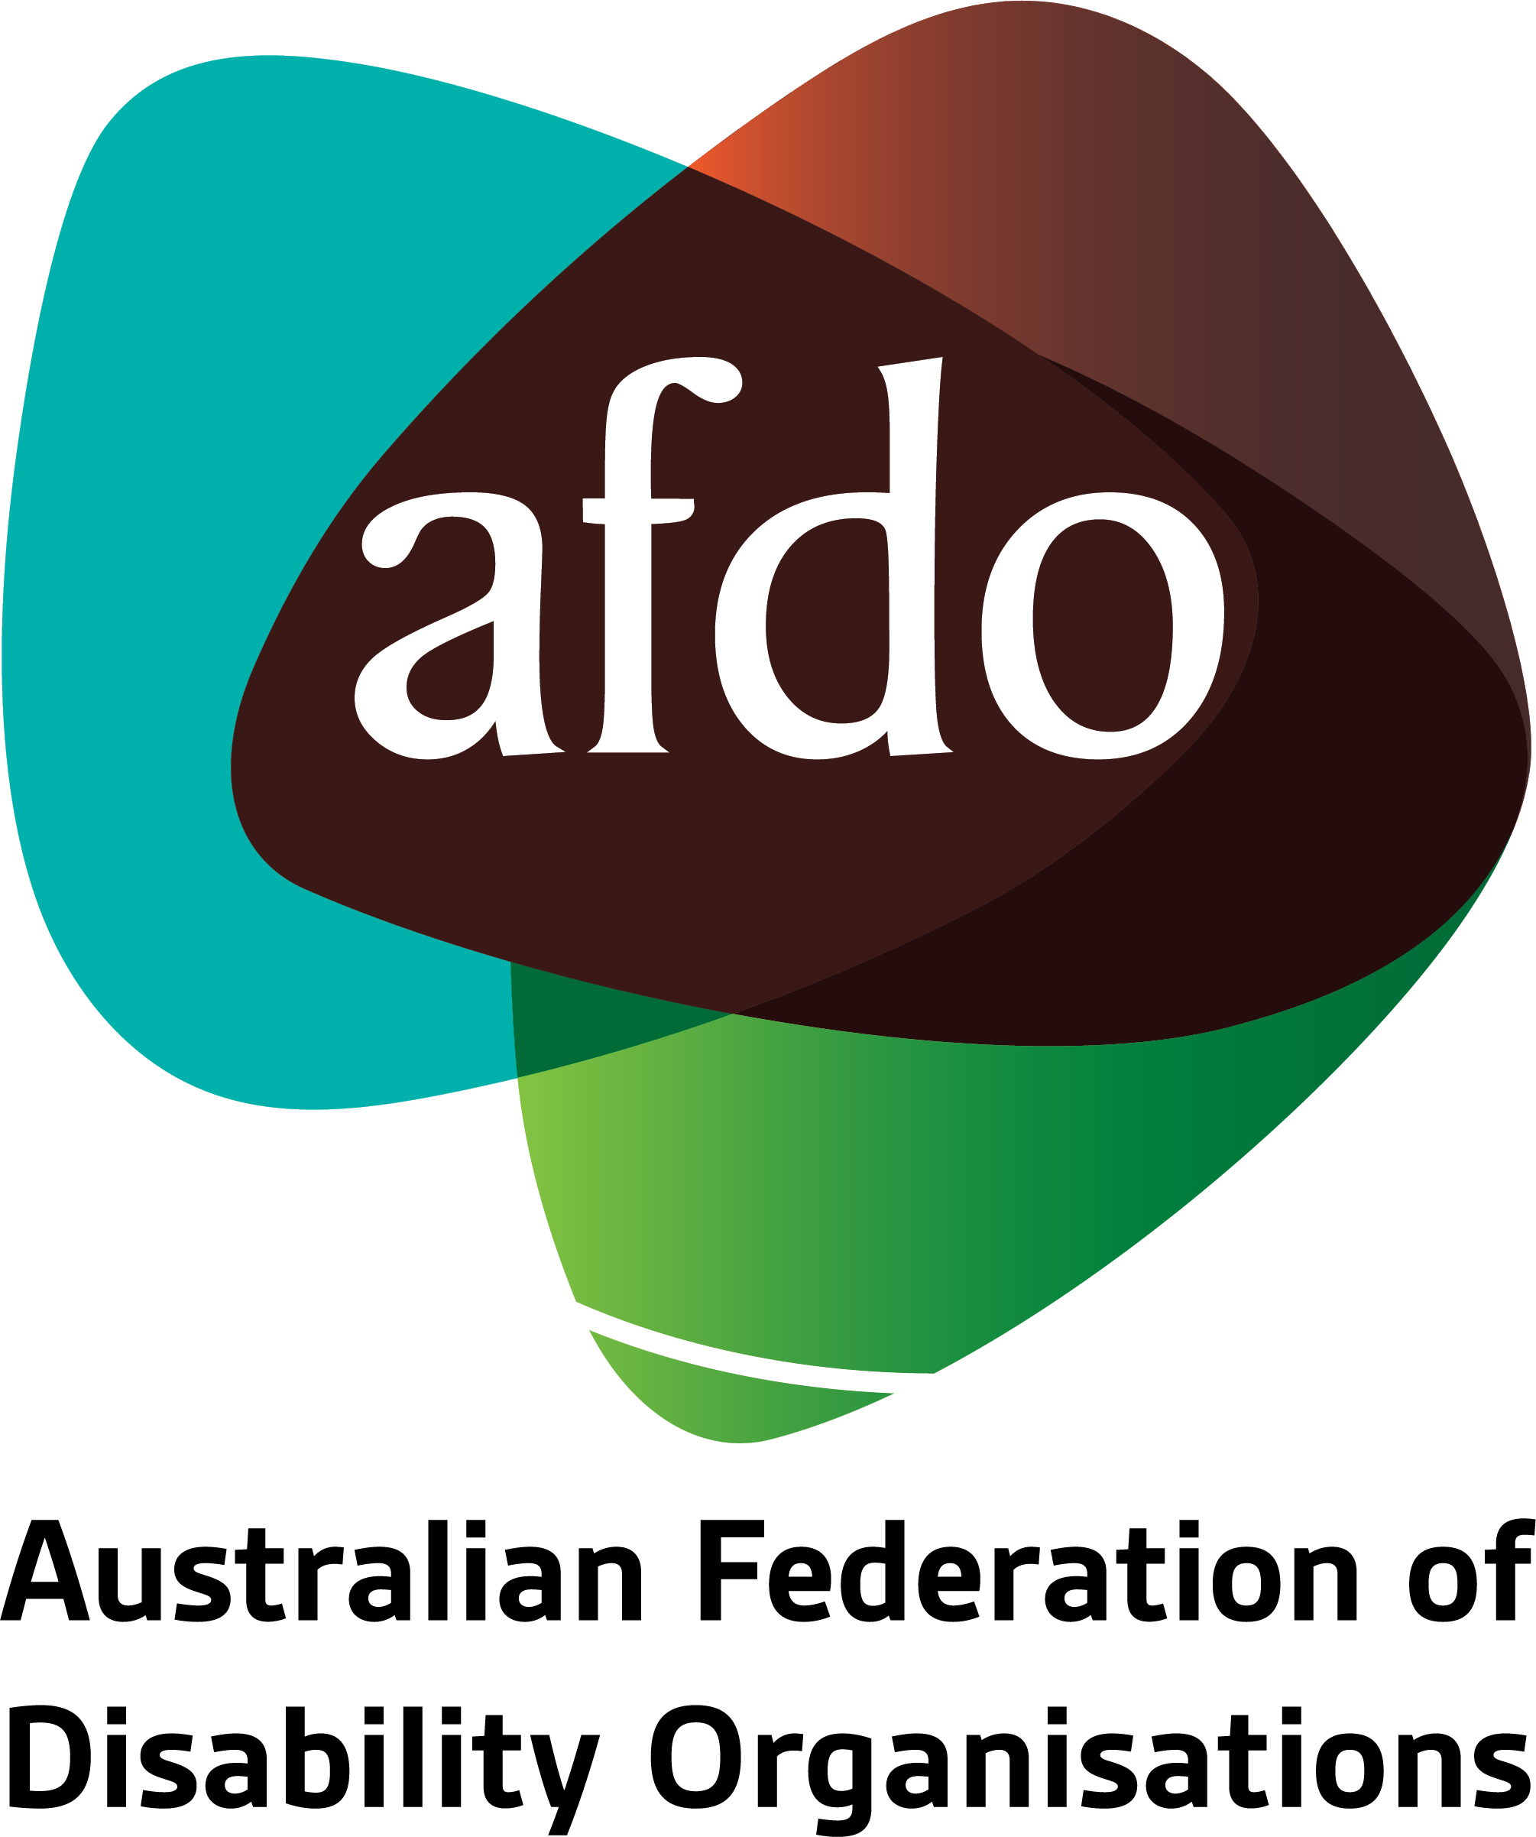

Issues for
Children with Disability
in
Out of Home Care

August 2019

Contributors
This paper has been developed through the collective expertise of a number of key people, and AFDO would like to acknowledge this and thank them for their commitment, contribution and their ongoing work for the sector;
- Michael Perusco – CEO - Berry Street
- Bronwyn Pike – Side By Side Manager – Developmental Disability Western Australia
- Mikaila Crotty – Policy and Research Leader - JFA Purple Orange
- Deb Frith – CEO - My Voice
- Paige Armstrong – CEO - Queensland Disability Network
- Patrick McGee – National Manager – Policy, Advocacy & Research – AFDO

Table of Contents
Contributors 2
1. Context - Children with Disability in Out of Home Care 4
2. Unresolved Issues for Children with Disability in Out of Home Care 5
3. Emerging Issues for Children with Disability in Out of Home Care 8
4. What’s Working Well 11
5. Recommendations 12
Report contact 14
About AFDO 15

Context - Children with Disability in Out of Home Care
  - Whilst children with disability living in out of home care have always been a part of the disability sector; it is fair to say that many of the same issues, including abuse and neglect existed then as they do now.

  - The current case by case approach to the resolution of issues facing families with children with disability living in out of home care was also reflected under the state-based systems of funding for accommodation and support. This approach saw some families receiving high-quality disability supports and others receiving little or no supports at all.

  - Of particular concern is the impact of a case by case approach on Indigenous children with disability and their families, children with disability and their families living in regional and remote areas and children with disability and their families coming from culturally and linguistically diverse backgrounds

  - Children with disability in out of home care are more than likely to have never been the subject of the child protection system. Thus the relinquishment of the child with disability to the state has always been a last resort and generally occurs only in the face of the breakdown of funding for support and accommodation not the presentation of the child’s disability.

  - In the last six months there has been positive movement by the NDIA and state and territory jurisdictions towards restabilising support and accommodation for this group of vulnerable children with disability and their families.

  - In particular the outcomes relating to extending the provision of 24/7 care to children with disability in out of home care and the agreement that state and territory governments would the fund board and lodging of children in out of home care are welcomed and acknowledged.

Unresolved Issues for Children with Disability in Out of Home Care
There remain a number of outstanding issues that need to be addressed;

  - Children and Young People with Disability Australia (CYDA) promote the fundamental principle that;

The primary place of residence for a child with disability should always be in the family home when there are no safety or abuse concerns for the child.
This principle underpins the position that all efforts should be made to provide the level of disability support needed to ensure that the child with disability remains in the family home.
CYDA have expressed significant concern about children with disability having to leave the family home and be accommodated and supported in an alternative arrangement where there are insufficient services supports available to keep the child at home.
  - Building the capacity of parents with children with disability living in the family home is of paramount importance in the context of developing an NDIS Plan.
Unfortunately, some families have experienced the NDIS planning process as a conflict dynamic between what is the parent’s responsibility and what is a funded disability support.
  - The threshold to demonstrate the need for NDIS disability funded support remains very high. The level of evidence that needs to be provided in order to show the need for overnight disability support is significant and providers have only recently been informed that it is necessary.

Families and service providers are experiencing this requirement as onerous and burdensome given that children have a right to be cared for and supervised at night, regardless of their sleeping patterns.

There is currently a significant impact on parents who have their child living at home who are unable to get funded supports for night time care.
Parents in this situation are often having to provide significant levels of supervision over and above what a parent would normally with the resulting impact on family life, siblings and parent relationships. This may result in families feeling they have no choice but to relinquish the care of their child.
  - Families are continuing to experience the impact of services such as respite being discontinued despite the transition to other service delivery models that enable the effect of respite.

  - It remains unclear what constitutes out of home care and respite under the NDIA. This is affecting the cohesion of families who rely on respite care as core support that enables children with disability to continue to be cared for at home and prevents a need for out of home care. If the respite care is not funded at the level of need, then this throws families into crisis.

As an example, in NSW, a weekend of respite care can cost up to $3,000. This is having an effect on the funding packages of families of children with disability who require respite care. Families are experiencing a negative difference in the way respite is being funded under the NDIS compared to the old block funding system for respite care.

  - The situation remains critical in regional and remote areas where there is limited service delivery capacity in the areas of complex support, and this particularly affects Indigenous children with disability. A lack of skilled disability support providers and staff mean limited capacity to provide reliable and consistent disability support.

  - Prior to the establishment of the NDIS, the Victorian Government operated specialised disability group homes for children and young people. Under the NDIS, these homes have been transferred to the NDIA, and are being operated by external providers.

Because the NDIS doesn’t fund accommodation, children with disability are now being placed into the child protection residential care system. Residential care is provided to support young people who are no longer able to live at home and who have often been impacted by abuse, violence and neglect.

Placing young people with disabilities into this environment can leave them at risk of harm and trauma, without adequate support, if the residential care staff have not been appropriately trained.

  - In Western Australia, parents haven't always remained the legal decision-makers in the context of children in out of home care.

There remains a lack of clarity and transparency regarding the application of policy which affects which families get a negotiated plan agreement (between child protection and disability services and therefore retains legal guardianship) and which families end up having their child taken in to care with all rights taken away from them. Indigenous families with children with disability are particularly vulnerable in these circumstances.

  - Residential/Commercial care settings might have appropriate reference to disability in their organisational standards, but in practice, there is a lag between asserted standards in organisation’s operational guidelines and the level of staff skills and capacity to provide the specialist disability supports to children with disability.

  - The roles and responsibilities of the state providers and the NDIS remain confused on the ground and difficult to navigate for families and providers alike.

Emerging Issues for Children with Disability in Out of Home Care
  - The impact of no markets or thin markets is significant for families with children with complex disability presentations.

Families may receive well-funded plans but are unable to have the plan implemented due to a lack of disability support providers along with systemic deficits in knowledge skills and capacity.

For example, the parents of a child with disability could only work approximately once a fortnight because whilst there was the necessary funding to ensure appropriate disability support there was limited availability of well trained, consistent and reliable staff who were employed by a disability support provider with the necessary expertise and capacity to support such a complex roster.

  - Despite the principle of choice and control, families who have children living in out of home care are not able to self-manage or plan manage their children’s NDIS plan.

Self-management and plan management provides for much greater involvement and choice in the provision of disability support by the parents and enables ongoing involvement in the day to day life of the child.

Self-management and plan management also allows for greater flexibility when choosing and negotiating with providers. There are certain examples where the families would actually be better financial and service managers than the options they otherwise have available.

  - In NSW families are further restricted by having to use providers who are registered under the old “Voluntary Out of Home Care Program” previously run by NSW FACS. This limits the choice by families to a small handful of providers who generally are more concerned with traditional child protection service models.

These providers are being requested to rapidly change their business models and are under significant financial distress, given the changing policies and requirements in this space. The time taken, for example, to determine who pays for night time funding, has left some providers hundreds of thousands of dollars in arrears for care.

Placing providers under stress has a cascade effect on families who may be asked to personally pay the gap in funding and then to the children involved.

  - The engagement between children in out of home care and other NDIS interface areas such as transport, education, health and justice is emerging as a key issue for families of children with disability.

For example, a child with disability was funded for transport to and from disability supports, but no transport was available. For others, there remains no transport funding at all.

This is also true for families who have children using regular respite services and need transport to and from school to the facility.

A Legal Aid agency provided an example where a young person with disability in a detention facility was unable to be released because of delays in the provision of specialist assessment and specialist supports, the outcome being, that the young person was detained past the time of their sentence.

  - Disability Support providers are continually financing unfunded disability support, whilst the NDIA determines plan funding arrangements. This is placing significant financial burdens on small organisations and organisations in rural and remote areas.

  - NDIS planners have been stating that funding is also dependant on the availability of up to date behaviour support plans and other therapy reports.

However, the requirement for the improved relationships funding only to be NDIA managed and dependant on NDIA registered providers are having a deep impact. There are very few of these practitioners available, and delays can be up to 6 months long. This is resulting in considerable stress and uncertainty for all involved.

  - The interplay between trauma and disability for children living with disability in out-of-home care cannot be overstated. There is an ongoing need for increased workforce skills and training around trauma-informed care and understanding the relationship between trauma and disability for children with disability.

  - Particular service providers with specialist expertise in support and accommodation for children with complex disability presentations, a long history of service provision and a track record of involving the family in all aspects of support and accommodation, have generally been the providers of choice.

However, many families are also seeking to develop out of the family home accommodation models on their own or with other families in similar situations, seeking to purchase their own properties, and govern, manage and direct supports to ensure the safety and quality of care.

    - In South Australia children living with disability who are in out-of-home care arrangements are being cared for within a Specialist Disability provider centre. This is very new and does not have the necessary volume of resources behind it.

What’s Working Well
- In NSW, it is clear that there have been real changes in terms of the recognition of the needs of children and families in out of home care arrangements and the funding required to keep them safe. The recent involvement of specialist planners has been of benefit and will certainly help to ensure that there are proper oversight and care and that matters can be responded to more efficiently.
- The recent announcement of SDA funding approvals for the children resident at Farnell St in Sydney is an advancement on the rights of families to have supports provided in a manner that will ensure long term tenure security for their children. It may well encourage other families to consider funding the accommodation their children need and overtime reduce the vulnerabilities they otherwise face.
- The Intensive Support Team in Victoria provides the capacity to enable problem-solving in situations of complexity and is very well regarded
- The retention of Justice Case Managers by the Victorian Department of Health and Human Services acts as a disability informed bridge between the justice system and the NDIS
- Family-based care and kinship care models tend to be working well where the standards of care for Family Based Care/Kinship Care tend to be higher in practice, and the continuity of caregivers in the Family-Based Care/Kinship Care is genuinely positive

Recommendations

- Every effort should be made to ensure that children with disability are supported to remain living in the family home, and this includes having the necessary funding for that to occur. Ensure that there are crisis response pathways for families to access that avoid the family having to resort to out of home care arrangements

- Training for specialist NDIS planners on the experience of families with children with disability who need out of home care and the retention of legal guardianship by the parents

- Increased behaviour support through NDIS Plans available to families of children with disability needing out of home care arrangements

- Continued funding in NDIS plans that are commensurate with the disability support needs of the child with disability

- SDA funding extended to children with disability

- Where children do live in alternative supported accommodation to the family home that the service is appropriately and adequately funded to provide a safe and secure accommodation option

- If a young person with a disability enters the residential care system due to a lack of supported disability accommodation, training must be funded for residential care staff to provide appropriate support

- Engage planners from the start that understand the issues facing children in out of home care

- Build a workforce that has a high degree of competency around issues of complexity

- Provide culturally safe disability services and disability supports that enables access for Indigenous Australians with disability

- Build a service safety net that is responsive, accessible and has clear accountability

- Fund a Pilot Project allowing families to self-manage or plan manage their NDIS supports as per the NSW self-management pilots previously in operation under the state scheme

- Consider reviewing the NSW family governance models that were previously in operation under the state scheme and had highly successful outcomes

- Host a National Roundtable and Invite the families who proposed and commenced family governance models in NSW, only to have these models collapse under the transition to the NDIS, to present their vision of disability support and accommodation to the Child Protection Sub Working Group and the NDIS Joint Standing Committee

Report contact
For further information, please contact;

Patrick McGee
National Manager – Policy, Advocacy, & Research
Australian Federation of Disability Organisations
Email: patrick.mcgee@afdo.org.au
Mobile: 0423 303 344

About AFDO
Since 2003, the Australian Federation of Disability Organisations (AFDO), a Disabled Peoples Organisation (DPO) and recognised Disability Representative Organisation (DRO), has been the “go-to” national peak organisation in the disability sector, along with its disability-specific members, representing people with disability and their families.

AFDO and its members embrace and operate on a social model of disability in line with the United Nations Convention on the Rights of Persons with Disabilities (UNCRPD)

Our mission is to champion the rights of people with disability in Australia and support them to participate fully in Australian life.

As one of the three founding members of the National Disability and Carer Alliance, AFDO played a key role in the campaign for the introduction of the National Disability Insurance Scheme (NDIS) through its “Every Australian Counts” campaign. As the NDIS has moved through the trial phase and begun the transition to full scheme, AFDO and its members have continued to work constructively with the National Disability Insurance Agency (NDIA) as well as Commonwealth, State and Territory governments to provide critical feedback and address implementation issues as they arise.

Our 17 full member organisations represent disability-specific communities and advocacy with a total reach of over 1.7 million Australians.

AFDO’s members include:

Blind Citizens Australia
Brain Injury Australia
Deaf Australia
Deafblind Australia
Autism Aspergers Advocacy Australia
Down Syndrome Australia
Physical Disability Australia
Disability Advocacy Network Australia
Disability Justice Australia
People with Disability WA
Disability Resources Centre
Inclusion Australia (NCID)
People with Disabilities ACT
Women with Disabilities Victoria
Enhanced Lifestyles
Deafness Forum of Australia
Women with Disabilities ACT

