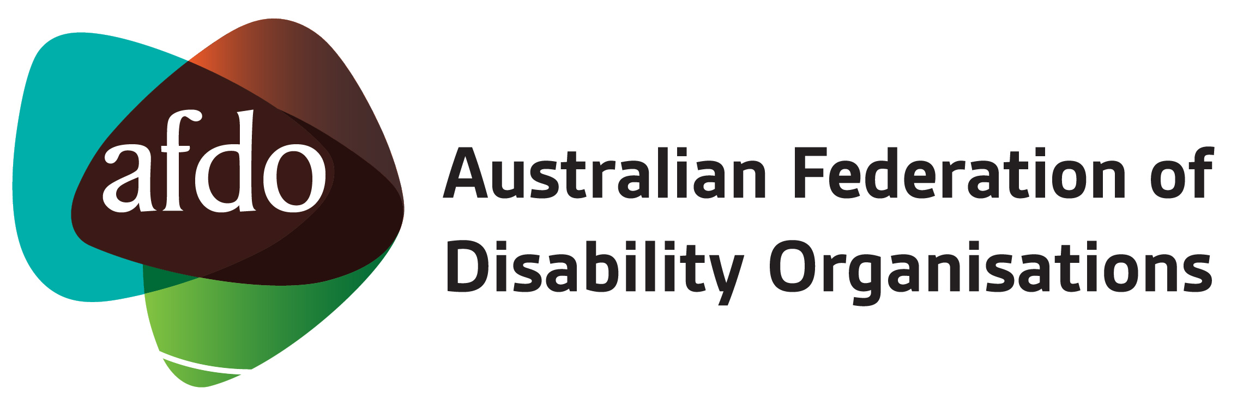

Joint submission on the
National Disability Insurance Scheme (Streamlined Governance) Bill 2019

28th August 2019

Table of Contents

Table of Contents 2
About AFDO 3
About DANA 4
Introduction 5
Joint Response 6
Outcomes 8
Recommendations 9
Submission Contact 10

About AFDO
Since 2003, the Australian Federation of Disability Organisations (AFDO), a Disabled Peoples Organisation (DPO) and recognised Disability Representative Organisation (DRO) has been the recognised and “go-to” national peak in the disability sector, along with its disability-specific members, representing people with disability.

We operate effectively, constructively and respectfully with Commonwealth, State, Territory and Local governments along relevant departments on inquiries, submissions, initiatives, systemic issues or other matters that impact or affect the lives of people with disability and their families.

As one of the three founding members of the National Disability and Carer Alliance, AFDO played a key role in the campaign for the introduction of the National Disability Insurance Scheme (NDIS) through its “Every Australian Counts” campaign. As the NDIS has moved through the transition to full scheme, AFDO and its members have continued to work constructively with the National Disability Insurance Agency (NDIA), the NDIS and all stakeholders, to provide critical feedback and address implementation issues as they arise.

Our 17 full member organisations represent disability-specific communities with a total reach of over 1.7 million Australians

AFDO’s members include:

Blind Citizens Australia
Brain Injury Australia
Deaf Australia
Deafblind Australia
Autism Aspergers Advocacy Australia
Down Syndrome Australia
Physical Disability Australia
Disability Advocacy Network Australia
Disability Justice Australia
People with Disability WA
Disability Resources Centre
Inclusion Australia (NCID)
People with Disabilities ACT
Women with Disabilities Victoria
Enhanced Lifestyles
Deafness Forum of Australia
Women with Disabilities ACT
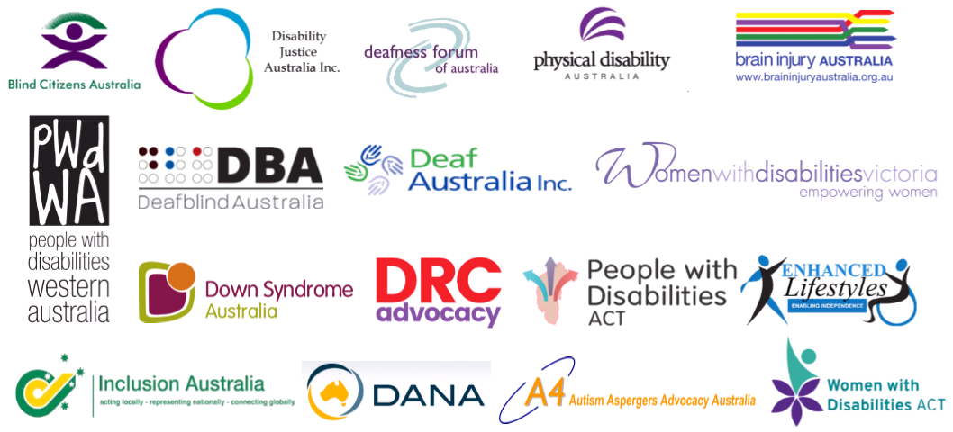

About DANA
Disability Advocacy Network Australia (DANA) is the national peak body for 70 independent disability advocacy organisations across Australia.
Our goal is to advance the rights and interests of people with disability by supporting our members in their targeted advocacy as well as engaging in systemic advocacy on a national level to further these objectives.
DANA works to a vision of a nation that includes and values persons with disabilities and respects human rights for all.
Independent advocacy agencies address the advocacy needs of those people with disabilities who are more likely to be vulnerable to abuse, neglect and/or breaches of their fundamental human rights.
They do this through a variety of delivery models that include systemic advocacy, legal advocacy, individual advocacy support by paid advocates, citizen advocacy using volunteer advocates, self-advocacy development and support, and family advocacy development and support.
DANA’s input provides insight into the myriad human rights problems faced by people with disabilities in contemporary Australia. Our membership is comprised of advocacy organisations that work to protect the rights and interests of some of the most disadvantaged and marginalised people with disabilities.
To manage within limited funding environments, advocacy services prioritise clients with cognitive impairments, communication barriers, complex needs, those with experience of institutionalisation, abuse or neglect, and those without strong networks of support from peers, family or friends.

Introduction
AFDO and DANA welcome the opportunity to provide comment on the National Disability Insurance Scheme (Streamlined Governance) Bill 2019 (the Bill). We would like to thank the Committee for also extending an invitation to provide evidence to the Committee on Friday the 30th of August. We look forward to that opportunity.
We also acknowledge the challenge that the government and community face in ensuring that this major social change adheres to the vision that people with disability hold for the NDIS.

Joint Response
AFDO and DANA understand that existing governance arrangements and structures that have been in place have proved difficult and in some situations, cumbersome to efficient and effective decision making.
We understand that it is this situation that acts as the motivation for this Bill. We also understand that the Commonwealth and States and Territories have been voluntarily engaging in governance processes such as time-limited decision making.
We are supportive of streamlining the governance arrangements outlined in the amendments contained in this Bill, however, like other Disability Representative Organisations providing evidence to the Committee, we would recommend delaying the passage of the Bill until after the completion of the Tune Review. We are aware that these amendments have been under consideration for some time prior to the announcement of the Tune Review.
The current review of the National Disability Strategy (NDS) and recommendations out of the Productivity Commission’s Review of the National Disability Agreement indicate a significant amount of change to the environment in which the disability sector generally and the NDIS specifically operate including governance arrangements.
It is our view that there may be outcomes from the Tune Review that influence or have an impact on governance arrangements and, as such, it is premature at this point to implement changes.
We note the existing voluntary participation by Commonwealth and States and Territories in these arrangements and conclude that this situation can be extended without undue impact until the insights and recommendations from the Tune Review are provided to the Minister.
We believe that the current partnership arrangements between the Commonwealth and the States and Territories are an important signal to the community about the shared investment in the NDIS.

One of the visible ways in which that shared investment is acknowledged is by the language that is used. A straightforward language that can be easily understood by the disability community remains extremely important. For this reason, we believe the terminology of “States and Territories” should remain and do not support a move to changing this to “Host Jurisdiction.”

AFDO and DANA agree with Young People in Nursing Homes when they state, “The NDIS Board and the Independent Advisory Council (IAC) The NDIS board, its advisory structures and its relationships with all participating governments must have a direct line of sight to the variety of communities and cohorts the NDIS must interact with.”
It is in this context that we make the point that there must be more people with disability on the NDIS Board and believe that there must be majority agreement between the Commonwealth and States and Territories for appointment to and terminations from the NDIS Board.
Similarly and taking into account the principle of an equitable partnership between the Commonwealth and States and Territories and the need for the disability community to continue to hold trust in that arrangement, we believe that a majority decision-making model needs to be in place for appointments and terminations to the Independent Advisory Council.
Given this reference to the Independent Advisory Council, we would like to propose that consideration be given to the idea of establishing Independent Advisory Council’s in each state and territory.
This would take some of the pressure off the agenda of the National IAC and allow for state and territory specific issues pertaining to the NDIS to be considered by state and territory representatives at the state and territory level.
Conclusion
AFDO and DANA support the broad direction that these amendments signal to ensure more efficient, effective and streamlined governance arrangements. However, we believe that such amendments to the NDIS Act and its Rules should be postponed until the conclusion of the Tune Review.

Outcomes
- AFDO and DANA support the amendment in this Bill where the Commonwealth and States and Territories will move to a majority decision-making model

- We support the implementation of the timeframes associated with decision making: 28 days for an initial response with an extension of 90 days upon request

- We do not support the term, “States and Territories” being replaced with “Host Jurisdiction”

- We support the continued partnership of the states and territories and the Commonwealth in appointments to the NDIS Board through a majority decision-making model (moving the Rules applying to appointments or terminations to the NDIS Board out of Category A and into Category C)

- We do not support the Rules applying to appointment or terminations to the IAC being changed and request this to align with the Board appointments and be through a majority decision-making model (by moving the Rules applying to the Independent Advisory Council Category C)

Recommendations

- Delay the passage of the NDIS – Streamlined Governance 2019 and continue with the existing voluntary arrangements that the Commonwealth and States and Territories are already practising until after the Tune Review into the NDIS Act, as there may be additional amendments and requirements that impact on this Bill as a result of the outcomes of that work

- Implement a comprehensive review of NDIS Governance Arrangements and Stakeholder Engagement

- In the NDIS - Streamlined Governance Bill, the original term “States and Territories” must remain and not be replaced

- In the NDIS - Streamlined Governance Bill, the Rules applying to appointment or termination to the Independent Advisory Council to be through a majority decision-making model by moving the Rules applying to the IAC into Category C

- Increase the number of people with disability on the Board of the National Disability Insurance Agency

- Establish an Independent Advisory Council in each State and Territory following the existing protocols for membership of the National Independent Advisory Council to broaden the engagement of People with Disability and respond to jurisdictional issues

- Include People with Disability and their representative organisations in Governance arrangements that relate to participation in the Interface Principles Jurisdictional Conversations through the Senior Officials Working Group and the Sub Working Groups in each of the Mainstream Service Systems

Submission Contact

If you have any questions about this submission, please contact;

Patrick McGee,
National Manager - Policy, Advocacy & Research
Australian Federation of Disability Organisations (AFDO)
Mobile: 0423 301 344 email: patrick.mcgee@afdo.org.au

Young People in Nursing Homes Submission to the Senate Community Affairs References Committee August 2019

