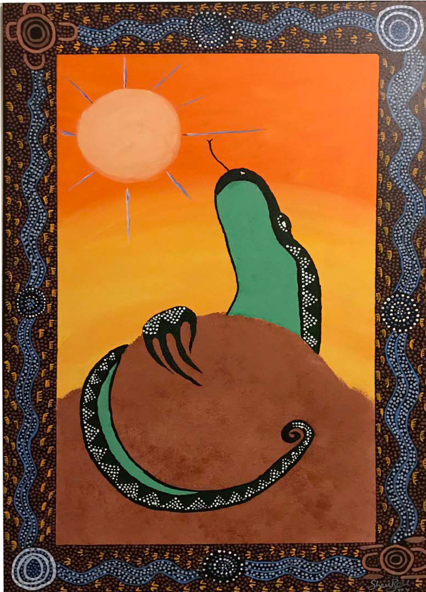

‘At what cost?’

Indigenous Australians’ experiences of applying

for disability income support (Disability Support Pension)
Karen Soldatic, ARC DECRA & Senior Research Fellow Michelle Fitts, Research Associate
Institute for Culture and Society, Western Sydney University

© Soldatic, K. & Fitts, M. 2018
Published by Western Sydney University DOI: 10.26183/5bce98d47d34e
'At what cost?' Indigenous Australians’ experiences of applying for disability income support (Disability Support Pension): Community Feedback Report.

Research funded under an Australian Research Council DECRA Project (DE160100478): Disability Pension Reform and Regional Australia: The Indigenous Experience.

CITATION:
Soldatic, K. & Fitts, M. (2018) ‘At what cost?' Indigenous Australians’ experiences of applying for disability income support (Disability Support Pension). Penrith, New South Wales: Western Sydney University.

AUTHORS:
Karen Soldatic is an Australian Research Council DECRA Fellow (2016–19) at the Institute for Culture and Society at Western Sydney University. Her DECRA, entitled ‘Disability Income Reform and Regional Australia: The Indigenous Experience’, draws upon two previous fellowships at the British Academy International Visiting Fellowship (2012) and The Centre for Human Rights Education, Curtin University (2011–12), where she remains an Adjunct Fellow. Karen’s research on global welfare regimes builds on her 20 years of experience as an international, national and state-based senior policy analyst and practitioner.

Michelle S Fitts has a diverse research background within public health, psychology and disability. Her multiple areas of research interest – traumatic brain injury, road safety, alcohol management and disability in Indigenous Australian communities are drawn together through the theme of injury prevention. Over the last ten years her work has contributed to a range of policy and practice changes and the development of educational resources and programs including a community-based drink driving program for regional and remote Indigenous communities. Her work has been recognised with a number of awards including the prestigious Peter Vulcan Award.

ACKNOWLEDGEMENTS: We would like to acknowledge and thank the ongoing support we have received from a diverse range of community members, legal and social support services, and persons living with disability and their networks and families who participated in focus groups and interviews. Without the ongoing support, generosity and commitment, this study would not have been possible.
Thank you.

ABOUT THE PROJECT: Disability Income Reform and Regional Australia: The lived experience for Indigenous Australians with disabilities is major three-year program of research funded by the Australian Research Council (DECRA Fellowship: ARC DE160100478). The project aims to investigate the ways in which Aboriginal and Torres Strait Islander Australians living with disabilities and their families respond to the challenges imposed by national disability income reform and rapid regional economic restructuring.

The views reflected in this report are those of the authors only and do not reflect the funder, the Australian Research Council. The report has been written with the aim to feedback to research participants the key overarching findings.

TABLE OF CONTENTS

ABOUT THE AUTHORS 2

ACKNOWLEDGEMENTS 2

ABOUT THE PROJECT 2

PROJECT ARTIST 4

SUMMARY & KEY FINDINGS 5

BACKGROUND 6

RESEARCH AIM & METHODS 8

FINDINGS 11

Services 11
Adapting to new medical requirements 11
Supporting clients to obtain medical reports and information 12
Reporting and work activities exceptions 13

Individuals living with disability 14
Advocacy during the application process 14
Challenges communicating with Centrelink staff 14
Mental health and wellbeing impacts of the process 15
Living on welfare payments 16

CONCLUDING REMARKS & RECOMMENDATIONS 16

REFERENCES 21

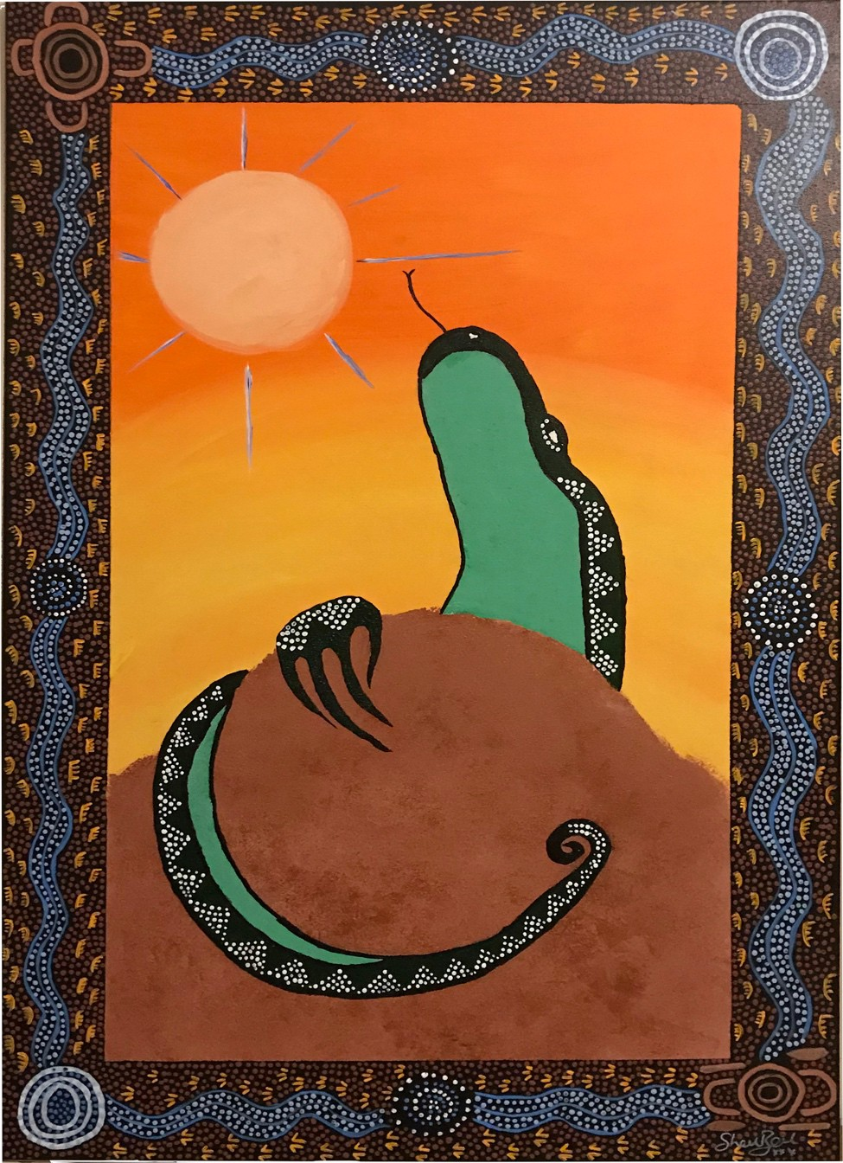Majinda May is a woman from the Birpai Clan and has been an artist now for about five years. Majinda is self-taught and usually works with images that express her thoughts and feelings. Majinda’s artistic work helps support and maintains her mental health and wellbeing. Majinda is active with her local women’s centre, supporting women who have experienced or are going through domestic violence.

Sunset over Uluru was developed when Majinda was exploring a range of art images that reflected her feelings and emotions of mental wellbeing at the time of
painting. Majinda selected this painting from her collection for this community report as she felt that it went well with the narratives of the research participants, and their sense of hope, that may come about by participating in the research for a more socially just system of support for her people.

Summary
The Disability Support Pension (DSP) is the primary financial income support payment for Australians living with a disability who are unable to be fully employed within the open labour market. It has been a core component of Australia’s social security framework since 1908 (formerly as Invalid Pension). Since the early 2000s, a series of changes have been enacted by the Australian Government to the DSP eligibility criteria and the assessment process. Despite major changes, there has been limited scholarly attention of the implications for Aboriginal and Torres Strait Islander Australians. Aboriginal and Torres Strait Islander Australians experience approximately twice the rate of disability as non-Indigenous Australians. This report examines the impact to Aboriginal and Torres Strait Islander Australians in the community applying for the DSP. It also reviews the impact of the changes to the DSP to a range of service providers who support Aboriginal and Torres Strait Islander Australians living with disability. The information within the report is taken directly from interviews and focus groups conducted in four jurisdictions across Australia between February 2017 and September 2018. The people interviewed include mostly Aboriginal and Torres Strait Islander people who have applied or are in the process of applying for the DSP. Additionally, interviews and focus groups with medical practitioners and non-medical service providers are also included. Combined, these interviews show the impact on individuals, their families and support networks, and the services that support them. A number of recommendations to improve the current process are outlined.

Key findings
- Aboriginal and Torres Strait Islander Australians living with disability experience several barriers to fulfilling the eligibility criteria and assessment requirements including, but not limited to, increased financial costs and transportation limitations.

- Applicants required significant support and assistance with advocating their eligibility for the DSP, understanding the paperwork and attending appointments. In many cases, family members, non-medical service providers and medical practitioners acquired this advocacy role. This responsibility was usually outside the perimeters of resourcing and position descriptions for service providers and medical practitioners.

- Applicants had significant challenges communicating with Centrelink and obtaining support from Centrelink during the DSP process.

- Changes to the process used to assess and evaluate medical information were considered to illegitimate the medical opinions of treating medical practitioners and treating specialists, even though medical experts had long been involved with their clients with disability.

- Applicants awaiting the outcome of their DSP application remained on Newstart Allowance (general unemployment benefit). While applicants required exemptions from their NSA reporting and work activity requirements based on medical grounds, it was Centrelink practice to deny more than one medical exemption for the same health condition, even though the person’s medical condition was chronic and/or a permanent condition.

Background
The primary social support payment for working-aged individuals in Australia is the Disability Support Pension (DSP). The DSP is a core component of Australia’s social security program for working-aged individuals living with impairments and/or chronic conditions. It was developed to recognise that this group of persons were unable to participate fully in the open labour market and therefore, required ongoing and/or flexible income support. The DSP was first established in 1908 and was known as the Invalid Pension.

Between 1972 and 2004 there was a 400 percent increase in the number of recipients of the DSP (Dalton & Ong, 2007). This experience is not unique to Australia, with the number of working-age people receiving financial payments for disability increasing within a majority of developed nations. There have been many reasons for this growth including, but not limited to, structural changes to the Australian labour market, changes to Australia’s social security payments, and the persistent discrimination in the labour market leading to low employment outcomes for persons with disabilities (at approximately 53% over this period, AIHW 2017). In response, successive Australian governments have implemented a succession of new policies aimed at curtailing the number of new and ongoing DSP recipients (Soldatic & Sykes, 2017). The primary aim of bipartisan support for changes to the DSP has been to reduce the growth of DSP expenditure.

In Australia, approximately 4.2 million Australians live with a disability (ABS, 2012a). The prevalence of disability is significantly higher among Aboriginal and Torres Strait Islander people than the general population (Australian Institute of Health and Welfare, 2009). For instance, Aboriginal and Torres Strait Islander Australians aged 35 to 54 years are around two and half times more likely to have a disability than non-Indigenous people (ABS, 2012b). Greater exposure to disadvantage mean that Aboriginal and Torres Strait Islanders are more likely than other Australians to experience ‘higher unemployment rates, poverty, isolation, trauma, discrimination, exposure to violence, trouble with the law and alcohol and substance abuse. For some people, this disadvantage is coupled with impairments that result in disability.’ (ABS 2017: 1).

A higher proportion of Aboriginal and Torres Strait Islander Australians also live within regional and remote Australia, whereby health and treatment services are deficient (Australian Institute of Health and Welfare, 2016). Poor access to healthcare and medical specialists care can increase the risk of a person acquiring a longer-term disability, and/or result in a secondary condition. Despite being at severe risk of impact by the Australian Government DSP reforms, there has been little investigation about the impacts Aboriginal and Torres Strait Islander Australians living in regional localities to understand their experiences applying for the DSP under the increased restrictions of this social security payment. This study aims to address this gap, particularly for Aboriginal and Torres Strait Islander Australians living in regional towns and centres.

General Criteria for Eligibility
The DSP is accessible to individuals aged between 16 and 64 years who experience a reduced participation capacity due to physical, intellectual, or psychiatric condition. At the time of publication, to meet the medical criteria, individuals applying for the DSP must be manifestly medically eligible or have a disability or medical condition that is:

- fully diagnosed, treated and stabilised;
- has a minimum impairment rating of 20 points under the Impairment Tables of the Social Security Determination on the Federal Register of Legislation website for a single, diagnosed condition; and,
- has been assessed as unable to work or be retrained for any work of at least 15 hours a week in the next two years.

An Overview of The Disability Support Pension Reforms
The key reforms to the DSP eligibility criteria and assessment processes that will impact prospective and existing recipients of the DSP are summarised below.

2006 reforms: Moving individuals from Disability Support to Newstart Allowance
The 2006 Welfare to Work reforms intended to increase labour market participation of working age recipients who were previously eligible to the DSP and to re-direct them for assessment to be transferred to the general unemployment benefit, Newstart Allowance (NSA). This set of reforms reduced the work hours capacity for applicants to meet to be DSP eligible (Australia Government, 2005) from 30 hours per week to 15 hours per week. Under these changes, applicants were required to be assessed as having a work capacity of less than 15 hours per week for their DSP claim to be successful. Effectively, this set of reforms cut hours of work criterion in half. Previously, eligibility was assessed as a work capacity of under 30 hours. From 2006, the changes meant that if new applicants were assessed with a partial work capacity of between 15 and 29 hours per week they no longer qualified for the DSP and were only able to access the NSA (Australian Government, 2005). Recipients of the NSA receive a lower fortnightly payment and are not eligible for a range of subsidies targeted at pension recipients (Soldatic, 2018). The NSA is an unemployment income benefit payment, not a pension.

2012 reforms: “Improving job readiness” among Disability Support Pension recipients
Further reforms introduced from July 2012 were intended to increase the labour force participation of DSP recipients. To move DSP recipients into work, participation interviews became compulsory for individuals receiving the DSP who were younger than 35 years of age (Macklin, 2011). The interviews were used to develop and monitor a formal participation plan. Individuals receiving the DSP could increase their work hours up to 30 hours per week without penalty. Previously recipients’ payments were suspended or cancelled once they worked 15 hours a week or more. Having remained largely unchanged since 1997, the impairment tables used in the process of determining the eligibility for prospective applicants for the DSP were also updated. The earlier approach of assessing medical diagnoses and their impact on body systems was modified to an
assessment approach that focuses on functional abilities required for work and/or training activities.

2014/15 reforms: Compulsory work participation, targeting young people and changes to the assessment of medical evidence and records
These reforms, still in place at the time of writing this report, had a strong focus on young people with the aim of encouraging young people with disability to enter the workforce. Targeting people aged 35 years and under, people assessed with a work capacity of eight hours or more per week are now required to participate in activities. This is the first time that compulsory participation requirements have been attached to the DSP. The mandatory activities are intended to support young people living with disability to find employment. Activities include working for the dole, job search activities, work experience, education and training and connecting with disability employment services.

As part of the same reforms, the medical evidence provided by applicants and the assessment methods used to assess this evidence were amended. From July 2015 individuals submitting an application claim for the DSP were required to provide their medical records, including a submission of a medical report from their treating doctor (Australian Government, 2018a). The current assessment to determine if an applicant is eligible for the DSP is a two-tiered process. The first stage requires applicants to complete a Job Capacity Assessment (JCA). JCA assessments are conducted by allied health professionals, such as an occupational therapist, psychologist or social worker. The assessment measures an applicant’s level of permanent functional impairment resulting from permanent medical condition(s) and assesses their ability to work based on the medical condition (Australian National Audit Office, 2016). If a JCA assessor deems the applicant’s condition(s) to be fully diagnosed, treated and stabilised, then an impairment is rated using the points system in the impairment tables (Australian Government, 2018b). If concluded by the JCA assessor the applicant meets the DSP criteria, the applicant moves to the second stage of the process where a Disability Medical assessment is conducted.
Conducted by a government-contracted doctor, the medical evidence provided by the applicant in support of their application is reviewed to verify whether the evidence demonstrates the medical condition(s) is permanent as defined by DSP qualification, and the level of functional impairment resulting from any permanent medical conditions.

Aims of the research
This study aims to: i) Understand the lived experiences of Aboriginal and Torres Strait Islander peoples applying for a Disability Support Pension (experiences with Centrelink, services and supports); ii) Examine issues of poverty and economic inequality for Aboriginal and Torres Strait Islander peoples living with disability on different welfare payments; iii) Explore the impacts for families and local communities by having a family member with a disability who is on welfare.

Methods

Setting
Data was collected from four jurisdictions: Geelong, Broome, Illawarra (South Coast Corridor NSW) and the Townsville region including Palm Island.

Broome is located in the tropical north of Western Australia’s Kimberly coast. The remote town is recognised for its pearling and tourism industries. At the 2016 census, the urban population was 13,984, with 2,997 (21.4%) identifying as Aboriginal and/or Torres Strait Islander background (ABS, 2018). The Indigenous population of Broome is almost seven times the Western Australian state population.

Geelong is located 75 kilometres from Melbourne and is the second largest Victorian city, with an estimated urban population of 192,393. At the 2016 census, 1% of the population identifying as Aboriginal and/or Torres Strait Islander background (ABS, 2018).

Illawarra, Nowra and Batemans Bay are located on the South Coast of NSW. According to the 2016 Census, 2.8% of the Illawarra regional identified as being of Aboriginal and/or Torres Strait Islander background, 9.8% of the Nowra region identified as Aboriginal and/or Torres Strait Islander background, and 7.7% of the Batemans Bay area identified as Aboriginal and/or Torres Strait Islander background. The Indigenous population of Nowra is more than three times the NSW state population (ABS 2018).

Townsville is a regional city located in tropical North Queensland. According to the 2016 census, Townsville had a population of 168,729 (49.8% of men) with 12,418 (7.4%) people identified as being of Aboriginal and/or Torres Strait Islander background (ABS, 2018). The Indigenous population in Townsville is almost twice the Queensland state population (4.0%). Palm Island is located 65 kilometres northeast of Townsville and is home to approximately four thousand people.

Participants
The study involved three participant groups:
Community members: interviews with community members (referred to as participants in the report) were conducted to understand their personal experiences of applying for the DSP including the length of the process, challenges, support received and the outcome of the process; payment now receiving and additional activities to maintain access to the payment; experience living on this payment including access to social programs, broader community based disability supports and payment concessions (bus/ train transport, council rates, pharmaceuticals etc). Participants were also asked to recommend changes to the disability income support payments. 76 interviews were conducted face to face across the regional sites of Broome, Illawarra, Nowra, Batemans Bay surrounding areas, Townsville and Palm Island. Interviews were conducted at a location nominated by the participant, often with the support of their service provider when requested. All participants received a small honorarium of $20.00 for their time participating in the research. Focus groups and individual interviews went from 90 – 120 minutes.

Medical practitioners and non-medical service providers: interviews were conducted with service providers to understand how these legislative and process changes have impacted on them, how Indigenous people understanding their impairment and the way they engage with the assessment process. 25 interviews were conducted with medical practitioners and non-medical professionals. Non-medical professionals included disability employment services, general and Indigenous-specific support organisations and community legal services. Medical practitioners consisted of medical specialists and general practitioners.

Local council representatives: interviews were conducted to explore the impact of the DSP reforms on the wider community, and the different strategies and programs that have been implemented to address them where available.

At the time of data collection, Townsville, Palm Island and Greater Geelong were also trial sites for the National Disability Insurance Scheme (NDIS). Western Australia did not join the NDIS until July 2018. Interviews undertaken in Broome occurred in 2017, 12 months prior to Western Australia participating in the scheme. The NDIS aims to address the high levels of unmet need for disability supports and services. The policy is designed to provide access to supports and services through tailored funding packages. It aims to help improve equitable access to individualised supports. The local councils and service providers of the regions involved in the trial deliver of the NDIS were therefore, undergoing changes to their work practices or were members of committees designed to respond to the NDIS national rollout. Full implementation of the NDIS is scheduled for the end of 2019. It should be noted that the NDIS is not an income support or pension benefit scheme and therefore, its principles, aims and objectives are distinct from the primary disability social security payment of interest to this research. While participants may have been involved with the NDIS, it was not the subject of this research. Though, it should be noted, that some participants that had been ineligible for the DSP, were granted the DSP if they were assessed as eligible for the NDIS. In these cases, individuals reported that sometimes, NDIS eligibility resulted in them seeking a Centrelink re-assessment for the DSP, which they were then granted. In one instance, one of the participants stated that they had applied for the DSP on at least six occasions over numerous years and was only accepted after being determined eligible for the NDIS on the basis of their intellectual disability and cognitive impairment.

Six times I’ve been trying. Six times. Five times I’ve been knocked back. Six times, I’m on payment now. […] Because I think, because with the National Disba
- um, National - with the NDIS thing […] I think because I gave them my plan, I gave them my plan and I think because NDIS and Department of Human Services are like that, I think because they’ve seen that, OK look, hold on, yes [participant’s name] got a disability problem here. You know, he’s on NDIS. You know? That’s what I’m thinking.

Such narratives suggest that there are numerous issues in relation to the DSP eligibility criteria, the assessment process, and the role of evidence used in determination, and hence, the need for this community feedback report.

Findings

This section will first focus on the experience of service providers working with clients who are seeking access to the DSP, and then, moves to those issues raised by individual community members.

Service providers
Adapting to new medical requirements
Prior to the 2015 reforms, medical evidence to accompany a DSP application was collected in a standard government-approved form. Compared to this earlier process, medical practitioners described the new process with the 2014/15 reforms, whereby a letter outlining each condition(s), prognosis and treatment is required as prolonged and inefficient:

But now this new process where you physically have to do the letter yourself, each medical condition, when it was diagnosed, what the treatments have been, the prognosis, blah blah blah. It just takes forever.

The new process of supplying medical documentation for the DSP application was also lengthy for medical practitioners because of their limited knowledge about the new DSP assessor process and eligibility criteria (calculation of the points system). But that GP also has to know his way around the system.

Medical professionals found clients with conditions that were considered treatable, for example cancer and mental illness, experienced challenges being granted the DSP: And then there was another one, he’s got [oral] cancer […], and he’s on oncology and radiotherapy; I mean it’s spread here, he’s got a peg (percutaneous endoscopic gastrostomy tube), so in other words he can’t even feed properly, and he’s as thin as a rake because he’s living in nutrition, they turned him down as well.

Service providers across all sites had noted this has a general impact for clients with conditions that were considered treatable: I mean, that’s the tightest thing - people who are quite profoundly ill, if their doctor hasn’t, you know, provided all the specific medical documents …

Rejection outcome letters were considered by participants as ambiguous, notifying applicants their claim was rejected on the basis their application did not obtain the 20 points required to be eligible for the DSP based on the information provided in the application regarding their condition(s).

Some service providers saw the changes to assessing medical evidence in DSP applications as discrediting the knowledge and integrity of medical professionals to be impartial when determining the level of disability of their client:

Well maybe we need to actually go back to respecting the person’s GP and what they’ve said on a regular basis. And not presuming that they’re going to be biased to their patient.

Some medical professionals have requested Centrelink make better efforts to inform medical practitioners on how to complete the medical documentation supporting DSP applications: No, no. We’ve asked that, in fact, I did, I actually phoned one of the Centrelink people up and said, “why is it we’ve been declined all the time. Why doesn’t somebody from Centrelink come and give us clear instructions about what we’re doing wrong that we cannot fill these letters?” You know, why they fail. […] I’ve asked them to, but they didn’t. […] And they don’t want us to succeed, I believe. And I think that’s probably part of it. It’s so...I have asked several times, please, get somebody to come across and tell us how do we do this thing.

Supporting clients to obtain medical reports and information
Although outside their mandate, non-medical service providers supported Aboriginal and Torres Strait Islander clients to obtain the relevant medical information and evidence to strengthen their DSP applications: … definitely the lack of capturing of medical evidence and really not knowing the right questions to ask, or how to capture the information, there needs to be more support in that area.

Non-medical service providers stated that this support was necessary to ensure that their clients received a fair assessment of their impairment and/or medical condition: … need to have an advocate present with them who has made sure that they’ve got their medical - sufficient medical evidence, and that they’re getting a fair assessment. Because at the moment they’re not getting a fair assessment.

Transport was identified as another barrier impinging on clients attending medical appointments to collect documentation for their DSP applications. Clients were usually a recipient of the NSA and unable to afford additional transport costs or were unable to drive or catch public transport due to their condition. Public transport in the region was also described as inadequate.

to get an assessment done, that’s...it’s not exactly, you don’t go and stand on the road to wait for the bus. It’s just not going to happen. It’s fairly sort of, exercise in logistics. But um, and then if something goes wrong and the assessment’s not right, and they say, “come back next week and we’ll do another one.” And who’s going to do that? Jesus - it took me a week to get here, I just got back there and you want me to come back down there?

As part of as the new eligibility criteria of being ‘fully treated’, individuals are required to demonstrate they have accessed treatment which is reasonably located and accessible to them and available at a reasonable cost. A fully treated condition often occurs across a substantial period of time.

One of the problems in the Centrelink assessment processes is that medical information must be two years old. By the time it’s two years old it’s expired.

Any form of assessment’s expired. A person’s had paediatric diagnosis, and they’ve had their intervention, by the time they get to school, that information, as one person told me, has been eaten by the cockroaches. But they’re, the assessment was made, and it’s permanent. And that goes totally against the, um, the method process of those assessments and the way impairment tables worked.

Demonstration of what is considered to be ‘reasonable’ by both medical and non-medical professionals was a further barrier for Aboriginal and Torres Strait Islander clients to fulfill the DSP assessment process criteria.

It’s also very hard, if you’re - I mean if you’re living in Derby or Halls Creek itself, it’s one thing to get down to Broome, but if you’re living in a remote community, to get down to Broome to get an assessment done, that’s...it’s not exactly, you don’t go and stand on the road to wait for the bus.

Medical and non-medical professionals found accessing medical specialists for reports and recommended treatment options a significant financial obligation for Aboriginal and Torres Strait Islander clients receiving the NSA. The maximum fortnightly NSA payment for a single person with no children was $550.20 and $595.10 for a single person with a dependent child or children (Department of Human Services, 2018). The following quotes illustrate how the cost of treatment and medical evidence can impact on Aboriginal and Torres Strait Islander clients fulfilling the DSP application requirements: And also, the Medicare number that they used to be able to do reports under, has been removed. So if they’re being referred…Just making it harder and harder. So if clients are being referred for a Medico Legal Report, there is no Medicare number to put that under. So clients are being asked to pay for those reports. And that’s a huge barrier for all people seeking Disability, but absolutely for indigenous people seeking Disability. A much bigger barrier.

Reporting and work activities exceptions
The DSP application and processing time was a challenging period for Aboriginal and Torres Strait Islander people. After experiencing periods of poor health and/or impairment, Aboriginal and Torres Strait Islander clients were commonly encouraged by family or medical professionals to submit a DSP application. In turn, Indigenous clients were often severely unwell during this period. It was common for Aboriginal and Torres Strait Islander clients who applied for the DSP to wait up to twelve months for an outcome. In responding to their health condition, Aboriginal and Torres Strait Islander individuals required medical certificates as evidence of incapacity to comply with their work and reporting activities attached to their NSA payments. Medical and non-medical professionals supported clients to manage NSA expectations through obtaining medical certificates.

So in that… On that time plan, what’s to say that a culturally significant event arises and they miss one of those psych evaluations? You know, I’ve been dealing with Centrelink for a long time, and if you miss something and there’s not what they consider a valid reason or you know, why didn’t you tell me? Why didn’t you ring up? How does that happen? Does that affect…? You’re back to start A.

Due to the protracted application processing timeframes, Aboriginal and Torres Strait Islander clients usually required more than one medical exception from their NSA work and reporting requirements. As illustrated by the following quote, it was standard practice from Centrelink to not accept subsequent medical certificates for the same condition following one accepted medical certificate: So that’s very hard for the job seekers. Like, they are unable to find employment. They are very sick. But if they will get – they have been exempted or suspended from the previous month, but then they’re still weak to the normal task, they are very ill. If they will get another three months exemption for all our medical certificate from their doctor and take it to Centrelink and again, what with [colleague] said, same terminology, Centrelink will then decline that.

Individuals applying for the disability support pension

Advocacy during the application process
Advocacy during the DSP application process assisted Aboriginal and Torres Strait Islander participants to navigate the Centrelink system. The support received from Aboriginal and Torres Strait Islander participants was predominantly received from a family member, medical professional including a hospital clinician or a GP or an Indigenous community-based support group. Advocates for participants assisted with communicating with Centrelink and health service related appointments including transporting participants to appointments: They’ve definitely got to have somebody with them to talk up for them. […]And thanks to services like this one [Indigenous support organisation] who advocate, who send people with you or something like that, know how to talk to people, who offer their services, that’s - I think they keep an eye on their client base like that, to make sure they’ve got the support and the education program to get advocacy and things like that. But otherwise they’ve got to have somebody with them, especially family.

Advocates also assisted participants with completing DSP application paperwork, with many participants finding the forms extensive and the information required invasive:
that a lot of information - too much information - compared to NSA. Compared to NSA or Youth Allowance. It’s too much paperwork. Um...like I said to [interviewer], they want to know what kind of jocks you’re wearing.

Challenging communicating with Centrelink staff
Participants commonly described challenges with communicating with Centrelink at multiple stages of the application process. There was no clear processing timeframe with almost all participants describing the application processing time extensive and during this waiting period, they received few updates from Centrelink regarding the progress of their application.
And you’ve got to jump through so many hoops to achieve what you need. That’s the worst of it. People are suffering between these back and forward meetings they call all the time. And it’s just…it’s too long for people to wait.

Participants commonly postponed contacting Centrelink for information or to re-schedule appointments due to the extended wait time. Telephone contact was difficult. It was common for Aboriginal and Torres Strait Islander participants to be on hold for up to an hour to speak with a customer representative: Oh hopeless. Everything you read on Current Affairs, they talk about, everything like that, you know, I started just before 8:30 dialing, and I still can’t get through, still on the line a couple of hours later or something. I know if I ring at about quarter to ten or something, I never ever get through, so I just put it down to having morning tea, so that’s why you never get through at that time. You can almost work out their schedule by the timing that you ring up.

Mental health and wellbeing impacts of the process
As outlined above, almost all participants were receiving NSA at the time of applying for the DSP. Applying for the DSP did not exempt individuals from NSA participation and job seeking activities. Therefore, participants were required to continue to participate in looking for jobs and reporting to employment services. Participants stated that the additional pressure of complying with NSA requirements, combined with applying for the DSP and being unwell contributed feelings of stress and pressure.

…like he works and then he goes downhill so badly, but he just can’t get on to that pension, and it’s maddening when he’s an absolutely genuine case, and it’s very hard on all of us.
Participants were concerned their payments would be terminated by Centrelink if they did not comply with their NSA requirements. Participants stated that if they did not comply with requirements in full their payment could be reduced by $50 each day. Some participants obtained medical certificates to exempt them from their NSA conditions due to the additional pressure this placed on them: It’s pretty hard. That’s why I’m on a medical certificate at the moment. I just can’t cope with it - looking for 20 jobs a month, and doing work for the dole as well just to get by with the Centrelink wage.

Living on welfare payments
Financial struggles were a part of life for Aboriginal and Torres Strait Islander participants living on the DSP and NSA. After paying for essential services and living costs, participants were left with limited funds. Some participants held casual jobs with services in the community where they received a small amount of money:

Because you struggle like, you get paid one day, and two days later, you’re broke again, after you’ve paid everything off. It’s not a life. It’s pretty terrible. That’s why I come down to work at the [community-based service], to try and get money on Friday. Try and have a bit of assistance on a Friday, so I have money on the weekend.

Family were described by participants as their primary support for assisting with NSA reporting requirements, job search requirements and financially assisting participants with paying for essential services. Aboriginal and Torres Strait Islander participants were also receiving essential items and services from local support services including clothing, shoes and haircuts.

Concluding remarks and recommendations
The DSP is the primary financial support for people in Australia living with disability. The participants and service providers interviewed for this study indicate that the reforms implemented to tightened the eligibility for the DSP and the new process to assess medical information and evidence have had serious implications for Aboriginal and Torres Strait Islander Australians living with disability and the service providers working closely with them. Some of the challenges Aboriginal and Torres Strait Islander Australians experience during their application process are not exclusive to them, but rather a reflection of the wider issues experienced when engaging with Centrelink (Hinton, 2018).

Confronted with the challenges of the reforms, medical practitioners and non-medical professionals have developed of variety of innovative service- and client-contact level processes. Largely, these processes were seen as necessary to ensure Aboriginal and Torres Strait Islander clients were fairly and appropriately assessed for the DSP. Yet, these additional supports were in addition to organisational existing services and were outside of their contractual agreements. Therefore, in most cases, services did not receive funding for these additional supports that were deemed necessary for their clients. Service providers, however, worked with their Aboriginal and Torres Strait Islander clients, to mitigate the numerous challenges that arose due to the lengthy and complex processes involved.

The experiences of community members applying for the DSP, their families and support networks, alongside the medical and non-medical service providers interviewed were largely consistent across the different regional sites. The assessment and medical evidence procedures did not take account of Indigenous cultural engagement with the body, the limitations on medical care and service availability, nor longstanding discriminatory processes that marginalized Aboriginal and Torres Strait Islander engagement. The assessment and evidence requirements were particularly onerous and burdensome, and it would be fair to suggest, that the current assessment, evidence and criteria does not appear ‘fit for purpose’ in determining DSP eligibility.

Recommendations
Based on the results, the following recommendations are made with the intention of improving the application process for Aboriginal and Torres Strait Islander Australians applying for the DSP and the communication pathways Centrelink has with Aboriginal and Torres Strait Islander Australians, medical practitioners and service providers.

Recommendation One
Greater community outreach and information dissemination by Centrelink staff about the Disability Support Pension, eligibility criteria and amendments to the application process is required.

In both the participant and service provider interviews, it was common for there to be uncertainty of the process to apply and how the impairments tables with the point system were used to determine eligibility. In many cases, individuals applying for the DSP felt Centrelink were not forthcoming with informing them about the DSP process. Greater outreach and engagement on behalf of Centrelink to the wider community is required to promote the DSP and the application process. Where there are amendments to legislation from the Department of Human Services, dissemination of this information to medical practitioners is required. Greater outreach by Centrelink will ensure medical practitioners and service providers have adequate time to respond suitably to any changes. Addressing this issue may involve: Centrelink staff meeting with medical practitioners and Indigenous health workers at Aboriginal medical services and local hospitals to promote the new application process and assessment process including educating relevant staff on how to complete the medical documentation to support applications.

Outreach should be conducted on a bi-annual basis as a minimum to capture new staff or update existing staff of new processes or changes to the assessment process and criteria, particularly in relation to the impairment tables.

Updating information on Centrelink webpages and other publicly available materials.
Centrelink staff presenting information at locally run forums including Council and community meetings, community-based services, job employment networks, Aboriginal and Torres Strait Islander women’s and men’s groups and corporations.

Developing resources with plain language and clear process instructions including online videos about how to apply for the DSP, contact details of helplines or services potential applicants can contact for more information without excessive waiting periods, and supports available during the waiting period.

Centrelink staff promoting the DSP to individuals who contact Centrelink and where the persons circumstances indicate they may be eligible for the DSP.

Recommendation Two

Coordinated support during the application process

Individuals applying for the DSP encountered difficulties navigating the process including managing the paperwork, attending medical appointments, collecting the medical evidence and communicating with Centrelink. While some individuals were supported by family members or were linked to service providers who advocated for them during the application process, many others did not have this additional support. Some individuals did not complete the DSP application until the necessity for support was recognised and addressed by services. Addressing this may involve: Co-ordinated support throughout the application process. This could include Centrelink staff making direct contact with individuals who have requested DSP application paperwork. Contact could confirm individuals have received relevant paperwork for the application or prompts to remind applicants of appointments during the assessor process of the application.
Regular updates on the progress of application should be provided to individuals awaiting on the outcome on their application.

More opportunities to access face to face contact with Centrelink staff.
Greater employment and participation of Indigenous staff and social work staff in the application process.

A better resourced telephone system to reduce the current wait times being experienced.
Improved communication pathways between Centrelink and individuals applying for the DSP may reduce the additional time spent by family members and non-medical service providers assisting with the application process and navigation of the DSP assessment process.

Recommendation Three

Minimum standards for application processing timeframes.
Almost all participants who applied for the DSP in this study encountered protracted and unrealistic lengthy processing times. Minimum standard timeframes for application processing are required. The majority of participants were recipients of the NSA at the time of completing their application. The NSA payments were insufficient for participants to cover medical costs associated with their health condition. Moreover, the applicants are not necessarily eligible for other potential disability services as a recipient of the NSA.

Timescales are established to ensure that appropriate eligible assessment occurs
Applicants are provided with a clear schedule of time scales for each phase of the assessment process which is communicated in inaccessible and appropriate formats in response to the person’s individual, cultural and languages needs.

A maximum period of assessment for DSP should be no longer than 3 months from the point of application to receiving notification of outcome.

Recommendation Four

Comprehensive outcome information and support for applicants following an unsuccessful claim for the DSP outcome.
The written correspondence from Centrelink regarding a rejection outcome were considered ambiguous and unhelpful by both medical professionals, service providers and
participants applying for the DSP. To improve this, the following amendments could be made:
Centrelink correspondence notifying applicants of unsuccessful outcomes should provide comprehensive information regarding the decision. This will enable medical practitioners to provide informed guidance for their clients going forward about the most appropriate option(s) based on their circumstances. If the unsuccessful applicant agrees, this information could then be provided to support services which the person has contact to inform decisions around future appropriate supports and services.

Applicants who are unsuccessful in the DSP claim should be immediately referred by Centrelink to key community legal services and other support agencies that may be able to assist them in understanding their options following an unsuccessful DSP claim.

Centrelink should ensure applicants are receiving other appropriate financial assistance and payments they may be entitled, and guidance on how to access and apply for other appropriate financial assistance and payments.

Centrelink should undertake an individualized assessment to identify other potential areas of support required and referred immediately to appropriate services to ensure individual wellbeing.

Recommendation Five

Exempting individuals applying for the DSP from Newstart Allowance reporting and work activities.
The majority of participants were recipients of NSA payments. Due to prolonged poor health, it was common for participants to require extended periods of time away from their NSA reporting and work activities particularly while they were working towards submission of their DSP application. Centrelink practice is to not accept multiple medical exceptions for the same condition, leaving participants to comply with their NSA requirements while unwell. It is recommended this practice is amended to acceptance of ongoing or multiple medical certificates for the same condition.

Individuals with disability/ies and/or chronic conditions deemed ineligible for the DSP should be exempt from continual reporting to maintain access to the NSA.

Individuals with disability/ies and/or chronic conditions deemed ineligible for the DSP should be afforded a single medical exemption that recognizes the continuity of their conditions and the ongoing requirement for extended periods of time away from the NSA reporting and work activities.

Medical exemption certificates should be provided by the persons treating contact and specialists who have long standing expertise in relation to the individuals condition.

Recommendation Six

Supporting individuals to undertake a range of activities for the community benefit beyond that of merely labour market related activities.
Numerous participants interviewed for this study were seeking greater flexibility to the DSP and NSA allowance, beyond mandatory forms of labour market related activities and Centrelink reporting to build their capabilities, confidence and support networks.

Informal forms of participation, such as volunteering in local community events and organisations, with high levels of flexibility and responsiveness to cater for their individual circumstances, would overcome issues of social isolation, stigmatization and personal vulnerability. Many of the participants identified the severe levels of loneliness and hardship that they suffered in isolation, without support and resources, creating a range of secondary concerns about the individual’s mental wellbeing. Flexible, responsive and locally based engagement was identified as a benefit to the individual and often, the broader community. It should be noted that many of the participants were keen to participate during those occasions where they were well enough to engage outside of their homes without a further deterioration of their condition. Participants of this study on either the DSP or the NSA were keen to be supported to participate in locally based activities on a voluntary and flexible basis.

References
Australian Bureau of Statistics. (2012a). 4430.0 Disability, Ageing and Carers, Australia: Summary of Findings. Canberra: ABS.
Australian Bureau of Statistics. (2012b). 4433.0.55.005 - Aboriginal and Torres Strait Islander People with a Disability. Canberra: ABS.
Australian Bureau of Statistics. (2018). Census 2016. Retrieved from: http://www.abs.gov.au/census.
Australian Government. (2005). Budget 2005/06: Welfare to Work. Retrieved from: https://www.budget.gov.au/2005-06/overview2/html/welfare_01.htm
Australian Government. (2018a). 3.6.2.10 Medical & Other Evidence for DSP, in Guides to Social Policy Law: Social Security Guide. Canberra: Australian Government. Retrieved 17/9/2018 from http://guides.dss.gov.au/guide-social-security-law/1/1/j/10
Australian Government. (2018b). Guides to Social Policy Law: Social Security Guide. Canberra: Australian Government. Retrieved 17/9/2018 from http://guides.dss.gov.au/guide-social-security-law/1/1/j/10
Australian Government Productivity Commission. Disability Care and Support Productivity Commission Inquiry Report Overview and Recommendations Report No 54. Canberra: Commonwealth of Australia; 2011.
Australian Institute of Health and Welfare. (2016). Medical practitioners workforce 2015. Canberra: Australian Government.
Australian Institute of Health and Welfare (2009). Australia’s Welfare 2009, Australia’s Welfare Series No. 9, cat. no. AUS 117. Canberra: Australian Government.
Dalton, T., & Ong, R. (2007). Welfare to work in Australia: disability income support, housing affordability and employment incentives. European Journal of Housing Policy 7(3): 275–97.
Department of Human Services. (2018). Newstart Allowance: How much you can get. Canberra: Australian Government. Retrieved 21/9/2018 from https://www.humanservices.gov.au/individuals/services/centrelink/newstart- allowance/how-much-you-can-get
Hinton, T. (2018). Paying the price of welfare reform: the experiences of Anglicare staff and clients in interacting with Centrelink. Hobart, Tasmania: Anglicare. Retrieved 21/9/2018 from http://www.anglicare.asn.au/docs/default-source/default-document- library/report-brief.pdf?sfvrsn=0
Macklin J (2011). Tackling disadvantage in the midst of the boom. Ministerial keynote speech at Economic and Social Outlook Conference, Melbourne, 30 June. Soldatic, K. (2018). Neoliberalising disability income reform: what does this mean for Indigenous Australians living in regional areas? in D. Howard-Wagner, M. Bargh & I. Altamirano-Jiménez (eds), The neoliberal state, recognition and Indigenous rights.
Canberra: ANU Press, 131–146.
Soldatic, K. & Sykes, D. (2017) Disability and poverty’ . In K. Serr (ed.), Thinking About Poverty, 2nd edn, Sydney, Federation Press.

