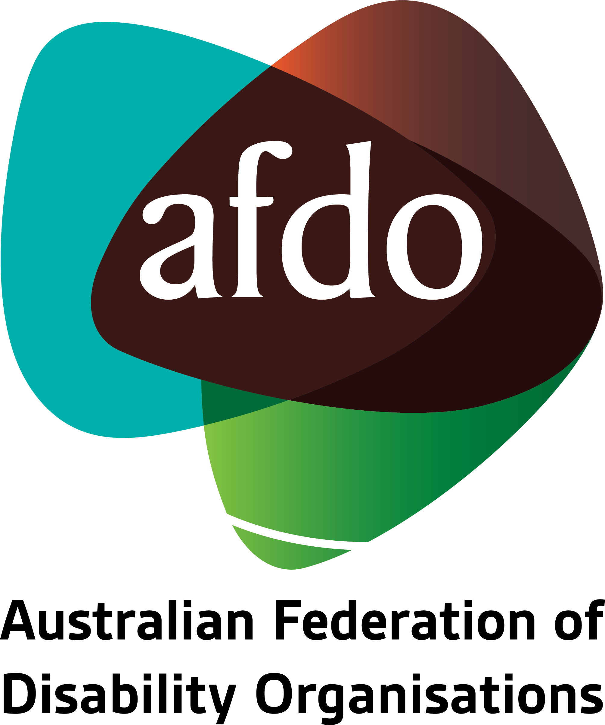

Submission on Draft Terms of Reference for the Royal Commission into Violence, Abuse, Exploitation & Neglect of People with Disability

To
Department of Social Services

27th March 2019

Table of Contents

About AFDO 3
Introduction 4
Draft Terms of Reference (TOR) 5
Additional requirements 6
A. Terms of Reference: 6
B. Government requirements: 7
Contact 8

About AFDO
Since 2003, the Australian Federation of Disability Organisations (AFDO), a Disabled Peoples Organisation (DPO) and recognised Disability Representative Organisation (DRO), has been the recognised national peak organisation in the disability sector, along with its disability specific members, representing people with disability.

AFDO’s mission is to champion the rights of people with disability in Australia and support them to participate fully in Australian life.

As one of the three founding members of the National Disability and Carer Alliance, AFDO played a key role in the campaign for the introduction of the National Disability Insurance Scheme (NDIS) through its “Every Australian Counts” campaign. As the NDIS has moved through the trial phase and begun the transition to full scheme, AFDO and its members have continued to work constructively with the National Disability Insurance Agency (NDIA) as well as Commonwealth, State and Territory governments to provide critical feedback and address implementation issues as they arise.

Our 17 full member organisations, with nearly all being DPO’s and 10 national members also being recognised DRO’s, represent disability specific communities and advocacy organisations with a total reach over 1.7 million Australians.

AFDO’s members include:

Blind Citizens Australia
Brain Injury Australia
Deaf Australia
Deafblind Australia
Autism Aspergers Advocacy Australia
Down Syndrome Australia
Physical Disability Australia
Disability Advocacy Network Australia
Disability Justice Australia

People with Disability WA
Disability Resources Centre
Inclusion Australia (NCID)
People with Disabilities ACT
Women with Disabilities Victoria
Enhanced Lifestyles
Deafness Forum of Australia
Women with Disabilities ACT

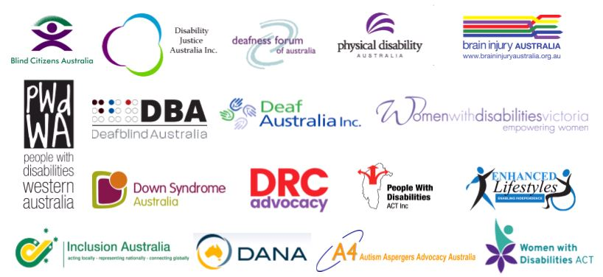

Introduction
AFDO and our 17 full member organisations welcome the Coalition Governments commitment to a Royal Commission into Violence, Abuse, Neglect and Exploitation of People with Disability across all settings in Australia.
For well over seven years AFDO and our member organisations have been seeking a Royal Commission into Violence, Abuse, Neglect and Exploitation of people with disability.
We understand the seriousness of issues first hand, which people with disability have to deal with across all environments in Australia on a daily basis, including as you are reading this submission. This is inclusive of; extreme violence resulting in the deaths of people with disability, sexual assault & abuse, restraint and physical deprivation, emotional & financial abuse or exploitation, basic and comprehensive neglect and a disturbing array of human rights abuses contrary to law and the UNCRPD of which Australia is a signatory.
AFDO, its members, other peaks, people with disability, their families, supporters, sector colleagues and stakeholders as well as human rights advocates have continued an unrelenting and extensive campaign to obtain a Royal Commission. Until now this has been unsuccessful despite numerous inquiries across multiple jurisdictions as well as a Senate Inquiry in 2015, which recommended a Royal Commission be established based on the evidence it reviewed at that time.
In 2017 the Federal Opposition Leader, Hon. Bill Shorten committed the Australian Labor Party (ALP) to implement a Royal Commission when they obtained office. This was further backed up in late 2018, with a commitment of $26 million dollars to fund this work.
In February this year, The Greens Senator, Jordon Steel-John, proposed a motion for a Royal Commission which was supported by The Greens, the ALP and also a number of cross-bench Senators. This passed in the Senate and was then referred to the House of Representatives.
The House of Representatives agreed with this motion and following on the Prime Minister committed the Coalition Government to support the implementation of a Royal Commission with an immediate commencement.
The Coalition Government has moved swiftly, issuing draft terms of reference for public comment as well as seeking further input, via the Department of Social Services, from recognised Disability Representative Organisations (DRO’s) and other key advocacy organisations across Australia.
AFDO and its members have reviewed the Terms of Reference and wish to provide input into these as well as identifying some areas which we believe need to be addressed and further explored to ensure that the Royal Commission is comprehensive and will allow the full participation in the Royal Commission by people with disability from all of Australia.

Draft Terms of Reference (TOR)
AFDO and our members were pleased to see reflected in the Draft TOR a number of components which we see as essential in ensuring a thorough and comprehensive Royal Commission and which we fully support;
- Authority of the Royal Commission to examine all settings or contexts across Australia

- Maintaining the broadest context and avoidance of prescriptive definitions of settings or contexts

- Referencing of the CRPD, the United Nations Convention on the Rights of Persons with Disabilities

- Ensuring that people with disability will have all their accessibility requirements met in order to that all are able to participate in and engage with the Royal Commission’s processes.

- Ensure that a frequent and regular communications schedule is established for the Royal Commission and that all publications are issued in a wide range of accessible formats.

Additional requirements

Terms of Reference:
It is not the place of AFDO or our members to provide a rewrite of the Terms of Reference; We see this being appropriately handled and the responsibility of the Attorney General’s Department and others responsible at Government who can ensure conformity with Australian Law and legislative requirements.
Following our review of the Draft TOR, we believe there are a number of areas which would benefit from amendment and/or inclusion to ensure that the Royal Commission is comprehensive and will meet the outcomes, hopes and wishes of people with disability and those who support them.
The Terms of Reference for the recent Royal Commission into Institutional Response to Child Sexual Abuse can serve as an appropriate model for the changes we would like to see. They provide for greater outcomes, potential justice and appropriate redress than the current Draft TOR and should be utilised on a comparison basis.
We believe the Royal Commission into Violence, Abuse, Neglect and Exploitation of People with Disability Terms of Reference must contain the following:
  - Cover all settings and contexts across Australia in which mistreatment of people with disability has occurred with no restrictions or exclusions;
  - A minimum of three Commissioners, one or more of which to be a person with disability, beyond the minimum, there should be the further appointment of people with disability into the roles;
  - Commissioners selection must ensure an appropriate gender mix;
  - Commissioners must be selected from across Australia to ensure a depth of understanding of differing jurisdictions;
  - Full investigatory powers with no restrictions;
  - Provide for prosecution recommendations for identified human rights and criminal law/or legal breaches;
  - Provide a redress scheme for people with disability who have experienced violence, abuse, neglect and/or exploitation and had their human and/or legal rights breached;
  - Provide recommendations from its investigations to remedy, rectify, revise and remove violence, abuse, exploitation and neglect of people with disability from any settings or contexts;
  - Provide regular and detailed interim reports throughout its lifespan in a wide range of accessible formats; and

  - Provide support for people with disability to give evidence to the Royal Commission before during and after their involvement inclusive of accessibility, support and professional counselling.

Government requirements:
The Government needs to commit to the following in support of a comprehensive Royal Commission:
  - To fully fund the Royal Commission to undertake a comprehensive inquiry across multiple budgets and financial years as necessary;

  - To publish the Terms of Reference, appoint the Commissioners and direct the work to begin as soon as practicable in 2019;

  - Ensure there is adequate support for people with disability to both give evidence, observe proceedings and to fully participate in the Royal Commission before, during and after their participation inclusive of accessibility, supports and professional counselling through suitably qualified Royal Commission Staff or contracted providers; and

  - Provide additional Federal Government funding support to advocacy and systemic advocacy organisations to assist people with disability to engage, before, during and after the Royal Commissions’ operation.

Contact
Please contact the following via email, to clarify any elements;

Ross Joyce
Chief Executive Officer
Australian Federation of Disability Organisations
Email: ceo@afdo.org.au

