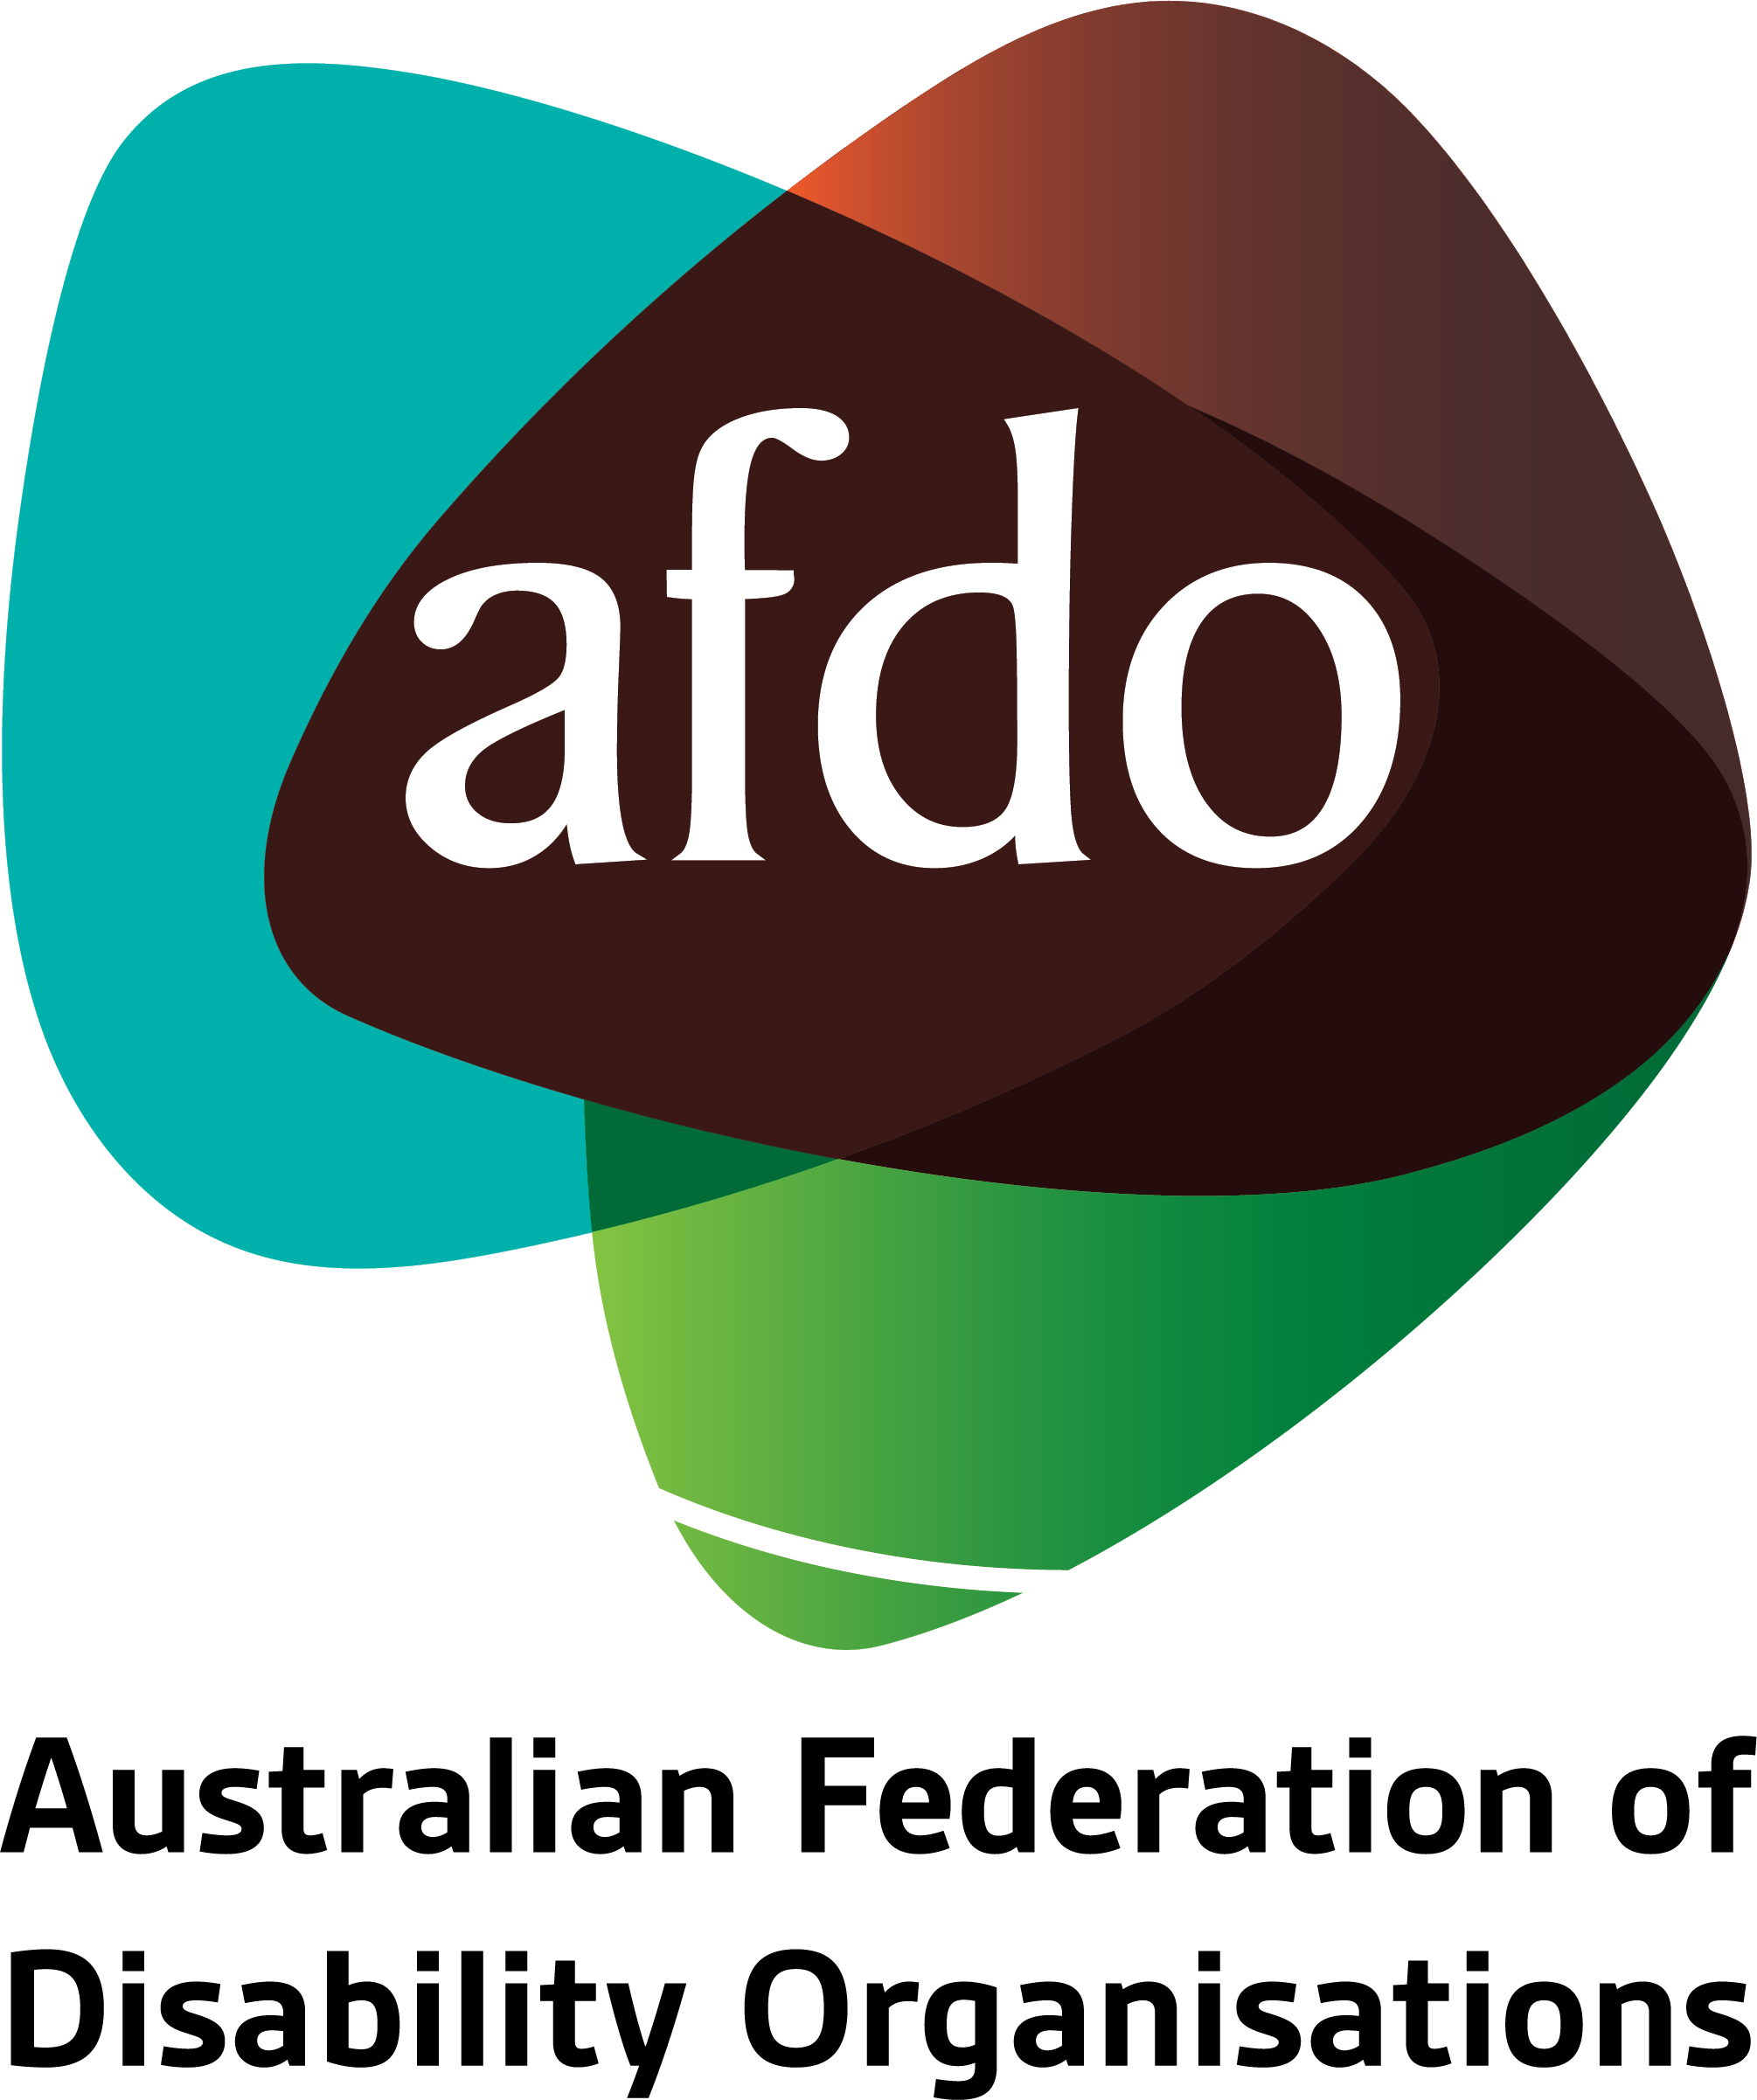

Senate Inquiry – Community Affairs References Committee

Adequacy of Newstart and related payments and alternative mechanisms to determine the level of income support payments in Australia

7th October 2019

Table of Contents
Table of Contents 2
About AFDO 3
Focus of the AFDO Submission 4
Introduction 5
The Inadequacy of Newstart 7
Increase of PwD on Newstart from DSP reforms 8
Impairment 9
Partial Capacity to Work and Newstart 11
Table. Response to Standard of Living (SoL) indicators 14
Newstart producing Financial Insecurity & Hardship 15
Conclusion 16
Recommendations 17

About AFDO
Since 2003, the Australian Federation of Disability Organisations (AFDO), a Disabled Peoples Organisation (DPO) and Disability Representative Organisation (DRO), has been the recognised cross-disability national peak organisation in the disability sector, along with its disability specific members, representing people with disability and their families.
AFDO’s mission is to champion the rights of people with disability in Australia and support them to participate fully in Australian life.

As one of the three founding members of the National Disability and Carer Alliance, AFDO played a key role in the campaign for the introduction of the National Disability Insurance Scheme (NDIS) through its “Every Australian Counts” campaign. As the NDIS has moved through the trial phase and begun the transition to full scheme, AFDO and its members have continued to work constructively with the National Disability Insurance Agency (NDIA) as well as Commonwealth, State and Territory governments to provide critical feedback and address implementation issues as they arise.

Our member organisations represent disability specific communities with a total reach of over 1,700,000 Australians.

AFDO’s members include:

Blind Citizens Australia
Brain Injury Australia
Deaf Australia
Deafblind Australia
Autism Aspergers Advocacy Australia
Down Syndrome Australia
Physical Disability Australia
Disability Advocacy Network Australia
Disability Justice Australia
People with Disability WA
Disability Resources Centre
Inclusion Australia (NCID)
People with Disabilities ACT
Women with Disabilities Victoria
Enhanced Lifestyles
Deafness Forum of Australia
Women with Disabilities ACT
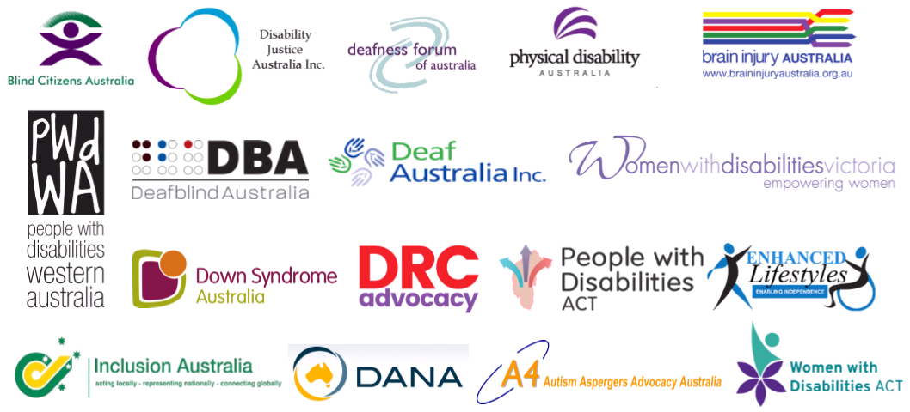

Focus of the AFDO Submission
Many people who would have been previously eligible for the DSP and, who have been assessed as having a disability by their treating doctor, are now on Newstart, and have had their mutual obligations under Newstart waived due to their disability. This group, numbering approximately 200,000 Australians, have also been assessed as having a partial capacity to work.
AFDO will focus in this Submission on people who have previously been eligible for the Disability Support Pension, but who now, no longer meet the DSP eligibility criteria, and instead have been placed onto Newstart and those within this group who have then been assessed as having a partial capacity to work.
AFDO wishes to acknowledge the significant work of the Social Security Rights Network on this area, from which some of their content has been drawn.

Introduction
Australia is a party to the International Covenant on Economic, Social and Cultural Rights (ICESCR) and the Convention on the Rights of Persons with Disabilities (CRPD). Under articles 9 and 28 of these instruments respectively, the Australian Government is obliged to ensure that all persons with disabilities have access to social security, social protection and an adequate standard of living.
Australia’s social security system is crucial to the realisation of this right, particularly through the payment of Disability Support Pension to people who cannot realise economic security through paid work participation. Access to this form of income support is especially crucial due to the inaccessibility of meaningful, secure and appropriately remunerated employment for many persons with disabilities in Australia
The Disability Support Pension (DSP) is a form of financial support available to people who are deemed to be unable to support themselves through paid work due to the impact of their impairment.
Even more fundamentally, the provision of adequate, accessible and disability-specific social security is necessary for the reduction and alleviation of poverty and promotion of the social inclusion and participation of persons with disabilities in Australia.
AFDO maintains that the Newstart Allowance is completely inappropriate for people with disability, it does not meet the requirements above, it is not adequate or disability specific and creates further disadvantage and inequity.
The Australian Federation of Disability Organisations (AFDO) is concerned that changes to the Disability Support Pension and wider social security system by successive governments in recent decades, have led to the exclusion of many persons with disabilities from access to this essential social security.
AFDO is particularly concerned about people with disability who, once would have been eligible for the Disability Support Pension, but who now do not meet changing eligibility criteria, are being placed onto Newstart with its lower level of payments and higher level of obligations. This group of people are designated to have a partial capacity to work, yet many have their mutual obligations under Newstart removed by the Department.
According to research from the National Centre for Social and Economic Modelling (NATSEM) and Monash University, people with disability even on the Disability Support Pension have higher living costs and poorer health outcomes than people without disability, let alone those forced onto Newstart.
Thanks to successive governments winding back eligibility, 200,000 people with disability are now on Newstart, despite having higher living expenses and being unable to work because of their disability.
AFDO does not believe that people with disability who need to be on the DSP should instead be forced onto Newstart. If people with disability are placed onto Newstart and are having their obligations to look for work waived because of their disability, then they should be placed on the Disability Support Pension.
AFDO does not support the eligibility for the Disability Support Pension being exclusively determined by a medical model of disability without any reference to the social model of disability and the impacts of society on the individual with disability.

The Inadequacy of the Newstart Allowance
Newstart is a key mechanism of income support for people experiencing a need for financial support during times of difficulty such as unemployment and was constructed as a short term fix, pending the person returning to work. Unfortunately, the current rate of Newstart does not adequately support people who are experiencing difficult times and has drifted well below the poverty line
“After housing costs, households whose main income is Newstart are $124 a week below the poverty line. This very committee declared the rate of Newstart to be below the poverty line as early as 2014”
It is well documented that the Newstart payment is inadequate for meeting the financial needs of individuals. The maximum rate of Newstart for a single adult is just $278 per week - less than $40 a day. It’s less than half the minimum wage after tax and more than $180 less than the aged pension. It is also the equal-lowest unemployment payment amongst the 33 OECD countries.
Research by the University of New South Wales calculated a conservative minimum healthy budget for a single adult without children to be $434 per week - which was $96 more than the single rate of Newstart, Rent Assistance, and the Energy Supplement combined in July 2016.
As of April 2019, 1 in 4 people receiving Newstart were living with disability. The rate of Newstart isn’t enough for people with disability to meet the higher costs of living associated with their conditions, such as specialist appointments, medication, and aids. As a result, many people are regularly forced to choose between vital medication or care, and paying for things like their electricity bills or food.

Increase of PwD on Newstart resulting from DSP reforms
The latest 2018 Department of Social Services data (DSS, 2018) shows that in December 2018 there were 750,045 recipients of the DSP - 399,603 (53.3%) of whom were men and 350,442 (46.7%) were female. Most DSP recipients were single (578,399 persons or 77.1%) with 171,646 (22.9%) being partnered.
There were 49,035 people receiving the DSP who self-identified as Aboriginal, Torres Strait Islander or South Sea Islander. This suggests that Indigenous Australians are two and a half times more likely to be on the DSP than non-Indigenous Australians, reflecting both a higher prevalence of disability as well as significantly higher rates of unemployment and socio-economic disadvantage (Soldatic, 2018; Soldatic, 2018a).
The number of new DSP recipients per year has decreased from 89,000 in 2009–10 to around 32,000 in 2016–17. The rate of successful DSP claims has also declined markedly from 69% in 2010-11, 40.6% in 2013-14 to 29.8% in 2017-18. The average duration over which individuals receive a DSP payment is 688 weeks or around 13 years.”
In 2018 the Disability Human Rights Clinic at Melbourne Law School authored a report for AFDO, called “A Thematic Analysis of Administrative Appeals Tribunal (AAT) Decisions Involving Claiming and Reviewing the Disability Support Pension”
That report outlined changes to the DSP eligibility process that meant fewer people with disability were being made eligible for the DSP:
“A series of legislative changes in recent years have tightened the eligibility requirements for the DSP, making fewer people with disabilities eligible.”
“Eligibility depends on an applicant proving they have impairments which limit functional capacity (that is, the ability to do certain everyday activities), demonstrating a continuing inability to work, and satisfying residency and age requirements.”

Impairment
Under s 94(1)(a) of the Social Security Act 1991, a person must have ‘a physical, intellectual or psychiatric impairment’ in order to be qualified to receive the disability support pension.
(a) Impairment Tables and 20 points or more
Further, for someone to be eligible, their impairment(s) must be ‘of 20 points or more under the Impairment Tables’.
The Impairment Tables are found in a legislative instrument – the Social Security (Tables for the Assessment of Work-related Impairment for Disability Support Pension) Determination 2011. Their purpose is to enable decision-makers to assign an ‘impairment rating’.
This is expressed in terms of a number of ‘points’ – based on the extent of ‘functional impact’ arising from a medical condition.
(b) Permanency of impairment – a precondition for assigning points
Under s 6(3) of the Impairment Tables, an impairment rating can only be assigned if the condition which causes an impairment is ‘permanent’. In order to be considered permanent, the condition must have been ‘fully diagnosed’ by ‘an appropriately qualified medical practitioner’, ‘fully treated’, and ‘fully stabilised’ and be likely to persist for 2 years.
Whether a condition is fully stabilised can depend on whether the individual has ‘undertaken reasonable treatment’ and whether further treatment is ‘unlikely to result in significant functional improvement’ to the extent that they would be able to work within two years.
Alternatively, it could be proved that the person would not experience ‘functional improvement’ allowing them to work within two years or that ‘there is a medical or other compelling reason’ which prevented the person pursuing ‘reasonable treatment’. The cost, location, risks, reliability, and availability of treatment are relevant to determining whether it was ‘reasonable’.
(c) Functional impairment: the basis for assigning points:
The Impairment Tables draw attention to ‘what the person can, or could do’, that is, their ‘functional capacity’.
Each Impairment Table relates to a specific kind of function [See Box 1]. Under each Table, an impairment can be assessed to cause:
- ‘no functional impact’, leading to 0 points being assigned.
- ‘mild functional impact’, leading to 5 points being assigned.
- ‘moderate functional impact’, leading to 10 points being assigned.
- ‘severe functional impact’, leading to 20 points being assigned.
- ‘extreme functional impact’, leading to 30 points being assigned.
The level of functional impairment is assessed by reference to particular examples of activities or tasks which a person can or cannot perform.
A number of key reforms by successive governments since 2006 have impacted on eligibility for the Disability Support Pension including:
- In 2006 the number of hours that a person with disability on the DSP could work was lowered from 30 hours to 15 hours. This meant that if a person with a disability was assessed as having the capacity to work for more than 15 hours then they no longer qualified for the Disability Support Pension. This leads to an increase of the numbers of people with disability being assessed and placed onto Newstart.
- In 2012 Impairment Tables were introduced and a shift in determining eligibility from assessing medical diagnosis and their impact on body systems to a focus instead on functional abilities required to work
- In 2014/2015 reforms targeted people under 35 who were assessed as having a work capacity of eight hours or more per week to participate in activities. As well the inclusion of a new eligibility criteria which requires people to be fully diagnosed treated and stabilised was also imposed.

Partial Capacity to Work and Newstart
“In Australia, people who have a disability and are aged between 16 years and the age pension age are eligible for the social security benefit “the Disability Support Pension” (DSP). This is a means-tested payment subject to the assessment of an individual’s capacity to work.
Since 1 July 2006 people with disability who apply for income support and who can work 15-29 hours a week are placed on the Newstart Allowance (NSA), or Youth Allowance, rather than the DSP. These individuals are known as the ‘partial capacity to work’ group of beneficiaries. However, the NSA provides a significantly lower benefit and has a more stringent income test.
The tightening of the eligibility criteria for DSP has led to a significant transition of recipients from receiving the DSP to the NSA which is paid at a lower rate. At December 2014 there were 153,582 individuals in the partial capacity to work group receiving the NSA, representing 21.1 per cent of all NSA recipients. Four years later, in December 2018 the number had grown by 30.2 per cent to almost reaching 200,000 Australians. Those classified as having ‘partial capacity to work’ now account for nearly 28% of all NSA recipients.” Since 2006, the eligibility for the DSP was further tightened, in 2012 and again in 2014-2015.
NATSEM modelling of the 2006 budget measure suggested that the living standards of people with disability could be cut by up to 31% compared with the tax and transfer system in 2005. A significant number of Australians with disability and their families are now living in poverty.
By December 2018, the number of people who were assessed as having partial capacity to work stood at almost 200,000 people.
AFDO recommends that of that the eligibility criteria for the DSP be returned to the requirements that existed pre the changes made in 2014-2015.
“New data from the social services department shows there were 199,907 Newstart recipients with “partial capacity to work” in December, an increase of 50% – or about 65,000 – over the past five years. The figure represents 26% of the 722,923 on the dole.”
People with disability are firstly and usually diagnosed by their treating doctor (general practitioner) about the existence and nature of their disability, this is the physician who knows and understands their disability as well as their personal history. This diagnosis usually takes place in the context of significant daily functional impairments that prevents them for engaging in the community in the same manner, such as sustaining employment, as people without disability.
However, when they get to Centrelink, a second assessment takes place where people with a medical diagnosis of disability are informed that their diagnosed disability, by their own treating general practitioner, does not meet the Department of Human Services criteria for eligibility and they are then placed onto Newstart.
Two key aspects of that process act as barriers to people with disability being able to receive the DSP:
- The exclusive legislative basis that requires the use of a medical model to assess disability and excludes the social model of disability
- The use of the job capacity assessment as the basis upon which people’s disability is assessed
“This reflects the silence of the regulatory framework on the social causes of disability. Indeed, as the Impairment Tables exclusively direct attention to the tasks and activities an individual is able to perform, evidence relating to the way in which social structures disable people with impairments is largely irrelevant. Evidence of marginalisation or discrimination is not the basis for the ‘award’ of points under the Impairment Tables.”
AFDO remains concerned that successive Governments have made meeting the eligibility threshold so burdensome and difficult that many people with disability who may have been eligible in the past, can no longer access the DSP and instead are having to exist on Newstart.
Professor Laurie Brown at the National Centre for Social and Economic Modelling (NATSEM) at the University of Canberra, found that Australian households with at least one adult family member with disability need on average an extra $110 per week to meet to the economic cost of living with a disability. This gap in income rises substantially for families living on the DSP or Newstart

Professor Brown at NATSEM also found;
“The income support provided through the DSP to households is inadequate to provide these families with the same standard of living as households that are similar in every other way but who have no family member with disability, and the gaps in standards of living are much higher for households where a family member with disability is on Newstart.
To close the gap in household income so there aren’t inequities in households’ standards of living, families already receiving the DSP would need an extra $183 per week on average, and those on Newstart $343 more. If the Government spent an additional $3.1 billion a year on the DSP then the gap in the standard of living of households already on the DSP would nearly halve.
Because of this extra cost, people with disability and their families experience different standards of living. Many households cannot afford to have family or friends over for dinner once a month, some families even going without meals due to a shortage of money; or couldn’t save money having to get financial assistance from community organisations or help from friends and relatives; or couldn’t afford to have a night out once a fortnight or have a holiday for a week once a year.”

The AFDO commissioned, NATSEM Report, highlights a Standards of Living Index which looks at 16 indicators showing financial hardship and the Table follows on the next page. The Standards of Living Index measure the financial hardship through the 16 indicators for;
- All Australian Households;
- People on the DSP;
- Indigenous Australians on the DSP;
- People on the Newstart Allowance; and
5) People on the Aged Pension.

Table. Response to Standard of Living (SoL) indicators
Variable | All HHs  (%) | DSP  (%) | Indigenous DSP  (%) | NSA  (%) | AP  (%)
Can’t afford to buy new clothes most of the time | 11.0 | 28.5 | - | 48.0 | 10.7
Can’t afford to spend time on leisure or hobby activities | 10.4 | 27.0 | - | 44.5 | 10.2
Can’t afford a holiday away from home for at least 1 week a year | 22.6 | 46.3 | - | 66.2 | 25.4
Can’t afford to have a night out once a fortnight | 16.6 | 39.0 | - | 54.8 | 18.1
Can’t afford to have friends or family over for a meal once a month | 7.3 | 23.6 | - | 27.7 | 9.0
Can’t afford to have a special meal once a week | 11.9 | 29.6 | - | 46.8 | 12.1
Couldn’t pay fuel/telephone bill on time due to money shortage | 9.7 | 18.9 | 26.8 | 31.4 | 4.8
Couldn’t pay car registration/insurance on time due to shortage of money | 3.9 | 7.7 | 10.2 | 13.0 | 0.6
Went without meals due to shortage of money | 2.7 | 11.5 | 13.1 | 14.4 | 0.9
Couldn’t heat or cool home due to shortage of money | 2.3 | 5.9 | 5.5 | 14.8 | 1.8
Couldn’t raise $2000 within a week | 13.2 | 37.5 | 71.0 | 43.4 | 13.6
Sought assistance from welfare/community organisations due to money shortage | 2.6 | 10.7 | 23.0 | 16.6 | 2.1
Sought financial help from friends/family | 7.0 | 14.3 | 34.7 | 29.1 | 2.4
Saving is not a main emergency money source of HH | 33.3 | 59.3 | - | 73.0 | 28.5
HH standard of living worse than 2 years ago | 23.7 | 34.7 | - | 54.7 | 26.2
Unable to save money most weeks | 55.3 | 72.3 | - | 88.2 | 60.6
Source: Authors’ calculations from the 2015–16 HES. Numbers in Table 3 are weighted to be representative for the Australian population. For Indigenous households data were sourced from the 2014-15 National Aboriginal and Torres Strait Islander Social Survey
2 x higher than
All HHS ≥3 x higher than All HHs

Newstart producing Financial Insecurity & Hardship
The distribution of responses to the 16 indicators used to construct the Standard of Living Index are telling in terms of the differences in the financial vulnerability of households with members with disability and in receipt of either the DSP or NSA compared with all Australian households.
On 15 of the 16 indicators the proportion of households with a member with disability and on NSA answering yes to these questions was more than twice that for all Australian households, and on 12 indicators 3 or more times higher. The proportion of families with a member on the DSP answering yes to these questions was at least twice that of all households on 12 indicators.
Overall, nearly one in four Australian households thought their standard of living was worse (in 2015/16) than 2 years previously.
However, over a third of households with a person with disability on the DSP thought their standard of living had dropped and a staggering 55 per cent of those receiving NSA.
Cost of Disability – Income Gaps in Standards of Living
Overall, in 2015 to obtain the same standards of living of similar households without an adult with disability, households with members with disability needed on average an additional $107 a week over and above their net (disposable) income (including benefits received). Couple households needed an extra $152 per week compared to an additional $46 found among single adult households, and households with members having profound/severe disability needed on average an extra $173 per week compared with $87 for those with mild/moderate severity.

Conclusion
It is of significant concern to AFDO that almost 200,000 people with disability are now living on the inappropriate Newstart Allowance, following successive governments tightening eligibility to the Disability Support Pension.
There are significant additional costs of living with disability including accessible housing, transport and access to health services, to name a few. These costs are particularly acute for people with disability living in regional and remote areas of Australia.
AFDO believes the financial cost of living with a disability and the declining access to the DSP is causing significant economic, social and psychological stress and unnecessary hardship for people with disability.
The Newstart Allowance does not adequately cover the day to day cost for people without disability and this inadequacy becomes even more acute for people with disability who have greater costs of living.
AFDO believes that people with disability who need to be on the Disability Support Pension should have access to the Disability Support Pension, and not be pushed onto an inappropriate level of support for their needs.
The current Newstart Allowance is not an appropriate social benefit for people with disability and is grossly inadequate.

Recommendations
- That the Newstart Allowance be urgently reviewed and increased to ensure that it is kept above the accepted poverty line and maintained ongoing with this also linked to the rates provided by like OECD countries that are in line with Australia’s international level and standing
- That an urgent review be undertaken into the adequacy of the Disability Support Pension on a similar basis, and that this includes a revision of the eligibility and application process
- That the eligibility for the DSP be returned to the requirements which were in operation pre changes made to these in 2014-2015
- That no further persons with disability be placed on the Newstart Allowance by having their mutual obligations removed as a replacement for the Disability Support Pension

Department of Human Services, Disability Support Pension (22 October 2018) <https://www.humanservices.gov.au/individuals/services/centrelink/disability-support-pension>.
Committee on Economic, Social and Cultural Rights, General Comment No 19 (2008): The Right to Social Security, 39th sess, UN Doc E/C.12/GC/19 (4 February 2008) para 3; United Nations General Assembly, Report of the Special Rapporteur on the rights of persons with disabilities, 70th sess, UN Doc A/70/297 (7 August 2015) para 7.
Bridging Our Divide: Inequality in Australia, Community Affairs References Committee, The Senate, December 2014.
‘Newstart and other Government Allowances: Incomes, Financial Stress and Poverty’ (2019), ANU Centre for Social Research and Methods.
Bridging Our Divide: Inequality in Australia, Community Affairs References Committee, The Senate, December 2014.
OECD Benefits and wages data base (2017).This calculation was done in relation to the after-tax pay of a single adult production worker, and included any housing benefits. The other OECD country with the lowest rate is Greece.
Saunders, P & Bedford M (2017), New Minimum Income for Healthy Living Budget Standards for Low-Paid and Unemployed Australians. Social Policy Research Centre, UNSW Sydney.
Department of Social Services, DSS Payment Demographics Data (2018)
Jinjing Li, Hai Anh La, Laurie Brown, Riyana Miranti and Yogi Vidyattama Inequalities in Standards of Living: evidence for Improved Income Support for People with Disability” National Centre for Social and Economic Modelling” September 2019
Eunice Ghita and Eliza Waters, “Thematic Analysis of Administrative Appeals Tribunal (AAT) Decisions Involving Claiming and Reviewing the Disability Support Pension” Disability Human Rights Clinic Melbourne Law School 2018
Michelle Fitts and Karen Soldatic ‘Disability Income Reform and Service Innovation: Countering Racial and Regional Discrimination’ (2018) 12 (1) Global Media Journal Australian Edition 1, 2, 10.
Social Security Act 1991 (Cth) s 94 (‘Social Security Act’).
Different eligibility requirements apply to people with permanent blindness. See Social Security Act 1991 (Cth) s 95.
Social Security Act 1991 (Cth) s 94(1)(b).
Social Security (Tables for the Assessment of Work-related Impairment for Disability Support Pension) Determination 2011 (Cth) s 11 (‘Impairment Tables’).
Ibid s 11(1)-(2).
Ibid s 6(3).
Ibid s 6(4).
Ibid s 6(6)(a).
Ibid s 6(6)(b).
Ibid s 7.
Ibid s 6(1).
Ibid.
Ibid.
Jinjing Li, Hai Anh La, Laurie Brown, Riyana Miranti and Yogi Vidyattama Inequalities in Standards of Living: evidence for Improved Income Support for People with Disability” National Centre for Social and Economic Modelling” September 2019
Luke Henriques-Gomes, “Record number of sick or disabled Newstart recipients as Coalition seeks savings” The Guardian Australia 10th April 2019
This term was used in certain cases. See, eg, McDonald and Secretary, Department of Social Services (Social services second review) [2017] AATA 2282 (20 November 2017), [41], [46]; Taylor and Secretary, Department of Social Services (Social services second review) [2018] AATA 3632 (25 September 2018) [7].
Eunice Ghita and Eliza Waters, “Thematic Analysis of Administrative Appeals Tribunal (AAT) Decisions Involving Claiming and Reviewing the Disability Support Pension” Disability Human Rights Clinic Melbourne Law School 2018
Jinjing Li, Hai Anh La, Laurie Brown, Riyana Miranti and Yogi Vidyattama Inequalities in Standards of Living: evidence for Improved Income Support for People with Disability” National Centre for Social and Economic Modelling” September 2019
ibid
Jinjing Li, Hai Anh La, Laurie Brown, Riyana Miranti and Yogi Vidyattama Inequalities in Standards of Living: evidence for Improved Income Support for People with Disability” National Centre for Social and Economic Modelling” September 2019

