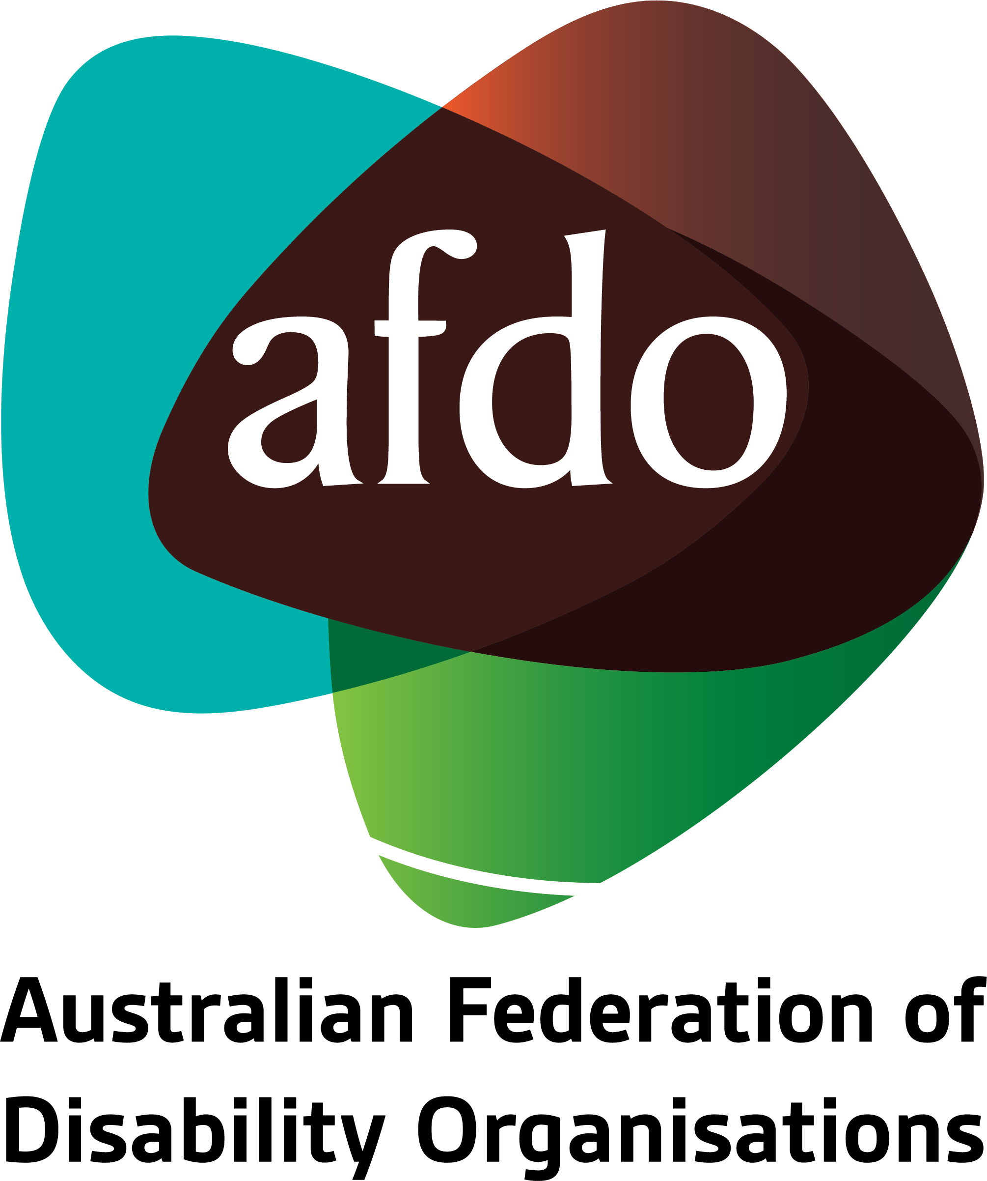

Thin Markets Joint Submission
From
AFDO & MHACA

30th August 2019

Table of Contents

Table of Contents 2
About AFDO 3
About Mental Health Association of Central Australia 4
Thin Markets Submission 5
Landscape Affecting Indigenous Australians with Disability 6
Thin markets impact for Indigenous Australians with disability in Alice Springs 7
Market Challenges 9
Cultural Blindness 10
Limiting factors 11
Workforce issues Affecting the Viability of a Disability Market in Central Australia 14
Viability Issues for Markets Based Approach in Alice Springs 16
Suggestions on the investment required 17
A Model Culturally Safe Disability Support for Titjikala 18
Provider of last resort 19
Recommendations 20
Submission Contact 21

About AFDO
Since 2003, the Australian Federation of Disability Organisations (AFDO), a Disabled Peoples Organisation (DPO) and recognised Disability Representative Organisation (DRO), has been the recognised national peak organisation in the disability sector, along with its disability specific members, representing people with disability.

AFDO’s mission is to champion the rights of people with disability in Australia and support them to participate fully in Australian life.

As one of the three founding members of the National Disability and Carer Alliance, AFDO played a key role in the campaign for the introduction of the National Disability Insurance Scheme (NDIS) through its “Every Australian Counts” campaign. As the NDIS has moved through the trial phase and begun the transition to full scheme, AFDO and its members have continued to work constructively with the National Disability Insurance Agency (NDIA) as well as Commonwealth, State and Territory governments to provide critical feedback and address implementation issues as they arise.

Our member organisations represent disability specific communities with a total reach of over 1,700,000 Australians.

AFDO’s members include:

Blind Citizens Australia
Brain Injury Australia
Deaf Australia
Deafblind Australia
Autism Aspergers Advocacy Australia
Down Syndrome Australia
Physical Disability Australia
Disability Advocacy Network Australia
Disability Justice Australia
People with Disability WA
Disability Resources Centre
Inclusion Australia (NCID)
People with Disabilities ACT
Women with Disabilities Victoria
Enhanced Lifestyles
Deafness Forum of Australia
Women with Disabilities ACT
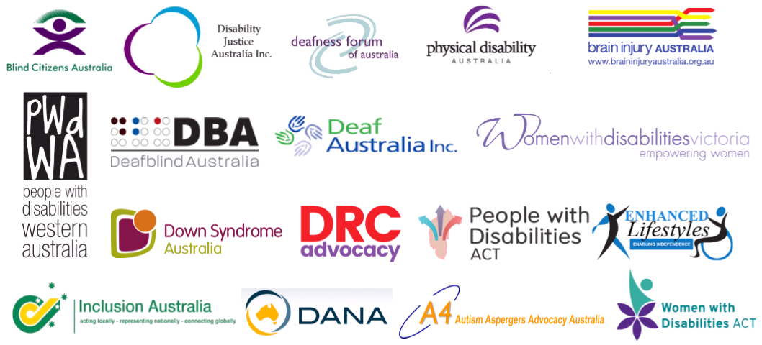

About Mental Health Association of Central Australia
Established in 1992, MHACA offers psychosocial support services and educational programs aimed at enhancing the mental health and wellbeing of people living in Central Australia. It is the only specialist psychosocial support organisation in Central Australia.

We strive to make a difference in the lives of people with a mental illness by supporting participant-driven mental health recovery, and assisting communities and organisations to actively improve mental health and well-being through:

- Individual support to people experiencing mental illness;
- Drop-in centre offering shower and laundry facilities, group activities and peer support;
- Tenancy support for people who are homeless or at risk of homelessness due to mental illness;
- Mental health promotion to reduce stigma and raise community awareness;
- Training in mental health first aid and suicide intervention;
- NDIS support coordination;
- Advocacy for improved services at local, state and national levels;
- A Territory wide suicide prevention program developed and delivered in conjunction with remote Aboriginal communities.

Thin Markets Submission
This Submission on Thin Markets will particularly focus on observations of two organisations on the market-based approach taken by the NDIS to providing disability supports to Indigenous Australians with disability particularly in the Alice Springs region of Central Australia.
The Australian Federation of Disability Organisations (AFDO) and the Mental Health Association of Central Australia (MHACA) are partnering in writing this submission.

Landscape Affecting Indigenous Australians with Disability
In remote and very remote areas of the Northern Territory and particularly in the Alice Springs region, the critical mass of culturally safe, reliable and consistent, person-centred, human rights focussed disability and psycho-social supports and disability advocacy that would be needed to support a market-based model to work is not apparent.
This is not to say that there are no agencies working in the disability space or that there is no evidence of individual disability support programs providing disability supports. It is just that there is not enough diversity or the critical mass to support the market-based model.
This paucity of culturally safe disability supports makes it impossible to implement the key NDIS principle of choice and control in Alice Springs and surrounding areas.
In this submission we question whether the market driven model for the NDIS is feasible in remote community settings.
In the Barkly region, where NDIS has been in operation for five years, the scheme has done little to attract new providers and the varying quality of existing service provision both continue to be a significant issues. This results in participants having to settle for less than ideal arrangements generating confusion, disenchantment and disengagement by participants, and organisational failure for providers.

Thin markets impact for Indigenous Australians with disability in Alice Springs
- Indigenous Australians with disability in Alice Springs are staying in hospitals or step down / transitional care accommodation because of limited specialist disability supports in the community that allow for discharge or are being discharged into the community without the appropriate levels of disability support in place such as aids and equipment, home modifications or allied healthcare services such as occupational therapy, physiotherapy or speech therapy.

- Indigenous Australians with disability are being detained, often indefinitely, in maximum security prisons because there are no alternative accommodation and support options that would allow for diversion from custodial options or upon their release are returned to the same set of circumstances in which their offending occurred only to return to custody in the near future a cycle called recurrent detention. Many Indigenous Australians with a disability when they enter custody are not screened for disability and thus go through the entire custodial detention with no one realising they have a disability;

“In many instances, delayed or inadequate provision of supports and poor quality of services leads to avoidable detention and other infringements on an individual’s human rights, and significantly compromises their ability to achieve their chosen life goals.”

- Limited behaviour support means that Indigenous Australians with disability with high levels of risk of harm to others due to behaviours of concern do not receive the level of early intervention targeted disability support they require. As an outcome what may start as a manageable behaviour of concern can escalate into a serious risk of harm to others resulting in contact with the criminal justice system.

- The limited nature of the provision of culturally safe disability support by providers means that Indigenous Australians with disability do not have access to information in their primary language and culturally safe disability and psycho-social supports are often provided by family members with all of the risks and vulnerabilities that that arrangement entails without any support from disability specific agencies

- Older Indigenous Australians with disability are often having to be supported and accommodated in mainstream aged care facilities with aged care supports rather than in the community with disability supports

- Violence, Abuse and Neglect perpetrated by disability support workers often goes unpunished or the need for disability support workers override concerns about such behaviour when it is perpetrated in other organisations. As such, a disability worker can be violent, abusive or neglectful towards a person with a disability and may have their employment terminated but go on to work in another disability agency that is desperate for disability support workers. To make matters worse the person with a disability who suffered the violence abuse and neglect will more than likely to come into contact with their perpetrator in a different setting.

- The lack of appropriately trained entry level disability support workers or disability support workers with more training and experience who can work with more complex clients or in more challenging circumstances leaves people with disability and their families and communities vulnerable to inexperienced disability support that can have the characteristics of indifference and racism. At its worst this can lead to situations where the health and welfare of people with disability is placed at risk and at its best people with disability are left to lead a life filled with boredom and hopelessness.

Market Challenges
It is our view that the issue in Alice Springs and the surrounding Indigenous communities is not just a matter of thin markets but a sixth tier (Cultural blindness) to the thin market challenges identified in this submission: where the community setting is unable to support the concept of a disability market because of a fundamentally different understanding of the world, a complex interplay of the cultural understandings of disability, support on community, the social and economic disadvantage of many communities and the sheer weight of unfulfilled need on community.

Cultural Blindness
There is a huge gap between what people want and need, and the supports available through the scheme. The fundamental world view is different and cannot be accommodated in the culturally blind NDIS models. As an example the notion of ‘a return to country’ the central importance of place to spiritual and emotional well-being and the capacity to express a person’s important role within their community, is not accommodated.
We often hear profoundly ignorant responses to requests for people to return to country for spiritual and emotional renewal or to meet cultural obligations with, “NDIS doesn’t pay for holidays”.
All the issues outlined in the Thin Markets Discussion Paper in Figure 3: Particular Thin Market Challenges are relevant to the general conversation about thin markets. However, it is our view that the conversation in the Alice Springs region needs to start with the fact that a market based model that provides culturally safe disability supports for Indigenous Australians with disability, does not at this point exist and nor is it likely to in the future.
In the Alice Springs region there is limited capacity around a disability support system or disability advocacy system that enables culturally safe, targeted and specialist disability support.
This is not to say that Indigenous organisations working with people with disability do not provide culturally safe disability support or that disability service providers do not provide culturally safe disability support. The point is that there is no market based system of culturally safe disability support provision in the Alice Springs and Tenant Creek areas. Outside of Alice Springs and Tenant Creek most disability supports for Indigenous Australians are delivered through Aboriginal Health Clinics and Northern Territory Health Clinics or Aged Care Services with the exception being the NPY Women’s Council.

Limiting factors
One of the difficulties in introducing the NDIS into remote areas is that we do not have an existing service system matched to the needs of the clients in place. As a result, the basic building blocks for service delivery are not in place and so many people who could be eligible for NDIS support do not have access to the diagnostic services to ascertain their disability, or exposure to the options available to them. It also means that any interested new providers would have to start from scratch. We are not talking thin market – we are talking no capacity to deliver at all.
“Identification of children potentially eligible for NDIS Services is limited by the lack of specialist diagnosticians for areas such as delayed intellectual development, acquired brain injury and foetal alcohol spectrum. Children who display symptoms of these and similar conditions need to attend diagnostic services in Alice Springs, Adelaide or Port Augusta. Resources limit the number of children who can receive such opportunities, so diagnosis is generally informal, based on behaviour and history. The situation is exacerbated by many (Anangu) not prioritising appointments and not attending them.”
Despite high levels of cognitive disability in Aboriginal communities there is extremely limited neuropsychological diagnostic capacity. There are no brain injury specific services, no access to rehabilitation support and no transition support from the clinical space to community.
Similarly despite hearing loss being at epidemic proportions, here are no hearing services for people with hearing loss and no Auslan interpreter readily available in Alice Springs. A similar situation exists for children and young people with autism. There is limited access to early intervention programs, no educational support and limited specialist behaviour support.
And again, there is limited culturally safe, targeted, informed disability support and disability advocacy for people with disability in contact with the criminal justice system.
Specialist disability knowledge and understanding is often sourced from Darwin and people with this specialist disability knowledge and understanding via “fly in fly out” which does not support a coherent evidenced based support model anchored in Alice Springs.

“Despite the number of these services, many are inadequately staffed in relation to the number of potential clients and are severely limited in their ability to provide in-depth assistance or support. Many operate on a ‘fly in fly out’ basis. On the other hand, some communities, especially the smaller ones, have few or no services”
This structure of response largely impacts on Aboriginal people and Aboriginal communities as it means that establishing and maintaining relationships, the bedrock of involvement with Aboriginal people, cannot occur. Racist practices and policies, both direct and indirect, undermine every effort in Alice Springs to support Indigenous Australians to enable their cultural structures and allow for culturally safe disability support to flourish. Racism colours almost every interaction in Central Australia. It is pernicious and ubiquitous and it often means that well-meaning effort at establishing and maintaining disability supports comes to nothing.

To provide an example of direct and indirect racism. All of the people detained indefinitely in the Northern Territory are Indigenous Australians with disability. Some of these people are detained at the Secure Care Facility in Alice Springs which provides treatment focussed support for people detained under custodial supervision orders. Despite being in operation since 2012 not one staff member at the SCF is drawn from the Arrernte communities. Not one staff member speaks Arrernte despite all of the people with disability detained at the SCF coming from Arrente communities and speaking Arrente. Until recently people with disability detained at the SCF did not have any cultural activities planned for them.
There is limited culturally safe disability supports available to people with disability in the town of Alice Springs. Whilst there are individuals engaging in culturally safe practices when they interact with Indigenous Australians with disability, culturally safe disability support is not a disability community wide practice.
Similarly, the issue for Indigenous Australians with disability living on community is that while their care will be grounded in the cultural practices of their community the quality of the disability support provided often by family members itself may be ill informed and lack purpose. Again, there are individuals who live on community providing high quality culturally safe disability support to community members with disability, however, often people on community are providing such disability support without significant understanding of disability practices such as supported decision making, person centred planning, positive behaviour support, etc.

”For Anangu, the process of familiarisation involves the development of a trusting relationship with the workers- involving repeated supportive visits to that family over time. Developing a supportive relationship is likely to involve that worker helping the family with issues that may appear at best peripherally related to the child’s disability, but which respond to the family’s expressed needs.”
The impact of social and economic disadvantage and its direct impact on the capacity of providing disability support to community members with disability cannot be underestimated.
The level of social disadvantage is so acute in Central Australia for Indigenous Australians generally and Indigenous Australians with disability specifically that people cannot engage with the promise of the NDIS.
The pressures on community are intense and relentless. Poverty is the fundamental issue that undermines a community’s ability to provide disability support to community members with disability. Hopelessness, lack of opportunity, hunger, violence, abuse and neglect, drug and alcohol addiction, also serve to undermine the capacity of community to provide disability support.
All these factors coalesce and impact on the opportunity to develop a disability market in Alice Springs and the surrounding remote Indigenous communities. In Alice Springs the provision of high quality culturally safe disability supports for Indigenous Australians with disability, their families and communities is not about thin markets it is about an approach taken by the NDIS that does not align itself with the circumstances of the area. In this context it is necessary to take into account Alice Springs as an example of other key remote centres and develop an informed position on an approach to a disability marketplace for remote locations that is tailored to the circumstances of remote regional centres.

Workforce issues Affecting the Viability of a Disability Market in Central Australia
The limited nature and significant mobility of the population in the Central Australian region often means that a stable critical mass of appropriately trained individuals needed to sustain a diverse disability support workforce is not possible. There are two issues that need to be teased out in the context of a highly mobile population.
The first issue relates to the fact that there is little regulatory requirement that people new to the disability workforce be trained in disability support, let alone the level of training that is required to provide specialist culturally safe disability support in closed environments with people who are a serious risk of harm to others, or with people complex health, or age related disability support needs. In Central Australian circumstances a certificate four in disability support is often a ‘desirable criteria’, rather than an ‘essential criteria’ for entry level disability support in the face of a critical need for disability support workers. Unfortunately, certificate four in disability support does not offer any academic and practical training designed to develop insights and understanding of issues such as cultural safety, complex presentations of disability and its intersectionality with poverty, family violence, mental health, drug and alcohol addictions.
Staff turnover is very high which adds to organisational costs and impacts on capacity to maintain viability and sustain service delivery commitments. We are aware of two recent instances where organisations have been offered the potential to expand their service but have decided not to as they do not believe they can recruit workers with the skills and experience that would allow them to offer a quality service to the client group.
The groups of people who are likely to take up entry level disability support work are young people with little or no training for disability support work who are in the region but unlikely to be in the region for the long term. Another group of people who are available to work as entry level disability support workers are often newly arrived individuals to Australia from a range of countries including those in East Africa and East Asia. There is a paucity of training opportunities, mobility churn of the population who would seek work in a disability agency and a lack of cultural awareness or understanding.
An emerging concern amongst disability advocates is the impact of the lack of understanding about how to provide culturally safe disability supports to Indigenous Australians with disability, particularly for fly in workers. In combination with little or no exposure to the principles, standards and cultural practices that frame disability in Australia and a short-term employment opportunity mean that Indigenous Australians with disability are particularly vulnerable to poor quality disability supports that lack cultural safety.
Whilst the clear answer is to attempt to build the workforce skills within local remote and very remote settings, the development of a skilled workforce with capacity to support and mentor entry level staff needs a ten-year strategy. It also needs to be recognised that there will often not be capacity to build scale to achieve a viable or sustainable service, and that reliance on sole traders has huge risks in terms of quality and reliable service options.

Viability Issues for Markets Based Approach in Alice Springs
A market based model is not fit for purpose in a cross cultural context such as the very remote areas of Australia and the current pricing guidelines do not take into account the true cost of doing business in a remote setting
There is no capacity within the current pricing guidelines to adequately remunerate cross cultural skills such as language and knowledge of cultural safety.
The limited capacity to gain funding for interpreters to NDIS planning, leave particularly small agencies in a position of not being able to use interpreters in relationship building and negotiating service delivery.

Suggestions on the investment required
The model of thin market challenges in the discussion paper is blind to social disadvantage and the different world view that stems from culture.
We believe that there needs to be a population health, evidence-based approach to the building of markets. The reliance on the NDIS demand estimates through the government actuary is not sufficiently nuanced to specifically target the disability profile of people in the NT, yet there is ample evidence of need. As an example; studies on juvenile detention centres in the NT have identified high rates of hearing impairment and cognitive/learning disability.
Public health initiatives mean we can map the developmental issues for children up to the age of seven, and we could then extrapolate what their needs will be as they age.
We could then anticipate demand and invest in service development tapping into existing community infrastructure, rather than investing in the creation of a new parallel system of supports, or waiting for the emergence of individual NDIS plans to provide the stimulus for service development.
Building capability at the community level – Community Connectors from community, access to culturally informed diagnostic assessment, culturally safe disability support provided by community members to community members and well-trained cross-cultural Support Coordinators and supported by the wider disability system is a positive direction which has been implemented by Miwatj in East Arnhem Land.
Investment on other communities to support the development of a similar capacity to deliver across the whole continuum would be a first step in building remote capacity.

A Model Culturally Safe Disability Support for Titjikala
The provision of culturally safe disability support is crucial to overcoming the barriers to Indigenous Australians with disability being able to access the support they need in the manner they need it.
This model is designed to overcome the lack of structured, agency-based disability supports on a remote Indigenous community south east of Alice Springs called Titjikala.
Community Members provide culturally safe disability support to community members with disability. In the majority of circumstances community members are already providing disability support to community members with disability - they are providing disability support in isolation of the institutionalised systemic structures that exist in other areas of NDIS markets: access to information and training, disability advocacy, NDIS practice standards, mechanisms for the resolutions of conflicts, complaints mechanism where breaches of the practice standards and NDIS legislation occurs, support coordination, plan managers and coordinators of supports.
Culturally Safe Disability Support is disability support provided in the language of the community member with disability by a trusted culturally approved community member. A senior Community Member with the Cultural Authority to determine, who, when, how and why such support provides oversight to the support arrangement and makes decisions about the nature of the support provided and its direction.
Such a model is supported by key community members, identified by community, acting in the front facing roles including the role of Community Connector and Support Coordinator. The Community determine the community member who will fill these roles. These roles should be supported by agencies working in the NDIS space with expertise in capacity building and support coordination from the nearest regional centre.
These two roles will be responsible to community for ensuring that culturally safe disability support is provided in a manner that community are satisfied with and meets the obligations for disability supports set out in the NDIS legislation and in line with community expectations. These two roles will assist community members with disability to undertake plan reviews and build the capacity of community members providing the culturally safe disability support to receive the necessary training and support.
These community owned and community identified roles will act as a bridge into the wider NDIS system allowing for institutional structural support for community engagement with the NDIS and structural and administrative support for the two community owned positions of community connector support coordinator.

Provider of last resort
The development of a service system with capacity to adequately support people with disability in remote settings is a long-term prospect.
In the meantime, many people are missing out or becoming disenchanted with the NDIS and disengaging.
There needs to be a transparent process to access the provisions for provider of last resort so that people’s needs, and the promise made to them through the scheme can be realised.

Recommendations
- Culturally safe disability support responses for indigenous people with disability in rural, remote or very remote communities to be developed and co-designed with the relevant indigenous community; to be community owned and managed.

- Establishment and promotion of a transparent process to access the provisions for “provider of last resort”, so that the needs of people with disability, and the promise made to them through the Scheme can be realised.

- Undertake a population health, evidence-based approach to the building of markets concerning rural, remote or very remote indigenous communities.

- Training courses in disability support to be modified to include academic and practical training designed to develop insights and understanding of issues such as cultural safety, complex presentations of disability and its intersectionality with poverty, family violence, mental health, drug and alcohol addictions.

- Building capability at the community level by investment in Community Connectors and providing access to culturally informed diagnostic assessment, and well-trained cross-cultural Support Coordinators supported by the wider disability system.

- Revise the NDIS current pricing guidelines to adequately remunerate cross cultural skills such as language and knowledge of cultural safety.

- Revise guidelines to allow funding for interpreters in community language, to be used for NDIS planning, building relationships and negotiating service delivery.Submission Contact.

If you have any questions about this submission, please contact;

Patrick McGee,
National Manager - Policy, Advocacy & Research
Australian Federation of Disability Organisations (AFDO)
Mobile: 0423 301 344 email: patrick.mcgee@afdo.org.au

The Victorian Office of the Public Advocate. “The Illusion of Choice and Control. The difficulties for people with complex and challenging support needs to obtain adequate supports under the NDIS” 2018.
Ngaanyatjarra Pitjantjatjara Yankunytjatjara Women’s Council, “Assisting Indigenous Australians in the Anangu Pitjantjatjar Yankunytjatjara (APY) Lands to Benefit from the National Disability Insurance Scheme (NDIS)” Final Report September 2016
Ngaanyatjarra Pitjantjatjara Yankunytjatjara Women’s Council, “Assisting Indigenous Australians in the Anangu Pitjantjatjar Yankunytjatjara (APY) Lands to Benefit from the National Disability Insurance Scheme (NDIS)” Final Report September 2016
Ngaanyatjarra Pitjantjatjara Yankunytjatjara Women’s Council, “Assisting Indigenous Australians in the Anangu Pitjantjatjar Yankunytjatjara (APY) Lands to Benefit from the National Disability Insurance Scheme (NDIS)” Final Report September 2016

