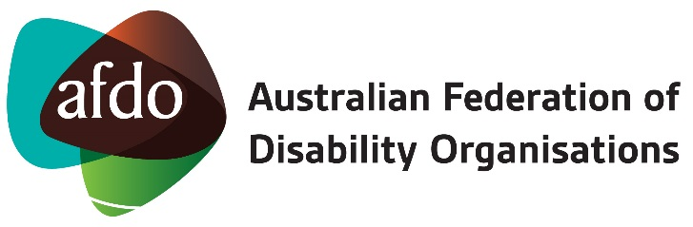

Position Description: National Manager – Disability Initiatives & Projects

PD approved: 25th October 2019

Location: Designated workplace - Melbourne Office
Flexibility to work from remote Home Office

Reports to: Chief Executive Officer

Positions reporting to the role:
- Manager – Business Development & Engagement
- Diversity Field Officers x 2
- NDIS & Special Projects Officer
- Project Coordinator & Project Officer – NDIS JMFR1
- Project Coordinator(s) or Officer(s) (as engaged)
- Volunteers, Tertiary Students or Consultants (as engaged)

Hours of work: 75 hours per fortnight (37.5 per week) – worked Monday - Friday.

POSITION SUMMARY

This position reports directly to the CEO and is responsible for managing and developing existing and new initiatives or projects in line with AFDO’s Vision, Mission and Strategic Plan.

This position develops and maintains these areas working as required with: AFDO Board, staff, volunteers, AFDO member organisations, the wider disability sector, key stakeholders, the community sector, other sectors including; employment, business and the education sector. Relevant areas at a federal, state and local government level, non-government agencies, not for profits, trusts, foundations as well as key service providers within the disability sector.

This position provides advice to the CEO on any emerging trends and issues that may affect people with disability, AFDO Members and stakeholders within positions areas of responsibility.

DUTIES:

KEY RESPONSIBILITIES
It is the responsibility of the National Manager – Disability Initiatives & Projects to:
      - Manage and lead the development of initiatives or project ideas in line with AFDO’s strategic direction
      - Seek out opportunities for funding or resourcing for newly developed or existing initiatives or projects
      - Prepare proposals, briefings and funding approaches as requested by potential partners/organisations/funders and agreed by the CEO
      - Seek out fee for service opportunities for AFDO developed offerings, across; governments, non-government, disability, health, education, arts & culture, recreation, community and business sectors
      - Manage and lead the formulation and response to funding opportunities and submissions for initiatives or projects
      - Manage and lead the implementation, ongoing review and reporting of any initiatives or projects funded from various sources in line with AFDO’s strategic direction
      - Contribute, as required, on issues of importance to people with disability and their families, including strategies for their promotion and implementation
      - Contribute, as required, into submissions and responses aimed at achieving positive changes to legislation, policy and service practices in partnership with our members, stakeholders, advocacy agencies and other key organisations
      - Develop and capture case studies and individual stories from participants in projects or initiatives for people with disability or those without, of their experience and outcomes
      - Provide advice to the CEO on emerging trends in government, community and disability sector that may impact on the lives of people with disability and/or their families, AFDO’s operation and AFDO Members, in line with the authority of this position
      - Work with the CEO as appropriate, to enhance AFDO’s national profile, maintain & strengthen existing relationships, build new strategic relationships and further develop stakeholder support
      - Contribute and work effectively as a member of the AFDO Leadership Team on strategic direction, organisation culture, staff engagement, organisation operations, sustainability strategy, member engagement, sector/stakeholder engagement, major sector issues, AFDO projects and initiatives, national advocacy and policy matters.

SPECIFIC RESPONSIBILITIES
      - Manage initiatives or projects on time, on budget and in accordance with agreed standards and any contractual requirements and in line with AFDO strategic direction
      - Development of ideas for initiatives or projects, identifying and obtaining funding or alternative funds for implementation
      - Manage current staff roles (as listed) and any additional roles engaged for future initiatives or projects
      - Manage any volunteer(s) or tertiary students assisting with projects or initiatives and the required workflow
      - Attend and participate in AFDO meetings or other meetings on behalf of AFDO as required
      - Other duties as required relevant to the scope of this role

KEY SELECTION CRITERIA
- This position is only available for those who identify as a person with disability as allowed under 'special measures' of the Equal Opportunity Act 2010, you need to outline how you meet this requirement
- Tertiary qualification at a Degree level in a relevant discipline or relevant extensive management experience
- Minimum 5 years professional experience in a service development role and/or development and management of projects and programs
- Demonstrated experience and success in obtaining funding or alternative funds for projects or initiatives
- Demonstrated ability to build and maintain strong stakeholder relationships
- Excellent written and verbal communication skills
- Excellent interpersonal skills including ability to influence and negotiate to build consensus on key issues
- Ability to manage multiple tasks, set priorities, organise work and achieve objectives within timelines and budget
- Ability to work in a sensitive, complex and demanding environment with a high degree of autonomy and self-management
- Ability to work both independently and collaboratively within a team
- Experience in policy development, systemic advocacy and research within the disability sector would be highly regarded.

