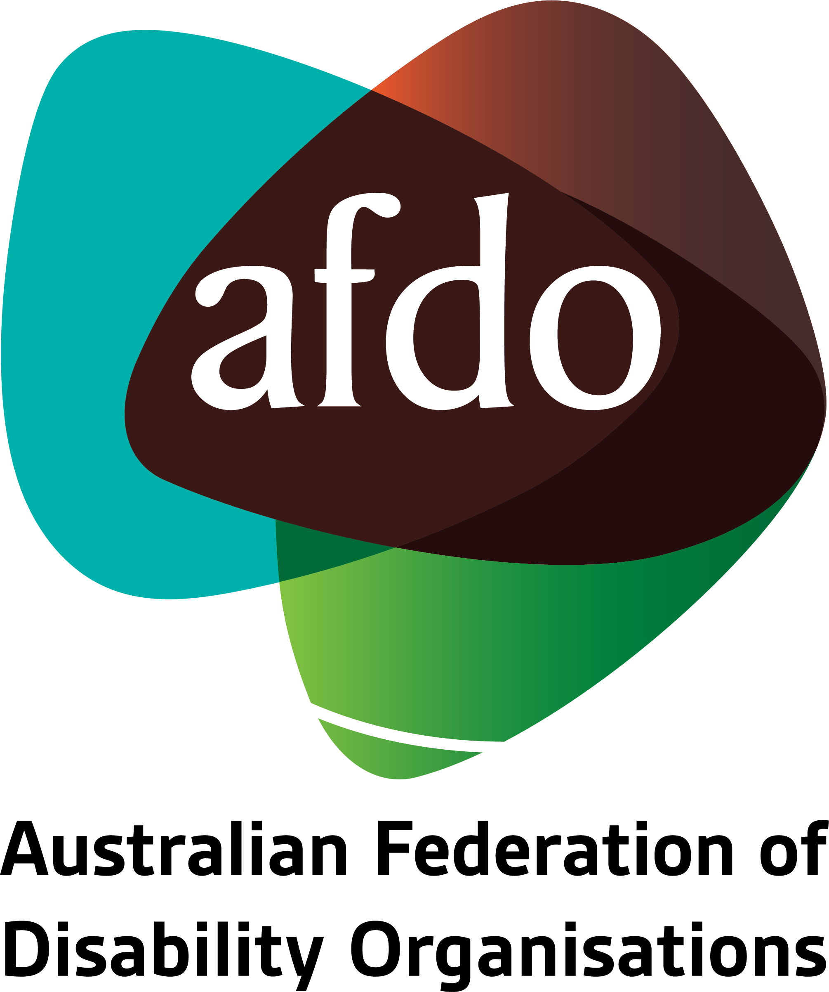

Religious Discrimination Act 2019

Submission on
Second Draft of Legislation

31st January 2020

Table of Contents
Table of Contents 2
About AFDO 3
Introduction 4
Context 5
Position 6
Recommendation 8

About AFDO
Since 2003, the Australian Federation of Disability Organisations (AFDO), a Disabled Peoples Organisation (DPO) and recognised Disability Representative Organisation (DRO), has been the recognised national peak organisation in the disability sector, along with its disability specific members, representing people with disability. AFDO’s mission is to champion the rights of people with disability in Australia and support them to participate fully in Australian life.

As one of the three founding members of the National Disability and Carer Alliance, AFDO played a key role in the campaign for the introduction of the National Disability Insurance Scheme (NDIS) through its “Every Australian Counts” campaign. As the NDIS has moved through the trial phase and begun the transition to full scheme, AFDO and its members have continued to work constructively with the National Disability Insurance Agency (NDIA) as well as Commonwealth, State and Territory governments to provide critical feedback and address implementation issues as they arise.

Our member organisations represent disability specific communities with a total reach of over 2,800,000 Australians.

AFDO continues to provide a strong, trusted, independent voice for the disability sector on national policy, inquiries, submissions, systemic advocacy and advisory on government initiatives with the Federal and State/Territory governments.

AFDO’s members include:

Blind Citizens Australia
Brain Injury Australia
Deaf Australia
Deafblind Australia
Autism Aspergers Advocacy Australia
Down Syndrome Australia
Physical Disability Australia
Disability Advocacy Network Australia
Disability Justice Australia
People with Disability WA
Disability Resources Centre
Inclusion Australia (NCID)
People with Disabilities ACT
Women with Disabilities Victoria
Enhanced Lifestyles
Deafness Forum of Australia
Women with Disabilities ACT
National Mental Health Consumer and
Carer Forum (NMHCCF)

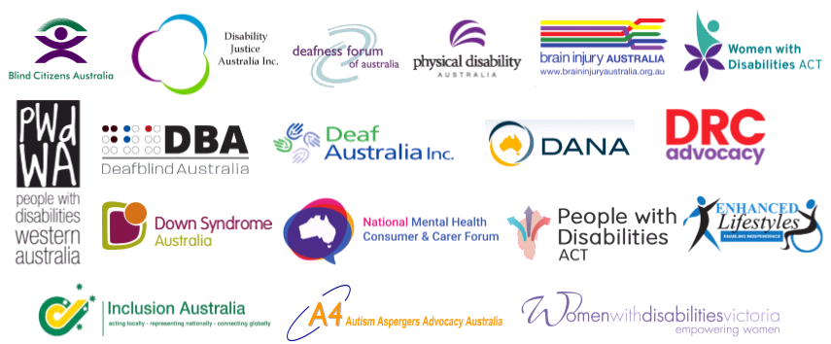

Introduction
The Australian Federation of Disability Organisations (AFDO) makes this submission to the Attorney-General’s Department in relation to the Department’s consultation on the second drafts of a package of three Bills that the Department describes collectively as the ‘Religious Freedom Bills’. The Religious Freedom Bills comprise drafts of the:
- Religious Discrimination Bill 2019 (Cth) (the Bill)
- Religious Discrimination (Consequential Amendments) Bill 2019 (Cth) (the Consequential Amendments Bill)
- Human Rights Legislation Amendment (Freedom of Religion) Bill 2019 (Cth) (the Freedom of Religion Bill).
AFDO is pleased to make a submission on the second drafts, as part of this further public consultation process.

Context
AFDO believes that the legislation before the Federal Parliament is not so much a religious freedom bill but more, an anti-discrimination statute. And whilst AFDO supports the inclusion of religion as a protected attribute we would point to the fact that complaints about disability discrimination dramatically outweigh in numbers any complaints about religious discrimination.
In 2018 – 2019 discrimination on the grounds of disability was the leading area of concern for people lodging complaints, accounting for 44% of all complaints received by the Australian Human Rights Commission. Further the number of complaints regarding discrimination on the grounds of disability has risen every year for the last five years.
Over the last five years, the Australian Human Rights Commission received 11 complaints concerning religious discrimination at the Commonwealth level that were contrary to freedom of religion or belief. This was out of a total of 10,423 complaints over the same period for all other areas of discrimination.
Whilst these 11 complaints are only about complaints received at a Commonwealth level, they give a reflection on the likelihood and level of concern in the community about religious discrimination.
“Australians with disability continue to experience unacceptably high levels of discrimination, especially in relation to employment and the provision of goods and services,” said Commission President, Emeritus Professor Rosalind Croucher.
AFDO are further concerned about the impact that this Bill might have on people with disability. In the past, some people have held the belief that disability is a ‘divine punishment for sin or the result of negative karma’ AFDO is concerned that should this Bill be passed by the Parliament, people holding such beliefs may again be allowed under law to discriminate against people with disability.

Position
AFDO supports enforceable protections against religious discrimination for all people in Australia. We recognise that there are existing protections against religious discrimination at the Commonwealth, State and Territory level, as well as our responsibilities under international law, however, these protections could be further strengthened in line with best international practice, rather than creating an additional piece of legislation solely for religious discrimination.
An example being that, in certain instances, such as complaints to the Australian Human Rights Commission (AHRC), concerning religious discrimination in employment, there are no enforceable remedies even when discrimination is proven. The lack of enforceability by the AHRC requires urgent attention.
We already have statutory protection against discrimination on the grounds of race, sex, disability, age, and religion, and there needs to be equivalent protections across all of these attributes. The protections on the grounds of religious belief or activity need strengthening but, AFDO would argue that these need to be undertaken within the existing statutory protections, not by creating additional separate legislation focussed solely on one human right, this would be more in keeping with article 2 of the Universal Declaration of Human Rights that human rights are indivisible and universal.
AFDO endorses elements of the Bill, which represent a standard means of incorporating certain protections from international human rights law into Australia’s domestic law but emphasise that these should be included in existing anti-discrimination legislation.
However, AFDO is concerned that in other respects, this Bill would provide protection to religious belief or activity at the expense of other rights which have been hard fought. The Bill also includes a number of provisions that have no counterpart in any other anti-discrimination laws and appear to be designed to address one off individual cases that have gained media exposure over the last two years.
AFDO is very concerned about the manner in which the legislation has been drafted from the first and also with this second draft, considering it as poor in its construction, containing extremely bad legislative practice, all of which will lead to unintended and undesirable consequences.
AFDO’s main concerns are:
The continuing broad scope of the Bill and its definition of who may be a victim of religious discrimination.
The Bill, in this second draft, has removed the reference to corporations but has now linked this to individuals and associates, which is still unacceptable, as it opens the coverage to wider than an individual. This is unlike all other Commonwealth, State or Territory discrimination laws, which focus on the rights of natural persons to be free from discrimination. This departure from Federal, State or Territory and international human rights laws, which protect only the rights of natural persons, is totally unacceptable.
It still provides that religious bodies, which includes; religious schools, religious charities and other religious bodies, are entirely exempt from engaging in religious discrimination, as long as this is in good faith and in accordance with their religious doctrines, tenets, beliefs or teachings. This is still a very wide and totally unacceptable exemption, which would undercut existing protections against religious discrimination, particularly in the areas of employment and for the provision of goods or services.
The serious issues with the ‘statements of belief’ remain, as whilst an action may contravene existing legislation, under this statements use, a person will be exempt from the other Commonwealth, State or Territory anti-discrimination laws.
AFDO finds it unacceptable that discriminatory statements of belief will no longer be unlawful, whether they would amount to racial discrimination, sex discrimination or discrimination on any other ground which is prohibited by other existing laws.
The overriding of all other Australian discrimination laws is bad legislative practice, not warranted, sets an alarming precedent, and is inconsistent by seeking to favour one right over all others.

Recommendation
AFDO considers the proposed Religious Discrimination ACT 2019 (second draft) as;
- Badly constructed legislation
- Unreasonably overriding all other existing Australian anti-discrimination laws
- Setting up bad legislative practice and an unacceptable precedent
- Not required, based on protections in existing anti-discrimination legislations, which could be easily strengthened for further identified religious discrimination issues
- Not supported, based on the minor levels of issues and complaints reported or lodged with relevant authorities compared with other forms of discrimination
- Divisive, resulting in unintended/unacceptable consequences, and not in the best interests of people with disability, other minority communities as well as the wider Australian community
- Against the best interests of Australia both nationally and internationally in maintaining a strong focus on providing human rights for a natural person

AFDO makes the following strong recommendation;
That the Religious Discrimination ACT 2019 (second draft) legislation be withdrawn and not passed by Federal Parliament for the reasons outlined in the AFDO submission to the Attorney Generals Department

https://www.humanrights.gov.au/about/news/disability-discrimination-tops-commission-complaints
AHRC Submission to the Religious Discrimination Bill

