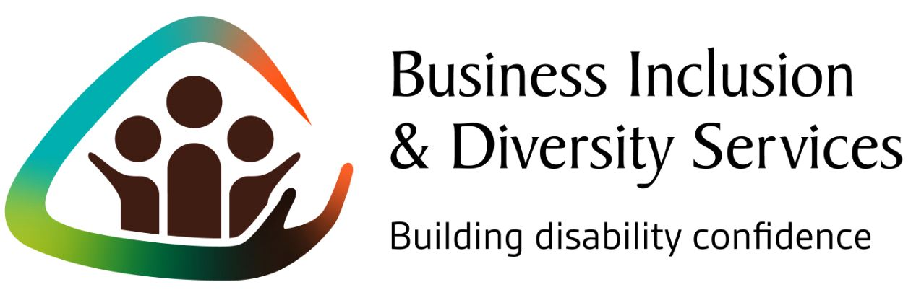

A Snapshot - Business Inclusion & Diversity Services
AFDO’s Business Inclusion & Diversity Services (BIDS) has worked with 110 businesses to date.
Our service was evaluated by Deakin University, initially evaluating the pilot project of our service in 2015 – 2017, with a further two evaluations as the service continued to operate from 2018 onwards following the success of the pilot project.
- We have worked with a total of 110 businesses
- 124 employment pathways were created for people with disability
- 29% of businesses recruited people with disabilities after engaging with us
- 38% of businesses have, or plan to, include welcoming wording in job advertisements and position descriptions
- 38% of businesses used more accessible recruitment and interview processes after engaging with our service
- 29% of businesses have improved ﬂexibility for their employees, such as amending working hours
- 33% of businesses have improved the physical access of their workplaces
- 38% of businesses have committed to improve mental health in their workplace
- 100% of businesses indicated that there might be an opportunity to employ people with disability in the next 12 months

Note: AFDO’s Business Inclusion & Diversity Services was initially called the “Diversity Field Officer” project. The name was changed to Business Inclusion & Diversity Services (BIDS) in March 2020.

