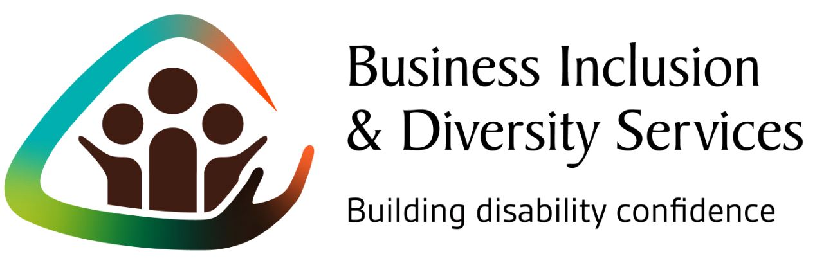

Who are we?
The Australian Federation of Disability Organisations (AFDO) runs the Business Inclusion & Diversity Services (BIDS).

AFDO’s Business Inclusion & Diversity Services focuses on building the disability confidence of small and medium-sized businesses to become more welcoming, confident and accessible.

This service has been designed to explore and understand what resource-stretched small and medium sized businesses require, rather than make assumptions
or offer a cookie cutter approach. The recommendations we make are targeted just for your business.

Our service provides a customised approach for each business to build confidence and tap into the benefits that come from being more welcoming.

Why?
Almost 20% of Australians identify as having a disability. That’s 4 million Australians who are a potentially untapped recruitment pool, customer base and market segment that your business may be missing out on.

What benefits can I expect by building disability confidence?
Increased ability to support and retain employees who may acquire a disability (or may already have a disability that is not visible or disclosed).

Become more welcoming of the 1 in 5 Australians who have a disability and their colleagues, family and friends - a potentially untapped market.

What will my business get out of the process?
- One to one approach to build the capacity of your business and leadership to implement good practice as a leader in your industry
- Customised business analysis to understand your business and its objectives
- Disability friendly check to explore what your business needs to become more confident, such as removing recruitment barriers and improving work practices and accessibility
- Tangible practical steps and early wins that your business can adopt
- Specialist advice plus the right connections to implement recommendations seamlessly

What’s involved?
A small amount of your time (3 meetings) with ongoing support available.

We want to work with businesses that have an open mind so that we can maximise the impact of what we can offer.

Want to learn more?
Please contact us at AFDO to learn more about how our Business Inclusion & Diversity Services can help you to become a “Disability Confident” employer.

Contact:
Jim Valavanis
Manager – Business Development & Engagement
Australian Federation of Disability Organisations (AFDO)
E: Jim.Valavanis@afdo.org.au
M: 0456 003 767
www.afdobids.com.au

The Business Inclusion & Diversity Services is an initiative of the Australian Federation of Disability Organisations (AFDO). The service is supported by over 20 local, state and national organisations including our research partner Deakin University, and supporters including the Victorian Government and Worksafe Victoria.

One-to-one support for small to medium sized businesses that is customised and flexible.

