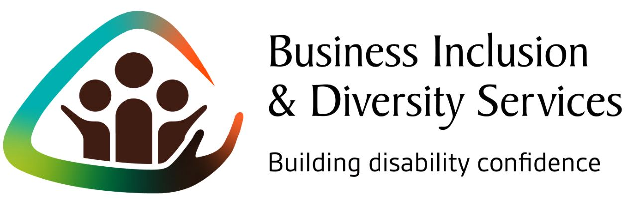

What our assistance looks like
Our service works one-on-one with businesses to enable you to become more confident in 3 ways. We focus on:

- Understanding your customers
- Managing and retaining your existing staff
- Tapping into the broadest talent pool

A personal, tailored business review
Our first step is to understand what your business does, its goals and where there might be opportunities to build your ‘disability confidence’. We ask you a range of questions to understand and identify options that are right for your business.

Building your capability as a leading business
We know that sustainable change begins at the top with leaders who are passionate and committed to bring others on a journey – this might be you or a leader in your team. By working with you to build your awareness and grow your understanding, diversity improvements made now will have more chance of gaining traction and lead to longer-term sustainable gains for your business. This includes interactive and experiential activities.

A disability friendly check
What are the barriers that once removed could make a big difference to your business?

Our check considers improvements to physical accessibility, communications, workplace culture, retention practices, recruitment and customer service, with strategies handpicked for your business.

A recommendations document
We will develop a customised document outlining practical achievable steps to improve accessibility (ranging from suggestions for creating a more inclusive workplace culture to improving physical access). We work with your priorities and change can occur one step at a time. A small step can have significant positive consequences for your business.

Establishing the right connections for your business
We know that change is most effective when we are connected with others who get and support what we do. We will connect you with local services that understand how to put good intent into practice. This could include specialist services to provide you with ongoing advice, different paths to recruit people with disability or services that build your awareness about disability. You will also have access to 60+ participating workplaces to connect with, and discuss, your successes and learning, as well as opportunities, such as events, to grow your confidence and networks.
Being a disability confident workplace is simpler than you think. We’re here to help you take that first step and to keep things straightforward for you and your business.

Contact us
Please contact us at AFDO to learn more about how our Business Inclusion & Diversity Services can help you to become a “Disability Confident” employer.

Contact:
Jim Valavanis
Manager – Business Development & Engagement
Australian Federation of Disability Organisations (AFDO)
E: Jim.Valavanis@afdo.org.au
M: 0456 003 767
www.afdobids.com.au

AFDO’s Business Inclusion & Diversity Services is an initiative of the Australian Federation of Disability Organisations (AFDO). The service is supported by over 20 local, state and national organisations including our research partner Deakin University, and supporters including the Victorian Government and Worksafe Victoria.

One-to-one support for small to medium sized businesses that is customised and flexible.

