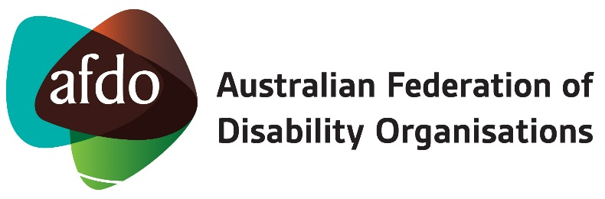

AFDO
The Australian Federation of Disability Organisations (AFDO) is a Disabled People’s Organisation (DPO). That means the majority of our members and our management are people with a disability. We are the national voice representing people with disability in Australia. Our members are national and state disability advocacy organisations run by and for people with disability and their families, representing Australians with disability.
AFDO provides advice to government and organisations on matters that affect the lives of people with disability. AFDO also works to educate the general community about disability, and we work to develop a community where people with disability can participate in all aspects of social, economic, political and cultural life.
The Afdo website is at: www.afdo.org.au

Disability Loop
Disability Loop is a way to find out more about the National Disability Insurance Scheme (NDIS). AFDO developed Disability Loop to be the “go to” place for NDIS news, information, resources and events.

We are committed to making NDIS news and resources available in Plain English through the Disability Loop website, social media pages, and our regular e-news.

The Disability Loop website is at: www.disabilityloop.org.au

Here you can access a range of news items and resources. On this site you can also link to Disability Loop on Twitter, Facebook and YouTube. We invite you to sign up to our Disability Loop eNews, an email newsletter that comes out four times a year, by using the simple subscription form found at the bottom of each page of the Disability Loop site.

Please note, the NDIS website www.ndis.gov.au is the place to go to find formal documents, often available in a variety of accessible formats. The NDIS website can be difficult to navigate because there is so much information to look through. Using the search function is often easier than trying to move through menus, particularly if you already know what you are looking for.

