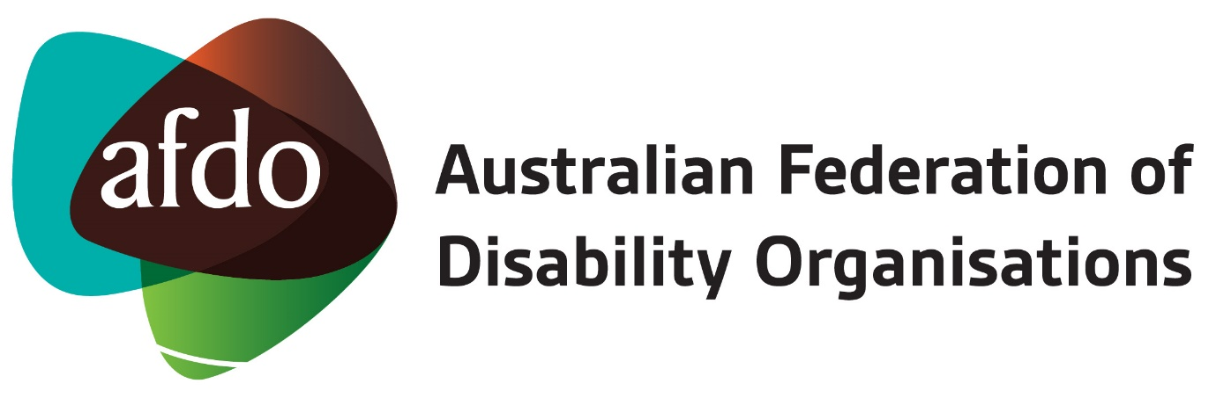

Toolkit:
Submissions and Community Forums
for the Disability Royal Commission

Contents

A note from the AFDO Expert Advisor 3
Introduction 4
Definitions 5
Submissions 6
Who can make a submission? 6
What is the submission about? 6
How can I make a submission? 6
Techniques for putting the submission together 8
Submission on an incident of violence, abuse, neglect or exploitation 8
Identifying and describing the incident(s) 8
Complaints about the incident(s) 8
Lasting impacts 9
Stopping it from happening again 9
Submission on systemic issue(s) 9
Area of concern 9
Where it happened/is happening 9
Who 10
When 10
Impact 10
Resolving the issue 10
Language and Style 11
Community Forums 12
How to participate in Community Forums 12
Tips for advocates and people with disability attending Community Forums 12
Keeping Safe and Support Services 13
Counselling Services 13
Legal Services 13
Advocacy Services 13
About AFDO 14
Our members 15

A note from the AFDO Expert Advisor

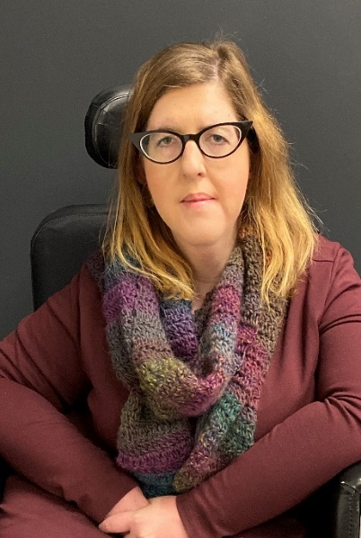

People with disabilities in Australia have long called for a Royal Commission into violence, abuse, neglect and exploitation. Since its announcement in April 2019, people with disability, their families and supporters have been invited to engage with the Commission voluntarily. This is either through submissions or attending community forums.

This Toolkit is designed to assist people with disability, their families, advocates or organisations in putting together a submission or attending a community forum. It is general in nature so if you need individual assistance, head down to page 12 for more information on where you can go for individual assistance.

It is critical that people with disability have their stories heard in the Royal Commission. The time has arrived!

If you have any questions about this Toolkit or the Royal Commission contact me at natalie.wade@afdo.org.au.
Natalie Wade
AFDO Expert Advisor on the Disability Royal Commission

Introduction
The Royal Commission into Violence, Abuse, Neglect and Exploitation of People with Disability (‘Commission’) was established on 4th April 2019. The Commission must inquire into the violence, abuse, neglect and exploitation of people with disability, in accordance with the Terms of Reference. The Terms of Reference are extremely broad and cover all forms of violence, abuse, neglect and exploitation of people with disabilities, whatever the setting or context.

The Commission will be looking at what should be done to prevent and better protect people with disability from this treatment, what should be done to encourage the reporting of, and effective investigation of the conduct and what should be done to promote a more inclusive society. The words “violence”, “abuse”, “neglect” and “exploitation” have been interpreted by the Commission. The definitions of these words will assist people to better understand whether the treatment they have experienced falls within the scope of the inquiry.

This Toolkit is for any advocate or person with a disability who wants to provide a submission to the Commission. Submissions may be in writing, over the phone or an accessible means. This Toolkit can be used no matter what way you make a submission. The Toolkit focuses on voluntary engagement with the Commission: through making a submission or attending a community forum.

Definitions
The Commission has provided the following definitions for key terms:

Violence and abuse
Violence and abuse include assault, sexual assault, constraints, restrictive practices (physical and chemical), forced treatments, forced interventions, humiliation and harassment, financial and economic abuse and significant violations of privacy and dignity on a systemic or individual basis.

Neglect
Neglect includes physical and emotional neglect, passive neglect and wilful deprivation. Neglect can be a single significant incident or a systemic issue that involves depriving a person with disability of the basic necessities of life such as food, drink, shelter, access, mobility, clothing, education, medical care and treatment.

Exploitation
The improper use of another person or the improper use of or withholding of another person’s assets, labour, employment or resources including taking physical, sexual, financial or economic advantage.

Submissions

Who can make a submission?
Anyone can make a submission. Currently, there is a public invitation for people to make a submission about their experience of violence, neglect, abuse or exploitation. A submission can be made by a person who has experienced this treatment, a family member, friend or someone you work for or with, or as a carer.

Submissions cannot be made confidential at this time, however provision will become available for that shortly.

What is the submission about?
There are three broad categories which you could use as a guide when developing an idea for a submission:

- Identify an incident or experience of violence, abuse, neglect or exploitation.
  - This does not have to be from the person with a disability who was victim to this treatment. A submission about an incident could be provided by a friend, family member, carer or employee from their perspective.
- Identify a systemic issue or area for change
  - This might not specifically relate to an incident but instead it may relate to processes, procedures or policy concerns.
- First Nations People Experience
  - Where a First Nations person with a disability has missed out on any services, care or communication that increased their risk of an incident. This may be connected to where they live in Australia.

How can I make a submission?
The Commission has provided a Submission Form to assist people making a submission. However, it does not have to be used to make a valid submission. Submissions can be made via email, post or phone. The Submission Form provides a number of questions to prompt a person to provide details of their experience of violence, abuse, neglect or exploitation. These questions are not compulsory, and a person can answer as many as they like.
A person may be assisted to make a submission by an advocate, lawyer or supporter. A free legal advice service has been funded through National Legal Aid and the National Aboriginal and Torres Strait Islander Service. Funding has also been provided to advocacy organisations through the National Disability Advocacy Program (NDAP).

If a person needs specific access accommodations, AFDO encourages them to ask for it if it is not already available. If an accommodation is needed to make a submission, the person or advocate should contact the Commission.

There is no word or page limit to a submission. However, an effective submission is one which clearly communicates the story or message.

Techniques for putting the submission together

Submission on an incident of violence, abuse, neglect or exploitation

Identifying and describing the incident(s)
Identifying and describing the incident is critical for a submission concerning an incident involving violence, abuse, neglect or exploitation:

- Consider the terms (violence, abuse, neglect and exploitation) using the definitions against what happened:
  - You can identify more than one term

- Once you identify which term(s) apply to the situation, describe the situation by:
  - Who was involved?
  - What happened?
  - Where did it happen?
  - When did it happen?

Complaints about the incident(s)
This will only apply to some incidents of violence, abuse, neglect and exploitation.

- Was a complaint made about the incident? If so, describe:
  - Who made the complaint?
  - Where was the complaint made? (i.e. Police, NDIS Quality and Safeguarding Commission, State complaints body)
  - Was there a response to the complaint?
  - When was the complaint made? (i.e. immediately after the incident, sometime later)

Lasting impacts
This will only apply to some incidents of violence, abuse, neglect and exploitation.

- Has there been a lasting impact on the person with a disability or you (if you are a carer, friend, family member etc.)? If yes, describe:
  - What is the impact?
  - Have you sought help with coping with that impact? If yes:
    - Who from?
    - Has it been effective?

Stopping it from happening again
This will only apply to some incidents of violence, abuse, neglect and exploitation.

- What would you want to be done to stop this from happening again or to someone else?
  - Consider current complaint and legal mechanisms available.
  - If a complaint mechanism is not available, what would a good complaint mechanism look like?

Submission on systemic issue(s)

Area of concern
- Consider the definitions (violence and abuse, neglect and exploitation) and identify which applies to the systemic issue you are making a submission about.
  - This could be more than one definition.

Where it happened/is happening
- Describe where the systemic issue has arisen
  - This should put your systemic issue into context.
  - Describe the place, system or setting where the systemic issue arises.
  - Consider who is responsible to respond to the systemic issue (i.e. Government Department, individual NGO or school), this may be different from who is involved.

Who
- Who was involved?
  - Decision-makers, policy officers, operational staff etc.

When
- When did you observe or interact with the systemic issue?
  - Identify the month and year if possible. It may be a period of time (i.e. 2017-2019)
  - If the date or time period is not known, estimate when it may have occurred (i.e. 10 years ago).

Impact
- How did the systemic issue result in or impact people with disabilities experiencing, or who have experienced violence, abuse, neglect or exploitation?
  - Describe the impact.
  - Give examples or description of what the impact was (i.e. the person couldn’t access services, they went to jail, they weren’t able to go to school anymore).

Resolving the issue
- Do you have any views on how the systemic issue should be resolved?
  - Consider other models you have seen interstate, in other areas or internationally.
  - What do you think should have happened?
  - Is it possible to resolve the systemic issue? (note: some systemic issues may not need resolution because they have come to end, for example state funded disability services which have now been replaced by the NDIS)

Language and Style
When drafting a submission, it is important that the style is kept true to the person whose submission it is. If you are a person with a disability making a submission about your experience, write it in your voice. Similarly, if an advocate is assisting a person with a disability to make the submission care should be taken to ensure that the submission remains in the voice of the person with a disability. This is important to ensure that the person with a disability is empowered to be heard. It is also important in the event a person is called to give evidence before the Commission that they can speak to the incident they have put forward in their submission.
The submission can be written in everyday language. There is no need to be academic or legalistic in the approach. The goal of the submission is to communicate the experience of person clearly and accurately. The techniques in this Workshop will provide you with the tools to formulate a clear and accurate submission.

Community Forums
The Commission will hold community forums throughout Australia. Community forums are an opportunity to hear about the work of the Commission and share their stories.

How to participate in Community Forums
People must register their attendance at a community forum. Registrations can be made via email at DRCenquiries@royalcommission.gov.au, or by phone 1800 517 199. TTY (teletypewriter) users call 133 677 then ask for 1800 517 199

To give a brief statement of your story at a community forum, the person should advise the Commission when you register. A guideline will be provided to registered speakers.

At the community forum, people will be able to speak to Commission staff or provide written feedback. Anyone can participate in the conversation on the day.

Dates and places of the community forums are listed here: https://disability.royalcommission.gov.au/engagement/Pages/community-forums.aspx

Tips for advocates and people with disability attending Community Forums
- Be aware that it is an open environment where everyone in attendance will hear your statement or views on a particular topic.
- If there is confidential information you do not wish to share with the forum, you should speak to one of the Commission staff on the day or contact the Commission prior to attending.
- Register to make a brief statement if you would like to do so, this will ensure you are given the opportunity to do so.
- Consider preparing your statement before attending. It may be helpful to have your thoughts written down so that you make the point you want to make.
- You can make a submission and attend a forum.

Keeping Safe and Support Services
Whether you are an advocate or person with lived experience, engaging with the Disability Royal Commission may be confronting and raise issues. It is important that all people involved look after themselves and seek help when they need it. Support services are being funded to support those engaging with the Commission or affected by it.

Counselling Services
A free National Counselling and Referral Service is provided by Blue Knot. You can contact them on 1800 421 468 or 02 6146 1468 (TTY users call 133 677 then ask for 1800 421 468) to obtain:
- support for your emotional wellbeing
- support for making choices about telling your story
- information on other practical supports available to you.
The Service operates 9:00am to 6:00pm weekdays and 9:00am to 5:00pm weekends (AEST).

Legal Services
Free legal advice is available from National Legal Aid and the National Aboriginal and Torres Strait Islander Legal Service by phoning 1800 771 800 (TTY users call 133 677 then ask for 1800 771 800) between 9:15am to 5:15pm AEST, Mon – Fri, excluding public holidays.

Advocacy Services
Advocacy Services funded under the National Disability Advocacy Program can provided advocacy assistance with engaging with the Commission. To find your local provider, use the Disability Advocacy Finder or contact AFDO for more information.

About AFDO
Since 2003, the Australian Federation of Disability Organisations (AFDO), a Disabled Peoples Organisation (DPO) and Disability Representative Organisation (DRO), has been the recognised national peak organisation in the disability sector, along with its disability specific members, representing people with disability. AFDO’s mission is to champion the rights of people with disability in Australia and support them to participate fully in Australian life.

Our member organisations represent disability specific communities with a total reach of over 2,800,000 Australians.

AFDO continues to provide a strong, trusted, independent voice for the disability sector on national policy, inquiries, submissions, systemic advocacy and advisory on government initiatives with the Federal and State/Territory governments.

We work to develop a community where people with disability can participate in all aspects of social, economic, political and cultural life. This includes genuine participation in mainstream community life, the development of respectful and valued relationships, social and economic participation, and the opportunity to contribute as valued citizens.

Our vision
That all people with disabilities must be involved equally in all aspects of social, economic, political and cultural life.

Our mission
Using the strength of our membership-based organisations to harness the collective power of uniting people with disability to change society into a community where everyone is equal.

Our strategic objectives
To represent the united voice of our members and people with disability in national initiatives and policy debate.

To enhance the profile, respect and reputation for AFDO through our members.

To build the capacity and sustainability of AFDO and our members.

To foster strong collaboration and engagement between our members and stakeholders.

To enhance AFDO's connection and influence in international disability initiatives, particularly in the Asia Pacific region, through policy, advocacy and engagement.

Our members

AFDO’s Full members include:

- Autism Aspergers Advocacy Australia
- Blind Citizens Australia
- Brain Injury Australia
- Deaf Australia
- Deafblind Australia
- Deafness Forum of Australia
- Down Syndrome Australia
- Disability Advocacy Network Australia
- Disability Justice Australia
- Disability Resources Centre
- Enhanced Lifestyles
- Inclusion Australia (NCID)
- National Mental Health Consumer and Carer Forum (NMHCCF)
- People with Disability WA
- People with Disabilities ACT
- Physical Disability Australia
- Women with Disabilities Victoria
- Women with Disabilities ACT

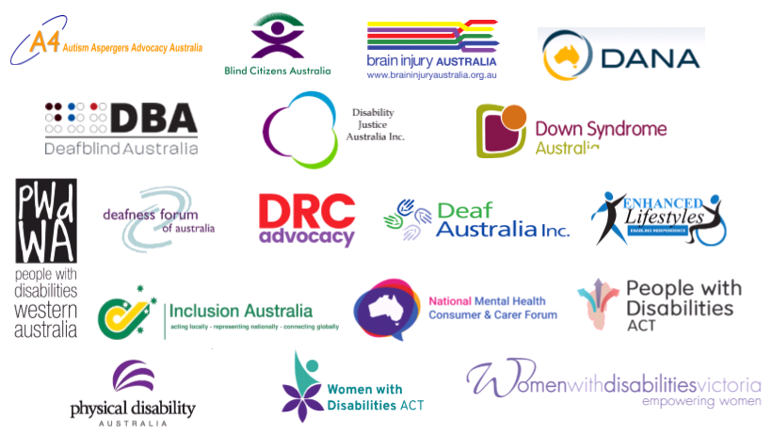

This may be through facilitated communication or a support person.

