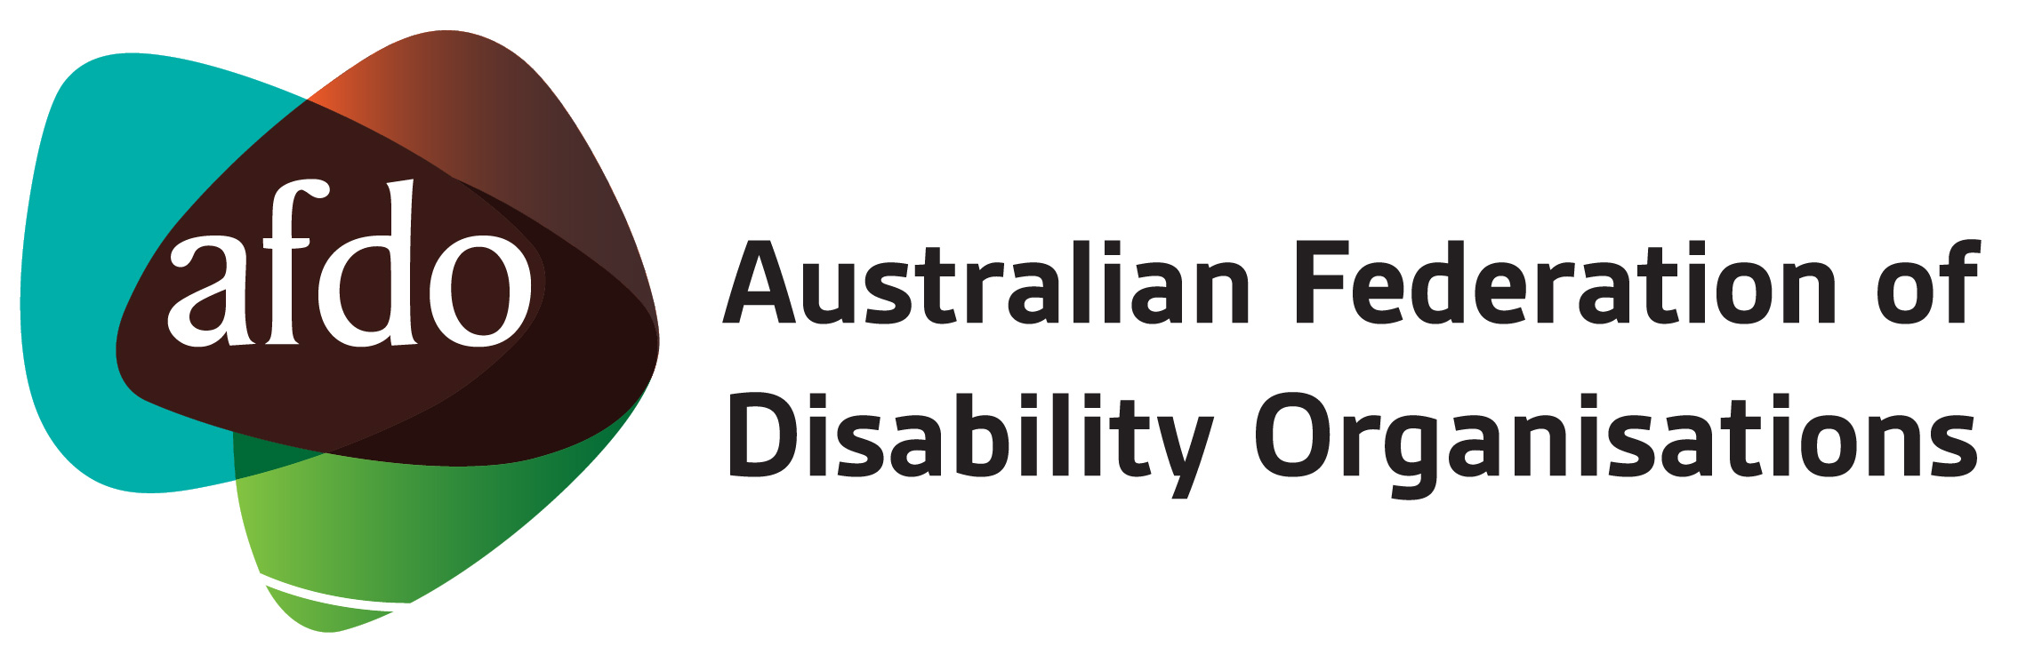

AFDO Membership Application Form (Associate Member)

Organisation:

ABN:

Contact Person:

Position:

Email:

Address:

Please check the boxes as appropriate, next to the four statements below:

- ☐ We are a Not-for-Profit disability organisation or a Community Based Group/Organisation.
- ☐ Our prime role is to advocate for the rights and wellbeing of people with disability.
- ☐ We do not have any purposes contrary to the purposes of AFDO.
- ☐ We are not eligible to become a Full member of AFDO.

Signed:

Name:

Title:

On approval of your Associate membership application, AFDO will forward you an invoice for $30 plus GST. Please provide your accounts department email address below.

Accounts contact email:

Please attach your latest Constitution and Annual Report with your application.

Applications for membership should be sent to the CEO & Company Secretary at ceo@afdo.org.au

For further information about membership, please contact the AFDO office on (03) 9662 3324 or by email to office@afdo.org.au or visit the AFDO website.

The Board of AFDO considers all membership applications, and will notify you within 60 days if your application is successful. All decisions made by the AFDO Board on membership applications are final.

Australian Federation of Disability Organisations
ABN 25 105 510 898

