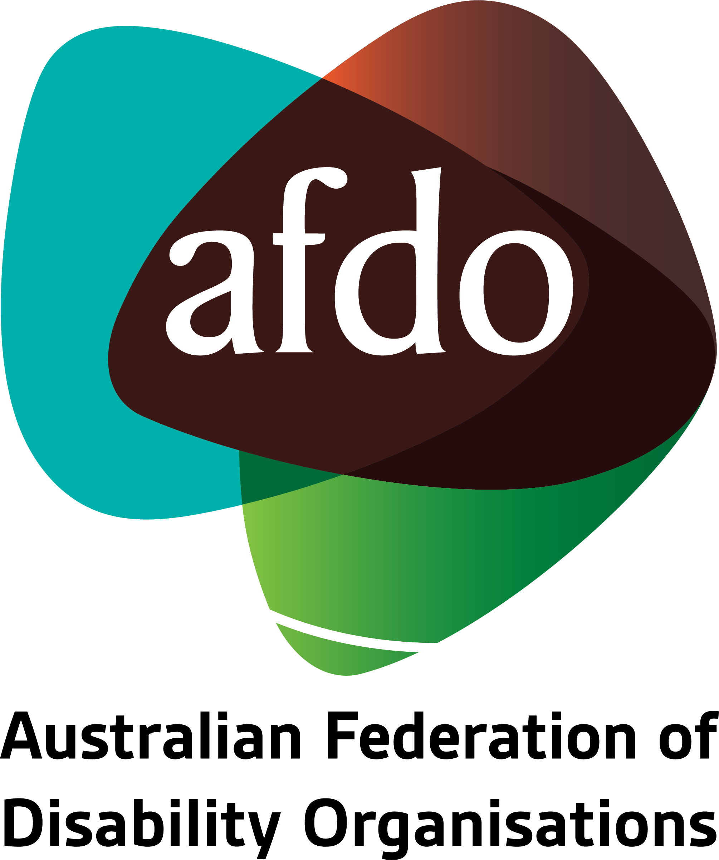

Experiences of people with disability during the ongoing COVID-19 pandemic

Statement to the Royal Commission into Violence, Abuse, Neglect and Exploitation of People with Disability

14th August 2020

Table of Contents

About AFDO 3
Our members 4
Open Letter to the National Cabinet 5
Statement of Concern 6
Areas of concern 7
Education 7
Congregate settings 7
Forensic Disability Units 9
Economic impact 9
Personal Protective Equipment (PPE) 12
Accessibility 13
The strain on ADFO & our member organisations 14
Looking to the future 15
Immediate Actions & Recommendations 16
Forensic Disability Units 17
NDIA Supplementary Payments 17
Disability Support Pension 17
Food, products and medication access 17
Personal Protective Equipment and Training 17
Engagement Strategy 18

About AFDO
Since 2003, the Australian Federation of Disability Organisations (AFDO), a Disabled Peoples Organisation (DPO) and Disability Representative Organisation (DRO), has been the recognised national peak organisation in the disability sector, along with its disability specific members, representing people with disability. AFDO’s mission is to champion the rights of people with disability in Australia and support them to participate fully in Australian life.
Our member organisations represent disability specific communities with a total reach of over 2.8million Australians.
AFDO continues to provide a strong, trusted, independent voice for the disability sector on national policy, inquiries, submissions, systemic advocacy and advisory on government initiatives with the Federal and State/Territory governments.
We work to develop a community where people with disability can participate in all aspects of social, economic, political and cultural life. This includes genuine participation in mainstream community life, the development of respectful and valued relationships, social and economic participation, and the opportunity to contribute as valued citizens.
Our vision
That all people with disabilities must be involved equally in all aspects of social, economic, political and cultural life.
Our mission
Using the strength of our membership-based organisations to harness the collective power of uniting people with disability to change society into a community where everyone is equal.
Our strategic objectives
To represent the united voice of our members and people with disability in national initiatives and policy debate.
To enhance the profile, respect and reputation for AFDO through our members.
To build the capacity and sustainability of AFDO and our members.
To foster strong collaboration and engagement between our members and stakeholders.
To enhance AFDO's connection and influence in international disability initiatives, particularly in the Asia Pacific region, through policy, advocacy and engagement.

Our members
AFDO’s Full members:
- Autism Aspergers Advocacy Australia
- Blind Citizens Australia
- Brain Injury Australia
- Deaf Australia
- Deafblind Australia
- Deafness Forum of Australia
- Down Syndrome Australia
- Disability Advocacy Network Australia
- Disability Justice Australia
- Disability Resources Centre
- Enhanced Lifestyles
- Inclusion Australia (NCID)
- National Mental Health Consumer and Carer Forum (NMHCCF)
- People with Disability WA
- People with Disabilities ACT
- Polio Australia
- Physical Disability Australia
- Women with Disabilities Victoria
- Women with Disabilities ACT

AFDO’s Associate members:
- AED Legal Centre
- Aspergers Victoria
- DACSSA (Disability Advocacy and Complaints Service of South Australia)
- Leadership Plus
- National Organisation for Fetal Alcohol Spectrum Disorder (NOFASD)
- Accessible Inclusion Matters (AIM)
- YDAS – Youth Disability Advocacy Service

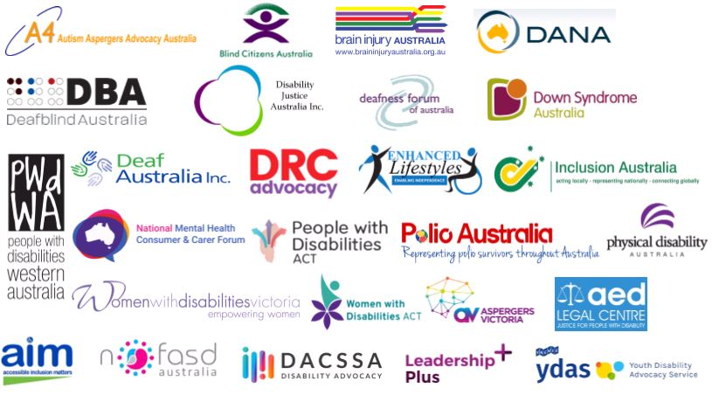

Open Letter to the National Cabinet
On 2nd April 2020, on behalf of AFDO, we authorised the endorsement of an Open Letter to the National Cabinet highlighting the immediate actions required for Australians with disability in response to the COVID-19 pandemic (the Open Letter). The letter, endorsed by over 50 organisations from across Australia, representing the interests of people with disability, their families, carers and support persons.

A copy of the Open Letter is available on the AFDO website.

AFDO worked on the development of the Open Letter along with other national peaks. This was because we were gravely concerned about the lack of specific and targeted measures put forward by the Australian Governments as an outcome from the National Cabinet decisions (involving governments at a Federal, State and Territory level), to protect and support people with disability proactively, their families, carers and support persons. When looking at the immediate responses to the growing pandemic, we found that people with disability were missing in action and were not part of significant decisions or considerations.

The Open Letter called upon the Australian Governments at a Federal, State and Territory level, to undertake ten urgent actions. This became known as the ’10 Point Plan’. The 10 Point Plan was put forward to ensure the safety, security and inclusion of people with disability in any future responses to the pandemic.

The Governments response to these ten points was mixed with;

      - Points 1, 2, 3, and 4, some progress made;
      - Point 5, no movement on including those on the DSP in the Coronavirus Supplement additional payment;
      - Point 6, no definition provided on what constitutes an essential service for people with disability as guidance for service providers and congregate settings;
      - Point 7, some progress with additional supports and recognition of this for people with disability along with the wider community;
      - Point 8, children & young people with disability still suffering from discrimination across all education systems;
      - Point 9, slight progress on ensuring the human rights of people with disability are recognised in congregate settings; and,
      - Point 10, no additional resources to Disabled Peoples Organisations (DPOs) and Disability Representative Organisations (DROs) to advocate for people with disability

Statement of Concern
On 15th April 2020 a Statement of Concern entitled COVID-19: Human rights, disability and ethical decision-making was released (the Statement of Concern). A copy of the Statement of Concern is available on the AFDO website.

The Statement of Concern was signed by many internationally recognised Australian experts in the areas of human rights, bioethics and disability, it was commissioned and paid for its development by AFDO along with; People with Disability Australia, Women with Disabilities Australia, National Ethnic Disability Alliance, First Peoples Disability Network, and the ACT Council of Social Service Inc.

The Statement of Concern emphasised key human rights principles and standards that need to underpin ethical decision-making in the context of disability and the COVID-19 pandemic.

The Statement of Concern was a result of our concerns about the health response during the pandemic for people with disability and was deemed to be of particular importance after hearing some worrying examples from overseas.

We still think there is continuing work that needs to be done in this space. People with disability often do not get the appropriate recognition, respect and treatment they deserve in the health system and they are often triaged out of the system. We consider there to be a lack of understanding of our obligations under the United Nations Convention on the Rights of Persons with Disabilities (UNCRPD), the Disability Discrimination Act 1992 (Cth) (DDA), and complimentary legislation which each state and territory has enacted, such as Anti Discrimination/Equal Opportunity Acts that prohibit discriminatory treatment of people with disabilities. The rights enshrined in all these documents need to be protected and importantly, enforced.

While we are pleased with the way the Statement of Concern was received, we had concerns that it required the sector to push hard to ensure that people with disability were front and centre in the decision-making and policy-making arenas, critically in these exceptionally fast-moving health emergency responses.

Areas of concern
This pandemic has illustrated that there needs to be more work done on how we can respond to a similar health crisis (pandemic or epidemic), or natural disasters in the future. The issues raised by the pandemic seem to have caught every government jurisdiction unaware. This increased the number of significant areas of concern;

Education
Immediately from the outset and at present, the continuing school closures have a complete lack of consideration for young people with disability and their families.

There has been a lack of planning in terms of how the education system can assist children and young people with disability when it comes to accessibility and support. This was amplified by the need for homeschooling with no support for parents or guardians available, many of whom were also working from their home office. This creates a more significant emotional strain on families and particularly sole parents with their children, affecting their collective physical health, mental health and overall wellbeing.

This pressure and lack of supports has put children and young people with disability at a more considerable disadvantage and created the opportunity for family breakdowns or greater violence or abuse within the home.

Congregate settings
When we say congregate settings, we are referring to settings where a number of people with disability are gathered in one space, such as group homes, aged care centres and Australian Disability Enterprises (ADEs) (the latter formerly known as “Sheltered Workshops”).

We believe there has been no real policy consideration given to how supports could continue to be provided for people with disability in these settings, or for how people could remain in communication with their support networks.

The lockdown, across a range of these types of settings, was of significant concern as it put people in a vulnerable position where they had no access or support, meaning no external monitoring and a closed environment.

This was exacerbated because advocates do not have the authority to enter a congregate setting, even if a person in the environment was an existing client. Advocates are not classified as a worker or a visitor for access rights. In a lot of jurisdictions advocates, who may have been working with people with disability, including those who need assistance with decision-making or communication, could not see the person and were denied entry by operators of those services.

This needs to change urgently, and advocates must be classified as workers and have a right to enter any of these settings to visit people with disability whom they were already supporting, during any health or other disaster.

This was also an issue for young people with disability (from youth to under 65 years of age) who, due to their disability and care needs, have no option but to reside in an aged care environment. These young people were denied the right to have visitors or access by other workers, such as advocates, placing them in a vulnerable position with no access, support or external oversight.

We would say that the Aged Care system, as opposed to other settings, mostly got it right in the end. Still, there was an initial lack of understanding or even acknowledgement of the issue, which impacted on a large number of people with disability when the lockdown was first introduced. This needs to be locked into any future emergency response through funding, policy and operating quality standards.

We had great concern over the fact that many ADEs continued to operate during the pandemic as we do not believe that ADEs could be classed as an essential service.

People in ADEs are often vulnerable, particularly from a health point of view, and there did not appear to be any consistent policy or response put in place across this sector. We have raised this issue with the National Disability Insurance Agency (NDIA) and the Department of Social Services, who fund and control ADEs. We have asked for clear policy directives and guidelines to be issued now and for any future emergencies.

We also asked for answers to be sought from ADEs who continue to operate during the pandemic. We firmly believe that many ADE operators would be in breach of their obligation to provide their “workers”, whom they classify as their management staff and all people with disability attending, an environment which protects and ensures their health and safety.

The loose feedback we received from this engagement, was that those ADEs remaining open considered their operation to fall under the definition of an essential service as a number of them were packaging items for hospitals or medical supplies. We were not satisfied with that response, and it seemed to be an example of “policy on the run” or public relations “spin” and ignored the health vulnerability and heightened risk for people with disability who attended.

With the recommencement of lockdown in metro Melbourne in July and possibly occurring elsewhere, we were concerned that issues will arise again as there are still no specific Government or Agency directives for ADEs to ensure the protection and safety of people with disability.

Forensic Disability Units
All states and territories have transferred responsibility for disability support to the Commonwealth NDIS, except for the provision of forensic disability support which they have all retained.

The mechanisms, pathways and structures that initially supported the implementation of forensic disability support have been eroded, including independent monitoring and oversight. An example being; In the Northern Territory despite there being a legislative requirement for a disability panel to refer issues that relate to the use of restraint at any facility, no such panel exists currently, or is in planning to be formed. This lack of external oversight and COVID 19 meant that there were fewer opportunities to engage in external monitoring and reviews of detention for treatment.

Despite a request by AFDO, and others in the sector, to convene the DSS Justice Interface Working Group, to discuss the issue of COVID-19, this has still not occurred, This Group is where the Commonwealth all states and Territories and the NDIS all sit and consider NDIS and justice issues. We acknowledge the lack of action on this request was due to, the pressure from the speed at which the COVID-19 experience unfolded, leading to a lack of time, resources and opportunity to organise. We believe this needs to happen urgently and should also consider responses to future emergencies.

People with disability detained in forensic disability units were highly vulnerable to transmission of COVID-19; however, Forensic Disability was not referenced in the DSS report on COVID-19 and disability with responses left up to each state and territory.

The numbers of support staff rostered on at these facilities, the close working conditions with those detained, the need for them to continue to provide support, all made people with disability who are vulnerable, susceptible to transmission. Yet, in another example, Victoria Forensic Disability Units were not classed as “health services” and so were not provided with urgent access to Personal Protective Equipment (PPE) or the national PPE stockpile.

Economic impact
We were concerned to see that the NDIA placed a temporary 10 per cent increase to the price limit of some Core and Capacity Building supports for participants under the NDIS Price Guide, which service providers could charge. There was no similar increase provided in participant plans. This means that those participants affected, were disadvantaged by a fee levied for the pandemic, decreasing the value of their approved plan, on top of the cost of living increases due to the pandemic, which they also had to bear and which we have outlined later in this Statement.

Another issue which has impacted people with disability in an economic sense is that the Disability Support Pension (DSP) was not included in the Pandemic Supplement payment. Despite AFDO and the sectors direct requests since the commencement of measures of support for the pandemic, the Federal Government has maintained that this decision was made because the DSP is a “pension” rather than a “benefit”.

We maintain that this is an incorrect view when considering the significant cost increases faced by people with disability during the pandemic. From a cost of living perspective, there have been significant increases, as well as a lessening of opportunity for people on the DSP to access appropriate services.

People receiving the Disability Support Pension were not given the Coronavirus Supplement as opposed to those receiving the old Newstart / now Jobseeker benefit. This is despite the acknowledgement that people with disability had higher living costs and were often living in poverty.

In the 2019 NATSEM Report, commissioned by AFDO and entitled; “The Economic Impact of Disability Support Pension in Australia”, it provides evidence that additional payments on the DSP, (of around $100 per fortnight for single persons and $310 per fortnight for a couple), was needed and would provide a significant impact on poverty reduction.

The report showed that the proportion of DSP recipients living below the poverty line would drop from 17.8% to 9.7%, and these were the findings before the pandemic. The pandemic has only exacerbated the hardship for those currently on the DSP.

DSP and Carer Payment recipients are more vulnerable to the pandemic (both through direct health and other secondary consequences). They have been disproportionately negatively affected compared to others in the community.

Recipients are more likely to need to remain in isolation, beyond any restrictions and some until a vaccine developed or the pandemic subsides, exacerbating their living costs and barriers to support.

This includes a lack of access to public transport, increased costs for food, products and delivery, increased utility costs, inability to access bulk or cheaper priced food and necessities, and difficulty in obtaining necessary medication.

Regarding supermarket access, the current 7 am dedicated hour for access by people with disability, aged, and their carers, which was instigated in certain supermarkets is helpful for some. But, many people with disability are unable to access that time as their physical, cognitive disability, or other issues may prevent them from participating at that selected hour. Access to priority delivery online also involved an expensive delivery fee which complicated the capacity of people with disability to access the delivery service. Smaller orders also had a surcharge attached.

Despite the evidence of the cost of living and general expenditure for DSP and Carer Payment recipients increasing on average due to the pandemic, both payments remained at their current level. Only two economic support payments of $750.00 per fee or $1500 in total, were provided to DSP and Carer Payment recipients.

In contrast, the JobSeeker Payment (previously Newstart) was doubled (March - September 2020) and is now significantly higher than the DSP. This is also going to continue at a reduced level beyond September 2020. This has created confusion and anxiety for existing DSP recipients who feel their needs (especially during a time of crisis) are being ignored or discounted by the Government.

Whilst noted, that steps are being undertaken to increase support during the pandemic through the NDIS, many DSP recipients are not participants of the NDIS and do not have access to any of these increases or additional support.

The disparity between DSP and JobSeeker Payment has caused potential DSP applicants to attempt to remain on the JobSeeker Payment. It has also led DSP recipients to question whether they should stay on the DSP given their immediate living costs and increased expenditures. This was broadcast widely on social media posts by people with disability; however, quick action form the advocacy sector ensured that those considering this as an option were dissuaded from proceeding to give up their DSP for Newstart. The DSP is clearly the more appropriate payment given both groups’ disability and work capacity.

Many recipients of DSP and Carers Payment were in part-time or casual work to supplement their income prior to the pandemic. This cohort is more sensitive to a shrinking job market and more likely to have lost their source of supplemental income early during the pandemic or forced to voluntarily withdraw from the workforce to prioritise their health or the health of those they support. Many who have left or lost their jobs during the pandemic have either been unable to or found difficulty in obtaining JobKeeper, which is not a social security payment. There will continue to be high unemployment for people with disability requiring continued access to Jobseeker and the DSP.

The category of people with ‘Partial Capacity’ on JobSeeker Payment often have severe disabilities and/or a range of comorbidities, that makes them highly vulnerable and therefore, they should not be forced to participate in programs such as work for the dole, mutual obligations and associated activities. While we commend the Federal Government for amending many mutual obligation requirements during the pandemic, but for this specific cohort, such activities should be removed permanently as a requirement of payment.

Personal Protective Equipment (PPE)
The provision of PPE in the community was a significant issue for people with disabilities, their families and service providers.

      - Many people with disabilities need PPE to continue to receive in-home services safely.
      - It was unclear who or how the PPE would be funded, via NDIS plans or separately as participants own responsibility?
      - It was unclear who was responsible for providing the PPE, the person with disability, the service provider, or both?
      - Those with self-managed plans which needed PPE were left uncertain as to what were their obligations or requirements.
      - It was unclear when PPE was required, was it to be a routine measure or only if someone was symptomatic?

The provision of PPE is essential in keeping people with disabilities safe (from violence, abuse, neglect and exploitation) because it is needed to continue services safely for people with disability, their families and support workers.

PPE is also essential to keeping people with disabilities, vulnerable to COVID-19, safe in their homes and the community. This was a unique experience for the disability community. However, there was a lack of consistent messaging, funding or coordinated strategy of how PPE could be obtained or would be made available. The NDIA changed its policy stance for participants over two weeks, further adding to this confusion.

The lack of training or approach developed to rapid upskilling on the use of PPE for people with disability, their families and support workers further impacted on the confidence and safety of all concerned. The expectation, that all support workers were automatically trained in the use of PPE, as part of their organisation training, was unreasonable at that time, as the majority of support workers were not required to have any medical training nor were they undertaking any medical supports.

The pandemic, however, showed a massive gap in this element and has demonstrated that to respond safely to the current or to future emergencies all support workers should be trained in the use of PPE and infection control with regular refresher training as needed. Resources and training should also be made available to people with disability and their families. There also needs to be tailored training and resources specifically for people with disability who are self-managing their plans and supports under the NDIS.

The impact of shortages on PPE for people with disabilities was not adequately addressed from a systems-level and that left people with disabilities vulnerable to cancelling services fearing they would not be protected, or they would expose others to risk. It also resulted in some services withdrawing to an essential level only, exposing the person with a disability to the risk of not receiving the services they need or having any informal safeguarding supports in place.

Despite a Federal Government Stockpile of PPE, this has again proven to be ineffective with; cumbersome, inflexible and restrictive access; the inability to ensure the maintenance of sufficient stock levels; and critically the inability to ensure supply chain and supply chain quality. The Federal Government advised at the start of the pandemic that the stockpile was under the required stock level due to the issuing of masks over the December to February bushfire crisis. This further demonstrated issues in the control and management of the stockpile, with this being such a critical national resource required in any health emergency be it a pandemic or epidemic.

Similar issues to those experienced with the PPE Stockpile during the H1N1 Swine Flu Pandemic of 2009 were experienced again in Australia, some eleven years later and this should be unacceptable to the Australian community.

Not only were primary health care provided with limited access and supplies, disability service providers were ineligible to access the stockpile with many forced to join together to find overseas suppliers. We are aware that the representative peaks, National Disability Services and Ability First, explored or reached agreements with overseas suppliers to ensure their members had access to a sustainable PPE supply. People with disability and their families were ineligible and unable to access the stockpile and had to make their arrangements.

Accessibility
In respect of meetings just concerning COVID-19 issues, we had to ensure accessibility was provided for a number of our members, when participating in our member meetings or for meetings held with other sector peaks. This includes, as a minimum, captioning and Auslan interpreting, which is an unfunded or subsidised direct cost to AFDO. This equates to an immediate loss of approximately $400 per hour per meeting with a minimum of two hours required by one provider, even if the meeting is for under an hour. We may, at times, need to provide other supports such as tactile interpreting, braille, large print, support workers, dependent upon who is attending.

Accessibility supports are necessary to ensure that people with disability are able to stay informed, provide relevant input into issues and maintain their voice on matters which affect them. AFDO, and a majority of our national members, as well as some of our State members, have to provide a variety of accessibility supports dependent upon attendees. These are direct organisation costs, and there is no subsidised rate or funding provided from any source.
For externally held meetings such as those undertaken by DSS, other Departments or the Minister's Office, etc. we have provided accessibility advice and resources, which we have also shared with the Disability Royal Commission, to assist them in correctly booking the relevant supports. In certain circumstances we undertook the necessary bookings directly for which we were reimbursed, but only for the actual accessibility cost, no allowance for our time in arranging.

The strain on ADFO & our member organisations
For at least the first two months of the pandemic, the staff at AFDO and our member organisations were under unrelenting pressure to keep up with our workloads and respond to the rapidly changing policy and supports being considered. We were in meetings for numerous hours a day. We were liaising with other people within the sector to ensure that people with disability were kept front and centre of any decisions concerning COVID-19. We have been undertaking significant systemic advocacy and ensuring that our members were kept up to date. In turn, they need to keep their members informed so they could also provide feedback, and relate issues, or their member issues.

AFDO staff have been operating remotely since August 2019 as a result of changes we introduced at that time to lessen our outgoings. We ensured that staff home offices were fully compliant for occupational health and safety including electrical safety tag and testing, we provided necessary furniture and equipment including laptop, additional screens, printer/scanners, etc. all at AFDOs expense. This allowed us to continue to work through the pandemic with little changes required for our operation. This was not the same for all of our member organisations, with additional costs being incurred to adjust to remote working.

We understand that these are unprecedented times, but we have not received any extra funding for the additional emergency work we undertook at the start of the pandemic, nor for the continuing work involving COVID-19 specific issues, which are not part of our funded activities.

To put this into blunt context, AFDO and ten of our National Peak members receive just over $27,000 a year each from the Federal Government through Department of Social Services (DSS), as recognised Disability Representative Organisations. This is to fund each organisation for our usual systemic advocacy work and government engagement, it does not cover this additional emergency work, and specifically the additional costs in the way we need to do this work properly with our members and their communities. In contrast, other funded Disability Representative Organisations (outside of AFDO and our national members), receive $300k for their own organisation, it is not split with others, and their agreement with DSS has the same conditions and requirements. While DSS has advised they are undertaking a review of systemic and individual advocacy funding levels and support, and the current arrangements are in place until 30th June 2022.

This lack of adequate funding was an existing problem for AFDO and our national members pre the pandemic, but this has now been exacerbated.

Even before the pandemic, we had a set contract for DRO work, but have never received any funding, or recognition, concerning accessibility needs for the participation of people with disability in all of our work.

As an example, AFDO alone spent over $60,000 on accessibility needs last financial year and $66,000 the year before. We consider this essential and something which every organisation should be providing for people with disability, recognising the requirements of the UNCRPD and the DDA. We feel that this is yet another example of people with disability and their national representative bodies being unvalued and receiving second class treatment.

We would also highlight that the same issues for AFDO and our member organisations, also apply to the Individual Advocacy Agencies across Australia. There was significant additional work generated outside of their contract agreements in terms of responding to pandemic issues and individual needs, welfare checks on clients, as well as additional responses and reports to governments. There was no additional funding provided to assist them through this emergency.

Looking to the future
A key strategy to strengthen the voice of people with disability would include them as a group of people with equal status, to other key population groups who may be affected by COVID-19, requiring bespoke and targeted strategies. During the initial months of COVID-19 people with disability were not evident in the discussions that formed the framework of response from the Government. It was in April / May, much later in the pandemic, that planning and responding for people with disability occurred from DSS.

Having a well-developed pre-prepared communication strategy and plan is necessary to strengthen the voice of people with disability during a crisis such as COVID-19. A generalised pre-prepared crisis communication strategy for people with disability should be developed with the Government in preparation for an emergency rather than during the crisis. It can then be adapted to suit the circumstances of the crisis at the time.

The crisis communication strategy should be co-designed by people with disability, civil society and Government. But it must be funded by Government and led by people with disability through the entire process, including the work involved so that they have ownership of what is ultimately developed. It will strengthen their voice and ensure that they can participate as equals during any crisis rather than feeling as though they are an afterthought.

Immediate Actions & Recommendations
Our recommendations are as follows.

- Federal Government to define what constitutes an “essential service” for people with disability in any emergency response and policy context.

- Governments must undertake an urgent review, to build a consistent response and initiate legislation, policies and operational responses for the supports required for children and young people in education systems, particularly relating to home schooling requirements and in school requirements during any emergency response.

- Governments to undertake an urgent review, to build a consistent response and initiate legislation, policies and operational responses to the current and any future emergencies, for those people with disability in congregate settings including aged care, group homes or accommodation as well as Australian Disability Enterprises. To ensure the health, safety and welfare of those present as the priority in recognition and aligned with their universal human rights.

- Governments to immediately establish legislation, policies and operational responses to allow Advocates from Individual Advocacy Organisations access as a worker to all congregate settings to meet with an existing client, being a person with disability.

- Governments to provide immediate financial assistance to DPOs and DROs as well as Individual Advocacy Agencies (funded via the National Disability Advocacy Program) in recognition of the additional work undertaken outside of any contractual arrangement in advocating and representing people with disability operating throughout the current emergency.

- Federal Government to provide funds to support DPOs or DROs in providing accessibility supports for people with disability to engage, consult with, and provide their input and advice on current issues or initiatives.

- Governments to respond to human rights, disability and ethical decision making in health and how they are going to embed this into their health systems and future emergency responses.

Forensic Disability Units
- That DSS immediately convene the Justice Interface Working Group to discuss the issue of COVID-19 and in particular the suitability of responses by Forensic Disability Units for people with disability and agree on a policy of how this should be undertaken now and for any future emergency responses.

NDIA Supplementary Payments
- That the NDIS and NDIA ensure that any supplementary price increases for supports or services implemented during any emergency, be likewise provided to the same level, to participants plans of those impacted.

Disability Support Pension
- Federal Government to immediately increase the DSP and Carer Payment proportionately to the increase in JobSeeker Payment to acknowledge the increased cost of living and loss of employment or opportunities, for DSP and Carer Payment recipients.

- Federal Government to suspend and legislate the removal of mandatory participation in mutual obligations requirements, for those people with disability with partial capacity, currently on the JobSeeker payment or those that may come onto this payment in the future, without limiting or delaying any qualification for the DSP (through the Program of Support requirements).

Food, products and medication access
- Governments must urgently continue to work closely with supermarkets, healthcare services, public transport services, and other essential goods and service providers to ensure that any barriers to these are removed or reduced for persons living with disability and their carers during the current and in any future emergency responses.

Personal Protective Equipment and Training
- Federal Government must undertake an urgent review of the operations and response of the Federal Government PPE Stockpile during this pandemic. This must include delays in maintaining agreed stock levels, review of the access request process and its response times, distribution of PPE supplies, delays and suitability of amounts or type provided. The need to ensure rapid access and delivery to other sectors and areas affected and at-risk outside of only medical organisations and personnel.

- Governments to legislate and ensure as quality standards that PPE and infection control training & resources, including regular refresher training, are a requirement for all disability support workers.

- Federal Government and Agencies to ensure that PPE and infection control training, guidelines and resources are, developed, available and distributed to all participants on the NDIS, including those who self-manage their plans. The training, guidelines and resources must also be made available to people with disability who self-fund their supports.

Engagement Strategy
- Governments must develop a robust engagement strategy, to consult, work closely with, and engage those living with disability, and disability representative organisations, employment rights services, and social security rights services to ensure appropriate policy development and its implementation for those living with disability and their carers, particularly during this pandemic or any future emergencies.

