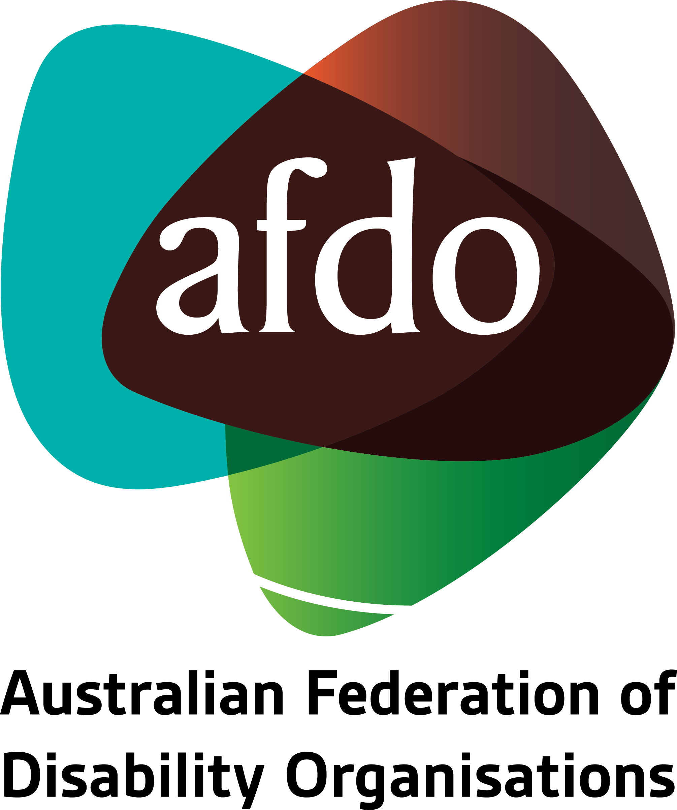

NDIS Joint Standing Committee
Submission on

Review of NDIS Quality & Safeguards Commission

October 2020

Table of Contents

About AFDO & our members 3
Our members 4
Submission Recommendations 5
NDIS Participants with Cognitive and Psychosocial Disabilities Under Forensic Orders 6
A. Case Study 10
B. Community Technical Experts (Auditors with Disability) 12
C. The Role of People with Disability as Community Technical Experts (Auditors): 14
D. Endorsement of Other Submissions Including Recommendations to the Inquiry on the NDIS Quality and Safeguards Committee 15
Further information 16

About AFDO & our members
Since 2003, the Australian Federation of Disability Organisations (AFDO), a Disabled Peoples Organisation (DPO) and Disability Representative Organisation (DRO) has been the recognised national peak organisation in the disability sector, along with its disability- specific & cross-disability members representing people with disability.
AFDO’s mission is to champion the rights of people with disability in Australia and support them to participate fully in Australian life.
AFDO continues to provide a strong, trusted, independent voice for the disability sector on national policy, inquiries, submissions, systemic advocacy and advisory on government initiatives with the Federal and State/Territory governments.
We work to develop a community where people with disability can participate in all aspects of social, economic, political and cultural life. This includes genuine participation in mainstream community life, the development of respectful and valued relationships, social and economic participation, and the opportunity to contribute as valued citizens.
Our vision
That all people with disabilities must be involved equally in all aspects of social, economic, political and cultural life.
Our mission
Using the strength of our membership-based organisations to harness the collective power of uniting people with disability to change society into a community where everyone is equal.
Our strategic objectives
To represent the united voice of our members and people with disability in national initiatives and policy debate.
To enhance the profile, respect and reputation for AFDO through our members.
To build the capacity and sustainability of AFDO and our members.
To foster strong collaboration and engagement between our members and stakeholders.
To enhance AFDO's connection and influence in international disability initiatives, particularly in the Asia Pacific region, through policy, advocacy and engagement.

Our members
Full members:
- Autism Aspergers Advocacy Australia
- Blind Citizens Australia
- Brain Injury Australia
- Deaf Australia
- Deafblind Australia
- Deafness Forum of Australia
- Down Syndrome Australia
- Disability Advocacy Network Australia
- Disability Justice Australia
- Disability Resources Centre
- Enhanced Lifestyles
- National Mental Health Consumer and Carer Forum (NMHCCF)
- People with Disability WA
- People with Disabilities ACT
- Polio Australia
- Physical Disability Australia
- Women with Disabilities Victoria
- Women with Disabilities ACT

Associate members:
- AED Legal Centre
- All Means All
- Aspergers Victoria
- DACSSA (Disability Advocacy and Complaints Service of South Australia)
- Disability Law Queensland
- Leadership Plus
- National Organisation for Fetal Alcohol Spectrum Disorder (NOFASD)
- YDAS – Youth Disability Advocacy Service

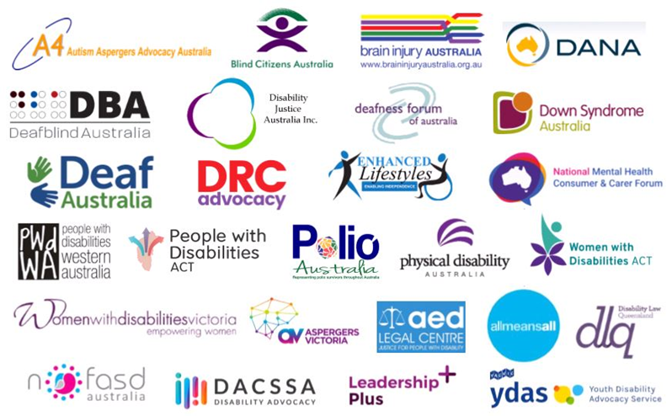

Submission Recommendations
AFDO Recommendations:

- That all state and territory forensic that have legislative responsibility for NDIS participants under Forensic Orders become registered providers under the NDIS Provider Registration Scheme.

- To implement the recommendations of the 2016 Senate Inquiry into Indefinite Detention for People with Cognitive Disabilities and Psychosocial Disability in relation to:
  - Nationally consistent approaches for Forensic Orders
  - Mandated requirements for less restrictive treatment
  - Regular reviews including assessment treatment of therapeutic benchmarks
  - Independent oversight of indefinite detention under Forensic Orders
  - Independent oversight of restrictive practices under Forensic Orders
  - Proactively fund construction or acquisition of a range of appropriate supported accommodation in metropolitan and regional locations
  - Nationally consistent and improved Record and Data Keeping
  - Embed Cultural Safety in therapeutic interventions
  - Transition Planning for Exiting Indefinite Detention
- To implement the recommendations of the Community Visitor Schemes Review 2018 to ensure the safety and welfare of NDIS Scheme participants
- Review of the NDIS Quality & Safeguards policy and procedures in relation to NDIS participants detained under forensic orders to ensure that the safeguarding of rights has equal weight with any privacy considerations

- That all states and territories provide access to restrictive practice review mechanisms that are established, operational, independent and transparent to review these for any NDIS participants detained under forensic orders

- To implement the Community Technical Experts Program outlined under the NDIS Quality and Safeguards Legislation

NDIS Participants with Cognitive and Psychosocial Disabilities Under Forensic Orders
The Australian Federation of Disability Organisations is highly concerned that the conditions of the forensic detention system for people with cognitive and psychosocial disabilities lay outside the protections of the NDIS Quality and Safeguards Commission for those who are participants of the National Disability Insurance Scheme.

AFDO is concerned that very vulnerable people, a disproportionate number being Aboriginal or Torres Strait Islanders, are indefinitely detained and subject to treatment that may or may not be or be of dubious benefit. Often the detention is arbitrary and the therapeutic benefit of the treatment questionable.

To further complicate the vulnerability, people indefinitely detained through this mechanism are often assessed as a risk of harm to others. A final dynamic in this set of circumstances, which was recently highlighted at the Disability Royal Commission is the reliance on and overuse of chemical restraint.

All NDIS participants, including those with cognitive or psychosocial disabilities, who are detained for the purposes of treatment under Forensic Orders, need to have the protection of the NDIS Quality and Safeguards Commission.

“Recognition of the need for this inquiry grew out of this committee's 2015 inquiry into violence, abuse and neglect against people with disability (abuse inquiry), during which a range of evidence was presented on the indefinite detention of people with cognitive or psychiatric impairment. The committee heard that people who have been charged with a criminal offence and found unfit to plead, or not guilty by reason of mental incapacity, can find themselves detained for the purpose of involuntary therapeutic treatment. This form of detention is indefinite, as it has no specified end date. Detention often occurs in prison, even though the person has not been found guilty of any offence, and too often the therapeutic intervention, the purported reason for the detention, is either not adequately provided or not provided at all.”

There have now been a significant number of reports and senate enquiries dealing with this issue, and all have made similar recommendations including from:

- No End in Sight: The imprisonment, and indefinite detention of Indigenous Australians with A Cognitive Impairment Aboriginal Disability Justice Campaign 2012
- Report on the Arbitrary Detention and Cruel and Unusual Punishment of Four Indigenous Men Detained in the Northern Territory Forensic Detention: Notice under s 29 of Australian Human Rights Commission Act 1986 (Cth) Australian Human Rights Commission 2014
- Access to Justice in the Criminal Justice System for People with Disability Australian Human Rights Commission 2014
- A predictable and Preventable Path: Indigenous Australians with Mental Health Disorders and Cognitive Disabilities in the Criminal Justice System: Professor Eileen Baldry and Professor Leanne Dowse, UNSW 2015
- Inquiry into the Indefinite Detention of People with Cognitive and Psychiatric Impairment in Australia, Senate Community Affairs References Committee: 2016
- The provision of services under the NDIS for people with psychosocial disabilities related to a mental health condition, NDIS Joint Standing Committee 2017
- "I needed help; instead I was punished": abuse and neglect of prisoners with disabilities in Australia, Human Rights Watch 2018
- The Forensic Disability Service Report – An Investigation into the Detention of People at the Forensic Disability Service, Queensland Ombudsman August 2019
- He’s Never Coming Back: People with Disability Dying in Western Australian Prisons, Human Rights Watch 2020

The Forensic Detention System detains people with cognitive and psychosocial disabilities who are a risk of harm to others for the purposes of treatment. For people with cognitive disabilities, this treatment is primarily through behaviour change and for people with psychosocial disabilities, this treatment is primarily through pharmacotherapy.

The legal mechanism through which people are detained for the purposes of treatment are cited as follows:

“When a person with a cognitive or psychiatric condition is alleged to have committed a crime, there is provision in all states and territories for that person to declare themselves or be declared 'unfit to stand trial'. People who are deemed unfit to stand trial may become subject to a forensic or criminal order. The court, or mental health review tribunal, will assess that person's risk to themselves or others and the need for ongoing treatment and will impose forensic orders to detain the person in a prison, hospital, mental health care facility or prison hospital for mental health treatment. In some cases, they may be allowed to live in the community in a designated location.”

Due to the nature of the treatment, the detention is indefinite, and this is of specific concern to the United Nations Committee for the Convention on the Rights of Persons with Disability who in the 2014 and again in the 2019 Concluding Observations have asked Australia to dismantle its indefinite detention regime.

In 2014;

“The Committee is concerned that persons with disabilities, who are deemed unfit to stand trial due to an intellectual or psychosocial disability can be detained indefinitely in prisons or psychiatric facilities without being convicted of a crime, and for periods that can significantly exceed the maximum period of custodial sentence for the offence. It is equally concerned that persons with disabilities are over-represented in both the prison and juvenile justice systems, in particular women, children and Aboriginal and Torres Strait Islander peoples with disability.”
And again in 2019;

“27. The Committee is seriously concerned about:
a) Legislative frameworks, policies and practices which result in the arbitrary and indefinite detention and forced treatment of persons with disabilities, disproportionately experienced by Indigenous persons with disabilities, persons with intellectual or psychosocial disabilities;
b) Ongoing practice of compulsory treatment for persons with “cognitive and mental impairment”, including through indefinite detention in psychiatric centers, despite recommendations of the Senate Community Affairs References Committee’s 2016 report on indefinite detention of persons with “cognitive and psychiatric impairment”;
c) The commitment of persons with intellectual or psychosocial disabilities to custody, often indefinitely or for terms longer than those imposed in criminal convictions;
d) The absence of data on the number of persons found not guilty due to “cognitive or mental health impairment” indefinitely detained and a number of cases on an annual basis;”

In October 2020, AFDO convened a national meeting of concerned practitioners from all states and territories of Australia involved in forensic detention as a result of anecdotal evidence of human rights breaches taking places in forensic detention facilities. This meeting was convened because people with disability, including sychosocial disabilities were being detained by state and territory governments within the context of a fractured monitoring and oversight system whilst the state and territory disability programs had been absorbed into the National Disability Insurance Scheme.
Concern that forensic disability programs managed by state and territory governments in the absence of more coherent disability structures and programs may have left people with disability detained in those facilities vulnerable to human rights breaches, “The Investigation found that that the FDS had failed to deliver programs to adequately promote the development, the habilitation, rehabilitation and quality of life of people detained. This has impacted upon their reintegration into the community, a key objective of the Forensic Disability Act”
The conclusions from the above October 2020 national meeting of disability justice practitioners, who are specifically concerned with upholding the rights of people with disability detained in forensic facilities, are:

- The majority of people with disability are not being serviced or supported appropriately and that this is clearly evident when it comes to people with disability in the criminal justice system
- The lack of a trauma-informed framework built into the care and protection of people detained in forensic facilities
- People with disability detained under forensic orders diverted to prisons when forensic facilities are full despite not being convicted of a crime
- People with disability under orders either seem to have incredibly tight restrictions imposed or are left in relative freedom, with a poorly functioning community based forensic accommodation and support service system
- There is little to no effort in ensuring Indigenous Australians detained in forensic facilities in the Northern Territory have access to cultural safety – this lack of cultural safety could be applied nationwide
- It is difficult to have a robust line of sight regarding forensic facilities on a national basis
- People with disability are often held under the mental health act, and psychiatric expertise is lacking in the context of disability
- It remains unclear who is responsible for care and wellbeing of people with disability in the criminal justice system
- There is a strong need for more Commonwealth investment in specialist advocacy services such as community visitors
- There is a lack of nationally consistent rights-based checks and balances for people with disability in forensic facilities in relation to restrictive practices
- Concern regarding the high threshold for confidentiality at the Quality and Safeguards Commission and a prioritising of privacy over safeguarding

The Eastern Region Mental Health Association (ERMHA) in a submission to the Disability Royal Commission made these general observations:

“In the past 12 months, a large number of the people that ermha365 supports have been in conflict with the law or interfaced with the criminal justice/ justice system in some way. The proportion is highest in the Northern Territory (56%) and lower, but still significant in Victoria (26%).

While not all experiences with the criminal justice system have been negative, the most common negative experiences reported by our clients include:

- Verbal abuse
- Physical or chemical restraint
- Withdrawal or withholding of privileges without explanation
- Extended periods in isolation
- Court hearings being deferred without clear explanation to the client
- Clients having to pursue multiple legal services until securing a respectful representative (leading to extra costs/time/resources and added stress); and
- The lack of appropriate accommodation exacerbating these situations, leading to prolonged detention or hospitalisation as a last resort.”

Case Study
In early 2020 the joint guardians and NDIS funded services providers of a young Indigenous man detained in a forensic program in the Northern Territory became involved in a conflict with the Forensic Disability Unit regarding the elimination of chemical restraint. Up until that point, there had been relatively good cooperation regarding the two-year program to eliminate the chemical restraint for this young man as per the National Framework for Reducing and Eliminating the Use of Restrictive Practices in the Disability Service Sector. The program was coordinated by the young man’s GP with clinical supervision provided by a psychiatrist with experience in intellectual disability.

The conflict began as a result of a difference of opinion about how to manage the emerging behaviours associated with the elimination of chemical restraint. A particular issue was the frequent and intense head banging behaviour that the young man engaged in which distressed everybody and led to his hospitalisation.
Other differences of opinion lay in the lack of a cultural safety framework, the implementation of less restrictive alternatives and the involvement of practitioners from outside of the Forensic Disability Unit. This led to tense and difficult interactions and communication between the guardians and the FDU.

The conflict sharpened considerably after the third hospitalisation as the FDU took the unilateral decision to involve a forensic psychiatrist who immediately recommended the reinstatement of chemical restraint. THE FDU and Forensic Psychiatrist undertook this without the consent and involvement of the guardians or family. The FDU then cut off all communication with the guardians and the family save for a generic email address with no person identified as a FDU contact point.

Under the direction of the CEO of the Department of Health, the FDU then assumed all decision making authority for the young man and began making decisions on his behalf including developing Behaviour Support Plans and Transition Plans for the young man. The FDU also refused to allow the young man to visit family on country. At this time there were no speakers of the young man’s Indigenous language employed at the FDU. The FDU then cancelled all joint case conferences and directed staff not to speak with the guardians.

In Part 7 Division 1 Section 69, the Northern Territory Government established a Review Panel for Restrictive Practices for people with disability detained under the Disability Services Act 2012. This Review Panel has never been established by the Northern Territory Government. Should the Review Panel for Restrictive Practices have been established a conflict such as this could have been referred to the Review Panel for adjudication

Contact was made with the Quality and Safeguards Commission who also stated that because this young man was in a Territory funded forensic disability service and despite being an NDIS participant, he was not eligible to make a complaint.

The conflict remains unresolved.

AFDO is of the view that should people with disability, cognitive and psychosocial disabilities, who are NDIS participants and under forensic orders, continue to remain outside the protections of the NDIS Quality and Safeguards Commission there will continue to be serious breaches of people’s human rights.
In the case of people detained under forensic orders, such breaches are very serious and can include arbitrary detention and cruel and unusual punishment as the Australian Human Rights Commission noted in its 2014 report.
The current mechanisms for state and territory oversight and monitoring are fragmented and under-resourced and in some cases, lack the legislative authority to enable systemic changes.
Further, as the Australian Law Reform Commission noted:
“The report noted that serious concerns had been expressed to the ALRC abut the inappropriate and under-regulated use of restrictive practices in a range of settings in Australia, including under disability and mental health legislation. The ALRC also noted that while laws on mental impairment and fitness to stand trial are designed to be protective, in practice, a finding of unfitness or mental impairment on the basis of an intellectual or cognitive disability can lead to adverse outcomes, including a person with a disability being detained for an indefinite period in a prison or a secure mental health facility”

Engagement with People with Disability Community Technical Experts
The proper functioning of the NDIS Quality and Safeguards Commission is now integral to people with disability, their families, civil society and government providing the platform to address the systemic issues that ensures a community where people with disability are not only safeguarded but feel safe and included.

One key strategy to enabling a community where people with disability feel safe that is still to come to fruition is engagement with people with disability directly in all aspects of the work of the NDIS Quality & Safeguards Commission.

The South Australian July 2020 Safeguarding Task Force Report extensively details the consequences of a Commission that does not understand or practice engagement with people with disability.

Engagement with people with disability is an important trust-building exercise which requires significant time and resources. It is a process of building relationships and then maintaining those relationship, and it needs to be undertaken in a co-design framework that sees people with disability as partners.

AFDO’s current observation is that more time and more resources should be devoted by the Commissions to a co-designed strategic and structured engagement with people with disability, their families and their representative organisations to “turbocharge” this engagement.

Best practice demonstrates that engagement with people with disability needs to be a co-designed multifaceted, strategic approach that allows for immediate opportunities to be taken up with longer-term goals identified, planned and budgeted for through the mechanism of forward planning.

In this Submission, AFDO will focus on recommending one particular strategy that is already legislatively available to the Commission to address engagement.

Community Technical Experts (Auditors with Disability)
In 2018, AFDO became aware of the inclusion in the National Disability Insurance Scheme (Approved Quality Auditors Scheme) Guidelines 2018 of the obligation on the NDIS Quality and Safeguards Commission;

“A consumer technical expert is a person with disability who has the training, experience, or skills to be involved in the audit team (see definition in section 4). A person with disability may be included in an audit team, for example, where they have a disability relevant to the supports and services under the registration classes or groups subject to the audit.”

Community Technical experts are identified in the National Disability Insurance Scheme (Approved Quality Auditors Scheme) Guidelines 2018 Section 30 – 33 with Section 33 being key. Further details can be found, However, it is the note attached to Section 33 that identifies Community Technical Experts as people with disability and lived experience who have auditing skills;
“33. Consumer Technical Experts
(1) Consumer technical experts will initially only be required to form part of the audit team when this is required by the Commissioner in relation to the particular NDIS provider (including when specified as a condition of registration).
(2) A consumer technical expert shall:
(a) possess demonstrated knowledge and skills related to and recent experience of the supports and services delivered under the registration class(es)/groups being audited;
(b) be competent to reach an informed opinion on the appropriateness of the services being offered within the service being audited; and
(c) be able to identify trends in relation to supports provided.

Note: A consumer technical expert is a person with disability who has the training, experience, or skills to be involved in the audit team (see definition in section 4). A person with disability may be included in an audit team, for example, where they have a disability relevant to the supports and services under the registration classes or groups subject to the audit.”

The experience in both the United Kingdom and in New Zealand where people with disability have acted as auditors of disability services for over twenty years is extremely positive. It parachutes people with disability into the very heart of upholding disability rights and standards, such as the right to live in a safe community and feel safe.
It both provide people with a disability with responsibility for making real and relevant rights and standards and gives them the mechanism by which to undertake this. The work has the potential for large scale impact on changing the experience of people with disability receiving disability support.
“The Social Services Select Committee report “Inquiry into the quality of care and service provision for people with disabilities, September 2008”. This report clearly suggests developmental evaluation approaches influence other monitoring approaches.
For example:
- “We have been told the developmental evaluation approach is preferable to Ministry of Health auditing under the Health and Disability Services (Safety) Act because it addresses quality of life issues. We consider Disability Services’ recent introduction of developmental evaluations to be a step in the right direction, but wish to see this change extended to other monitoring and audit processes...”,
- “Consideration should be given to requiring all providers to meet similar standards (we note our preference for developmental evaluations), and to ensuring people with disabilities and their families have a key role in the monitoring process...” and
- “ ... develop disability standards for community services, with appropriate outcomes focused evaluation processes, and require the lead disability agency to ensure that duplication is avoided and that best practice is followed”

Through the mechanism of participation in auditing disability services providers, people with disability will have an equal stake in setting expectations about disability rights and standards from the services who provide them with disability support. Enabling people with disability to act as auditors of disability services providers creates a powerful perception that people with disability are no longer just the recipients of support but indeed have a valued place in determining the standards to which that support should be upheld,
Employing people with disability to act as auditors of disability support providers challenges the perception and practice where people with disability are simply service users - it an exercise in the re-distribution of power that was a fundamental aspiration of the early thinking of the NDIS, which appears to be diminishing. It will give people with disability the chance to make decisions as the rights bearers they are and provide an example to people with disability generally of how to advocate for the right to shape their lived experience. Finally, it can shape the employment prospects of people with a disability through the dynamic of valuing disability as a skill that people can use to become employed in a highly specialised and technical area of work and career.

The strategic planning resourcing and implementing of this legislative obligation of the Commission whilst required, remains as yet, unfulfilled. It will serve as emblematic of the way in which the Commission takes seriously, engagement with people with disability. It is AFDO’s view that this would also help address the growing sense of alarm in the community that the Commission will not be able to successfully lead them toward a community where people with disability feel safe. There is a danger that people with disability will judge the Commission as one more example of disappointment in the general community’s commitment and capacity to support people with disability to participate fully in the life of the community.

The Role of People with Disability as Community Technical Experts (Auditors):

AFDO believe that operationalising the community technical experts Section 33 of the NDIS Quality and Safeguards Legislation will enable people with disability to be trained to act as auditors and partner with Auditing agencies to audit NDIS Registered Providers, which will provide three significant outcomes for people with disability and the National Disability Insurance Scheme:
- Provides employment, career opportunities with inclusion supports for people with disability by utilising their specialist experience and insights into lived experience to inform the audit process

- Parachutes people with disability into the very heart of the National Disability Insurance Scheme by providing them with the authority to speak about the quality of the service system of which they are participants

- Supports people with disability to build their skills and capacity to act as effective and valued auditors.

Endorsement of Other Submissions Including Recommendations to the Inquiry on the NDIS Quality and Safeguards Committee
The AFDO Submission has specifically focussed on People with Cognitive and Psychosocial Disabilities under Forensic Orders and Community Technical Experts.

We commend the work of other Sector Colleagues and specifically endorse the Submissions and Recommendations of the following:

- Victorian Office of the Public Advocate – Submission to the Joint Standing Committee on the NDIS July 2020

- VALID - Submission to the Joint Standing Committee on the NDIS July 2020

- Disabled People’s Organisations Australia - Submission to the Joint Standing Committee on the NDIS July 2020

Further information
Ross Joyce
Chief Executive Officer
Australian Federation of Disability Organisations (AFDO)
E: ceo@afdo.org.au
M: 0402 842 040

Patrick McGee
National Manager – Policy, Advocacy & Research
Australian Federation of Disability Organisations (AFDO)
E: Patrick.McGee@afdo.org.au
M: 0423 301 344

Community Affairs References Committee: “Indefinite detention of people with cognitive and psychiatric impairment in Australia
Community Affairs References Committee: “Indefinite detention of people with cognitive and psychiatric impairment in Australia” November 2016
United Nations Convention on the Rights of Persons with Disability. “Concluding observations on the initial report of Australia, adopted by the Committee at its tenth session (2–13 September 2013)”
United Nations Convention on the Rights of Persons with Disability. Concluding Observations: UN Report on Australia’s Review of the Convention on the Rights of Persons with Disability (CRPD), 24 September 2019
Queensland Ombudsman: “The Forensic Disability Service Report – An Investigation into the Detention of People at the Forensic Disability Service” August 2019
ERMHA: Submission to the Issues Paper on Violence Abuse and Neglect and Exploitation of People with Disability in the Criminal Justice System” May 2020
“Community Visitor Schemes Review” Westwood Spice December 2018
Standards and Monitoring Service (SAMS) - Position Statements - July 2013 (https://www.sams.org.nz/assets/PDF-Files/SAMS-Position-Statements.pdf)

