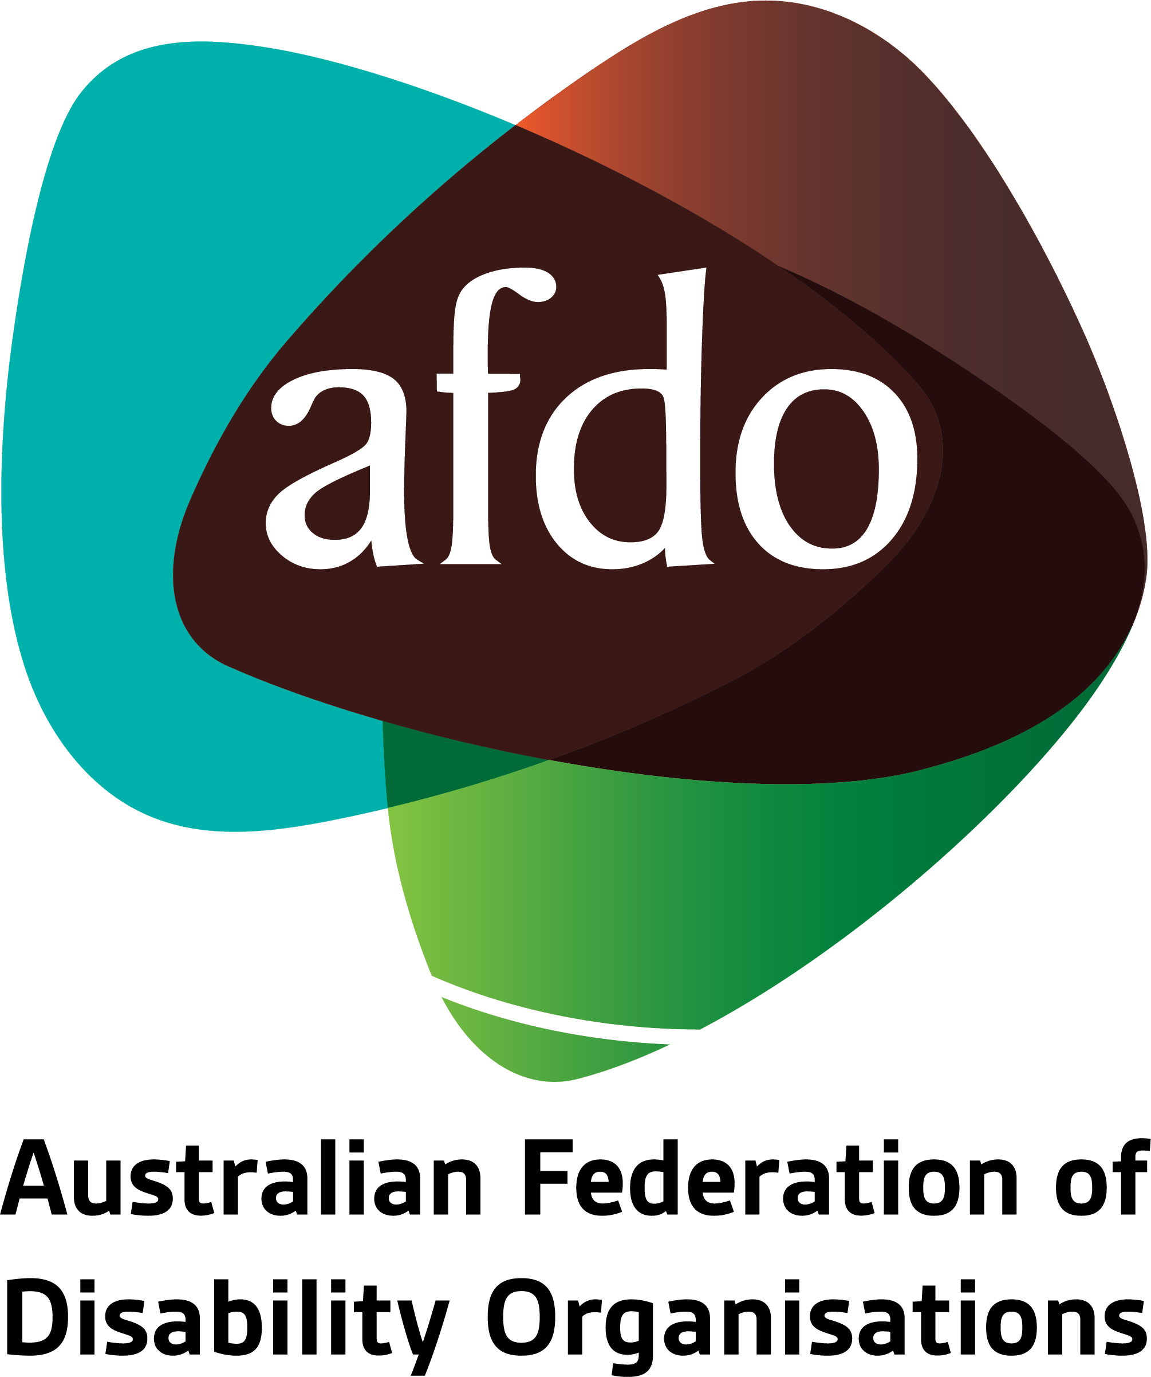

National Disability Strategy Position Paper
- Response

November 2020

Table of Contents

About AFDO 3
Our members 4
Introduction 5
Recommendations 6
Question 1 Response: 8
Question 2 Response: 9
Question 3 Response: 11
Question 4 Response; 12
Question 5 Response; 15
Question 6 Response; 16
Question 7 Response; 18
Question 8 Response; 19
Further information 21

About AFDO
Since 2003, the Australian Federation of Disability Organisations (AFDO), a Disabled Peoples Organisation (DPO) and Disability Representative Organisation (DRO), has been the recognised national peak organisation in the disability sector, along with its disability-specific members, representing people with disability. AFDO’s mission is to champion the rights of people with disability in Australia and support them to participate fully in Australian life.
Our member organisations represent disability-specific communities with a total reach of over 3.8 million Australians.
AFDO continues to provide a strong, trusted, independent voice for the disability sector on national policy, inquiries, submissions, systemic advocacy and advisory on government initiatives with the Federal and State/Territory governments.
We work to develop a community where people with disability can participate in all aspects of social, economic, political and cultural life. This includes genuine participation in mainstream community life, the development of respectful and valued relationships, social and economic participation, and the opportunity to contribute as valued citizens.
Our vision
That all people with disabilities must be involved equally in all aspects of social, economic, political and cultural life.
Our mission
Using the strength of our membership-based organisations to harness the collective power of uniting people with disability to change society into a community where everyone is equal.
Our strategic objectives
To represent the united voice of our members and people with disability in national initiatives and policy debate.
To enhance the profile, respect and reputation for AFDO through our members.
To build the capacity and sustainability of AFDO and our members.
To foster strong collaboration and engagement between our members and stakeholders.
To enhance AFDO's connection and influence in international disability initiatives, particularly in the Asia Pacific region, through policy, advocacy and engagement.

Our members
Full members:
- Autism Aspergers Advocacy Australia
- Blind Citizens Australia
- Brain Injury Australia
- Deaf Australia
- Deafblind Australia
- Deafness Forum of Australia
- Down Syndrome Australia
- Disability Advocacy Network Australia
- Disability Justice Australia
- Disability Resources Centre
- Enhanced Lifestyles
- National Mental Health Consumer and Carer Forum (NMHCCF)
- People with Disability WA
- People with Disabilities ACT
- Polio Australia
- Physical Disability Australia
- Women with Disabilities Victoria
- Women with Disabilities ACT

Associate members:
- AED Legal Centre
- All Means All
- Aspergers Victoria
- Disability Advocacy and Complaints Service of South Australia (DACSSA)
- Disability Law Queendland
- Leadership Plus
- National Organisation for Fetal Alcohol Spectrum Disorder (NOFASD)
- YDAS – Youth Disability Advocacy Service
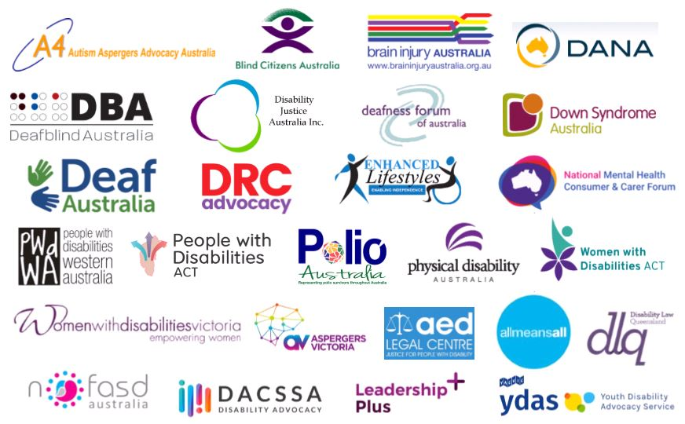

Introduction
AFDO is pleased to provide our response to the National Disability Strategy Position Paper, which was released earlier this year for public comment.
We have participated in consultations, as well as undertaken a collaborative advisory and guidance role in supporting the Department of Social Services with this review and informing for the next iteration of the NDS.
Our response was undertaken with engagement and input by AFDO member organisations.

Recommendations
AFDO proposes the following recommendations for the National Disability Strategy which outlined in more detail in our response;
- Undertaken as a full co-design process involving people with disability, which AFDO notes is still absent from the development process

- Change a word in the Vision Statement from ‘enables’ to ‘ensures’ in keeping a focus on achieving outcomes for people with disability as necessary and required

- Articulate its support and foundation as being intrinsically linked in promoting, the Social Model of Disability

- Acknowledge and reflect the rights committed to by Australia under the United Nations Convention on the Rights of Persons with Disabilities.

- Acknowledge the Uluru Statement of the Heart to ensure greater inclusion and recognition of the issues faced by First People, Aboriginal and Torres Strait Islanders.

- Must link the National Disability Strategy with other essential National Strategy’s significantly, the National Mental Health Strategy, Closing the Gap and the various standards under the Disability Discrimination Act, including the transport standards and accessibility standards

- Needs to demonstrate a significant focus on identifying and ensuring concrete, measurable and reportable outcomes for people with disability.

- Must have a bi-annual reporting process involving all levels of government (Federal, State, Territory and local) through the mechanisms of the state and territory action plans – link the National Disability Strategy to the State and Territory Disability Actions Plans and Local Government Action Plans; with measurable and reportable outcomes.

- Must implement the recommendations from the Productivity Commission regarding the incorporation of the National Disability Agreement into the National Disability Strategy

- Must set out the aspirational objective for disability policy in Australia — people with disability and their carers have an enhanced quality of life and participate as valued members of the community.

- Must provide an overarching agreement for disability policy, to clarify roles and responsibilities, to promote cooperation and to enhance accountability.

- Should articulate the roles and responsibilities of all governments in progressing; outcomes sought for people with disability; and a nationally consistent performance reporting framework for tracking progress against those outcomes.

- Must direct that information for people with disability needs to be in accessible formats, multiple languages and its presence and uses needs to be communicated directly to communities in language and modalities that are culturally appropriate and accessible to all.

- Must include a commitment to funding by all levels of government to enact the Strategy and achieve the identified concrete outcomes.

Question 1 Response:
During the first stage of consultations, we heard that the vision and the six outcome areas under the current Strategy are still the right ones. Do you have any comments on the vision and outcome areas being proposed for the new Strategy?
AFDO believes that the new National Disability Strategy should have a focus on concrete outcomes and frame the Strategy using the social model of disability articulated in the Convention on the Rights of People with Disability
“An inclusive Australian society that enables people with disability to fulfil their potential as equal members of the community.”
AFDO member organisation, Disability Justice Australia, hold the view that the vision statement needs to be amended to include;
An inclusive Australian society that ensures people with disability fulfil their potential as equal members of the community.
Changing the word ‘enables’ to ‘ensures’ is in keeping with AFDO’s view that a focus on outcomes for people with disability is necessary and required.
Using the word ensures, places responsibility on all levels of government, the community and people with disability. It implies the need for partnership between government, the community, people with disability and is one of the foundation principles that can drive concrete outcomes for people with disability.

Question 2 Response:
What do you think about the guiding principles proposed here?
Broadly speaking, AFDO supports the current Guiding Principles but seeks the following additions:
Acknowledge the Uluru Statement of the Heart
Acknowledge First Nations people with disability in the Principles of the National Disability Strategy. Acknowledging the Uluru Statement of the Heart should be at the beginning of the Principles for the National Disability Strategy
Include Rights and Inclusion
People with disability have suffered significant historical and ongoing breaches of their rights in all aspect of their lived experience.
It is AFDO’s view that there is an urgent need to strengthen the rights protection model for people with disability. AFDO acknowledges that this is not only the responsibility of the National Disability Strategy but also the Disability Discrimination Act and the Australian Human Rights Commission Act. In saying this, however, the National Disability Strategy needs to both set the expectations for benchmarking rights protections for other national mechanisms and legislation.
Disability Support Provided by All Levels of Government
State the need for all level of government in Australia to fund and provide disability support.
Policies and Practices
To ensure concrete outcomes, AFDO recommends adding Access to Advocacy, Co-Design, Cultural Safety and Trauma-Informed Practice to Policies and Principles:
Access to Advocacy – due to individual and structural barriers that exist in the Australian community people with disability will require continuing access to develop self-advocacy skills, as well as strongly supported individual and systemic advocacy agencies to overcome all barriers.
Co-design – the involvement of people with disability in all aspects of the planning, implementation and evaluations of legislation, policy and practice that impact on their daily lived experience
Cultural Safety – the acknowledgement of the traumatic impact of colonisation on First Nations people with disability the importance of First Nations people with disability speaking in the language of their people and having the continuing opportunity to practice their culture
Trauma-Informed Practice – acknowledging that people with disability have experienced high rates of trauma through violence abuse and neglect
Populations
AFDO supports the view of Down Syndrome Australia to recognise people with intellectual disability as a priority population under guiding principle four. However, in AFDO’s perspective, this should be framed by using the term cognitive disability, which can then take into account:
- Intellectual disability
- Acquired brain injury
- Foetal alcohol syndrome disorder
- Dementia

Question 3 Response:
What is your view on the proposal for the new Strategy to have a stronger emphasis on improving community attitudes across all outcome areas?
Improving community attitudes towards valuing people with disability is the first step in changing systems and the systems that frame the lived experience of people with disability.
The frameworks supporting the system's operation across all outcome areas need to change for people with disability to be able to exercise their citizenship rights and fully participate in the life of the community.
For example; how is it that the only four groups of people who can be indefinitely detained in Australia are terrorists, paedophiles, asylum seekers and people with cognitive/psychosocial disability?
Does the wider Australian community really believe that people with cognitive or psychosocial disability are as dangerous as terrorists and paedophiles and require indefinite detention?
There needs change with the States and Territories legislation, policies and practices to the indefinite detention of people with disability. These should reflect instead that they are valued members of the community and deserve a better response to the assessment of their disability, rather than it leading to a finding of unfitness to plead and permanent incarceration.
Aspirational goals and motherhood statements about the rights of people with disability to participate in the life of the community is no longer enough.
AFDO maintains throughout this submission that there is a need to change community attitudes towards truly valuing people with disability as part of a community; such a change requires the political will to commit to this and the necessary funding to effect changes across the community.
But any campaigns or programs that seek to change community attitudes must have the following components:
- Be co-designed by people with disability
- Employ people with disability to lead and implement
- Have measurable goals and outcomes
- Be independently evaluated
- Have clearly identified outcome reporting mechanisms

Question 4 Response;
How do you think that clearly outlining what each government is responsible for could make it easier for people with disability to access the supports and services they need?
It is all well and good to outline what each government is responsible for; however, concrete outcomes for people with disability require a commitment and agreement on which the progress towards their achievement can be measured, evaluated and independently reported
“Improving the well-being of people with disability and carers across the nation requires a collaborative response from all levels of government, extending well beyond the NDIS to many other service systems, such as housing, transport, health, justice, and education.”
Many critical issues have emerged throughout the current National Disability Strategy that have impacted upon the progress towards concrete positive outcomes for people with disability, including:
- In Australia there is no Federal Bill Of Rights that can uphold the rights of citizens including people with disability
- Whilst the Sovereign Nation of Australia is signatory to the Convention on the Rights of People with Disability, the States and Territories are not signatory and thus believe they are not held to the obligations articulated under the CRPD
- The ‘toothless tiger’ of federal, state and territory human rights legislation
- The responsibility for planning and funding for 465,000 people with disability lays now with the National Disability Insurance Scheme (NDIS) whilst responsibility for the planning and funding of many of the services that the people with disability on the NDIS use lay with the States and Territories
- There are at least 4.4 million people with disability living with disability in Australia, with ultimately only around 10% (465 thousand) people with disability having any formalised and funded disability supports under the NDIS.
The fact of these circumstances for people with disability and their expectation of concrete outcomes requires the strict, unequivocal, decisive recitation of Federal, State, Territory and Local Government responsibility for the delivery of these outcomes for people with disability
For example; AFDO worked with the Commonwealth Representative for the Justice Interface Principles Working Group responsible for operationalising the Disability Justice Interface Principles, between the NDIA and the States and Territories to include the Voices of People with Disability in that work. After eighteen months of partnership between AFDO and DSS there was zero progress made on how to include the voices of people with disability in the disability justice conversation going on between the NDIA, DSS and the State and the Territories. This played out in the perverse context and knowledge of all concerned that people with disability were being kept in indefinite detention because no suitable accommodation and support could located or implemented across any jurisdictions that would enable them to be released.
In order to achieve concrete outcomes for people with disability there needs to be a strengthening of an effective and accessible complaints pathway for participants and tangible consequences when service provision and policy do not align with responsibilities outlined in relevant legislation
Case Study:
In early 2020 the joint guardians and NDIS funded service providers of a young Indigenous man, detained in a forensic program in the Northern Territory, became involved in a conflict with the Forensic Disability Unit, in which he is held, regarding the elimination of chemical restraint.
Up until that point, there had been relatively good cooperation regarding the two-year program to eliminate the chemical restraint for this young man as per the National Framework for Reducing and Eliminating the Use of Restrictive Practices in the Disability Service Sector.
The program was coordinated by the young man’s GP with clinical supervision provided by a psychiatrist with experience in intellectual disability.
The conflict began over a difference of opinion about how to manage the emerging behaviours associated with the elimination of chemical restraint. A particular issue was the frequent and intense headbanging behaviour that the young man engaged in which distressed everybody and led to his hospitalisation.
Other differences of opinion lay in the lack of a cultural safety framework, the implementation of less restrictive alternatives and the involvement of practitioners from outside of the Forensic Disability Unit. This led to tense and difficult interactions and communication between the guardians and the FDU.
The conflict sharpened considerably after the third hospitalisation as the FDU took the unilateral decision to involve a forensic psychiatrist who immediately recommended the reinstatement of chemical restraint. THE FDU and Forensic Psychiatrist undertook this without the consent and involvement of the guardians or family.
The FDU then cut off all communication with the guardians and the family save for a generic email address with no person identified as a FDU contact point.

Under the direction of the CEO of the Department of Health, the FDU then assumed all decision making authority for the young man and began making decisions on his behalf including developing Behaviour Support Plans and Transition Plans for the young man.
The FDU also refused to allow the young man to visit family on country. At this time there were no speakers of the young man’s Indigenous language employed at the FDU. The FDU then cancelled all joint case conferences and directed staff not to speak with the guardians.
In Part 7 Division 1 Section 69, the Northern Territory Government established a Review Panel for Restrictive Practices for people with disability detained under the Disability Services Act 2012.
This Review Panel has never been established by the Northern Territory Government. Should the Review Panel for Restrictive Practices have been established a conflict such as this could have been referred to the Review Panel for adjudication
Contact was made with the Quality and Safeguards Commission who also stated that because this young man was in a Territory funded forensic disability service and despite being an NDIS participant, he was not eligible to make a complaint.
The conflict remains unresolved.

Any failure to address the “life cycle” of information in the ways outlined above, must be factored into the reporting and assessment of the relevant government agency or program in question.

Question 5 Response;
How do you think the Strategy should represent the role that the non-government sector plays in improving outcomes for people with disability? (Examples of the non-government sector include big, medium and small businesses, community organisations, employees of these businesses, private research, investment organisations and individuals.)
The National Disability Strategy needs to articulate that non-government sector organisations are operating in a landscape governed by federal, state and territory policy and legislation and their obligations in light of this, as recipients of concomitant funding, should be explicitly articulated.
As an example; for the Deafblind community, the strategy should clearly outline organisations’ obligations as the instruments of this strategy and should make clear the connection between providing meaningful language access and the effective realisation of those obligations.
In addition, a robust complaints process/infrastructure is required, that can be accessed in a multi-lingual/multi-format manner directed by an individual making a complaint as necessary along with repercussions for failing to meet those obligations, such as removal of registration.

Question 6 Response;
What kind of information on the Strategy’s progress should governments make available to the public and how often should this information be made available?
AFDO is recommending bi-annual process for reporting between the Commonwealth and the States and the Territories / Local Government concerning progress on achieving the outcomes of the NDS (this would provide for five reports over the life of the Strategy).
- Year One Reporting through State and Territory Disability Action Plans by Local Government and State, and Territory Action Plans to the Commonwealth
- Year Two Reporting by the Federal Government to the Parliament inclusive of the information from Year One Reporting
AFDO recommends the following principles should guide reporting:
- One Minister and One Department responsible for the Measuring and Reporting Cycle
- Bi-Annual Reporting to be independently reviewed by the Australian National Audit Office every five years and be publicly available
- Measuring and Reporting be funded state and territory and federal governments via a COAG agreement
- Include the public sector and private sector measuring and reporting
- Enlist the services, expertise and skills and knowledge of the ABS and the measurable and reporting are legislatively defined and measurable
- Demonstrate the connection between activity, the supports necessary to engage in that activity, and the progress made towards an individual’s broad spectrum/quality of life goals as a result of that activity
- Take into account market conditions, e.g. many deafblind individuals may not receive the amount of interpreting funded in their plan not because the figure was overestimated, but because there simply are not enough interpreters nationally to service current demand. In all ways possible, the report should seek to mitigate confusion regarding correlation and causation.
Outcome Areas such as employment, need to have clearly defined deliverables that could include:
- The number of people with disability employed over each year of the strategy in full time/part time/casual work
- Numbers of people with disability who participate in training for employment
- Number of hours worked by people with disability
- Measures undertaken to dismantle barriers to employment
How should the Information Be Made Available?
- In formats that are accessible for every person with disability
- How you find out where the information is should also be fully accessible
- Federal, State, Territory and Local Governments should publish a statement of compatibility framed with the relevant articles on people with disability
- Information published every two Years in Line with the Reporting Cycle
- Set up a National Reference Group with state and territory reps and national reps to advise governments on accessibility in regards to the reporting cycle
The Council of Australian Governments (COAG) Australian Data and Digital Council agreed to establish a National Disability Data Asset (NDDA), which, once developed, will help inform service choices by people with disability and their carers.
The NDDA will bring together, for the first time, de-identified Commonwealth and services data, National Disability Insurance Scheme data, and service system data from states and territories. The integrated and shared data will provide a better understanding of how people with disability are supported through services, payments and programs across multiple service systems.
The National Disability Data Asset could serve as the basis for the Bi-Annual Reporting Process and could be coordinated by the Australian Bureau of Statistics.

Question 7 Response;
What do you think of the proposal to have Targeted Action Plans that focus on making improvements in specific areas within a defined period of time (for example within one, two or three years)?
AFDO and its Member Organisations support the inclusion of Targeted Actions Plans in the new National Disability Strategy believing that such a mechanism could become a critical part of the infrastructure for understanding and reporting on the measuring of progress towards the concrete outcomes.
Targeted Actions Plans will need robust levels of funding and transparent and accountable methods for reporting.
They can also have the capacity to respond to emerging issues affecting particular people with disability over the life of the National Disability Strategy or act as a signal of concern when particular people with disability are involved in ways that require a targeted response.
They can be pointed towards people with disability that have small population numbers but maybe experiencing significant barriers and discrimination, for example, deaf blind people needing access to interpreters to participate in community-based activities
Targeted Action Plans could act as a key mechanism for building specific progress towards concrete outcomes addressing violence abuse and neglect in each of the Outcome Area
For example, in the Outcome Area of Rights Protection Justice and Legislation Targeted Actions Plans could:
- Understand how many people with cognitive disability are indefinitely detained under orders and jails in forensic facilities
- Identify how many people with cognitive disability are indefinitely detained under forensic orders that are First Nations people
- Identify the models of specialist community-based support for people with cognitive disability under forensic orders
- Set a target for dismantling indefinite detention in a particular jurisdiction

Question 8 Response;
How could the proposed Engagement Plan ensure people with disability, and the disability community, are involved in the delivery and monitoring of the next Strategy?
A key criticism of the current National Disability Strategy relates to the paucity of mechanisms by which people with disability can own and engage with the Outcome Areas.
AFDO fully supports a well-funded and measureable Engagement Plan with concrete outcomes for all people with disability.
In the new National Disability Strategy, engagement plans could operate at the Federal, State, Territory and Local Government level by a Reference Groups whose membership is constituted by people with disability and comprised of people with disability.
People with Disability on such Reference Groups, at all levels of government, could act as Strategy Auditors whose role is to monitor and report on progress towards achieving concrete outcomes from a lived experience perspective.
Community Technical Experts, by which people with disability are employed as auditors under the Quality and Safeguards Commission Legislation, could have a pivotal role to play in providing a lived experience perspective thus parachuting people with disability into the heart of the new National Disability Strategy.
Community Technical experts are identified in the National Disability Insurance Scheme (Approved Quality Auditors Scheme) Guidelines 2018 Section 30 – 33 with Section 33 being key. However, it is the note attached to Section 33 that identifies Community Technical Experts as people with disability and lived experience who have auditing skills;
“33. Consumer Technical Experts
(1) Consumer technical experts will initially only be required to form part of the audit team when this is required by the Commissioner in relation to the particular NDIS provider (including when specified as a condition of registration).
(2) A consumer technical expert shall:
(a) possess demonstrated knowledge and skills related to and recent experience of the supports and services delivered under the registration class(es)/groups being audited;
(b) be competent to reach an informed opinion on the appropriateness of the services being offered within the service being audited; and
(c) be able to identify trends in relation to supports provided.

Note: A consumer technical expert is a person with disability who has the training, experience, or skills to be involved in the audit team (see definition in section 4). A person with disability may be included in an audit team, for example, where they have a disability relevant to the supports and services under the registration classes or groups subject to the audit.”

People with disability of such Reference Groups could be provided with the relevant training and accessibility and inclusion support to monitor and report on progress towards concrete outcomes in each of the Outcome Areas building the capacity of people with disability to participate and own the new National Disability Strategy.

Further information
Ross Joyce
Chief Executive Officer
Australian Federation of Disability Organisations (AFDO)
E: ceo@afdo.org.au
M: 0402 842 040

Patrick McGee
National Manager – Policy, Advocacy & Research
Australian Federation of Disability Organisations (AFDO)
E: Patrick.McGee@afdo.org.au
M: 0423 301 344

Department of Social Services. “National Disability Strategy – Position Paper” July 2020
Productivity Commission. “Review of the National Disability Agreement” January 2019

