Slide 1
Strengthening links between research, data and advocacy to transform lives
Presentation to the Australian Federation of Disability Organisations Annual General Meeting
Professor Bruce Bonyhady AM
Executive Chair and Director, Melbourne Disability Institute
19 October, 2020

Slide 2

Overview
The big forces shaping disability policy and practice and so the lives of people with disability in Australia for the next decade will be:
- National Disability Insurance Scheme and Agency
- National Quality and Safeguards Commission
- National Disability Strategy
- National Disability Data Asset
- National Disability Research Partnership
- Disability Royal Commission
Now, data, evidence and research has the potential to make advocacy much more effective and to transform the lives of people with disability, their families and carers. This will require new skills, new thinking and new collaborations and partnerships built on a shared vision and purpose. At MDI we are working to be a key contributor to this new world.

Slide 3

NDIS
Building the best whole of population and longitudinal disability data base in the world. Includes data on
- Participants based on functional impairments not just medical diagnosis
- Goals and, hence, aspirations
- Families and sustainability of informal supports
- Funding for core supports, capacity building and assistive technology and actual expenditures
- Disability market, including new and innovative providers, tele-disability and metropolitan, regional, rural and remote supplies (‘market ‘thickness’)
  - Outcomes across 8 key domains (Choice and control; Independent living; Relationships; Health and well-being; Home; Lifelong learning; Work; Social, community and civic participation) plus outcomes for families and carers
This data holds the key to optimising the NDIS so that it delivers on its promise

Slide 4

NDIS Quality & Safeguards Commission
An effective personalised quality and safeguards system needs:
- Developmental safeguards
- Preventative safeguards
- Corrective safeguards
Safeguard systems also need effective individual and systemic advocacy to protect individuals and meet Australia’s obligations under the UNCPRD
The regulator must have sufficient staff and skills along with a deep commitment to analysing data (incidence reports, reports of suspected abuse, etc) and then use the evidence to target interventions. The regulator must join the dots, because abuse and neglect is often hidden until it is too late. The best regulator pre-NDIS was the NSW Ombudsman who used data highly effectively
The NQSC must be prepared to use its own-motion powers relying on its analysis and evidence, as well as responding to reports

Slide 5

National Disability Strategy
Governments are currently consulting on the second National Disability Strategy (NDS), from 2020-2030. The six nominated key areas are:
- Inclusive and accessible communities
- Rights protection, justice and legislation
- Economic security
- Personal and community support
- Learning and skills
- Health and well-being
The first NDS had inspiring Goals but there were no clear outcomes, accountability framework or responsibilities. Data and research will be critical to the second NDS delivering and Australia in which people with disability are full citizens

Slide 6

The National Disability Data Asset is building a comprehensive view
The NDDA aims to include data for all people with disability and all government services and related outcomes.
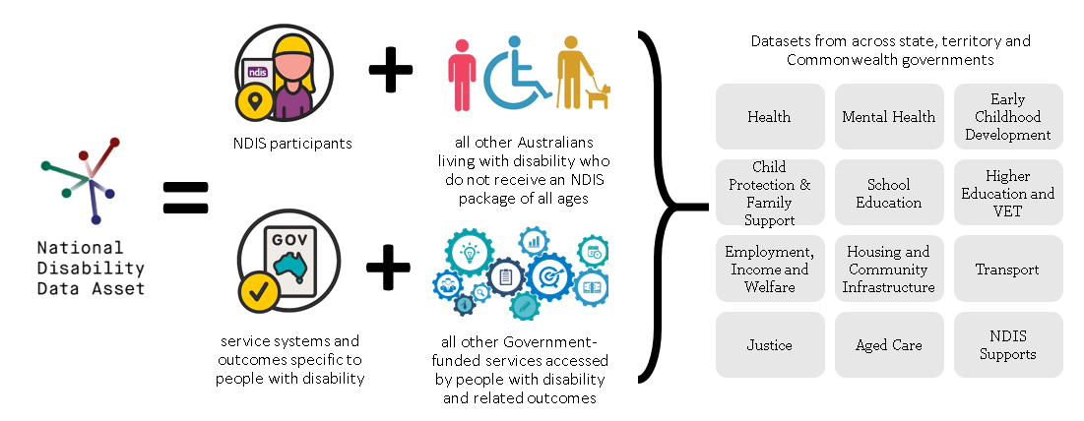

Slide 7

National Disability Data Asset – Pilot Phase (to end 2021)
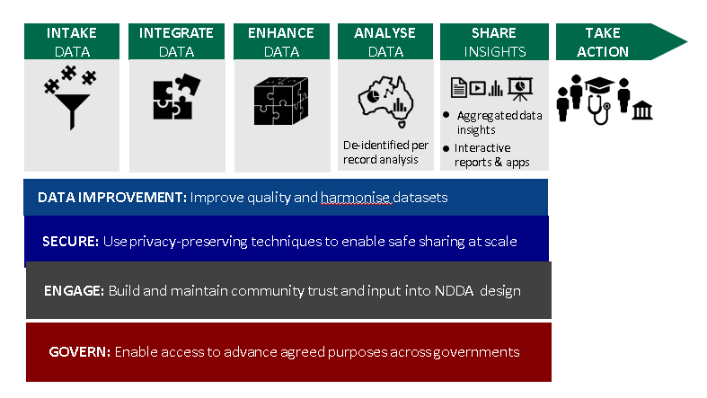

Slide 8

National Disability Research Partnership (NDRP)
The NDRP aims to create a collaborative, translational research program to conduct cutting-edge research that will improve policies and practices, ultimately enabling people with disability across Australia to participate fully in society
Initial funding from the Australian Government for two years until mid-2022, through a grant to the Melbourne Disability Institute (MDI), with the following objectives:
- Produce a Research Agenda building on existing foundations that focuses on research for evidence-informed policy and practice
- Develop a future governance model for the NDRP
- Map relevant research capability in Australia and proposing strategies and activities for building research capacity and partnerships
- Produce a practical guide to disability-inclusive research
- Undertake two demonstration projects, and
- Identify and develop international research partnerships and establish key international collaborations.

Slide 9

NDRP Research Agenda
The Audit of Disability Research in 2017 identified eight domains for research:
- Education
- Economic Participation
- Social Relationships
- Health and Well-being
- Community and Civic Participation
- Transport and Communication
- Sector Development and Sustainability
- Safety and Security
- Housing and the Built Environment
These will be updated by a highly inclusive consortium to create a 10-year Research Agenda.

Slide 10

Building the evidence for transformation – MDI
Vision: To transform the social and economic wellbeing and health of people with disability through high-quality research, teaching and training, and knowledge translation.
Mission: In partnership with key stakeholders, we will catalyse interdisciplinary research and teaching that addresses complex, systemic, strategic and cultural problems facing people with disability, their families and carers. The knowledge produced through our research will be translated in policy and practice through a process of continuous engagement and innovation.

Slide 11

MDI Priorities
Data – Established the Democratising Disability Data Coalition and now working with the Australian Digital Council and the new National Disability Data Asset
National Disability Research Partnership – Designing for Disability = Designing for All - service innovation, technology innovation, market design and policy development and improvement ($2.5 million over two years)
Plan utilisation – strategic research advice to the Victorian and Commonwealth Governments using quantitative and qualitative analysis to solve a policy conundrum
Co-design and building the capacity of people with disability as co-researchers
Partnership with the Brotherhood of St Lawrence and Baptcare focusing on enhancing Local Area Coordination, improving housing options (non-SDA) and increasing employment
Research Hubs: Social Work, Architecture & Universal Design, Children & Youth, Economics & Data, International (Nossal Institute for Global Health), Social & Political Science, Creative Arts
Global leadership:
- India: Modelling an NDIS; building family and community capacity
- Canada: working with Every Canadian Counts
- Cambodia: strengthening social protection for people with disabilities

Slide 12

MDI Community Based Research Program
MDI’s Community Based Research Scheme supports the evaluation and research of innovative ideas in the broader disability community by linking community organisations to researchers or students who provide rich evaluations or data that organisations can share with the wider community, use for applications to scale their project or demonstrate the unique and valuable projects that they have developed (see https://disability.unimelb.edu.au/home/current/community-based-research-scheme )
Last week we invited five community organisations that have recently completed the program to showcase their findings and we have also announced the next funding round for our Community Based Research Program: https://disability.unimelb.edu.au/news-and-events/community-based-research-scheme-now-open

Slide 13

Some concluding remarks
- Australia has the potential to have one of the best disability system in the world, which embraces disability rights, and for Australia to be globally recognised as a leader in disability reform
- Using data and evidence smartly and systematically is the key to world-best practices and policies
- People with disability are central to research – helping set the questions and engaging in research including as researchers or co-researchers
- At the Melbourne Disability Institute we are deeply committed to building the evidence for real transformation in the lives of people with disability, their families and carers and achieving this through long term partnerships based on trust, mutual respect and co-design
Reform never ends. Nor the fight for equity, justice and equal opportunity. Our aim, as advocates, is to create public benefits so that the world is a better place. There has never been a better time for deeper and long-term reform or to make advocacy even more effective. For that we need better data, more research and new and stronger partnerships to transform lives.

End of PowerPoint presentation.

