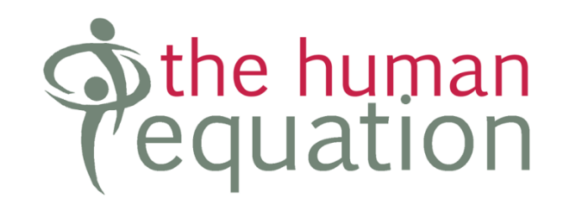

Candidate Information

Engagement Coordinator – Disability Royal Commission

Australian Federation of Disability Organisations

August 2021

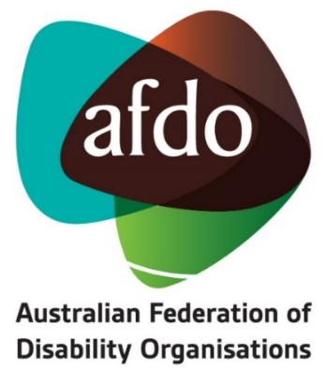

The Opportunity

- Support people with disability tell their stories
- Open only to people living with disability
- Part-time remote working

The Australian Federation of Disability Organisations (AFDO) is a Disabled People’s Organisation and a national cross-disability peak, championing the rights of people with disability and enabling them to participate fully in Australian life.

AFDO offers a supportive and collaborative work environment, with a team passionate about the rights of people living with disability. Benefits include options for workplace flexibility, remote working and immediate access to tax-reducing salary packaging.

As Engagement Coordinator, you will be AFDO’s go-to person for all Disability Royal Commission matters. To do this, you will:
- Take the lead on supporting AFDO and its member organisations in their interactions with and responses to the Commission
- Encourage and support people with disability to tell their stories at the Commission and facilitate their journey to do this
- Keep abreast with what is happening with the Commission and manage communications to keep stakeholders informed
- Coordinate the day-to-day functioning of AFDO’s DRC Strategy Group and ADFO’s reporting requirements.

This is a role with plenty of variety, autonomy and stakeholder engagement so to thrive in this role, you will:
- Demonstrate commitment to social justice for people living with disability and take a keen interest in the workings, objectives and outcomes of the Commission
- Have exceptional interpersonal skills with the ability to engage with a diverse range of people
- Well-developed written communication skills
- Bring an organised, self-directed approach to your work and ability to work in a remote environment
- Have personal lived experience of disability

This is a part time role (22.5 hours per week Tuesday to Friday) with an offer of an initial 12-month contract and potential for renewal.

Interested in applying?

Please submit a two-page cover letter responding to the selection criteria in this document with your resume, to consultant@thehumanequation.com.au using the subject line: Engagement Coordinator - DRC.

Only candidates invited for interview will be contacted.

Snapshot of AFDO

AFDO’s vision (its why): all people with disability are involved equally in all aspects of social, economic, political and cultural life.

AFDO’s mission is to champion the rights of people with disability in Australia and help them participate fully in Australian life. AFDO uses the strength of its membership-based organisations to harness the collective power of uniting people with disability to change society into a community where everyone is equal.

AFDO exists to:

- Represent people with disability in Australia and at the international level, and
- Help people with disability participate in all parts of social, economic, political and cultural life.

To do this, AFDO:

- Supports disability organisations and people with disability.
- Undertakes research on disability issues.
- Advises government, disability organisations and other organisations about their disability policies.
- Lobbies governments and other institutions on disability issues.
- Informs and educates the general community about disability.

AFDO’s Strategic Objectives

- Represent the united voice of its members and people with disability in national initiatives and policy debate.
- Enhance the profile, respect and reputation of AFDO through its members.
- Build the capacity and sustainability of AFDO and its members.
- Foster strong collaboration and engagement between members and stakeholders.
- Enhance the connection and influence of AFDO in international disability initiatives by policy, advocacy and engagement, focussed on the Asia Pacific region.

About AFDO

AFDO is the national voice of people with disability and family organisations in Australia. The organisation works to develop a community where people with disability can participate in all aspects of social, economic, political and cultural life. This includes genuine participation in mainstream community life, the development of respectful and valued relationships, social and economic participation, and the opportunity to contribute as valued citizens.

AFDO is a Disabled Peoples Organisation (DPO). A DPO is an organisation where the majority of the members as well as the governing body (Board of Directors) are persons with disability.

AFDO and its ten national members are funded by the Australian Government under the Disability Representative Organisations (DRO) program to provide systemic advocacy and representation for Australians with disability. Whilst this work is underfunded, AFDO continues to campaign to resolve this inequity in order to deliver outcomes for its members.

AFDO believes its strength is in its members. AFDO is made up of organisations who work together to contribute to the national policy agenda and address issues that impact the lives of people with disability in Australia. AFDO understands that disability-specific organisations play a key role in the provision of information and peer support to people with disability and their families. This organisational role keeps them closely connected to their grass roots communities. Each community has its peak organisation that uses its voice to advocate on issues. AFDO is the forum where these views are collected and coordinated to ensure Government is across issues impacting all people with disability in Australia.

AFDO is proud to be the organisation that has brought together both cross-disability organisations (representing the interests of people with all kinds of disability), and disability-specific organisations/peaks. It brings the understanding that cross-disability groups are only successful when they have access to the specific expertise of disability-specific organisations such Blind Citizens Australia, Brain Injury Australia, Deaf Australia, Down Syndrome Australia and others, as these disability-specific groups are connected to their communities.

For more information, head to: www.afdo.org.au

Current Organisational Design

About the Role

Reporting to: National Manager – Systemic Advocacy, Insight & Research

Direct Reports: Volunteers and consultants as needed

Location: Designated workplace - Melbourne CBD
Remote work available, subject to WHS requirements being met

Employment Status: Initial 12-month contract, part-time
22.5 hours per week – Tuesday to Thursday

Position Summary

AFDO has received funds from the Federal Attorney General's Department to undertake work to support the DRC over its life and ensure the promotion to and engagement of people with disability. AFDO has also received funding for a similar role to be performed by AFDO National Members who are not funded directly for this work.

The Engagement Coordinator – DRC works closely with AFDO’s DRC Strategy Group to ensure the voices of individuals with disability are heard by the DRC. The Engagement Coordinator supports the Group by keeping abreast of DRC challenges and requirements and collaborating on AFDO’s response. The Group is made up of the CEO, Expert DRC Advisor and the National Manager.

The Coordinator liaises with AFDO member organisations to promote the work and hearings of the DRC and support them to undertake submissions and encourage their members to submit statements and evidence.

This role also collects, analyses and reports on data from AFDO member organisations.

Key Responsibilities

- Stakeholder Engagement
- Act as the main point of contact for all DRC matters for ADFO staff and member organisations
- Work with the DRC Strategy Group to develop and implement an engagement plan to identify, encourage and support people with disability to participate in the DRC hearings
- Maintain and develop relevant networks, partnership and contacts of disability-specific and mainstream Community Service agencies working on DRC issues
- Work alongside people with disability to tell their story to the DRC (including written, oral or other style of submissions or private sessions)
- Liaise closely with AFDO member organisations to support them and their members to make DRC submissions
- Draft relevant articles and regular newsletters on the DRC and critical issues for distribution to AFDO member organisations and people with disability
- Organise meetings and other events for ADFO member organisations on DRC matters (including logistics such as venue and meeting supports, AV hire, online access and accessibility for attendees)
- Liaise with the Executive Assistant and Communications Officer to maintain social media and websites with accurate DRC information and media releases
- Assist AFDO DRC management in developing themes, concepts and strategies on the DRC

- DRC Strategy Group Coordination
- Manage the schedule of DRC Strategy Group meetings
- Prepare agendas, organise all logistics and participate in the DRC Strategy Group meetings
- Minute DRC Strategy Group meetings and manage action lists
- Prepare reports on the DRC Strategy Group’s operations as required

- DRC Support & Reporting
- Maintain oversight of the timetable of hearings by the DRC and provide updates or advice to the DRC Strategy Group and AFDO member organisations
- Coordinate AFDO’s response to all DRC issues
- Manage incoming email correspondence and draft responses on behalf of relevant management when required or forward to the relevant person for attention/response
- Draft reports, presentations, letters, and other documents as required
- Monitor issues concerning the DRC and keep AFDO DRC management informed
- Maintain an up to date online centralised electronic filing system for all DRC activity and stakeholder engagement activity
- Maintain and distribute information on the DRC as required
- Monitor and coordinate reporting for AFDO and the AFDO funded members to the funding body
- Advise AFDO DRC management of any funded member organisation which are not reporting or are providing insufficient reporting on their activities

- General Responsibilities
- Supervise the workload and tasks (as required) of any volunteers or consultants utilised for special projects
- Undertake other tasks as directed by management in keeping within the scope of this role

Selection Criteria

- This position is only available for those who identify as a person with disability as allowed under 'special measures' of the Equal Opportunity Act 2010; you need to outline how you meet this requirement
- Five years’ experience in a similar role within or outside of the sector
- Demonstrated commitment to social justice for people living with disability
- Outstanding stakeholder engagement skills with the ability to effectively connect with, communicate with and support a diverse range of people
- Ability to convey complex information to diverse stakeholders, including people with disability
- Excellent written communication with experience drafting reports and other documents
- Ability to manage tasks, set priorities, organise work and achieve objectives within timelines and budget
- Ability to work in a sensitive, complex and demanding environment
- Ability to work both independently and collaboratively within a team
- Demonstrated administrative and project management skills
- Strong computer literacy with experience in managing databases
- Relevant qualifications would be an advantage
- Ability to maintain productivity in a remote working environment
- Suitable remote working facilities (ie, working from home facilities)

How to Apply

Please write a two-page covering letter outlining how you meet the above selection criteria and send it along with your resume to consultant@thehumanequation.com.au
Please use the subject line Engagement Coordinator – DRC.

Only candidates invited for interview will be contacted.

