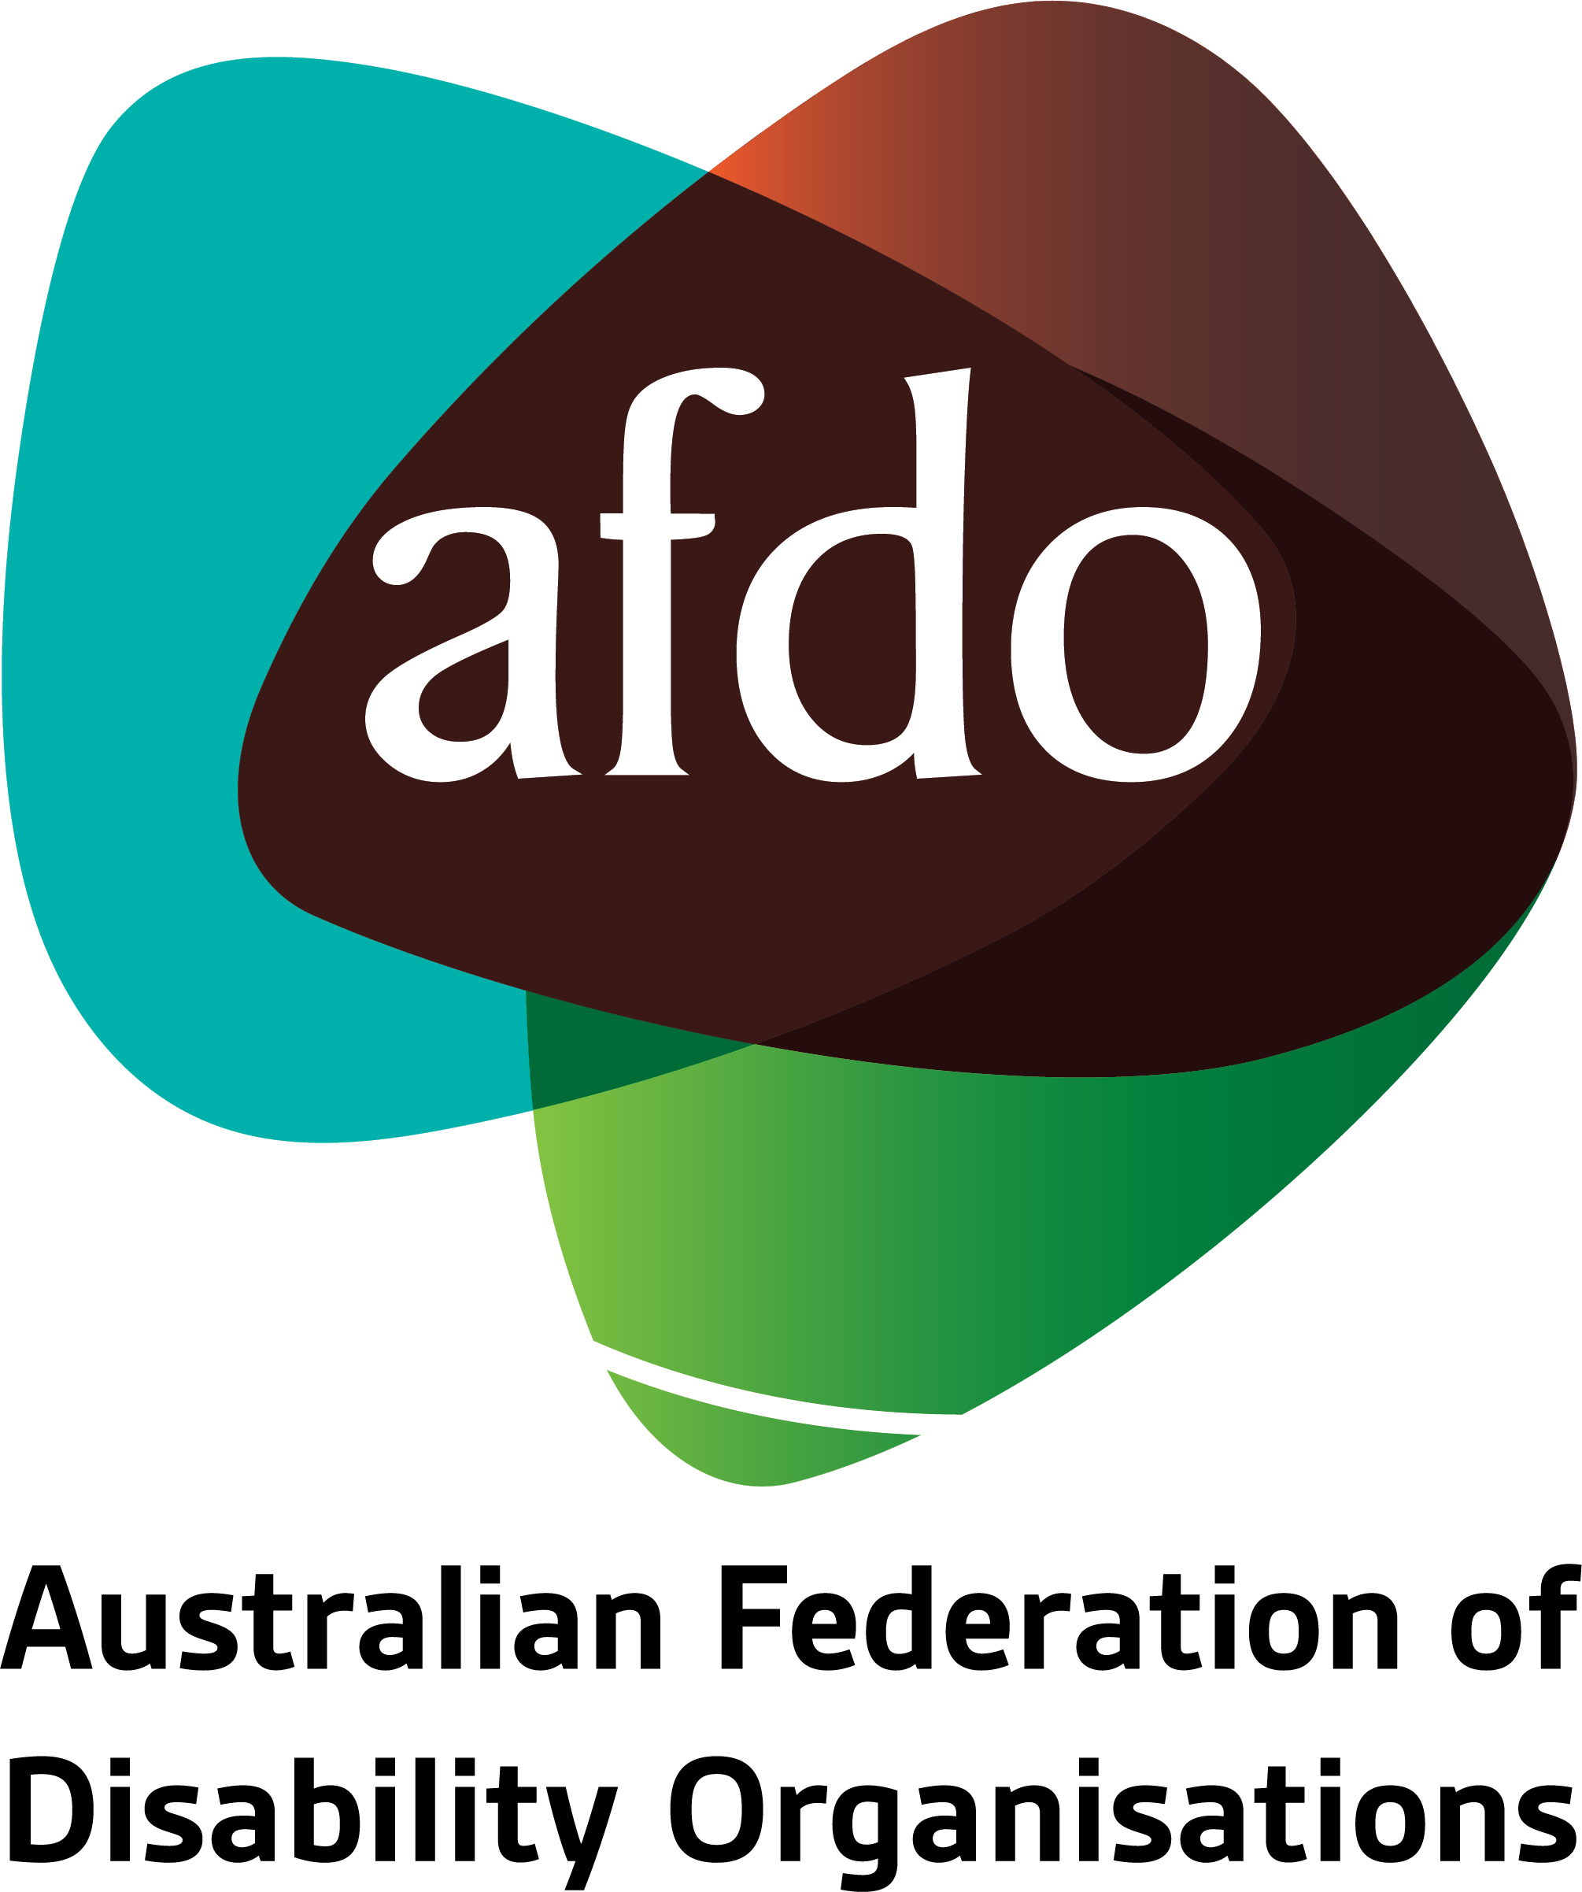

Response to the Proposed NDIS Legislative Amendments
Submission by AFDO
7 October, 2021

Table of Contents

About AFDO 3
Our Members 4
Acknowledgements 5
Endorsements 6
Executive Summary and Recommendations 7
Introduction 9
Section 1: General Comments 10
Concerns Regarding the Consultation Process 10
Highlighting Positive Elements of the Proposed Changes 12
The Tune Review 12
Other General Concerns 13
Section 2: Specific Concerns and Recommendations 15
Plan Variation without Consultation 15
Changes to the 'Becoming a Participant' Rules 15
Changes to Plan Management and Payment of Supports 16
Reasons for Decisions 16
Increase in Discretionary Powers of the CEO 17
Additional Recommendations 17
Conclusion 18
References 19

About AFDO
Since 2003, the Australian Federation of Disability Organisations (AFDO), a Disabled People’s Organisation (DPO) and Disability Representative Organisation (DRO), has been the recognised national peak organisation in the disability sector, along with its disability specific members, representing people with disability. AFDO’s mission is to champion the rights of people with disability in Australia and support them to participate fully in Australian life.

Our member organisations represent disability specific communities with a total reach of over 3.8 million Australians.

AFDO continues to provide a strong, trusted, independent voice for the disability sector on national policy, inquiries, submissions, systemic advocacy and advisory on government initiatives with the Federal and State/Territory governments.

We work to develop a community where people with disability can participate in all aspects of social, economic, political and cultural life. This includes genuine participation in mainstream community life, the development of respectful and valued relationships, social and economic participation, and the opportunity to contribute as valued citizens.

Our vision
That all people with disabilities must be involved equally in all aspects of social, economic, political and cultural life.

Our mission
Using the strength of our membership-based organisations to harness the collective power of uniting people with disability to change society into a community where everyone is equal.

Our strategic objectives
To represent the united voice of our members and people with disability in national initiatives and policy debate.
To enhance the profile, respect and reputation for AFDO through our members.
To build the capacity and sustainability of AFDO and our members.
To foster strong collaboration and engagement between our members and stakeholders.
To enhance AFDO's connection and influence in international disability initiatives, particularly in the Asia Pacific region, through policy, advocacy and engagement.

Our members

Full members:
- Arts Access Australia
- Autism Aspergers Advocacy Australia
- Blind Citizens Australia
- Brain Injury Australia
- Deaf Australia
- Deafblind Australia
- Deafness Forum Australia
- Down Syndrome Australia
- Disability Advocacy Network Australia
- Disability Justice Australia
- Disability Resources Centre
- Enhanced Lifestyles
- National Mental Health Consumer and Carer Forum (NMHCCF)
- People with Disabilities WA
- People with Disabilities ACT
- Polio Australia
- Physical Disability Australia
- Women with Disabilities Victoria
- Women with Disabilities ACT

Associate members:
- AED Legal Centre
- All Means All
- Amaze
- Aspergers Victoria
- Disability Advocacy and Complaints Service of South Australia (DACSSA)
- Disability Law Queensland
- Leadership Plus
- National Organisation for Fetal Alcohol Spectrum Disorder (NOFASD)
- Star Victoria Inc
- TASC National Limited
- Youth Disability Advocacy Service (YDAS)

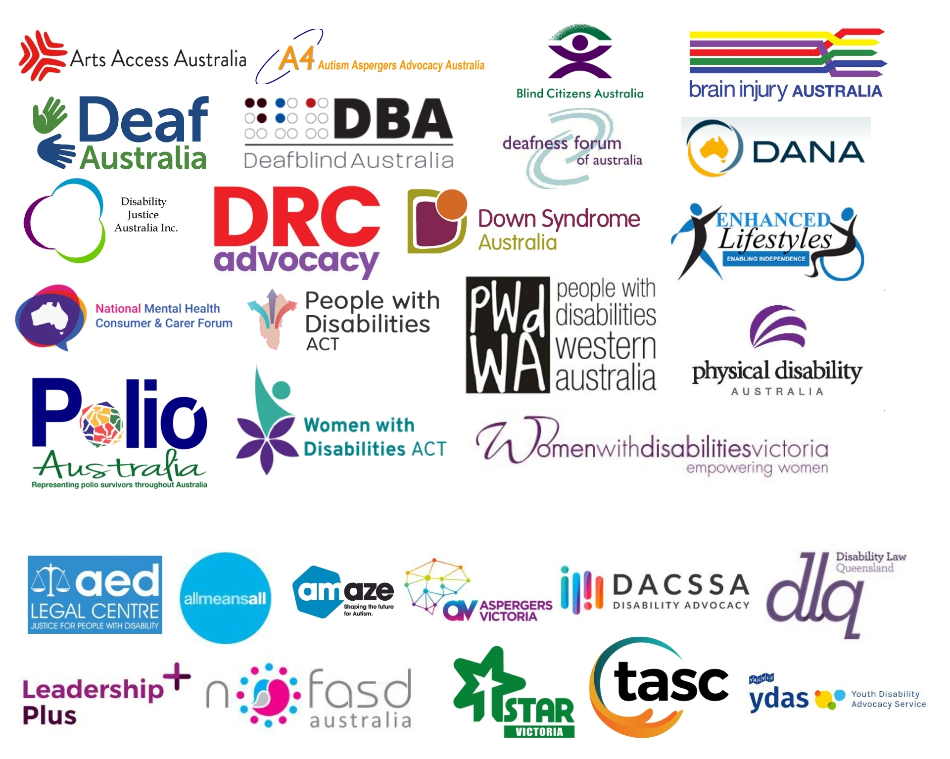

Acknowledgements
Acknowledgement of Country
AFDO as a National Peak acknowledges all Aboriginal and Torres Strait Islander people as the traditional custodians across all the lands, as well as those on which our Member organisations meet. AFDO recognises Aboriginal and Torres Strait Islander peoples’ continuing connection to land, waters, and community, and pay our respects to their Elders past, present, and emerging.
AFDO also acknowledges people with disability, particularly those who have suffered, and continue to suffer, violence, abuse, and exploitation.

Our Thanks...
Mr David Tune AO PSM
AFDO acknowledges the extensive work undertaken by Mr David Tune AO PSM in developing the ‘Review of the National Disability Insurance Scheme Act 2013 – Removing Red Tape and Implementing the NDIS Participant Service Guarantee, 2019’ (referred to as the ‘Tune Review’).
AFDO is particularly appreciative of the candour provided to Mr Tune by a significant range of stakeholders within the disability community, including NDIS participants; their families, friends, and supporters; providers of NDIS services; and disability advocacy bodies.

The wide and honest consultative process is evidenced by the sensitive and considered Report and Recommendations clearly referenced within the Tune Review.

Public Interest Advocacy Centre (PIAC)
AFDO owes a debt of gratitude to PIAC for their outstanding professional, independent, and rapid response to the disability sector of the ‘Proposed Legislative Changes to the National Disability Insurance Scheme’. Without the generosity of PIAC’s expertise in legal frameworks, AFDO would have experienced significant difficulty and delay in meeting the prescribed time constraints for this Submission’s lodgement.

Endorsements
AFDO is aware there is likely to be a wide representation of people with disability and disability organisations who will be providing feedback addressing the ‘Proposed Legislative Changes to the National Disability Insurance Scheme’. This is despite the very tight timeframe allotted to the consultation process.

AFDO wishes to acknowledge the incredible dedication of those who have sacrificed their limited and valued time and resources to this process. It is important to also acknowledge those individuals with disability and the wider disability sector who were prevented, once again due to the short timeframe, from adding ‘their voice’ to this important feedback process. AFDO shares your frustration and anger, and believes this denial of due process contravenes article 29 of the Convention on the Rights of People with Disability (CRPD), to which Australia is a signatory.

AFDO supports the content and recommendations of all other Submissions by our Member organisations relating to the NDIS Act.

In consultation with our Members, this report was co-authored by:
- Mary Henley-Collopy – AFDO Expert Consultant on NDIS
- Tracylee Arestides – AFDO Interim National Manager (Policy, Sustainability, Initiatives & Projects)
- Rebecca Rudd – AFDO Coordinator of Policy and Submissions

Executive Summary and Recommendations
In this Submission on the amendments to the NDIS Act, AFDO has considered the proposed changes in relation to the core values and philosophical underpinnings of the original Scheme; namely, its emphasis on individual choice and control. AFDO believes these ideals remain fundamental to the spirit and intent of the Scheme, and any modifications made must equally reflect them.

The Submission has been organised as follows:
Section 1: General Comments
In this preliminary section a number of general issues are highlighted, beginning with the multiple deficiencies associated with the consultation process. These include:
- Insufficient time.
- Lack of resources.
- Inaccessibility.

Other general comments relating to the amendments and the NDIS Act itself that warrant further discussion are then raised, including:
- The Tune Review.
- Over-reliance on the Rules.
- Positive elements of the proposed amendments.
- Clarification on the changes relating to Psychosocial Disability.
- The importance of inclusive language.
- Terms requiring further clarification or definition.

Section 2: Specific Areas of Concern
In this subsequent section the proposed legislative amendments are examined in greater detail, raising five specific areas of concern. These are as follows:
- Plan Variation without Consultation.
- Changes to the ‘Becoming a Participant’ Rules.
- Changes to Plan Management and Payment of Supports.
- Reasons for Decisions.
- Increase in Discretionary Powers of the CEO.

While AFDO and our Members would have preferred to submit a longer and more comprehensive Submission, this unfortunately was not possible due to significant time and resource constraints. Despite the brevity of this consultation process, AFDO would hope that the Government intends to engage with the disability sector in good faith by taking its well-considered feedback on board.

Recommendations:
- AFDO believes that the existing CEO powers are sufficient and can see no reason why the Agency should be able to vary plans without consultation or consent by the participant. AFDO recommends that this extension of power be omitted from the proposed changes.
- That agreed upon definitions need to be included in the Rules and must be produced in consultation with people with disability and their representative organisations.
- That NDIS, in consultation with people with disability and their representative organisations, re-draft section 45 to provide greater clarity and security to self-managed participants regarding their existing payment methods.
- In order for the Agency to be fully inclusive of and transparent with all participants, that:
  - The need for participants to make a request be removed, and that this be included as an automatic requirement on the part of the Agency to provide reasons for decisions to all participants who are subject to any decision being made about them.
  - A provision be inserted to make this a legislated requirement. Such a provision would ensure that every decision made by an NDIA reviewer must be accompanied by a statement of reasons.
- That the proposed changes be revised to align with the recommendations made in the Tune Review regarding the degree of CEO discretion granted.
- That the NDIS Act amendments and additional Rules and Regulations be referred to the Joint Standing Committee on the National Disability Strategy for further inquiry to address issues raised in submissions. To ensure that people with disability are included and fully participating in the operation of the NDIS, this must incorporate the governance of the Scheme in addition to all levels of management and staffing by the NDIA.
- That people with disability must be included in representation on the NDIA Board, with the NDIS Act being amended to include this as a requirement, specifically:
  - That a minimum of fifty percent of Director positions on the NDIS Board be reserved specifically for people with disability.
  - That the Chair be a designated position for a person with disability.
  - That the requisite supports and reasonable adjustments be provided to support this structure.
- Future consultations should ensure allocation of the appropriate CRPD-required timeframes, thus enabling disability organisations, people with disability, their supporters, and other interested parties sufficient time to provide meaningful feedback on legislation that affects them.

Introduction
The National Disability Insurance Scheme (NDIS), contained within the legislative framework of the National Disability Insurance Scheme Act 2013 (NDIS Act) and the NDIS Rules, represents a landmark moment in Australian disability policy. From its very inception, the Scheme embraced a person-centred and disability-led philosophy, wherein an individual’s needs and preferences served as the primary driving force governing the planning and decisions that occurred in relation to their care. This emphasis on individual choice and control was widely welcomed by the disability community, and continues to be upheld as a core principle in disability policy and practice today.

Alongside our Members and others in the sector, AFDO has awaited the proposed amendments to the NDIS Act with both hopefulness and trepidation. Though it was an arduous task to examine these extensive and complex materials in such a short period of time, our Submission endeavours to highlight both the positive elements of the legislation as well as areas of significant concern requiring further attention or clarification.

As AFDO would remind the Department, it remains imperative to the spirit and intent of the Scheme that people with disability have agency of their inclusion through choice and control.

Section 1: General Comments
AFDO appreciates the opportunity to provide feedback on the NDIS Act and identify possible adverse impacts that the implementation of such changes may have on Scheme participants.

AFDO welcomes the efforts of the Department of Social Services (DSS) in allowing people with disability, their families and supporters, and disability representative organisations (DROs) to participate in this legislative drafting process.
Concerns Regarding the Consultation Process
While any occasion to provide feedback is welcomed by AFDO and our Members, the process by which this consultation has been undertaken presents a number of barriers to full engagement by people with disability and their representative organisations. In many cases, this has prevented both individuals and organisations from providing more comprehensive feedback on the proposed changes.
Specifically, AFDO has received significant statements of concern from our Members regarding the following issues:
- Insufficient time: Given the extensive nature of the amended legislation and the legal education required to properly comprehend and respond to it, we question why a timeframe of only four weeks was allocated and why a request for additional time was denied. This is even more perplexing given the broader social context of the ongoing global pandemic, where perpetual lockdowns are contributing to fatigue and poorer health outcomes, particularly for people with disability. We are concerned that many people with disability, as well as disability representative organisations, will be simply unable to respond in such a short time, especially when the subject matter is so complex.
AFDO acknowledges that there has been some consultation, namely that which led to the proposed reforms to the NDIS Act arising from the Tune Review. However, considering the breadth, depth, and potential impact on people with disability of the reforms, AFDO strongly believes the four-week consultation period falls short of the necessary window required for people with disability wishing to provide their own submission, or to allow their representative organisations to consult with them in an accessible and inclusive manner. While the Minister may consider the disability sector as having been widely consulted in the lead-up to the reforms, AFDO would argue that this has been totally inadequate, and is indeed even more reason to provide a proper consultation period so as to enable meaningful consideration of the reforms proposed.
Lack of resources: AFDO is further concerned that, despite the significant time and effort required on the part of organisations to respond to these 16 pieces of dense legislation, no additional resources have been provided to DROs. Given that the sector is already chronically underfunded, this will undoubtedly have prevented many organisations from providing submissions.

AFDO would remind DSS that DROs do not receive any Federal resources to review and respond to matters relating to the NDIS. Consultations such as these therefore necessitate that AFDO draws upon resources from other significant areas of its work to meet the demands within the NDIS arena, thus ensuring the disability sector is represented.
AFDO has also heard that our Members have been inundated with requests for assistance in responding to the consultation process by individuals - many of whom were referred on by the Department themselves. Again, AFDO would remind DSS that DROs are not Federally resourced to support individual people with disability to respond to the NDIS Act. DSS must realise these funding shortfalls are extremely draining on DROs’ limited financial capacity. Many within the disability advocacy sector report that they simply do not have the capacity to assist individuals with disability to understand and contextualise the proposed NDIS reforms sufficiently, nor to support the preparation and submission process.

Unfortunately, given these significant time and resource constraints, it is likely that many individuals have been denied the opportunity to participate.
- Inaccessibility: The consultation process for the proposed reforms presents a number of accessibility concerns.

Firstly, the sheer volume of legalistic documentation to read and meaningfully consider is overwhelming and unreasonable for many people with disability. The material has been presented in complex and high-level language that is difficult for the layperson to understand. No plain language alternative has been provided, much less an Easy English version, which is essential for full participation of all people with disabilities.

We acknowledge and thank the Department for providing some information concerning the legislation and changes in Plain Language and Auslan as part of the release, along with a relatively straightforward guide to preparing a submission on their website. However, AFDO would advise that that no Easy English version of a guide for undertaking a submission was provided, leaving this critical information inaccessible to a number of groups, including people with intellectual disability, people with brain injuries, and people with limited literacy.

Furthermore, the documents provided are not well-suited to people using assistive technology such as screen readers, resulting in the exclusion of an additional cohort of people with disability. Our organisations have experts who can assist the Department in ensuring that these essential accessibility requirements are covered in any future consultative processes so that all people with disability are included.

Finally, submissions can only be made in written format, presenting another barrier to accessibility.

In combination, these issues raise significant concerns about the validity and procedural fairness of the consultation process for the NDIS Act. AFDO would remind DSS there are legally binding requirements of inclusive consultation under the Convention on the Rights of Persons with Disabilities (CRPD), and would expect all future consultations to be cognisant of these requirements.

Future consultations should ensure allocation of the appropriate CRPD-required timeframes, thus enabling disability organisations, people with disability, their supporters, and other interested parties sufficient time to provide meaningful feedback on legislation that affects them.
Highlighting Positive Elements of the Proposed Changes
Firstly, AFDO considered the briefing session given by the Department to the disability sector prior to public announcement of the NDIS ACT to have been very constructive and helpful. AFDO would be highly supportive of future briefing sessions.

AFDO welcomes several positive inclusions in the proposed amendments. Specifically, AFDO commends the following areas:
- Addressing transparency of the NDIA’s own annual performance review through granting the Commonwealth Ombudsman the power to report against the Participant Service Guarantee in addition to learning about, and reporting on, individual participants’ experience.
- Reducing of the ambiguity of language around the frequently used term ‘review’ within numerous NDIS contexts.
- Embracing much-needed refinement of timeframes - inclusive of NDIS decision-making processes, participant plan development, internal reviews, and access provisions - into the NDIS Act and Rules.
- Providing improved access pathways that acknowledge and include the frequently episodic and fluctuating nature of psychosocial disability.
- Adding the vital NDIS principle of people with disability being ‘co-designers’ of future revisions or changes to funding and assessment modelling.
- Granting the NDIA more defined powers to undertake market intervention on behalf of participants. AFDO would note, however, that thin markets in rural and remote areas make this problematic, and question how this will be resolved.
- Addressing the Administrative Appeals Tribunal (AAT)’s parameters when reviewing plans varied or replaced by new plans throughout an appeal process.
- Granting the CEO the power to vary a Plan on their own initiative for ‘light touches’, whereby minor technical changes can be made to resolve minor issues.
The Tune Review
Due to these aforementioned constraints, both AFDO’s Members and the sector in general report there has been insufficient time and resources to adequately map all 29 of Mr Tune’s thoughtfully considered recommendations against the actuality of the current reforms being proposed.

AFDO would note the Tune Review was tabled in Parliament in December 2019. It also remains unclear as to why all 29 of the recommendations made by Tune have not been included in the NDIS Act.

Other General Concerns
Over-reliance on the Rules
AFDO is compelled to remind DSS that the original spirit, intent, and principles of the NDIS Scheme was to enshrine the Act within an accessible, inclusive, equitable, and transparent framework and format for those whom the provisions were designed - people with disability.

It would seem the NDIS Act is shifting away from these overarching drivers, with NDIS’ apparent over-reliance on vital details being contained within the Rules rather than within the actual Act. AFDO questions why such critical information is not given ‘centre stage’ - in plain view for all to see and easily reference - within the proposed Act, rather than being relegated to the Rules.

Psychosocial Disability
While supportive of the improved pathways for people with psychosocial disability, AFDO reminds DSS there is potential for the provisions to add to the already blurred health and NDIS boundaries.

People with disability very often experience significant barriers to accessing medical treatments. This is further exacerbated when they do not receive the appropriate supports to access their medical appointments, treatments, and care. As a consequence, the requirement that those with psychosocial disability be addressing their treatment in order to be eligible for the NDIS limits their ability to qualify, as they may require additional supports to access treatment in the first place.

AFDO would also highlight that some treatment options potential NDIS participants may seek to access, by way of determining eligibility to NDIS participation, are often only available through the private health system – beyond the financial reach of many receiving income supports. AFDO is concerned this financial barrier may penalise them by preventing access into the NDIS Scheme.

AFDO would seek clarification, therefore, on the requirement to seek treatment – is the intent to bring people with psychosocial disability above the substantially reduced capacity line? Given it can take considerable time for some conditions to be ‘managed’, are people to be denied NDIS supports during that process?

Language Matters
AFDO would urge NDIA to keep all and any changes to the NDIS Scheme in keeping with the ‘social model of disability’ and within the original spirit and intent of the Act. In doing so, language within the Act, Rules, principles, guidelines, and policies will remain reflective and respectful of all people with disability, regardless of culture.

Specifically, AFDO would draw attention to Section 50J of the Review of proposed changes to the National Disability Insurance Scheme Act 2013 (NDIS Act), which states:

50J CEO to comply with requirements in relation to prospective participants or participants The National Disability Insurance Scheme rules may prescribe requirements with which the CEO must comply in relation to the following:
(a) the preparation of plans for participants;
(b) plans that have come into effect for participants;

Rephrasing sentence (b) to read “the preparation of plans with participants” would be a more inclusive approach.

AFDO strongly holds to the view that all participants should have an active, meaningful, and ongoing contribution to setting their desired direction through the preparation and reassessment process – for their entire participation with NDIS.

Terms Requiring Clarification
AFDO has identified a number of terms in the proposed amendments that lack clear definition and are potentially open to interpretation and inconsistent application. AFDO is greatly concerned the amendments will be meaningless without clarification of the following widely used NDIS terms:
- ‘Permanent disability’
- ‘Appropriate treatment’
- ‘Substantially reduced capacity’
- ‘Fluctuating conditions’
- ‘Managing a condition’
- ‘Substantial improvement’
- ‘Treatment’
- ‘Sustainability’ (of the Scheme)

Section 2: Specific Areas of Concern in the Amendments

In consultation with its Members and other organisations within the disability sector and the broader community, AFDO has identified five specific areas of concern in the proposed changes to the legislation.

- Plan Variation without Consultation
The proposal in section 47A to allow plans to be varied by the NDIS without a ‘reassessment’ would enable plans to be amended, or corrected, where these changes are not significant. It would also allow for amendments to be made when requested by the participant – such as correcting technical mistakes, changes to a participant’s goals and aspirations, or changes following an AAT decision.
While we acknowledge that representatives of DSS as well as the NDIS Minister have recently indicated that this is not the intention of this change, AFDO is alarmed that section 47A of the proposed changes allows for a plan to be reassessed or varied at the CEO’s own initiative and discretion - without request, consultation, or consent from the participant. It is also noted that under the NDIS Act, the CEO’s power to vary plans is not constrained (see Rule 10 of the new Plan Administration Rules).
Recommendation 1:

AFDO believes that the existing CEO powers are sufficient and can see no reason why the Agency should be able to vary plans without consultation or consent by the participant. AFDO recommends that this extension of power be omitted from the proposed changes.
- Changes to the ‘Becoming a Participant’ Rules
The proposed changes to these Rules include new requirements for determining whether a person applying to become a participant has a ‘permanent’ impairment or ‘substantially reduced functional capacity’.

AFDO is concerned about the lack of definition in relation to the new requirements; for example, the terms ‘appropriate treatment’, ‘managing’ (their condition), and ‘substantial improvement’. A full list of terms requiring clear definition are provided on page 14 of this Submission. AFDO believes the lack of definition in the Rules could potentially create opportunity for subjective decision making. The lack of clarity around many NDIS terms leaves interpretation of each at the discretion of the CEO or their delegate, potentially resulting in inconsistent participant outcomes.
Recommendation 2:

That agreed upon definitions need to be included in the Rules and must be produced in consultation with people with disability and their representative organisations.

- Changes to Plan Management and Payment of Supports
Under sections 43 and 44 of the NDIS Act and the Plan Management Rules, a risk management process will be imposed on participants who request to have their funding plan managed. The proposal will bring those participants in line with the risk assessment process for self-management and reflects the Tune Review recommendation. Changes have also been proposed to section 45 of the NDIS Act regarding the way in which supports are paid. These changes are purportedly intended to make it easier for self-managing participants to make claims.

AFDO is concerned that the currently proposed amendment to section 45, which states that payment is to be made ‘to the person determined by the CEO’, provides uncertainty for self-managed participants around being able to continue their existing payment methods.

Recommendation 3:
That NDIS, in consultation with people with disability and their representative organisations, re-draft section 45 to provide greater clarity and security to self-managed participants regarding their existing payment methods.

- Reasons for Decisions
Proposed section 100(1B) and (1C) of the NDIS Act allows participants to request reasons for decisions made by the Agency, prior to any internal review application.

AFDO notes this may be a positive change toward inclusion and transparency as it facilitates understanding of decisions made about individuals at the initial stage – for example, initial decisions about access or participant plans.

However:
- As the proposal stands, participants must request information regarding the decision. This excludes participants who may not have the access, supports or capacity to make such a specific request.
- There is no corresponding requirement for reasons to be provided once a review of the decision has been made under section 100(6). It is our understanding that the reasons are often provided in relation to internal reviews, but that this is not always the case.

Recommendation 4:

AFDO strongly recommends that:
  - The need for participants to make a request be removed, and that this be included as an automatic requirement on the part of the Agency to provide reasons for decisions to all participants who are subject to any decision being made about them.
  - A provision be inserted to make this a legislated requirement. Such a provision would ensure that every decision made by an NDIA reviewer must be accompanied by a statement of reasons.

- Increase in Discretionary Powers of the CEO
The CEO’s discretionary power to make various decisions and changes has been increased beyond what was recommended in the Tune Review (for example, No. 40, subsection 101).

AFDO is concerned that this lack of constraint may result in arbitrary and subjective decisions being made by the CEO, potentially resulting in inequitable participant outcomes.

Recommendation 5:

That the proposed changes be revised to align with the recommendations made in the Tune Review regarding the degree of CEO discretion granted.

Additional Recommendations
It is acknowledged that the NDIS Minister recently advised that the amendments are intended to be referred to the Joint Standing Committee on the National Disability Insurance Scheme for their inquiry.

AFDO thanks the Minister for her advice and supports this course of action as a means to conducting further consultation to clarify or amend aspects of the proposed legislation to address the issues raised in this Submission.
Recommendation 6:
That the NDIS Act amendments and additional Rules and Regulations be referred to the Joint Standing Committee on the National Disability Strategy for further inquiry to address issues raised in submissions. To ensure that people with disability are included and fully participating in the operation of the NDIS, this must incorporate the governance of the Scheme in addition to all levels of management and staffing by the NDIA.

Recommendation 7:
That people with disability must be included in representation on the NDIA Board, with the NDIS Act being amended to include this as a requirement; specifically:
  - That a minimum of fifty per cent of Director positions on the NDIA Board be reserved for people with disability.
  - That the Chair be a designated position for a person with disability.
  - That the requisite supports and reasonable adjustments be provided to support this structure.

Recommendation 8:
Future consultations should ensure allocation of the appropriate CRPD-required timeframes, thus ensuring disability organisations, people with disability, their supporters, and other interested parties have sufficient time to provide meaningful feedback on legislation that affects them.

Conclusion
While AFDO and our Members would have preferred to submit a longer and more comprehensive response to these proposed amendments to the NDIS Act, as has already been addressed, this unfortunately was not possible due to the significant time and resource constraints.

Though the proposed changes include a number of positive elements, we remain highly concerned about the five issues identified in Section 2 of this Submission, namely:
- Plan Variation without Consultation.
- Changes to the ‘Becoming a Participant’ Rules.
- Changes to Plan Management and Payment of Supports.
- Reasons for Decisions.
- Increase in Discretionary Powers of the CEO.

Despite the brevity of this consultation process, AFDO would hope that the Government intends to engage with the disability sector in good faith, by taking its well-considered feedback on board.

References
National Disability Insurance Scheme Act 2013 (Cth.) No. 20, 2013, accessed 1 October 2021.
<https://www.legislation.gov.au/Details/C2020C00392>

Parliament of Australia (2021) National Disability Insurance Scheme Amendment (Participant Service Guarantee and Other Amendments) Bill 2021, Exposure Draft, accessed 1 October 2021.
< https://engage.dss.gov.au/proposed-ndis-legislative-improvements-and-the-participant-service-guarantee/national-disability-insurance-scheme-amendment-participant-service-guarantee-and-other-amendments-bill-2021/>

Public Interest Advocacy Centre (PIAC) (2021) Explainer: What are the proposed changes to the NDIS Act?, accessed 1 October 2021.
<https://piac.asn.au/2021/09/20/explainer-what-are-the-proposed-changes-to-the-ndis-act/>

Tune, D. (2019) Review of the National Disability Insurance Scheme Act 2013: Removing Red Tape and Implementing the Participant Service Guarantee, accessed 1 October 2021. <https://www.dss.gov.au/disability-and-carers-programs-services-for-people-with-disability-national-disability-insurance-scheme/review-of-the-ndis-act-report>

United Nations (2006) Convention on the Rights of Persons with Disabilities, Treaty Series, vol. 2515, Dec. 2006.

Tune 2019.
PIAC 2021.
UN 2006.
NDIS Act 2013.
Tune 2019.

