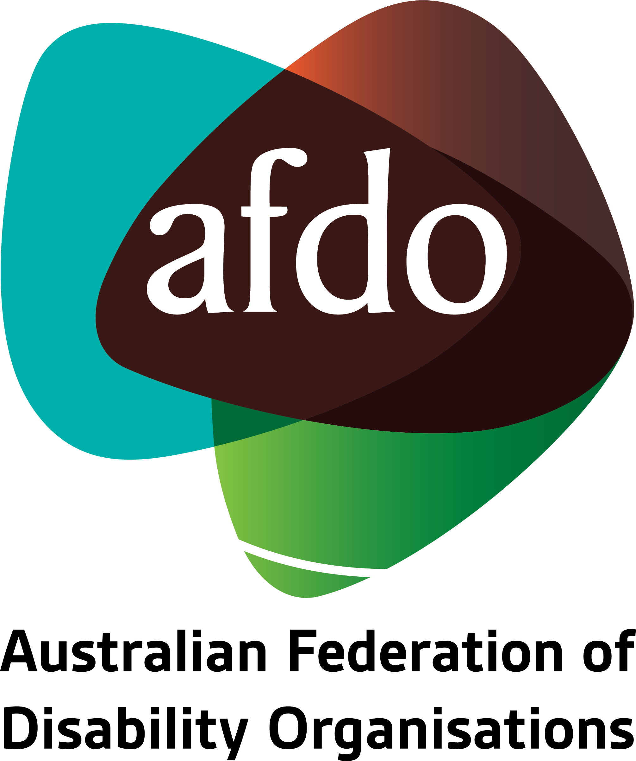

NDIS Amendment (Participant Service Guarantee and Other Measures) Bill 2021
Submission by AFDO
9 November, 2021

About AFDO
Since 2003, the Australian Federation of Disability Organisations (AFDO), a Disabled People’s Organisation (DPO) and Disability Representative Organisation (DRO), has been the recognised national peak organisation in the disability sector, along with its disability specific members, representing people with disability. AFDO’s mission is to champion the rights of people with disability in Australia and support them to participate fully in Australian life.

Our member organisations represent disability specific communities with a total reach of over 3.8 million Australians.

AFDO continues to provide a strong, trusted, independent voice for the disability sector on national policy, inquiries, submissions, systemic advocacy and advisory on government initiatives with the Federal and State/Territory governments.

We work to develop a community where people with disability can participate in all aspects of social, economic, political and cultural life. This includes genuine participation in mainstream community life, the development of respectful and valued relationships, social and economic participation, and the opportunity to contribute as valued citizens.

Our vision
That all people with disabilities must be involved equally in all aspects of social, economic, political and cultural life.

Our mission
Using the strength of our membership-based organisations to harness the collective power of uniting people with disability to change society into a community where everyone is equal.

Our strategic objectives
To represent the united voice of our members and people with disability in national initiatives and policy debate.
To enhance the profile, respect and reputation for AFDO through our members.
To build the capacity and sustainability of AFDO and our members.
To foster strong collaboration and engagement between our members and stakeholders.
To enhance AFDO's connection and influence in international disability initiatives, particularly in the Asia Pacific region, through policy, advocacy and engagement.

Our members

Full members:
- Arts Access Australia
- Autism Aspergers Advocacy Australia
- Blind Citizens Australia
- Brain Injury Australia
- Deaf Australia
- Deafblind Australia
- Deafness Forum Australia
- Down Syndrome Australia
- Disability Advocacy Network Australia
- Disability Justice Australia
- Disability Resources Centre
- Enhanced Lifestyles
- National Mental Health Consumer and Carer Forum (NMHCCF)
- People with Disabilities WA
- People with Disabilities ACT
- Polio Australia
- Physical Disability Australia
- Women with Disabilities Victoria
- Women with Disabilities ACT

Associate members:
- AED Legal Centre
- All Means All
- Amaze
- Aspergers Victoria
- Disability Advocacy and Complaints Service of South Australia (DACSSA)
- Disability Law Queensland
- Leadership Plus
- National Organisation for Fetal Alcohol Spectrum Disorder (NOFASD)
- Star Victoria Inc
- TASC National Limited
- Youth Disability Advocacy Service (YDAS)

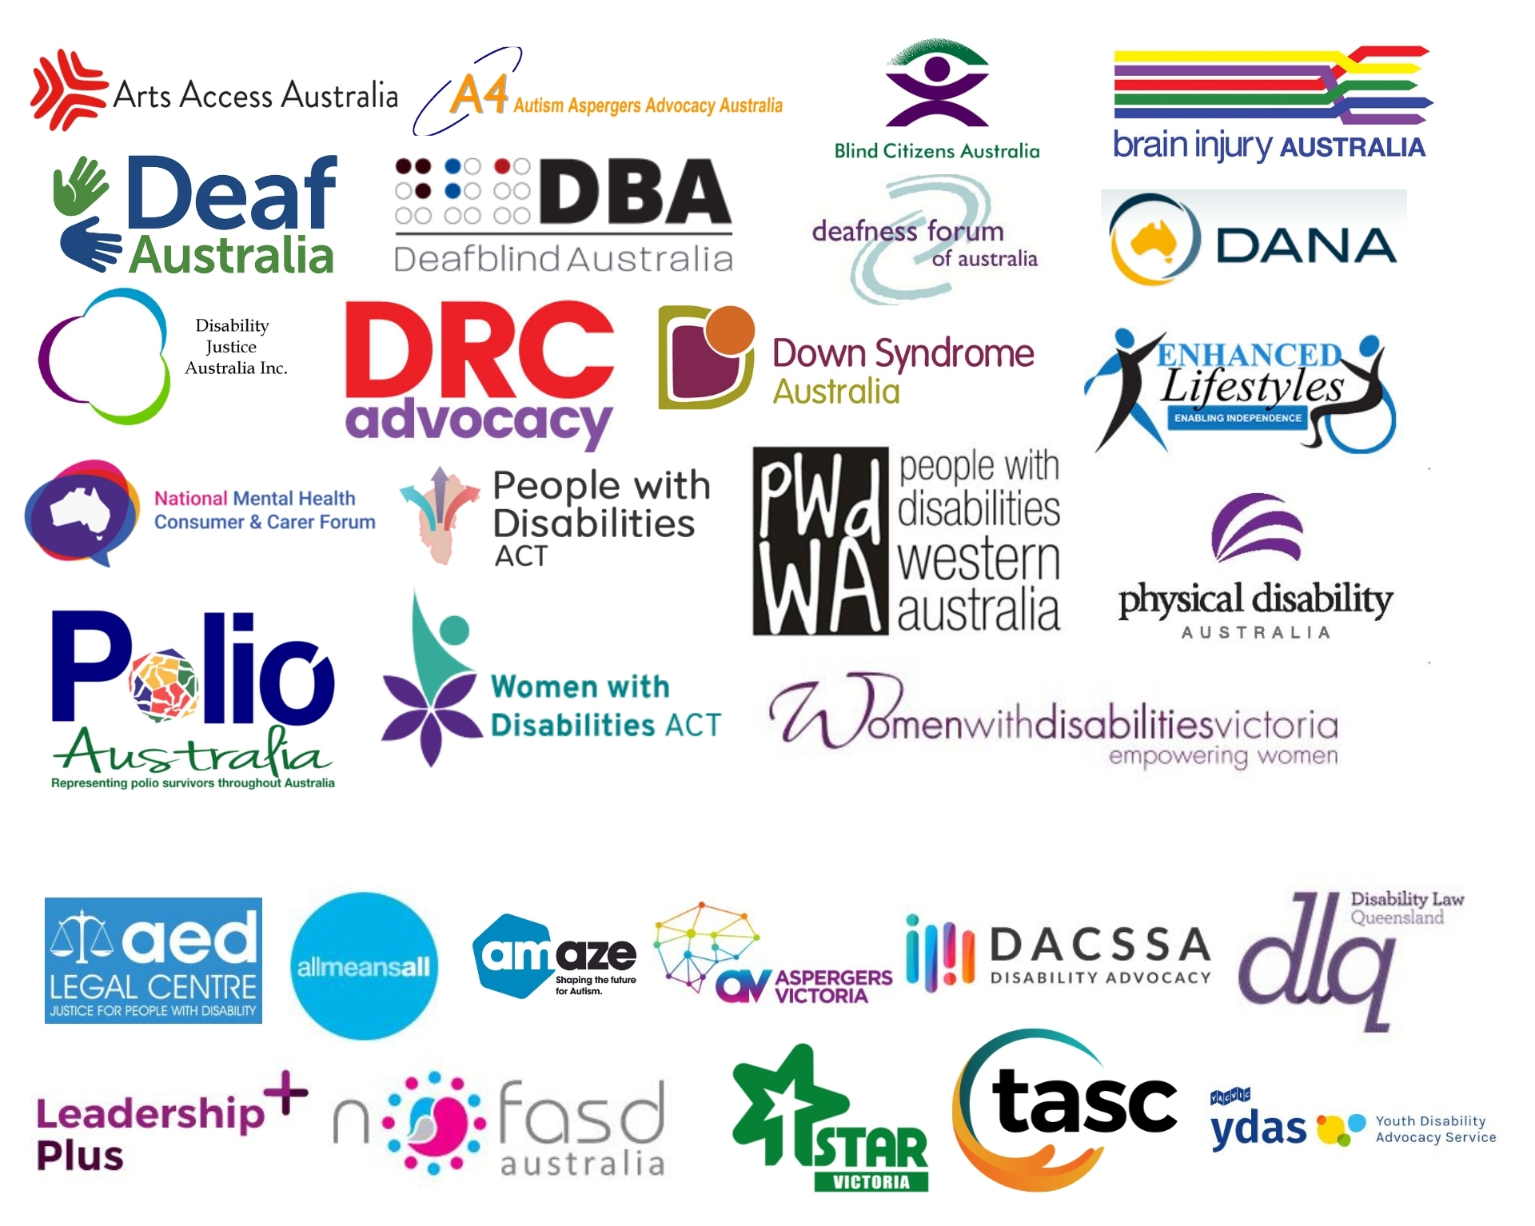

Table of Contents

Acknowledgements.....................................................................................................5

Mary’s Perspective on the Proposed Amendments 6

Introductory Remarks ...............................................................................................7
What AFDO Supports..................................................................................................9

What AFDO Cannot Support.....................................................................................10

Increase in CEO discretionary powers including plan variation without consent.................................................................................................................10
Changes to the ‘Becoming a Participant’ Rules and the repercussions for Psychosocial and other fluctuating and episodic conditions..........................12
Changes to Plan Management and Payment of Supports..................................14
Parity of representation for people with disability on the NDIA Board..........15
Plan Management and Risk....................................................................................16

Issues Requiring Further Consultation or Clarification.............................................17
References........................................................................................................................19

Acknowledgements
Acknowledgement of Country
AFDO as a National Peak acknowledges all Aboriginal and Torres Strait Islander people as the traditional custodians across all the lands, as well as those on which our Member organisations meet. AFDO recognises Aboriginal and Torres Strait Islander peoples’ continuing connection to land, waters, and community, and pay our respects to their Elders past, present, and emerging.
AFDO also acknowledges people with disability, particularly those who have suffered, and continue to suffer, violence, abuse, and exploitation.

This report was co-authored by:
- Mary Henley-Collopy – AFDO Expert Consultant on NDIS
- Rebecca Rudd – AFDO Coordinator of Policy and Submissions
- Ellen Skladzien – CEO of Down Syndrome Australia
- Patrick McGee – AFDO National Manager of Advocacy and Research

Mary’s Perspective on the Proposed Amendments
My name is Mary Henley-Collopy, and I am the Expert Consultant for the NDIS with the Australian Federation of Disability Organisations (AFDO). I am a person with a significant disability and an NDIS Participant.

I strongly believe some aspects of the NDIS Amendment (Participant Service Guarantee and other Measures) Bill 2021 (hereafter referred to as the Bill), have been devoid and, frankly, dismissive of the very harsh and relentless reality of having a disability. The potential ramifications of these amendments run very deep, and some of the Bill’s changes in their proposed form are crushing, as you will read.

When the proposed Bill (Section 47A) states clearly that the CEO – whom has never met me - can vary my Plan at any time and without notice, I instantly become panicked and fearful. What services will I lose? How many of my support hours will be taken from me? Who will do my washing, hang, and return the clothes to my wardrobe? How often will my bed linen be changed? Who will assist with my grocery shopping and meal preparation?

I immediately question when, not if, I will require permanent care in an aged care facility. I have no desire to leave my home, my beloved pets, my friendship circle, and my independence that I have fought so very hard to maintain. This may well be forced on me if I lose my support hours and other vital assistance.

Why does the National Disability Insurance Agency (NDIA) maintain its refusal to include, and welcome as equal, the skills and wisdom of people with disability onto the NDIA Board? How can the NDIS be managed, and such far-reaching amendments as this Bill be developed, in the absence of at least a 50 per cent representation of people with disability where it really matters – in the NDIA Boardroom? If the NDIS is truly intended to provide me, as a person with disability, with greater flexibility, choice, control of my life, and improved access to my community and daily living supports, why am I not present at the boardroom table?

Why, if my Plan changes, can I request the reasons for those changes; yet, if the changes result from an internal review, I am not afforded this same courtesy of being informed of the reasons behind why my Plan has changed?

As a self-managed NDIS Participant, I am also very concerned as to what the real implications will be when the CEO can determine to whom my payments will be paid. The current payment system, though very difficult for me to navigate as a one-pointer-typist (a consequence of my disability), is manageable. What are the additional ‘hoops’, layers or changes really going to involve? I am capable and willing to maintain self-management. I know self-management saves the government valuable resources, so I would ask that this area not be made any more arduous than it already is, or needs to be.

In conclusion, I would commend the following Submission as additional information to these and other concerning issues relating to the Bill.

Introductory Remarks
In our previous Submission in response to the exposure draft version of the National Disability Insurance Scheme Amendment (Participant Service Guarantee and Other Measures) Bill 2021, AFDO raised a number of concerns relating to multiple elements of the proposed legislation. In line with the Public Interest Advocacy Centre (PIAC), we note that the changes made to the final Bill are largely cosmetic in nature, with the majority of our concerns remaining unaddressed.

Before delving into the specifics of our concerns, AFDO would draw attention to the deeply troubling paradigm shift that this proposed legislation represents. From its initial conception, the NDIS was intended to serve as a social insurance scheme; one that recognises the agency of its Participants and grants them the dignity of having control over their own lives. Participants should be empowered to make decisions about the quality and intent of the disability supports they require, and must not be forced back into a position where these decisions are made for them by others. This is an outdated and incomprehensible model of disability support that cannot be abided.

Certain amendments contained within the Bill diverge from the original NDIS ideal, foreshadowing a shift towards a bureaucratised, corporatised scheme that would abandon the original goals of the NDIS entirely. While AFDO would hope that this is not the Government’s intent, we cannot help but be concerned by the implications of such a dramatic transfer of power. These changes also represent a significant diversion from what was recommended in the Tune Review

AFDO submits that the increase in CEO powers contained within these amendments is the first step in this paradigm shift that extends the power of the CEO beond the original intent of the NDIS Legislation. In truth, what this amounts to is the power to limit the dreams and aspirations of people with disability; to hobble the choice and control that the Scheme offers to people with disability; and to determine what is reasonable and necessary through a fiscal lens only.

It is our conclusion that the Agency are initiating this fundamental shift by taking operational guidelines and making them Legislative Rules. Various clauses of this change and the timeframe in which they occur are troubling

And so we ask, where are the Legislative Rules, given they are clearly so fundamentally central to this paradigm shift? Why have they not been made available? Where is the consultation that the Minister had so clearly committed herself to? It seems to be, yet again, an insincere process; where some information is made available, but not the information that really matters. So much of this Bill relies on and makes reference to the Rules, and yet they have not been released for consultation. As has been aptly stated by PIAC:

As an overarching issue, the Bill continues to rely on rule-making powers for the Minister and broad discretion for the CEO. As we’ve previously explained, the use of rules allows more flexibility for the administration of the NDIS, but it also gives the Minister and the NDIA more capacity to define and redefine the scope of its own power.
An additional problem here is that we don’t know whether any aspect of the Rules have changed. The Department’s exposure draft consultation included all the new Rules which were being proposed. This final version of the Bill however, has not been published with any amended Rules – so we don’t know whether some of the concerns have been fixed.
This is one of the principal problems with the use of rules – they can be changed much more easily than legislation, and with less transparency.

AFDO supports the content and recommendations of all other Submissions by our Member organisations relating to the Bill. In addition, we strongly endorse the Submissions made by:
- The Mental Health Association of Australia.
- The Public Interest Advocacy Centre (PIAC).

What AFDO Supports
In general, AFDO is of the view that there is much to support in the Bill. And indeed, it is AFDO’s intention to support the Bill, but only if key amendments are included as articulated in this Submission. For now, AFDO welcomes the following positive inclusions in the proposed amendments.

Specifically, AFDO commends the following:
- Addressing transparency of the NDIA’s own annual performance review through granting the Commonwealth Ombudsman the power to report against the Participant Service Guarantee in addition to learning about, and reporting on, individual participants’ experience.
- Reducing of the ambiguity of language around the frequently used term ‘review’ within numerous NDIS contexts.
- Embracing much-needed refinement of timeframes - inclusive of NDIS decision-making processes, participant plan development, internal reviews, and access provisions - into the NDIS Act and Rules.
- Adding the vital NDIS principle of people with disability being ‘co-designers’ of future revisions or changes to funding and assessment modelling.
- Granting the NDIA more defined powers to undertake market intervention on behalf of participants. AFDO would note, however, that thin markets in rural and remote areas make this problematic, and question how this will be resolved.
- Addressing the Administrative Appeals Tribunal (AAT)’s parameters when reviewing plans varied or replaced by new plans throughout an appeal process.

In our previous Submission, we had raised concerns around the issue of Reasons for Decisions; specifically, proposed sections 100(1B) and 1(C). We are pleased to observe that section 100 has been changed to require that reasons for all ‘reviewable decisions’ be provided automatically to Participants. However, we note that there is no corresponding requirements for reasons to be provided once a review of the reviewable decision has been made under section 100(6), which we submit should also be a legislated requirement.

What AFDO Cannot Support
While AFDO is in favour of the aforementioned beneficial elements of this legislation, there are a number of serious concerns that must be addressed before we can consider supporting the Bill in full. The following elements of the proposed amendments are insupportable, and their inclusion - without significant modification in line with our recommendations - would force AFDO to rescind our support for the Bill.

Increase in CEO discretionary powers including plan variation without consent
Previously, AFDO had raised concerns around the proposal in section 47A to allow plans to be varied by the NDIS without a ‘reassessment’, which would enable plans to be amended, or corrected where these changes are not significant. It would also allow for amendments to be made when requested by the participant – such as correcting technical mistakes, changes to a participant’s goals and aspirations, or changes following an AAT decision.
There were concerns that section 47A of the proposed changes could allow for a plan to be reassessed or varied at the CEO’s own initiative and discretion – without consent from the participant. AFDO has since been advised by the Department that this is not the intent of section 47A, and that following consultation, they have elected to amend the Rules in line with the Tune Review by limiting these powers to a small number of specific situations, such as emergencies. While we welcome this change and hope to see the Department follow through on it, we can only respond to the documents we have been provided with, wherein the CEO powers are as yet unlimited. Further, AFDO is of the view that any changes to Participants’ Plans should only occur with the full consent of the Participants; however, per the Department, consent is not a concept that is not relevant to the NDIS.

For more technical discussion on the implications of these expanded CEO discretionary powers, we would refer the reader to PIAC’s Submission.

Tune Review recommendations for reference

Recommendation 20: The NDIS Act is amended to introduce a new Category D rule-making power that sets out the matters the NDIA must consider when deciding whether to undertake an unscheduled plan review.
Recommendation 21: The NDIS Act is amended to introduce a new Category D rule-making power giving the NDIA the ability to amend a plan in appropriate circumstances.
Recommendation 23: The NDIS Act is amended to clarify the Administrative Appeals Tribunal’s (AAT) jurisdiction, including the power for a plan to be amended while a matter is before the AAT.
Recommendation 25: That the NDIS Act is amended to legislate a Participant Service Guarantee as a Category C rule, to be updated from time to time, with:
  - new timeframes for decision-making, engagement principles and performance metrics, as set out in Chapter 10 of this report.
  - relevant existing timeframes for decision-making moved from the NDIS Act to the new rule.
  - prospective participants and participants being empowered to request an explanation of an access, planning or plan review decision made by the NDIA.
  - participants being empowered to receive a full draft plan before it is approved by the NDIA.
  - a review within two years of the rule being enacted.

Changes to the ‘Becoming a Participant’ Rules and the repercussions for Psychosocial Disability and other fluctuating and episodic conditions
The proposed changes to these Rules include new requirements for determining whether a person applying to become a participant has a ‘permanent’ impairment or ‘substantially reduced functional capacity’. In our previous Submission, we raised concerns around the lack of definitions in relation to the new requirements. AFDO believes this lack of definition in the Rules could potentially create opportunity for subjective decision-making. The lack of clarity around many NDIS terms leaves interpretation of each at the discretion of the CEO or their delegate, potentially resulting in inconsistent participant outcomes.
Our primary concern was that this amendment would move eligibility thresholds out of the Act and into the Rules, which can be amended much more easily. Having consulted with the Department, AFDO has been advised that this level of interpretation would be relegated to the Operational Guidelines rather than the Rules, and that following consultation with the sector, they intended to engage in a co-design process for drafting of the Guidelines – a move that AFDO would welcome.

Our second concern was that the specification of psychosocial disability as being fluctuating or episodic while still being considered permanent had the potential to exclude other kinds of fluctuating or episodic conditions from being eligible. The Department has stated that this was not the intention of the amendment, and that this would be clearly stated within the Operational Guidelines, which are more suited to such specifics.

AFDO would again welcome these moves, but as neither the Rules nor the Operational Guidelines have been made available as part of this consultation, we are unable to comment further.

For more detailed discussion on the implications of these proposed amendments for Psychosocial Disability, please refer to the Submission by the Mental Health Association which AFDO has endorsed.

Tune Review recommendations for reference
Recommendation 4: Governments and the NDIA provide more clarity around the definition of ‘reasonable and necessary’, with:
- the NDIA publishing information, in accessible formats, about how it determines when a support is reasonable and necessary.
- updating the NDIS Rules to reflect the DRC’s agreements on the boundaries between the NDIS and mainstream service systems.
- the DRC working to resolve the interface between the NDIS and ordinary living costs.
- amending the NDIS Act to clarify that reasonable and necessary supports are considered together as a package.
- amending the NDIS Act to clarify that the NDIS is not responsible for funding supports in the absence of that support being provided through another more appropriate service system.

Changes to Plan Management and Payment of Supports
Under sections 43 and 44 of the NDIS Act and the Plan Management Rules, a risk management process will be imposed on participants who request to have their funding plan managed. The proposal will bring those participants in line with the risk assessment process for self-management and reflects the Tune Review recommendation. Changes have also been proposed to section 45 of the NDIS Act regarding the way in which supports are paid. These changes are purportedly intended to make it easier for self-managing participants to make claims.

AFDO is concerned that the currently proposed amendment to section 45, which states that payment is to be made ‘to the person determined by the CEO’, provides uncertainty for self-managed participants around being able to continue their existing payment methods. In the final version of the Bill, no substantive changes to section 45 have been made, and so our concerns remain the same.
Tune Review recommendations for reference

Recommendation 9: The NDIS Act is amended to give a prospective participant up to 90 days to provide information requested by the NDIA to support an access decision, before it is deemed they have withdrawn their access request.

Recommendation 16: The NDIS Rules are amended to:
- set out the factors the NDIA will consider in funding support coordination in a participant’s plan.
- outline circumstances in which it is not appropriate for the providers of support coordination to be the provider of any other funded supports in a participant’s plan, to protect participants from provider’s conflicts of interest.

Recommendation 19: The NDIS Act is amended so a participant who requests to ‘plan manage’ their NDIS funding be subject to the same considerations that apply when a participant seeks to ‘self-manage’.
Recommendation 25: That the NDIS Act is amended to legislate a Participant Service Guarantee as a Category C rule, to be updated from time to time, with:
- new timeframes for decision-making, engagement principles and performance metrics, as set out in Chapter 10 of this report.
- relevant existing timeframes for decision-making moved from the NDIS Act to the new rule.
- prospective participants and participants being empowered to request an explanation of an access, planning or plan review decision made by the NDIA.
- participants being empowered to receive a full draft plan before it is approved by the NDIA.

Parity of representation for people with disability on the NDIA Board
AFDO’s NDIS Expert Consultant, Mary Henley-Collopy, has provided a statement on the important distinction between people with disability and people with lived experience of disability:

As a person with a disability, it is important that my life is told by me. While other people within my circles may have their thoughts and feelings about my experiences – they are, in fact, only interpretations of my experiences, made within their own life context. It is for this reason that I alone I must speak for myself is public discussions.

People with disability must be included in representation on the NDIA Board, with the NDIS Act being amended to include this as a requirement.

Specifically, AFDO recommends:
- That a minimum of fifty per cent of Director positions on the NDIA Board be reserved for people with disability.
- There is gender parity on the board of people with disability
- That the Chair be a designated position for a person with disability.
- That the requisite supports and reasonable adjustments be provided to support this structure.

Plan Management and Risk
The following section had been provided by our member organisation Down Syndrome Australia.

Further to our concerns regarding plan management, we note that the proposed amendments to section 43 and 44 of the ACT and the Plan Management Rules would require a risk management process for participants who are plan managed. This means that participants would face the same requirements to be plan managed as they face for self-management. Participants who were deemed to be at ‘higher risk’ would no longer have the option to use an unregistered provider. This is problematic as it significantly reduces choice and control for a significant number of participants. As of Q4 of the NDIS report, 49 per cent of participants use a plan manager. It should be noted that this approach to management has increased significantly over the last two years. Currently only 20 per cent of participants choose to be Agency-Managed.
The proposed amendment will have a significant impact on nearly half of the scheme participants. It is unclear how many of these participants would have to move to Agency-Managed supports, limiting their choice and control. Some participants have indicated that the use of unregistered providers is essential to having their support needs met and would be significantly and adversely impacted if they were to be forced to be plan managed by the NDIA requiring them to only use NDIS registered providers. We have heard anecdotally that the current approach to risk assessment for self-managed participants is quite conservative and depending on how respondents choose to answer specific questions about their confidence in managing funds, this can make an impact on the risk that is assigned to them.
The use of a plan manager versus being self-managed is a different proposition in terms of the requirements for managing finances, keeping records etc. When a participant’s supports are plan managed, the plan manager pays any organisation providing support as part of the participant’s approved plan. The plan manger must be a registered NDIS provider and meet the NDIS quality and safety standards. In contrast, self-managers are responsible for paying providers directly and retaining appropriate records.

It is inappropriate to use the same risk approach across these two very different management options. Under current NDIS operating guidelines it specifies that the participants financial history should have no bearing on whether they can have a plan manager appointed. This is an appropriate setting given that the plan manager is dealing with all the payments and record keeping on behalf of the participant.

We recommend that this change to the legislation is not included as it has potential negative impacts on a significant number of NDIS participants.

Issues Requiring Further Consultation or Clarification
In addition to the aforementioned positive and negative elements of the proposed legislation, AFDO has identified several concerns requiring further consultation or clarification.

Over-reliance on the Rules
AFDO is compelled to remind DSS that the original spirit, intent, and principles of the NDIS Scheme was to enshrine the Act within an accessible, inclusive, equitable, and transparent framework and format for those whom the provisions were designed - people with disability.

It would seem the NDIS Act is shifting away from these overarching drivers, with NDIS’ apparent over-reliance on vital details being contained within the Rules rather than within the actual Act. AFDO questions why such critical information is not given ‘centre stage’ - in plain view for all to see and easily reference - within the proposed Act, rather than being relegated to the Rules.

Language Matters
AFDO would urge NDIA to keep all and any changes to the NDIS Scheme in keeping with the ‘social model of disability’ and within the original spirit and intent of the Act. In doing so, language within the Act, Rules, principles, guidelines, and policies will remain reflective and respectful of all people with disability, regardless of culture.
Specifically, AFDO would draw attention to Section 50J of the Review of proposed changes to the National Disability Insurance Scheme Act 2013 (NDIS Act), which states:
50J CEO to comply with requirements in relation to prospective participants or participants The National Disability Insurance Scheme rules may prescribe requirements with which the CEO must comply in relation to the following:
  - the preparation of plans for participants;
  - plans that have come into effect for participants;
Rephrasing sentence (b) to read “the preparation of plans with participants” would be a more inclusive approach.
AFDO strongly holds to the view that all participants should have an active, meaningful, and ongoing contribution to setting their desired direction through the preparation and reassessment process – for their entire participation with NDIS.

Terms Requiring Clarification
AFDO has identified a number of terms in the proposed amendments that lack clear definition and are potentially open to interpretation and inconsistent application. AFDO is greatly concerned the amendments will be meaningless without clarification of the following widely used NDIS terms:

- ‘Permanent disability’
- ‘Appropriate treatment’
- ‘Substantially reduced capacity’
- ‘Fluctuating conditions’
- ‘Managing a condition’
- ‘Substantial improvement’
- ‘Treatment’

References
Public Interest Advocacy Centre (PIAC) (2021) The proposed changes to the NDIS Act: Explainer Part 2, accessed 5 November 2021.
<https://piac.asn.au/2021/11/02/the-proposed-changes-to-the-ndis-act-explainer-part-2/>

Tune, D. (2019) Review of the National Disability Insurance Scheme Act 2013: Removing Red Tape and Implementing the Participant Service Guarantee, accessed 1 October 2021. <https://www.dss.gov.au/disability-and-carers-programs-services-for-people-with-disability-national-disability-insurance-scheme/review-of-the-ndis-act-report>

PIAC 2021.
PIAC 2021.
Tune 2019, 15.
Tune 2019, 15.
Tune 2019, 15.
Tune 2019, 15.
Tune 2019, 13.
Tune 2019, 15.
Tune 2019, 14.
Tune 2019, 15.
Tune 2019, 15.
Tune 2019, 16.

