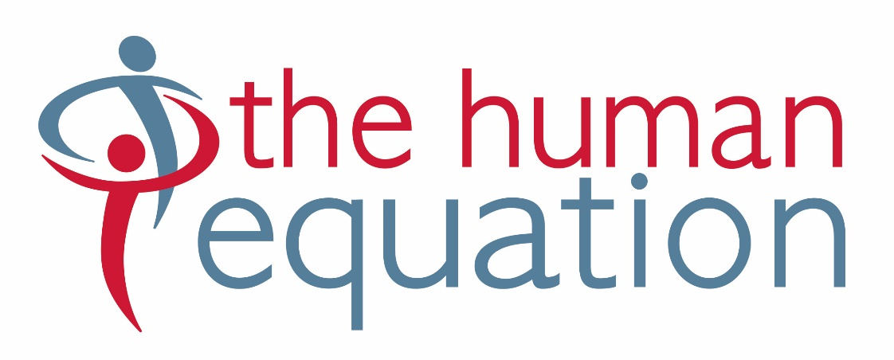

Candidate Information

Administration Officer

Australian Federation of Disability Organisations

June 2022

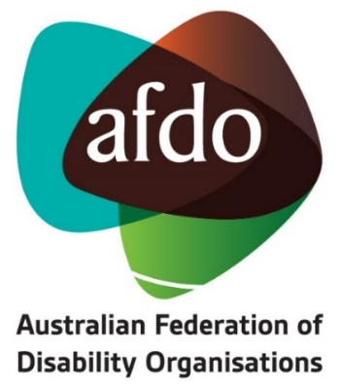

The Opportunity

- New role – make it your own!
- Part-time, flexible hours
- Fully remote, collaborative and friendly team

The Australian Federation of Disability Organisations (AFDO) is a Disabled People’s Organisation and a national cross-disability peak, championing the rights of people with disability and enabling them to participate fully in Australian life. AFDO offers a supportive work environment, with a team passionate about the rights of people living with disability. Benefits include options for workplace flexibility, remote working and immediate access to tax-reducing salary packaging ($15,900 tax free income per year).

What you will be doing

You’ll have plenty of variety in this role, turning your hand to whatever needs to be done to keep the organisation functioning effectively. On any day, you might:

- Respond to phone and email enquiries
- Monitor AFDO’s central email inboxes, responding and re-directing as needed
- Keep the organisational calendar of events up to date
- Monitor the use of Sharepoint and make sure that the records management system is working well
- Liaise with external providers (IT and co-located office space)
- Process invoices, expenses claims and credit cards
- Help out the Executive Assistant and other staff when needed.

About You

You enjoy rolling your sleeves up, collaborating with the team about what needs to be done and adapting to things as they come up. You’ll enjoy interacting with external stakeholders and making sure that enquiries are followed up. You’ll bring about three years’ experience in office administration, well-developed time management skills and a good attention to detail. You are comfortable with the Microsoft suite and are up for learning the new CRM (Dynamics). You will have the ability to maintain your productivity in a remote environment and have suitable home office facilities.

People with lived experience of disability are strong encouraged to apply

This is a part-time role (22.5 hours per week subject to negotiation) with an offer of an initial 12-month contract and opportunity for renewal.

Interested in applying?
Please submit a two-page cover letter responding to the selection criteria in this document with your resume, to carol@thehumanequation.com.au.
Only candidates invited for interview will be contacted.

Snapshot of AFDO

AFDO’s vision (its why): all people with disability are involved equally in all aspects of social, economic, political and cultural life.

AFDO’s mission is to champion the rights of people with disability in Australia and help them participate fully in Australian life. AFDO uses the strength of its membership-based organisations to harness the collective power of uniting people with disability to change society into a community where everyone is equal.

AFDO exists to:

- Represent people with disability in Australia and at the international level, and
- Help people with disability participate in all parts of social, economic, political and cultural life.

To do this, AFDO:

- Supports disability organisations and people with disability.
- Undertakes research on disability issues.
- Advises government, disability organisations and other organisations about their disability policies.
- Lobbies governments and other institutions on disability issues.
- Informs and educates the general community about disability.

AFDO’s Strategic Objectives

- Represent the united voice of its members and people with disability in national initiatives and policy debate.
- Enhance the profile, respect and reputation of AFDO through its members.
- Build the capacity and sustainability of AFDO and its members.
- Foster strong collaboration and engagement between members and stakeholders.
- Enhance the connection and influence of AFDO in international disability initiatives by policy, advocacy and engagement, focussed on the Asia Pacific region.

About AFDO

AFDO is the national voice of people with disability and family organisations in Australia. The organisation works to develop a community where people with disability can participate in all aspects of social, economic, political and cultural life. This includes genuine participation in mainstream community life, the development of respectful and valued relationships, social and economic participation, and the opportunity to contribute as valued citizens.

AFDO is a Disabled Peoples Organisation (DPO). A DPO is an organisation where the majority of the members as well as the governing body (Board of Directors) are persons with disability.

AFDO and its ten national members are funded by the Australian Government under the Disability Representative Organisations (DRO) program to provide systemic advocacy and representation for Australians with disability. Whilst this work is underfunded, AFDO continues to campaign to resolve this inequity in order to deliver outcomes for its members.

AFDO believes its strength is in its members. AFDO is made up of organisations who work together to contribute to the national policy agenda and address issues that impact the lives of people with disability in Australia. AFDO understands that disability-specific organisations play a key role in the provision of information and peer support to people with disability and their families. This organisational role keeps them closely connected to their grass roots communities. Each community has its peak organisation that uses its voice to advocate on issues. AFDO is the forum where these views are collected and coordinated to ensure Government is across issues impacting all people with disability in Australia.

AFDO is proud to be the organisation that has brought together both cross-disability organisations (representing the interests of people with all kinds of disability), and disability-specific organisations/peaks. It brings the understanding that cross-disability groups are only successful when they have access to the specific expertise of disability-specific organisations such Blind Citizens Australia, Brain Injury Australia, Deaf Australia, Down Syndrome Australia and others, as these disability-specific groups are connected to their communities.

For more information, head to: www.afdo.org.au

Current Organisational Design

About the Role

Reporting to: Executive Assistant

Direct Reports: Volunteers and consultants as needed

Location: Designated workplace – North Melbourne
Remote work available, subject to WHS requirements being met

Employment Status: 12-month maximum contract – opportunity for renewal

Hours: 22.5 per week, worked over three or four days

Position Summary

The Administration Officer provides administration and back-office operational support to assist in keeping AFDO running smoothly.

Responsibilities and Key Decision Making in this Role

Responsibilities and Key Decision Making in this Role
- Oversight of key organisational support processes
- Making decisions concerning:
  - Travel and accommodation costs
  - Meeting costs such as venue, catering, A.V. hire, interpreters, captioning etc

Responsibilities

- Organisational Support
- Act as the external point of contact for AFDO, taking phone messaging from serviced offices and the office voicemail, returning or redirecting calls.
- Monitor email correspondence for organisational email accounts, responding to or forwarding correspondence as required.
- Develop and update AFDO’s global calendar of key events, external meetings and deadlines for funding reports/acquittals.
- Oversee the architecture of AFDO’s electronic records management system.
- Manage relationship and service levels with IT services provider.
- Manage contract with provider of co-located office space.
- Review and process approval relevant incoming invoices and expense claims.
- Assist with updating manuals, member records, passwords, and other key documents on Sharepoint.
- Assist with making travel and accommodation arrangements when required.
- Provide assistance with board meeting logistics including attending to accessibility requirements.
- Back-Up Support
- Provide back-up support for the Executive Assistant to cover absences – attending to diary management, email management and other duties.
- Assist the Board & Governance Coordinator as required.

- General
- Maintain a broad awareness of external matters relevant to AFDO’s work.
- Work collaboratively with team members to contribute broadly to the achievement of AFDO’s objectives.
- Participate in organisational and team planning initiatives.
- Provide regular reporting as necessary.
- Undertake other tasks as directed by management in keeping within the scope of this role.

Selection Criteria

- Minimum three years’ experience in office administration
- Strong organisational and time management skills
- Strong attention to detail
- A flexible, adaptive and proactive approach to work
- Sound verbal communication and interpersonal skills
- Proficiency in Microsoft suite and other technologies required for remote work
- Ability to work in a sensitive, complex and demanding environment
- Ability to maintain productivity in a remote working environment
- Suitable remote working facilities (ie, working from home facilities)

How to Apply

Please write a two-page covering letter outlining how you meet the above selection criteria and send it along with your resume to carol@thehumanequation.com.au

Only candidates invited for interview will be contacted.

