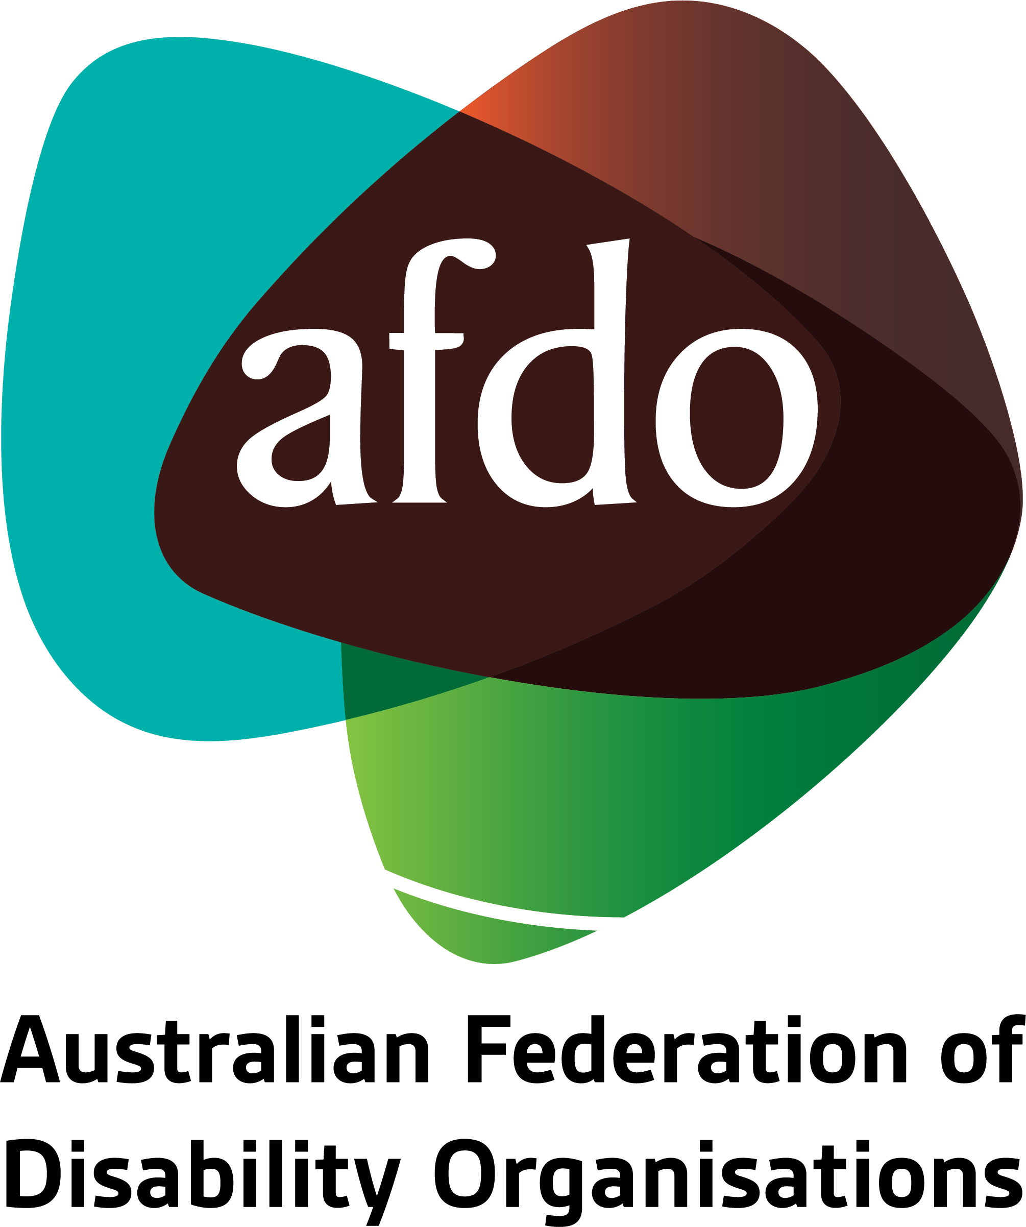

Submission to Senate Standing Committee on Community Affairs
National Disability Insurance Scheme Amendment (Improving Supports for At Risk Participants) Bill 2021
July 2021

About AFDO
Since 2003, the Australian Federation of Disability Organisations (AFDO), a Disabled People’s Organisation (DPO) and Disability Representative Organisation (DRO), has been the recognised national peak organisation in the disability sector, along with its disability specific members, representing people with disability. AFDO’s mission is to champion the rights of people with disability in Australia and support them to participate fully in Australian life.
Our member organisations represent disability specific communities with a total reach of over 3.8 million Australians.
AFDO continues to provide a strong, trusted, independent voice for the disability sector on national policy, inquiries, submissions, systemic advocacy and advisory on government initiatives with the Federal and State/Territory governments.
We work to develop a community where people with disability can participate in all aspects of social, economic, political and cultural life. This includes genuine participation in mainstream community life, the development of respectful and valued relationships, social and economic participation, and the opportunity to contribute as valued citizens.
Our vision
That all people with disabilities must be involved equally in all aspects of social, economic, political and cultural life.
Our mission
Using the strength of our membership-based organisations to harness the collective power of uniting people with disability to change society into a community where everyone is equal.
Our strategic objectives
To represent the united voice of our members and people with disability in national initiatives and policy debate.
To enhance the profile, respect and reputation for AFDO through our members.
To build the capacity and sustainability of AFDO and our members.
To foster strong collaboration and engagement between our members and stakeholders.
To enhance AFDO's connection and influence in international disability initiatives, particularly in the Asia Pacific region, through policy, advocacy and engagement.

Our members
Full members:
- Autism Aspergers Advocacy Australia
- Blind Citizens Australia
- Brain Injury Australia
- Deaf Australia
- Deafblind Australia
- Deafness Forum of Australia
- Down Syndrome Australia
- Disability Advocacy Network Australia
- Disability Justice Australia
- Disability Resources Centre
- Enhanced Lifestyles
- National Mental Health Consumer and Carer Forum (NMHCCF)
- People with Disability WA
- People with Disabilities ACT
- Polio Australia
- Physical Disability Australia
- Women with Disabilities Victoria
- Women with Disabilities ACT

Associate members:
- AED Legal Centre
- All Means All
- Aspergers Victoria
- Disability Advocacy and Complaints Service of South Australia (DACSSA)
- Disability Law Queensland
- Leadership Plus
- National Organisation for Fetal Alcohol Spectrum Disorder (NOFASD)
- YDAS – Youth Disability Advocacy Service
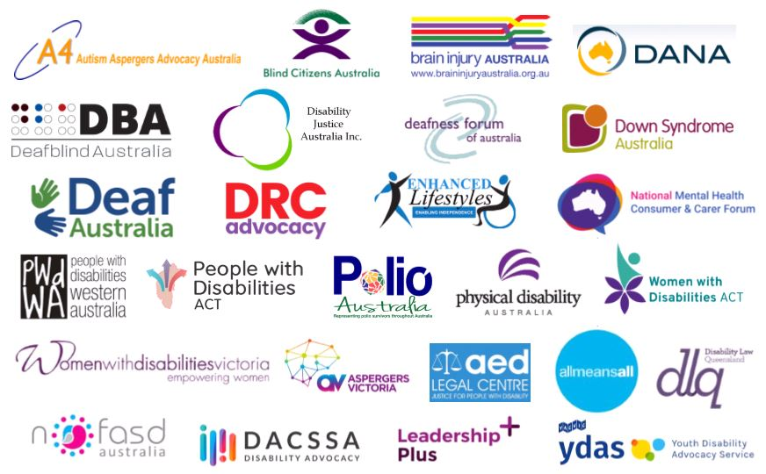
National Disability Insurance Scheme Amendment (Improving Supports for At Risk Participants) Bill 2021

This Submission by AFDO will address two key issues:
- The Lack of Consultation with Disability Representative Organisations regarding the proposed changes to the NDIS Act to implement the recommendations from the Robertson Review.
- The ‘Missed Opportunity’ by the Quality and Safeguards Commission to address the issue of improving supports for at risk participants who are detained under forensic orders for the purposes of treatment.

Lack of Consultation with Disability
In responding to the death of Ms Anne-Marie Smith in South Australia, AFDO was contacted by the Robertson Review to provide perspective on how to improve support for vulnerable participants. That was the sole point of consultation in this process that led to Minister Reynolds seeking changes to the NDIS Act to improve supports for at risk participants.
In receiving the Review Report in September 2020, it is AFDO’s view that the Quality and Safeguards Commission had a responsibility to once again involve people with disability and Disability Representative Organisations in consultations regarding what changes to the NDIS Act might be needed. This did not occur.
It is AFDO’s view that the lack of consultation about the recommendations of the Robertson Review and proposed changes to the NDIS Act has led in this particular circumstance to a missed opportunity. The ‘missed opportunity’ here for AFDO was discussion about improving supports for at risk participants such as those detained under order in state and territory forensic facilities.

Improving supports for at risk participants who are detained under forensic orders for the purposes of treatment: A Missed Opportunity
Through the Joint Standing Committee on the NDIS’s Review of the Quality and Safeguards Committee, AFDO has raised the issue of the lack of access to Quality and Safeguards Commissions legislative protections for NDIS Participants detained for the purposes of treatment under forensic orders in state and territory forensic facilities a number of times. In the context of this review, AFDO first raised these concerns with the NDIS Joint Standing Committee in October 2020 and again at a Special Hearing for the Review in May 2021. AFDO formally lodged the issue with the Quality and Safeguards Commission in the Consultative Committee for the NDIS Quality and Safeguards Commission this week.
AFDO believes that this situation is an anomaly that no Federal or State and Territory agency saw as an outcome for NDIS Participants. AFDO is highly concerned for the welfare of NDIS Participants in this anomaly because of the particular vulnerabilities to systemic and significant serious human rights breaches including arbitrary detention and cruel and unusual punishment. A Human Rights Watch Report from 2018, “I Needed Help, Instead I was Punished: The Abuse and neglect of Prisoners with Disabilities in Australia”, describes the situations in which violence, abuse, and neglect can and does occur.
People with disability and/or psycho-social impairment detained under forensic orders for the purposes of treatment will generally have been found by state and territory legal processes to be mentally impaired and unfit to plead. They are detained indefinitely as a result of this process. In 2014 and then again in 2019 the United Nations Convention on the Rights of People with Disability Concluding Observations asked Australia to dismantle its indefinite detention regime. The issue of the Indefinite Detention of people with disability and psycho-social impairment has been the subject of an Inquiry by this Committee in 2016.
Currently, an NDIS participant detained under forensic orders in a state or territory forensic facility can make a complaint about an NDIS funded support but not about the nature of the detention or the restrictive practices they have applied to them in detention as they are funded through the state and territory. The issue of indefinite detention was the subject of a Disability Royal Commission Hearing in February 2021 and the issue of the use of psychotropic medication and behaviours of concern was the subject of a Hearing in September 2020. The Disability Royal Commission is also investigating the issue of violence, abuse, and neglect of people with disability and psycho-social impairments in closed environments such as prisons, inpatient psychiatric units, and forensic disability units.
Matters that relate to indefinite detention or restrictive practices such as chemical restraint remain the responsibility of the states and territories. The only mechanism for a participant to make a complaint relating to either the nature and operation of the detention and the nature and operation of restrictive practices are the state and territory community visitor schemes; or in Victoria, the Disability Services Commission, because the forensic program is regulated under the Disability Services Act. In the Northern Territory, there is currently no mechanism to make complaints or have an independent assessment of the use of restrictive practices. Community Visitor Schemes are an important mechanism for institutional oversight and reporting, but can be limited in their ability to effect change by a lack of resources and a lack of legislative authority.
There are now a number of organisations in every state and territory that are concerned with improving supports for at risk participants, the lack of adequate rights protections mechanisms, and access to those protections. At the Special Hearting in May, the following organisations gave evidence: the Victorian Office of the Public Advocate, VALID, Forensicare, NT Legal Aid, Equality Lawyers SA, and Villamanta Legal Service. Previously, UNSW and the Queensland Office of the Public Advocate had been involved in discussions about this issue. .
At the NDIS Joint Standing Committee’s Review of the Quality and Safeguards Commission Special Hearing in May 2021, the Commissioner for the Quality and Safeguards Commission, Mr Graeme Head, gave evidence that people detained under forensic orders in state and territory forensic facilities were simply not eligible under Section 181 of the NDIS Act for the legislative protections outlined under the Act, and that was the end of the matter. Mr Head indicated that any concerns regarding this anomaly could be raised in the context of the Review of the Quality and Safeguards Framework which is due to take place later this year. AFDO welcome the Review but remain concerned that this process may not be assertive or broad enough to lead to the substantial change that is needed.
At the Special Hearing, Natalie Wade, CEO of Equality Lawyers, put the view forward that changes to Section 79x and changes to Section 181 of the NDIS Act would enable NDIS participants detained under forensic orders in state and territory forensic facilities access to the Quality and Safeguards Commission.
“Currently, the NDIS Quality and Safeguards Commission will only receive complaints relating to NDIS Providers. This is a result of the current drafting of section 181G and 73X. It is in spite of section 181E which provides the Commission with necessarily broad core functions. Receipt of complaints relating to NDIS Providers means that people with disability who are self-managed and using services through non-registered providers, or those who are in closed environments such as forensic disability facilities, mental health wards or prisons cannot make complaints to and be protected by the Commission. We do not accept this as adequate protection for people with disability and believe that it is contrary to the core functions of the Commission as described in section 181E.”
Ms Wade advised that Section 73x be amended to:
- The National Disability Insurance Scheme rules may prescribe arrangements relating to the management and resolution of complaints concerning the health, safety, and well-being of people with disability receiving supports or services, including thiose received under the National Disability Insurance Scheme.
This will allow all people with disability to be protected by the NDIS Quality and Safeguards Commission as intended by the Parliament and community in the 2013 Act.
AFDO have come to understand, however, that to allow access for NDIS Participants detained under orders in state and territory forensic units, there would need to be changes made to state and territory regulatory systems in addition to the NDIS Act. AFDO are currently negotiating with legal organisations to undertake work to identify what needs to change in the national and state and territory regulatory systems that would enable regulatory changes to occur.
Following the advice at the Special Hearing from Mr Head that NDIS Participants detained under orders in state and territory forensic units were not eligible for national legislative rights protections, AFDO sought a Legal Briefing from the Public Interest Advocacy Centre on Section 181. PIAC’s advice identified that Section 181E, which outlined the core functions of the Quality and Safeguards Commission’s Commissioner, were as follows:
(a) to uphold the rights of, and promote the health, safety and wellbeing of, people with disability receiving supports or services, including those received under the National Disability Insurance Scheme.
(b) to develop a nationally consistent approach to managing quality and safeguards for people with disability receiving supports or services, including those received under the National Disability Insurance Scheme.
PIAC’s legal briefing also identifies that Section 181D(1)(f) also has the function, “to do anything incidental or conducive to the performance of any of the above functions” – that is, they are able to do anything incidental to their core functions. PIAC advised that Section 181E does not extend to receiving complaints, but might however include, “policy, consultation or collaborative functions to ensure that a person with disability receiving NDIS supports is not subject to abuse by State/Territory facilities (for example). It might also include consultation with States and Territories to ensure there is a consistent approach to ensuring quality supports are being provided to people with disability across all levels of government.”
However, subsequent conversations with senior Department of Social Services representatives and a number of state and territory governments in late June revealed that changes to the Commonwealth, state and territory regulatory and legislative systems regarding forensic detention would be needed as well as legislative change to Section 79x of the NDIS Act to enable NDIS participants protections under the Quality and Safeguards Commission.
In developing an understanding of this issue with representatives of Minister Ruston’s office, AFDO met with senior DSS representatives and Ms Samantha Taylor from the Quality and Safeguards Commission. At the end of the meeting, where they reiterated that this issue lay outside the scope of the changes to the NDIS Act, DSS and the Quality and Safeguards Commission advised that they would be willing to host a national meeting to discuss the issue of rights protections for NDIS Participants detained under forensic orders in state and territory disability forensic units. Through the Community Affairs Reference Committee Inquiry, AFDO intends to hold DSS accountable to that commitment.
In order to make any national meeting worthwhile, AFDO believe there is a need for an issues paper that:
- Addresses the lack of legislative and programmatic protections at the state and territory level for people with disability and psychosocial impairment who are unfit to plead and detained for the purposes of treatment under forensic orders.
- Identifies changes needed to Commonwealth, state and territory forensic regulatory and legislative systems.
- Identifies legislative changes needed in the NDIS Act to enable access to the Quality and Safeguards Commission and other national rights protections agencies.

Recommendations:
- The Department of Social Services host a national meeting involving the Commonwealth, State and Territory Governments and Civil Society to address the issue of rights protections for NDIS participants detained under orders in state and territory forensic units
For AFDO, the lack of consultation with Disability Representative Organisations including AFDO about changes to the NDIS Act to improve supports for vulnerable participants is one of missed opportunity to formally discuss the issue of rights protections for NDIS participants detained under orders in state and territory forensic units.
Endorsements: AFDO endorses the Submission to this Inquiry by People with Disability Australia.

Natalie Wade, Equality Lawyers to Patrick McGee, AFDO, 12th June 2021.
Public Interest Advocacy Centre Legal Briefing on Section 181 of the NDIA Act 2021
Public Interest Advocacy Centre Legal Briefing on Section 181 of the NDIA Act 2021

