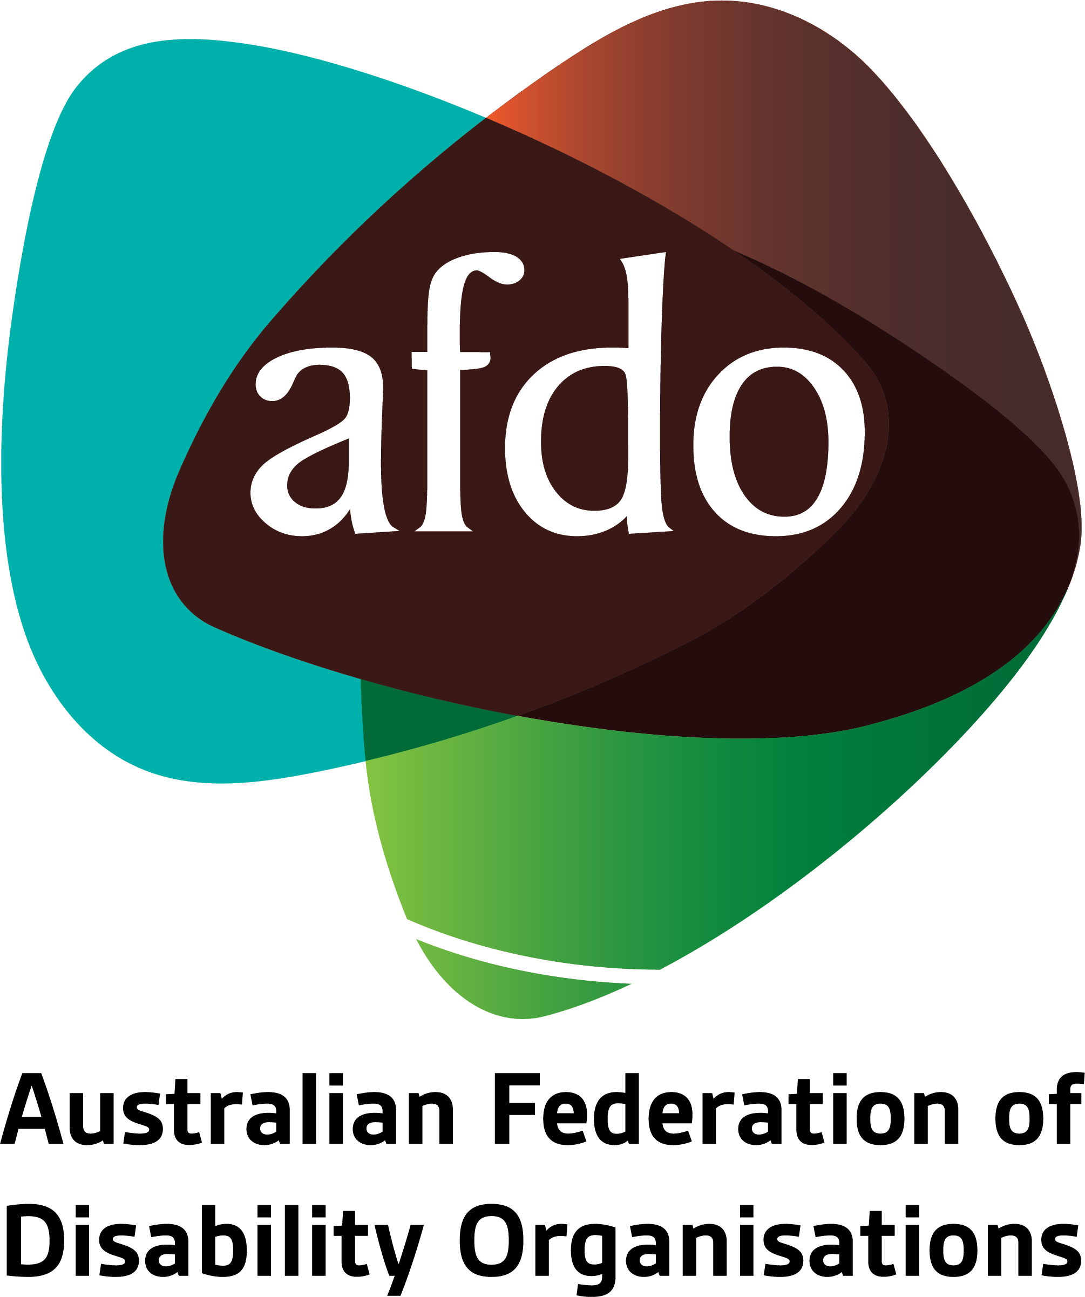

Review of the National Disability Advocacy Framework 2022-2025
Submission by AFDO

July 2022

Table of Contents
Table of Contents 1
About AFDO 3
Acknowledgements 6
Responding to Select Questions from the Submission Guide:
1. Do you believe the new NDAF encompasses your vision of advocacy? If not, what changes are required?
3. Are the outcomes of the NDAF clear and achievable? Should different ones be included? If so, what should be included?
4. Are the responsibilities, reform, and policy directions of the NDAF relevant or should different ones be included?

About AFDO
Since 2003, the Australian Federation of Disability Organisations (AFDO), a Disabled Peoples Organisation (DPO) and Disability Representative Organisation (DRO), has been the recognised national peak organisation in the disability sector, along with its disability specific members, representing people with disability. AFDO’s mission is to champion the rights of people with disability in Australia and support them to participate fully in Australian life.
Our member organisations represent disability specific communities with a total reach of over 3.8 million Australians.
AFDO continues to provide a strong, trusted, independent voice for the disability sector on national policy, inquiries, submissions, systemic advocacy and advisory on government initiatives with the Federal and State/Territory governments.
We work to develop a community where people with disability can participate in all aspects of social, economic, political and cultural life. This includes genuine participation in mainstream community life, the development of respectful and valued relationships, social and economic participation, and the opportunity to contribute as valued citizens.
Our vision
That all people with disabilities must be involved equally in all aspects of social, economic, political and cultural life.
Our mission
Using the strength of our membership-based organisations to harness the collective power of uniting people with disability to change society into a community where everyone is equal.
Our strategic objectives
To represent the united voice of our members and people with disability in national initiatives and policy debate.
To enhance the profile, respect and reputation for AFDO through our members.
To build the capacity and sustainability of AFDO and our members.
To foster strong collaboration and engagement between our members and stakeholders.
To enhance AFDO's connection and influence in international disability initiatives, particularly in the Asia Pacific region, through policy, advocacy and engagement.

Our members
Full members:
- Arts Access Australia
- Autism Aspergers Advocacy Australia
- Blind Citizens Australia
- Brain Injury Australia
- Deaf Australia
- Deafblind Australia
- Deafness Forum of Australia
- Down Syndrome Australia
- Disability Advocacy Network Australia
- Disability Justice Australia
- Disability Resources Centre
- Enhanced Lifestyles
- Multiple Sclerosis Australia
- National Mental Health Consumer and Carer Forum (NMHCCF)
- People with Disability WA
- People with Disabilities ACT
- Polio Australia
- Physical Disability Australia
- Women with Disabilities Victoria
- Women with Disabilities ACT

Associate members:
- AED Legal Centre
- All Means All
- Amaze
- Aspergers Victoria
- Disability Advocacy and Complaints Service of South Australia (DACSSA)
- Disability Law Queensland
- Leadership Plus
- National Organisation for Fetal Alcohol Spectrum Disorder (NOFASD)
- Star Victoria
- TASC National Limited
- YDAS – Youth Disability Advocacy Service

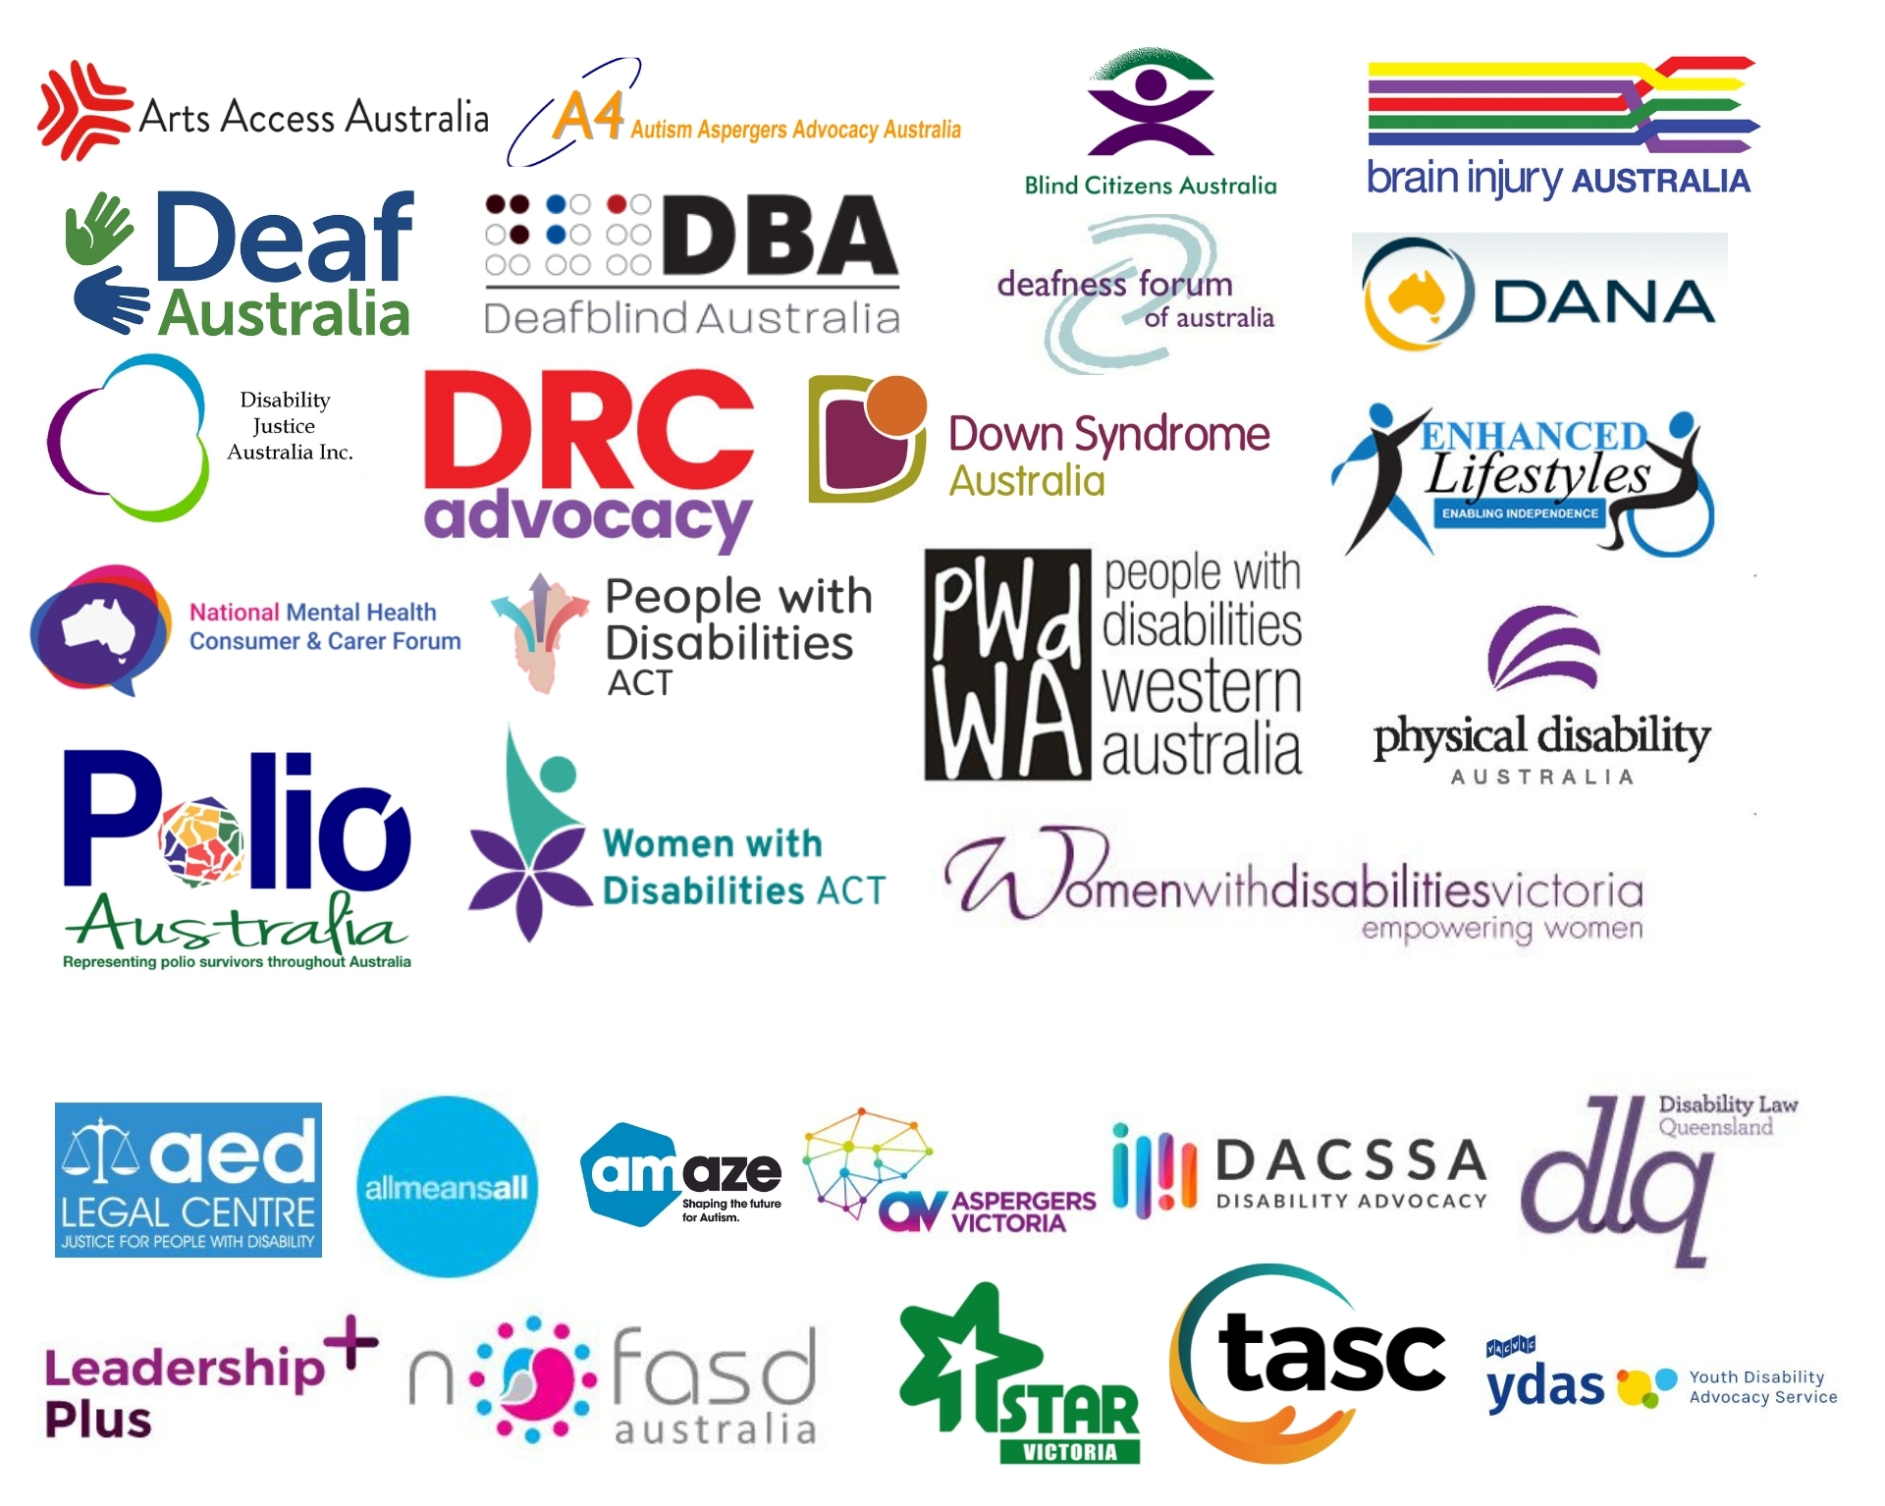

Acknowledgements
AFDO acknowledges Aboriginal and Torres Strait Islander people as the traditional custodians of the land on which we stand, recognising their continuing connection to land, waters, and community. From our head office in Melbourne, we pay our respects to the Bunurong Boon Wurrung and Wurundjeri Woi Wurrung peoples of the Eastern Kulin Nation and to their Elders past, present, and emerging. We also pay our respects to the traditional owners of all lands on which we operate or meet around the country.
AFDO acknowledges people with disability, particularly those individuals that have experienced or are continuing to experience violence, abuse, neglect, and exploitation. We also acknowledge their families, supporters, and representative organisations and express our thanks for the continuing work we all do in their support.
This Submission has been compiled by the Australian Federation of Disability Organisations (AFDO) in collaboration with People with Disability Australia (PWDWA).
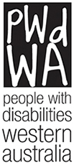

Responding to Select Questions from the Submission Guide
As a national peak organisation, AFDO and its members represent disability specific communities with a total reach of over 3.8 million Australians. AFDO is dedicated to undertaking systemic advocacy across a range of disability types with the goal of enabling all people with disability to be involved equally in all aspects of social, economic, political, and cultural life. AFDO welcomes the opportunity to respond to the draft National Disability Advocacy Framework 2022-2025 (the Framework).
1. Do you believe the new NDAF encompasses your vision of advocacy? If not, what changes are required?
The Framework’s emphasis on long-term change has the potential to miss the role that systemic advocacy plays in addressing critical issues as they occur. While it is important that funding and capacity be allocated to service longer-term changes, systemic advocacy also has a place in responding to emerging issues. This can be seen in the proposed Independent Assessment amendments earlier this year, where organisations including AFDO utilized systemic advocacy to address an immediate concern, with the added benefit of contributing to the discussion on long-term policy changes around the NDIS. Unfortunately, despite the importance of systemic advocacy and its potential to create beneficial change, Disability Representative Organisations (DROs) lack sufficient funding and thus capacity to undertake this critical work.
The framework acknowledges the various intersecting issues around diversity but fails to adequately recognize the importance of the diversity of different cohorts of people with disabilities. Where many organisations are explicitly focused on the needs of particular groups, such as women with disabilities or people from CALD backgrounds with disabilities, AFDO has a diverse membership that includes many different identities and disability types. It is critical that the framework ensures a representative voice in the systemic space that recognises this diversity and is cognizant of the varying needs of different cohorts and disability types. Examples of groups with diverse needs who require a seat at the table include Deaf people, people with complex communication needs, people with psychosocial disabilities, and people with intellectual disabilities.
3. Are the outcomes of the NDAF clear and achievable? Should different ones be included? If so, what should be included?
The outcome of systemic advocacy is ultimately changes in legislation, policy, and practices. However, this is very broad and may be difficult to measure and quantify if changes are long-term and slow. The Framework must be clearer on the expected outcomes of systemic advocacy – not only for the organizations themselves, but also government, as government has a clear role in ensuring the success of systemic advocacy.
- Data collection - The collection, use and reporting of evidence-based data needs to include outcomes of individual and systemic advocacy, not just administration and planning. Individual advocacy data is critical to informing systemic advocacy. Any data collection that is undertaken should include a transparent process for sharing aggregate data to inform systemic advocacy. Disability advocacy agencies must be consulted when interpreting program data. When data is interpreted in a vacuum, poor policy decisions are made.
All governments must agree to work together to streamline and build capacity for the collection of data to remove the administrative and financial burden of complying with multiple data collection and reporting systems. Data collection should also not create an excessive administration burden and should be relevant to the outcomes being measured under the Framework. Programs should be supported to demonstrate outcomes through data.
Data must be about more than planning of disability advocacy and improvement of service systems. Data helps to paint a picture of what is happening and can be beneficial in informing systemic advocacy work. Currently, NDAP programs funded for systemic advocacy record data on DEX. However, the systemic data captured under this system is focused on output, not outcomes. Although there are guidelines for systemic data entry, it is structured in a way that allows for large variations in how it is recorded, and little meaningful data is likely to result.
Governments must be transparent with the data collected under not only disability advocacy programs, but all areas of disability policy. They must commit to investing in ways of capturing and sharing data that supports collaboration on systemic advocacy initiatives.

People with disability, their representatives, and advocates must also be involved in how data is used to inform policy and decision-making. Data in isolation, without context, is not a complete picture. The National Disability Data Asset and the National Disability Research Partnership are two initiatives that could align well with the Framework in supporting systemic advocacy to achieve its outcomes.
4. Are the responsibilities, reform, and policy directions of the NDAF relevant or should different ones be included?
The Framework does not assign any particular responsibilities to Commonwealth, State or Federal Governments. While the Framework has parties agreeing to share the responsibility for disability advocacy, this should specify a commitment to fully fund organisations to undertake this work. A commitment is needed from both Federal and State/Territory governments to fund ongoing disability advocacy as both have a responsibility to people with disabilities. Funding must also ensure sustainability and stability of the sector. Short-term grants (less than 3-5 years) and last-minute extensions do not support capability building in the sector and can result in issues attracting and retaining qualified staff to funded programs.
Commonwealth, states and territories are critical to ensuring the success of systemic advocacy activities. If they do not provide avenues for systemic advocacy to be heard, and they are not required to factor systemic advocacy into decision-making, then it will be impossible for outcomes envisioned under the Framework to be achieved. Opportunities for systemic advocacy to influence legislation, policy, and practices must be genuinely available. Government must ensure people with disabilities are central in decision-making process which will directly impact on their lives. They must commit to ensuring representation through lived experience, advocacy representatives, DROs, and accessible consultation and co-design.
Funding must be available to a broad range of organizations across all levels of diversity and recognise the importance of individual advocacy informing systemic advocacy. Funding approaches must also foster collaboration, not just coordination – this is a critical role for peak bodies such as AFDO to play. Importantly, individual organizations must have the capacity and resources to contribute to the activities of peak bodies, as well as put forward their own views and experiences. In determining how Commonwealth, State, and Territory governments share responsibility, the approach must ensure disability advocacy is not undermined by arbitrary separation of state and federal issues, both at the individual advocacy and systemic advocacy levels.
Investment must also be made in building the capability of people with disabilities to engage in not only self-advocacy, but also systemic advocacy. This includes giving people with disabilities the tools, supports, and knowledge to effectively participate in systemic advocacy on both a local, state, and national level. This could include resourcing systemic advocacy programs to develop training, mentoring, and resources; something which they have limited capacity to do currently.

