Inquiry into Carer Leave
AFDO Submission to the Productivity Commission

March 2023

Table of Contents
Table of Contents 1
About AFDO 3
Our Members 4
Acknowledgements 6
Introductory comments 7
Response to Position paper - Information Requests 8
Response to Position paper - Recommendations 12
References 14

About AFDO
Since 2003, the Australian Federation of Disability Organisations (AFDO), a Disabled Peoples Organisation (DPO) and Disability Representative Organisation (DRO), has been the recognised national peak organisation in the disability sector, along with its disability specific members, representing people with disability. AFDO’s mission is to champion the rights of people with disability in Australia and support them to participate fully in Australian life.
Our member organisations represent disability specific communities with a total reach of over 3.8 million Australians.
AFDO continues to provide a strong, trusted, independent voice for the disability sector on national policy, inquiries, submissions, systemic advocacy and advisory on government initiatives with the Federal and State/Territory governments.
We work to develop a community where people with disability can participate in all aspects of social, economic, political and cultural life. This includes genuine participation in mainstream community life, the development of respectful and valued relationships, social and economic participation, and the opportunity to contribute as valued citizens.
Our vision
That all people with disabilities must be involved equally in all aspects of social, economic, political and cultural life.
Our mission
Using the strength of our membership-based organisations to harness the collective power of uniting people with disability to change society into a community where everyone is equal.
Our strategic objectives
To represent the united voice of our members and people with disability in national initiatives and policy debate.
To enhance the profile, respect and reputation for AFDO through our members.
To build the capacity and sustainability of AFDO and our members.
To foster strong collaboration and engagement between our members and stakeholders.
To enhance AFDO's connection and influence in international disability initiatives, particularly in the Asia Pacific region, through policy, advocacy and engagement
Our members
Full members:
- Arts Access Australia
- Autism Aspergers Advocacy Australia
- Blind Citizens Australia
- Brain Injury Australia
- Deaf Australia
- Deafblind Australia
- Deafness Forum of Australia
- Down Syndrome Australia
- Disability Advocacy Network Australia
- Disability Justice Australia
- Disability Resources Centre
- Enhanced Lifestyles
- Multiple Sclerosis Australia
- National Mental Health Consumer and Carer Forum (NMHCCF)
- People with Disabilities WA
- People with Disabilities ACT
- Polio Australia
- Physical Disability Australia
- Women with Disabilities Victoria
- Women with Disabilities ACT

Associate members:
- AED Legal Centre
- All Means All
- Amaze
- Aspergers Victoria
- Disability Advocacy and Complaints Service of South Australia (DACSSA)
- Leadership Plus
- National Organisation for Fetal Alcohol Spectrum Disorder (NOFASD)
- Star Victoria
- TASC National Limited
- YDAS – Youth Disability Advocacy Service

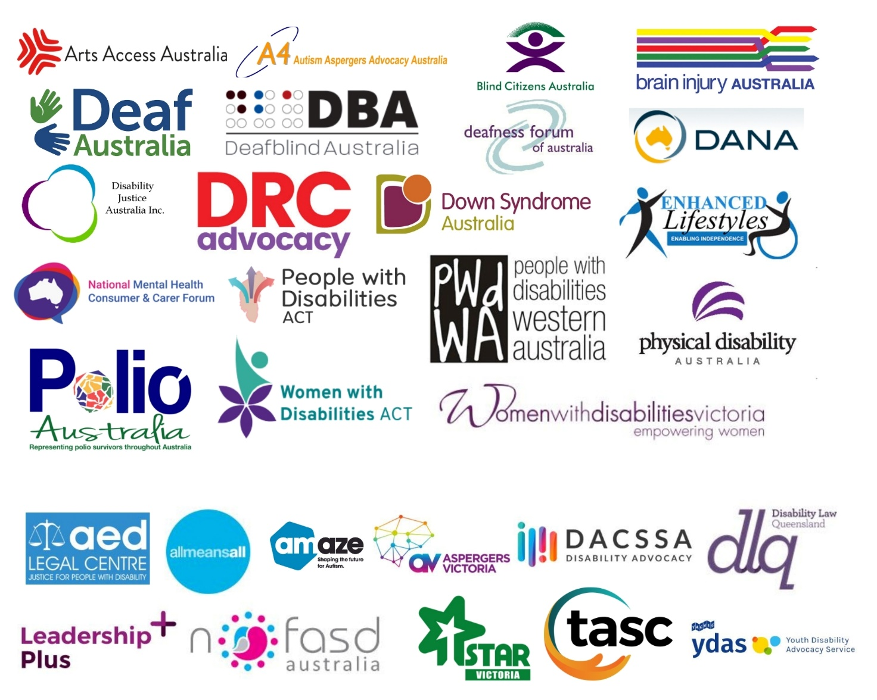

Acknowledgements
AFDO acknowledges Aboriginal and Torres Strait Islander people as the traditional custodians of the land on which we stand, recognising their continuing connection to land, waters, and community. From our head office in Melbourne, we pay our respects to the Bunurong Boon Wurrung and Wurundjeri Woi Wurrung peoples of the Eastern Kulin Nation and to their Elders past, present, and emerging. We also pay our respects to the traditional owners of all lands on which we operate or meet around the country.
AFDO acknowledges people with disability, particularly those individuals that have experienced or are continuing to experience violence, abuse, neglect, and exploitation. We also acknowledge their families, supporters, and representative organisations and express our thanks for the continuing work we all do in their support.
Report Author: Rebecca Rudd, Coordinator – Policy and Submissions
Review Team: TBC

Introductory comments
AFDO welcomes the opportunity to provide comment and thanks the Productivity Commission for their consideration of this submission. Informal carers perform a crucial role by reducing the need for professional renumerated care, although their value often fails to be captured by traditional measures of economic productivity. However, time spent on caregiving significantly limits carers’ ability to engage in employment or pursue higher education, with considerable financial and social consequences.
While this inquiry is primarily focused on the provision of aged care, AFDO would argue that this discussion is equally applicable to carers of people with disability, and so provision of entitlements should be extended to all carers, including carers of people with disability. Our use of the term “carer” in this submission will thus refer to all carers, including those of people with disability.
When speaking of carers in this context, we are largely referring to informal carers, that is, individuals who provide care within the context of an existing relationship, such as family members or friends. The majority of informal carers are unpaid. Per the Australian Bureau of Statistics (ABS) Survey of Disability, Ageing and Carers, in 2018 there were 2.65 million people who provided informal care in Australia. This equates to approximately 10% of the Australian population. Of these, roughly 1 in 3 carers were primary carers, meaning they provided the most care to the individual in one or more core activities. Primary carers equate to approximately 3.5% of the Australian population. In 2020, it was estimated that the population of informal carers had increased to almost 2.8 million; a 5.5% increase from 2018, attributable to population growth.
Certain demographic trends can be observed in the carer population. Carers are more likely to be women, with 12.3% of all females being carers versus 9.3% of all males. Of primary carers, more than 7 in 10 were women. This gender disparity increases with age, with women comprising 82% of carers aged 35-44, and 75% of carers aged 45-54. Carers are more than twice as likely than the rest of the population to have a disability themselves (37.4% versus 15.3%). Carers are also more likely to be of lower socio-economic status, with half (50.2%) of all carers living in a household in the lowest two income quintiles, twice that of non-carers (25.6%).
As these statistics demonstrate, carers are more likely to be from marginalised populations, and the burden of caring further compounds their marginalisation by reducing employment opportunities and confining them to a position of lower economic status.
Response to Position paper – Information Requests
AFDO’s primary critique of the Position paper is its failure to acknowledge the simple reality that informal care cannot and should not serve as a substitute for formal care. By limiting discussion to only unpaid carer leave arrangements, the Paper considers them in a vacuum, thus precluding a more systemic view of the issue and neglecting to consider the broader context of systems that may affect whether informal caregivers find the proposed changes to the National Employment Standards (NES) helpful or valuable.
Though beyond the scope of this inquiry, greater benefit would be found in addressing the lack of institutional support for people with disability, older people, and others requiring care, and the burden this then places on their informal caregivers. Critically, in order for informal care arrangements to be both sustainable and beneficial, they must occur alongside the provision of quality and appropriate formal care.

Information Request 1:
The durations of leave carers are most likely to want to access extended unpaid carer leave.
The nature of disability is diverse and at times unpredictable. Many health conditions and disabilities are fluctuating in nature, meaning that the demand placed on carers’ time can be variable and inconsistent. While some of these situations may be planned for, other crises or unexpected events can arise suddenly, making the four-week notice requirement for leave problematic. Additionally, some informal caregivers may prefer shorter periods of leave, but have no option other than using up their annual or sick leave or taking unpaid leave. When caregivers repeatedly take time off to fulfill their caring duties, they may eventually be forced to quit their job or switch to part-time employment sooner than anticipated, with implications for social and financial health and wellbeing.
The burden of caring is reflected in the workforce participation rates of carers, who are often forced to reduce their hours worked or withdraw from the labour force entirely. In 2018, among carers aged 15-64 years, 7 in 10 (70.8%) were in the labour force. Primary carers were less likely to be employed (58.8%) versus non-primary carers (76.6%) and non-carers (81.5%). The gender disparity is again reflected here, with 71.8% of male carers being employed versus 63.2% of female carers. Among primary carers aged 15-64, roughly half were employed (55.5%), however their employment status varied with the hours of care provided per week. Of primary carers providing more than 40 hours of care per week, less than one third (28.6%) were employed. This figure increased to over half (52.8%) among those providing less than 20 hours of care per week. These lower rates of employment were naturally reflected in household incomes of carers. In 2018, the median gross income of all carers was $800 per week, compared to $997 for non-carers. Primary carers were more than twice as likely (38.4%) to receive a government pension than other carers (17.2%) and non-carers (9.2%).
Research has indicated that the impact of care in relation to work stress is context-dependent, varying with the hours of care provided and the trajectory of said care. The financial burden of caring contributed to stress at work, and informal carers who worked more hours were more likely to experience higher levels of stress. These findings suggest that the negative impact that balancing work and care can have upon wellbeing is exacerbated under certain contexts, such as when the carer’s finances or work performance are affected. More positively, when care hours were not excessive, care provision was linked to better subjective well-being and reduced levels of perceived work-related stress.
Balancing work and care is also associated with significant opportunity cost. Opportunity cost measures the formal sector productivity losses associated with caring, as time spent on caring responsibilities cannot be spent in the paid workforce. In Australia, an estimated 160,900 primary carers and 53,000 non-primary carers are assumed to not be in paid employment due to their caring duties. This is equivalent to approximately 1.51% of Australia’s labour force. In 2020, the estimated missed earnings for these primary and non-primary carers was $11.4 billion and $3.8 billion respectively. Combined, this amounts to an opportunity cost of $15.2 billion; approximately 0.8% of Australia’s GDP and 10.6% of the value of formal health care. As these figures make clear, the burden of balancing work and informal care has significant repercussions not only for individual carers and recipients, but for the economy as a whole.
Given the variable nature of caring, it is critical that any amendments to carer leave entitlements be flexible, and not exclude those whose care obligations do not fit into a narrowly defined bureaucratic category.

Information Request 2:
The expected effects on carers of upcoming changes to the flexible working arrangements provisions of the Fair Work Act 2009.
The Covid-19 crisis served to shine a light on the struggle that many carers face in attempting to balance their work and caring responsibilities. In doing so, it also revealed the potential that flexible work practices have to help mitigate this burden. Post-covid workplaces now have an opportunity to embed flexibility and enable caring to be shared equally within households, advancing gender equality and enabling all carers to make valuable contributions in the workforce and in public life more broadly.
Flexible workplace provisions have great potential to reduce the strain experienced by working carers, providing a range of benefits to both employees and employers, as well as Australian society as a whole. These include:
- Reduced costs of employee turnover: the financial impact of staff turnover is considerable, costing approximately one-third of the annual salary of an employee. By providing flexibility that enables staff to balance their work and caring responsibilities, employers are more likely to retain experienced employees, reducing costs associated with recruitment, training, and resulting loss of productivity.
- Increased productivity: implementing flexible work practices can enable organisations to focus on outputs and outcomes, rather than hours worked. This can help to clarify tasks and encourage multi-skilling across teams. Less stressed employees are almost more likely to be productive.
- Improved service delivery: employees who feel appreciated and looked after are more likely to look after clients and customers. Flexible provisions such as extended start and finish times can also enhance customer experience by enabling the provision of services outside of standard business hours.
- Reducing employee stress and absenteeism: employees who cannot access flexible work practices will more often resort to taking personal leave to deal with their caring responsibilities. By providing employees with options to help them balance work and care, and encouraging them to take up these provisions, employers can reduce stress on carers and subsequent staff absenteeism.
- Attracting quality workers: implementing flexible working arrangements has been found to not only benefit existing employees, but also serves as an incentive for prospective employees to choose a particular employer.
- Increased staff morale: staff who feel supported by their employer are more likely to be loyal and productive workers. Investing in services and supports for staff that foster a positive environment will improve the workplace experience of all employees, and this culture can flow through the entire organisation.
- Building a resilient workforce: providing staff with information about caring will help to build their resilience to potential change and may improve their capacity to keep working if they need to take on a caring role.

Additional ways to support informal carers, beyond those discussed in this position paper.
The research literature examining work and care suggests a number of strategies to better support working carers in balancing their responsibilities. In their survey Juggling caring, parenting and work: Lessons for the post-COVID workplace, the Victorian Equal Opportunity and Human Rights Commission identified five key strategies to ease the burden on working carers. While these strategies are based on the Victorian context, they are easily generalisable to Australia as a whole:
- Explore opportunities for free, accessible, and adequately funded childcare to support greater workforce participation by parents, particularly women, who often face a dual burden with regard to caring responsibilities.
- Embed flexible work as part of a business-as-usual approach, enabling parents and carers to better balance and share caring responsibilities.
- Ensure workplace equality is prioritised by the Victorian Government as part of its response to COVID-19 and recovery efforts.
- Invest in strategies to transform societal attitudes towards unpaid caring and parenting, to adequately ascribe value to the ‘second shift’ many workers perform outside of their formal working hours.
- Strengthen enforcement of the Equal Opportunity Act to better protect parents and carers from discrimination.
In addition to these strategies, the financial difficulties encountered by carers could be partially mitigated by increasing income support payments through the Carer’s Payment.

Response to Position paper - Recommendations
Draft recommendation 1: Providing information about how to request flexible work to working carers.
The Australian Government should ensure that carers of older people are provided with tailored information about flexible working arrangements and how to request them. This should include, at a minimum:
- Developing fact sheets designed to help carers talk to their employer about flexible work. The fact sheets should take into account upcoming changes to flexible work provisions of the Fair Work Act 2009.
- Routinely providing the fact sheets to carers at key points in time, such as when they contact the Carer Gateway.
AFDO response:
- This recommendation should be expanded to include carers of people with disability; that is, the fact sheets should include information relevant to carers of people with disability and should be made equally available to people with disability.
- In addition, carers should be further provided with individualised support and assistance to enable their return to the workforce when their caring duties have ended.
Draft recommendation 2: Reviewing definitions of care relationships in the National Employment Standards.
The definition of ‘carer’ in the National Employment Standards is used for both paid and unpaid carer leave. Changing this definition is beyond the scope of this inquiry. But the current definition only guarantees carer leave to employees providing care for an immediate family or household member. This can mean that people whose care relationships are broader than their immediate family or household (such as nieces, nephews, people with Aboriginal or Torres Strait Islander kin relationships or families of choice) are unable to access leave to provide care, and potential care recipients receive less care.
To address this, the Australian Government should review the eligibility restrictions in the National Employment Standards which limit access to carer leave based on strictly defined relationships between the employee and the person they care for. The review should look at how to amend the eligibility restrictions so that they better reflect the diverse caring relationships of Australian families, friends and communities, and reduce the extent to which carers are excluded from accessing key workplace supports.
AFDO response:
- AFDO agrees that the Australian Government should amend the eligibility restrictions in the NES to better reflect the diverse reality of caring relationships. The current definition excludes many care relationships, leaving both the caregiver and the recipient of care without support.

References
Australian Bureau of Statistics (ABS) (2019) Disability, Ageing and Carers, Australia: Summary of Findings, 2018. ABS cat. no. 4430. Canberra: ABS.
Carers Australia (2022) Carers in the Workplace, Accessed 15 September 2022.
<https://www.carersaustralia.com.au/about-carers/carers-in-the-workplace/>
Cheng, Z., Jepsen, D. M. & Wang, B. (2020) ‘A dynamic analysis of informal elder caregiving and employee wellbeing,’ Journal of Business and Psychology, 35: 85–98.
Deloitte & Carers Australia (2020) The value of informal care in 2020, Accessed 15 September 2022.
<https://www.carersaustralia.com.au/wp-content/uploads/2020/07/FINAL-Value-of-Informal-Care-22-May-2020_No-CIC.pdf>
Dugan, A. G., Barnes-Farrell, J. L., Fortinsky, R. H. & Cherniack, M. G. (2020) ‘Acquired and persistent eldercare demands: Impact on worker well-being’, Journal of Applied Gerontology, 39(4): 357–367.
Ghaffar, A. (2020) ‘The impact of the financial cost of caring for greying on emotional exhaustion in the workplace: The mediating role of stress’, Turkish Journal of Business Ethics, 13(1): 1–22.
Kim, J., Ingersoll-Dayton, B. & Kwak, M. (2011) ‘Balancing eldercare and employment: The role of work interruptions and supportive employers’, Journal of Applied Gerontology, 32(3): 347–369.
Lam, W. W. Y., Nielson, K., Sprigg, C. A. & Kelly, C. M. (2022) ‘The demands and resources of working informal caregivers of older people: A systematic review’, Work & Stress, 36(1): 105-127.
Reid, R. C., Stajduhar, K. I. & Chappell, N. L. (2010) ‘The impact of work interferences on family caregiver outcomes’, Journal of Applied Gerontology, 29(3): 267–289.
Trukeschitz, B., Schneider, U., Muhlmann, R. & Ponocny, I. (2013) ‘Informal eldercare and work-related strain’, Journals of Gerontology - Series B Psychological Sciences and Social Sciences, 68(2): 257–267.
Victorian Equal Opportunity and Human Rights Commission (2021) Juggling caring, parenting and work: Lessons for the post-COVID workplace, Accessed 15 September 2022. <https://www.deafnessforum.org.au/wp-content/uploads/2021/08/Parents-and-carers-Lessons-for-the-post-COVID-workplace.pdf>
Zacher, H., Jimmieson, N. L. & Winter, G. (2012) ‘Eldercare demands, mental health, and work performance: The moderating role of satisfaction with eldercare tasks’, Journal of Occupational Health Psychology, 17(1): 52–64.

ABS 2019.
Ibid.
Ibid.
Ibid.
Ibid.
Ibid.
ABS 2019.
Ibid.
ABS 2019.
Ibid.
Dugan et al. 2016; Trukeschitz et al. 2013.
Ghaffar 2020.
Kim et al. 2011.
Lam et al. 2022.
Cheng et al. 2020; Trukeschitz et al. 2013.
Deloitte & Carers Australia 2020.
Ibid.
Victorian Equal Opportunity and Human Rights Commission 2021.
Carers Australia 2022.
Victorian Equal Opportunity and Human Rights Commission 2021.

