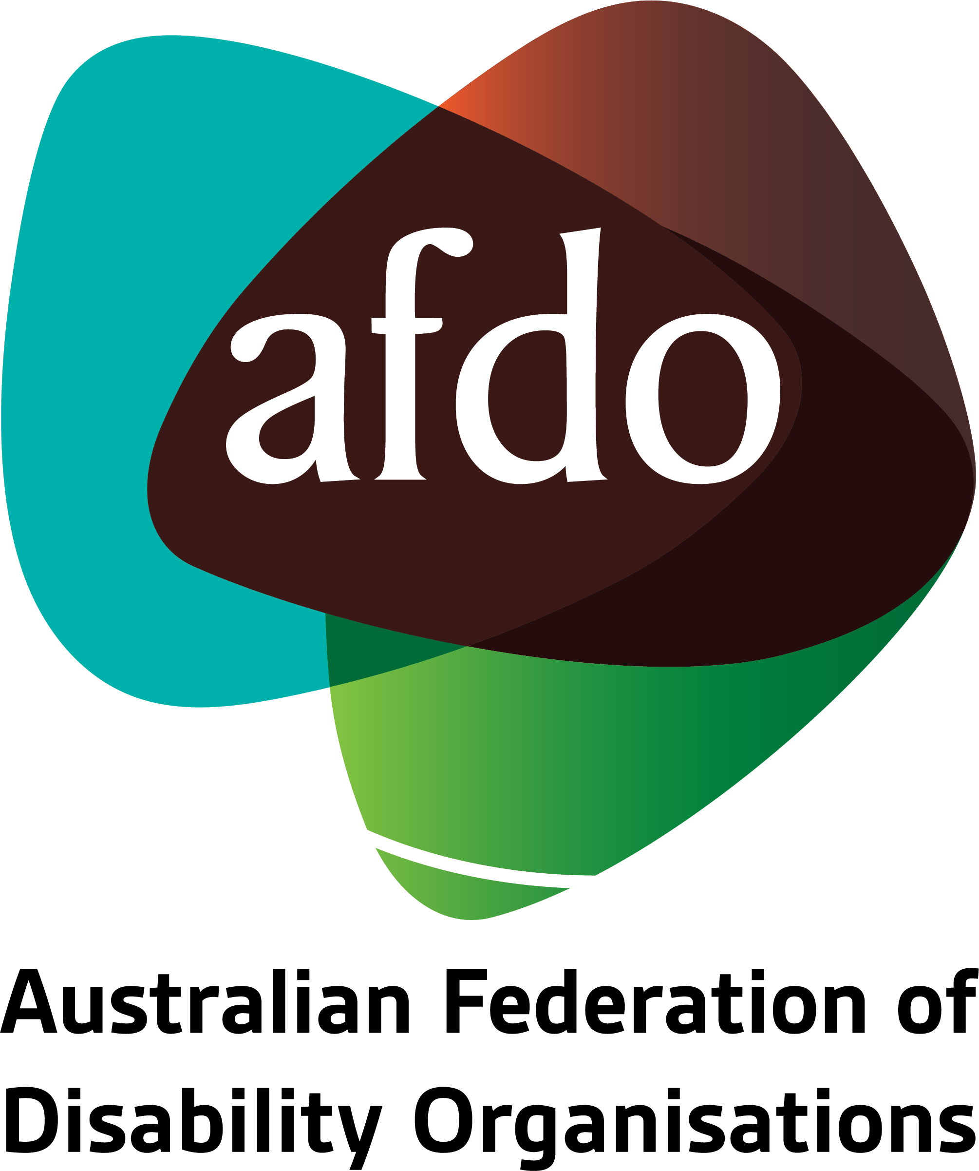

Disability Employment Services Quality Framework
Response to Discussion Paper

March 2023

Table of Contents
Response to Discussion Paper 1
About AFDO 3
Our members 4
Acknowledgements 6
Summary of recommendations 7
Introduction 9
Overall Considerations 10
What characterises excellent quality? 10
Exploring the Quality Elements 17

About AFDO
Since 2003, the Australian Federation of Disability Organisations (AFDO), a Disabled Peoples Organisation (DPO) and Disability Representative Organisation (DRO), has been the recognised national peak organisation in the disability sector, along with its disability specific members, representing people with disability. AFDO’s mission is to champion the rights of people with disability in Australia and support them to participate fully in Australian life.
Our member organisations represent disability specific communities with a total reach of over 3.8 million Australians.
AFDO continues to provide a strong, trusted, independent voice for the disability sector on national policy, inquiries, submissions, systemic advocacy and advisory on government initiatives with the Federal and State/Territory governments.
We work to develop a community where people with disability can participate in all aspects of social, economic, political and cultural life. This includes genuine participation in mainstream community life, the development of respectful and valued relationships, social and economic participation, and the opportunity to contribute as valued citizens.
Our vision
That all people with disabilities must be involved equally in all aspects of social, economic, political, and cultural life.
Our mission
Using the strength of our membership-based organisations to harness the collective power of uniting people with disability to change society into a community where everyone is equal.
Our strategic objectives
To represent the united voice of our members and people with disability in national initiatives and policy debate.
To enhance the profile, respect and reputation for AFDO through our members.
To build the capacity and sustainability of AFDO and our members.
To foster strong collaboration and engagement between our members and stakeholders.
To enhance AFDO's connection and influence in international disability initiatives, particularly in the Asia Pacific region, through policy, advocacy and engagement.

Our members
Full members:
- Arts Access Australia
- Autism Aspergers Advocacy Australia
- Blind Citizens Australia
- Brain Injury Australia
- Deaf Australia
- Deafblind Australia
- Deafness Forum of Australia
- Down Syndrome Australia
- Disability Advocacy Network Australia
- Disability Justice Australia
- Disability Resources Centre
- Enhanced Lifestyles
- Multiple Sclerosis Australia
- National Mental Health Consumer and Carer Forum (NMHCCF)
- People with Disability WA
- People with Disabilities ACT
- Polio Australia
- Physical Disability Australia
- Women with Disabilities Victoria
- Women with Disabilities ACT

Associate members:
- AED Legal Centre
- All Means All
- Amaze
- Aspergers Victoria
- Disability Advocacy and Complaints Service of South Australia (DACSSA)
- Leadership Plus
- National Organisation for Fetal Alcohol Spectrum Disorder (NOFASD)
- Star Victoria
- TASC National Limited
- YDAS – Youth Disability Advocacy Service

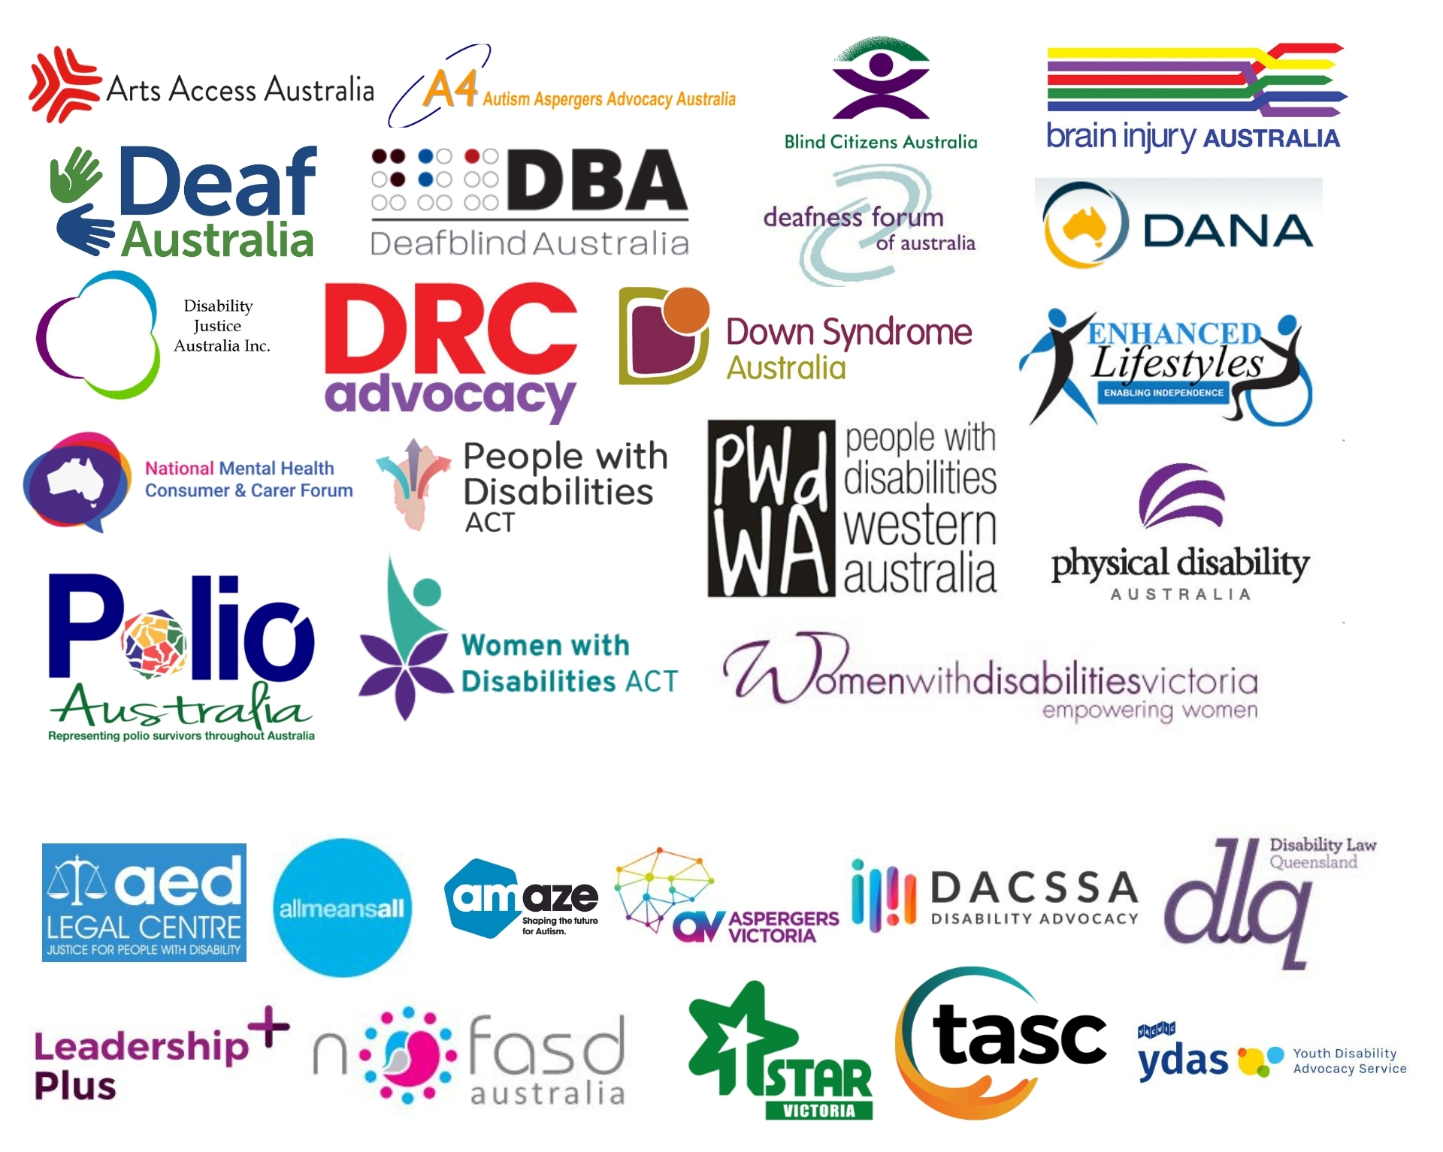

Acknowledgements
AFDO acknowledges Aboriginal and Torres Strait Islander people as the traditional custodians of the land on which we stand, recognising their continuing connection to land, waters, and community. From our head office in Melbourne, we pay our respects to the Bunurong Boon Wurrung and Wurundjeri Woi Wurrung peoples of the Eastern Kulin Nation and to their Elders past, present, and emerging. We also pay our respects to the traditional owners of all lands on which we operate or meet around the country.
AFDO acknowledges people with disability, particularly those individuals that have experienced or are continuing to experience violence, abuse, neglect, and exploitation. We also acknowledge their families, supporters, and representative organisations and express our thanks for the continuing work we all do in their support.

Report Author: Jessica Zammit – AFDO Expert Advisor on Inclusive Employment
Report Review: Ross Joyce – Chief Executive Officer
Lauren Henley – Senior Systemic Advocate

Report Contribution Acknowledgement:
AFDO recognises and thanks its membership for contributing their invaluable expertise, as well as their respective organisations membership lived experience and expertise into this submission.
We would also like to thank our colleagues at Disability Employment Australia, with whom we have an active MOU, for sharing their understanding, expertise and member experience as the peak organisation for the majority of DES service providers across Australia.

Summary of recommendations
- The Department must clearly define what “excellent quality” looks like from the perspective of people with disability and service providers.

- The draft framework places a strong emphasis on compliance, which does not always guarantee quality. The new framework must be underpinned by consumer-led, strengths-based language that focuses on the goal of getting people with disability into open employment that is aligned with their skills and aspirations.

- The draft Framework must be updated to include an additional quality element. This would appear as quality element 1 and would read: "Partnering with people with disability, their families, carers, and kin in a genuine co-design process.”

- Noting that the full suite of reforms will not be completed until 2025, it is critical that the new quality framework includes a transparent review mechanism, with a review at 12 months to collect the experiences of people with disability and their families, providers, and employers to determine the effectiveness of the Framework to date.
- The Department must remain cognisant of other related reform agendas to avoid duplication or unnecessary regulatory burden. Such as; the review and refresh of the Commonwealth Disability Services Act and the development of the National Disability Data Asset.
- AFDO supports the recognition of providers that are not only meeting, but exceeding, the parameters of the Framework. This enables providers to stand out in a competitive market and provides participants with confidence that they are selecting an effective provider.

- AFDO broadly supports the idea of earned autonomy, noting that this point will require more in-depth negotiation with the sector.

- Quality should be measured by independent researchers to address the potential conflict of interest of provider supplied or commissioned data.

- AFDO supports the co-development of information resources with other peak bodies, as well as the subsequent future development and/or refinement of materials with DES participants.

- The Department must work to develop a long-term funding strategy to ensure the effective resourcing, and sustainability of disability advocacy services; including both individual and systemic advocacy services.

- The Department consider partnering with AFDO and Disability Employment Australia through our existing Memorandum of Understanding, to roll out additional training to providers.

- AFDO supports the proposed introduction of a ‘Reasonable Adjustments’ quality indicator.

- AFDO supports the proposed development of service quality benchmarks and is in a unique position to lead a co-design process around the development of these benchmarks based on our significant experience in delivering our Business Inclusion & Diversity Services program for over eight years.

- As the frequency of collection for the NSDS standard is not within scope for change, AFDO recommends that the number of complaints received (via CRSS, by the Department and at a service level) as a proportion of caseload, resolution timeliness, and participant satisfaction with the resolution of the complaint, should be reviewed at a minimum at least every 12 months.

- AFDO supports the idea of a mechanism for providers to provide feedback to the Department. This mechanism should allow for anonymous feedback from individual DES staff to capture grassroots insights and identify where improvements can be made.

- The Department should undertake annual reporting around key feedback trends and how recommendations will be incorporated. With performance reporting taking place either quarterly or a minimum of twice per year.

- AFDO is supportive of the use of quality scorecards, provided scores are based on metrics that are useful to jobseekers with disability and confirmed by people with disability and their representative organisations prior to any implementation.

Introduction
AFDO welcomes the proposed introduction of a Quality Framework (the Framework) as part of the broader Disability Employment Services (DES) reform agenda.
AFDO has prepared the following submission in response to the Discussion Paper, with recommendations to maximise the effectiveness of the Framework with both participants and providers in mind.
Rather than respond to all questions posed, we have provided considered responses to questions where we have insight or suggestions to enhance the Framework.

Overall Considerations

What characterises excellent quality?

While AFDO sees a number of promising elements to the Framework, the definition of what excellent quality looks like in practice is unclear.
For people with disability and their families – the very people at the centre of the model – quality includes, but is not limited to:
- Securing employment opportunities that align with the skills and interests of participants - the most important indicator of quality. Without this at the heart of the Framework, the intent of DES is unable to be achieved, with the below characteristics less meaningful.
- A relationship built on trust and respect (participants, DES providers, and employers).
- Active listening and seeking to understand the lived experience and aspirations of each participant.
- Investing in a genuine discovery process by getting to know a person’s strengths and interests, their contributions, and the conditions needed for success.
- Disability awareness and knowledge of different disabilities, recognising that each person will experience disability differently, with different needs and aspirations.
- Supportive goal setting, with clear steps to achieve goals and evidence of progress.
- Championing skills and experience to potential employers.
- Providing support in the lead up, during, and post placement.
- Understanding the labour market and other concurrent support systems.
- Continuous improvement embedded within the culture and practices of the organisation.
- A focus on tangible outcomes (people in genuine long term work) rather than just outputs.
- Communicates in an inclusive and accessible way (interpersonal communication, written word and other forms of communication).
For employers, quality includes:
- A provider that is responsive and supportive.
- Understanding the labour market, industry requirements, and skill needs.
- Understanding the culture of an employer.
- Identifying suitable candidates that meet their requirements, with a smooth, seamless transition into employment.
- Providing post placement support and assistance to resolve any issues occurring in the workplace.

Recommendation 1:
The Department must clearly define what “excellent quality” looks like from the perspective of people with disability and service providers.

The Discussion Paper places a strong focus on compliance, which in and of itself does not guarantee quality. The ultimate objective is to get people with disability into open employment that is aligned with their skills and aspirations, with high levels of satisfaction from both participants and employers. These markers need to be reflected in the proposed new Framework.
As noted by the National Mental Health Consumer and Carer Forum relating to this point:
“The discussion paper for the quality framework still appears to be coming from a narrow medicolegal risk approach, which will ensure the continuation of the DES Program being predicated on a risk-based autonomy-earned model. There is inherent danger in taking this approach at a governance level because it continues to trickle down to scheme participants, blames victims, and ultimately leaves participants open to the exploitation the Disability Royal Commission has previously uncovered.
The idea of a ‘quality process’ needs to be thought of beyond "not putting vulnerable people at greater risk". Inversely, when this is the focus, it creates more risk.
It is vital that consumer-led, strengths-based language is embedded within the framework itself, which makes the necessary shift away from the thinking that punitive remediation is the only way to ensure one’s human rights are respected.
The NMHCCF in partnership with MHLEEN are in the process of launching a governance framework document for entities working with people with lived experience of mental ill-health and their families, carers, and kin. It is designed to sit alongside corporate and financial governance frameworks with all types of bodies, committees, and organisations to ensure lived experience is involved in all processes and at all levels.
This framework advises a human, compassionate approach to helping those who need assistance and advancing their interests, rather than coming from an approach that is fear-based, risk-averse and preservational. Once published, this can be used as a useful resource to inform the Quality Framework of the DES Program”.

Genuine co-design

While AFDO recognises that the Discussion Paper seeks the feedback of people with disability and their families, providers, and other interested parties, the process used has not placed consumers and their representative organisations at the centre (i.e. designing the parameters of the Framework with consumers prior to a discussion paper being released) and has not taken into account people with disability who require more support to provide informed feedback.
People with an intellectual disability may find it more difficult to provide feedback to this process without the intensive support (time and resources) of organisations that represent their needs and aspirations. We refer the Department to Inclusion Australia’s submission regarding their specific concerns.
People who require information in other formats, such as Auslan, do not have access to the paper in a format that is inclusive. It is imperative that the next stage of the process is fully inclusive.
In addition to co-design of future engagement regarding the Framework that is inclusive of people with disability and their representative organisations, AFDO’s members recommend a sixth Quality Element (which would be numbered 1 as a Quality Element) - Partnering with people with disability, their families, carers, and kin in a genuine co-design process. This ensures that the markers of quality, outlined above, are adequately captured.
Recommendation 2:
The draft framework places a strong emphasis on compliance, which does not always guarantee quality. The new framework must be underpinned by consumer-led, strengths-based language that focuses on the goal of getting people with disability into open employment that is aligned with their skills and aspirations.

Recommendation 3:
The draft Framework must be updated to include an additional quality element. This would appear as quality element 1, and would read: "Partnering with people with disability, their families, carers, and kin in a genuine co-design process."

Timing of the release of the Framework

The Framework is set to be developed prior to significant reforms of DES, presenting a risk that the Framework may not be fit for purpose in 2025. AFDO recognises that the introduction of a Quality Framework, at this time, seeks to improve outcomes for participants, rather than remain in a holding pattern until the reforms are complete.
It is therefore essential that:
- A transparent review mechanism is built into the Framework, with a review at 12 months to collect the experiences of people with disability and their families, providers, and employers to determine the effectiveness of the Framework to date.
- Co-design is built in to make improvements to the Framework to reflect the new DES rollout and address any concerns and issues.
Recommendation 4:
Noting that the full suite of reforms will not be completed until 2025, it is critical that the new quality framework includes a transparent review mechanism, with a review at 12 months to collect the experiences of people with disability and their families, providers, and employers to determine the effectiveness of the Framework to date.

Compatibility with other reforms

There are a number of reforms and reviews happening concurrently to the development of the Framework. This includes attempts to align the Disability Services Act and Australia’s Disability Strategy 2021-2031 Outcomes Framework to the United Nations Sustainable Development Goals – Convention on the Rights of Persons with Disabilities. The development of this Framework should be cognisant of these reforms to minimise duplication - if the agreed regulatory processes and legislation are based within a human rights framework then the DES program, and this Framework, should naturally follow suit.
Likewise, reforms are currently underway in the mental health sector. Alignment is needed to ensure that we do not create additional regulatory burdens and ensure a continuum of support for people with disability, people with a mental health condition and their families, as well as clarity for providers.
Recommendation 5:
The Department must remain cognisant of other related reform agendas to avoid duplication or unnecessary regulatory burden. Examples include the review and refresh of the Commonwealth Disability Services Act and the development of the National Disability Data Asset.

First Nations Inclusion

First Nations people with disability face additional difficulties in finding and retaining employment. DES who have clients with a First Nation background must ensure their approaches are culturally sensitive and address the unique situations and challenges in accessing the labour market. Further guidelines and development may be needed in this area with relevant advocates such as the First Nations Disability Network.
Further cultural sensitivities may need to be addressed with clients from CALD backgrounds and LGBTQI+ communities.

An application-based model for demonstrating quality

AFDO supports the recognition of providers that are not only meeting, but exceeding, the parameters of the Framework. This enables providers to stand out in a competitive market and provides participants with confidence that they are selecting an effective provider.
Recommendation 6:
AFDO supports the recognition of providers that are not only meeting, but exceeding, the parameters of the Framework. This enables providers to stand out in a competitive market and provides participants with confidence that they are selecting an effective provider.

Earned autonomy – how can quality be demonstrated?

AFDO and our membership broadly supports the idea of “earned autonomy”, noting the need for further detail and significant reservations expressed by AFDO member Physical Disability Australia (please refer to PDA’s own submission regarding their concerns).
Providers that consistently attain the top-most rating, i.e., three times consecutively, could be considered eligible for less frequent reporting (noting that this will depend on the frequency of reporting i.e., annually). This approach rewards providers who are going above and beyond agreed requirements.
If a provider continues to sustain a high level of compliance to the Framework, a less frequent reporting timeline could continue. Where a provider’s rating drops, a conversation with the provider exploring current circumstances and mitigation strategies is recommended, prior to more intensive reporting being reinstated.
Our recommendation recognises that reporting can be time and resource intensive for providers that may already be spread thin – more time on reporting can mean less time and fewer resources directed to service delivery that is customised and supportive. This consideration seeks to strike a balance: ensuring participants can identify high quality providers, while rewarding the efforts of providers who are exceeding agreed requirements.
Recommendation 7:
AFDO broadly supports the idea of earned autonomy, noting that this point will require more in-depth negotiation with the sector.

Demonstrating quality before additional flexibility is granted

Below are some considerations of potential measures. Rather than set a prescriptive list of measures, AFDO considers the value of a more open-ended approach, enabling providers to innovate in how they deliver and improve their service quality over time.
While AFDO recognises that this may make it more difficult for the Department to compare providers like for like, key principles could be adopted to enable comparison. These might include:
- Providers actively implementing measures to improve employment outcomes and the delivery of their service, with evidence that:
- actions are underway;
- progress is being achieved; and
- improvements have been made, resulting in an increase in employment outcomes and increased participant satisfaction.
- Providers are showing growth and maturity in how they deliver their services (testing new approaches and refining service delivery), with satisfaction reported by participants.
- Participant satisfaction remains consistent and improves over time.
As noted, relaxing of requirements would require consistent high performance and scoring.
Potential voluntary measures might include:
- Consumer panels, with evidence that recommendations have been incorporated into business improvement processes.
- Customised mentoring programs, including mentoring on the job. A recent survey by Aspergers Victoria highlighted the value of a job coach with specific understanding of Aspergers and autism.
- Specialist work-readiness programs – again, supported by Aspergers Victoria members.
- Work sampling and customised employment programs (including specialist expertise related to job carving for people with intellectual disability).
- Collection or aggregation of feedback through online channels (positive and negative) in addition to surveys, with evidence of how feedback has been incorporated into business improvement processes.
- Improvements to resolution processes (this could include responsiveness to complaints, thoroughness of investigating and resolving issues, participant satisfaction regarding complaints handling, etc.).
- Demonstrated growth in the number of participants choosing to use the service provider, with satisfaction remaining high with increased numbers.
- Evidence of measures to improve staff retention (this could take the form of anonymous staff surveys, actions taken to improve retention and satisfaction based on staff feedback, skill enhancement and professional development, recognition and rewards, internal promotions).
- Staff satisfaction is above 75% and remains consistent (or increases) over the contractual period.
- Outlets for feedback from family, carers and kin through surveys or interviews
Our recommendation for greater flexibility enables providers to identify and implement measures that are the best fit for their service, rather than take part in a ‘tick and flick’ exercise, resulting in a greater genuine choice for participants.
Importantly, quality should be measured by independent researchers to address the potential conflict of interest of provider supplied or commissioned data. We would welcome the opportunity to explore how AFDO and its members can offer neutral, nuanced assessment of quality in DES provision for people with disability across Australia.

Recommendation 8:
Quality should be measured by independent researchers to address the potential conflict of interest of provider supplied or commissioned data.

What kind of flexibility would be appropriate?

Potential flexibility could include less frequent reporting (for example, bi-annual to annual reporting). Alternatively, this could take the form of shorter or less time-intensive reporting requirements (for example, a smaller series of questions that demonstrate that the provider remains on track and has adequate systems in place that can be verified).
Again, this should be worked through with relevant engagement and input from the disability sector representative organisations.

Exploring the Quality Elements
Quality Element 1: Participant Rights
What other indicators or measures could be used to monitor and assess the practical application of DES participants’ human rights?
Participation and inclusion, and the ‘right to dignity and risk’, could be measured via questions relating to the perceived level of self-direction that a participant is able to exercise in achieving their employment goals. Questions could include whether the consumer feels that:
- They were able to set their own goals.
- The support offered was informed, objective, and helpful in achieving their goals (informed by facts and job availability rather than opinions).
- They are making progress in achieving their goals (if goals have not yet been achieved).
To ensure the full inclusion of people experiencing a mental health condition, the National Mental Health Consumer and Carer Forum (NMHCCF) recommend compatibility with the National Framework for Recovery-oriented Mental Health Services: A Guide for Practitioners and Providers which outlines numerous indicators and measures that can be used to assess the application of DES participants’ human rights.

Developing participant surveys

AFDO recommends that surveys be co-designed with participants and disability representative organisations to maximise their take up and effectiveness. At minimum, surveys should:
- Be short in length.
- Include a supporting statement indicating why the information is being collected, who will read the information, and how it will be used
- Be used sparingly to ensure that participants are not excessively surveyed (undertaken no more than two times per year).
- Written in plain language, with no jargon.
- Provide examples to support each question.
- Provide the option to opt out of surveys.
- Undertaken by independent researchers, noting our earlier concerns.
The NMHCCF recommend the National Safety and Quality Mental Health (NSQMH) Standards for Community Managed Organisations (CMOs) as an example of how people with mental health conditions, their families, carers, and kin are informed and involved in safeguarding their own human rights as a priority by a service.
NMHCCF recommend that surveys also consider the views of families, carers, and kin during visits to collect feedback on services and any issues they, or their loved one, have experienced. This approach recognises that family and supports are program participants by proxy, also requiring adjustments and support.

Information resources for participants

Ensuring participants and their families are informed of their rights, and the supports available to them, requires time and a dedicated approach.
Consider the NDIS, which has been in operation for almost a decade: while some people with disability and their families are comfortable making a plan, purchasing supports, and problem solving with providers (and moving between providers), many people with disability continue to find the process daunting, unclear, and challenging.
The upcoming reforms of DES also mean that participants’ current understanding of the system may be upended. Providing information resources alone will not lead to an informed consumer, with a dedicated budget and resources needed to enable consumers to learn in ways that meet their needs. This includes resourcing of the consumer and carer sector to provide information via a range of methods that are clear to the people they represent (this could include small group consultations) and provider resourcing.
AFDO supports the co-development of information resources with peak bodies, as well as the subsequent future development and/or refinement of materials with DES participants. AFDO recommends that information that is developed is multi-layered, taking into account the complexity that comes with choosing the right provider based on an individual’s circumstances.
This multi-layered approach should consider initial information provided at the first point of contact. Messaging should be clear and in plain language, touching on topics including:
- What is an employment service provider?
- What should I expect of a provider?
- What providers can I choose from?
- How do I know if a provider is any good?
- How can I make an informed choice?
- Where can I access independent information?
- What support can I expect?
- In which areas can I exercise choice?
Second and third layers should be individualised, covering topics including:
- What if I have a complaint?
- Who do I speak with if I am worried about my rights or feel unsafe?
This should be followed by a list of providers relevant to the jobseeker in terms of job aspiration, region, and factors determined by the jobseeker as important; provider performance (ratings, reviews) and how other providers can be selected, if those listed are unsatisfactory. Information should also be provided of independent advisory channels to assist with making an informed decision, outlined in more detail further below.
Information for jobseekers must be underpinned by universal design principles. Information, particularly for the first stage, must be available in a variety of formats, such as large print, Easy English, Auslan, captioned videos, and Braille.
Additional resources that could be useful include:
- A participant journey outlining the steps of engaging with a provider and expectations of providers at each stage.
- ‘What to expect’ factsheet outlining the responsibilities and obligations of providers and participants, including mandatory expectations (e.g., active engagement with a DES provider to receive income support; respectful interaction with staff that is free from discrimination in any form, etc.) and voluntary expectations (e.g., the ability to choose how to engage with a DES provider, such as in person, over the phone, or online) in agreement with the provider.
- Case studies across a wide variety of industries where employment outcomes have been achieved, with the steps taken to secure employment.
Dissemination of information should be wider than government sites, with arrangements negotiated with national people with disability and family led organisations and provider bodies. As noted, factsheets, portals, and provider information alone will not in and of themselves lead to good decision-making or outcomes.
Up to this point, people with disability have been largely subject to systems designed to assist them rather than exercising real choice and decision-making capability - in employment settings, people with disability have been chronically disempowered and discouraged from exercising active decision-making due to a highly regulated compliance system.
Dismantling consumer passivity is a slow process, evident in the continuing but lessening passivity of people with disability that has resulted from the closure of institutions, introduction of voting rights, and greater accessibility of the built environment. Confidence and informed decision-making require time and genuine investment which has not been factored into the proposed Framework.
As has become evident with the rollout of the NDIS, independent information available to people with disability is critical to ensure that decisions are well informed, independently made, and have the potential to lead to better outcomes.
From AFDO’s work in building NDIS readiness of people with disability, resources and information hubs have not been enough, with people with disability seeking:
- Peer support networks of people with similar life experiences.
- Information that is dynamic and tailored to their needs with examples of what works and why.
- Workshops to build capability and understanding of the inner workings of the NDIS and opportunities to test ideas before a decision is made.
This role has been undertaken by people with disability and family led organisations, who are currently poorly resourced to provide the comprehensive support that is required at a time of significant change and increased decision-making by people with disability.
To genuinely improve outcomes, appropriate funding for disability representative organisations is needed to assist people with disability to think beyond current models (this work needs to begin now, noting the DES reforms are slated for 2025), to understand their rights, to hear about providers that are demonstrating excellence, to build aspiration and personal responsibility, and to know what to expect, and ask for, of service providers who are being paid to assist them.

Recommendation 9:
AFDO supports the co-development of information resources with other peak bodies, as well as the subsequent future development and/or refinement of materials with DES participants.
Recommendation 10:
The Department must work to develop a long-term funding strategy to ensure the effective resourcing, and sustainability of disability advocacy services, including both individual and systemic advocacy services.

Additional support measures for providers

Specialised disability awareness training could be particularly useful in supporting providers to provide more customised support to participants.
Over the last six years, AFDO has developed and refined a suite of training products, designed with small and time-poor businesses in mind. To date, training has been delivered to 185 businesses across Australia by trained professionals with disability, building the knowledge and confidence of small businesses to engage and employ people with a wide variety of disability.

AFDO has reviewed these modules with employment service providers in mind, working with Disability Employment Australia to explore rollout of training across Australia. AFDO member Brain Injury Australia are also working closely with DEA to build the knowledge of its members to best support people with an acquired brain injury.
Incorporating quality within the training modules could be a quick win for the Department and providers to ensure that staff are confident and comfortable to deliver customised support.
Recommendation 11:
The Department consider partnering with AFDO and Disability Employment Australia to roll out additional training to providers.

Quality Element 2: Quality of Service

AFDO supports the proposed introduction of a ‘Reasonable Adjustments’ quality indicator. AFDO also supports the collection of data from both participants and employers regarding their perceptions of service delivery.
Indicators that could be considered include:
- How well supported participants and employers feel in the lead up to a participant commencing employment and at three, six, 12, and 24 months post placement. Follow up beyond 12 months is important, with some employers noting that knowledge of where to access continued support can be lacking.
- Likeliness to use the services of the DES provider in the next 12 and 24 months.
- Likeliness to recommend to friends and family (DES participant), other employers and their networks (provider).
- How well the provider understands the business’ workforce requirements (measured via a Likert scale).
- The skill and culture fit of the employee within the business (Likert scale).
- Additional connections brokered by the provider to ensure a smooth experience (e.g., access to disability awareness training, connection to JobAccess, etc.).
Recommendation 12
AFDO supports the proposed introduction of a ‘Reasonable Adjustments’ quality indicator.

Service quality benchmarks

AFDO supports the proposed development of service quality benchmarks via a co-design process.
AFDO is in a unique position to have experience of both the needs of consumers and of employers through our rollout of our Business Inclusion & Diversity Services (BIDS), formerly named the Diversity Field Officer Service, engaging with 116 business across Australia to build their confidence and readiness to employ people with disability. AFDO has also formed an MOU with DEA to support continued capacity building of DES providers across Australia. AFDO has started the delivery of BIDS across two new areas, the Hunter Valley in NSW and across the entire ACT. In addition, we currently have this proven tertiary evaluated model operating under licence with Spinal Life Australia.
Disability peak bodies, as well as employment service provider representative bodies, should be involved from the very initial stages of the development of service quality benchmarks. AFDO is in a unique position to lead the co-design process, drawing on our connections and substantial on the ground experience with small to medium enterprises, the largest employer group in Australia.
Recommendation 13:
AFDO supports the proposed development of service quality benchmarks and is in a unique position to lead a co-design process around the development of the benchmarks.

Quality Element 3: Provider Capability and Governance

AFDO recommends minimal additional requirements with regard to capability and governance assurance beyond what is expected of any mainstream providers.
See Additional Support Measures for Providers.

Quality Element 4: Feedback and Complaints

Participants are more likely to make a complaint at a service level, rather than to the Department or via CRSS. The complaints process needs to be accessible and provide safety from negative consequences in making a complaint.

Audits currently occur every 36 months to meet compliance to NSDS Standard 4: Complaints and Feedback, which is a very long period of time. AFDO supports the proposal to include the views of participants and employers via surveys, detailed in this submission.
As the frequency of collection for the NSDS standard is not within scope for change, AFDO recommends that the number of complaints received (via CRSS, by the Department and at a service level) as a proportion of caseload, resolution timeliness, and participant satisfaction with the resolution of the complaint, should be reviewed at a minimum every 12 months.
A potential solution proposed by AFDO member Physical Disability Australia is to require DES providers to register as a NDIS Provider and expand the remit of the NDIS Commission to look into complaints from non-NDIS participant users of DES provider services. This aligns with our earlier recommendation that individual schemes/reforms ‘speak’ to one another and ideally leverage existing systems and processes.
An assessment of quality should be meaningful rather than a statistical measure alone. This includes a qualitative approach based on testimonies of unplaced and placed participants and employers sourced by an independent researcher.
Recommendation 13:
As the frequency of collection for the NSDS standard is not within scope for change, AFDO recommends that the number of complaints received (via CRSS, by the Department and at a service level) as a proportion of caseload, resolution timeliness, and participant satisfaction with the resolution of the complaint, should be reviewed at a minimum at least every 12 months.

Key considerations re: weighting and analysing feedback & complaints

The views of participants and employers via surveys should be given a minimum of 35% weighting – DES services are there, after all, to support people with disability and employers. Suggestions of potential survey metrics have been highlighted earlier in this document.
Weighting of employer and participant feedback should consider what is within the direct control of the service (such as staffing numbers and staff conduct) vs requirements set by the Department (such as the fairness of mutual obligations).
Feedback on issues that are outside of the formal requirements of a DES provider should not be weighted (e.g., organising supports that would more appropriately fall under another scheme such as the NDIS).
Participants are also more likely to share feedback online (Google reviews, social media, etc.). AFDO recognises that consumers (not only of DES) are more likely to post negative rather than positive feedback, which can skew the perception of service quality. Mutual obligations to receive income support can also affect a participant’s view of a service. Conversely, participants that have had an exceptional experience are also likely to share this with others online and via word of mouth.
Online feedback should not be weighted at this point of time. As with our earlier comments, how a provider adapts their service as a result of feedback could form one of many voluntary measures.

Quality Element 5: Formal Assurance

A mechanism for providers to provide feedback to the Department
The success of the Framework is reliant upon a genuine three-way partnership. AFDO supports the idea of a mechanism for providers to provide feedback to the Department. This mechanism should allow for anonymous feedback from individual DES staff to capture grassroots insights and identify where improvements can be made.
Transparency is also critical. AFDO recommends annual reporting by the Department of key feedback trends and how recommendations will be incorporated. Performance reporting should be more frequent (quarterly to twice yearly).
Recommendation 14:
AFDO supports the idea of a mechanism for providers to provide feedback to the Department. This mechanism should allow for anonymous feedback from individual DES staff to capture grassroots insights and identify where improvements can be made.

Recommendation 15:
The Department should undertake annual reporting around key feedback trends and how recommendations will be incorporated. Performance reporting should take place either quarterly or twice yearly.

What are the key considerations with respect to weighting and analysing breaches?

Serious misconduct that compromises the trust and/or safety of participants, breaches relating to the safety of participants and staff, and/or repeated complaints of the same nature with no clear redress must be treated seriously.

Quality Scorecards and Quality Assessment Ratings

The fact that almost all aged care providers received a 3-star or higher rating despite the findings of the Aged Care Royal Commission shows the risk of a check-box approach. If any rating system is to be applied it needs to be rigorous and broken down into service parameters (accessibility, understanding, communication, training options, etc) and outcomes.
The success rate in securing sustained employment that meets participants’ goals and their financial and professional needs is the most important indicator of quality.
The proposed continuum (Significant improvement required - working towards quality standards - meeting quality standards - exceeding quality standards - significantly exceeding quality standards) has the capacity to be useful, learning from the above experience. Clear and easy to understand language should be used to ensure that all participants, including participants with intellectual disability, understand the quality difference between providers and what this actually looks like in practice.

Comments regarding quality scorecards

AFDO sees potential merit in the introduction of quality scorecards, with Down Syndrome Australia noting that scorecards would be particularly helpful for parents and families who are key supporters in decision making. Information needs to be meaningful to people with disability. Key information that would be useful to participants include:
- % of caseload who have secured a job.
- % who are still employed 12 months on.
- Satisfaction rating from participants of the service (independently verified) – the participant’s overall rating of using the service (which could include work readiness, staff knowledge and understanding and other metrics co-designed with people with disability and their families).
Judgments regarding quality should be participant centric, rather than only provided at a department level.
The requirement for each provider to provide their scorecard prior to registering with a service has the dual benefit of acting as a marketing resource for high performing providers and incentivising lower performing providers to invest in their service to improve outcomes.

Recommendation 15:
AFDO is supportive of the use of quality scorecards, provided scores are based on metrics that are useful to jobseekers with disability.

National Framework for Recovery-oriented Mental Health Services: A Guide for Practitioners and Providers
National Safety and Quality Mental Health (NSQMH) Standards for Community Managed Organisations (CMOs)

