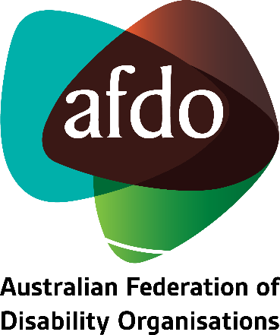

Feedback to Inform the National Dementia Action Plan 2023-2033
Submission to the Department of Health and Aged Care

January 2023

Table of Contents
Table of contents 1
About AFDO 3
Our members 4
Acknowledgements 6
Introductory comments 7
Summary of recommendations 8
Considering how the Action Plan will intersect with Australia's Disability Strategy 2021-31 10
Making dementia care and prevention more inclusive and accessible for people with disability 11
Improving outcomes for people with Down Syndrome 14
Adequately addressing the link between brain injury and dementia 15
Prioritising supported decision-making under the new Action Plan 16
Safeguarding people with dementia from violence, abuse, and neglect 18
Facilitating access to assistive technology to promote improved quality of life for people with dementia 19
Concluding comments 22

About AFDO
Since 2003, the Australian Federation of Disability Organisations (AFDO), a Disabled Peoples Organisation (DPO) and Disability Representative Organisation (DRO), has been the recognised national peak organisation in the disability sector, along with its disability specific members, representing people with disability. AFDO’s mission is to champion the rights of people with disability in Australia and support them to participate fully in Australian life.
Our member organisations represent disability specific communities with a total reach of over 3.8 million Australians.
AFDO continues to provide a strong, trusted, independent voice for the disability sector on national policy, inquiries, submissions, systemic advocacy and advisory on government initiatives with the Federal and State/Territory governments.
We work to develop a community where people with disability can participate in all aspects of social, economic, political and cultural life. This includes genuine participation in mainstream community life, the development of respectful and valued relationships, social and economic participation, and the opportunity to contribute as valued citizens.
Our vision
That all people with disabilities must be involved equally in all aspects of social, economic, political and cultural life.
Our mission
Using the strength of our membership-based organisations to harness the collective power of uniting people with disability to change society into a community where everyone is equal.
Our strategic objectives
To represent the united voice of our members and people with disability in national initiatives and policy debate.
To enhance the profile, respect and reputation for AFDO through our members.
To build the capacity and sustainability of AFDO and our members.
To foster strong collaboration and engagement between our members and stakeholders.
To enhance AFDO's connection and influence in international disability initiatives, particularly in the Asia Pacific region, through policy, advocacy and engagement
Our members
Full members:
- Advocacy for Inclusion
- Arts Access Australia
- Autism Aspergers Advocacy Australia (A4)
- Blind Citizens Australia
- Brain Injury Australia
- Deaf Australia
- Deafblind Australia
- Deafness Forum of Australia
- Down Syndrome Australia
- Disability Advocacy Network Australia
- Disability Justice Australia
- Disability Resources Centre
- Enhanced Lifestyles
- Multiple Sclerosis Australia
- National Mental Health Consumer and Carer Forum (NMHCCF)
- People with Disability WA
- People with Disabilities ACT
- Polio Australia
- Physical Disability Australia
- Women with Disabilities Victoria
- Women with Disabilities ACT

Associate members:
- AED Legal Centre
- All Means All
- Amaze
- Aspergers Victoria
- Disability Advocacy and Complaints Service of South Australia (DACSSA)
- Disability Law Queensland
- Leadership Plus
- National Organisation for Fetal Alcohol Spectrum Disorder (NOFASD)
- Star Victoria
- TASC National Limited
- YDAS – Youth Disability Advocacy Service

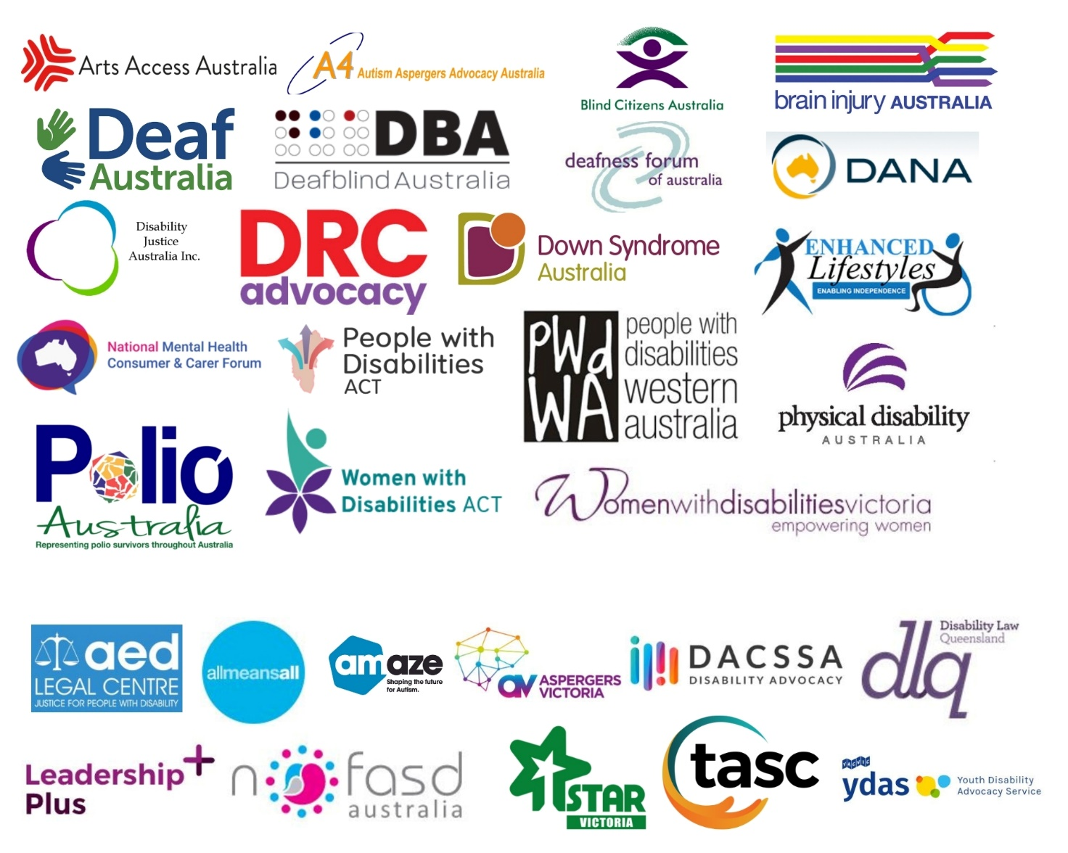

Acknowledgements
AFDO acknowledges Aboriginal and Torres Strait Islander people as the traditional custodians of the land on which we stand, recognising their continuing connection to land, waters, and community. From our head office in Melbourne, we pay our respects to the Bunurong Boon Wurrung and Wurundjeri Woi Wurrung peoples of the Eastern Kulin Nation and to their Elders past, present, and emerging. We also pay our respects to the traditional owners of all lands on which we operate or meet around the country.
AFDO acknowledges people with disability, particularly those individuals that have experienced or are continuing to experience violence, abuse, neglect, and exploitation. We also acknowledge their families, supporters, and representative organisations and express our thanks for the continuing work we all do in their support.

Introductory comments
AFDO thanks the Department of Health and Aged Care (the Department) for providing an opportunity to submit feedback to inform the development of the National Dementia Action Plan for 2023-2033. AFDO recognises dementia as a primary form of disability, as it falls within the definition outlined under Article 1 of the Convention on the Rights of Persons with Disabilities. As such, we have a vested interest in ensuring the rights of people with dementia are adequately promoted, protected, and upheld. We are also concerned with how activities pertaining to dementia prevention and care can be made more accessible to people with other forms of permanent and severe disability. As such, the issues and recommendations raised throughout this submission reflect our desire for the National Dementia Action Plan to result in:
- A reduction in the prevalence and impact of dementia in Australia, particularly among people with other forms of permanent and severe disability.
- An improvement in the accessibility and inclusivity of dementia-related information and services.
- Enhanced safeguards to protect people with dementia from violence, abuse, and neglect.
- Enhanced mechanisms to facilitate the right to supported decision-making in the context of dementia-care.
- An increase in the number of people with early onset dementia receiving services under the National Disability Insurance Scheme (NDIS).
- Improved access to assistive technology for people with dementia who are excluded from the NDIS.
Summary of recommendations
- The Department must ensure the National Dementia Action Plan contributes to key deliverables relating to the health and wellbeing of people with disability as outlined under Australia’s Disability Strategy 2021-31.
- The Department must consider how the National Dementia Action Plan can be used to increase the capacity of staff working across the health and community care sectors to provide services that are accessible, inclusive, and responsive to the needs of people with disability.
- The Department must consider how the National Dementia Action Plan can be used to drive increased availability of dementia-related information in accessible formats such as Braille, Easy Read, and Australian sign language.
- The Department must be directed to undertake targeted consultation with people with disability and their representative organisations to identify and eliminate barriers to accessing dementia related information and services.
- The Department must work directly with Down Syndrome Australia to further refine aspects of the National Dementia Action Plan relating to the prevention, care, and treatment of people with Down Syndrome who are at risk of, or who already have a diagnosis of dementia.
- The Department must engage directly with Brain Injury Australia as it seeks to further develop and refine aspects of the National Dementia Action Plan relating to the prevention, care, and treatment of dementia for people with brain injury.
- The Department must consider how the National Dementia Action Plan can be used to uphold and strengthen the right to supported decision-making in the context of dementia care. In particular, it must require the Department to work collaboratively with civil society and all arms of Government to establish a national policy and legislative framework for supported decision-making across all settings; including health, disability and aged care.
- The vision and purpose of the National Dementia Action Plan must reflect the need for people with dementia to be safeguarded from violence, abuse, and neglect.
- The Department must consider how the National Dementia Action Plan will intersect with the next National Plan to respond to the abuse of older Australians, while setting out actions aimed at safeguarding people with early onset dementia from violence, abuse, and neglect, and recognising that people with other forms of permanent and severe disability may require additional safeguards.
- The Department must consider how it could work with other arms of Government to implement measures to ensure greater oversight of people with dementia who face increased vulnerability to violence, abuse, and neglect, such as people with disability. Such measures might include:
- A mandatory community visitors scheme.
- Mandatory access for advocates.
- The National Dementia Action Plan must outline how the government intends to provide equitable access to assistive technology for people with dementia who are not eligible for the NDIS. This includes those receiving in-home care, as well as those living in residential care.

Considering how the Action Plan will intersect with Australia’s Disability Strategy 2021-31
We encourage the Department to consider how the National Dementia Action Plan will intersect with Australia’s Disability Strategy 2021-31, and how it may be used to drive change under this strategy.
Notably, outcome area six referenced under Australia’s Disability Strategy requires that:
“People with disability attain the highest possible health and wellbeing outcomes throughout their lives.”
The following relevant policy priorities are referenced underneath this outcome area:
- “All health service providers have the capabilities to meet the needs of people with disability.”
- “Prevention and early intervention health services are timely, comprehensive, appropriate and effective to support better overall health and wellbeing.”
We recommend the Department review the aforementioned components of Australia’s Disability Strategy, and the accompanying outcomes framework for the strategy as it continues to further develop and refine the National Dementia Action Plan.
Recommendation 1: The Department of Health must ensure the National Dementia Action Plan contributes to key deliverables relating to the health and wellbeing of people with disability as outlined under Australia’s Disability Strategy 2021-31.

Making dementia care and prevention more inclusive and accessible for people with disability
People with disability experience poorer health outcomes compared to people without disability. This is largely due to the fact that people with disability continue to face a range of barriers to accessing healthcare services, including:
- Affordability.
- Inaccessibility of physical spaces.
- Lack of access to information in accessible formats.
- Discriminatory or ableist attitudes of staff working in healthcare settings.

According to the Australian Institute of Health and Welfare:
- 1 in 13 people aged under 65 with disability delay or do not see a GP when needed because of cost.
- 1 in 5 people with disability who need help with health-care activities have their need for assistance only partly met, or not met at all.
- 1 in 2 people aged 5–64 with disability who need health care assistance receive only informal assistance.
- Two in five people with disability have difficulty physically accessing medical facilities.
- One in six people with disability experience discrimination by health staff.,
Considering this last point, it is important to remember that there are a range of staff working across the health and community care sectors who may make up an individual’s dementia-care journey. These might include:
- Doctors.
- Nurses.
- Social workers.
- Chaplains.
- Community care workers.
- Dementia counselling and support workers.
- Geriatricians.
- Palliative care workers.
It is critical that staff working across each of these professions have an understanding of disability awareness and are able to provide services on a non-discriminatory basis. This also requires them to have the capacity to communicate with people in a manner that is accessible and inclusive. This means providing information in a range of formats such as Braille, Easy Read, and Australian sign language, and ensuring communication supports are routinely available. To this end, we direct the Department to the following recommendations from the concluding observations on the combined second and third periodic reports of Australia, handed down by the Committee on the Rights of Persons with Disabilities in 2019:
- All persons with disabilities, in particular persons with disabilities living in remote areas, Aboriginal and Torres Strait Islander persons with disabilities, persons with intellectual or psychosocial disabilities, persons with disabilities living in institutions and women and children with disabilities, have access to information on an equal basis with others and to affordable, accessible, quality and culturally sensitive medical equipment and health services;
- All health-care services are based on a non-discriminatory, human rights model of disability and that any medical treatment is provided with the free and informed consent of the person concerned prior to any medical treatment;
- Health-care practitioners receive training on the human rights model of disability to enhance their capacity to provide accessible, quality health care to persons with disabilities.
These recommendations should be factored into the development of the National Dementia Action Plan to ensure people with disability can access dementia related information and services on an equitable basis with others. In implementing these recommendations, it is important for the Department to remember that people with disability are not only patients, but also carers. In fact, more than a third of primary carers across Australia have a disability. It is therefore vital that people with disability who are caring for a friend or family member with dementia can access information and services in a manner that is inclusive to their needs.
Recommendation 2: The Department must consider how the National Dementia Action Plan can be used to increase the capacity of staff working across the health and community care sectors to provide services that are accessible, inclusive, and responsive to the needs of people with disability.
Recommendation 3: The Department must consider how the National Dementia Action Plan can be used to drive increased availability of dementia related information in accessible formats such as Braille, Easy Read, and Australian sign language.
Recommendation 4: The Department must be directed to undertake targeted consultation with people with disability and their representative organisations to identify and eliminate barriers to accessing dementia related information and services.

Improving outcomes for People with Down Syndrome
The Department’s consultation paper acknowledges that there is a high prevalence of dementia among people with Down Syndrome, with around 50% of people with Down Syndrome developing dementia by age 60. We recommend the Department work closely with AFDO member organisation, Down Syndrome Australia, to further develop and refine aspects of the Action Plan relating to the experience of people with Down Syndrome. The Down Syndrome Federation is made up of State and Territory associations providing support, information, and resources to people with Down syndrome and their families across the country. The associations have come together to represent and progress the needs, interests, and aspirations of people with Down Syndrome and those that support them.
Recommendation 5: The Department must work directly with Down Syndrome Australia to further refine aspects of the National Dementia Action Plan relating to the prevention, care and treatment of people with Down Syndrome who are at risk of, or who already have a diagnosis of dementia.

Adequately addressing the link between brain injury and dementia
The Department’s consultation paper acknowledges that people who have a significant brain injury are more likely to develop early onset dementia, or dementia later in life. AFDO member organisation, Brain Injury Australia, has extensive expertise in this area and will be able to advise further on relevant measures and targets that need to be reflected in the National Action Plan. Brain Injury Australia is the central clearinghouse of information and gateway to nationwide referral for optimising the social and economic participation of all Australians living with brain injury.
Recommendation 6: The Department must engage directly with Brain Injury Australia as it seeks to further develop and refine aspects of the National Dementia Action Plan relating to the prevention, care and treatment of dementia for people with brain injury.

Prioritising supported decision-making under the new Action Plan
While the consultation paper acknowledges the need for supported decision-making, it does not propose any targeted actions aimed at upholding and strengthening an individual’s right to supported decision-making in the context of dementia care. As such, we remind the Department that the right to supported-decision making is central to Australia’s obligations under Article 12 of the Convention on the Rights of Persons with Disabilities (Equal recognition before the law). Article 12 requires that:
- States Parties reaffirm that persons with disabilities have the right to recognition everywhere as persons before the law.
- States Parties shall recognize that persons with disabilities enjoy legal capacity on an equal basis with others in all aspects of life.
- States Parties shall take appropriate measures to provide access by persons with disabilities to the support they may require in exercising their legal capacity.
- States Parties shall ensure that all measures that relate to the exercise of legal capacity provide for appropriate and effective safeguards to prevent abuse in accordance with international human rights law. Such safeguards shall ensure that measures relating to the exercise of legal capacity respect the rights, will and preferences of the person, are free of conflict of interest and undue influence, are proportional and tailored to the person’s circumstances, apply for the shortest time possible and are subject to regular review by a competent, independent and impartial authority or judicial body. The safeguards shall be proportional to the degree to which such measures affect the person’s rights and interests.
In 2014, the Australian Law Reform Commission published a report entitled Equality, Capacity and Disability in Commonwealth Laws. This report included a number of recommendations aimed at strengthening supported decision-making which have still not been implemented. In its concluding observations on the combined second and third periodic reports of Australia, the Committee on the Rights of Persons with Disabilities recommended that Australia:

“Implement a nationally consistent supported decision-making framework, as recommended in a 2014 report of the Australian Law Reform Commission entitled Equality, Capacity and Disability in Commonwealth Laws.”
We recommend the Department refer to the Older Persons Advocacy Network’s (OPAN’s) 2022 Position Statement on Supported Decision-making when considering how the above is to be implemented.
Recommendation 7: The Department must consider how the National Dementia Action Plan can be used to uphold and strengthen the right to supported decision-making in the context of dementia care. In particular, it must require the Department to work collaboratively with civil society and all arms of Government to establish a national policy and legislative framework for supported decision-making across all settings; including health, disability and aged care.

Safeguarding people with dementia from violence, abuse, and neglect
The 2020 report from the Royal Commission into Aged Care Quality and Safety shone a light on the high prevalence of violence, abuse, and neglect that is experienced by people with dementia across Australia. It is therefore concerning that the need to safeguard people with dementia from violence, abuse, and neglect is barely acknowledged in the Department’s consultation paper.
In 2019, the Australian Government worked with state and territory Governments to develop the National Plan to Respond to the Abuse of Older Australians (Elder Abuse) 2019–2023. Given this Plan will soon expire, the Department must consider how the National Dementia Action Plan might intersect with the next iteration of the Elder Abuse Plan to establish safeguards to protect people with dementia from violence, abuse, and neglect. Given there are currently around 228,800 Australians who experience early onset dementia (diagnosed prior to age 65), however, it is critical that key deliverables relating to safeguarding sit underneath the National Dementia Strategy as this is an issue that is not unique to older people. It is also important to remember that people with disability are also statistically more likely to experience violence, abuse and neglect throughout their lives, which can be exacerbated by a diagnosis of dementia. Additional measures are therefore required to safeguard this cohort against violence, abuse and neglect.
Recommendation 8: The vision and purpose of the National Dementia Action Plan must reflect the need for people with dementia to be safeguarded from violence, abuse, and neglect.
Recommendation 9: The Department must consider how the National Dementia Action Plan will intersect with the next National Plan to respond to the abuse of older Australians, while setting out actions aimed at safeguarding people with early onset dementia from violence, abuse, and neglect, and recognising that people with other forms of permanent and severe disability may require additional safeguards.
Recommendation 10: The Department must consider how it could work with other arms of Government to implement measures to ensure greater oversight of people with dementia who face increased vulnerability to violence, abuse, and neglect, such as people with disability. Such measures might include:
- A mandatory community visitors scheme.
- Mandatory access for advocates.

Facilitating access to assistive technology to promote improved quality of life for people with dementia
The consultation paper acknowledges the role of assistive technology in enhancing the quality of life of people with dementia. The only proposed action in the paper relating to assistive technology, however, is as follows:
“Understanding and promoting the role of technology to advance the quality of life of people living with dementia.”
This action will be meaningless without adequate investment in the support systems that are needed to facilitate timely access to affordable assistive technology for people with dementia.
While people with early onset dementia who are eligible for the NDIS only need to interact with one scheme to access funding for assistive technology, the situation for those outside the scheme is far more complex. A recent study located 87 Government funders, administering 108 assistive technology and home modifications schemes outside the NDIS.
This means that, at present, people with dementia who are not eligible for the NDIS are required to navigate a complex, confusing maze of funding in order to access the assistive technology they need. There is also a distinct lack of equity and consistency across the assistive technology schemes operating outside the NDIS. For example:
- People with the same or similar needs can receive different levels of support depending on age, location, and when or where their disability was acquired.
- The categories of assistive technology listed on funder websites equate to less than 10% of the full range of solutions available under the international standard AS/ISO 9999 Assistive Products for Persons with Disability.
- Few schemes outside the NDIS fund the wraparound services required to support effective service delivery, such as skilled assessment and referral, equipment trials and demonstrations, customisation, delivery and setup, training, and maintenance/review.
- While people with early onset dementia who are eligible for the NDIS can access fully funded assistive technology, this is rarely the case for those aged 65 and over who are required to access their support from other service systems. Many funding schemes outside the NDIS only provide subsidies for a small proportion of market costs. As a result, many people go without the assistive technology they need or continue using products that are unsafe or not fit for purpose. They may also go without other critical services so they can afford the equipment they need.
- Two thirds of older people with disability who are not eligible for the NDIS access support from the aged care system. The average spend on assistive technology and home modifications per person per year for NDIS participants is $2,500, compared with just $51 per person per year for aged care recipients.
According to the World Health Organization:
“Access to assistive technology is a fundamental human right, a legal obligation for all countries within the Convention on the Rights of Persons with Disabilities and a prerequisite for the full and equitable achievement of the Sustainable Development Goals.”
Furthermore, a 2017 report published by the Special Rapporteur on the Rights of Persons with Disabilities acknowledged that:
“States must establish legal and policy frameworks that ensure that support services and arrangements, including assistive technologies, are available, accessible, adequate and affordable.”
As such, it is critical that the National Dementia Action Plan includes key deliverables aimed at providing equitable access to assistive technology to support the quality of life of people with dementia, in line with the following recommendations from the Royal Commission into Aged Care Quality and Safety:
Recommendation 72: By 1 July 2024, every person receiving aged care who is living with disability, regardless of when acquired, should receive through the aged care program daily living supports and outcomes (including assistive technologies, aids and equipment) equivalent to those that would be available under the National Disability Insurance Scheme to a person under the age of 65 years with the same or substantially similar conditions.
Recommendation 73: By 1 July 2024, the Disability Discrimination Commissioner and the Age Discrimination Commissioner should be required, as part of the new National Disability Strategy, to report annually to the Parliament on the number of people receiving aged care with disability who are aged 65 years or older and their ability to access daily living supports and outcomes (including assistive technologies, aids and equipment) equivalent to those available under the National Disability Insurance Scheme.
Recommendation 125: Individuals who are assessed as needing social supports, assistive technologies and home modifications, or care at home should not be required to contribute to the costs of that support.
While we acknowledge the work that is currently being undertaken by the Department to establish a new assistive technology program for in-home care, we are also concerned that people living in residential aged care are being left out of this dialogue altogether. As such, the new Action Plan must outline how assistive technology will be funded and implemented to enhance the quality of life of people with dementia living in residential settings.
We remind the Department that there is also an economic imperative to improving access to assistive technology. For every dollar spent on assistive technology and home modifications, there is a conservative estimated two-fold return on investment relating to savings on the cost of paid carers, support, and medical services.
Recommendation 11: The National Dementia Action Plan must outline how the government intends to provide equitable access to assistive technology for people with dementia who are not eligible for the NDIS. This includes those receiving in-home care, as well as those living in residential care.

Concluding comments
Thank you once again for providing AFDO with an opportunity to submit feedback to inform the new National Dementia Action Plan. Should you require further information about any of the issues that have been outlined in this submission, please do not hesitate to contact our Senior Systemic Advocate, Lauren Henley.
Lauren can be contacted by phone on 0422 098 369, or by email at lauren.henley@afdo.org.au

United Nations Enable (2006) Convention on the Rights of Persons with Disabilities: Article 1 - Purpose, accessed 30 January 2023, retrieved from <https://www.un.org/development/desa/disabilities/convention-on-the-rights-of-persons-with-disabilities/article-1-purpose.html>.
Australian Institute of Health and Welfare (2020) People with Disability in Australia, accessed 30 January 2023, retrieved from <https://www.aihw.gov.au/getmedia/ee5ee3c2-152d-4b5f-9901-71d483b47f03/aihw-dis-72.pdf.aspx?inline=true>.
Australian Institute of Health and Welfare (2022) People with disability in Australia, Access to health services, accessed 30 January 2023, retrieved from <https://www.aihw.gov.au/reports/disability/people-with-disability-in-australia/contents/health/access-to-health-services>.
Committee on the Rights of Persons with Disabilities (2019) Concluding observations on the combined second and third periodic reports of Australia, paragraph 48.
Carers Australia (2023) Who is a Carer, accessed 30 January 2023, retrieved from <https://www.carersaustralia.com.au/about-carers/who-is-a-carer/#:~:text=Donate%20now%20and%20help%20Carers,of%20Australia's%202.65%20million%20carers.>.
Committee on the Rights of Persons with Disabilities (2019) Concluding observations on the combined second and third periodic reports of Australia, paragraph 24.
Dementia Australia (2022) Younger onset dementia in Australia: Prevalence estimates 2022-2058, accessed 30 January 2023, retrieved from <https://www.dementia.org.au/sites/default/files/2021-03/2021-DA-Prev-Data-YOD-in-Aus.pdf>.
Layton, N., & Brusco, N. (2022) The Australian assistive technology equity studies: Improving access to assistive technology for people with disability who are not eligible for the NDIS, accessed 30 January 2023, retrieved from <https://doi.org/10.26180/21113887>.
World Health Organization (2020) Policy brief: Access to assistive technology, accessed 30 January 2023, retrieved from <file:///C:/Users/LaurenHenley/Downloads/9789240005044-eng.pdf>.
Special Rapporteur on the Rights of Persons with Disabilities (2017) Access to rights-based support for persons with disabilities, accessed 30 January 2023, retrieved from <https://documents-dds-ny.un.org/doc/UNDOC/GEN/G16/436/64/PDF/G1643664.pdf?OpenElement>.
Royal Commission into Aged Care Quality and Safety (2021) Final report: List of recommendations, accessed 30 January 2023, retrieved from <https://agedcare.royalcommission.gov.au/sites/default/files/2021-03/final-report-recommendations.pdf>.
Australian Healthcare Associates (2020) Review of Assistive Technology Programs in Australia: Final Report to the Commonwealth Department of Health.

