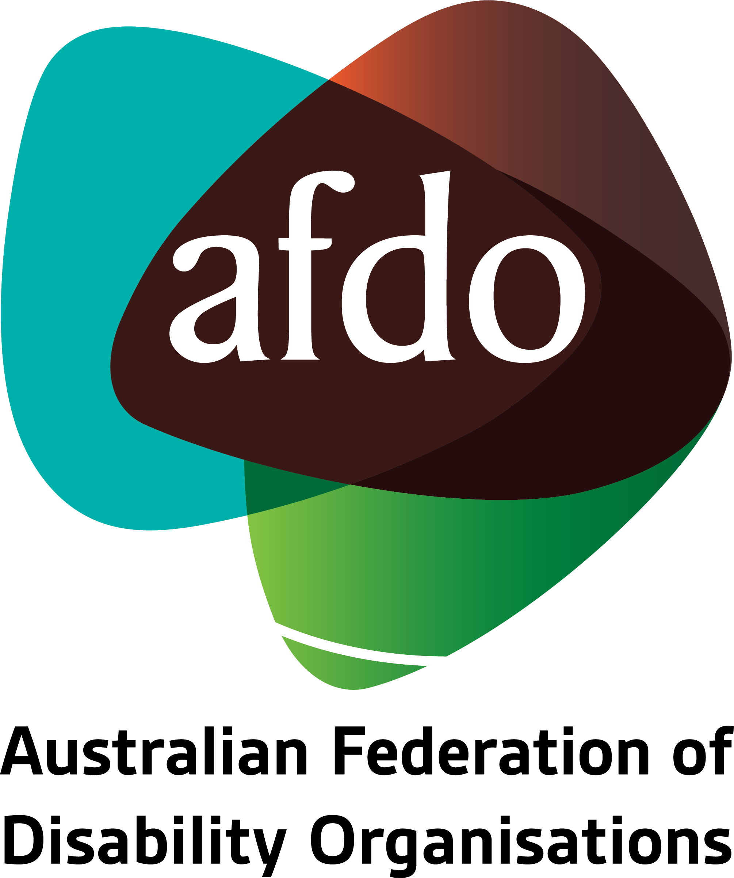

Australia Post:
Postal Services Modernisation
Submission to the Department of Infrastructure, Transport, Regional Development, Communications, and the Arts

April 2023

Table of Contents
Table of Contents 1
About AFDO 3
Our Members 4
Acknowledgements 6
Recommendations 7
Introduction 8
Background 9
Legislative and disability rights 10
People with disability and use of postal services 12
Digital exclusion among people with disability 13
Potential economic costs 14
Conclusion 15

About AFDO
Since 2003, the Australian Federation of Disability Organisations (AFDO), a Disabled Peoples Organisation (DPO) and Disability Representative Organisation (DRO), has been the recognised national peak organisation in the disability sector, along with its disability specific members, representing people with disability. AFDO’s mission is to champion the rights of people with disability in Australia and support them to participate fully in Australian life.
With our thirty-two member organisations, we are the only national peak representing disability specific and cross disability-based communities with a total reach of over 4 million Australians.
AFDO continues to provide a strong, trusted, independent voice for the disability sector on national policy, inquiries, submissions, systemic advocacy and advisory on government initiatives with the Federal and State/Territory governments.
We work to develop a community where people with disability can participate in all aspects of social, economic, political, and cultural life. This includes genuine participation in mainstream community life, the development of respectful and valued relationships, social and economic participation, and the opportunity to contribute as valued citizens.
Our vision
That all people with disabilities must be involved equally in all aspects of social, economic, political, and cultural life.
Our mission
Using the strength of our membership-based organisations to harness the collective power of uniting people with disability to change society into a community where everyone is equal.
Our strategic objectives
- Represent the interests and united voice of our members and people with disability at a national and international level in all relevant forums.
- Build the capacity, profile, reputation, and sustainability of AFDO through the strength of our member organisations.
- Enhance the connection & influence of AFDO in international disability initiatives by policy, advocacy & engagement, focused on the Asia Pacific region.

Our members
Full members:
- Advocacy for Inclusion
- Arts Access Australia
- Autism Aspergers Advocacy Australia
- Blind Citizens Australia
- Brain Injury Australia
- Deaf Australia
- Deafblind Australia
- Deafness Forum Australia
- Disability Advocacy Network Australia
- Disability Justice Australia
- Disability Resources Centre
- Down Syndrome Australia
- Enhanced Lifestyles
- National Mental Health Consumer & Carer Forum
- People With Disabilities WA
- Polio Australia
- Physical Disability Australia
- Women With Disabilities ACT
- Women with Disabilities Victoria

Associate members:
- All Means All
- AED Legal Centre
- Amaze
- Aspergers Victoria
- Disability Advocacy and Complaints Service of South Australia
- Explorability Inc
- Leadership Plus
- Multiple Sclerosis Australia
- National Organisation for Fetal Alcohol Spectrum Disorder
- National Union of Students - Disabilities Department
- Star Victoria Inc
- TASC National Limited
- Youth Disability Advocacy Service

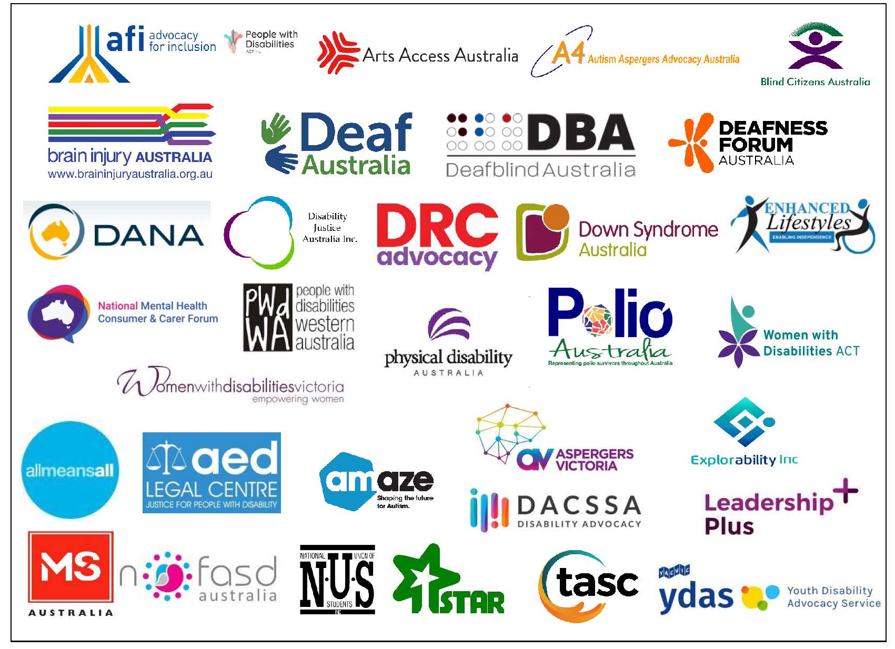

Acknowledgements
AFDO acknowledges Aboriginal and Torres Strait Islander people as the traditional custodians of the land on which we stand, recognising their continuing connection to land, waters, and community. From our head office in Melbourne, we pay our respects to the Bunurong Boon Wurrung and Wurundjeri Woi Wurrung peoples of the Eastern Kulin Nation and to their Elders past, present, and emerging. We also pay our respects to the traditional owners of all lands on which we operate or meet around the country.
AFDO acknowledges people with disability, particularly those individuals that have experienced or are continuing to experience violence, abuse, neglect, and exploitation. We also acknowledge their families, supporters, and representative organisations and express our thanks for the continuing work we all do in their support.
Report Author: Nick Wilson, Policy & Advocacy Officer
Reviewed by: Ross Joyce, Chief Executive Officer
Rebecca Rudd, Coordinator – Policy and Submissions

Recommendations
- AFDO is opposed to the proposed changes to Australia Post services as outlined in the discussion paper as these will significantly disadvantage and impact on the lives people with disability.

- AFDO strongly urges the Federal Government to ensure that Australia Post maintains daily mail deliveries in accordance with current legislative provisions to ensure service provision is maintained across all jurisdictions but in particular for regional, rural, rural remote and very remote locations.

- That Australia Post conduct an assessment of how people with disability currently utilise their services, with particular emphasis on regional, rural, rural remote and very remote areas in standard times and in times of emergencies and/or disasters.

  - That this be coordinated by Australia Post’s Disability Reference Group and engage people with disability and their representative organisations.

Introduction
AFDO welcomes the opportunity to provide comment on the Postal Services Modernisation and thanks the Department of Infrastructure, Transport, Regional Development, Communications, and the Arts for their consideration of this submission.
People with disability rely on services performed by Australia Post to a much greater extent than people without disability. As such, any changes made to Australia Post are likely to have a disproportionate impact on people with disability.
The digitisation of commerce, services, and social connections in Australia has failed to properly include people with disability in a just and equitable way, leaving many people with disability disadvantaged or excluded from using digital technology.
The changes proposed in the Postal Services Modernisation Plan Discussion Paper (the discussion paper) fail to consider the current relationship that people with disability have with postal services, often in very crucial areas of their lives.
AFDO submits that these changes are premature and short-sighted at best, and neglectful at worst, towards people with disability and their capacity to participate equitably and justly within Australian society.
AFDO strongly opposes any changes to Australia Post service delivery as this will directly adversely impact on the lives of people with disability.

Background
In March 2023, the Department of Infrastructure, Transport, Regional Development, Communications, and the Arts announced it would begin a series of consultations regarding a “modernisation” plan of Australia Post (AP).
Although no specific changes have been stated in the initial discussion paper, the following principles of the plan were put forward:
- Australia Post remaining in full public ownership, providing a universal and equitable service that meets the needs of Australian people and businesses;
- Australia Post remaining financially sustainable, and invest in its networks, services, and people to support improved national productivity and supply chain resilience;
- Postal services that support Australia’s digital economy, particularly as a critical enabler of the growing eCommerce market;
- Providing appropriate coverage of the Post Office network, particularly in regional and rural areas, and supporting LPO and CPA financial sustainability; and
- Reducing Australia Post’s operating cost in delivering regulated letter services, freeing up delivery and processing resources to support parcels delivery to respond to increasing demand and consumer expectations.
While it is stated that access to postal services would be equitable and universally accessible, it is also heavily implied that many of Australia Post’s services will be reduced or digitised. In this submission, AFDO will explain why such measures would run counter to Australia Post’s goal of being equitable and universally accessible in relation to people with disability.
AFDO will also provide recommendations on how Australia Post should manage changes to its business model in a changing world, while including people with disability who, as existing customers, rely on its services.

Legislative and disability rights
AFDO’s position on the proposed changes to Australia Post’s provision of services is grounded in both Australian law and Australia’s international human rights obligations, specifically, the United Nations Convention on Rights of Persons with Disabilities (UNCRPD) and The Australian Postal Corporation Act 1989.
The section of the UNCRPD relevant to this submission is Article 9, regarding accessibility:
“to information and communications, including information and communications technologies and systems, and to other facilities and services open or provided to the public, both in urban and in rural areas”
The article goes on to state:
“Parties… shall take appropriate measures to ensure to persons with disabilities access, on an equal basis with others, to information, communications and other services.”
This matter also has relevance to Article 21: Freedom of expression and opinion, and access to information:
“(a) Providing information intended for the general public to persons with disabilities in accessible formats and technologies appropriate to different kinds of disabilities in a timely manner and without additional cost.”
In Australian law the Australian Postal Corporation Act 1989 states that:
“Australia Post shall ensure:
(a) that, in view of the social importance of the letter service, the service is reasonably accessible to all people in Australia on an equitable basis, wherever they reside or carry on business; and
(b) that the performance standards (including delivery times) for the letter service reasonably meet the social, industrial, and commercial needs of the Australian community.”
Additionally, in the discussion paper it clearly states: “the Australian Government considers that as a major part of the Australian community, Australia Post should continue to play a role in supporting Australians with diverse needs.”
It is clear from both national and international law that Australia has direct obligations pertaining to accessibility of its information and communication systems for people with disability.
In our submission, AFDO will demonstrate the degree that people with disability rely on AP services for information and communication, as well as how any proposed cutbacks to these services would breach both the UNCRPD and Australian legislation regarding its effect on people with disability.

Use of postal services by people with disability
Although there are no exact numbers on how many people with disability make use of postal services, research commissioned by Australia Post and conducted by Deloitte Access Economics reveals that people with disability use AP services:
- To access general information (8% vs 4% of general population)
- To apply for community grants (5% vs 2% of general population)
- To apply and access government assistance (10% vs 3% of general population)
- To connect with friends and relatives (15% vs 4% of general population)
- To access cash and banking services (17% vs 5% of general population)
- To receive essential supplies (12% vs 7% of general population)
There is a clear difference between the way in which people with disability and people without disability use Australia Post’s services. It should also be noted that the ability to access community grants plays a significant role in community participation for people with disability, so measures that would hinder their ability to apply for them would have a significant flow-on effect.
Additionally, 17% of survey respondents with disability indicated that they require a post office during a natural disaster or other emergency to access banking services. This is compared to just 5% of respondents without disability.
The recent changes with AP taking on agreements to offer a range of banking services for the four main Australian banks, with subsequent bank closures or rationalisations taking place particularly across regional and rural areas further enforces the priority of AP maintaining full services for these communities and for people with disability.
The impact of natural disasters and emergencies on people with disability is already an area of concern to both the Australian government and representative organisations like AFDO. With the prevalence of natural disasters forecast to increase with climate change, AFDO strongly opposes any proposed cuts to availability and frequency of Australia Post services.
This position is also in alignment with that of the UNCRPD, the Australian Postal Corporation Act 1989, and the discussion paper on this issue.

Digital exclusion among people with disability
Australia is more digitally connected than ever before and will continue in this direction. This transition, however, has not included people with disability fairly and equitably. The Australian Digital Inclusion Index (ADII) tracks and reports statistic related to Australians’ internet use from the Australian Internet Usage Survey to measure digital inclusion in terms of Access, Affordability, and Digital Ability. People with disability make up 18% of the population or just over 4.5 million Australians.
The latest figures (2021) from the ADII record Australians with disability as being 10.8 points behind Australians without disability on measures of digital inclusion. The ADII noted that 11% of Australians are highly excluded digitally, while 23% of highly excluded Australians have a disability. This would amount to 648,600 Australians with a disability being highly excluded digitally.
Although this has improved from 17% from the previous report in 2020, this is likely a one-time spike brought on by efforts to digitise, needed to cope with isolation brought on by the COVID-19 pandemic.
The ADII report goes on to show that 14% of all Australians would need to pay more than 10% of their household income to gain quality, reliable connectivity. For Australians in the lowest income quintile, most (67%) would have to pay more than 10% of their household income to gain this same connection. This is particularly an obstacle for people with disability, as they are disproportionately a low-income cohort, and other schemes such as the NDIS do not provide equipment if it does not relate directly to a person’s disability.
It costs more to live for a person with disability than for a person without disability, further impacting on their inability to afford essentials let alone improve their digital connection or digital accessibility.
AFDO appreciates the efforts made to better include people with disability in the digital world. Despite evidence that this is improving, this is slow and there remains a significant gap in people with disability being able to access the digital world. The digital world does not operate on a level field for all areas of the community.
The underlying causes of this gap will not be addressed in time to match the pace of change as proposed in the discussion paper and will leave many people with disability at risk of being left without the vital services and connections on which they rely. The proposed modernisation of AP services in the paper will have a wide-reaching and adverse effect on the lives of people with disability in Australia, who are already digitally excluded and will be further disadvantaged if AP replaces services currently delivered offline with digital alternatives.

Potential economic costs
Much of the discussion paper, as well as media coverage, have emphasised the financial losses that Australia Post’s letter service has been making in recent years, including a first-half year’s loss before tax of $189.7 million leading to a full financial loss for 2022-2023.
It is also notable that in its main revenue-making service, parcel delivery, AP must compete against specialist, for-profit multi-national corporations such as FedEX, DHL and TNT, who have no social mandate to provide services for the community or provide coverage to Australians on an equal and affordable basis.
The need to ensure financial sustainability is understandable. That said, as a public service with a societal and moral mandate beyond mere profit margins, there are several other costs to the marginalisation of people with disability – a core cohort of Australia Post users – that policymakers ought to consider before changing its operations.
An interim report by the Royal Commission into Violence, Abuse, Neglect and Exploitation of People with Disability has demonstrated the economic cost of exclusion and neglect of people with disability. This is occurring both through direct costs borne by services and via missed economic opportunities brought by exclusion of people with disability.
The report attributes a $27.7 billion loss to issues of systemic failure and neglect, defined as the failure of government, business, and other systems to provide equal opportunity to participate in the economy, equal access to quality services, and to prevent systemic discrimination.
Although there are no exact figures specifically related to postal services, the higher reliance of people with disability on postal services, and the loss of access to these quality services without accessible alternatives, would constitute a systemic failure and neglect of people with disability.
This failure would likely incur a substantial additional cost to government, the economy, and society, far exceeding any savings generated from the proposed cutbacks to postal services.

Conclusion
The modernisation of postal services as proposed in the discussion paper, including digitalisation and reduction in mail delivery services, have not been conceived with proper consideration of the potential impact it would have on people with disability.
The discussion paper also presents a false economy with respect to the enormous costs that systemic failures and neglect the changes would impose on government, the economy, and society, compared with any direct cost savings the plan would bring to Australia Post.
AFDO strongly opposes any proposed changes to Australia Post that would reduce the availability and frequency of postal services without proper understanding of how this would affect people with disability and the importance of such services in maintaining their quality of life.

Department of Infrastructure, Transport, Regional Development, Communication & the Arts. 2023. “Postal Services Modernisation.” March. Accessed April 11, 2023. https://www.infrastructure.gov.au/sites/default/files/documents/postal-services-modernisation-discussion-paper.pdf.
United Nations Department of Economic and Social Affairs. 2006. Accessed April 11, 2023. https://www.un.org/development/desa/disabilities/convention-on-the-rights-of-persons-with-disabilities/article-9-accessibility.html.
United Nations Department of Economic and Social Affairs. 2006. Article 21 - Freedom of expression and opinions, and access to information. December. Accessed April 11, 2023. https://www.un.org/development/desa/disabilities/convention-on-the-rights-of-persons-with-disabilities/article-21-freedom-of-expression-and-opinion-and-access-to-information.html.
Australian Postal Corporation Act 1989 (Cth) S.27, emphasis added.
Department of Infrastructure, Transport, Regional Development, Communication & the Arts. 2023. “Postal Services Modernisation.” March. Accessed April 11, 2023. https://www.infrastructure.gov.au/sites/default/files/documents/postal-services-modernisation-discussion-paper.pdf.
Deloitte Access Economics. 2018. “Economic and social value of Australia Post.” August. Accessed March 29, 2023. https://www2.deloitte.com/content/dam/Deloitte/au/Documents/Economics/deloitte-au-economics-value-australia-post-150818.pdf.
Ibid.
Thomas, J., Barraket, J., Parkinson, S., Wilson, C., Holcombe-James, I., Kennedy, J., Mannell, K., Brydon, A. 2021. Australian Digital Inclusion Index: 2021. Survey, Melbourne, RMIT, Swinburne University of Technology, and Telstra.
Ibid.
Ibid.
Ibid.
Ibid.
Royal Commission into Violence, Abuse, Neglect & Exploitation of People with Disability. 2023. “Economic cost of violence,.” 21 February. Accessed March 8, 2023. https://disability.royalcommission.gov.au/publications/economic-cost-violence-abuse-neglect-and-exploitation-people-disability#:~:text=The%20report%20found%20that%20in,and%20exploitation%20perpetrated%20by%20individuals.
Ibid.
Ibid.

