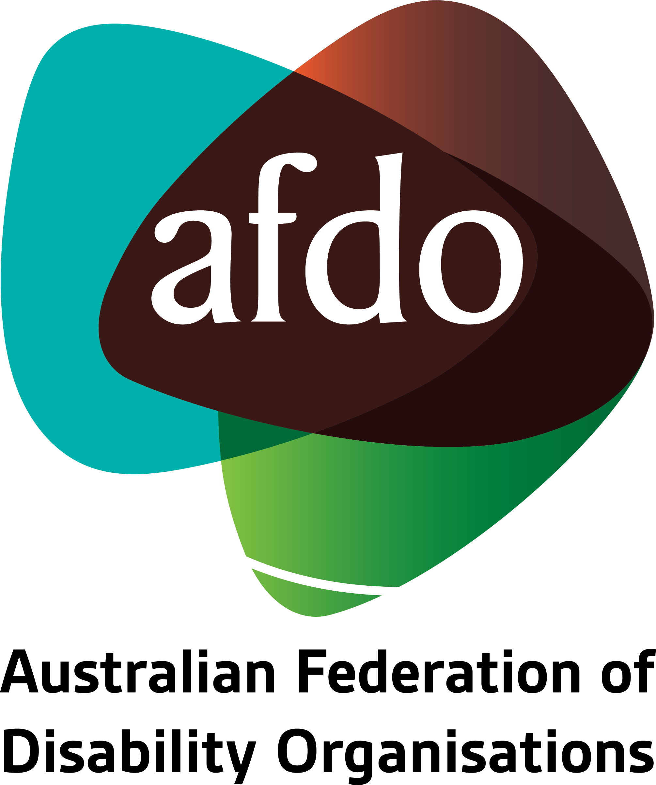

Royal Commission into the Robodebt Scheme
Submission by AFDO

February 2023

Table of Contents
Table of Contents 1
About AFDO 2
Our Members 4
Acknowledgements 6
Introductory comments 7
The right to social security and protection 8
The impact of the Robodebt scheme on people with disability 10
The relationship between poverty and income support 24
Key Principles for a Fair and Reasonable Income Support System 27
Reference List 28

About AFDO
Since 2003, the Australian Federation of Disability Organisations (AFDO), a Disabled Peoples Organisation (DPO) and Disability Representative Organisation (DRO), has been the recognised national peak organisation in the disability sector, along with its disability specific members, representing people with disability. AFDO’s mission is to champion the rights of people with disability in Australia and support them to participate fully in Australian life.
Our member organisations represent disability specific communities with a total reach of over 3.8 million Australians.
AFDO continues to provide a strong, trusted, independent voice for the disability sector on national policy, inquiries, submissions, systemic advocacy and advisory on government initiatives with the Federal and State/Territory governments.
We work to develop a community where people with disability can participate in all aspects of social, economic, political and cultural life. This includes genuine participation in mainstream community life, the development of respectful and valued relationships, social and economic participation, and the opportunity to contribute as valued citizens.
Our vision
That all people with disabilities must be involved equally in all aspects of social, economic, political, and cultural life.
Our mission
Using the strength of our membership-based organisations to harness the collective power of uniting people with disability to change society into a community where everyone is equal.
Our strategic objectives
To represent the united voice of our members and people with disability in national initiatives and policy debate.
To enhance the profile, respect and reputation for AFDO through our members.
To build the capacity and sustainability of AFDO and our members.
To foster strong collaboration and engagement between our members and stakeholders.
To enhance AFDO's connection and influence in international disability initiatives, particularly in the Asia Pacific region, through policy, advocacy and engagement.

Our members
Full members:
- Arts Access Australia
- Autism Aspergers Advocacy Australia
- Blind Citizens Australia
- Brain Injury Australia
- Deaf Australia
- Deafblind Australia
- Deafness Forum of Australia
- Down Syndrome Australia
- Disability Advocacy Network Australia
- Disability Justice Australia
- Disability Resources Centre
- Enhanced Lifestyles
- Multiple Sclerosis Australia
- National Mental Health Consumer and Carer Forum (NMHCCF)
- People with Disability WA
- People with Disabilities ACT
- Polio Australia
- Physical Disability Australia
- Women with Disabilities Victoria
- Women with Disabilities ACT

Associate members:
- AED Legal Centre
- All Means All
- Amaze
- Aspergers Victoria
- Disability Advocacy and Complaints Service of South Australia (DACSSA)
- Leadership Plus
- National Organisation for Fetal Alcohol Spectrum Disorder (NOFASD)
- Star Victoria
- TASC National Limited
- YDAS – Youth Disability Advocacy Service

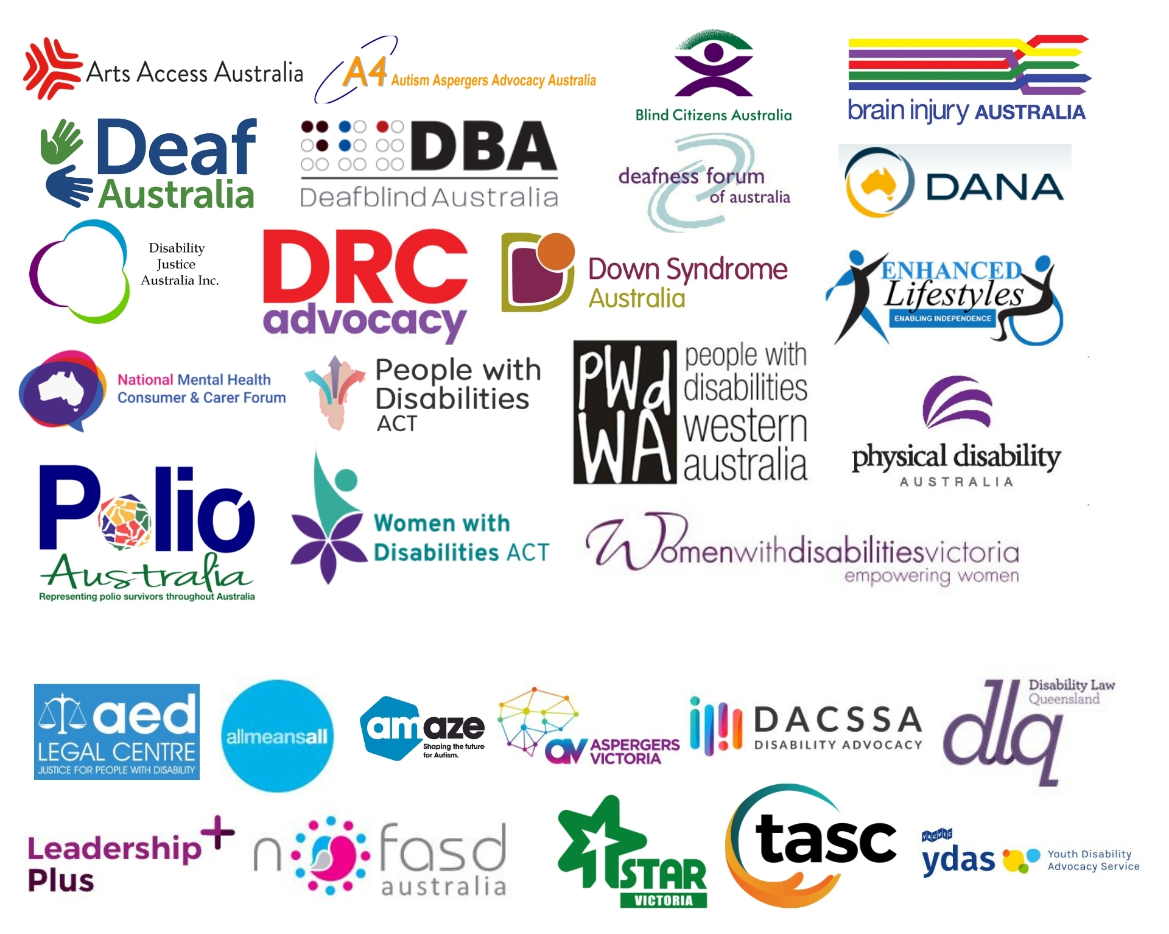

Acknowledgements
AFDO acknowledges Aboriginal and Torres Strait Islander people as the traditional custodians of the land on which we stand, recognising their continuing connection to land, waters, and community. From our head office in Melbourne, we pay our respects to the Bunurong Boon Wurrung and Wurundjeri Woi Wurrung peoples of the Eastern Kulin Nation and to their Elders past, present, and emerging. We also pay our respects to the traditional owners of all lands on which we operate or meet around the country.
AFDO acknowledges people with disability, particularly those individuals that have experienced or are continuing to experience violence, abuse, neglect, and exploitation. We also acknowledge their families, supporters, and representative organisations and express our thanks for the continuing work we all do in their support.

Report Author: Rebecca Rudd, Coordinator – Policy and Submissions
Review Team: Ross Joyce, Chief Executive Officer

Introductory comments
AFDO welcomes the opportunity to provide comment on the Royal Commission into the Robodebt scheme, and thanks the Commission for their consideration of this submission. People with disability are more likely to rely on the Disability Support Pension or other income support payments, and so as a group they are likely to have been disproportionately affected by the Robodebt scheme. The purpose of this submission is to illustrate the depth of harm inflicted on people with disability through presenting a series of case studies and exploring the key themes that emerge from their testimony.
As a signatory to the Convention on the Rights of Persons with Disabilities (CRPD), Australia is obliged to uphold the rights of people with disability, in this case, the rights to social support and social protection. As AFDO has argued in a recent submission to the Royal Commission into Violence, Abuse, Neglect and Exploitation of People with Disability (Disability Royal Commission), these failures of the income support system contravene Australia’s human rights obligations under the CRPD and constitute institutional neglect of people with disability. It is the position of AFDO that the Robodebt scheme represents a particularly egregious manifestation of this neglect that has been borne out of broader historical trends in social security policy towards regulatory compliance and reducing expenditure through labour market activation.
While this submission will reiterate some of those same arguments, its primary aim is to highlight the depth of harm enacted on individuals and people with disability through the Robodebt scheme.

The right to social security and protection
Australia is a signatory and a state party to both the International Covenant on Economic, Social and Cultural Rights (ICESCR) and the Convention on the Rights of Persons with Disabilities (CRPD). Under articles 9 and 28 of these instruments respectively, the Australian government is obliged to ensure that all people with disability have access to social security, social protection, and an adequate standard of living.
Per Article 28 of the CRPD, state parties to the Convention must “take appropriate steps to safeguard and promote the realization” of these rights. This imposes a positive obligation upon states to provide the necessary supports and services to people with disability. Notably, countries must “ensure access by persons with disability…to social protection programs” and ensure people with disability who are living in poverty have access to “assistance from the State with disability-related expenses.”
The term ‘social protection’ refers to:
… a variety of public and private interventions aimed at securing the well-being of a person in the event of social risk and need, such as (a) lack of work-related income, (b) unaffordable access to health care and (c) insufficient family and child support… social protection is understood broadly to cover a variety of interventions designed to guarantee basic income security and access to essential social services, with the ultimate goal of achieving social inclusion and social citizenship.
In line with the Special Rapporteur on the rights of persons with disabilities, AFDO contends that social protection as defined above “constitutes an essential condition for social and economic development for all.” Furthermore, an effective national social protection system – of which income support payments like DSP are a crucial component – serves as a powerful instrument, not only through “providing income security and reducing poverty and inequality”, but also by playing a crucial role in enabling the social inclusion and social citizenship of people with disability.
Social citizenship, which has been described as a “pre-condition for meaningful democracy”, refers to an individual’s full enjoyment of and access to political, civil, and social rights. In the absence of these basic necessities of life, individuals are marginalised from real political, economic, and social power, and cannot be said to be meaningfully participating in democracy as they lack the political influence necessary to improve their conditions of life.
As AFDO has most recently argued in a submission to the disability Royal Commission, and in accordance with the definition of neglect provided therein,
Neglect includes physical or emotional neglect, passive neglect or wilful deprivation. Neglect can be a single significant incident or a systemic issue that involves depriving a person with disability of the basic necessities of life such as food, drink, shelter, access, mobility, clothing, education, medical care and treatment.
AFDO submits that the failure of the Australian government to provide adequate and accessible social support and social protection to people with disability, as evidenced in the significantly higher rates of poverty seen within the disabled community, constitutes institutional neglect through a wilful deprivation of basic life necessities and subsequent denial of social citizenship.
In addition, we argue that the then Federal Government, relevant Ministers, responsible Deputy Ministers, relevant Government Departments, Agencies, and their associated public service officers responsible for the introduction and continuation of the Robodebt scheme knowingly prosecuted, harassed, and bullied individuals inclusive of people with disability. Worse still, and as clearly outlined in the series of case studies presented in this submission, themselves representing only a small sample of what we know to be significant numbers of affected individuals, the then Federal Government was responsible for implementing and overseeing a scheme that constituted an attack on the individual human rights to fairness, equity, and transparency.
As will be demonstrated through these testimonies, the Robodebt scheme ignored and aggrieved the rights of individuals inclusive of people with disability, and in doing so contravened international signed human rights commitments as well as Australia’s own legislative bounds. It inflicted mental violence and abuse on some of the most vulnerable members of the Australian community. Furthermore, it undertook a perversion of justice and demonstrated neglect on the part of the then Federal Government, who chose to obfuscate instead of addressing legitimate concerns raised from the scheme’s inception.
The case studies presented within this submission reflect a distressingly common set of themes and outcomes, including:
1. Extreme emotional distress, trauma, and stress
2. Exacerbation of physical and mental health issues
3. Suicidal ideation
4. Material impact
5. Loss of faith in system
6. Assumed guilty until proven innocent

The impact of the Robodebt scheme on people with disability
This submission will now present a series of case studies to elaborate on the degree of harm caused to people with disability and explore common themes emerging from their testimonies. All stories have been sourced from NotMyDebt, a website where individuals affected by Robodebt can anonymously share their stories with the public. Individuals in the selected stories are either recipients of the DSP or indicate lived experience of disability. In some cases, these stories have been edited for length and coherency and bolded for emphasis.
Case studies will be presented and grouped by the primary themes they incorporate. In many cases, stories will reflect multiple themes, and so they have been grouped by best fit.
Theme 1: Extreme emotional distress, trauma, and stress
A core theme that emerged again and again in individuals’ stories was the extreme stress and emotional distress they experienced as a result of the Robodebt scheme.
Alleged debt: $15,000
I've been through this twice now. Both times it was obvious to me where the mistake lay in their algorithms, and I was able to explain it. But I was told I had to prove it anyway. Both debts were 100% waived but after a painstaking wait.
The impact on my mental and physical health was profound.
The process was stressful, frustrating, time consuming, resource intensive, and I lost lots of sleep. Worst of all is the damage it did to my sense of security and place in society - I felt a criminal, I felt like I was in an abusive relationship, I felt intimidated, humiliated, and at mercy to their every whim. All while being utterly dependent and vulnerable.
I eventually suffered a Psychotic Depressive episode (I've never had this before) and am clawing back my health and am now under the care of Psychiatrist and MH professionals and taking 3 new meds. It costs hundreds in script and gap fees, and this is on top of my existing physical illness expenses for which I get the DSP.
I feel like a sitting duck to whatever dirty tactic they want to employ next - I feel like they just want us to just die.

Alleged debt: $638
It’s a weird question to be asked, how has the debt affected me? …I don't know how to answer it. I'm crushed. I did the right thing, I'm a good person, I didn't break the law and I was so careful because I was so grateful for the support.
I'm confused, I feel bullied, and I've been threatened. I’ve been medicated for stress and anxiety. I've cried and I've yelled, and I've given up and changed my mind more times than I can count. Financially, well, apparently it has affected my credit rating and I'm trying to buy a house, so this could be the end of that dream for me that I have worked so damn hard for.

For some individuals, these experiences were severe enough to cause significant trauma with ongoing effects that continue to this day.
Alleged debt: $1,052
When I first received the letter informing me of my debt, I knew there must have been some kind of mistake. I had been on Youth Allowance as a high school and undergraduate student and was always diligent in recording my fortnightly income. I only went on Newstart after experiencing a mental health crisis and being unable to work for six months. This was the only time since age 15 that I had been unemployed. I have serious mental health issues, and am diagnosed with major depression, generalised anxiety disorder, and borderline personality disorder stemming from early life trauma.
Through a lot of hard work and very expensive private therapy, I improved my mental health and was able to work part time while completing a graduate degree. Receiving this Robodebt last year brought me back to a very low point.
I tried my best to appeal the debt, supplying all my payslips from three separate jobs up to four years ago. The online interface where I was supposed to enter this information was incredibly difficult to navigate. After days of trying to enter my information, the system cut me off at 5pm sharp. At this point, I had a complete mental breakdown from extreme anxiety. My partner had to pull me away from the computer where I was in hysterics.
The entire situation had a severe toll on my mental health. I genuinely feel that I have developed PTSD from this experience. I am overwhelmed with crippling anxiety whenever I hear or read the word ‘Centrelink’, and I feel sheer panic whenever they text or call me. I will do everything in my power to avoid ever being on Centrelink again.

Alleged debt: $2,126
I have been diagnosed with depression and an anxiety disorder. Most of the time this is manageable, but sometimes it becomes incapacitating, to the point where I have been hospitalised. Any stressful situation doesn't help my symptoms, but my recent dealings with Centrelink have sent my stress levels through the roof. I also have an autoimmune disease which affects my ability to work and leaves me constantly fatigued. As well as this, I experience chronic pain from a shoulder injury. Needless to say, stress makes these problems worse.
… After hearing about so many people being threatened with false debts, I naturally became frightened that this might happen to me, so in early January 2017, I checked my personal page on the Centrelink website. There I found a letter pointing out discrepancies between information Centrelink had received from the Australian Tax Office and information they had received from me. I was being accused of not declaring my income, even though that income had stopped a month before I received a Centrelink payment.
…I was panicking now, but Jason said if I could obtain an Employment Separation Certificate from my former employer, I might be able to get the debt cancelled. Jason offered to call the company and get the certificate for me, which he did. But this took 24 hours, and in the meantime, I was distraught, not knowing how much I might have to pay or by what date I had to pay it. I was so upset I could barely eat or sleep. It got to the point where I felt suicidal and phoned Lifeline three times within 24 hours.
… This morning it seems my debt has been cancelled, with no explanation. So, I don't know if that's the end of it, or if another random debt will be generated against me at any time. I now live in fear of Centrelink, even though I am dependant on their payments to survive.
It took 3 days and endless hours on the phone and endless stress to sort this out. And in the end, I still don't know why the debt was issued or why it was cancelled. This fake debt caused me to have a complete nervous breakdown: screaming, crying, collapsing on the ground, and shaking uncontrollably. I became suicidal and had to call Lifeline three times within 24 hours. I couldn't eat or sleep. It has seriously been one of the worst experiences of my life. I am now off work for two weeks with a medical certificate and I have to take medication to get to sleep. I feel utterly traumatised by this fake debt. I live in fear of it happening again. I am still paralysed with anxiety and can barely function.

Theme 2: Exacerbation of physical and mental health issues
Many individuals described how their existing physical and mental health issues – in some cases, the same disabilities that prevented them from working and caused them to claim DSP or other payments in the first place – were negatively impacted by their Robodebt experience.
Alleged debt: $3,200
When I found out I had a panic attack and cried; this is the third time they have given me a debt and the other two turned out to be invalid as well. At this point, I live in permanent fear - I feel Centrelink could come after me at any time. I am chronically ill and on disability, and all doctors tell me to avoid stress, but there is no avoiding the stress Centrelink cause me.
Last year, I ended up in a psych ward feeling as though I should just give up and die because of the way they were treating me. My boyfriend and mum have both held me as I've cried hysterically, saying I feel I cannot possibly cope.
Today, I am more hopeful I can fight this. But even if this debt is sorted, who knows when the next one will come? I have no trust, no faith in this system. I have nothing to give - no savings, no assets. Only medical bills and living costs. Sometimes I feel like I will never escape from under this weight.

Alleged debt: $5,898
I had an aortic dissection and aneurysm almost 14 years ago. I was advised I would never be able to work again by surgeons and my GP. After a few years I did some adult study as I wanted to do something to contribute to society. After a complete lifestyle change and many years of recovery, I obtained employment in a kindergarten doing part time work. I was once again contributing to society and reporting all of my income earned correctly.
I received a request from Centrelink 18 months ago for me to prove I had not been overpaid by them for what they deemed approximately $6000. I did not have payslips. I spoke to many people at Centrelink and was given conflicting information… My support pension did not appear in my account the following Monday…
… I have had severe headaches and I am in constant body pain from my surgery and arthritis. I have had suicidal thoughts due to this supposed debt and have just felt that my life would be much easier if I did not work at all. With my anxiety being up, my body pain is also up. Some days I cannot get out of bed. I seem to have a constant cold and stomach issues.
I feel I am being punished for wanting to contribute to society even though I was advised by specialists I would never be able to work again.

Alleged debt: $8,753
My wife has a disability and hasn't worked in years. I am also suffering from disability and injury and haven't worked in years. They claim that I owe them over $4,000 from not declaring work I did in 2012. They say my wife was overpaid the exact same amount, for the same period.
Due to this, my health has deteriorated to the point where I use a cane daily and suffer often from respiratory infections. I recently contracted pneumonia and my memory and cognitive abilities have suffered greatly. I have spent time in the hospital and can barely function some days. My speech is slurred, my coordination is way off, and I have been accused of being drunk or affected by drugs. I have a pain problem due to an old leg injury which is now a disability.
A far cry from the national level athlete I was in 2011.

Alleged debt: $14,000
Neurocardiogenic Syncope (NCS), among other conditions, can be triggered by stress. During the second appeal process for the debt, the Centrelink officer would not advise time of call, call back or SMS so that medication could be taken to manage the NCS.
During the second phone call, the officer wouldn't let me finish a sentence, speaking over the top, refusing to listen to what myself or my carer were saying. NCS causes TIA (transient ischemic attack) events. Slurring of speech, loss of movement in right side that progresses to loss of all speech, loss of cognitive function, etc. The second phone call ended with a TIA event. She continued to call on days I had requested no phone calls as a carer was not available. TIA events are also followed by chronic fatigue and mental incoherency for up to a week.
I have not spoken to this officer again, but she remains my appeals officer… Other medical conditions have been triggered. I have been recommended by my GP and Specialists to "let it be", as health is more important.
I have spent more money on medication, hospitals, and doctors for the stress induced from this debt, not including the money wasted on chasing it down, than the total amount it was worth. On a more personal note, I know how it made me feel, the guilt and shame increasing with the already attached stigma that comes to one on disability benefits. I felt I only had one option left for being a burden on society, but I was surrounded by kind, loving family who gave me strength to see past blind, bureaucratic prejudice. My heart goes out for those who don't have that support base.

Theme 3: Suicidal ideation
Tragically, many stories expressed feelings of extreme hopelessness and despair, sometimes to the point of engaging in suicidal ideation.
Alleged debt: $13,500
I worked in mental health since 2006. I live with Bipolar, PTSD, and Dissociative disorder. In 2011, I had to stop work as I was fighting a 12 month long depressive episode. I was actively suicidal and ended up hospitalised. I fought my way back to recovery and returned in a limited capacity to the workforce, while still having the safety net of the DSP to fall back on. It was a hard battle, and I finally went back to work fulltime, again in mental health, and was hopeful of staying well.
I received letters from Centrelink midway through 2018 and my nightmare began. I was slammed with a $12,000 debt for the period 2013 to 2015. I appealed, but my mental health took a massive hit. I still work fulltime, but now have a constant battle with suicidal thoughts. I have had to increase my medications and return to seeing a psychologist. My disassociation has become my coping mechanism.
… I am now still working fulltime in mental health while walking around with my own suicidal thoughts. I have appealed the entire debt again. I am angry and frustrated and anxious, but I refuse to let them beat me. It's a struggle every single day.
The Government has displayed cowardice by hunting down the most vulnerable people. I have lost complete faith in them. I will never seek assistance from them again…. I want to go to them and show them the thoughts that are now in my head. It's a nightmare. I have fought and fought against my mental illness and the government have kicked me in the face and tried to crush me.

Alleged debt: $8,207
My daughter requested more information about the debt, she called numerous times and they did nothing. They started drawing $95.20 out of my support pension. It must be a huge mistake, extremely stressful for my family.
My wife has a disability and is in poor health, but she is not qualified to claim the Disability Support Pension. She a senior citizen, 60 years old, turning 61 soon. Centrelink asked her to look for work as long as she is mobile, despite her health conditions, and turned down the medical certificate issued by her GP. She missed one appointment with the disability employment provider and was cut off from Newstart allowance. My wife is suffering from serious depression, and she has thought of ending her life because she feels she failed at being a good mother to our daughter by putting her in financial hardship while she is looking after us on her own.
What is our government really doing to help the old, sick, and vulnerable?

Alleged debt: $14,500
I suffer from schizophrenia and was hospitalised in 2014 when this debt overpayment began. My partner is my only carer and was a temporary resident ineligible for any income payments from Centrelink. My debt was raised due to him being my partner. I have been suffering extremely by this government policy and even considered suicide, but I won't let them win.
Under section 24 of the Social Security Act, which I wasn't aware of, it clearly states that you're not considered a partner if you are ineligible for social security payments. It’s their own law. They are targeting the sickest and poorest in society who have very little knowledge of their own rights. As I said I have considered suicide and my stress levels are extremely high.
I will have to take out my super because I can't afford to pay rent or bills. I worked, but became ill, so Centrelink is the only way I can support myself.

For many individuals, their experiences with the Robodebt scheme and the crippling debt they found themselves in left them believing that their lives were permanently ruined and any hope for the future was lost.
Alleged debt: $7,000
Paralysed with depression, have been considering suicide since I received this notice. How am I supposed to pay this when already multiple times throughout the year I go to bed hungry because I'm unable to pay for food, medication, and housing expenses on the allowance I get? The government doesn't care about me, I'm a liability in its eyes nothing more

Alleged debt: $30,000
I have been given a Robodebt of about $30,000. I was in-between jobs and signed up for Newstart for 2-3 weeks a few months ago, and I received the notice almost straightaway. I actually remember the rules at the time when I was on the Disability Support Pension. We could receive a full pension and work 2 days per week. I never expected to get a debt like this 5 years later. Back then, I believe there was no income limit like there is now.
Centrelink haven't told me how they calculated the debt, so I don't know how they arrived at this figure. I'm scared to appeal in case they charge me with fraud or something which would completely ruin my future. They won't accept repayments of less than $200 per fortnight. I already have two credit cards and a personal loan. With this kind of debt, I will never own my own house. Just no way. I'm scared, terrified, and suicidal.

Theme 4: Material impact

Theme 4: Material impact
For many individuals, incurring a Robodebt had a significant material impact, leaving them financially insecure and affecting their access to housing and healthcare, and impeding their ability to maintain employment.
Alleged debt: $18,000
An Authorised Review Officer (ARO) waited 7 months for me to send them documents to prove I do NOT owe this debt. They then re-established the debt and started taking $128 out of my pension.
I have Chronic PTSD and having this hanging over my head has been a relentless nightmare. I am about to start a medication which is not on the PBS and will require approximately $300 per month. This reduction in funds may exclude me from this medication.
I believe this misunderstanding is due to my being paid out for Total and Permanent Disability (which Centrelink has no right to assess as income). I asked for proof and was told I must prove my innocence because the ATO records reflect monies that Centrelink is not able to discern is an insurance payout.

Alleged debt: $9,000
I am a support person for someone who is on the Disability Support Pension. This person has extreme anxiety associated with being on the spectrum, dyslexic, and intellectual disability. Now having to deal with a complex situation such as receiving an employment confirmation letter that is totally incorrect.
He now works full time, sourcing the job independently, which he now has to jeopardise due to taking time to phone compliance and past employees that keep making up excuses to why they haven't gathered the payment summary information.
This, in turn, is placing a considerable amount of stress on this person, who is unable to retain information and understand what is required. He is extremely worried in regard to his current job, which he loves. In asking for too much time off.
He is lucky he has me as support, but some people don’t, and I can see why it’s easier to give in. We will fight this and may have a talk to the Ombudsman in regards to the employment agency.

Alleged debt: $4,581
I have an accumulated debt from a period in which I worked 3 jobs apparently, from 5 years previous. I have moved house 2 times since this time and no longer have my payslips, etc. I claimed all my work in that time period, but I was taxed wrongly by one of the jobs, so I ended up with a tax bill that year. Now I have a Centrelink debt on top of it with no way of which to prove it. This came to light when I applied for a payment.
I'm currently unemployed due to health issues, and as a single person living alone in private housing, that $50 they are taking from me could be paying my electricity bill that's currently behind. I'm stressed, depressed, and unable to afford to eat right or the extra things I need like medication.
I already suffer PTSD & prolonged grief syndrome as well as permanent back damage. I can't get on disability, but they can give me a debt. This just adds up to further mental health issues that make me unable to deal with fighting this debt.

For individuals with children and families to support, the impact of Robodebt and its negative consequences also extended to them, with their housing, healthcare, and lifestyle in general likewise placed at risk.
Alleged debt: $10,782
This is a disgrace, it was 4.5 years ago, it's going to be a mammoth task to find everything to prove them wrong. It's not a small amount of money and being on Carers pension isn't easy; this is stretching budgets to breaking point.
… This going to have a big impact on my family as we have a child with respiratory problems... I have epilepsy, and stress and lack of sleep are my triggers. If I have a seizure, I lose my licence for a year. If I have to pay this back, how am I supposed to afford to catch the bus or taxi to take my kids to school, shopping, and all my son's many medical appointments?
… it's hard enough trying to keep the budget on track without this shoved on top. We did everything right, reported fortnightly, put our tax in; why did they not pick up this supposed overpayment that year?

Alleged debt: $140,000
I am a disability pensioner and was hurt in a workplace accident, so trying to pay $140,000 back is impossible. They cut my Centrelink payments for all of November, and what little savings I had, I had to pay into rent, which destroyed my Christmas, and I will probably never financially recover.
I have 3 kids I’m trying to raise and screwing all this up so close to Christmas is unbelievably poor judgment on the politicians’ part and seems very deliberate. This has cost me relationships and I’m stressed all the time about it, and I have great deal of stress for people who are not as strong as me who may take their own lives over the stress these politicians have caused…

Theme 5: Loss of faith in system
Many stories describe how the individual’s experience with Robodebt has caused them to distrust Centrelink and the social support system, or even lose faith in it entirely, leaving them less likely to seek support in the future.
Alleged debt: $77,000
I gave Centrelink my income information three times. Two years later, they came back to me and said I owe them $77,000. They have no record of the information I gave them. They are calling me a liar to my face and have said I should be happy I am not being prosecuted for fraud.
… Every time I deal with Centrelink, I feel like killing myself. It is just too hard. They do not listen; they do not read their own files. They have problems with their computer system and will not acknowledge it.
I have not lied, but I have no way to prove it. My husband was with me when I went to Centrelink, but they have made it clear they don't believe my husband either. He now has dementia so can't help. They don't believe my diary entries.
I cannot sleep for days at a time, my life is consumed by trying to prove I am not a liar, my poor husband’s care is affected by my poor health and mood over this. Centrelink is not honest. I trusted them and this is the result.

Alleged debt: $834
I woke up to my phone beeping with a text message saying that I had a letter waiting for me at my.gov.au from Centrelink. Since it had been a long time since I'd received welfare, I logged in immediately, only to be told that a decision had been made under social security law that I had not declared income properly and that I had been overpaid and must now pay them the money back.
I had a feeling that they were wrong, so I began to dig up old payslips and was determined to prove them wrong. After almost 2 months of wasting hours and hours of my time on the phone with Centrelink and a lot of stress and anxiety, they told me there was no debt.
Seriously, Centrelink is a disgrace. I've never bludged. I was previously on welfare for a chronic pain disorder that has caused me debilitating pain for over 13 years. I now work full time and support myself despite the pain. I'd rather suffer than accept their money. And do you think they would apologise for all the stress and anxiety they caused me? Not on your life!

Similarly, many stories expressed regret for ever working in the first place, and that they felt they were being punished for trying to better themselves.
Alleged debt: $22,000
I was medically retired in 2009, aged 40 Decided to retrain. I had been put on disability. My doctors approved and supported retraining. It took me 7 years to become a Registered Nurse
The day I told Centrelink my new income, I was told by their staff that I would be receiving a letter, and by the time I got home I had received via email a notice to say I had to review my income back to 2011. 8 years.
… So much for beginning a new career. Oh yeah, they gave me a month to pay in full! They've also sent me a second notice of intent to take my tax. That topped off a bad week for me. I will fight this, but I don't know where to start ...I guess I'll end up paying. I would rather lose everything and be homeless than go on Centrelink ever again!
I retrained to have a better life than the disability pension after a serious workplace injury. Two years of rehab, ten surgeries. I am the best I’ll ever be medically. $30k HECS debt. Now this.... What was the point of trying?

Alleged debt: $4,089
Despite multiple mental health disabilities and an autistic spectrum disorder, I tried re-entering the workforce. I obtained two qualifications and found work teaching other people with disabilities. I was, for most of that time, working three part time casual teaching jobs.
Centrelink claimed there were discrepancies between what I earned all those years ago and what I declared. Yet, they refused repeatedly to show evidence or details and have been overtly obstructionist. In lieu of providing me a copy of their calculations, they sent me a cryptic printout of a spreadsheet devoid of any context.
… I have come to regret trying and will never try to work again. Even if I made mistakes in declaring (and I don't know if I did), that is because Centrelink has outsourced its administration to me. It was hard enough to work with my disabilities, but Centrelink's belligerent stonewalling and abuse has destroyed my confidence. When I received the first letter, I was in the early stages of trying to work again. I was setting up a small business. I cancelled those plans because Centrelink's abusiveness and persecutory actions mean I no longer feel safe trying.
I have good friends and am grateful to Lifeline for helping me through the despair and suicidal thoughts. But part of me is damaged, broken by Centrelink.

Theme 6: Assumed guilty until proven innocent
A common theme repeated through many of these stories was the sense of being presumed guilty by Centrelink, often without any form of evidence provided, and then required to prove their innocence in a perversion of due process.
Alleged debt: $12,000
I too have fallen victim to the Robodebt Scam, with Centrelink attempting to recover $12,000 from me. This news came in the same week as losing my part-time job. I received the letter asking me to review my income for the periods 2014-19. After attempting multiple times to contact previous employers, I was unable to retrieve payment summaries from them, with Centrelink now withholding $60 per fortnight of my $599 per fortnight student allowance. As a student in her twenties looking for work and without another income source, this is a sizeable chunk as I am currently paying $240 per week in rent.
… As a sufferer of anxiety and depression who is often overwhelmed by life’s pressures, receiving this letter and the consequent follow-up in an attempt to lower or clear this false debt has left me in tears and compounded the stress of an already difficult period. The Robodebt system is targeting Australia’s most vulnerable, tarring us with the brush of ‘guilty until proven innocent’. While I am still battling to appeal the decision made by Centrelink, I am only one of many affected by this system of extortion.

Alleged debt: $23,000
The first I heard of my debt was from a debt collector. When I spoke to Centrelink, they accused me of not responding to letters of notification, letters I never received. They said I had not received them because I had not updated my address (years after stopping payments). Over the past few years, I have contacted Centrelink countless times to dispute this debt and never once have they called or sent me a letter. I later found out they have no records of a single letter or phone call to myself, and in fact, my address was correct the entire time.
… This whole debacle has caused me significant stress. I have a chronic health condition which is exacerbated by stress. I am a registered nurse working in the public system and I have recently taken a break from working and from studying my master's to focus on my health. Even now, hearing about the Robodebts, or spending hours on the phone trying to get Centrelink to do something, I get extremely anxious.
They have taken my tax return twice, with no notification and no justification. They have provided no proof as to why I have a debt and I am sure I reported correctly for the period I studied. I have lodged appeals and I never hear anything. I feel powerless and out of options, like a prisoner. The system that is built to help the vulnerable is now treating them like criminals.

Many individuals described being accused of lying, rorting the system, or otherwise being treated “like a criminal” who had purposely defrauded the government. Some were threatened with being investigated and imprisoned for fraud and were unwilling to challenge the debt because of fear of retaliation.
Alleged debt: $3,800
I was on a disability support pension and was required to report every fortnight. I followed the reporting to a tee. I jumped through the hoops as required and did everything that was required.
After receiving the letters, I was told that the federal police will be involved, and that I had to start a payment plan before the debt was confirmed. I also had a security guard standing behind me at the counter which was quite intimidating. This has caused a lot of undue stress and pressure. I have spent hours trying to prove myself innocent as I was told I needed to do this. I was also told that they will get the money back however they see fit. Amongst other threats and demands.

Alleged debt: $2,600
I have never under-declared any earnings. They've been taking money out of my fortnightly payments. I made an official complaint weeks ago and attached my pay slips for all the work I did, but I've not heard a word. It is, and has been, very stressful.
… It is a blatant bullying technique and I've received threatening letters from them that if I drop the amount of money being debited from my fortnightly payments, they will investigate me thoroughly. I wish they would investigate thoroughly, because I have nothing to hide

Alleged debt: $14,765
I was sent a threatening letter, went to Centrelink, but they could not help sort out the problem. I had to ring up, and after many attempts and many hours of waiting, I was able to speak to a real person who was rude to me. They accused me of fraud. It really scared me, and I was told that a sum of money would be deducted from any future payments. I was very scared and agreed to whatever they wanted.
I was threatened with police action, and I still do not understand what they were talking about. I am autistic and have enough day-to-day challenges without the government threatening me personally. Accusing me of a criminal act is just too absurd! How can I defend myself from such bullies?
Since the continuing deductions, and the online reporting every two weeks, I have not heard from them. Fortunately, I have a good friend who helps me socially and financially, so that my anxiety and feeling like a criminal is not so bad, because I am not a criminal.

The relationship between poverty and income support
Income support payments play an integral role in ensuring income security and enabling realisation of the rights to social security and social protection. They serve as a critical mechanism through which poverty can be directly alleviated, allowing the promotion of social and economic wellbeing, inclusion, and participation. This is especially true for people with disability, who face greater barriers to meaningful and accessible employment and incur additional disability-related expenses.
History and purpose of the DSP
The DSP is intended to serve as the primary income support payment for Australians with disability who are unable to maintain full employment within the open labour market. First established in 1908 as the Invalid Pension, it was developed out of recognition that people with disability may not be able to participate fully in competitive employment and thus required ongoing income support. It remains a core component of Australia’s social security system.
Administration of the DSP has followed the broader trends seen in social security reform over the past few decades, namely, a strong push towards regulatory compliance and reducing expenditure through labour market activation. The original Invalid Pension distinguished between people with disability who were unable to work and were therefore entitled to support, and people with disability who, in spite of their impairment, had some capacity to support themselves. This distinction derives from the idea of the deserving versus the undeserving poor; a common trope that can be observed throughout the history of the welfare-state and which continues to be perpetuated today by political rhetoric promoting welfare-to-work policies and demonising recipients of income support as “lazy” and “work-shy”.
In 1991, the Invalid Pension was replaced with the DSP in an attempt to reduce dependency on long-term income support and encourage labour market participation among people with disability. Eligibility now included an assessment of an individual’s functional capacity and the extent to which they could sustain full-time employment. This tightening of criteria further divided people with disability into two distinct classes - those who were ‘severely disabled’ and thus entitled to support, and those who were only ‘partially disabled’ and should be encouraged to find employment. This shift to encouraging employment of people with disability was not accompanied by sufficient investment in active labour market policies, and so the structural barriers that hindered people with disability from finding and maintaining employment remain in place.
From the year 2000 onwards, a series of reforms were introduced that severely restricted eligibility for the DSP and resulted in “a major reduction in the standard of living” for Australians with disability. In 2006, the Howard Government introduced its Welfare to Work reforms with the goal of increasing labour market participation of working-age recipients who were previously eligible for the DSP, redirecting them to the general unemployment benefit Newstart Allowance, now known as JobSeeker Payment.
Per the ICESCR, the right to social security may only be limited “for the purpose of promoting the general welfare in a democratic society”, with any limitations being “proportional” and “the least restrictive alternative… available”, as well as “of limited duration” and “subject to review”. The ICESCR explicitly states that any retrogressive measures, that is, measures that “reduce the extent to which an economic, social, and cultural right is guaranteed”, must be adequately justified. Unfortunately, as a direct result of these years of deliberately regressive social security legislative reform, the DSP in its current form is highly restricted and difficult to access beyond what could be reasonably considered justified. As a result, it fails in its primary directive of providing financial security and thus social protection to people with disability.
The cost of disability
Another factor contributing to higher rates of poverty amongst people with disability are the additional costs that living with a disability incurs.
Life costs more for disabled people and their families, spending more on essential goods and services like; heating, insurance, equipment, and therapies. These extra costs mean disabled people have less money in their pocket than non-disabled people, or simply go without. The result is that disabled people are more likely to have a lower standard of living, even when they earn the same.
The cost of disability is defined as the inequality in the standard of living experienced by people with disability that arises from the interaction between a person’s impairment and the barriers they face to societal participation, rather than the cost of the disability itself.
The marginally higher rate of DSP as compared with JSA is intended to address these extra costs associated with disability, however, it is still grossly inadequate. Per the National Centre for Social and Economic Modelling (NATSEM), in order for a household with an adult with disability to achieve the same standard of living as a household without an adult with disability, they require an additional $107 per fortnight over and above their net disposable income.

Data relating to people with disability and income support
- One in five (21%) of all income support payment recipients aged 16-64 received the DSP at June 2020.
- Recipients of the DSP tend to remain on the DSP for long periods of time, with very few moving on to other payments or exiting the income support system entirely. At June 2020, 81% of recipients aged 16–64 had been on the DSP for at least 5 years, and 56% for 10 or more years. This reflects the reality of many people living with disability, for whom employment may not be feasible and DSP is the primary source of income.
- Due to the tightening of eligibility criteria described above, receipt of the DSP has declined over time. Successful claims for DSP decreased from 64% in 2010 to a low of 25% in 2016. Since then, successful claims have slowly increased, but remain below 50%.
- Declining rates of DSP receipt has led to an increase in people with disability claiming unemployment benefits, which is reflected in the number of people receiving JSA who have been assessed as having a partial capacity to work (PCW). The number of JSA recipients with PCW was 375,000 in 2021, increased from 124,000 in 2013. Changes to DSP eligibility criteria are the driving force this shift.
- While the DSP rate is marginally higher than that of JSA, both are below the poverty line.

Key principles for a fair and reasonable income support system
- All persons have a human right to social security and social protection. The right to social security is also a core right of national citizenship in Australia that has long been embedded in legislation and government policy (e.g., Invalid and Old-aged Pension Act, 1908).

- The right to social security and social protection does not deny the right to work for persons with impairment/s and/or chronic condition/s but recognises that across the life course, persons with disability will require differing levels of socio-economic support to account for changes in personal circumstances and in the labour market.

- Persons with disability who are unable to work or are limited in their capacity to work due to impairment, have a right to social protection and economic security. Mainstream unemployment benefits and income support payments are inappropriate and not fit for purpose as social security payments for persons with disability.

- The assessment of disability social security eligibility needs to be fair, reasonable, and based upon an objective measure of need to ensure it is first, responsive to the individual and their circumstances, and second, does not generate hardship or greater economic insecurity.

- Disability social security assessment processes should be undertaken by relevant medical and allied health professionals who have the required expertise in relation to the individual’s impairment/s and chronic condition/s alongside the everyday impacts the impairment/s and/or chronic condition/s have over a period of time and the impacts of social barriers like stigma, discrimination, and inaccessibility of the labour market.

- Personal information and evidence provided by the assessing medical and allied health professionals, and the individual concerned, remains protected under national privacy legislation, and cannot be shared nor drawn upon without the explicit permission of the individual concerned.

- Disability social security assessment processes, procedures, and outcomes must be freely and readily available and distributed widely in inclusive, accessible formats and languages to ensure that all persons with disabilities, their support networks, and medical and allied health professional support networks are fully informed.

- Responsible government department/s should publish regular and comprehensive de-identified data documenting the core demographic information of recipients alongside changes to regulations and guidelines to enable, first, the monitoring of impact of such changes, and second, to ensure that persons with disabilities and/or chronic conditions, medical and allied health professionals, and relevant organisations are fully informed at all times. These data should be in a form that allows for secondary analysis by independent parties.

Reference List
Australian Government (2021) Key Terms, Royal Commission into Violence, Abuse, Neglect and Exploitation of People with Disability, accessed 27 August 2021.
<https://disability.royalcommission.gov.au/about-royal-commission/key-terms>
Australian Institute of Health and Welfare (AIHW) (2022) People with disability in Australia 2022: In brief, catalogue number DIS 81, AIHW, Australian Government.
<https://www.aihw.gov.au/getmedia/d4f8b523-a6e9-427f-a88e-31cb1b61dc3b/aihw-dis-81-people-with-disability-in-australia-2022-in-brief.pdf.aspx?inline=true>
John, E., Thomas, G. & Touchet, A. (2019) The Disability Price Tag 2019: Policy report, SCOPE, accessed 30 August 2021.
<https://www.scope.org.uk/campaigns/extra-costs/disability-price-tag/>
Li, J., Brown, L., La. H.N., Miranti, R., & Vidyattama, Y. (2019) Inequalities in Standards of Living: Evidence for Improved Income Support for People with Disability, NATSEM, Institute for Governance and Policy Analysis, University of Canberra.
Melbourne Institute of Applied Economic and Social Research (Melbourne Institute) (2022) Poverty Lines: Australia, ISSN 1448-0530, June Quarter 2022.
Soldatic, K. & Pini, B. (2012) ‘Continuity or Change? Disability Policy and the Rudd Government’, Social Policy & Society, 11(2): 183–196.
Thornton, D., Bowman, D. & Mallet, S. (2020) Safety net to poverty trap? The twentieth-century origins of Australia’s uneven social security system, Working Paper, September 2020, Fitzroy: Brotherhood of St Laurence.
United Nations General Assembly (1966) International Covenant on Economic, Social and Cultural Rights, Treaty Series, vol. 993, 16 December 1966.

UN General Assembly 1966, art. 9, 11; UN 2006, art. 28.
UN 2006, art. 28 (1, 2).
Ibid art. 28 (2c).
Devandas Aguilar 2015, 4, emphasis added.
Ibid., 4.
Ibid., 4.
Liebenberg 1999, 59.
Marshall 1950.
Australian Government 2021.
notmydebt.com.au/
Soldatic & Pini 2012.
Thornton et al. 2020.
Li et al. 2019.
UN General Assembly 1966.
Ibid.
John et al. 2019.
Li et al. 2019.
Li et al. 2019.
AIHW 2022.
Ibid.
Ibid.
Ibid.
Melbourne Institute 2022.

