Senate Select Committee on the Cost of Living
Submission by AFDO

March 2023

Table of Contents
Table of Contents 1
About AFDO 3
Our Members 4
Acknowledgements 6
Recommendations 7
Introductory comments 8
Poverty in Australia 9
The cost of living crisis 11
Key mechanisms for easing the cost of living crisis 12
The right to social security and social protection 16
Key principles for a fair and reasonable income support system 18
Reference list 20

About AFDO
Since 2003, the Australian Federation of Disability Organisations (AFDO), a Disabled Peoples Organisation (DPO) and Disability Representative Organisation (DRO), has been the recognised national peak organisation in the disability sector, along with its disability specific members, representing people with disability. AFDO’s mission is to champion the rights of people with disability in Australia and support them to participate fully in Australian life.
Our member organisations represent disability specific communities with a total reach of over 3.8 million Australians.
AFDO continues to provide a strong, trusted, independent voice for the disability sector on national policy, inquiries, submissions, systemic advocacy and advisory on government initiatives with the Federal and State/Territory governments.
We work to develop a community where people with disability can participate in all aspects of social, economic, political and cultural life. This includes genuine participation in mainstream community life, the development of respectful and valued relationships, social and economic participation, and the opportunity to contribute as valued citizens.
Our vision
That all people with disabilities must be involved equally in all aspects of social, economic, political and cultural life.
Our mission
Using the strength of our membership-based organisations to harness the collective power of uniting people with disability to change society into a community where everyone is equal.
Our strategic objectives
To represent the united voice of our members and people with disability in national initiatives and policy debate.
To enhance the profile, respect and reputation for AFDO through our members.
To build the capacity and sustainability of AFDO and our members.
To foster strong collaboration and engagement between our members and stakeholders.
To enhance AFDO's connection and influence in international disability initiatives, particularly in the Asia Pacific region, through policy, advocacy and engagement
Our members
Full members:
- Arts Access Australia
- Autism Aspergers Advocacy Australia
- Blind Citizens Australia
- Brain Injury Australia
- Deaf Australia
- Deafblind Australia
- Deafness Forum of Australia
- Down Syndrome Australia
- Disability Advocacy Network Australia
- Disability Justice Australia
- Disability Resources Centre
- Enhanced Lifestyles
- Multiple Sclerosis Australia
- National Mental Health Consumer and Carer Forum (NMHCCF)
- People with Disabilities WA
- People with Disabilities ACT
- Polio Australia
- Physical Disability Australia
- Women with Disabilities Victoria
- Women with Disabilities ACT

Associate members:
- AED Legal Centre
- All Means All
- Amaze
- Aspergers Victoria
- Disability Advocacy and Complaints Service of South Australia (DACSSA)
- Leadership Plus
- National Organisation for Fetal Alcohol Spectrum Disorder (NOFASD)
- Star Victoria
- TASC National Limited
- YDAS – Youth Disability Advocacy Service

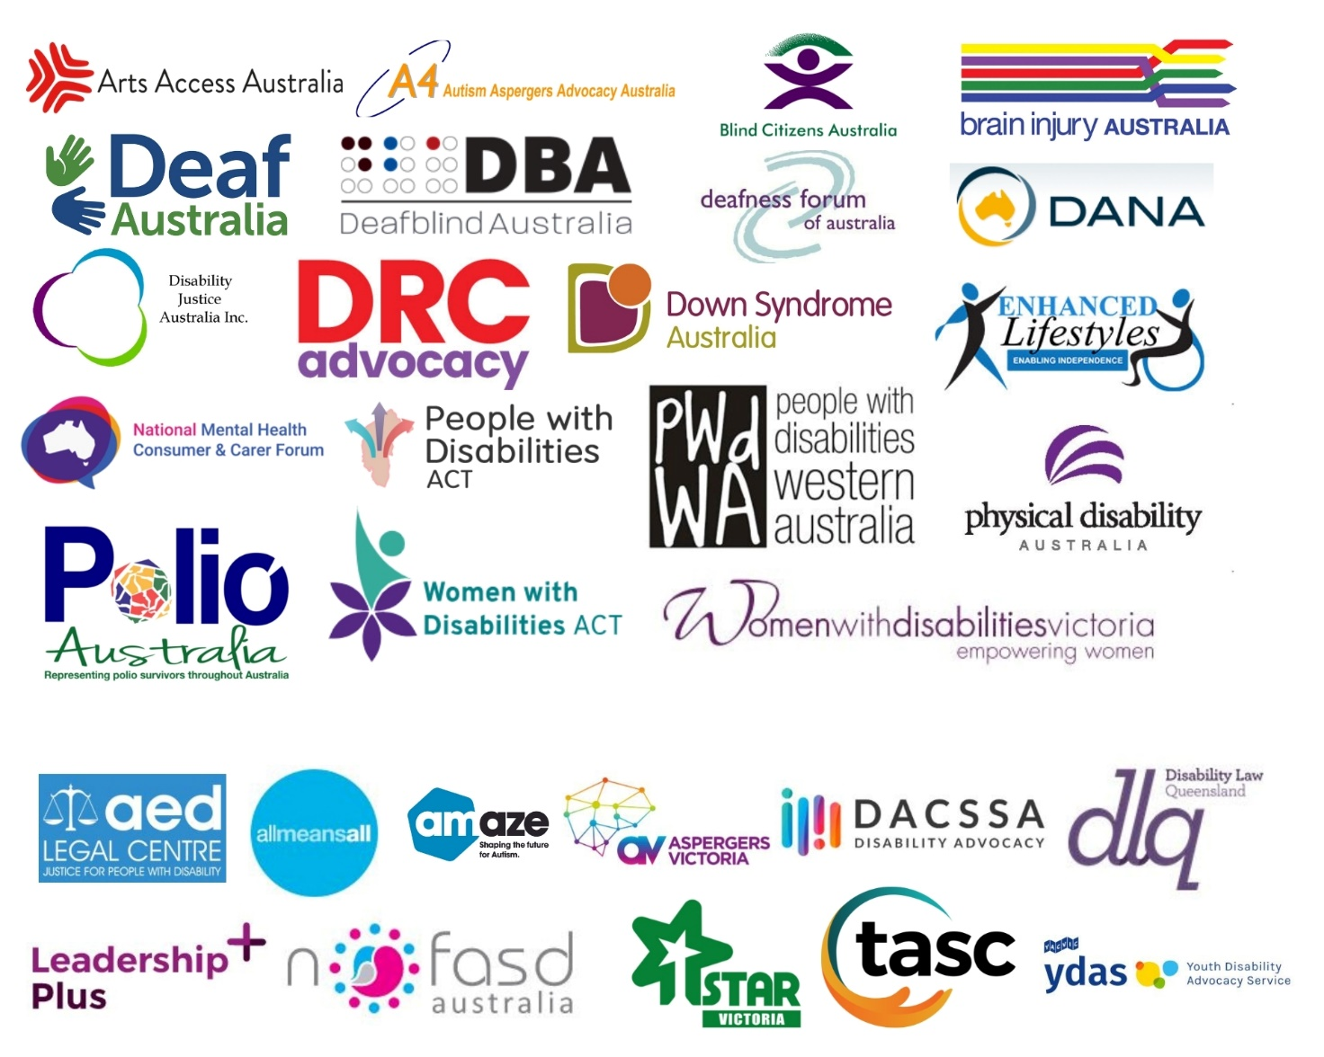

Acknowledgements
AFDO acknowledges Aboriginal and Torres Strait Islander people as the traditional custodians of the land on which we stand, recognising their continuing connection to land, waters, and community. From our head office in Melbourne, we pay our respects to the Bunurong Boon Wurrung and Wurundjeri Woi Wurrung peoples of the Eastern Kulin Nation and to their Elders past, present, and emerging. We also pay our respects to the traditional owners of all lands on which we operate or meet around the country.
AFDO acknowledges people with disability, particularly those individuals that have experienced or are continuing to experience violence, abuse, neglect, and exploitation. We also acknowledge their families, supporters, and representative organisations and express our thanks for the continuing work we all do in their support.
Report Author: Rebecca Rudd, Coordinator – Policy and Submissions
Review Team: Ross Joyce, Chief Executive Officer
Nick Wilson, Policy & Advocacy Officer

Report Contribution Acknowledgement:
AFDO recognises and thanks its membership for contributing their invaluable expertise, as well as their respective memberships’ lived experience and expertise, into this submission.

Recommendations
- That the federal government take a leadership role in developing and implementing a national housing strategy with all state and territory governments, encompassing all areas of the housing market and utilising a broad range of policy levers towards both short-term and long-term solutions.
- That the federal government take a leadership role in ensuring that all state and territory governments commit to investing in social housing to immediately increase the supply of secure, affordable, and accessible housing over a short to medium-term timeframe.

- That the federal government take a leadership role in ensuring all state and territory governments commit to a program to retrofit and modify a percentage of existing social housing to a minimum accessibility threshold, to increase the supply of secure, affordable, and accessible housing over short to medium-term timeframe.

- Review annually and increase Commonwealth Rent Assistance (CRA) so that it better meets the needs of all low-income renters and matches increased cost of living expenses.
- Introduce nationally consistent rent regulation legislation that ties the national rent price index with the median wage index and limits rent increases to once every 12 months.
- That all states and territories commit to adopting the minimum mandatory access standards in the National Construction Code within a reasonable timeline.
- Establish an independent body to review and permanently increase all social security payments to above the recognised poverty line and indexed in line with wages, ensuring they are sufficient to enable all people to live with dignity and to fully participate in community, social, and economic life.
- Increase income support payments – in particular, the Disability Support Pension and JobSeeker Allowance – to bring the standard of living of households with members with disability in line with the standard of living of similar households without disability.
Introductory comments
AFDO welcomes the opportunity to provide comment and thanks the Senate Select Committee on the Cost of Living for their consideration of this submission.
While the current crisis is an issue that affects all Australians, it is important to acknowledge that people with disability face additional challenges in relation to increased cost of living. Many people with disability have higher living expenses due to their need for disability-specific products and services.
Additionally, people with disability are more likely to face barriers to employment and education, limiting their ability to earn a living wage and contributing to financial insecurity. People with disability may also experience discrimination in housing and access to public services, which can limit their ability to secure affordable housing and access essential services such as healthcare and transportation.
The purpose of this submission is to highlight the experiences of people with disability during this cost of living crisis and ensure they are given due consideration with respect to any proposed policy solutions.
This submission will also include two relevant excerpts from AFDO’s recent submission to the Inquiry into the extent and nature of poverty – The right to social security and social protection and Key principles for a fair and reasonable DSP – for further reference.

Poverty in Australia
It is the position of AFDO that the existence of poverty in a wealthy country like Australia represents a systemic failure of government to protect its most vulnerable citizens.
As a signatory to the Convention on the Rights of Persons with Disabilities (CRPD), Australia is obliged to uphold the rights of people with disability, in this case, the rights to social support and social protection. Despite this obligation, there is a well-established link between poverty and disability, with the two existing in a cyclical relationship that entrenches and reinforces disadvantage across multiple spheres of life. This cycle of disadvantage drags individuals further into poverty and presents a ‘wicked problem’ that continues to remain impervious to many past and present policy solutions.
The disproportionate impact that poverty has on people with disability is made readily apparent by the available data. When speaking of the Australian population in general, most recent figures cite 13.4% or 3.3 million people as living in poverty. But, amongst people with disability, the rate of poverty is 17.2% when using the 50% median income poverty line, and a staggering 28.4% when using the 60% median income line. Of people experiencing poverty, 37% identify as having a disability. Australia is not unique in this regard, as people with disability are overrepresented among impoverished populations across the globe.

It is important to note that much of the data regarding disability and poverty in Australia ranges from six months to over four years old, in some cases predating the Covid-19 pandemic. Given the social and economic developments of the past twelve months and subsequent cost of living crisis, it is expected that forthcoming statistics will reflect an increase in poverty, both in general and amongst people with disability. The situation is likely even more dire than the data presented here would suggest.
The cost of living crisis
The tumultuous events of the past three years, most notably the Covid-19 pandemic and the war in Ukraine, have left the global economy in a precarious state and many countries, including Australia, experiencing a cost of living crisis. Lockdowns and supply chain disruptions have resulted in shortages and contributed to rising prices for essential goods and services, otherwise known as inflation. Governments and central banks have responded with various stimulus measures, such as direct payments to individuals and businesses, but these measures have also contributed to inflation and increased national debt levels. The pandemic also led to significant job losses and reduced incomes for many individuals and families, exacerbating existing financial insecurity and making it more difficult to afford basic needs. In Australia, lack of affordable housing is another primary factor in the cost of living crisis, with many experiencing housing insecurity and at risk of homelessness.
People with disability are more likely to be negatively impacted by the cost of living crisis due to the additional expenses that living with a disability incurs.
Life costs more for disabled people and their families, spending more on essential goods and services like; heating, insurance, equipment, and therapies. These extra costs mean disabled people have less money in their pocket than non-disabled people, or simply go without. The result is that disabled people are more likely to have a lower standard of living, even when they earn the same.
The cost of disability is defined as the inequality in the standard of living experienced by people with disability that arises from the interaction between a person’s impairment and the barriers they face to societal participation, rather than the cost of the disability itself.
Per the National Centre for Social and Economic Modelling (NATSEM), in order for a household with an adult with disability to achieve the same standard of living as a household without an adult with disability, they require an additional $107 per fortnight over and above their net disposable income.
While mitigating the cost of living crisis will require a multifaceted response, it is the opinion of AFDO that the Federal Government should begin by leveraging two key mechanisms – income support and affordable housing supply. By immediately alleviating the twin pressures of income insecurity and housing insecurity, the government can ease the burden of the cost of living crisis and promote financial stability for all Australians, including people with disability.

Key mechanisms for easing the cost of living crisis
The cost of living crisis has become a significant issue in Australia, leaving people with disability struggling to meet their basic needs due to the high cost of essential goods and services. To address this, the government should consider policies that address two root causes of the crisis – affordable housing supply and income support.

Housing
Lack of affordable housing is a major cause of poverty for all demographics. Individuals who cannot access affordable, secure, and appropriate housing are at risk of negative consequences including homelessness, poorer health outcomes, and lower rates of education and employment. Those in private rentals are most vulnerable, with renters being twice as likely to live in poverty as homeowners. Public housing tenants are at even greater risk, with 58% living in poverty. These figures demonstrate the failure of social security and housing policy in enabling individuals to access the basic need of housing without being driven into poverty.
For people with disability, lack of accessible housing is also a critical issue, and one that is further exacerbated by inconsistent adoption of the minimum mandatory access standards in the National Construction Code among the states and territories. Currently, all states and territories excluding Western Australia and New South Wales have agreed to a timeline for the adoption of the standards. Lack of accessible housing means people with disability will either be unable to find suitable accommodation, will be forced to make modifications at their own cost, or will be forced to live in more expensive housing that is accessible, all further adding to their financial burden.
In regard to people with disability:
- Of households who had at least one individual receiving DSP and were receiving Commonwealth Rent Assistance (CRA) as at June 2020, 32% were in rental stress after receipt of CRA; without CRA, 72% of these households would be in rental stress. This compares with 29% in rental stress after receipt of CRA and 55% in rental stress without CRA for all households receiving CRA.
- Only 0.3% of 74,300 rental properties, equating to 240 properties total, advertised in Australia on a selected weekend in March 2021 were affordable and appropriate for single people aged 21 and over receiving the DSP, compared with 1.2% (or 860 properties total) for a single person receiving minimum wage.
- Of clients who had accessed Specialist Homelessness Services (SHS) in 2021-2022, 3% or 7,300 had a disability. Two thirds of these had previously been assisted by a SHS agency at some point since July 2011.
To address the cost of living crisis, the government should implement a national housing strategy that includes provisions for both building new housing – including social housing and accessible housing, inclusive of requiring a program to retrofit and modify a percentage of existing social housing to a minimum accessibility threshold – and regulate the private rental market.

Recommendation: That the federal government take a leadership role in developing and implementing a national housing strategy with all state and territory governments, encompassing all areas of the housing market, and utilising a broad range of policy levers towards both short-term and long-term solutions.
Recommendation: That the federal government take a leadership role in ensuring all state and territory governments commit to investing in social housing to immediately increase the supply of secure, affordable, and accessible housing over a short to medium-term timeframe.
Recommendation: That the federal government take a leadership role in ensuring all state and territory governments commit to a program to retrofit and modify a percentage of existing social housing to a minimum accessibility threshold to increase the supply of secure, affordable, and accessible housing over short to medium-term timeframe.
Recommendation: Review annually and increase Commonwealth Rent Assistance (CRA) so that it better meets the needs of all low-income renters and matches increased cost of living expenses.
Recommendation: Introduce nationally consistent rent regulation legislation that ties the national rent price index with the median wage index and limits rent increases to once every 12 months.
Recommendation: That all states and territories commit to adopting the minimum mandatory access standards in the National Construction Code within a reasonable timeline.

Income support
Income support payments play an integral role in ensuring income security and enabling realisation of the rights to social security and social protection. They serve as a critical mechanism through which poverty can be directly alleviated, allowing the promotion of social and economic wellbeing, inclusion, and participation. This is especially true for people with disability, who face greater barriers to meaningful and accessible employment and incur additional disability-related expenses.
Data relating to people with disability and income support
- One in five (21%) of all income support payment recipients aged 16-64 received the DSP at June 2020.

- Recipients of the DSP tend to remain on the DSP for long periods of time, with very few moving on to other payments or exiting the income support system entirely. At June 2020, 81% of recipients aged 16–64 had been on the DSP for at least 5 years, and 56% for 10 or more years. This reflects the reality of many people living with disability, for whom employment may not be feasible and DSP is the primary source of income.

- Due to the tightening of eligibility criteria, receipt of the DSP has declined over time. Successful claims for DSP decreased from 64% in 2010 to a low of 25% in 2016. Since then, successful claims have slowly increased, but remain below 50%.

- Declining rates of DSP receipt has led to an increase in people with disability claiming unemployment benefits, which is reflected in the number of people receiving JSA who have been assessed as having a partial capacity to work (PCW). The number of JSA recipients with PCW was 375,000 in 2021, increased from 124,000 in 2013. Changes to DSP eligibility criteria are the driving force this shift.
While the DSP rate is marginally higher than that of JSA, both are below the poverty line.
As AFDO has stated in previous submissions, the government should leverage income support payments – in particular, the Disability Support Pension and JobSeeker Allowance – as an immediate means of reducing the burden of the increased cost of living and alleviating poverty.

Recommendation: Establish an independent body to review and permanently increase all social security payments to above the recognised poverty line and indexed in line with wages, ensuring they are sufficient to enable all people to live with dignity and to fully participate in community, social, and economic life.
Recommendation: Increase income support payments – in particular, the Disability Support Pension and JobSeeker Allowance – to bring the standard of living of households with members with disability in line with the standard of living of similar households without disability.

The right to social security and social protection
Australia is a signatory to both the International Covenant on Economic, Social and Cultural Rights (ICESCR) and the Convention on the Rights of Persons with Disabilities (CRPD). Under articles 9 and 28 of these instruments respectively, the Australian government is obliged to ensure that all people with disability have access to social security, social protection, and an adequate standard of living.
Per Article 28 of the CRPD, state parties to the Convention must “take appropriate steps to safeguard and promote the realization” of these rights. This imposes a positive obligation upon states to provide the necessary supports and services to people with disability. Notably, countries must “ensure access by persons with disability…to social protection programs” and ensure people with disability who are living in poverty have access to “assistance from the State with disability-related expenses.”
The term ‘social protection’ refers to:
… a variety of public and private interventions aimed at securing the well-being of a person in the event of social risk and need, such as (a) lack of work-related income, (b) unaffordable access to health care and (c) insufficient family and child support… social protection is understood broadly to cover a variety of interventions designed to guarantee basic income security and access to essential social services, with the ultimate goal of achieving social inclusion and social citizenship.
While the NDIS moves some way towards this approach, Australia’s social security system should ensure that all people with disability can access government assistance for disability-related costs regardless of eligibility.
In line with the Special Rapporteur on the rights of persons with disabilities, AFDO contends that social protection as defined above “constitutes an essential condition for social and economic development for all.” Furthermore, an effective national social protection system – of which income support payments like DSP are a crucial component – serves as a powerful instrument, not only through “providing income security and reducing poverty and inequality”, but also by playing a crucial role in enabling the social inclusion and social citizenship of people with disability. Social citizenship, which has been described as a “pre-condition for meaningful democracy”, refers to an individual’s full enjoyment of and access to political, civil, and social rights. In the absence of these basic necessities of life, individuals are marginalised from real political, economic, and social power, and cannot be said to be meaningfully participating in democracy as they lack the political influence necessary to improve their conditions of life.
As AFDO has most recently argued in a submission to the Disability Royal Commission, and in accordance with the definition of neglect provided therein,
Neglect includes physical or emotional neglect, passive neglect or wilful deprivation. Neglect can be a single significant incident or a systemic issue that involves depriving a person with disability of the basic necessities of life such as food, drink, shelter, access, mobility, clothing, education, medical care and treatment.
AFDO submits that the failure of the Australian government to provide adequate and accessible social support and social protection to people with disability, as evidenced in the significantly higher rates of poverty seen within the disabled community, constitutes institutional neglect through a wilful deprivation of basic life necessities and subsequent denial of social citizenship.

Key principles for a fair and reasonable Disability Support Pension
AFDO wishes to highlight the following eight key principles that should be adopted to ensure delivery of the DSP is consistent with our international human rights obligations.
- All persons have a human right to social security and social protection. The right to social security is also a core right of national citizenship in Australia that has long been embedded in legislation and government policy (e.g., Invalid and Old-aged Pension Act, 1908).

- The right to social security and social protection does not deny the right to work for persons with impairment/s and/or chronic condition/s but recognises that across the life course, persons with disability will require differing levels of socio-economic support to account for changes in personal circumstances and in the labour market.

- Persons with disability who are unable to work or are limited in their capacity to work due to impairment, have a right to social protection and economic security. Mainstream unemployment benefits and income support payments are inappropriate and not fit for purpose as social security payments for persons with disability.

- The assessment of disability social security eligibility needs to be fair, reasonable, and based upon an objective measure of need to ensure it is first, responsive to the individual and their circumstances, and second, does not generate hardship or greater economic insecurity.

- Disability social security assessment processes should be undertaken by relevant medical and allied health professionals who have the required expertise in relation to the individual’s impairment/s and chronic condition/s alongside the everyday impacts the impairment/s and/or chronic condition/s have over a period of time and the impacts of social barriers like stigma, discrimination, and inaccessibility of the labour market.

- Personal information and evidence provided by the assessing medical and allied health professionals, and the individual concerned, remains protected under national privacy legislation, and cannot be shared nor drawn upon without the explicit permission of the individual concerned.

- Disability social security assessment processes, procedures, and outcomes must be freely and readily available and distributed widely in inclusive, accessible formats and languages to ensure that all persons with disabilities, their support networks, and medical and allied health professional support networks are fully informed.

- Responsible government department/s should publish regular and comprehensive de-identified data documenting the core demographic information of recipients alongside changes to regulations and guidelines to enable, first, the monitoring of impact of such changes, and second, to ensure that persons with disabilities and/or chronic conditions, medical and allied health professionals, and relevant organisations are fully informed at all times. These data should be in a form that allows for secondary analysis by independent parties

Reference List
Anglicare Australia (2021) Rental Affordability Snapshot – national report April 2021, Anglicare Australia, accessed 1 Feb 2023.
<https://www.anglicare.asn.au/publications/rental-affordability-snapshot-2021/>
Australian Bureau of Statistics (ABS) (2018) Disability, Ageing and Carers, Australia: Summary of Findings, ABS, accessed 1 February 2023. <https://www.abs.gov.au/statistics/health/disability/disability-ageing-and-carers-australia-summary-findings/latest-release>
Australian Government (2021) Key Terms, Royal Commission into Violence, Abuse, Neglect and Exploitation of People with Disability, accessed 27 August 2021.
<https://disability.royalcommission.gov.au/about-royal-commission/key-terms>
Australian Institute for Health and Welfare (AIHW) (2021) Housing assistance in Australia, AIHW, accessed 1 February 2023.
<https://www.aihw.gov.au/reports/housing-assistance/housing-assistance-in-australia/contents/about>
Australian Institute of Health and Welfare (AIHW) (2022a) People with disability in Australia 2022: In brief, catalogue number DIS 81, AIHW, Australian Government.
<https://www.aihw.gov.au/getmedia/d4f8b523-a6e9-427f-a88e-31cb1b61dc3b/aihw-dis-81-people-with-disability-in-australia-2022-in-brief.pdf.aspx?inline=true>
Australian Institute for Health and Welfare (AIHW) (2022b) Specialist homelessness services annual report 2021-2022, AIHW, accessed 1 Feb 2023.
<https://www.aihw.gov.au/reports/homelessness-services/shs-annual-report-2020-21/contents/about>
Davidson, P., Bradbury, B. & Wong, M. (2020) Poverty in Australia 2020: Part 2, Who is affected? ACOSS/UNSW Poverty and Inequality Partnership Report No. 4, Sydney: ACOSS.
Devandas Aguilar, C. (2015) Report of the Special Rapporteur on the rights of persons with disabilities, United Nations General Assembly: New York. NY.
John, E., Thomas, G. & Touchet, A. (2019) The Disability Price Tag 2019: Policy report, SCOPE, accessed 30 August 2021.
<https://www.scope.org.uk/campaigns/extra-costs/disability-price-tag/>
Liebenberg, S. (1999) ‘Social Citizenship: A Precondition for Meaningful Democracy’, Agenda: Empowering Women for Gender Equity, 40: 59-65.
<https://doi.org/10.2307/4066019>
Marshall, T.H. (1950) Citizenship and Social Class and other essays, University Press: Cambridge.
Melbourne Institute of Applied Economic and Social Research (Melbourne Institute) (2022) Poverty Lines: Australia, ISSN 1448-0530, June Quarter 2022.
United Nations General Assembly (1966) International Covenant on Economic, Social and Cultural Rights, Treaty Series, vol. 993, 16 December 1966.
United Nations (2006) Convention on the Rights of Persons with Disabilities, Treaty Series, vol. 2515, Dec. 2006.

Davidson et al. 2020.
ABS 2018.
Davidson et al. 2020, 16.
Devandas Aguilar 2015.
John et al. 2019.
Li et al. 2019.
Li et al. 2019.
Davidson et al. 2020.
Davidson et al. 2020.
Rental stress is defined as rent exceeding 30% of gross household income.
AIHW 2021.
Anglicare 2021.
AIHW 2022b.
Ibid.
AIHW 2022a.
Ibid.
Ibid.
Ibid.
Melbourne Institute 2022.
UN General Assembly 1966, art. 9, 11; UN 2006, art. 28.
UN 2006, art. 28 (1, 2).
Ibid art. 28 (2c).
Devandas Aguilar 2015, 4, emphasis added.
Ibid., 4.
Ibid., 4.
Liebenberg 1999, 59.
Marshall 1950.
Australian Government 2021.

