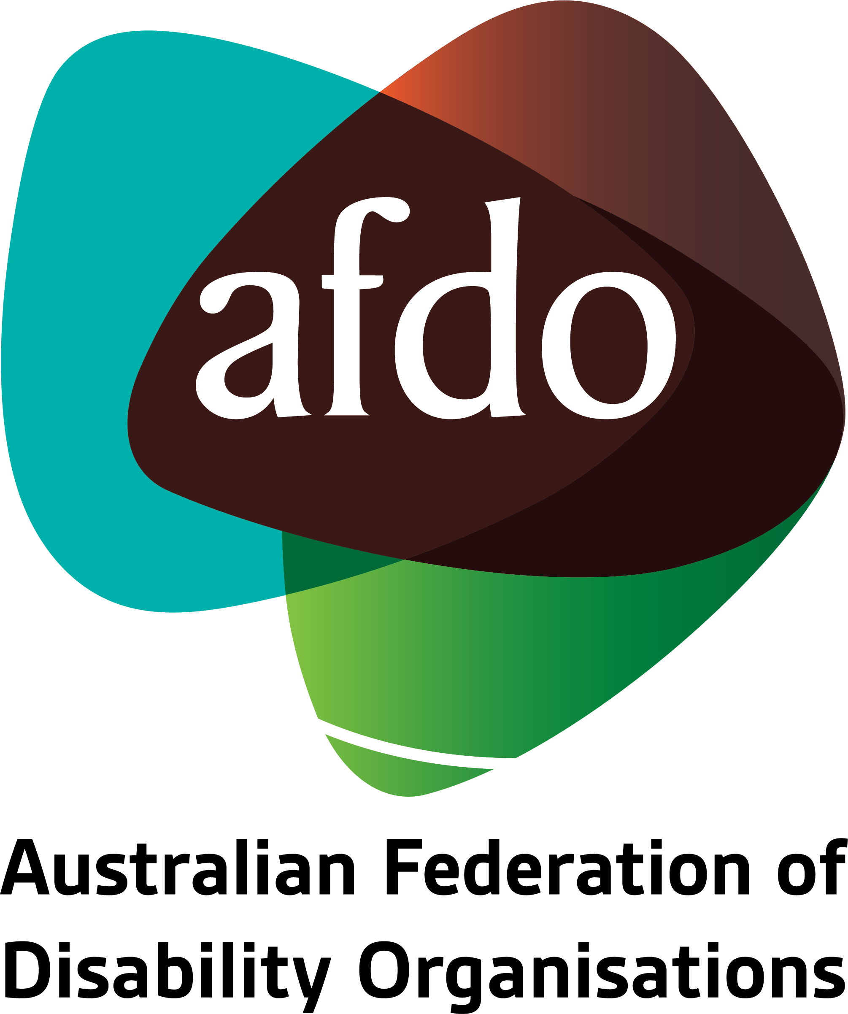

Draft General Comment on Article 4 of Optional Protocol to the Convention Against Torture and Other Cruel, Inhuman or Degrading Treatment or Punishment (OPCAT)

Submission to United Nations Subcommittee on Prevention of Torture

18th April 2023

Table of Contents
Table of Contents 2
Acknowledgements 3
About AFDO 4
Our members 5
Introduction 7
Responses to the General Comment 8

Acknowledgements
1. AFDO acknowledges Aboriginal and Torres Strait Islander people as the traditional custodians of the land on which we stand, recognising their continuing connection to land, waters, and community. From our head office in Melbourne, we pay our respects to the Bunurong Boon Wurrung and Wurundjeri Woi Wurrung peoples of the Eastern Kulin Nation and to their Elders past, present, and emerging. We also pay our respects to the traditional owners of all lands on which we operate or meet around the country.

2. AFDO acknowledges people with disability, particularly those individuals that have experienced or are continuing to experience violence, abuse, neglect, and exploitation. We also acknowledge their families, supporters, and representative organisations and express our thanks for the continuing work we all do in their support.
3.Report Author: Ross Joyce, Chief Executive Officer

4. AFDO recognises and thanks its membership for contributing their invaluable expertise, as well as the insights drawn from their respective memberships’ lived experience, for this submission.

About AFDO
- Since 2003, the Australian Federation of Disability Organisations (AFDO), a Disabled Peoples Organisation (DPO) and Disability Representative Organisation (DRO), has been the recognised national peak organisation in the disability sector, along with its disability specific members and cross disability members, representing people with disability & their families.

- AFDO’s mission is to champion the rights of people with disability in Australia and support them to participate fully in Australian life.

- With our thirty two member organisations we are the only national peak representing disability specific and cross disability based communities with a total reach of over 4 million Australians.

- AFDO continues to provide a strong, trusted, independent voice for the disability sector on national policy, inquiries, submissions, systemic advocacy and advisory on government initiatives with the Federal and State/Territory governments.

- We work to develop a community where people with disability can participate in all aspects of social, economic, political and cultural life. This includes genuine participation in mainstream community life, the development of respectful and valued relationships, social and economic participation, and the opportunity to contribute as valued citizens.

- AFDO holds consultative status with the United Nations Economic and Social Council (ECOSOC)
Our vision
- That all people with disabilities must be involved equally in all aspects of social, economic, political and cultural life.
Our mission
- Using the strength of our membership-based organisations to harness the collective power of uniting people with disability to change society into a community where everyone is equal.
Our strategic objectives
- Represent the interests and united voice of our members and people with disability at a national and international level in all relevant forums.
- Build the capacity, profile, reputation and sustainability of AFDO through the strength of our member organisations
- Enhance the connection & influence of AFDO in international disability initiatives by policy, advocacy & engagement, focused on the Asia Pacific region

Our members
- Full members:
- Advocacy for Inclusion
- Arts Access Australia
- Autism Aspergers Advocacy Australia
- Blind Citizens Australia
- Brain Injury Australia
- Deaf Australia
- Deafblind Australia
- Deafness Forum Australia
- Disability Advocacy Network Australia
- Disability Justice Australia
- Disability Resources Centre
- Down Syndrome Australia
- Enhanced Lifestyles
- National Mental Health Consumer & Carer Forum
- People With Disabilities WA
- Polio Australia
- Physical Disability Australia
- Women With Disabilities ACT
- Women with Disabilities Victoria

- Associate members:
- All Means All
- AED Legal Centre
- Amaze
- Aspergers Victoria
- Disability Advocacy and Complaints Service of South Australia
- Explorability Inc
- Leadership Plus
- Multiple Sclerosis Australia
- National Organisation for Fetal Alcohol Spectrum Disorder
- National Union of Students - Disabilities Department
- Star Victoria Inc
- TASC National Limited
- Youth Disability Advocacy Service

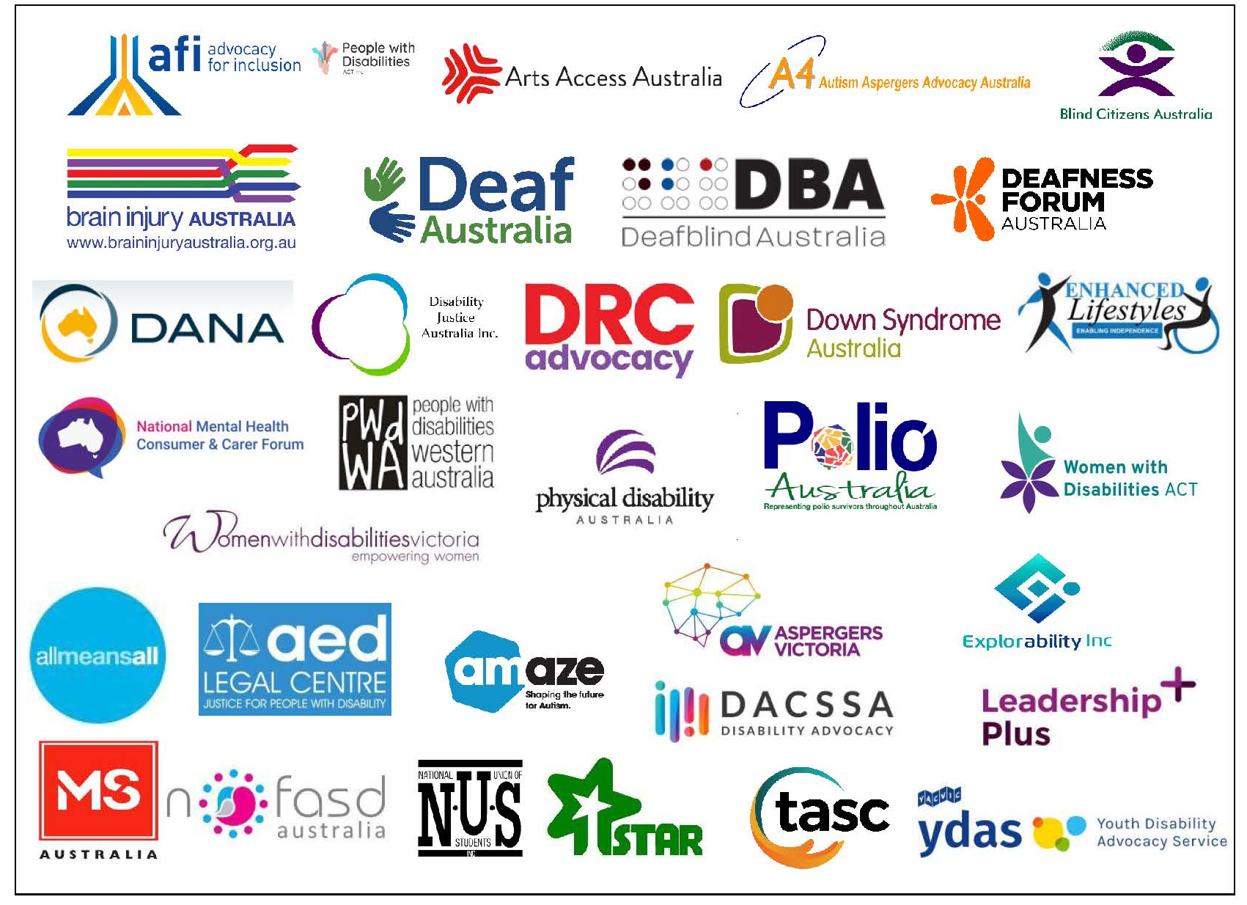

Introduction
- The Australian Federation of Disability Organisations welcomes the
opportunity to provide this submission to the United Nations Subcommittee
on Prevention of Torture (UN SPT) consultation on its Draft General Comment
on Article 4 of OPCAT. 1

- The bona fides of AFDO as a DPO, an Australian DRO, a National Peak representative member organisation and holding ECOSOC consultative status are outlined in paragraphs 5 – 17 in the preceeding section.

- AFDO advises that it is not a designated National Preventive Mechanism (NPM) or NPM-coordinator but continues its work independently as a memebre and along with the Australia OPCAT Network to promote compliance and provide an independent view on the actions Australia is required to undertake to ensure compliance with its international human rights obligations.

- AFDO, both independently and as a party to the Australia OPCAT Network, has long advocated for Australia’s full compliance with its OPCAT obligtaions

- AFDO urges changes to all Australian juridictions for people in detention and in particular for people with disbility in detention, that promotes stronger and more consistent protections of their human rights.

- AFDO is willing to provide further assistance to the UN SPT in its consideration of these issues by contacting : ceo@afdo.org.au

Responses to the General Comment
- AFDO fully supports the UN SPT’s objective in relation to misconceptions about the definition of places of deprivation of liberty and places of detention as these continue to create ambiguity giving rise to state parties and those responsible for administering places of detention avoiding their responsibilities under international law, conventions and treaties.

- AFDO agrees with the Subcommittee’s view at paragraph’s 3 and 24 that the phrase in Article 4(1) ‘jurisdiction and control’ should be understood to mean ‘jurisdiction or control’. This means ensures that State Parties are responsible for both jurisdictional areas over which they govern or circumstances within their territory where they still have responsibility for control.

- As noted by the Committee against Torture: “The Committee has recognized that any territory under a State’s jurisdiction includes all areas where the State party exercises, directly or indirectly, in whole or in part, de jure or de facto effective control, in accordance with international law”

- AFDO fully supports the Subcommittee’s outline and its comprehensive approach to the definition of places of deprivation of liberty.

- AFDO agrees with other submissions that the provision of examples of what is a place of deprivation of liberty, as is done in paragraphs 14, 36, 37 and 38, varies across the paragraphs. We recommend for consistency having one list for reference to remove inconsistency, allowance for or subsequent error in any interpretation.

- AFDO supports the extension of this to include settings where there are any persons held that may be subject to substitute decision-making inclusive of in specialist or specific accommodation, mental health or forensic mental health settings that effectively involving involuntary detention and these must be listed and considered within the scope of the OPCAT principles and monitoring requirements.

Committee against Torture, general comment No. 2 (2007), paras. 15–16.

