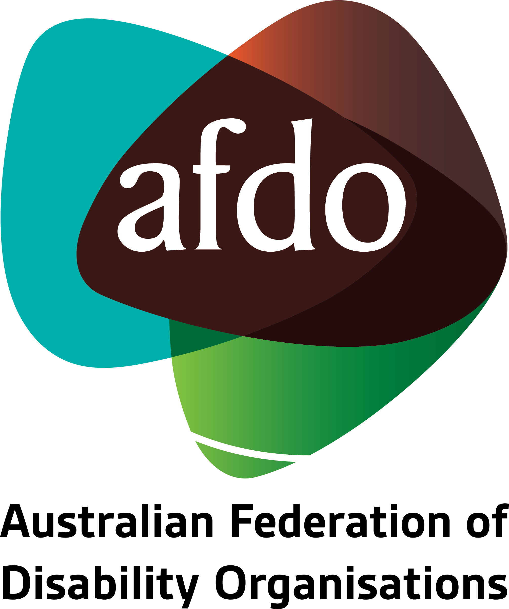

# 2022 Review of the Transport Standards

Submission by AFDO and NITAN

**June 2023**

Table of Contents

About AFDO 3  
About NITAN 6  
Acknowledgements 8  
Executive Summary 9  
Excerpts from "*A Line in the Sand"* 10  
Aviation 14  
Ride Share 15  
School Buses 16  
Recommendations 17  
References 18  
Appendix 1: Recommendations from Previous Reviews of the DSAPT 19

## About AFDO

Since 2003, the Australian Federation of Disability Organisations (AFDO), a Disabled Peoples Organisation (DPO) and Disability Representative Organisation (DRO), has been the recognised national peak organisation in the disability sector, along with its disability specific members, representing people with disability. AFDO’s mission is to champion the rights of people with disability in Australia and support them to participate fully in Australian life.

Our member organisations represent disability specific communities with a total reach of over 4 million Australians.

AFDO continues to provide a strong, trusted, independent voice for the disability sector on national policy, inquiries, submissions, systemic advocacy and advisory on government initiatives with the Federal and State/Territory governments.

We work to develop a community where people with disability can participate in all aspects of social, economic, political and cultural life. This includes genuine participation in mainstream community life, the development of respectful and valued relationships, social and economic participation, and the opportunity to contribute as valued citizens.

**Our vision**

That all people with disabilities must be involved equally in all aspects of social, economic, political and cultural life.

**Our mission**

Using the strength of our membership-based organisations to harness the collective power of uniting people with disability to change society into a community where everyone is equal.

**Our strategic objectives**

To represent the interests and united voice of our members and people with disability at a national and international level in all relevant forums.

To build the capacity, profile, reputation and sustainability of AFDO through the strength of our member organisations.

To enhance the connection and influence in international disability initiatives by policy, advocacy and engagement, focused on the Asia Pacific region.

## Our members

**Full members:**

* Advocacy for Inclusion Incorporated
* Arts Access Australia
* Autism Aspergers Advocacy Australia
* Blind Citizens Australia
* Brain Injury Australia
* Deaf Australia
* Deafblind Australia
* Deafness Forum Australia
* Disability Advocacy Network Australia
* Disability Justice Australia
* Disability Resources Centre
* Down Syndrome Australia
* Enhanced Lifestyles
* National Mental Health Consumer & Carer Forum
* People With Disabilities WA
* Polio Australia
* Physical Disability Australia
* Women With Disabilities ACT
* Women with Disabilities Victoria

**Associate members:**

* All Means All
* AED Legal Centre
* Amaze
* Aspergers Victoria
* Disability Advocacy and Complaints Service of South Australia
* Explorability Inc
* Leadership Plus
* Multiple Sclerosis Australia
* National Organisation for Fetal Alcohol Spectrum Disorder
* National Union of Students - Disabilities Department
* Star Victoria Inc
* TASC National Limited
* Youth Disability Advocacy Service

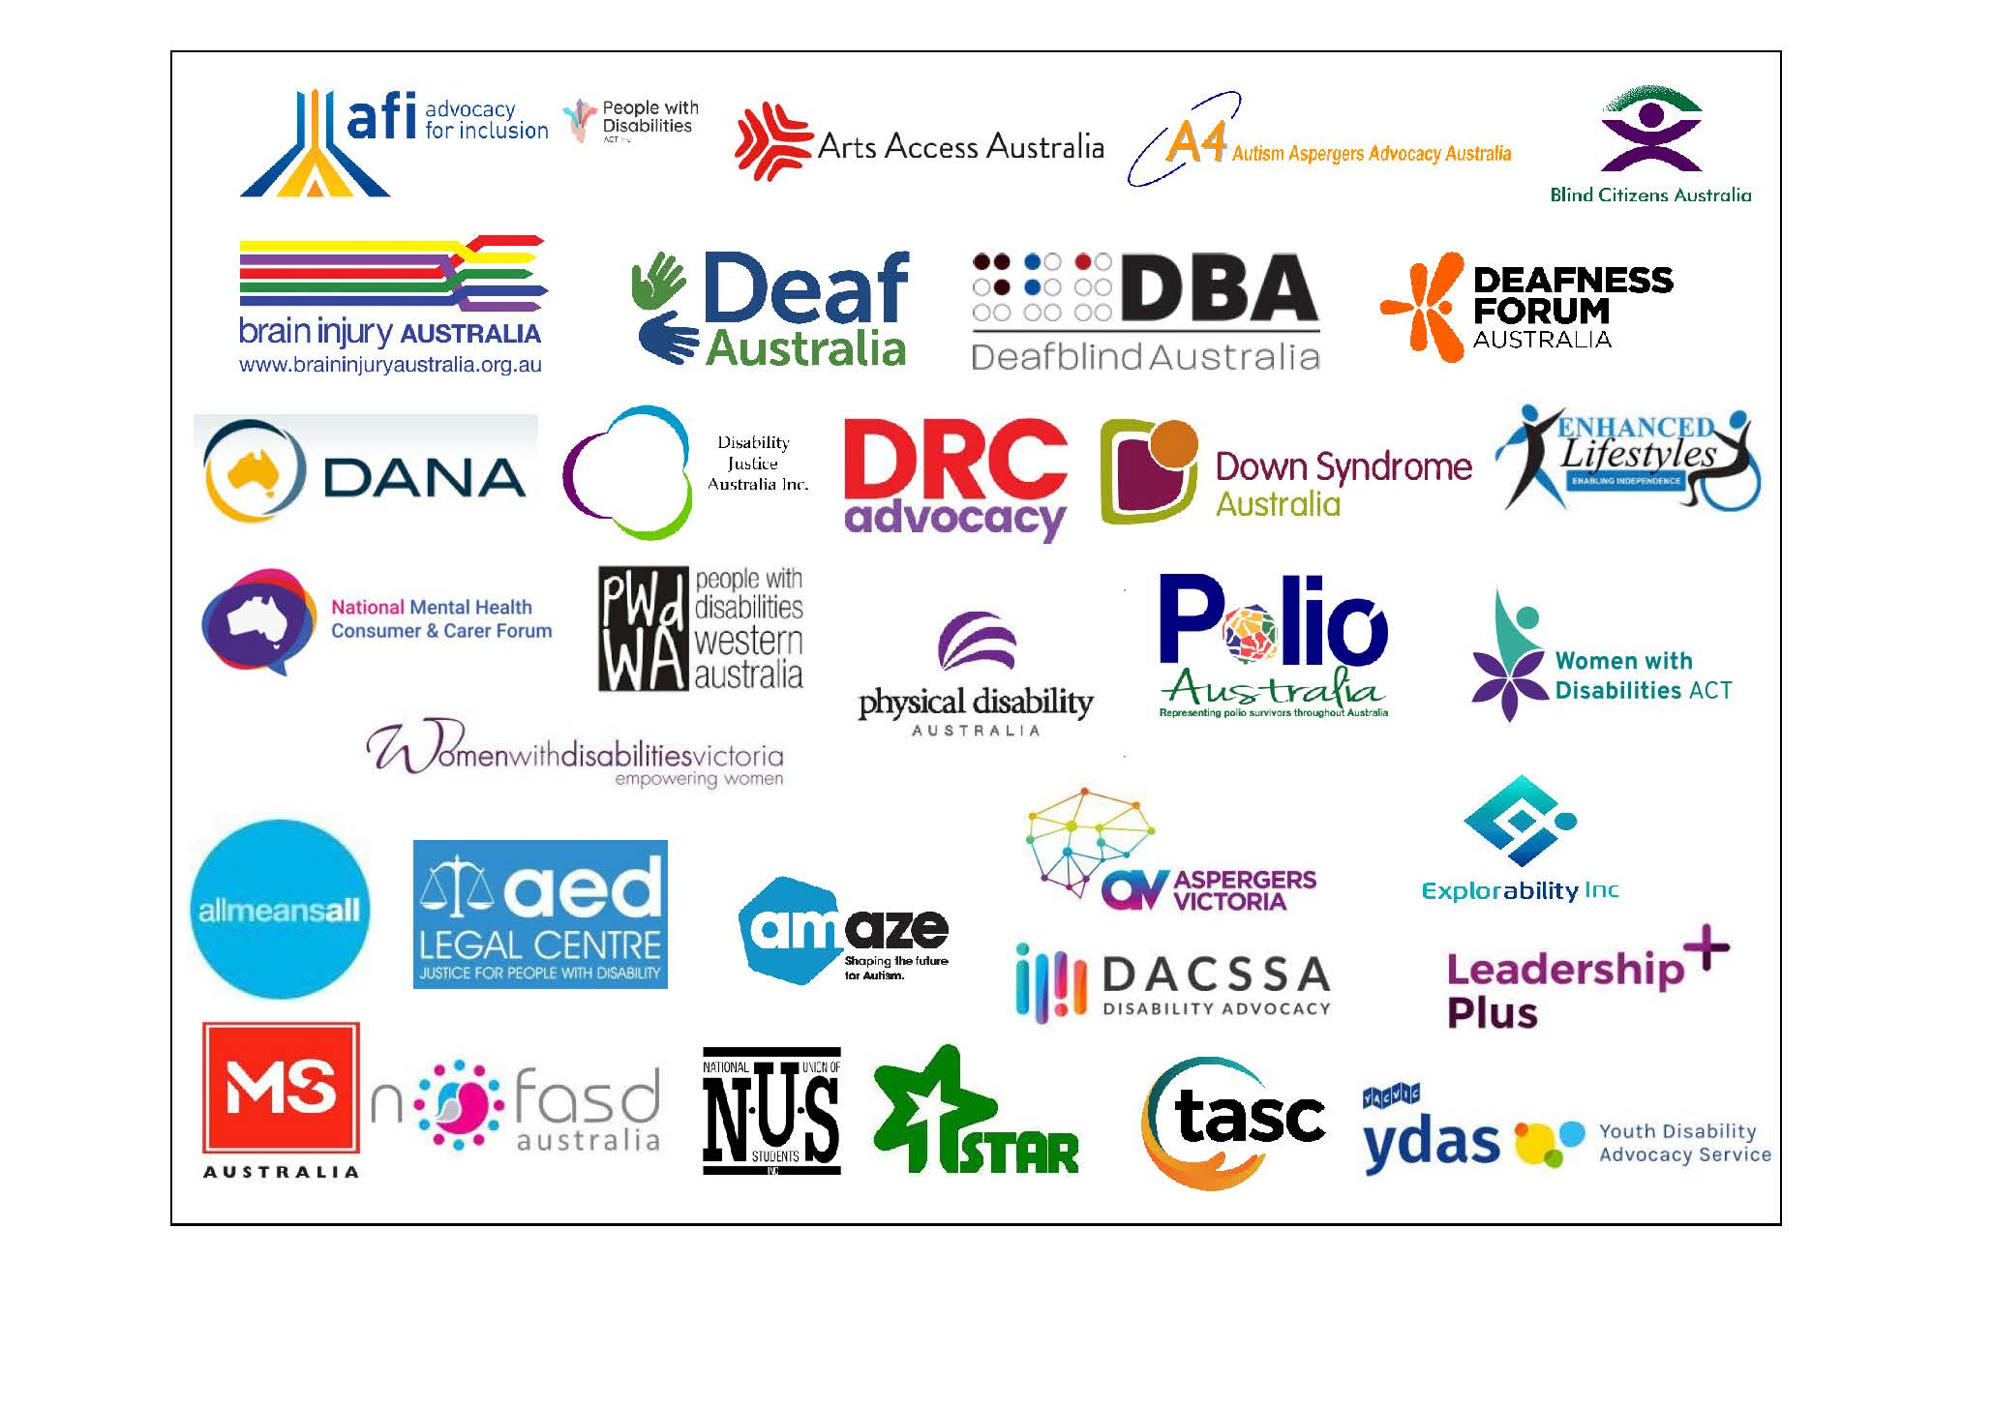

## About NITAN

The National Inclusive Transport Advocacy Network (NITAN) represents a national voice of people with disability advocating for accessible and inclusive public transport systems across Australia.   
  
<http://www.nitan.org.au/>

**Background**  
NITAN was established and is under the auspice of the Australian Federation of Disability Organisations (AFDO). However, NITAN operates independently; it is an unfunded group of people who share a specific interest in public transport matters.  
  
**Members**  
NITAN was established with a core working group of members from the following organisations:

* All Aboard Network
* Australian Federation of Disability Organisations
* Council for Intellectual Disability
* Disability Justice Australia
* Disability Resources Centre
* First Peoples Disability Network
* Inclusion Moves
* National Ethnic Disability Alliance
* People with Disability Australia
* Physical Disability Council of NSW
* Victorian Legal Aid

NITAN has since grown to also be supported by other state-based advocacy organisations and individuals with expertise in legal, transport, and disability rights. Our focus is unashamedly on disabled people having access to the same transport options as the wider community, spanning the full spectrum from active transport to public transport and the ability to self-drive.

**Purpose**We aim to be a voice of people with disability on transport matters; however, we recognise the disability community is made up of a diverse range of people with differing needs and priorities. We understand that to be effective, we need to engage

with experts in their field. We are open to ideas on how this can occur and look forward to shaping our voice with the disabled communities’ assistance.

**Our Objectives:**

* **Community Inclusion**: Promote the ethos that full, equal community integration of people with disability is not possible without a completely accessible ‘whole of journey’ public transport system Australia-wide, and advocate this position to all governments, industry, and community stakeholders.
* **Influence**: Ensure that the voices of people with disability are heard in the design and shaping of public transport systems across Australia and in their day-to-day operations. Support others with requisite experience and qualifications as they advocate on public transport issues encompassing a “nothing about us without us” approach.
* **Alliances**: Build a strong network of allies and rally the many voices of people with disability to speak as one national voice.

### What does NITAN do?

NITAN aligns itself fully with the goals of Australia’s Disability Strategy.

We provide a national voice and connection for people with disability and associated organisations that advocate for accessible and inclusive transport.

We work to educate people with disability on their transport rights. We also raise awareness of public transport issues facing people with disability.

We make sure that state and territory-based transport advocacy groups can feed into a national advocacy network that is independent and non-partisan.

## Acknowledgements

AFDO acknowledges Aboriginal and Torres Strait Islander people as the traditional custodians of the land on which we stand, recognising their continuing connection to land, waters, and community. From our offices in Melbourne, Canberra, Sydney and Brisbane, we pay our respects to the peoples of the lands on which these operate and to their respective Elders past, present, and emerging. We also pay our respects to the traditional owners of all lands on which we operate or meet around the country.

AFDO acknowledges people with disability, particularly those individuals that have experienced or are continuing to experience violence, abuse, neglect, and exploitation. We also acknowledge their families, supporters, and representative organisations and express our thanks for the continuing work we all do in their support.

This Submission has been compiled by the Australian Federation of Disability Organisations (AFDO) and the National Inclusive Transport Advocacy Network (NITAN).

**This submission has also been endorsed by the following organisations:**







## Executive Summary

It is noted that this review of the Disability Standards for Accessible Public Transport 2002 (the Standards) is at the end of its cycle. AFDO and NITAN understand that the modernisation consultation process has occurred and a position by Federal and State governments awaits.

It is within this context that this submission aims to highlight what we believe are significant issues within the current standards.

This submission provides a brief overview of the issues people with disability still encounter on a daily basis. The concerns raised will broadly address the following areas:

* Complaints system
* Aviation
* Ride Share
* School buses

This submission highlights these issues and provides recommendations as to what collectively we would like to see to ensure that the standards are improved for people with disability.

## Excerpts from “*A Line in the Sand”*

AFDO and NITAN have previously noted in our joint submission, *Line In The Sand Report* (dated January 2022) there are a number of issues within the Standards that relate to the Standards being complex and difficult to interpret for people with disability.

Relevant sections from the report that continue to remain unaddressed are quoted below.

**Complexity of the Transport Standards**

*While public transport passenger use areas are protected by Commonwealth, State, and Territory discrimination laws, the protections are not uniform and have complex interactions with the codes and Transport Standards. When the Transport Standards were developed in 2002, outdated standards already in place were incorporated, where they remain to this day. This is despite the wealth of disability research and literature that has emerged through the 1990s and early 2000s, which could easily be used to develop better Transport Standards.*

**Review process**

*Part 34 of the Transport Standards requires the Minister for Infrastructure, Transport and Regional Development, in consultation with the Attorney-General, to review the efficiency and effectiveness of the Transport Standards within five years of them taking effect, with subsequent reviews to be undertaken every five years.[1] The* *reviews must consider whether discrimination has been removed as far as possible, according to the requirements for compliance set out in Schedule 1; and any necessary amendments to the Transport Standards.*

*Despite having conducted three five-year reviews to date, all of which have broadly stated the same set of recommendations,[2] compliance to the standards continues to be poor with minimal evidence of progress and few consequences for failure to adhere.*

*We submit that the repeated failure of the Australian Government to implement the recommendations reiterated in successive reviews of the Transport Standards has resulted in systemic flaws preventing the provision of inclusive transport and consequent negative outcomes for people with disability.*

*Under Part 34 of the Transport Standards, the Minister for Infrastructure, Transport and Regional Development, in consultation with the Attorney General, is required to review the efficiency and efficacy of the Transport Standards on a five-yearly basis.[3] The purpose of these reviews is to consider whether discrimination has been removed – as much as is reasonably possible – in line with the compliance requirements laid out in Schedule 1.*

*Since the establishment of the Transport Standards in 2002, three reviews have been completed. The first five-year review commenced in 2007, with the final report and Australian Government response being released in June 2011. The second review was commenced in 2012 with the final report and Australian Government response released in July 2015. The most recent review was released to the general public on 2 December, 2021.*

*We are concerned about the failure to implement a significant number of recommendations from the two previous reviews of the Transport Standards. Having reviewed and analysed the two previous reports, we found that the same issues had been raised, the same recommendations made, and yet, on the majority of these issues and recommendations, no tangible progress had occurred. Whilst the Commonwealth has always responded to each Review of the Transport Standards with supportive statements, these have not translated into real action or outcomes. It is this lack of progress that NITAN finds abhorrent and astounding.*

*The Australian Human Rights Commission (AHRC) is obliged under section 67(e) of the DDA: “to monitor the operation of such standards and report to the Minister the results of such monitoring”.[4] Despite conducting regular five-yearly reviews, compliance to the standards continues to be extremely poor.*

*One of our primary concerns is that compliance with the Transport Standards is not effectively enforceable. Currently, the only mechanism for ensuring compliance with the Transport Standards is through a complaints process which can only be instigated individually by people with disability, mirroring the complaints process under the DDA.*

*The inability for the Transport Standards (and the anti-discrimination legislation it is embedded in) to enforce any compliance in the operation of public transport services also means it has no force at the design, tender and quotation, or development and building stages, leading to accessibility oversights that require costly rectification works or that are simply ignored, as was the case in the recent Queensland Rail decision.*

*We are also concerned about the current dissonance between the Transport Standards and the DDA highlighted by* *Haraksin v Murrays Australia (2013).[5] This is an example of the flaws that exist around accountability and enforcement of the Transport Standards. We believe that a breach of the Transport Standards should be unlawful and that the Transport Standards should be amended to reflect this position.*

*There is a lack of a detailed and comparable reporting mechanisms to allow for the measuring of compliance with the Transport Standards across all jurisdictions. Recommendation 1 of the 2012 Review stated that “the Commonwealth Government, jointly with state and territory governments, establish a national framework for reporting on progress against the Transport Standards”.*

*We are concerned that the lack of a nationally consistent audit of Transport Standards compliance is preventing the review from measuring progress against compliance targets with any accuracy; an issue that was recognised by the Commonwealth Government back in the first 2007 Review.*

In summary, we are asking for a new strategy for the Standards, one that contains an effective mechanism for enforcing compliance, as well as the necessary monitoring and nationally consistent data collection to ensure it is being implemented and targets set are known and are being met.

**Inequitable Complaints Process**

*Relying solely on an individual complaint for enforcement impedes the capacity of the Transport Standards to act as a driver for any significant change to accessibility of public transport. Further, the complaints process itself is inherently unfair and exposes an individual with disability to financial and emotional risk.*

*We feel strongly that the reliance on individual complaints for the enforcement of the Transport Standards impedes the capacity of the Standards to act as a driver for change to accessibility of public transport. This places an unnecessary administrative burden and also an onerous financial risk on people with disability, who should by now have equitable access to Australia’s public transport infrastructure as required by the Transport Standards as with any other service user.*

*The complaints process, which is mediated by the Australian Human Rights Commission (AHRC), brings the complainant, normally a person with disability, and a respondent, normally a public transport operator or provider, together to negotiate a settlement. The person with disability is normally only able to represent themselves, while the respondent often has a team of lawyers. Because of the inherent unfairness of this system, the resulting negotiated settlement, if one is reached, may still not result in compliance with the Transport Standards.*

*While it is true that complainants may seek to have unresolved discrimination complaints adjudicated by the Federal Courts, this is often not a viable course of action for many people with disability as it exposes them to further financial risk. In addition, the legal process and judicial system are both onerous and time-consuming, and the risk of emotional or psychological effects can often mean people with disability withdraw from the process prior to its conclusion.*

*As noted above, the complaints system can only be used to seek compensation for discriminatory conduct. It cannot stop public transport operators from purchasing and using non-compliant conveyances for considerable lengths of time. This is at odds with the fact that litigations costs are an inherent part of the process of bringing a complaint on and can run into the tens of thousands of dollars.*

In line with the position stated by the Public Interest Advocacy Centre (PIAC), we support an equal access model, which would enable successful applicants to recover their legal costs from the other party. Where an applicant is unsuccessful, each party will bear their own costs, excluding cases where the applicant has behaved vexatiously or unreasonably. This model would improve access to justice by allowing applicants to access lawyers on a ‘no win, no fee’ basis.

In light of the above, we believe that that complaints system is significantly flawed and is a reactive system. It is our belief that processes and legislation around the Standards should be proactive.

We request the urgent introcduction of an independent reporting system to ensure compliance to the standards.

## Aviation

AFDO and NITAN recognise that travelling by air continues to be problematic for people with disability. Issues around security screening, access to boarding, disembarking, and loss of and damage to mobility equipment are significant concerns that the airline industry and people with disability have been aware of and continue to endure over decades.

Security screening at airports can be very discriminatory for people with disability. Security systems lack of, or poor design, accompanied with a lack of training by security staff in disability awareness are issues that continue to be a source of ongoing complaints.

We are of the view that we need to consider other jurisdictional models in order for service providers to be both accountable and have enforceable measures that people with disability can have faith in to report and have satisfactory outcomes. This would also provide clarity and consistency for all parties.

It is our view that we require an independent body to identify accessibility barriers and provide an enforceable mechanism for their removal.

A model where public reporting by airlines of damage done to wheelchairs and mobility aids is one that we strongly encourage. Furthermore, we recommend that airlines and people with disability co-design a process that will be beneficial for all.

The issue of equivalent access is problematic and is the cause for many complaints for air travel. People with disability often feel degraded and discriminated against as a result of this standard. It enables providers to not invest in appropriate equipment and facilities. It also relies on people being appropriately trained. Standards and systems should not be person-based.

If this standard is to be maintained, then the onus must be on the transport provider to provide valid reasons as to why appropriate equipment or facilities are unable to be provided for people with disability. A set of criteria needs to be established and independantly reviewed for this standard to be implemented and should be seen as a last resort. Alternatively, this standard needs to be modified to ensure it is co-designed with People with disability to ensure appropriate service.

Equivalent access standards need to have proper, meaningful consultation with people with disability. A co-designed process that includes people with disability and their representatives is required. The process needs to be transparent with decisions made publicly available.

## Ride Share

Currently, ride share services in Australia are viewed as part of the gig economy and are exempt from the current Standards.

It is imperative that ride share services are viewed as a transport business and as such are considered a public service. Were this to occur, then ride sharing services should be covered under the Standards.

We are aware that there are issues with ride sharing services not providing services to people with disability, especially people who use assistance animals. Drivers not picking up passengers due to having their guide dogs with them is an unacceptable practice which continues discrimination and is contrary to legislated rules in place to protect the rights of people with disability and their use of assistive animals.

In addition, wheelchair users are unable to use ride share services, as there is no provision under the current Standards for ride share services to provide wheelchair accessible vehicles.

We request urgent clarification and changes to the Standards to define exactly what a public transport service is along with the obligations and responsibilities of operators and providers.

## School Buses

Currently, school buses are exempt under the Standards. We are of the opinion that there is no valid reason for this to continue as a school bus should be held to the same standard as any other bus service.

The current exemption for school buses compared to a regular bus service contiues discriminatory practice against children and young people with disability along with teachers or staff with disability.

We request the Standards be amended to include school buses and transportation as part of the defined public transportation and to outline the obligations and responsibilities of operators and providers.

## Recommendations

1. That DSAPT and its principles be amended to ensure it is stipulated as a whole of government approach inclusive of all government departments and agencies who must comply with its requirements.
2. That the Standards include transparent reporting and data collection in order to evaluate compliance to the Standards. This will enable effective monitoring of the Standards.
3. That the Department urgently prioritises work to ensure the technical standards associated with the DSAPT are contemporary and co-designed with all parties including people with disability and their representative organisations.
4. That the Federal Government, through COAG or other means, establish a process for the collection of current data and evidence on the extent to which people with disability are able to access public transport on an equal basis across all jurisdictions. Data collected must include organisational data, complaints and submissions, research, consultation with staff, customers, and the Australian Human Rights Commission. This data should be compiled into a report with a jurisdictional breakdown, which is made publicly available on either an annual basis, or at a minimum of at least every two years.
5. The 2002 decision to exempt school buses from the Standards should be immediately overturned by the Government to ensure that all school buses must comply with the Standards.
6. That ride share services are viewed as a transport business and are legislated to comply under the Standards.
7. That funding be providedfor an external party to provide independent oversight of reported compliance and action plans of transport providers. This funding should allow for targeted and systematic reviews or audits of their compliance. This funding should also be directed to ensure oversight of engagement mechanisms set up by transport providers in relation to any co-design work completed.

## References

Attorney-General’s Department (2005), *Disability Standards for Accessible Public Transport 2002*, Office of Legislative Drafting and Publishing, Attorney-General’s Department: Canberra.

*Disability Discrimination Act 1991 (Cth.)*

*Haraksin v Murrays Australia Limited* (No 2) [2013] FCA 217.

## Appendix 1: Recommendations from Previous Reviews of the DSAPT

**First Review:** The Allen Consulting Group (2009) *Review of the Disability Standards for Accessible Public Transport: Final Report*, October 2009, Report to the Minister for Infrastructure, Transport, Regional Development and Local Government and the Attorney-General.

**Recommendation 1:** Establish a national framework for Action Plan reporting and require annual reporting by each State and Territory government.

**Recommendation 2:** Request the ABS to include questions on public transport patronage in their Disability surveys.

**Recommendation 3:** A technical experts group be convened, with Standards Australia, to develop technical standards specifically suited to public transport conveyances and infrastructure. Once developed, these Standards should be referenced in the Transport Standards, and made available for public use.

**Recommendation 4:** Mode-specific guidelines be developed by modal sub-committees. These guidelines would be a recognised authoritative source for providers, which can be used during a complaints process.

**Recommendation 5:** A mobility labelling scheme be developed which identifies the weight of the aid and whether its dimensions fit within the dimensions for allocated spaces, boarding devices, access paths and manoeuvring areas on conveyances, as specified in the Transport Standards.

**Recommendation 6:** A best practice clearinghouse be established in a government agency or research body to collect and disseminate best practice solutions and ideas relating to accessible public transport

**Recommendation 7:** Commonwealth, State and Territory governments provide funding for projects in regional and rural regions where local governments are unable to resource upgrades of public transport infrastructure.

**Recommendation 8:** The Australian Human Rights Commission be tasked to provide greater support for representative complaints on behalf of people with disability, reducing the legal cost burden on individuals.

**Recommendation 9:** New governance arrangements be implemented to establish accountability for progressing recommendations from the five-year review. APTJC should have coordinating responsibility for new initiatives (including modal committees and the technical experts group) in partnership with APTNAC.

**Recommendation 10:** The 2017 compliance milestone for tram conveyances and infrastructure be reduced from 90 per cent to 80 per cent to better reflect vehicle replacement cycles.

**Recommendation 11:** The taxi modal sub-committee be tasked with developing a staged implementation timeframe similar to that for other modes of transport, and an appropriate performance measure, to replace the 2007 milestone for WAT compliance.

**Recommendation 12:** Government commission research into the safety of passengers travelling in conveyances whilst seated in mobility aids (including scooters). This research should make recommendations around whether there is a need for an Australian Standard addressing this aspect of safety for mobility aids.

**Recommendation 13:** The Transport Standards be amended to require new community transport vehicles greater than 12 seat capacity to comply with the Transport Standards commencing in 2017, (with full compliance by 2032).

**Recommendation 14:** Phased application of dedicated school bus services to physical access requirements in the Transport Standards, commencing in 2029 and being fully required by 2044.

**Recommendation 15:** Air travel modal sub-committee (the Aviation Access Working Group) be tasked to develop guidance on the carriage of mobility aids on aircraft.

**Second Review:** Department of Infrastructure and Regional Development (2015) *Review of the Disability Standards for Accessible Public Transport 2002: Final Report*, July 2015, Commonwealth of Australia: Canberra.

**Recommendation 1: Modernise the Transport Standards**   
That the Australian Government, jointly with state and territory governments, commence a process for updating and modernising the Transport Standards. This work should be undertaken in close consultation with local government, industry and the disability sector, and include research on the technical issues raised in this review, the development of options, and assessment of the impact of any proposed changes to the standards, with this work to be completed by 30 June 2017.

**Recommendation 2: National reporting on progress against the Transport Standards**That the Australian Government, jointly with state and territory governments, establish a national framework for reporting on progress against the Transport Standards by **Recommendation 3: The complaints process**That the Australian Government considers the concerns raised about the complaints process.

**Recommendation 4: Whole-of-journey accessibility**That the Australian Government, jointly with state, territory and local governments, develop accessibility guidelines for a whole-of-journey approach to public transport planning by 30 June 2016.

**Recommendation 5: National motorised mobility aid labelling scheme**That the Australian Government, in collaboration with state and territory governments, develop and implement a national motorised mobility aid labelling scheme.

**Recommendation 6: National wheelchair accessible taxi compliance milestones**That the Australian Government, jointly with industry, state and territory governments,  
develop consistent national compliance milestones and response times for wheelchair accessible taxis by 31 December 2016.

**Recommendation 7: Review of Disability Access Facilitation Plan**That the Department of Infrastructure and Regional Development, in close consultation with the Aviation Access Forum, undertake a review of the Disability Access Facilitation Plan initiative by 30 June 2015, with the aim of improving the overall effectiveness and accessibility of the plans.

**Third Review:** Department of Infrastructure, Transport, Regional Development and Communications (2021a) *Third Review of the Disability Standards for Accessible Public Transport 2002 (Transport Standards), November 2021*, Australian Government: Canberra.

**Recommendation 1: Reform and modernise the Transport Standards**   
That the Australian Government, jointly with state and territory governments, continue the process of reforming and modernising the Transport Standards, ensuring focus on key areas highlighted by the disability community and industry.

**Recommendation 2: Increase the involvement of the disability community**   
That the Australian Government work with the disability community to establish a national disability advisory body to involve people living with disability in decisions on the reform, modernisation and implementation of the Transport Standards.

**Recommendation 3—Foster an environment for innovation**That the Australian Government seek to create an environment that fosters and supports innovation in improving disability access on all modes of public transport with a particular focus on technological advancements and emerging forms of transport.

**Recommendation 4: Improve coordination and promotion of the Transport Standards**   
That the Australian Government improve the coordination and promotion of the Transport Standards at all levels of government.

**Recommendation 5: Invest in accessible public transport**   
That the Australian Government identify opportunities to invest in accessible public transport or leverage existing initiatives, particularly in key areas of underinvestment such as our regional cities and outer suburban areas.

**Recommendation 6: Improve the quality of accessibility data to identify problems and craft policy/legislative interventions**That the Australian Government work collaboratively with the states and territories to design a data quality framework for the collection of data and information that provides a more comprehensive understanding of the progress against the 2022 national public transport accessibility targets.

**Recommendation 7: Champion accessibility beyond minimum standards, particularly in staff training and universal design**   
That the Australian Government, in recognition of how crucial disability awareness training for public transport personnel is in ensuring successful travel by people with disability on public transport, commence work to identify and highlight examples of Australian industry best practice. The Australian Government should seek to identify opportunities for investment in public transport that meet universal design principles.

**Recommendation 8: Address uncertainty around the lawfulness of contravening a disability standard**That the Australian Government seek legal advice as to the interpretation of the Disability Discrimination Act 1992 (Cth) in relation to what substantiates that a breach of a disability standard is unlawful.

**Recommendation 9: Increase support for individuals to make a complaint under the *Disability Discrimination Act 1992 (Cth)***   
That the Australian Government ensure that the Australian Human Rights Commission is tasked to provide greater support for representative complaints on behalf of people with disability, reducing the legal cost and burden on individuals.

1. Attorney-General’s Department 2005, part 34.
2. See Appendix 1.
3. Attorney-General’s Department 2005, part 34.
4. *Disability Discrimination Act 1991 (Cth.)*, s. 67(e).
5. *Haraksin v Murrays Australia Limited* (No 2) [2013] FCA 217.