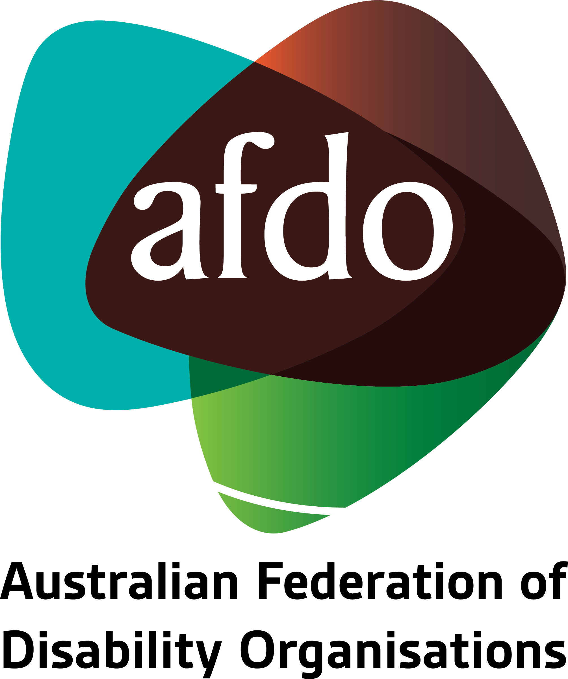

Defining reasonable and necessary
AFDO Submission to the NDIS Review

September 2023

Table of Contents
Table of Contents 2
About AFDO 3
Our members 4
Acknowledgements 6
Introductory comments and recommendations 7
1. What are the issues with the current defining of 'reasonable and necessary'? 8
2. How should this definition be changed to promote a fairer Scheme for participants? 10

About AFDO
Since 2003, the Australian Federation of Disability Organisations (AFDO), a Disabled Peoples Organisation (DPO), a funded Disability Representative Organisation (DRO), has been the recognised national peak organisation in the disability sector, along with its disability specific members, representing people with disability. AFDO’s mission is to champion the rights of people with disability in Australia and support them to participate fully in Australian life.
Our thirty five (35) member organisations represent disability specific communities and cross-disability communities with a total reach of over 4 million Australians.
AFDO continues to provide a strong, trusted, independent voice for the disability sector on national policy, inquiries, submissions, systemic advocacy and advisory on government initiatives with the Federal and State/Territory governments.
We work to develop a community where people with disability can participate in all aspects of social, economic, political and cultural life. This includes genuine participation in mainstream community life, the development of respectful and valued relationships, social and economic participation, and the opportunity to contribute as valued citizens.
Our vision
That all people with disabilities must be involved equally in all aspects of social, economic, political and cultural life.
Our mission
Using the strength of our membership-based organisations to harness the collective power of uniting people with disability to change society into a community where everyone is equal.
Our strategic objectives
To represent the interests and united voice of our members and people with disability at a national and international level in all relevant forums.
To build the capacity, profile, reputation and sustainability of AFDO through the strength of our member organisations.
To enhance the connection and influence in international disability initiatives by policy, advocacy and engagement, focused on the Asia Pacific region.

Our members
Full members:
- Advocacy for Inclusion Incorporated
- Arts Access Australia
- Autism Aspergers Advocacy Australia
- Blind Citizens Australia
- Brain Injury Australia
- Deaf Australia
- Deafblind Australia
- Deafness Forum Australia
- Disability Advocacy Network Australia
- Disability Justice Australia
- Disability Resources Centre
- Down Syndrome Australia
- Enhanced Lifestyles
- National Mental Health Consumer & Carer Forum
- People With Disabilities WA
- Polio Australia
- Physical Disability Australia
- South West Autism Network - WA
- Women With Disabilities ACT - ACT
- Women with Disabilities Victoria - Vic

Associate members:
- Advocacy WA
- All Means All
- AED Legal Centre
- Amaze - Vic
- Aspergers Victoria
- Disability Voices Tasmania
- Disability Advocacy and Complaints Service of South Australia
- Explorability Inc
- Leadership Plus
- Multiple Sclerosis Australia
- National Organisation for Fetal Alcohol Spectrum Disorder
- National Union of Students - Disabilities Department
- Star Victoria Inc
- TASC National Limited
- Youth Disability Advocacy Service

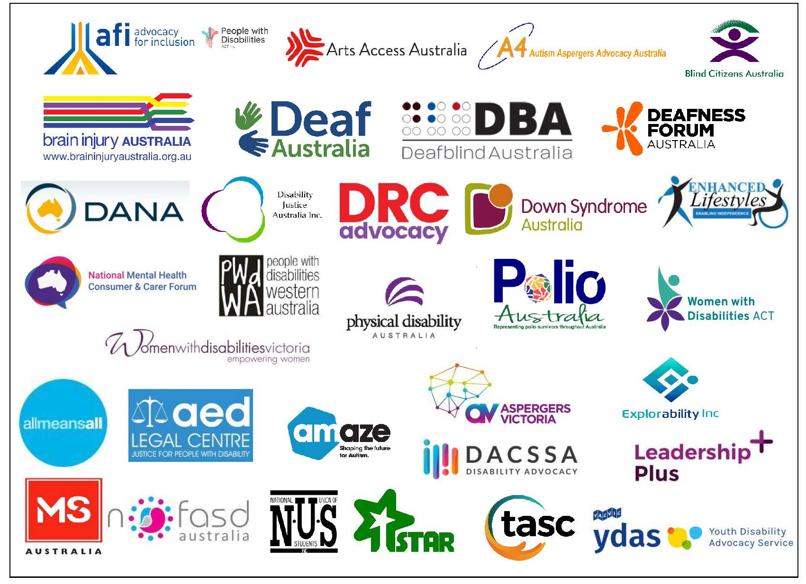

Acknowledgements
AFDO acknowledges Aboriginal and Torres Strait Islander people as the traditional custodians of the land on which we stand, recognising their continuing connection to land, waters, and community. From our offices in Melbourne, Canberra, Sydney and Brisbane, we pay our respects to the peoples of the lands on which these operate and to their respective Elders past, present, and emerging. We also pay our respects to the traditional owners of all lands on which we operate or meet around the country.
AFDO acknowledges people with disability, particularly those individuals that have experienced or are continuing to experience violence, abuse, neglect, and exploitation. We also acknowledge their families, supporters, and representative organisations and express our thanks for the continuing work we all do in their support.

Author: Rebecca Rudd - Coordinator of Policy and Submissions
Approved: Ross Joyce - Chief Executive Officer

Introductory comments and recommendations
The Australian Federation of Disability Organisations (AFDO) thanks the NDIS Independent Review Panel (the Panel) for their consideration of this submission. With respect to the Panel’s request for brevity, this submission will briefly address some key issues related to the NDIA’s current definition of ‘reasonable and necessary’ and outline a new approach that honours the original intent and purpose of the Scheme.
AFDO proposes the following recommendations in respect to defining what may be considered reasonable and necessary and implementing this in practice in the NDIS:
- Utilise a dialectical logic that acknowledges and allows for the inherent tension that exists between a clear and mutually understood definition of reasonable & necessary supports, and allows for the complex, variable, and ultimately individualised nature of disability.
- Development must prioritise co-design with people with disability, their families and carers that is acceptable to all parties.
- Foment a cultural and philosophical shift in the NDIA that acknowledges and respects the expertise of the lived experience of people with disability and that they are best placed to understand their own needs and the corresponding supports that they require.
- Introduce a system of checks and balances to ensure equitable outcomes among participants with one option being;
  - To review provided supports by disability type to ensure that all participants in that type are aware of and have access to these supports as needed.
- Be transparent with all decisions made regarding what can be considered reasonable and necessary. Provide detailed and evidence-based explanations to participants where any requests for support are rejected on the basis of not satisfying this criterion.
- Allow NDIS participants to directly engage in dialogue with NDIS decision-makers regarding their individual needs and what is reasonable and necessary for them. Critical information is often lost in translation when dealing with NDIA middle levels such as LACs and Planners, resulting in many participants being denied supports that are in fact reasonable and necessary for their specific circumstances.
- Disallow NDIA staff from overruling evidence and recommendations from qualified medical and allied health professionals. The burden of proof should be placed on the NDIA to disprove via qualified advice that a support is reasonable and necessary.

1. What are the issues with the current definition of ‘reasonable and necessary’?
As the NDIA itself has recognised, there is currently no shared understanding of what constitutes ‘reasonable and necessary’ among NDIS participants and their families and carers, healthcare professionals, and the Agency, often resulting in inconsistent and inequitable outcomes.

1.1. There are a number of key issues that have contributed to this present state of affairs, including:
1.1.1. Insufficient education and training of disability in general and the needs of specific disability types and conditions, among NDIA staff and Local Area Coordinators (LACs). This includes the different accessibility needs of people with disability, sometimes leaving them with no suitable means of communication.
1.1.2. Failure to recognise the complex and inherently individualised nature of disability. No two people with disability – even those with the same disability – will have the same experiences or require exactly the same supports at any given time. Attempting to force these diverse realities into fixed categories results in a Scheme that does not reflect the non-linear and ever-changing nature of disability. This is particularly evident in the Scheme’s inability to address the complexities of living with multiple disabilities and/or comorbidities, which often fail to be understood by staff and are not reflected in NDIS processes.
1.1.3. The NDIA and its staff do not recognise and respect the expertise of people with disability in regard to their own disabilities and subsequent support needs. This is further exacerbated by the NDIA employing very few staff with disability or with lived experience of disability themselves. As a result, participants are not taken at their word regarding what supports they require, and a culture is perpetuated in which the Agency assumes that “they know best.” This culture reinforces the power differential between the NDIA and participants and impedes the Agency’s ability to build trust among people with disability.
1.1.4. The NDIA utilises a short-sighted definition of ‘value for money’ that prioritises measuring and reducing direct expenditure on the Scheme, while disregarding the demonstrable return on investment the Scheme provides in other areas of the economy. A true measure of value should also consider the total combined benefit that a particular support provides, including intangible aspects like quality of life, provision of dignity and wellbeing, and a more equitable society.

1.2. Multiple negative impacts can be attributed to this overly restrictive definition of reasonable and necessary, with the overall effect being a deficit-focused model that does not encourage people with disability to grow and change, and thus undermines the original intent of the Scheme.
1.2.1. The high burden of evidence required to ‘prove’ and ‘reprove’ disability in order to justify support needs is both onerous for participants and incentivises lower functioning to avoid reduced funding.
1.2.2. Important elements that were originally intended to be included in the Scheme, such as social activities, participation in community events, and recreation, are not prioritised in the planning process or decision-making around funding, meaning participants often miss out on these fundamental everyday life experiences.
1.2.3. The lack of a cohesive definition of reasonable and necessary often results in unpredictable and inequitable funding outcomes.
1.2.4. Certain types of supports or therapies, such as art therapy or animal therapy, may not be funded for participants, despite evidence from professionals and the individual themselves demonstrating its efficacy.

2. How should this definition be changed to promote a fairer Scheme for participants?
There is a clear need for a coherent and mutually understood definition of what may be considered reasonable and necessary. At the same time, this definition must recognise the complex and inherently individualised nature of disability, allowing for flexibility based on individual needs.
While these elements may appear antithetical, it is possible to develop a dialectical definition of reasonable and necessary wherein these two seemingly contradictory statements can both be true.
The dialectical approach rejects black-and-white, yes-and-no thinking, instead encouraging curiosity and the development of creative solutions. In developing this new definition, the NDIA should consider the following:
2.1. Co-design with people with disability, as well as their families and carers, must be prioritised. This would reinforce the recommitment to co-design made by government in 2022 and would serve as a critical first step in rebuilding trust between the NDIA and the disabled community.
2.2. Fomenting a philosophical and cultural shift within the Agency that embraces the original intent of the NDIS. Reasonable and necessary supports should enable people with disability to thrive, not merely survive.
2.3. People with disability must be recognised as the primary authority on their own disabilities and subsequent support needs. Respect for the expertise that comes from lived experience must be entrenched at every stage and in every process. Doing so would help to mitigate the power imbalance that currently exists between participants and the NDIA, enabling a shift in understanding from the NDIS as something that is ‘done to’ or ‘given to’ people with disability to a mutual process that benefits both parties.
2.4. Evidence provided by medical and allied health professionals should be prioritised over bureaucratic concerns. The NDIA should not be able to overrule medical recommendations without justification and sufficient evidence of their own.

