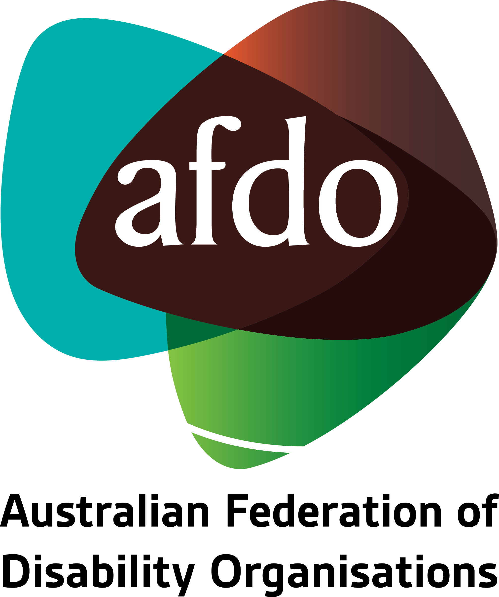

Beyond LACs: Designing better solutions for NDIS participants
AFDO Submission to the NDIS Review

September 2023

Table of Contents
Table of Contents 2
About AFDO 3
Our members 4
Acknowledgements 6
Introductory comments and recommendations 7
1. General issues with the NDIS 8
2. Issues relating to LACs and Planners 12
3. What changes should be made going forward? 17

About AFDO
Since 2003, the Australian Federation of Disability Organisations (AFDO), a Disabled Peoples Organisation (DPO), a funded Disability Representative Organisation (DRO), has been the recognised national peak organisation in the disability sector, along with its disability specific members, representing people with disability. AFDO’s mission is to champion the rights of people with disability in Australia and support them to participate fully in Australian life.
Our thirty five (35) member organisations represent disability specific communities and cross-disability communities with a total reach of over 4 million Australians.
AFDO continues to provide a strong, trusted, independent voice for the disability sector on national policy, inquiries, submissions, systemic advocacy and advisory on government initiatives with the Federal and State/Territory governments.
We work to develop a community where people with disability can participate in all aspects of social, economic, political and cultural life. This includes genuine participation in mainstream community life, the development of respectful and valued relationships, social and economic participation, and the opportunity to contribute as valued citizens.
Our vision
That all people with disabilities must be involved equally in all aspects of social, economic, political and cultural life.
Our mission
Using the strength of our membership-based organisations to harness the collective power of uniting people with disability to change society into a community where everyone is equal.
Our strategic objectives
To represent the interests and united voice of our members and people with disability at a national and international level in all relevant forums.
To build the capacity, profile, reputation and sustainability of AFDO through the strength of our member organisations.
To enhance the connection and influence in international disability initiatives by policy, advocacy and engagement, focused on the Asia Pacific region.

Our members
Full members:
- Advocacy for Inclusion Incorporated
- Arts Access Australia
- Autism Aspergers Advocacy Australia
- Blind Citizens Australia
- Brain Injury Australia
- Deaf Australia
- Deafblind Australia
- Deafness Forum Australia
- Disability Advocacy Network Australia
- Disability Justice Australia
- Disability Resources Centre
- Down Syndrome Australia
- Enhanced Lifestyles
- National Mental Health Consumer & Carer Forum
- People With Disabilities WA
- Polio Australia
- Physical Disability Australia
- South West Autism Network - WA
- Women With Disabilities ACT - ACT
- Women with Disabilities Victoria - Vic

Associate members:
- Advocacy WA
- All Means All
- AED Legal Centre
- Amaze - Vic
- Aspergers Victoria
- Disability Voices Tasmania
- Disability Advocacy and Complaints Service of South Australia
- Explorability Inc
- Leadership Plus
- Multiple Sclerosis Australia
- National Organisation for Fetal Alcohol Spectrum Disorder
- National Union of Students - Disabilities Department
- Star Victoria Inc
- TASC National Limited
- Youth Disability Advocacy Service

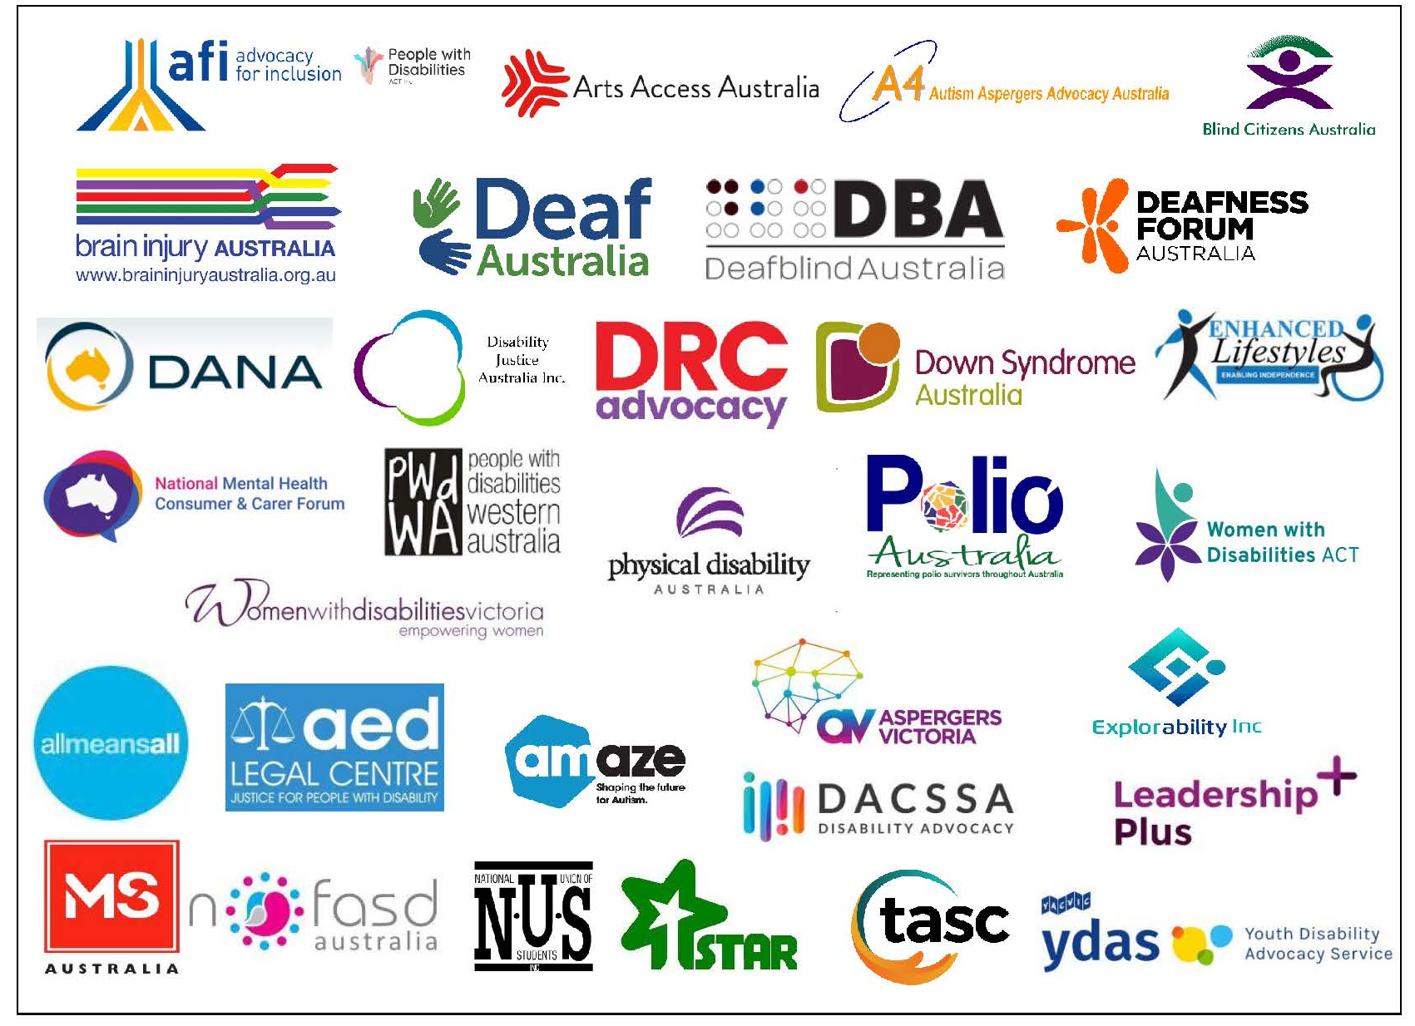

Acknowledgements
AFDO acknowledges Aboriginal and Torres Strait Islander people as the traditional custodians of the land on which we stand, recognising their continuing connection to land, waters, and community. From our offices in Melbourne, Canberra, Sydney and Brisbane, we pay our respects to the peoples of the lands on which these operate and to their respective Elders past, present, and emerging. We also pay our respects to the traditional owners of all lands on which we operate or meet around the country.
AFDO acknowledges people with disability, particularly those individuals that have experienced or are continuing to experience violence, abuse, neglect, and exploitation. We also acknowledge their families, supporters, and representative organisations and express our thanks for the continuing work we all do in their support.

Author: Rebecca Rudd - Coordinator of Policy and Submissions
Approved: Ross Joyce - Chief Executive Officer

Introductory comments and recommendations
The Australian Federation of Disability Organisations (AFDO) thanks the NDIS Independent Review Panel (the Panel) for their consideration of this submission. This submission will draw from data collected through AFDO’s recent survey of NDIS participants to discuss existing problems identified in their interactions with the NDIS, including problems with the Scheme in general and problems with Local Area Coordinators (LACs) and NDIS Planners specifically.
The following recommendations are based on responses to the survey as well as AFDO’s broader work in relation to the NDIS.
- Foment a cultural and philosophical shift in the NDIA that acknowledges and respects the expertise and lived experience of people with disability. Trust that people with disability are best placed to understand their needs and the corresponding supports they require.
- Consider transferring planning duties from lower-level LACs and NDIS Planners to higher-level NDIA staff who have the authority to approve planning and funding decisions.
- Consider subsuming the existing LAC and NDIS Planner roles into a single new role – the “NDIS Navigator”. The Navigator should be locally embedded, demonstrate disability expertise, and operate from a holistic and participant-centred perspective.
- Allow participants to review a draft plan before it is finalised so that they can identify and address any errors.
- Ensure that NDIA staff responsible for planning actually read participant reports and evidence and are familiar with the participant’s circumstances prior to their planning meeting.
- Introduce thorough and consistent training for all NDIS helpline staff. Ensure they all have ongoing disability awareness training, are providing accurate and consistent information by regularly reviewing calls and retraining where necessary.
- Be transparent and provide detailed and evidence-based explanations in plain language, for all decisions made in regard to planning and funding.
- Implement measures to retain staff and reduce high turnover, such as competitive wages, lower caseloads, and better training, disability awareness training and support.

1. General issues with the NDIS
Responses collected from AFDO’s survey of NDIS participants indicated multiple issues in their interactions with the Scheme. These concerns related to the application process, the planning process, the appeals process, and the general philosophy and culture of the NDIA.
  - Barriers to communication and accessibility, such as language barriers, limited access to Auslan or other interpreters, and lack of provision of live captioning during meetings. Concerns were also raised about carers and support persons not being allowed to actively participate in the planning and decision-making processes.
“I have asked that people send me an email first before contact and they contact me by phone without notice… I need an interpreter of my choice, not a support worker, present - an email allows me to have that person present at the time that is pre-arranged… It has now been one month since I have had one of these unhelpful unplanned calls. I asked via email again for contact and have received no word. This has been my common experience over the last three years.”
"When requesting live captioning for Zoom with them, they refuse to provide it."
"LACs do not understand screen readers or that some people are computer illiterate."
  - Confusion and frustration with the complexity of NDIS processes, which were time consuming and often resulted in delays and bureaucratic errors and were exacerbated by unclear language and unnecessary jargon. Participants reported difficulty in understanding the different types of funding and how they relate to their specific needs.
"Lots of jargon and assumptions made that I understand the system."
"Difficult to understand the different types of funding that are in the plan and what they are used for, and how they assist in day to day and support needs. Needs to be more defined and specific - too much jargon."
“Information from NDIS is patchy, often not relevant, & hard to find. Information on requirements change constantly & I find it difficult to get a direct answer on the helpline."
  - The high burden of proof for disability, and the onerous process of repeatedly proving and documenting disabilities, particularly where conditions were permanent and unchanging. Participants also highlighted the financial cost of diagnoses and documentation, which could be considerable when specialist appointments and reports were required.
"… when I applied for my daughter, I was asked to prove (in a recent diagnosis) that she has Down syndrome. The NDIS assessors clearly didn't know their customers, as Down syndrome isn't something you can catch or that can clear up. If you have it at birth, then you have it through your life.”
"I think it's ridiculous to have to prove your disability when I or other people have been on a Blind/Disability Support Pension since WE WERE 16 YEARS OLD. It was costly and demeaning to have to go to an eye specialist to have him prove you are blind, as the process took three hours in his surgery."
"You shouldn't have to pay $1500 in specialist reports to get onto the NDIS."
  - The traumatic nature of the NDIS process, especially when handled insensitively or dismissively.
"… I have been traumatized by the NDIS and I just can't fight anymore."
“When I first joined the NDIA my only goal (that wasn’t made up by the planner for me) was to get an Assistance Dog. Four years later I achieved that goal. Shortly after, I was moved to another NDIA office where a Manager and Planner conducted a four hour planning meeting and told me ‘We don’t fund Assistance Dogs’ and made out that I’d lose him. I still have nightmares about this…”
"I am terrified and traumatised having to deal with the NDIA, and refuse to go to the NDIA with my additional needs and increased disability and equipment needs and prefer to self fund then deal with the NDIA."
“… dealing with the incompetence of the NDIA staff in my area is traumatic."
  - Systemic issues within the NDIA, including a perceived focus on cost-cutting, adherence to rigid guidelines, and arbitrary decision-making that did not consider the circumstances and needs of a particular individual.
"It is not designed for the end user. It is designed for the administration needs of NDIS. Language and categories are misaligned between areas, and it is totally incomprehensible for the end user to map across and meet the required lexicon. A simple layman’s term used was taken out of context as meant something very specific within the NDIS categories. Common sense was non-existent. Expertise and knowledge about neurological conditions was missing and the NDIS assessor was not able to straddle the real work language and their categories for the end user which created an absolute nightmare to have to unpick.”
“… if what we say doesn’t fit in one of the boxes, too bad.”
“The worst are the bureaucrats who sadly thrive in the NDIA. I either fit into their basic, standard plan or cause more work. Many of these cling to operational guidelines even when those guidelines, when applied to my circumstances, break Rules and do not reflect the Act.”
  - A general lack of accountability and transparency in decision-making processes.
“These kinds of ridiculous bureaucratic malicious decisions are made by planners who do not follow or understand the Act, who rely on their own discriminatory judgements and refuse to listen to me or professionals who know me and have a history of working with me. I have spent much more time fighting the system, trying to engage with and manage fallout from the flawed disability services sector than building my ‘contributing’ life. There is zero accountability when the NDIA interactions are devastatingly wrong.”
"We had to appeal and then go to the AAT. All because we were not listened to. Decisions were made in total opposition to what we said and needed.”
"So often a decision was made by NDIA not to fund something but there was no advice of this, it was just not funded. Sometimes a hard fought decision on funding suddenly disappeared in the next plan, leaving us to prove it all over again or apply for a change of circumstances.”

  - An approach to disability that is grounded in the medical model and emphasises participants’ deficits rather than their capabilities.
"It is harrowing and confronting having to demonstrate all the things that I cannot do rather than focusing on my strengths. It’s very ‘disabling’.”
"… few people working for the LAC have high vision for people and their lives."
"People need to really listen. They need to believe that I can be the businessman I want to be, the musician that I am, that I can live in my own home with support without using a service or planner. I am capable."
  - An unequal power dynamic between participants and the NDIA that leaves individuals afraid to assert themselves and their needs for fear of losing funding. This anxiety reflects the fundamental lack of trust that many people with disability have in the NDIS.
"We are too scared to challenge a plan if it’s not quite right as we run the risk of losing funding if we ask for a review.”
“My needs have drastically increased since this time, but I don’t want to bring it up with the NDIA as I feel they will take away more than what they will give."
“I worry that if I needed to apply for a change of circumstances plan, the funding amount we currently have would be reduced and it is easier to just keep going with what we have, even if changes occur.”
“I live in fear from year to year due to the yoyo effect of my plan and the psychological challenges as a result if I can’t maintain my routine when funding is reduced. I’m 19 and I worry about my future when my family die and I won’t have the support they offer to ensure I am safe. It’s an emotional roller coaster every plan review… Mum is my financial guardian and nominee. She is a great help, but dad has stage 4 cancer, and my sister is in year 11. The uncertainty of funding puts loads of pressure on our entire family.”

Issues with LACs and NDIS Planners
In addition to these general issues with the NDIS, a majority of survey respondents indicated dissatisfaction with LACs or NDIS Planners specifically, including:
  - Lack of compassion, empathy, and respect, particularly in regard to invisible disabilities, masking, and complex needs. Participants felt that LACs/Planners did not fully comprehend the impact of their disabilities and their struggles in daily life, and some made insensitive comments or assumptions about participants' abilities and past experiences. Some respondents indicated that LACs/Planners were more interested in following a standardised process or ticking boxes rather than engaging in meaningful conversations.
"When my LAC found out that I was previously in the military, she kept asking me if my impairment is due to my trauma instead of my autism. I had to tell her multiple times that I don't have trauma and just because I was in the ADF doesn't mean I have trauma. I told her at one point I don't eat because I don't have capacity to cook, and she just moved onto the next question. She asked very little about my life or impairment."
"… lacked politeness, empathy, sensitivity, and the ability to listen – qualities that I would say are critical when dealing with a person living with disability and/or their parents/carers.”
"They already have in their mind who I am and what I can have, they just 'have to put up with me' speaking before they tell me their rehearsed line."
"My goals are not anything reflective of what I asked for, she just tried to squeeze them into a box that suited the wording she was comfortable with…I don't feel I can advocate for myself, nor do I feel there is any point as long as this woman is my LAC. She also said to me ‘so you were working until recently, so you've been fine until now?’. The lack of awareness of masking and how autistic women especially struggle to get through life. I had already told her I don't have friends or family. I didn’t do anything other than go to work and come home, but apparently that’s a perfectly fine quality of life according to my LAC."

  - General lack of knowledge and understanding of disability among LACs/Planners. Many respondents stated that staff appeared unqualified or lacked sufficient training to address complex disability-related matters, especially where participants had multiple disabilities and/or comorbidities. This lack of expertise and ignorance of specific disabilities often led to inaccurate assumptions and uninformed decisions and recommendations.
“The LAC was extremely ableist, had no idea what autism was, and didn't advise me of the Disability Gateway yet wrote in my plan that she did. When I noted one of my goals was around improving my cognitive abilities such as memory and executive functioning, she asked me, "would that be gross or fine motor?"
"They are simply not qualified for the role which they hold. They do not know their customers, they cannot calculate support plans properly (I provide working out in a spreadsheet and still have to walk them through it) … Please train everyone better."
"The staff rarely understand the word disability, have little or no knowledge of the complexity of living and caring for a person with a disability. Many of them talk at the person with disability instead of to them, causing behaviours.”
"NDIS Planners employed by NDIA are grossly underqualified for assessing the multiple disabilities for this participant. Has led to AAT actions."
  - Unwillingness or inability to recognise individual needs, resulting in plans that did not reflect participants’ goals or requirements. LACs/Planners often misunderstood or overlooked specific needs, leading to inadequate support. Some participants reported that planners tried to fit their needs into predefined categories or wording, rather than truly understanding their individual circumstances. This issue is further exacerbated by often heavy caseloads and increasingly casualised working conditions, leaving staff overworked and lacking sufficient time and energy to properly support each individual participant.
"Too many other cases, not interested, not treating people as individuals and taking all their specific needs into account."
"It depends on who you talk to. If you get a planner who understands your life you are treated more realistically. If you get one who doesn't know they disregard your evidence and you receive a plan to suit an anecdotal disability not based on evidence."
"My LAC is obviously overworked, unable to provide an appropriate level of support to me."
"The NDIA assessor fitting their boxes instead of what we needed and requested."
  - Dismissal of expertise and lack of respect for participants’ lived experience. Many respondents indicated that their expertise and insights regarding their own disability were ignored or dismissed by LACs/Planners, and their input and recommendations were not given due consideration in the planning process. This reflects the inherent power imbalance between participants and staff, which some respondents commented on, stating they were made to feel as if they were receiving an act of charity and should be grateful. Similarly, multiple patients indicated that they were not believed and were treated as if they were lying or trying to rort the system.
"They don’t understand or believe what we say. As a carer, I genuinely feel ‘guilty until proven worthy’ of support."
"As a disabled person who does not look or act ‘disabled’, I do not fit one of the narratives that lead many people into disability service work. That makes people uncomfortable. I have had many planners who genuinely believe that they know what is good for me, know what I should want and go so far as to write goals that have nothing to do with me or what I’ve told them… These people are not aware they are transferring themselves and their wants onto me. Then there are the ones who infantilise me. They can’t imagine ‘letting’ me do anything dangerous (aka normal if not disabled activity). They cannot see me as a whole person. If I succeed, I’m inspirational. If I’m unhappy or disagree with
their ‘wisdom’, I’m ‘trouble’, ‘don’t understand how things work’, or am ‘unsafe’.”
"My experience have been that I’ve been made to feel stupid and lack insight to my disability, and what I think, feel or experience means nothing in the bigger picture. In actual fact, I have a great understanding as I worked in the disability industry for approximately 30 years and specialised with a Bachelor of Habilitation plus a Masters in Developmental Disabilities. Now that I spend half my time in a wheelchair, I am not heard at all. Stigma is still out there.”
"Since starting with the NDIS my goals have not changed despite my needs changing. I have requested for my goals to be changed, but I was told by my LAC that she is too busy for that, and she knows better than I do what my needs are as she has a friend with the same diagnosis. Despite no two people being exactly the same, especially when it comes to Multiple Sclerosis."

  - Lack of inclusion or clear communication in planning process. Plans were often rushed or inadequately explained, leading to confusion and dissatisfaction with the allocated supports. Respondents expressed frustration with LACs/Planners not listening, ignoring their preferences, making decisions without considering their input, not reading documents, making mistakes, and providing general or inaccurate information during reviews. This lack of collaboration and exclusion from the planning process often resulted in plans that did not align with the actual needs and goals of individuals, leaving them feeling unheard.
"The problem is, they rarely communicate anything. Dealing with NDIS many times over the years has been like meeting a brick wall. There is NO communication about anything other than the plan reassessment. They never communicate what they have not funded that you asked for. They don’t
communicate plan adjustments or changes, these just occur and then you have to try to work out when and why?"
"… our LAC didn’t listen to our knowledge of our child’s individual needs. We had a dramatic reduction in support and as a result have had to reduce therapies to support our daughter’s intellectual development. Our plan has been rolled over twice without any communication to us aside from an email.”
"They don’t listen. We spend thousands on reports and the trauma of going through a review, then they just make up a plan with no thought to how it applies to our lives."
"The information given, from participants, carers, parents, and professionals, is rarely well represented in the finalised plan. Information is often incorrect."
  - Inconsistency of service and lack of continuity due to high staff turnover and inadequate training. Some respondents rarely heard from their LAC/Planner or lacked a clear means of communication with them, leaving them with feelings of isolation and uncertainty. Frequent changes in staff hindered the development of rapport and understanding of individual needs.
"It has been frustrating to say the least. Someone new or different has picked up the phone. No consistency, no support, no advice.”
"Sometimes they are great and sometimes they are not. They change too often, and do not respond when needed... One can never get put directly through to who you want, even when you have a name. You never get the same person twice and they all give you different responses. It is stressful and not conducive to increasing the positive mental health of participants.”
"It’s different every time. Staff often give conflicting advice and often do not know the answer. "
"It is impossible to form any type of rapport with the staff as they are constantly changing."
  - Disregarding evidence and recommendations in reports by medical and allied health professionals. Many respondents indicated that their LACs/Planners rarely read these materials at all, and where they did, they often did not understand or simply overruled them with no justification or any evidence to the contrary.
"Permanent disabilities are permanent. Very costly additional reporting stating the same. Yet the NDIA Planners do not read them."
"Planners do not read reports. It is a very secret process getting information about what information they read to assess Plan funding. The only times it unravels is when AAT action is taken. This should never be the case.”
"Planners and delegates overruling allied health professionals’ recommendations and placing participants in potentially unsafe environments. No justification is given other than it doesn’t meet reasonable and necessary. No other explanation of how they determined this level of funding.”
  - No authority to approve plans or make funding decisions. A number of participants expressed frustration with the powerlessness of their LACs/Planners, questioning why they could not speak directly with NDIA decision-makers instead of dealing with ineffectual middlemen.
"Planning process was fine. Once the plan went to a delegate it was knocked back for no reasonable reason!! Ideally, support from a person with experience and insight into how the NDIS makes decisions and who can advocate for change would make a huge difference.”
"The LAC staff are friendly and supportive. However, they could not help in the decision making. My mother had to go through stressful processes such as speaking to the delegate officer."
“… Stop employing planners that are below the level the plans have to go to for approval... Just let us plan with them??"

3. What changes should be made going forward?
The introduction of the NDIS was a watershed moment in Australian social policy and represented a great victory for people with disability, their families and carers, and their advocates and representative organisations. This Independent Review serves as as a valuable opportunity to implement meaningful changes that reflect the original purpose and intent of the NDIS. It is in this spirit that AFDO shares our critique and recommendations for the future.
3.1. Changes to planning process
The planning process as it currently exists is deeply flawed and has multiple areas in need of reform. At present, planning meetings are deficit-focused, inaccessible or confusing to many participants, and overly concerned with fitting participants’ diverse experiences of disability into fixed categories that do not reflect reality. Planning decisions are based on often inaccurate information collected by poorly trained, overworked, and increasingly casualised external staff. Subsequently, participants end up with unsuitable plans that do not reflect their goals or provide appropriate funding for their support needs and have little recourse outside of the AAT.
Many of these issues could be addressed by transferring planning duties from low-level NDIS Planners and LACs to experienced NDIA staff who have the authority to make decisions in regard to supports and funding. This would prevent information being lost in translation and allow participants to discuss any issues or required changes directly with NDIA decision-makers. Fewer referrals to the AAT would also result in reduced legal expenditure.
3.2. Changes to LAC and NDIS Planner roles
If planning duties are transferred to higher-level internal NDIA staff, the LAC and Planner roles become partially redundant and will be similarly in need of revision. One potential pathway forward could be to subsume the roles of LAC and Planner into a single new role – the NDIS Navigator. Once the planning process has been completed, the Navigator would then work directly with the participant to maximise their budget by bringing them into the local ecosystem of services and supports. While the Navigator would serve a similar function the LAC/Planner – sans any planning responsibilities – they should be locally embedded, demonstrate disability expertise, and operate from a holistic and participant-centred perspective.
Regardless of whether the LAC/Planner role remains as is or is replaced by some new configuration, there are several crucial principles and considerations that must be embedded into this role and into the ethos of the NDIA as a whole.
3.1.1. Wherever possible, the NDIA should employ staff with disability or with lived experience of disability. In addition, all staff should receive extensive training on the complex and highly individualised nature of disability and demonstrate a comprehensive understanding of all NDIS processes.
3.1.2. People with disability must be recognised by NDIA staff as the primary authority on their own disabilities and subsequent support needs. Respect for the expertise that comes from lived experience must be entrenched at every stage and in every process.

3.1.3. Staff should utilise a person-centred and holistic approach that genuinely focuses on the individual participant and addresses all relevant aspects of their well-being, including social activities and community participation. Focus should be shifted from the current deficit model to one that recognise participant capabilities and embraces opportunities for growth and change.
3.1.4. Staff and processes should be responsive and flexible according to individual participant needs.
3.1.5. Staff should be able to clearly communicate and provide participants with accurate and comprehensive information. Participants should be informed about their rights, appeal processes, and options for support, and be able to engage in transparent discussions where they can ask questions and seek clarification.
3.1.6. Emphasis should be placed on the importance of empathy, respect, and compassion, for both staff and the culture of the NDIA as a whole. Participants should feel valued and understood and have their needs and preferences respected.
3.1.7. The NDIA should endeavour to provide continuity and consistency of service. In particular, measures should be undertaken to address the high rates of staff turnover, which prevents the building of familiarity and rapport.

Additional comments and recommendations on the NDIA workforce can be found in AFDO’s submission on the Capability and Culture of the NDIA, which has also been provided to the Review Panel.

