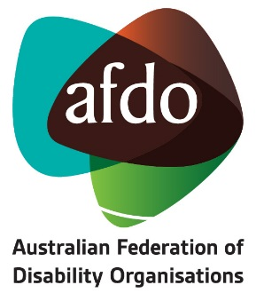

Canberra - Sydney - Melbourne
Phone (free call): 1800 219 969
Or (02) 6198 3361
Email: office@afdo.org.au
Website: www.afdo.org.au

ABN: 25 105 510 898

Expression of Interest – Applicant Details

Full Name
Address
Phone Number/s
Email/s
Disability
Accessibility Requirements
Experience
(Brief background)
Other (Why are you suitable for the role?)

NOTE: All information provided will be treated as confidential.

