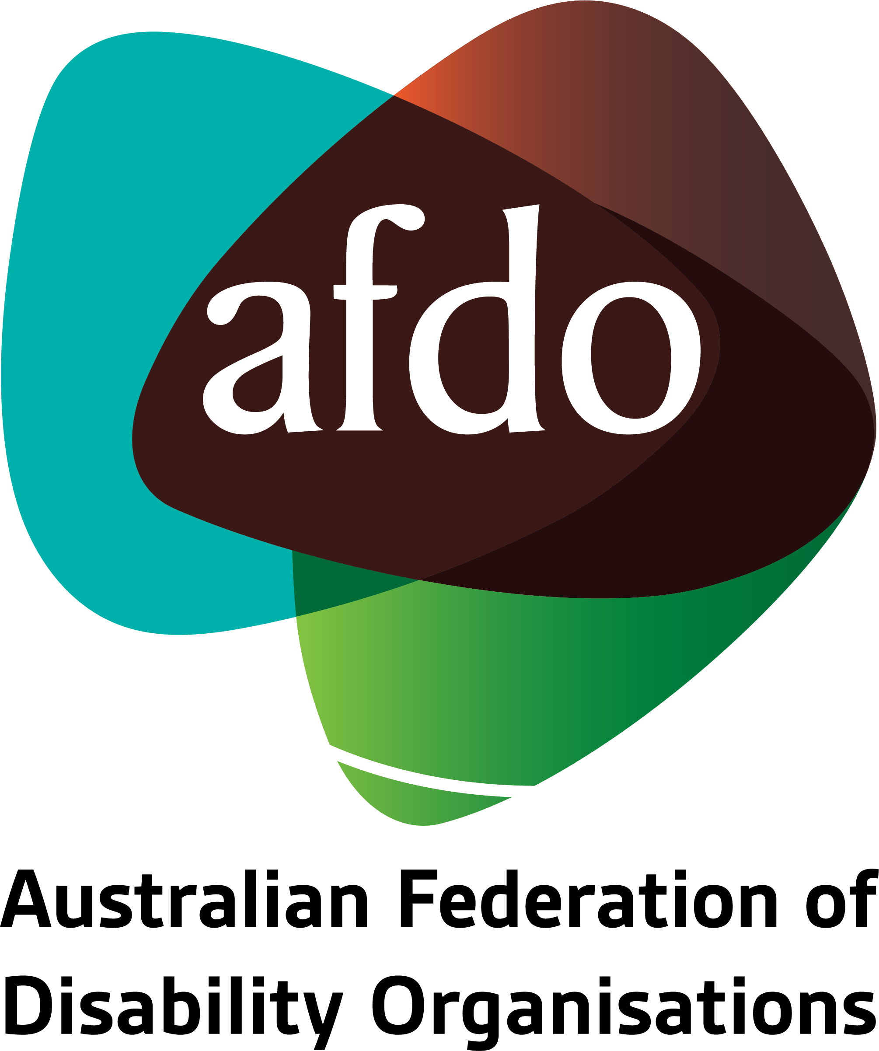

The Future of Supported Employment
Response to Discussion Paper

August 2023

Table of Contents
Submission to the Inquiry into 1
Australia's Human Rights Framework 1
Table of Contents 2
About AFDO 3
Our members 4
Acknowledgements 6
Introductory comments 7
1. Structural Adjustment Fund 8
2. Transition to the revised Supported Employment Services Award 10
3. Consultation on a disability business procurement initiative 11
4. Evaluation of supported employment initiatives and trials 13
5. Disability employment expos 14
Additional comments 17

About AFDO
Since 2003, the Australian Federation of Disability Organisations (AFDO), a Disabled Peoples Organisation (DPO), a funded Disability Representative Organisation (DRO), has been the recognised national peak organisation in the disability sector, along with its disability specific members, representing people with disability. AFDO’s mission is to champion the rights of people with disability in Australia and support them to participate fully in Australian life.
Our thirty four (34) member organisations represent disability specific communities and cross-disability communities with a total reach of over 4 million Australians.
AFDO continues to provide a strong, trusted, independent voice for the disability sector on national policy, inquiries, submissions, systemic advocacy and advisory on government initiatives with the Federal and State/Territory governments.
We work to develop a community where people with disability can participate in all aspects of social, economic, political and cultural life. This includes genuine participation in mainstream community life, the development of respectful and valued relationships, social and economic participation, and the opportunity to contribute as valued citizens.
Our vision
That all people with disabilities must be involved equally in all aspects of social, economic, political and cultural life.
Our mission
Using the strength of our membership-based organisations to harness the collective power of uniting people with disability to change society into a community where everyone is equal.
Our strategic objectives
To represent the interests and united voice of our members and people with disability at a national and international level in all relevant forums.
To build the capacity, profile, reputation and sustainability of AFDO through the strength of our member organisations.
To enhance the connection and influence in international disability initiatives by policy, advocacy and engagement, focused on the Asia Pacific region.

Our members
Full members:
- Advocacy for Inclusion Incorporated
- Arts Access Australia
- Autism Aspergers Advocacy Australia
- Blind Citizens Australia
- Brain Injury Australia
- Deaf Australia
- Deafblind Australia
- Deafness Forum Australia
- Disability Advocacy Network Australia
- Disability Justice Australia
- Disability Resources Centre
- Down Syndrome Australia
- Enhanced Lifestyles
- National Mental Health Consumer & Carer Forum
- People With Disabilities WA
- Polio Australia
- Physical Disability Australia
- South West Autism Network - WA
- Women With Disabilities ACT - ACT
- Women with Disabilities Victoria - Vic

Associate members:
- All Means All
- AED Legal Centre
- Amaze - Vic
- Aspergers Victoria
- Disability Voices Tasmania
- Disability Advocacy and Complaints Service of South Australia
- Explorability Inc
- Leadership Plus
- Multiple Sclerosis Australia
- National Organisation for Fetal Alcohol Spectrum Disorder
- National Union of Students - Disabilities Department
- Star Victoria Inc
- TASC National Limited
- Youth Disability Advocacy Service

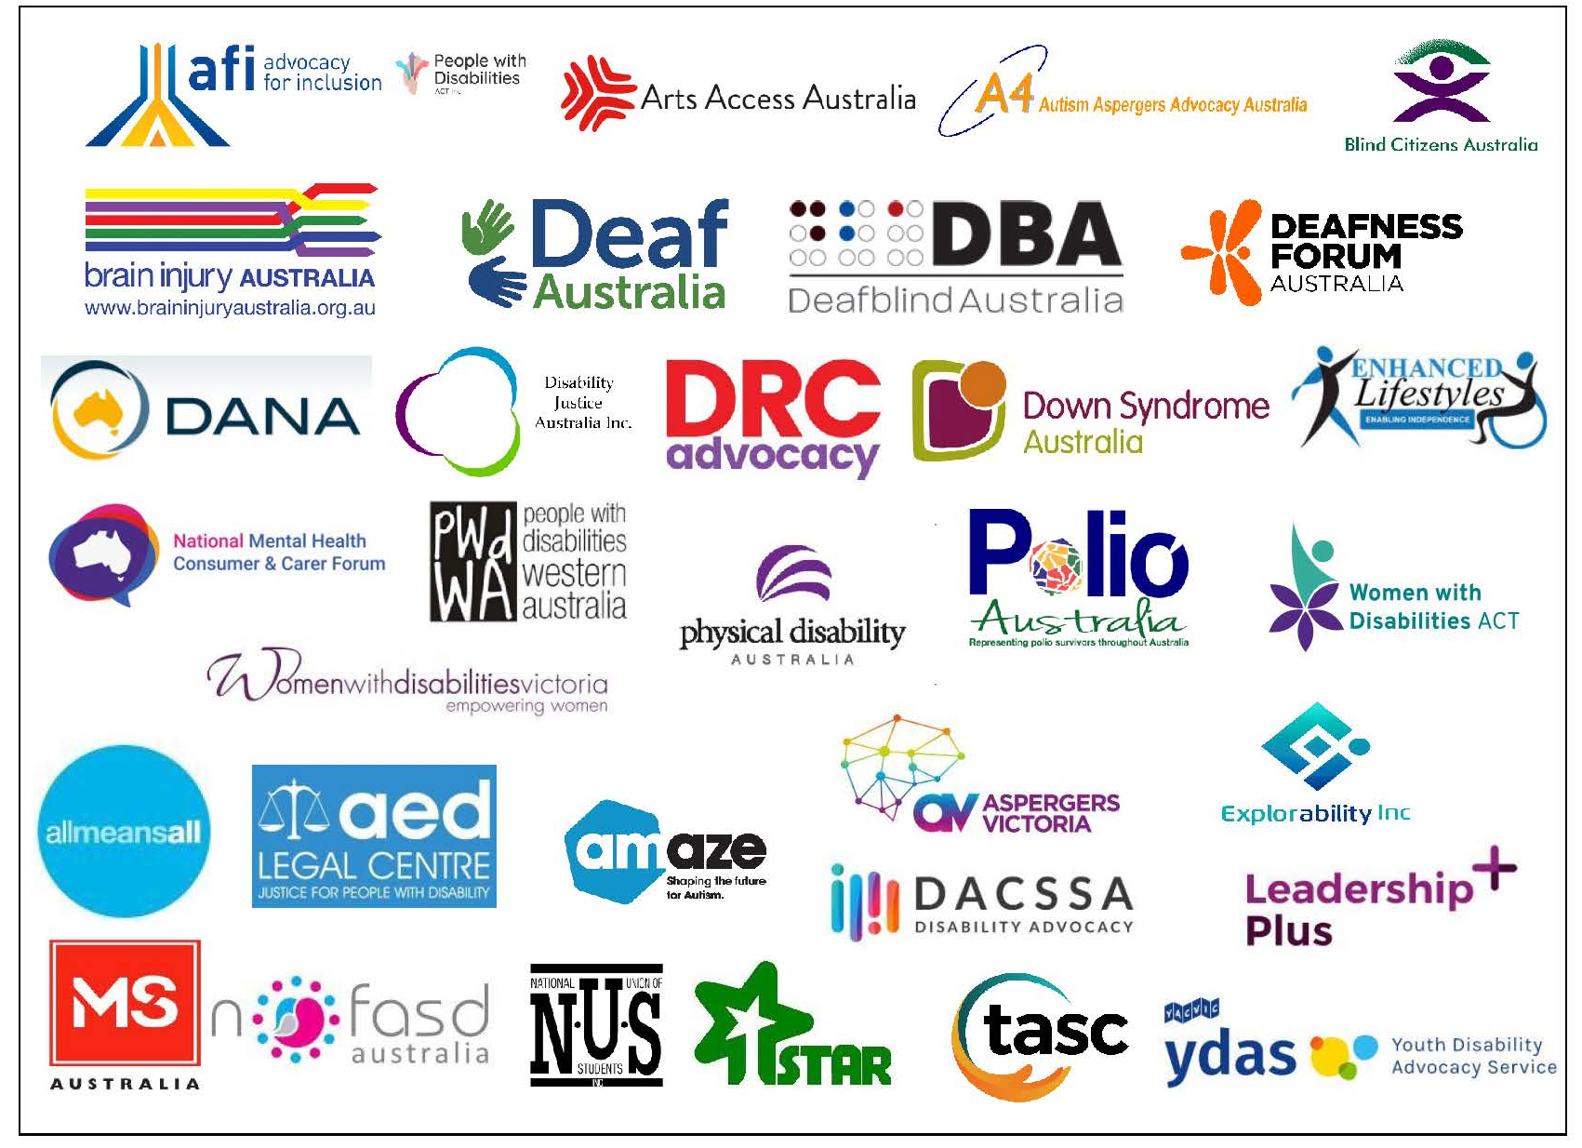

Acknowledgements
AFDO acknowledges Aboriginal and Torres Strait Islander people as the traditional custodians of the land on which we stand, recognising their continuing connection to land, waters, and community. From our offices in Melbourne, Canberra, Sydney and Brisbane, we pay our respects to the peoples of the lands on which these operate and to their respective Elders past, present, and emerging. We also pay our respects to the traditional owners of all lands on which we operate or meet around the country.
AFDO acknowledges people with disability, particularly those individuals that have experienced or are continuing to experience violence, abuse, neglect, and exploitation. We also acknowledge their families, supporters, and representative organisations and express our thanks for the continuing work we all do in their support.

Authors: Jessica Zammit - AFDO Expert Advisor on Employment
Rebecca Rudd - Coordinator of Policy and Submissions
Approved: Ross Joyce - Chief Executive Officer

Introductory comments
The Australian Federation of Disability Organisations (AFDO) thanks the Department of Social Services (DSS) for the opportunity to provide comment on the Future of Supported Employment discussion paper, and welcomes this consultation as a critical step in transitioning to a system of inclusive employment for people with disability.
Despite significant advocacy over many decades by people with disability and their representative organisations, congregate employment settings continue to exist, with 34% of NDIS participants in a paid job (on entry) working in an Australian Disability Enterprise (ADE). Currently, more participants enter an ADE each year than move out into open employment, with 16,000 Australians working in ADEs.
AFDO, with the support of its members and the sector, has long called for a timed closure of ADEs or reshaping of funding and operations to an inclusive setting aimed at real wages and models of open employment. With those people with disability working within the reformed and inclusive settings able to access real career paths or roles across the wider employment environment.
AFDO is currently working with its membership to review and undertake the setting of its current policy position(s) in respect of supported employment settings, inclusive of ADE’s and provide policy position statements which it will then advocate and provide to governments, the wider community make public via appropriate mediums.
All commentary provided in response to the discussion paper has been made with this review and goal in mind.

1. Structural Adjustment Fund
1.1. What objectives should be prioritised in the design of the Fund?
Key objectives that should be priotised include:
- Increased degree of choice in employment settings and options for people with disability and their families that offer fair work for fair pay.
- Increased rates of people with disability choosing to work in mainstream employment settings, with increased confidence that appropriate supports will be available to meet their needs.
- More ADEs transitioning into inclusive social enterprises.
- Increased availability of support coaches trained in customised employment.
- Increased confidence reported by businesses offering supported employment, including access to highly qualified support professionals
1.2. How could the grant selection process best foster innovative approaches?
Grant selection should consider the following elements:
- Is the project novel or untested? For example, trialing international approaches in an Australian context; scaling a model that has demonstrated early success; or piloting an entirely new program. Where there are similarities to existing projects, there will need to be detail provided as to how the project differs and/or addresses unmet needs.
- Is the project addressing an industry need? If yes, are partners involved in the delivery to ensure that the project has a reasonable chance of addressing this need in the short and medium term?
- Will the project lead to fairly remunerated jobs or the creation of self employment? This should be the central tenet of all projects.
- To what degree are people with disability involved in the project? Is the project led by people with disability, or are people with disability involved in the design, delivery, refinement, and evaluation of the project?
- Opportunities for collaboration have been actively considered, with named partnerships to ensure that the work isn't siloed.
- The project demonstrates a commitment to share knowledge in real time, creating opportunities to bring other projects together to learn from one another and share ideas during the delivery phase. This could help foster collaboration and further prevent siloisation.
1.3. Do you have any views on the proposed eligibility for Fund applicants?
AFDO comment: The proposed criteria appear to be reasonable. The only modification AFDO suggests would be to extend this to NDIS providers more broadly. The responsibility to demonstrate their expertise in assisting supported employees will rest with the applicant. This would allow additional providers to present ideas that challenge the status quo.
1.4. Do you have any views on the kind of projects which should be eligible under the Fund?
AFDO comment: If we are seeking to genuinely increase supported employment, all ideas should be welcomed and considered on their merit and compatibility with the key objectives as outlined in section 1.1. As an example, a project that works to build the capacity of supported employees would definitely be in scope, however, applications focusing on building capacity would need to be genuinely innovative, noting that most supported employees will also be NDIS participants and therefore theoretically able to access employment-focused supports as part of their goal setting and NEIS to establish their own business. The project on offer would need to complement these supports and test additional components, such as incorporating a particular industry lens.
1.5. What should be the upper funding amount for individual projects? Would it be better to provide fewer, high value grants or more low value grants?
AFDO comment: AFDO would suggest an upper floor of $2.5 million. This would allow for a minimum of 14 projects.
AFDO comment: The guidelines could indicate that projects priced between $40,000 - $1 million have a higher chance of being funded to allow for a greater breadth of projects. It should be further noted that applications over $1 million will be given due consideration where there is a clearly articulated novel approach, strong industry buy-in, and clear demonstration of research and/or practice that has been undertaken by the organisation prior to applying for the grant. Significant in-kind contributions would be essential.
1.6. Should the two grants rounds be open, competitive processes? Or should the second round be restricted to building on successful projects from the first round?
AFDO comment: AFDO recommends that the second round of grant applications also be conducted as an open, competitive process. The second round should also remain open to first round applicants seeking to scale their model. For these applicants, data will need to be supplied demonstrating their progress to date and explaining why the funding is required, how the funding will maximise impact, and the in-kind contributions of the organisation and other partners.

2. Transition to the revised Supported Employment Services Award
2.1. What information would best assist the sector to successfully transition to the revised Award?
AFDO comment: AFDO agrees with the approach proposed in the discussion paper. Additional considerations could include:
- Case studies, such as a step-by-step outline of the assessment process; or the transition of a supported employee from an outdated Award to the Supported Wage System (SWS), including how this was managed to address any concerns on the part of the supported employee, their family, and employer.
- Access to SWS experts, for both ADEs making the transition and people with disability and their families who may have questions.

3. Consultation on a disability business procurement initiative
3.1. What outcome should a procurement policy be seeking to achieve (e.g. increased employment for all people with disability or specific to those working in ADEs)?
AFDO comment: The proposed initiative has significant potential and should focus on increasing employment for all people with disability, rather than ADEs only. This would be consistent with efforts to increase mainstream employment opportunities.
3.2. What are the strengths of/opportunities created though the options described above?
AFDO comment: The options described present multiple opportunities:
- It is positive that we would not be “starting from scratch”, albeit we would be starting from a relatively low baseline spend of $3.2 million across all federal government departments. A significant marketing campaign will be required at a Secretary level to ensure that departments understand the impetus and rationale for preferred purchasing from disability businesses (not just ADEs).
- Mandatory recruitment for departments has its merits as this would have an almost immediate effect on spend, and therefore opportunities for people with disability.
- Regarding the standing procurement panel, there are both pros and cons:
- Pros: there would be a more manageable number of entities; suppliers are given some certainty of business to provide jobs for people with disability.
- Cons: it would be very difficult for new entrants to the market to gain access to the panel; the panel would likely be limited to suppliers that have very high numbers of people with disability working with them, rather than more inclusive organisations; it would limit the choice of where people with disability can work.
- Regarding the draft clauses for inclusion in the Commonwealth ClauseBank, AFDO requires more detail before we can provide comment.
AFDO comment: In addition to these opportunities, AFDO also wishes to highlight several areas of concern:
- Similar procurement frameworks have been embedded at the state level in Victoria and Western Australia with varying levels of success. Change is gradual and often not sustained; for example, the purchase of labour for big builds has led to project by project employment, leaving marginalised groups in highly casualised employment without consistent wrap-around supports.
- Regarding the registration and promotion of existing exemptions, it is important to note that this could become very overwhelming for purchasers. An interactive tool that enables purchasers to select by region, type of service, short spiel of the organisation and their point of difference (supplier supplied) and ratings (if doable) could be useful.
3.3. Are there any potential risks associated with pursuing a disability procurement policy?
AFDO comment: As this initiative is further developed, the associated risks will become more evident. There are some challenges which will need to be considered in the design:
- Competing procurement objectives; for example, the requirement to procure from Indigenous businesses. Departments will already have processes in place for such things – procurement could be modelled on (or at the very least look at learnings from) these requirements.
- It is important that Department staff are able to identify which organisations pay regular Award wages and which pay SWS. While SWS is a legally recognised pay instrument, there may be a preference to award contracts to organisations paying minimum wage or above.
- Clear and compelling business case needs to be outlined in order for those to change their current procurement practice:
- Work needs to be undertaken to ensure that the procurement messaging is fully and legitimately supported and comes from the highest levels of governance and management of any organsiation or it will not result in changes in procurement or real uptake.

4. Evaluation of supported employment initiatives and trials
4.1. What success factors should be measured through the evaluation?
AFDO comment: Success factors that should be measured include:
- Number of ADEs that have transitioned to social enterprise models, including number in each that have disclosed their disability and the numbers listed in positions across the organisation hierarchy in each social enterprise.
- Rates of self-employment among people with disability.
- Incidence of employment being listed as a goal in NDIS planning meetings.
- Number of people with disability choosing mainstream employment ahead of ADEs as an employment opportunity.
- Number of people with disability trialling mainstream employment from an ADE setting.
- Number of people with disability in an ADE trialling new roles (i.e. professional and career development within an existing workplace).
- Increase in the sessions undertaken and skills developed of supported employees to explore new opportunities.
- Development of best practice materials and training to build a support coach workforce to assist supported employees to excel in mainstream employment
- Number of qualified support coaches.
- New/hybrid models identified that present scalability.
4.2. How can the perspective of people with high support needs be best captured in the evaluation?
AFDO comment: This must ensure the following;
- The involvement of people with “high support needs” should be required as part of project design and execution, rather than solely during evaluation.
- Data collection during the delivery of projects is critical in capturing real time experiences, understanding what works, and how it is being received on the ground.

5. Disability employment expos
5.1. What kind of information would people with disability like to receive at these events? Would it be helpful to have presentations on particular topics (perhaps in a separate space to the stalls)?
AFDO comment: AFDO agrees that the idea of separate presentations would be beneficial.
Information that could be helpful includes:
- SWS information and interface with DSP, specifically in regard to taper rates. This should be coupled with Services Australia experts being made available after each session for 1:1 conversations with people with disability and their families to answer questions and demystify the process. This will be essential in helping to alleviate fears of potential pension loss that can be associated with moving out of ADEs into mainstream employment, and also addresses the issues of long wait times and general unavailability of Services Australia staff due to high call volumes.
- Outlines of different employment settings with panelists who currently work in ADEs and people working in mainstream employment sharing their experiences from a cross-section of industries. Content could include jobs undertaken, types of supports accessed in the workplace, inclusions in their NDIS plan, support accessed from Jobaccess, travelling to and from work, following routines at work, the experiences of managers and colleagues, how the person is socially included in the workplace, and how issues are resolved as they arise, among others.
- Preparing for work, with a focus on what is it like to work in a mainstream employment setting.
- Practice or mock interviews
- Practice in various mock mainstream employment settings to provide experience and feedback.
- Advice on preparing a CV and other basic job-seeking skills.
5.2. Do you have suggestions for exhibitors who could be invited?
AFDO comment: Potential exhibitors could include:
- Federal government departments with entry level roles that lend themselves to supported employees. Careful selection would need to occur to ensure that departments have roles that that are suitable for supported employees, with sufficient volume so that unrealistic expectations aren't set.
- JobAccess.
- Advocacy sector organisations with a program or expertise in disability employment and on the ground delivery with both employees and employers. An example being; AFDO has developed and tertiary evaluated programs and training that it has been providing for over nine years and is currently implementing in two further regions being, Hunter Valley NSW and across the Australian Capital Territory.
5.3. How can we best attract mainstream employers to these events? Do you have suggestions for disability confident employers that could be invited?
AFDO comment: In regard to attracting employers generally:
- Consider large national or state-based businesses that have a demonstrated commitment to the employment of people with disability; this could include such things as membership of the Australian Network on Disability, having a diversity and inclusion plan that specifically mentions disability or a disability action plan, having targets around the employment of people with disability, or working in and around disability.
- Approach small business representative bodies and chambers of commerce (or the like) as well as local government to ensure that a good representation of SME’s (employing 1 to 200 employees) as these are the largest employers (98%+ of all employment) across Australia. Large business are good to market the story but the aforementioned SME’s are the largest employers and greatest opportunity for widespread change.
In regard to attracting mainstream employers:
- Develop a compelling business case alongside experienced disability organisations, employers, and marketing specialists so that businesses are able to see the value in not only investing time to attend, but in making a longer term commitment to employing people with disability.
- AFDO can promote to the businesses that it has already worked with and trained in disability awareness, etc. over the last nine years.
5.4. What accessibility factors should be considered?
AFDO comment: Accessibility factors that should be considered include:
- Fully accessible venues that are close to public transport and have accessible parking.
- Fully accessible toilets in working order. (doors easily openable, not used for storage, etc.)
- Quiet rooms or areas
- Provision of Auslan interpreters, captioning and hearing induction loop(s).
- Information provided in Plain Language and Easy English should be made available for people with disability to take home. There should also be a requirement that presentations are easy to understand, for example, no jargon or overly complex language.
- Providers should commit to following up where interest is expressed from a supported employee.
5.5. How should these events be promoted?
AFDO comment: Channels for promotion should include:
- ADEs – bulletin boards, email newsletters, flyers, etc.
- Peer support groups for people with disability and families of people with intellectual disability and autism, noting that these two groups are highly represented in ADE figures.
- Facebook support groups. Moderators of these groups should be identified and provided with information to pass on to members.
- Disability Representative Organisations (DROs) Such as AFDO who already work on the ground in the open employment space.
- Media outlets – ABC, SBS, local radio stations, community radio and tv, etc.

5.6. Where could these events be held (both which cities, and any suitable venues)?
AFDO comment: Noting that this is a pilot program.
- It will be necessary to include a cross-section of locations, including metro, regional, and at least one rural event, while also ensuring each is tailored to its local context.
- Tap into local industry opportunities.
- Ideal locations should be informed by data;
  - AIHW data regarding moderate to profound disability by location and informed by current ADE locations and Local Government Areas (LGA).
  - NDIA data on LGA numbers of participants
  - Possible drill down by NDIA on numbers with employment in plans subject to participant confidentiality being maintained.
  - Employment opportunities in a particular LGA or region
  - Number SME’s employing 1 – 200 employees
  - Number of industries or large scale employers
  - Public transport and accessible transport in the LGA or region
5.7. Would there be a benefit in holding one of the Expos online?
AFDO comment: We would suggest that two be held online – one during late business hours, and the second after hours or on a weekend to cater to people with disability who are currently participating in ADEs and their families that work.
5.8. What should be put in place to support people with a disability at the events and after?
AFDO comment: Refer to earlier comments regarding Services Australia personnel availability post session.
- Having additional personnel available that are not rushed to answer questions accounts for the additional time that may be needed to increase knowledge and build confidence of people with disability attending the session.
- Supports as would be provided at other disability focused events should also be considered, such as support workers to assist with toileting, quiet rooms, etc.
5.9. Do you have any suggestions for how these events can be designed to work well for different cohorts of people with disability including:
AFDO comment:
- young people transitioning from school to work
It may be useful to have one or two 'mini' expos specifically for young people with disability transitioning from school, including at least one online. Alternatively, the expo could be separated into two parts – a morning session specifically designed for young people with tailored sessions, followed by an afternoon session open to all potential supported employees, including students.
- First Nations people
Involvement of First Nationas representative organisations in the first instance in codesign. Ensure local First Nations engaged in each area where the expo will be staged. Development of information and resources by First Nations representative organisations, on how to create a culturally safe space should be shared and workshopped with the expo providers prior to the event.
- culturally and linguistically diverse people
Engagement and codesign with CaLD representative organisations in expo development. In addition to providing information in plain language and Easy English, these resources could also be translated into multiple languages with advice taken from representative organisations of languages tailored for the areas where each expo will be held.
- residents in regional and remote areas?
Draw on the DEWR extended regional network to disseminate information in local regional communities, as well as regional local government networks. Where events are held in larger cities, work with local councils to determine if there is sufficient interest to accessibly 'bus in' people.

Additional comments
Regarding question 6.1. Do you have any feedback on the proposed approach?
AFDO comment: Agree that the proposed approach appears reasonable.
Regarding the funding figures outlined in point 7:
AFDO comment: This is not a significant sum of money, so it will be necessary to clarify what exactly is to be achieved with the funding provided, noting that there are now a number of academic research centres focused on disability, in addition to the Centre for Disability Employment Research and Practice (CDERP) which is independent. Will there be an independent analysis of current offerings to draw out the best elements of each, or to determine if one or more models can be supported or scaled?
Regarding point 15, “organisations seeking to deliver innovative programs to support people with disability to gain employment”:
AFDO comment: Would this include specialist DROs? AFDO supports the idea of enabling mainstream industry to access grants where there are skill shortages and where they display a genuine openness to offer supported employment opportunities.
Regarding point 38, “The Expos could also provide an opportunity for local people with disability who own a micro enterprise to promote their businesses and/or sell their products. This could demonstrate the variety of jobs that people with disability can do”:
AFDO comment: Agree that this would be a good idea.

National Disability Insurance Agency (2021) Achieving a ‘sense of purpose’: pathways to employment for NDIS participants with intellectual disability, on the autism spectrum and with psychosocial disability in Australia. Prepared by L Smith, A Ames, M Bennett, R Morello.
Wilson, E.; Qian-Khoo, J.; Cutroni, L.; Campbell, P.; Crosbie, J. & Kelly, J. (2022). The ADE Snapshot, Explaining the Evidence for Reform Series. Hawthorn: Centre for Social Impact.

