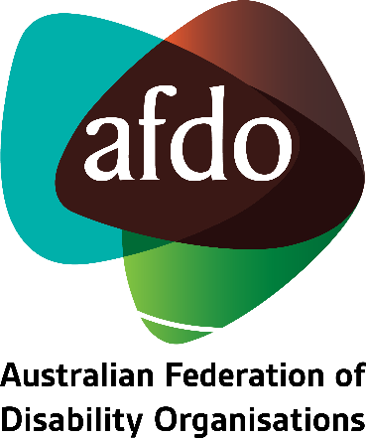

Committee on Economic, Social and Cultural Rights:
List of issues in relation to
the sixth periodic report of Australia
AFDO Feedback & Comments on Draft Report

August 2023
Contents
About AFDO 3
Our members 3
AFDO Feedback & Comments 6
I. General information 6
II. Issues relating to the general provisions of the Covenant (arts. 1–5) 10
IV. Best practices 18

About AFDO
Since 2003, the Australian Federation of Disability Organisations (AFDO), a Disabled Peoples Organisation (DPO) and Disability Representative Organisation (DRO), has been the recognised national peak organisation in the disability sector, along with its disability specific members, representing people with disability. AFDO’s mission is to champion the rights of people with disability in Australia and support them to participate fully in Australian life.
Our member organisations represent disability specific communities with a total reach of over 4 million Australians.
AFDO continues to provide a strong, trusted, independent voice for the disability sector on national policy, inquiries, submissions, systemic advocacy and advisory on government initiatives with the Federal and State/Territory governments.
We work to develop a community where people with disability can participate in all aspects of social, economic, political and cultural life. This includes genuine participation in mainstream community life, the development of respectful and valued relationships, social and economic participation, and the opportunity to contribute as valued citizens.
Our vision
That all people with disabilities must be involved equally in all aspects of social, economic, political and cultural life.
Our mission
Using the strength of our membership-based organisations to harness the collective power of uniting people with disability to change society into a community where everyone is equal.
Our strategic objectives
To represent the interests and united voice of our members and people with disability at a national and international level in all relevant forums.
To build the capacity, profile, reputation and sustainability of AFDO through the strength of our member organisations.
To enhance the connection and influence in international disability initiatives by policy, advocacy and engagement, focused on the Asia Pacific region.

Our members
Full members:
- Arts Access Australia
- Autism Aspergers Advocacy Australia
- Blind Citizens Australia
- Brain Injury Australia
- Deaf Australia
- Deafblind Australia
- Deafness Forum of Australia
- Down Syndrome Australia
- Disability Advocacy Network Australia
- Disability Justice Australia
- Disability Resources Centre
- Enhanced Lifestyles
- Multiple Sclerosis Australia
- National Mental Health Consumer and Carer Forum (NMHCCF)
- People with Disability WA
- People with Disabilities ACT
- Polio Australia
- Physical Disability Australia
- Women with Disabilities Victoria
- Women with Disabilities ACT

Associate members:
- AED Legal Centre
- All Means All
- Amaze
- Aspergers Victoria
- Disability Advocacy and Complaints Service of South Australia (DACSSA)
- Disability Law Queensland
- Leadership Plus
- National Organisation for Fetal Alcohol Spectrum Disorder (NOFASD)
- Star Victoria
- TASC National Limited
- YDAS – Youth Disability Advocacy Service
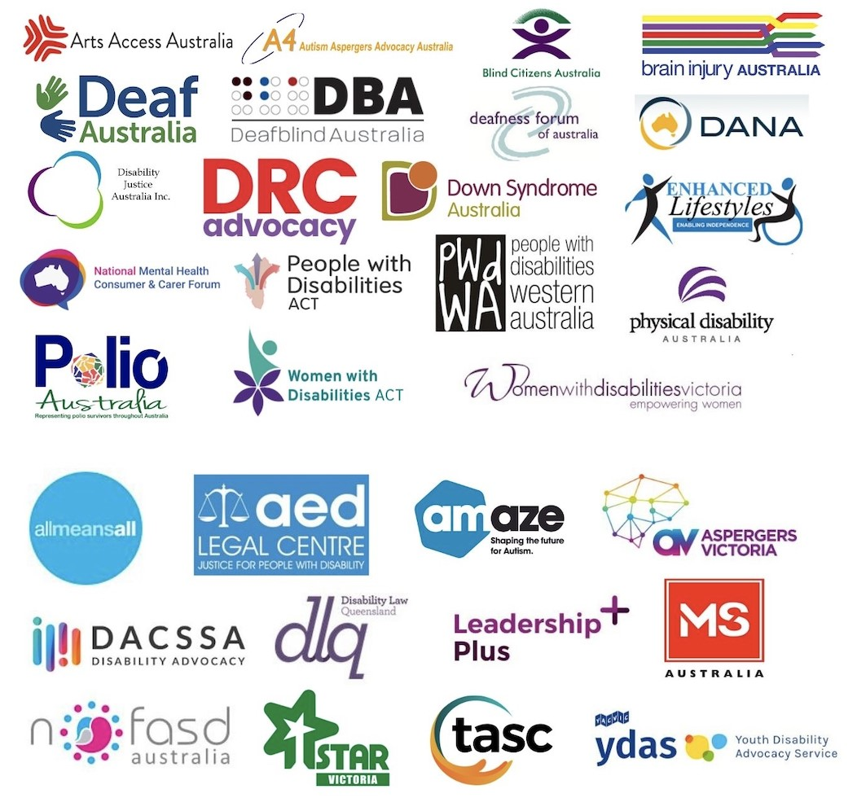

AFDO Feedback & Comments
- General information
- Please report on the measures taken to fully incorporate the provisions of the Covenant into domestic legal order and indicate any steps taken to introduce a federal charter of rights guaranteeing the full range of economic, social and cultural rights. Please also report on cases in which the provisions of the Covenant are invoked by domestic courts. Furthermore, please report on the measures taken to strengthen the capacity and the process of the Parliamentary Joint Committee on Human Rights, in order to ensure the compliance of domestic legislation with the Covenant; and to enhance the consideration of the views of the Parliamentary Joint Committee.

AFDO Feedback & Comments:
- AFDO does not agree that Australia’s legislative and policy framework complies with its international human rights obligations.
- Some ICSCR rights are protected under Australia's anti-discrimination framework, however the scope of protected rights and grounds of discrimination covered are far narrower than those covered under international human rights law.
- AFDO's work primarily intersects with the Convention on the Rights of Persons with Disabilities (CRPD). In its concluding observations on the combined second and third periodic reviews of Australia, the Committee on the Rights of Persons with Disabilities (the CRPD Committee) noted its concern with;
“…the insufficient harmonisation of the domestic legal framework with the Convention”.
- Australia’s legislative and policy framework continues to breach the rights of Australians with disability in many areas of social, economic and cultural life. We refer the Committee to the aforementioned 2019 concluding observations on Australia, which provides many examples.
- The glaring gaps in Australia’s human rights protections have been laid out by the Australian Human Rights Commission in its 2022 paper, “Free and equal”, which makes the case as to why Australia needs a National Human Rights Act. This same paper includes a number of recommendations that must be implemented to strengthen the role of Australia’s Parliamentary Joint Committee on Human Rights.
- On 15 March 2023, pursuant to section 7(c) of the Human Rights (Parliamentary Scrutiny) Act 2011, the Attorney-General requested that the Parliamentary Joint Committee on Human Rights undertake an inquiry into Australia's human rights framework, in the context of the Australian Human Rights Commission's proposal for Australia to introduce a National Human Rights Act. The Committee is due to report its findings to Government by March 2024.

- Please report on any steps taken to provide the Australian Human Rights Commission with an explicit mandate to deal with the rights enshrined in the Covenant; and to increase the budget allocated to the Commission to fully carry out its mandate. Please also provide information on the measures taken to improve access to judicial remedies for violations of economic, social and cultural rights and on free legal aid provided for those in need to claim these rights.

AFDO Feedback & Comments:
- As noted in the Australian Human Rights Commission's 2021-22 annual report, the Commission is not adequately resourced to respond to complaints in a timely manner and is currently operating with a significant backlog. Anecdotally, we know from our members that it is currently taking the Commission up to six months to action new complaints.
- The fact that the AHRC does not have the power to make legally binding decisions or enforce compliance means many complaints are unable to be resolved through conciliation. If a matter is unable to be resolved through conciliation, an individual has 60 days in which to file the matter with the Federal Court of Australia or the Federal Circuit court should they wish to pursue it further. Any individual who pursues a disability discrimination case in court could be ordered to pay the other party’s legal costs. Regrettably, many people with disability cannot meet these costs and are unable to progress their complaint beyond conciliation.
- A report released earlier this year demonstrates that every $1 spent on Commonwealth legal aid generates a $2.25 return in quantitative benefits. Despite this fact, the Law Council of Australia estimates that current funding levels under the National Legal Assistance Partnership and other funding streams currently sit at below half of what is needed in real terms.
- In Australia, it is still possible to convict and imprison someone who did not qualify for legal aid but was unable to afford legal representation. Legal Aid is also generally directed to criminal and family matters, meaning there is little support for civil proceedings. This situation is compounded by the fact that There are limited lawyers who practice in disability discrimination, have awareness of the relevant complaint mechanisms and provide services that are accessible to people with disability.
- Please report on any steps taken by the State party to reconsider its climate change and energy policies and commitments, especially its emission reduction target, to make them compatible with the requirements of the Paris Agreement. Please also indicate the measures taken to limit the use of fossil fuels and to replace them with renewable energy and the efforts made to reconcile its continuing support of coal mines and coal exports and its obligations under the Covenant, both in the State party and extraterritorially. Please also report on the measures taken to address the adverse effects of climate change on the enjoyment of economic, social and cultural rights, particularly by indigenous peoples, people living in disaster-prone areas and other disadvantaged and marginalized individuals and groups. Furthermore, please report on the contributions that the State party has committed to and made to the Green Climate Fund.

AFDO Feedback & Comments:
- The CRPD Committee, in its 2019 concluding observations on Australia, recommended that Australia:
"(a) Nationally consistent emergency management standards that ensure access to disability-specific and disability-responsive support during emergencies.
(b) A mechanism for engagement with organizations of persons with disabilities in the implementation of the Sendai Framework for Disaster Risk Reduction 2015–2030 at the national level and in its reporting process."
- We do not believe these recommendations have yet been fully implemented.
- Please report on the framework policy and legislation to ensure that business entities domiciled in the State party or under its jurisdiction respect the rights enshrined in the Covenant and indicate whether they provide for legal obligations of those business entities to exercise human rights due diligence. Please also report on the measures taken to ensure access to remedies in the State party by non-nationals whose rights have allegedly been violated by Australian companies abroad and include any exemplary cases thereof. Furthermore, please provide information on the extent to which the awareness of business entities has been raised regarding their human rights due diligence.

AFDO Feedback & Comments:
- The CRPD Committee, in its 2019 concluding observations on Australia, recommended that Australia:
"Undertake a comprehensive review of Australian Disability Enterprises to ensure that they adhere to article 27 of the Convention and provide services to enable persons with disabilities to transition from sheltered employment into open, inclusive and accessible employment, ensuring equal remuneration for work of equal value."
- AFDO asserts that the above recommendation has not yet been fully implemented. Despite significant advocacy by people with disability over many decades, congregate employment settings continue to exist. According to data published by the National Disability Insurance Agency (NDIA) 34% of participants who are in a paid job (upon entry to the scheme) work in an Australian Disability Enterprise (ADE) - currently more participants enter an ADE each year than move out into open employment, with 16,000 Australians working in ADEs .

II. Issues relating to the general provisions of the Covenant (arts. 1–5)
  - Please provide information on the evolution over the past 10 years of the following:
- The proportion of the population living below the nationally defined poverty line, before and after taxes and transfers;
- The levels of inequality, defined both as the ratio between the total income accruing to the richest decile of the population and the total income of the poorest 40 per cent, before and after taxes and transfers; and as the ratio between the assets owned by the richest decile of the population and the assets owned by the poorest 50 per cent;
- The proportion of public revenue that is generated through taxes;
- Tax rates levied on corporate profits and on personal income, the value added tax rate (exclusive of value added tax on certain items, including luxury items) and the percentage of total revenue that is generated from personal income tax collected from the richest 10 per cent of the population;
- Public expenditure as a percentage of gross domestic product and, within total public expenditure, the proportion of the public budget that is allocated to social spending, including social security, food, water and sanitation, housing, health and education;
- Any fiscal policy adopted to respond to the COVID-19 pandemic.

AFDO Feedback & Comments:
- (a) There is a well-established link between poverty and disability, with the two existing in a cyclical relationship that entrenches and reinforces disadvantage across multiple spheres of life. According to research undertaken by the Australian Council of Social Services (ACOSS), 37% of Australians living in poverty identify as having a disability.
- Two of the most significant drivers of poverty among people with disability in Australia are lack of access to affordable housing and exclusion from the labour market.
- While poverty is a complex problem requiring a multifaceted, whole-of-government response, income support is a key mechanism through which the work of lifting people out of poverty should begin. It 3. We draw the Department's attention to the CRPD Committee's 2019 concluding observations on Australia, which recommended that Australia:
(b) End the eligibility restrictions on the Disability Support Pension, increase the rate of Newstart Allowance unemployment payments and other income support payments to ensure that persons with disabilities have access to an adequate standard of living."
- Many people with disability are reliant on either the Disability Support Pension (DSP) or Jobseeker Allowance (JSA). According to research published by the Melbourne Institute of Applied Economic and Social Research in 2022, both of these payments still place people below the poverty line.

- AFDO's 2022 submission to the Inquiry into the Extent and Nature of Poverty in Australia includes a range of recommendations that would help ensure Australia's social security system is providing people with disability with an adequate standard of living.

- Please report on the progress made through implementation of the national disability strategy for 2010–2020 in realizing the rights of persons with disabilities, especially the rights to work, social security, housing, health and education; and the challenges faced in the new strategy and the measures envisaged to address them. In particular, please provide information on the implementation of the recommendations made by the Joint Standing Committee on the National Disability Insurance Scheme and other measures taken to improve the National Disability Insurance Service. Please also provide information on the measures taken to improve the employment of persons with disabilities in the public and private sectors, including quotas and the supported employment; and to address discrimination they face at work, including as regards provision of reasonable accommodation in the workplace and wages. Furthermore, please report on the steps taken to provide for the prohibition of forced sterilization in legislation and to address the continuing practice of forced sterilization carried out on persons with disabilities.

AFDO Feedback & Comments:

National Disability Strategy 2010/20 & Australia’s Disability Strategy 2021-2031
- Australia’s new Disability Strategy for 2021-31 is intended to improve outcomes for all Australians with Disability. We therefore see Australia’s Disability Strategy 2021-31 as playing a critical role in helping to bridge the divide between people with disability who are and are not funded for an individual package of supports under the NDIS. Regrettably, however, implementation still seems to be centred predominantly around NDIS participants. Earlier this year, we provided feedback to inform the Safety Targeted Action Plan that sits underneath Australia’s Disability Strategy 2021-31. One of our primary concerns with the draft plan was its disproportionate emphasis on NDIS participants and processes. We share the same concern in relation to the remaining 4 Action Plans.

- We submit that the Australian Government cannot expect to achieve any tangible change under any of the outcome areas referenced underneath the strategy unless people with disability are provided with the prerequisite personal supports they need to thrive, including assistive technology and home modifications. As demonstrated under our comments in relation to older Australians, there is still a long way to go. We would therefore like to see the Department work with the sector to develop a robust action plan to improve the availability of disability-related services and supports to people with disability who are not eligible for the NDIS (including those who are under and over 65).

- In light of the Government’s recent performance around OPCAT, we believe this should be another key area of focus. As of January this year, Australia’s National Preventive Mechanism (NPM) Network is now fully established. We therefore assert that a Targeted Action Plan is needed to explore steps that must be taken by all levels of Government to ensure the NPM network adequately safeguards the rights of all people with disability living in places of detention.

- Many of the systemic issues that are experienced by people with disability continue to arise as a result of confusion between the responsibilities of different levels of Government, and outdated funding agreements between Governments. It is our understanding from previous interactions with the Department of Social Services (DSS) that Australia’s Disability Strategy is only meant to support Governments with the existing infrastructure they have in place. It is not meant to help resolve interjurisdictional issues. Looking at the overall intent and purpose of the Strategy, it would seem that addressing interjurisdictional issues should fall within the remit of the Strategy.

- Given the Strategy is intended to be Australia’s blueprint for the domestic implementation of the CRPD, it is frustrating that it does not follow previous concluding observations made by the CRPD Committee. The Committee has clearly outlined what steps need to be taken to implement CRPD rights in Australia, however these continue to be largely ignored.
National Disability Insurance Scheme (NDIS)
- Australia’s disability policy landscape is inherently ageist. The NDIS Act states that an individual must be under age 65 at the time of making an access request for the scheme in order to be eligible. Those who entered the scheme prior to their 65th birthday are able to remain in the scheme as they age.
- People with disability who were already 65 when the NDIS became available in their area, and those who acquire a disability after their 65th birthday are required to access their support from the aged care system.
- If the aged care system provided older people with disability with adequate access to services and supports, this situation would not be so problematic. There is, however, an extensive body of evidence to demonstrate that older people with disability who are excluded from the NDIS are not afforded the same access to services and supports as their younger peers.
- The equity gaps that are experienced by older Australians with disability who are excluded from the NDIS were well documented in the report from the ‘Review of Assistive Technology Programs in Australia’, which states:
“Stakeholders frequently cited inequities between the aged care, health and disability sectors as a major challenge within the AT landscape, with age seen as a major cause of inequity. For example, a consumer aged 65 years or older is ineligible for NDIS support if they were not an NDIS recipient before the age of 65. This consumer is less likely to have their AT needs met than a consumer with the same condition who is aged 64 and is eligible for NDIS funding for the rest of their lives. This was seen as creating a two-tiered system, with older people who must rely on the aged care system for AT often missing out."
- Evidence also exists from a more recently released research report exploring the inequity in the provision of assistive technology and home modifications to older people with disability who are not eligible for the NDIS. This report found that the average spend on assistive technology and home modifications per person per year for NDIS participants was $2,500, compared with just $51 per person per year for aged care recipients.
- The Australian Government’s continued inaction on this issue constitutes a breach of its obligations under the CRPD. The CRPD Committee, in its general comment on living independently and being included in the community, stipulates:
“Disability support services must be available, accessible, affordable, acceptable and adaptable to all persons with disabilities and be sensitive to different living conditions, such as individual or family income, and individual circumstances, such as sex, age, national or ethnic origin and linguistic, religious, sexual and/or gender identity. The human rights model of disability does not allow the exclusion of persons with disabilities for any reason, including the kind and amount of support services required.”
- A report published by the Special Rapporteur on the Rights of Persons with Disabilities goes on to clarify that:
“States have an international obligation to promote, protect and ensure the full and equal enjoyment of all human rights and fundamental freedoms by all older persons with disabilities, including by reviewing their legal and policy frameworks; prohibiting discrimination on the basis of age and/or disability; and ensuring access to rights-based community support.”
AFDO supports this report and notes that the Australian Government continues to fail in its obligations.
- Forced sterilisation is still carried out against women and girls with disability in Australia; as is forced abortion, contraception and hormone suppression.
AFDO asserts that urgent action is required on this issue and that the Australian Government continues to fail in its obligations.
- In its 2019 concluding observations on Australia, the CRPD Committee recommended that Australia:
"(a) Review and amend laws, including the section of the Family Law Rules 2004 relating to applications for medical procedures, in line with the Convention and adopt uniform legislation prohibiting, in the absence of free and informed consent, the sterilization of adults and children, the administration of contraception and the imposition of abortion procedures on women and girls with disabilities;
(b) Adopt clear legislative provisions that explicitly prohibit the performance of unnecessary, invasive and irreversible medical interventions, including surgical, hormonal or other medical procedures on intersex children before they reach the legal age of consent; also provide adequate counselling and support for the families of intersex children and redress to intersex persons having undergone such medical procedures."
AFDO supports these observations report and notes that the Australian Government continues to fail in its obligations.

- In light of the Committee’s previous recommendations as regards the right to education, please report on:
- The progress made, including through the implementation of the recommendations of the Gonski Review, in addressing the segregation in education and disparities in academic performance due to the income of the family, and in ensuring the equitable provision of quality education in all levels of public schools, including through an equitable school funding system;
- The progress made in improving the availability of culturally appropriate early education for indigenous children and the school attendance and educational achievements of indigenous children at all school levels;
- The measures taken to ensure that all refugee and asylum-seeking children within its territory or under its jurisdiction enjoy the right to education, without discrimination or harassment, and the results achieved;
- The progress made in improving the availability, accessibility and quality of inclusive education for students with disabilities, including those with cognitive impairments.

AFDO Feedback & Comments:
- Many children with disability to not enjoy equitable access to education and do not have their rights upheld as they move through the education system.
- The segregated education model (consisting of special schools, special units or special classrooms for children with disability) does not comply with Australia's obligations under either Article 24 of the CRPD or Article 13 of the International Covenant on Economic, Social and Cultural Rights.
- AFDO is one of 42 organisations to have signed the "End Segregation” Position paper. We also support the work of the Australian Coalition for Inclusive Education and refer the Department to their roadmap for achieving inclusive education in Australia.
- The recommendations outlined in the aforementioned documents would enable Australia to fulfil the following, as recommended by the CRPD Committee in 2019:
“(a) Conduct a robust review, in consultation with organizations of persons with disabilities, of the Disability Standards for Education 2005, implement the recommendations arising from that review and develop a national action plan for inclusive education;
(b) Address the increasing rate of segregation, seclusion and isolation and the lack of age-appropriate settings for students with disabilities at all levels, in particular Aboriginal and Torres Strait Islander students, and redirect adequate resources to a nationwide inclusive education system for all students
- Segregated education has received significant attention throughout the life course of the Royal Commission into Violence, Abuse, Neglect and Exploitation of People with Disability. As part of public hearing 24 of the Royal Commission, Professor Burns was asked to provide advice on Article 24 of the CRPD and the obligations it places on state parties to the CRPD in relation to inclusive education. Professor Burns advice is as follows:
“Article 24 of the CRPD obliges State Parties to transition to a system of fully inclusive education and this will involve over the medium-term to long-term the allocation of resources to general schools to support this transition and the eventual abolition of special schools or other forms of segregated education for children with disability. While some aspects of the right are immediately realisable, the obligation is one of ‘progressive implementation’. However, this obligation means that a number of steps need to be taken immediately including the adoption of a policy, a baseline assessment, the setting of measurable and time-defined goals, and a means of monitoring and reviewing progress."
- In light of the significant impact of new and emerging technologies, such as artificial intelligence, on the enjoyment of economic, social and cultural rights, please indicate any measures taken to ensure that human rights considerations and safeguards are embedded into the development and use of technology.

AFDO Feedback & Comments:
- Australia's previous Human Rights Commissioner, Edward Santow, led a three-year national initiative which culminated in the development of a 2021 report entitled, 'Human Rights and Technology'. This report sets out a number of recommendations that must be implemented in order to uphold human rights and respond to ethical risks in relation to new and emerging technologies; noting that some of these recommendations will require amendments to legislation or public policy. Despite all of the work that has been put into this project to-date, however, there is no real agenda in place to respond to the recommendations included in the final report.
- Australia's lack of action on accessible ICT procurement continues to result in businesses and Government agencies procuring services and systems that are not accessible to many people with disability.
- The CRPD Committee, in its general comment on accessibility, noted:
"Disability laws often fail to include ICT in their definition of accessibility, and disability rights laws concerned with non-discriminatory access in areas such as procurement, employment and education often fail to include access to ICT and the many goods and services central to modern society that are offered through ICT.”
- In 2020, Australia adopted AS EN 301 549:2020 – Accessibility requirements for ICT products and services following several years of lobbying by the disability advocacy sector. There is still no whole of Government strategy outlining how this Standard is to be operationalised. As such, the adoption of this standard has had little tangible impact.
- In its 2019 concluding observations on Australia, the CRPD Committee recommended that Australia:
“Take the necessary legislative and policy measures, such as the development of public procurement criteria, to implement the full range of accessibility obligations under the Convention, including regarding information and communications technologies and systems, and ensure effective sanctions measures for non-compliance.”
AFDO maintains that these observations still hold true.

IV. Best practices
- Please provide information on good practices in policy formulation and implementation that have been developed by the State party during the reporting period and that have effectively contributed to the realization of economic, social and cultural rights, in particular for marginalized and disadvantaged individuals and groups. Please indicate how the Committee’s previous concluding observations have been taken into account in developing such practices.
- Australia is committed to supporting and enhancing access to and enjoyment of economic, social and cultural rights in Australia. Australia appreciates the concluding observations of the Committee in response to Australia’s fifth periodic report under the ICESCR, which have been considered carefully.

AFDO Feedback & Comments:

- AFDO asserts that Australia's international human rights record does not receive enough attention either inside, or outside Parliament. We believe that the Attorney-General must be required to table concluding observations relating to Australia's implementation of the International Covenant on Economic, Social and Cultural Rights in both houses of Parliament. This process should apply to all international human rights treaties that have been signed and ratified by Australia and aligns with recommendations put forward by the Australian Human Rights Commission.

- The Australian Government should also maintain publicly available, up to date information about the status of all concluding observations made by treaty bodies, including:
  - The Department responsible for each recommendation
  - Actions that have been proposed to implement each recommendation.
  - Timeframes and measurable outcomes for implementation.

- These measures would help raise awareness of Australia's international human rights obligations and provide a greater level of accountability and transparency. They would also support civil society to monitor Australia's implementation of its international human rights obligations.

Committee on the Rights of Persons with Disability. 2019. “Concluding observations on the combined second and third periodic reports of Australia” http://docstore.ohchr.org/SelfServices/FilesHandler.ashx?enc=6QkG1d%2FPPRiCAqhKb7yhsnzSGolKOaUX8SsM2PfxU7sdcbNJQCwlRF9xTca9TaCwjm5OInhspoVv2oxnsujKTREtaVWFXhEZM%2F0OdVJz1UEyF5IeK6Ycmqrn8yzTHQCn
Australian Human Rights Commission. 2021, “Free & Equal: A reform agenda for federal discrimination laws.”, 10 December 2021 https://humanrights.gov.au/our-work/rights-and-freedoms/publications/free-and-equal-reform-agenda-federal-discrimination-laws
Parliamentary Joint Committee on Human Rights, 2023. “Inquiry into Australia’s Human Rights Framework.” 15 March 2023 https://www.aph.gov.au/Parliamentary_Business/Committees/Joint/Human_Rights/HumanRightsFramework
National Legal Aid. 2023. “The Benefits of Providing Access to Justice.” January https://www.nationallegalaid.org/wp-content/uploads/2023/05/Final-Public-Report-PwC-The-Benefits-of-Providing-Access-to-Justice1-January-2023.pdf
National Disability Insurance Agency. 2020 “Employment Outcomes – Participants, their Families and Carers.” 21 December 2020 https://data.ndis.gov.au/reports-and-analyses/outcomes-and-goals/employment-outcomes-participants-their-families-and-carers
ACPSS and UNSW Sydney. 2020 “Poverty in Australia 2020 Part 2: Who is affected? https://data.ndis.gov.au/reports-and-analyses/outcomes-and-goals/employment-outcomes-participants-their-families-and-carers
Australian Healthcare Associates. 2020. “Review of Assistive Technology Programs in Australia” 9 June 2020 https://data.ndis.gov.au/reports-and-analyses/outcomes-and-goals/employment-outcomes-participants-their-families-and-carers
Layton, N., & Brusco, N.. 2020. “The Australian Assistive Technology Equity Studies: Improving Access to Assistive Technology for People with Disability who are not Eligible for the NDIS” https://assistivetechforall.org.au/wp-content/uploads/2022/10/Australian_AT_Equity_Studies_Report-final.pdf
United Nations Committee on the Rights of Persons with Disabilities. 2017. “General comment No. 5 on Article 19 – the right to live independently and be included in the community.” 27 October 2017 https://www.ohchr.org/en/documents/general-comments-and-recommendations/general-comment-no5-article-19-right-live
Devandas-Aguilar, C.. 2019. “Report of the Special Rapporteur on the Rights of Persons with Disabilities” 17 July 2019 https://documents-dds-ny.un.org/doc/UNDOC/GEN/N19/221/53/PDF/N1922153.pdf?OpenElement
Coalition of Peak Bodies of Disability in Australia. 2020. “Segregation of People with Disability is Discrimination and Must End” September https://dpoa.org.au/wp-content/uploads/2020/11/Segregation-of-People-with-Disability_Position-Paper.pdf
Australian Coalition for Inclusive Education. 2021 “Driving Change: A Roadmap for Achieving Inclusive Education in Australia” February https://acie.org.au/acie-roadmap/
Byrnes, A.. 2022. “Analysis of Article 24 of the CRPD and note on the travaux préparatories.” 24 June 2022 https://disability.royalcommission.gov.au/publications/public-hearing-24-andrew-byrnes-2020-analysis-article-24-crpd-and-note-travaux-preparatoires
Australian Human Rights Commission. 2021. “Human Rights and Technology Final Report” https://humanrights.gov.au/our-work/rights-and-freedoms/publications/human-rights-and-technology-final-report-2021
United Nations Committee on the Rights of Persons with Disabilities. 2014. “General Comment No. 2 Article 9: Accessibility” 11 April 2014 https://www.ohchr.org/en/treaty-bodies/crpd/general-comments
Council of Standards Australia. 2020. “Accessibility Requirements for ICT Products and Services” 11 December 2020 https://store.standards.org.au/reader/as-en-301-549-2020?preview=1
E/C.12/AUS/CO/5.

