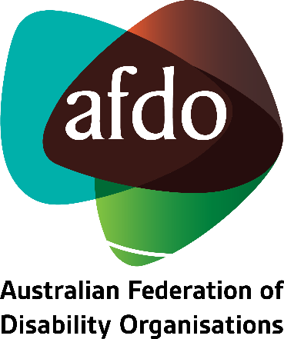

Disability Inclusion Bill 2022
Response to Exposure Draft

November 2022

Table of Contents

Table of Contents 2
About AFDO 3
Acknowledgements 6
General Comments on the Disability Inclusion Bill Exposure Draft 7

About AFDO
Since 2003, the Australian Federation of Disability Organisations (AFDO), a Disabled Peoples Organisation (DPO) and Disability Representative Organisation (DRO), has been the recognised national peak organisation in the disability sector, along with its disability specific members, representing people with disability. AFDO’s mission is to champion the rights of people with disability in Australia and support them to participate fully in Australian life.
Our member organisations represent disability specific communities with a total reach of over 3.8 million Australians.
AFDO continues to provide a strong, trusted, independent voice for the disability sector on national policy, inquiries, submissions, systemic advocacy and advisory on government initiatives with the Federal and State/Territory governments.
We work to develop a community where people with disability can participate in all aspects of social, economic, political and cultural life. This includes genuine participation in mainstream community life, the development of respectful and valued relationships, social and economic participation, and the opportunity to contribute as valued citizens.
Our vision
That all people with disabilities must be involved equally in all aspects of social, economic, political and cultural life.
Our mission
Using the strength of our membership-based organisations to harness the collective power of uniting people with disability to change society into a community where everyone is equal.
Our strategic objectives
To represent the united voice of our members and people with disability in national initiatives and policy debate.
To enhance the profile, respect and reputation for AFDO through our members.
To build the capacity and sustainability of AFDO and our members.
To foster strong collaboration and engagement between our members and stakeholders.
To enhance AFDO's connection and influence in international disability initiatives, particularly in the Asia Pacific region, through policy, advocacy and engagement.

Our members
Full members:
- Arts Access Australia
- Autism Aspergers Advocacy Australia
- Blind Citizens Australia
- Brain Injury Australia
- Deaf Australia
- Deafblind Australia
- Deafness Forum of Australia
- Down Syndrome Australia
- Disability Advocacy Network Australia
- Disability Justice Australia
- Disability Resources Centre
- Enhanced Lifestyles
- Multiple Sclerosis Australia
- National Mental Health Consumer and Carer Forum (NMHCCF)
- People with Disability WA
- People with Disabilities ACT
- Polio Australia
- Physical Disability Australia
- Women with Disabilities Victoria
- Women with Disabilities ACT

Associate members:
- AED Legal Centre
- All Means All
- Amaze
- Aspergers Victoria
- Disability Advocacy and Complaints Service of South Australia (DACSSA)
- Disability Law Queensland
- Leadership Plus
- National Organisation for Fetal Alcohol Spectrum Disorder (NOFASD)
- Star Victoria
- TASC National Limited
- YDAS – Youth Disability Advocacy Service

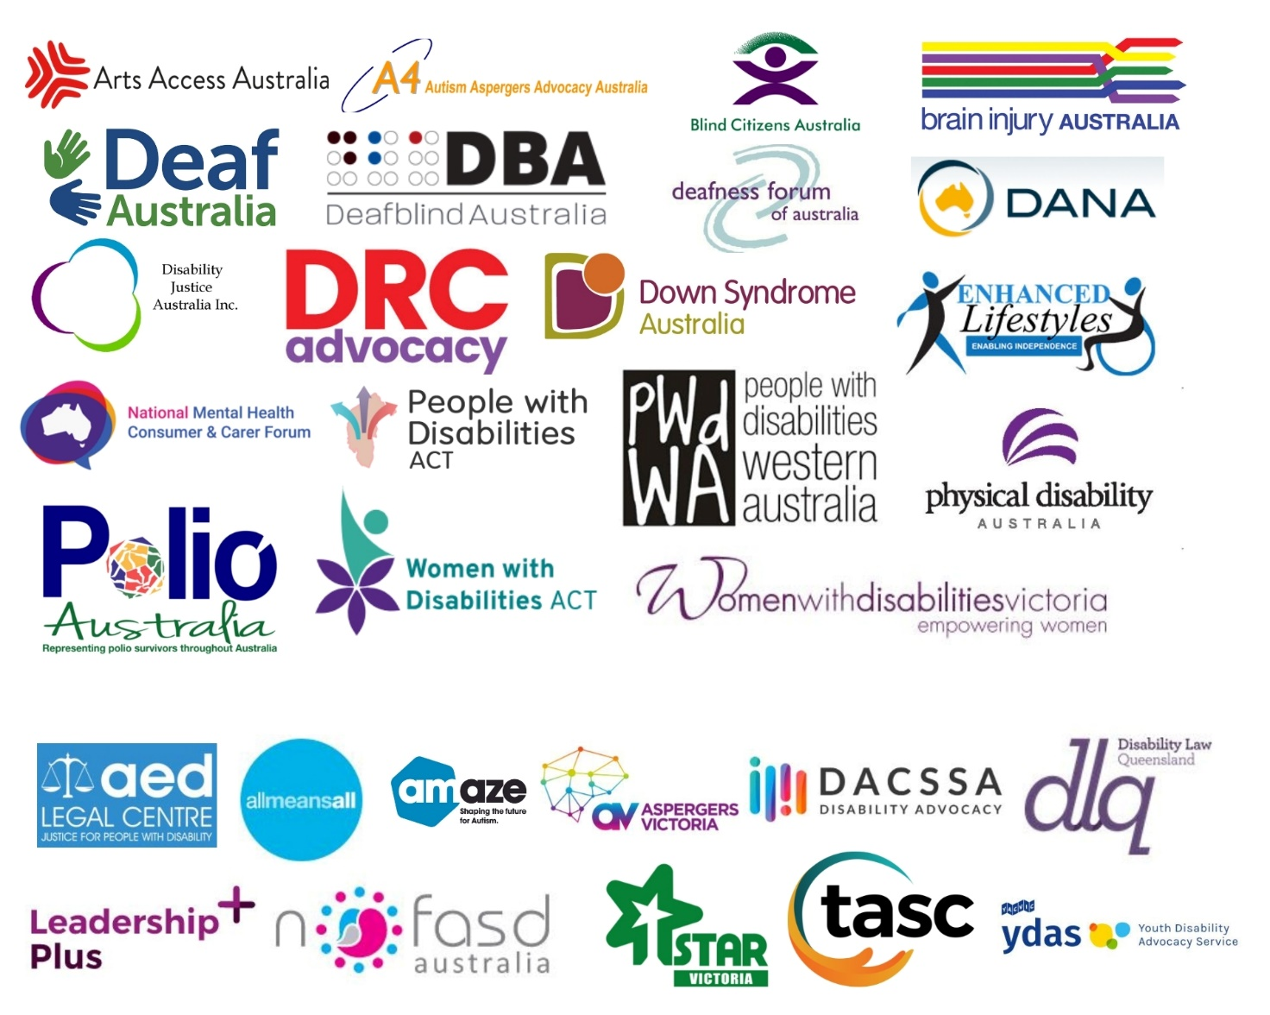

Acknowledgements
AFDO acknowledges Aboriginal and Torres Strait Islander people as the traditional custodians of the land on which we stand, recognising their continuing connection to land, waters, and community. From our head office in Melbourne, we pay our respects to the Bunurong Boon Wurrung and Wurundjeri Woi Wurrung peoples of the Eastern Kulin Nation and to their Elders past, present, and emerging. We also pay our respects to the traditional owners of all lands on which we operate or meet around the country.
AFDO acknowledges people with disability, particularly those individuals that have experienced or are continuing to experience violence, abuse, neglect, and exploitation. We also acknowledge their families, supporters, and representative organisations and express our thanks for the continuing work we all do in their support.

General Comments on the Disability Inclusion Bill Exposure Draft
As a national peak organisation, AFDO and its members represent disability specific communities with a total reach of over 3.8 million Australians. AFDO is dedicated to undertaking systemic advocacy across a range of disability types with the goal of enabling all people with disability to be involved equally in all aspects of social, economic, political, and cultural life. AFDO welcomes the opportunity to make comment on the Disability Inclusion Bill 2022 exposure draft (the Bill).
There are a number of positives in the proposed Bill that AFDO would highlight. These include:
- The philosophical underpinnings of intersectionality and self-determination for First Nations Australians are welcome inclusions. However, while it is beneficial that these concepts are recognised and centred from the Bill’s inception, simple recognition is not enough – it is crucial that mechanisms are built in to ensure the Bill remains true to these principles.
- The human rights-based approach with strong reference to the Convention on the Rights of Persons with Disabilities (CRPD).
- The emphasis on proactive approaches and positive duties. In line with the Equal Opportunity Act 2010, defined entities are not simply required to address issues of discrimination as they arise. Rather, they are obliged to actively address the systemic causes of disability discrimination and in doing so create an environment where it is unlikely to occur.
- The whole-of-government framework that centres disability inclusion and enables a coherent approach to all aspects of public administration.
- The Bill being shaped through public consultation demonstrates a commitment to co-design and collaboration with people with disability. It is critical that this commitment to centring the voices of people with disability continues to be upheld through all aspects of the Bill’s administration.
- The emphasis on transparent reporting processes with regular and defined timeframes. This will enable greater accountability and will ensure that the Bill is and continues to be fit-for-purpose.

While AFDO is largely in favour of the Bill, there are several points of concern that we would raise.
Accessibility of information
Defined entities are required to provide communications and disability action plans in at least one accessible format. The term “accessible format” covers a wide range of materials including Easy English, braille, audio and video recordings, large print, and tactile graphs, among others. Most of these formats are intended to address a specific kind of impairment and are not generalisable to the disabled population at large. While it is not reasonable to expect defined entities to provide information in every possible accessible format, effort should be made to provide information in those most commonly used to ensure that it is accessible to as many people with disability as possible. Providing information in only one accessible format would necessarily exclude large segments of the disabled community, and as such cannot be considered true accessibility.
Consultation and co-design
The requirements for defined entities to consult with people with disability are a welcome inclusion to the Bill. AFDO would caution, however, that while co-design and consultation have become commonly used terms, their status as buzzwords has the potential to dilute their meaning and reduce their effectiveness. No detail is provided in the Bill as to how this consultation will be undertaken, and it appears that per Part 8: General and miscellaneous, it will be largely at the Minister’s discretion under their power to set regulations for defined entities. Further detail on what these regulations for consulting with people with disability would look like is required before it can be considered true co-design.
Degree of discretion granted to Minister and government
Under Part 8: General and miscellaneous, it is stated that the Minister may issue guidelines to help defined entities meet and understand their obligations. Similarly, the government may issue regulations to further specify matters set out in the Act. It is not clear how transparent the process of developing these guidelines and regulations will be. AFDO would caution that allowing the Minister and government too much discretion in determining these matters may undermine the stated emphasis on collaboration with people with disability.
Implications for systemic advocacy funding
The Bill explicitly recognises that systemic advocacy is essential to advancing disability inclusion. While it is noted that under section 53 – funding guidelines, the Treasurer or Minister may issue guidelines for the allocation of funding or grants, further clarification on how this Bill will affect funding for systemic advocacy would be beneficial.

