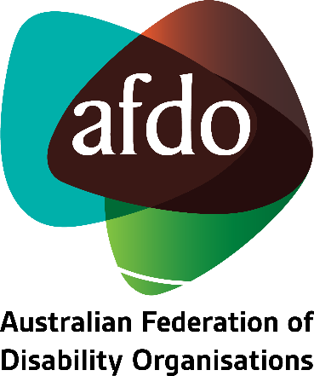

Ensuring the Royal Commission’s recommendations effectively uphold the rights of Australians with disability
AFDO Submission to the Royal Commission into Violence, Abuse, Neglect and Exploitation of People with Disability

29 December 2022

Table of Contents
Table of Contents 1
About AFDO 3
Our Members 4
Acknowledgements 6
Introductory Comments 7
Final recommendations and their Implementation 8
- Articles 1 – 5: General principles and obligations 8
- Article 5: Equality and non-discrimination 8
- Article 8: Awareness-raising 9
- Article 9: Accessibility 10
- Article 11: Situations of risk and humanitarian emergencies 11
- Article 12: Equal recognition before the law 11
- Article 13: Access to justice 11
- Article 16: Freedom from exploitation, violence and abuse 12
- Article 19: Living independently and being included in the community 12
- Article 21: Freedom of Expression and Opinion and Access to Information 13
- Article 23: Respect for home and the family 13
- Article 24: Education 13
- Article 25: Health 14
- Article 28: Adequate standard of living and social protection 14

Concluding Comments 16

About AFDO
Since 2003, the Australian Federation of Disability Organisations (AFDO), a Disabled Peoples Organisation (DPO) and Disability Representative Organisation (DRO), has been the recognised national peak organisation in the disability sector, along with its disability specific members, representing people with disability. AFDO’s mission is to champion the rights of people with disability in Australia and support them to participate fully in Australian life.
Our member organisations represent disability specific communities with a total reach of over 3.8 million Australians.
AFDO continues to provide a strong, trusted, independent voice for the disability sector on national policy, inquiries, submissions, systemic advocacy and advisory on government initiatives with the Federal and State/Territory governments.
We work to develop a community where people with disability can participate in all aspects of social, economic, political and cultural life. This includes genuine participation in mainstream community life, the development of respectful and valued relationships, social and economic participation, and the opportunity to contribute as valued citizens.
Our vision
That all people with disabilities must be involved equally in all aspects of social, economic, political and cultural life.
Our mission
Using the strength of our membership-based organisations to harness the collective power of uniting people with disability to change society into a community where everyone is equal.
Our strategic objectives
To represent the united voice of our members and people with disability in national initiatives and policy debate.
To enhance the profile, respect and reputation for AFDO through our members.
To build the capacity and sustainability of AFDO and our members.
To foster strong collaboration and engagement between our members and stakeholders.
To enhance AFDO's connection and influence in international disability initiatives, particularly in the Asia Pacific region, through policy, advocacy and engagement
Our members
Full members:
- Arts Access Australia
- Autism Aspergers Advocacy Australia
- Blind Citizens Australia
- Brain Injury Australia
- Deaf Australia
- Deafblind Australia
- Deafness Forum of Australia
- Down Syndrome Australia
- Disability Advocacy Network Australia
- Disability Justice Australia
- Disability Resources Centre
- Enhanced Lifestyles
- Multiple Sclerosis Australia
- National Mental Health Consumer and Carer Forum (NMHCCF)
- People with Disability WA
- People with Disabilities ACT
- Polio Australia
- Physical Disability Australia
- Women with Disabilities Victoria
- Women with Disabilities ACT

Associate members:
- AED Legal Centre
- All Means All
- Amaze
- Aspergers Victoria
- Disability Advocacy and Complaints Service of South Australia (DACSSA)
- Disability Law Queensland
- Leadership Plus
- National Organisation for Fetal Alcohol Spectrum Disorder (NOFASD)
- Star Victoria
- TASC National Limited
- YDAS – Youth Disability Advocacy Service

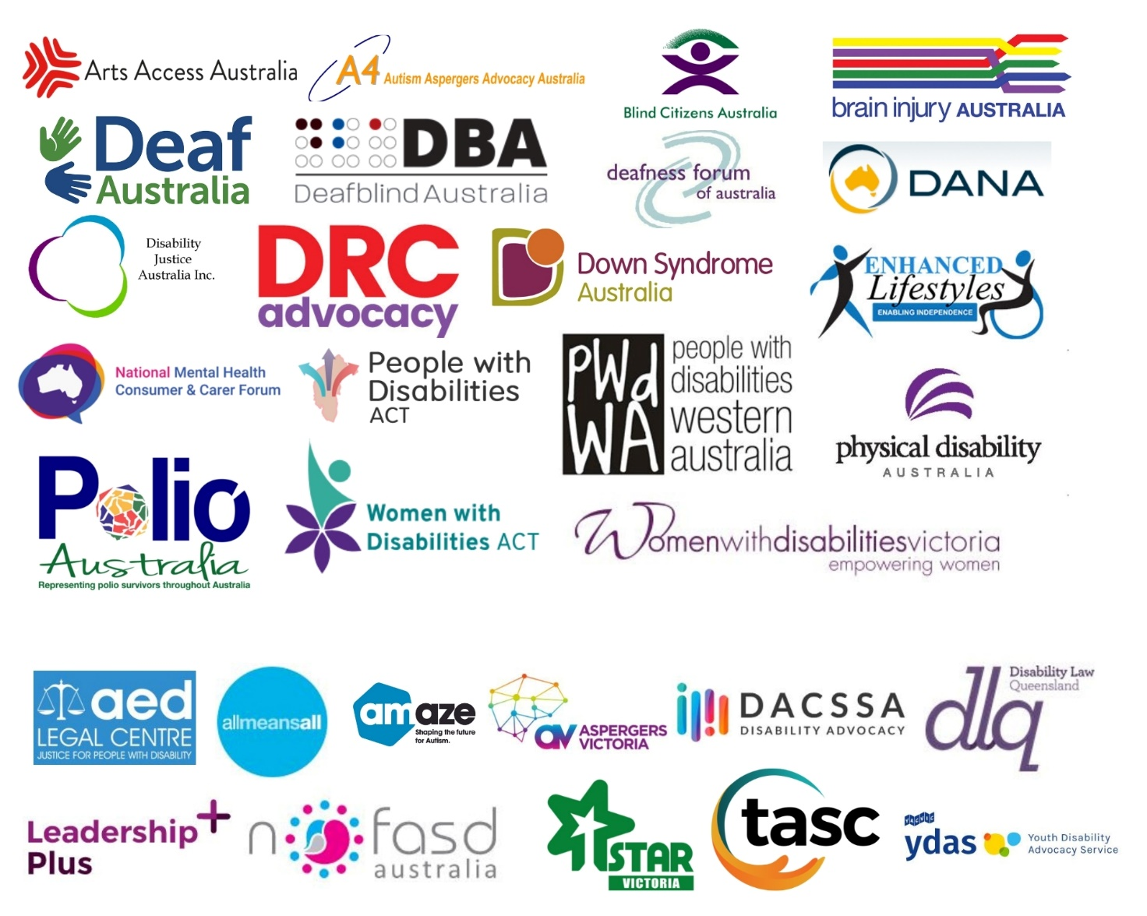

Acknowledgements
AFDO acknowledges Aboriginal and Torres Strait Islander people as the traditional custodians of the land on which we stand, recognising their continuing connection to land, waters, and community. From our head office in Melbourne, we pay our respects to the Bunurong Boon Wurrung and Wurundjeri Woi Wurrung peoples of the Eastern Kulin Nation and to their Elders past, present, and emerging. We also pay our respects to the traditional owners of all lands on which we operate or meet around the country.
AFDO acknowledges people with disability, particularly those individuals that have experienced or are continuing to experience violence, abuse, neglect, and exploitation. We also acknowledge their families, supporters, and representative organisations and express our thanks for the continuing work we all do in their support.

Submission prepared by:
Rebecca Rudd, Policy & Submissions Coordinator
Lauren Henley, Senior Systemic Advocate
Natalie Wade, AFDO Expert Consultant to the Royal Commission
Ross Joyce, CEO

Introductory Comments
The Australian Federation of Disability Organisations (AFDO) thanks the Royal Commission for providing us with a final opportunity to inform its investigations into the violence, abuse, neglect and exploitation of people with disability. This submission summarises the overarching measures we would like to see included in the Royal Commission’s final recommendations. It draws on several of the themes raised in our previous submissions to the Royal Commission. It also incorporates feedback that was gathered during two targeted workshops we hosted for our member organisations in November 2022 to discuss the key measures they wanted to see reflected in the Royal Commission’s final set of recommendations.

This submission is structured as a series of recommendations that align with particular Articles of the Convention on the Rights of Persons with Disabilities (CRPD). Importantly, many of these recommendations align with those put forward by the Committee on the Rights of Persons with Disabilities in its concluding observations on the combined second and third reports of Australia. Where a recommendation aligns with the concluding observations, this is indicated in brackets at the end of the recommendation.

While the recommendations put forward in this submission are broad and overarching, we also acknowledge and support many of the specialist recommendations put forward by our member organisations throughout the life course of the Royal Commission.

In preparing this submission, we acknowledge the many people with disability across Australia who have experienced, or continue to experience violence, abuse, neglect, and exploitation. We also proudly acknowledge the rich culture of our First Nations people and pay respect to their Elders past, present and emerging.

Submission Contact:
Lauren Henley
Senior Systemic Advocate
Australian Federation of Disability Organisations

Email: lauren.henley@afdo.org.au

Final Recommendations and their Implementation
Recommendation: The Royal Commission must structure its recommendations in a way that aligns with the various articles of the Convention on the Rights of Persons with Disabilities. This will help civil society to monitor Australia’s progress against the Convention and assist with the treaty body reporting process.
Recommendation: The Royal Commission provide an opportunity for civil society to submit feedback on its proposed recommendations, and the intended timelines for their implementation, in order to fully comply with its obligations under Article 4:3 of the Convention on the Rights of Persons with Disabilities.
Recommendation: The Australian Government quickly implement and properly resource an implementation task force that is led by people with disability and involves key decision-makers at all levels of Government, to assist with the timely and effective implementation of the Royal Commission’s final recommendations.
Articles 1 – 5: General principles and obligations
Recommendation: The Australian Government and State and Territory governments must work collaboratively to develop a long-term funding strategy to ensure the effective resourcing, and sustainability of disability advocacy services; including both individual and systemic advocacy services (see paragraph 6:G of concluding observations).
Recommendation: The Australian Government must review and withdraw its interpretive declarations on articles 12, 17 and 18 of the Convention on the Rights of Persons with Disabilities (see paragraph 6:B of concluding observations).
Article 5: Equality and non-discrimination
Recommendation: The Australian Government must embed the rights set out under the Convention on the Rights of Persons with Disabilities in domestic law by establishing a legally binding National Charter of Human Rights and Freedoms.
Recommendation: The Australian Government must commit to strengthening the Commonwealth Disability Discrimination Act to:
- Prohibit discrimination on all grounds;
- Acknowledge discrimination of an intersectional nature;
- Allow for systemic complaints, representative complaints, and class actions; and
- Introduce sanctions for non-compliance.
In strengthening the Act, consideration must also be given to how the Australian Human Rights Commission could be granted the power to make legally binding determinations, in order to prevent people with disability from having to pursue unconciliated cases through the court system (see paragraph 10: A and B of concluding observations).
Recommendation: The Department of Health must urgently address the inequity in the provision of supports to older people with disability (those 65 and over) who do not meet the age eligibility requirements for the NDIS by fully implementing recommendations 72, 73 and 125 of the Royal Commission into Aged Care Quality and Safety.
Recommendation: The Department of Health and Department of Social Services must address the inequity in the provision of supports to persons with disability (those aged 18 to 65 years of age) who do not meet the eligibility requirements for the NDIS but should receive relevant and timely supports in accordance with Australia’s obligations under the UNCRPD.
Article 8: Awareness-raising
Recommendation: The Australian Government and State and Territory governments work collaboratively with disability representative organisations to implement the targeted action plan on community awareness that’s been established under Australia’s Disability Strategy 2021-31.
Recommendation: Public sector employees working at all levels of Government be directed to undertake mandatory training on a human rights-based approach to people with disability and on disability awareness.
Recommendation: The Minister for Employment must be directed to work with the Australian Curriculum, Assessment and Reporting Authority, the Tertiary Education Quality and Standards Agency and the new independent Training Package Assurance function within the Department of Employment and Workplace Relations to ensure modules on disability awareness, accessibility and inclusive design are built into:
- The Australian school curriculum.
- Relevant VET accredited courses.
- Relevant university courses.
This work must be informed by people with disability and their representative organisations.
Article 9: Accessibility
Recommendation: The Australian Government must provide leadership to ensure that the New South Wales and Western Australia State Governments join, or are directed to join, all other State and Territory Governments in implementing the ABCB (Australian Building Codes Board) Standard for Livable Housing Design in the National Construction code.
Recommendation: The Australian Government work collaboratively with State and Territory governments to establish and implement a nationally consistent framework for reporting compliance against the Disability Standards for Accessible Public Transport 2002 and the Disability (Access to Premises – Buildings) Standards 2010 (see paragraph 18:A of concluding observations).
Recommendation: Standards Australia must be directed to ensure standards documents are available to people with disability at no cost, and in a variety of accessible formats, to enable them to effectively exercise their rights- in accordance with the UNCRPD and Australia’s Anti-Discrimination Legislation.
Recommendation: The Department of Transport must be directed to provide adequate and sustainable funding to support the work of the National Inclusive Transport Advocacy Network (NITAN) to enable it to provide systemic advice to Government Departments and transport providers.

Article 11: Situations of risk and humanitarian emergencies
Recommendation: State and Territory governments must implement measures to ensure disability advocates are recognised as essential workers, with access rights, during all future situations of risk and humanitarian emergencies. This is necessary to ensure the rights of people with disability are effectively upheld; particularly those who live in closed or congregate settings, those who cannot read or write and those who are unable to access information and services online.
Recommendation: The Australian Government must work with disability representative organisations to implement nationally consistent emergency management standards, to ensure access to disability-specific and disability-responsive support during situations of risk and humanitarian emergencies. This framework must also outline how support is to be provided to people with disability living in congregate settings including group homes, supported residential services and residential aged care facilities (see paragraph 21:A of concluding observations).
Recommendation: The Australian Government must work collaboratively with disability representative organisations to establish a fully accessible and inclusive mechanism to engage with persons with disabilities in the implementation and monitoring of the Sendai Framework for disaster risk reduction 2015-30 (see paragraph 22 of concluding observations).

Article 12: Equal recognition before the law
Recommendation: The Australian Government must be directed to review and implement all outstanding recommendations from the Australian Law Reform Commission's 2014 report from its Review of Equality, Capacity and Disability in Commonwealth laws; including the recommendation to establish a national policy and legislative framework for supported decision-making (see paragraph 24:B of concluding observations).

Article 13: Access to justice
Recommendation: The Australian Government be directed to fully implement all outstanding recommendations contained in the Senate Community Affairs References Committee 2016 report on Indefinite Detention of Persons with Cognitive and Psychiatric Impairment in Australia (see paragraph 28:B of concluding observations).
Recommendation: The Australian Government be directed to implement a timetable, along with legislative changes, to fully remove indefinite detention in all jurisdictions as a priority and in accordance with the continued recommendations and concluding remarks from the United Nations Observers.
Recommendation: All States and Territories must be required to adopt a Disability Justice strategy to provide an overarching framework for reform within a designated timeframe. The Commonwealth must work with State and Territory governments to establish a nationally consistent framework for reporting against these strategies and providing these reports publicly and in full.

Article 15: Freedom from torture or cruel, inhuman or degrading treatment or punishment
Recommendation: The Australian Government and State and Territory governments must cooperate, in full, with the Subcommittee on Prevention of Torture to enable it to carry out its mandate under the Optional Protocol to the Convention against Torture and other Cruel, Inhuman or Degrading Treatment or Punishment, to which Australia is a party. The Committee must be provided with all requested evidence, and granted access to all necessary facilities, to enable it to undertake its recently suspended visit to Australia as soon as practically possible.
Recommendation: The Commonwealth Ombudsman must ensure disability representative organisations can meaningfully engage with the work of the National Preventive Mechanism that has been established under the Convention against Torture and other Cruel, Inhuman or Degrading Treatment or Punishment (see paragraph 3:C of concluding observations).

Article 16: Freedom from exploitation, violence and abuse
Recommendation: The Australian Government, in close consultation with disability representative organisations, establish a national Commission against violence, abuse, neglect and exploitation of people with disability. The Commission must be:
- Adequately resourced to respond to complaints in a timely manner.
- Disability led.
- Have the ability to hear individual complaints, as well as those that are systemic in nature.
- Have the capacity to provide advice to Government on key issues, including law reform.
Recommendation: The Australian Government must implement measures to ensure greater oversight of people with disability who face increased vulnerability to violence, abuse, neglect and/or exploitation, across all jurisdictions, including:
- Mandatory community visitors scheme.
- Mandatory access for advocates.

Article 19: Living independently and being included in the community
Recommendation: The Australian Government must commit to working collaboratively with disability representative organisations to fully implement the recommendations from the Independent Review of the National Disability Insurance Scheme.
Recommendation: The Department of Social Services must be directed to work with the Department of Health and the National Disability Insurance Agency (NDIA) to develop a targeted action plan relating to the equitable provision of assistive technology to people with disability who are not eligible for the NDIS, including:
- People who are over 65 who do not meet the age eligibility requirements for the NDIS, and
- People under 65 who would benefit from assistive technology, but do not fully meet the other eligibility requirements for the NDIS.

Article 21: Freedom of Expression and Opinion and Access to Information
Recommendation: The Australian Government must enact legally binding information and communication standards that require all government departments, statutory authorities, courts, legal services and health services to provide information in a range of accessible formats, including Braille, Easy Read and Australian Sign Language.
Recommendation: The Australian Government must enact legally binding information and communication standards that require all government departments, statutory authorities, courts, legal services and health services to provide information in a range of accessible formats, including Braille, Easy Read and Australian Sign Language.

Article 23: Respect for home and the family
Recommendation: The Australian Government must implement mechanisms to ensure parents with disability are provided with adequate support, including advocacy, communication and decision-making support, in all matters pertaining to child protection cases.

Article 24: Education
Recommendation: The Department of Education must work collaboratively with disability representative organisations, children and young people with disability and their families to progress the recommendations from the 2020 review of the Disability Standards for Education.
Recommendation: The Department of Education must require all educational institutions to record data for all students on:
- Educational attainment.
- Completion rates.
- Suspension rates.
- Expulsion rates.
- The use of restrictive practices.
- Instances of bullying.
This data must be reported on annually (minimum) and made publicly available under Australia’s Disability Strategy 2021-31 (see paragraph 46:C of concluding observations.
Recommendation: The Department of Education must be required to work collaboratively with disability representative organisations to implement a nationally consistent framework for the schooling and home schooling of children and young people with disability during emergency situations.

Article 25: Health
Recommendation: The Department of Health must establish a mechanism to mandate training on the human rights model of disability for all Healthcare practitioners to ensure they have the capacity to effectively uphold the rights of people with disability and eliminate discriminatory practices (see paragraph 48:C of concluding observations).
Recommendation: The Department of Health must be directed to undertake targeted consultation with people with disability and their representative organisations to identify and eliminate barriers to accessing mental health services. Findings from this process must be used to update the National Mental Health and Suicide Prevention Plan.

Article 28: Adequate standard of living and social protection
Recommendation: The Australian Government must urgently review the eligibility criteria for the Disability Support Pension to bring it into line with Article 28 of the Convention on the Rights of Persons with Disabilities (see paragraph 52:B of concluding observations).
Recommendation: The Australian Government must urgently increase the rate of the Disability Support Pension, Newstart Allowance, Jobseeker payment and other income support payments to ensure people with disability have access to an adequate standard of living (see paragraph 52:B of concluding observations).
Recommendation: The Australian Government must be directed to develop a national poverty reduction plan that is inclusive and accessible to all people with disability, including First Nations people with disability (see paragraph 52:A of concluding observations).

Concluding Comments
As the national voice of people with lived experience of disability in Australia, AFDO look forward to working collaboratively with all levels of Government to progress the Royal Commission’s recommendations over the next few years.

We hope this process will lead to tangible change for people with disability across Australia, and ensure their rights are properly promoted, protected and upheld into the future.

