Senate Select Committee on Work and Care
Submission by AFDO

September 2022

Table of Contents
Table of Contents 2
About AFDO 3
Acknowledgements 6
Responding to Select Questions from the Terms of Reference
- The extent and nature of the combination of work and care across Australia and the impact of changes in demographic and labour force patterns on work-care arrangements in recent decades 7
- The impact of combining various types of work and care (including of children, the aged, those with disability) upon the well-being of workers, carers and those they care for 9
- The impact and lessons arising from the COVID-19 crisis for Australia’s system of work and care 12
- Consideration of the policies, practices and support services that have been most effective in supporting the combination of work and care in Australia, and overseas 14
Reference List 16

About AFDO
Since 2003, the Australian Federation of Disability Organisations (AFDO), a Disabled Peoples Organisation (DPO) and Disability Representative Organisation (DRO), has been the recognised national peak organisation in the disability sector, along with its disability specific members, representing people with disability. AFDO’s mission is to champion the rights of people with disability in Australia and support them to participate fully in Australian life.
Our member organisations represent disability specific communities with a total reach of over 3.8 million Australians.
AFDO continues to provide a strong, trusted, independent voice for the disability sector on national policy, inquiries, submissions, systemic advocacy and advisory on government initiatives with the Federal and State/Territory governments.
We work to develop a community where people with disability can participate in all aspects of social, economic, political and cultural life. This includes genuine participation in mainstream community life, the development of respectful and valued relationships, social and economic participation, and the opportunity to contribute as valued citizens.
Our vision
That all people with disabilities must be involved equally in all aspects of social, economic, political and cultural life.
Our mission
Using the strength of our membership-based organisations to harness the collective power of uniting people with disability to change society into a community where everyone is equal.
Our strategic objectives
To represent the united voice of our members and people with disability in national initiatives and policy debate.
To enhance the profile, respect and reputation for AFDO through our members.
To build the capacity and sustainability of AFDO and our members.
To foster strong collaboration and engagement between our members and stakeholders.
To enhance AFDO's connection and influence in international disability initiatives, particularly in the Asia Pacific region, through policy, advocacy and engagement.

Our members
Full members:
- Arts Access Australia
- Autism Aspergers Advocacy Australia
- Blind Citizens Australia
- Brain Injury Australia
- Deaf Australia
- Deafblind Australia
- Deafness Forum of Australia
- Down Syndrome Australia
- Disability Advocacy Network Australia
- Disability Justice Australia
- Disability Resources Centre
- Enhanced Lifestyles
- Multiple Sclerosis Australia
- National Mental Health Consumer and Carer Forum (NMHCCF)
- People with Disability WA
- People with Disabilities ACT
- Polio Australia
- Physical Disability Australia
- Women with Disabilities Victoria
- Women with Disabilities ACT

Associate members:
- AED Legal Centre
- All Means All
- Amaze
- Aspergers Victoria
- Disability Advocacy and Complaints Service of South Australia (DACSSA)
- Disability Law Queensland
- Leadership Plus
- National Organisation for Fetal Alcohol Spectrum Disorder (NOFASD)
- Star Victoria
- TASC National Limited
- YDAS – Youth Disability Advocacy Service

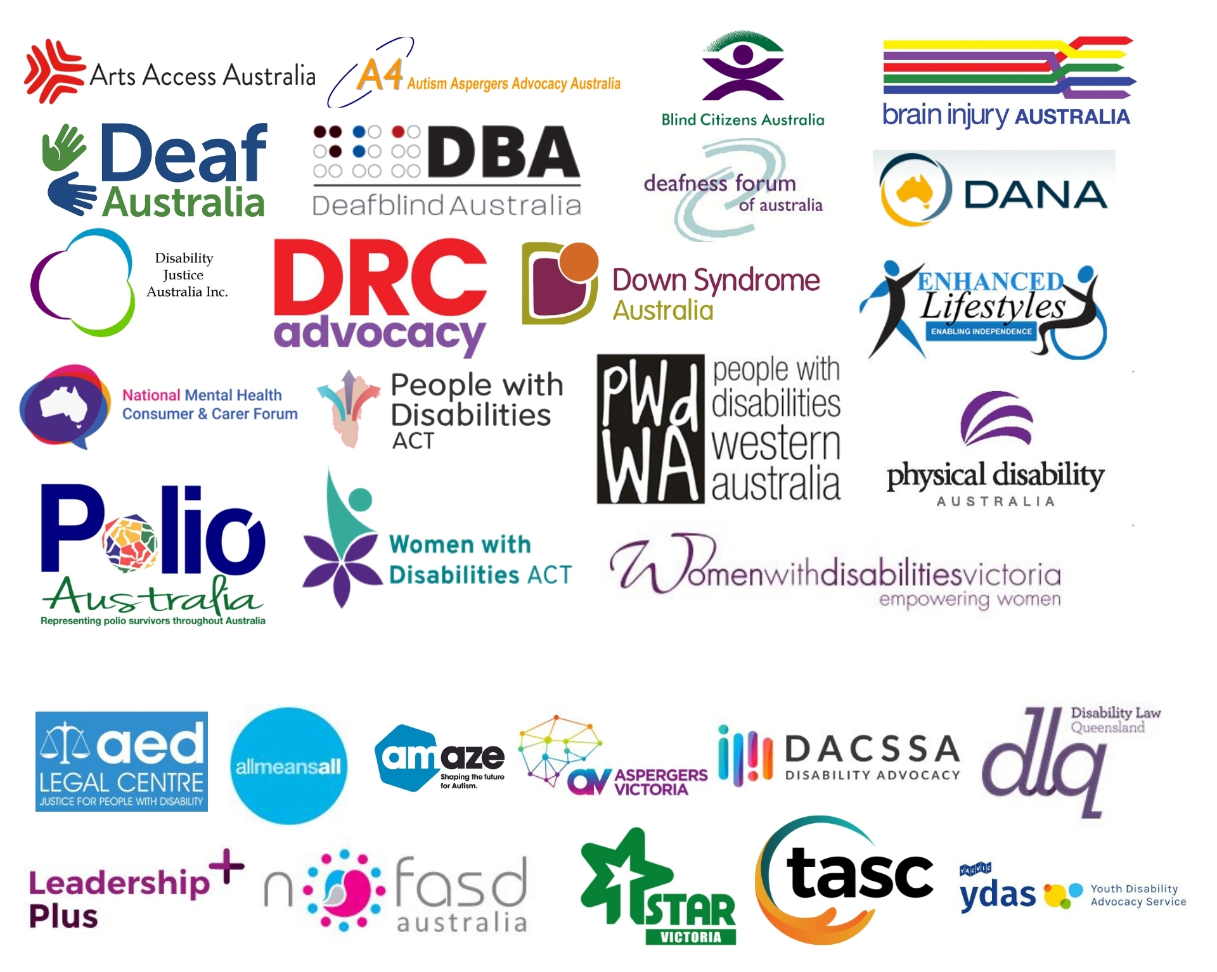

Acknowledgements
AFDO acknowledges Aboriginal and Torres Strait Islander people as the traditional custodians of the land on which we stand, recognising their continuing connection to land, waters, and community. From our head office in Melbourne, we pay our respects to the Bunurong Boon Wurrung and Wurundjeri Woi Wurrung peoples of the Eastern Kulin Nation and to their Elders past, present, and emerging. We also pay our respects to the traditional owners of all lands on which we operate or meet around the country.
AFDO acknowledges people with disability, particularly those individuals that have experienced or are continuing to experience violence, abuse, neglect, and exploitation. We also acknowledge their families, supporters, and representative organisations and express our thanks for the continuing work we all do in their support.

Responding to Select Questions from the Terms of Reference
The extent and nature of the combination of work and care across Australia and the impact of changes in demographic and labour force patterns on work-care arrangements in recent decades
Carers of people with disability perform a crucial role, although their value often fails to be captured by traditional measures of economic productivity. When speaking of carers in this context, we are largely referring to informal carers, that is, individuals who provide care within the context of an existing relationship, such as family members or friends. The majority of informal carers are unpaid. Per the Australian Bureau of Statistics (ABS) Survey of Disability, Ageing and Carers, in 2018 there were 2.65 million people who provided informal care in Australia. This equates to approximately 10% of the Australian population. Of these, roughly 1 in 3 carers were primary carers, meaning they provided the most care to the individual in one or more core activities. Primary carers equate to approximately 3.5% of the Australian population. In 2020, it was estimated that the population of informal carers had increased to almost 2.8 million; a 5.5% increase from 2018, attributable to population growth.
Certain demographic trends can be observed in the carer population. Carers are more likely to be women, with 12.3% of all females being carers versus 9.3% of all males. Of primary carers, more than 7 in 10 were women. This gender disparity increases with age, with women comprising 82% of carers aged 35-44, and 75% of carers aged 45-54. Carers are more than twice as likely than the rest of the population to have a disability themselves (37.4% versus 15.3%). Carers are also more likely to be of lower socio-economic status, with half (50.2%) of all carers living in a household in the lowest two income quintiles, twice that of non-carers (25.6%).
The burden of caring is reflected in the workforce participation rates of carers, who are often forced to reduce their hours worked or withdraw from the labour force entirely. In 2018, among carers aged 15-64 years, 7 in 10 (70.8%) were in the labour force. Primary carers were less likely to be employed (58.8%) versus non-primary carers (76.6%) and non-carers (81.5%). The gender disparity is again reflected here, with 71.8% of male carers being employed versus 63.2% of female carers. Among primary carers aged 15-64, roughly half were employed (55.5%), however their employment status varied with the hours of care provided per week. Of primary carers providing more than 40 hours of care per week, less than one third (28.6%) were employed. This figure increased to over half (52.8%) among those providing less than 20 hours of care per week. These lower rates of employment were naturally reflected in household incomes of carers. In 2018, the median gross income of all carers was $800 per week, compared to $997 for non-carers. Primary carers were more than twice as likely (38.4%) to receive a government pension than other carers (17.2%) and non-carers (9.2%).
As these statistics demonstrate, carers are more likely to be from marginalised populations, and the burden of caring further compounds their marginalisation by reducing employment opportunities and confining them to a position of lower economic status.
Case Study by Danielle:
I’m the primary carer for my adult daughter with intellectual disability and complex medical needs. Since her birth 30 years ago, I have continued to work and also completed a tertiary degree. When she was younger, I was able to do this because I had good family support close by. This became increasingly difficult to manage as my daughter got older, and when she was in school, as school hours don’t fit with work hours. There was a tension between flexible work and well-paid work. The nature of work that was flexible enough to accommodate caring for my daughter was low-paid, so precluded being able to afford supports after school hours. The nature of well-paid work, work with responsibility or seniority, was such that it precluded flexibility.
The biggest change in recent years has been the introduction of the NDIS. This has enabled my daughter to have age-appropriate supports and set her own agenda for activities – not have to rely on my availability and be squeezed in around work hours, other children, commuting, etc. This means that it’s now possible for me to have more consistent work and more stable hours, and thus better remuneration. Care actually became easier to manage after my daughter left school, but it is still a constant juggle of priorities.

The impact of combining various types of work and care (including of children, the aged, those with disability) upon the well-being of workers, carers and those they care for;
Individuals who seek to balance caring duties with paid employment face myriad challenges. In a scoping review mapping 92 relevant publications, Spann et al. identified a number of challenges that directly resulted from combining work and care. These include:
- High and/or competing demands: caring created high demands where the recipient required time-intensive care, constant monitoring, was severely limited in their mobility, or exhibited demanding behaviour. Competing demands emerged when work interfered with caring, or vice versa.
- Psychosocial/-emotional stressors: caring could be distressing, especially when the recipient of care was in pain or displayed difficult behaviour. Fluctuating care needs caused stress as carers found it difficult to plan ahead. Cultural or familial expectations limited carers’ perceived choice to engage in care, and were strongly tied to gender. Some carers experienced difficulty with their identity; unsure whether they were primarily carers or workers, they struggled to prioritise one role or the other. Conflict within the family, workplace, or with the recipient of care served as an additional source of distress. Finally, carers’ own view of their situation could have further impacts, with many describing feelings of guilt, resentment, abandonment or lack of appreciation.
- Distance: where the recipient of care did not live in the same household as the carer, the physical distance between the carer’s workplace and the recipient’s place of residence created further challenges.
- Carer’s health: the chronic physical and emotional exhaustion associated with caring may cause the development of new or exacerbation of existing health issues. Stress and lack of sleep could lead to decreased productivity at work and increased risk of accidents or mistakes. Carers may also be forced to take sick leave. Many carers did not prioritise their own personal health, as their caring responsibilities did not leave them enough time.
- Returning to work: carers may have a gap in their resume, or skills that had become outdated. Those who became carers early in life may have experienced opportunity costs regarding their education, with long-term consequences for both their career and confidence.
- Financial pressure: carers may have to reduce their work hours, resulting in a reduction of income. Being forced to take unpaid leave or exit the job market entirely meant carers had no income at all, and had repercussions for their future pension entitlements and retirement. As a result, many carers felt that they had no choice but to continue working, often to their own detriment. The costs of care services and therapies could also be substantial, further adding to the pressure. Some carers had to use their savings or take out loans to meet costs, often incurring debt.
In a systematic review examining the closely related issue of balancing paid work and informal eldercare, Lam et al. further expand upon the impact that caring has upon the health and wellbeing of informal carers. Their research suggests that informal carers experience conflict between work and family, particularly for those carers who worked more hours; spillover between roles, where emotions and behaviours expressed in one role carry over to the other role; and negative effects upon health and wellbeing including physical and mental health issues, lower self-esteem, and reduced life satisfaction.
Balancing work and care responsibilities can also have negative consequences for the carer’s employment. Research has indicated that the impact of care in relation to work stress is context-dependent, varying with the hours of care provided and the trajectory of said care. The financial burden of caring contributed to stress at work, and informal carers who worked more hours were more likely to experience higher levels of stress. These findings suggest that the negative impact that balancing work and care can have upon wellbeing is exacerbated under certain contexts, such as when the carer’s finances or work performance are affected. More positively, when care hours were not excessive, care provision was linked to better subjective well-being and reduced levels of perceived work-related stress.
The literature demonstrates a negative relationship between caring and work performance. Caring responsibilities were linked to reduced focus and commitment to work, higher levels of absenteeism and presenteeism, and engaging in time theft. Workers with caring responsibilities were more likely to leave early, arrive late, take time off, manage care over the phone while working, worry about the recipient of care, and take longer than permitted breaks. To cope with the demands of care, informal caregivers were also more likely to adjust their work schedules, take a leave of absence, reduce hours to part-time, reject promotions, and change jobs.
Balancing work and care is also associated with significant opportunity cost. Opportunity cost measures the formal sector productivity losses associated with caring, as time spent on caring responsibilities cannot be spent in the paid workforce. In Australia, an estimated 160,900 primary carers and 53,000 non-primary carers are assumed to not be in paid employment due to their caring duties. This is equivalent to approximately 1.51% of Australia’s labour force. In 2020, the estimated missed earnings for these primary and non-primary carers was $11.4 billion and $3.8 billion respectively. Combined, this amounts to an opportunity cost of $15.2 billion; approximately 0.8% of Australia’s GDP and 10.6% of the value of formal health care. As these figures make clear, the burden of balancing work and informal care has significant repercussions not only for individual carers and recipients, but for the economy as a whole.
Case Study by Amy:
The biggest impact has been very little or no time to myself, including social interaction with work colleagues, time for medical or dental appointments for myself, other outside interests or activities, etc. This has affected my wellbeing emotionally, physically, and mentally, particularly when the paid work was not very engaging. It has also impacted my daughter at times when she is getting an exhausted carer with little capacity to think or problem solve creatively, or at all.

The impact and lessons arising from the COVID-19 crisis for Australia’s system of work and care;
The Covid-19 crisis served to shine a light on the struggle that many carers face in attempting to balance their work and caring responsibilities. In doing so, it also revealed the potential that flexible work practices have to help mitigate this burden. Post-covid workplaces now have an opportunity to embed flexibility and enable caring to be shared equally within households, advancing gender equality and enabling all carers to make valuable contributions in the workforce and in public life more broadly.
According to the ABS Household Impacts of Covid-19 Survey, in November 2020, approximately 1 in 6 (16%) of Australians aged 18 years and over reported being an informal carer. Since March 2020, 25% of these informal carers reported difficulty in providing care or assistance because of restrictions put in place following Covid-19, 22% reduced their recreational activities, and 22% changed their working arrangements. The number of informal carers receiving financial support through Services Australia via the Carer Payment increased by 3.9% in March 2020 compared with March 2019, and 4.5% in September 2020 compared with September 2019. Similar changes were observed with the Carer Allowance, which had 623,000 recipients in September 2020, compared with 608,000 in September 2019. These increases may be related to changes in or loss of employment during the Covid-19 pandemic.
The pandemic had a number of effects on working carers, both positive and negative. Negative impacts include:
- Increased pressure placed on working carers: many workers took on additional parenting and caring responsibilities, meaning they needed greater support and flexibility from their employers. Almost two-thirds (63%) of carers found it difficult to balance their work and caring responsibilities during the pandemic, and 67% were forced to make trade-offs between caring and work. These trade-offs included relying more on partners, family members, or friends to provide care; not spending as much time on homeschooling as they wanted or needed to; and spending less time with their children.
- Reduced health and wellbeing: the increased challenges of caring while schools, childcare, and other facilities were closed caused the health, wellbeing, and financial security of many working carers to suffer.
- Increased risk of workplace discrimination: many working carers reported experiencing discrimination on the basis of their caring responsibilities, with the risk being greatest for those who were both carers and parents. One quarter (25%) of workers who were both parents and carers reported discrimination due to their parenting and caring responsibilities, while 13% of carers reported being discriminated against as a result of their caring responsibilities.
- Greater burden placed on women: irrespective of whether they worked full-time or part-time, women took on the greatest share of caring and parenting responsibilities during the pandemic. Women were more likely than men to spend time looking after their children (54% versus 47%), and men were more likely to report that their partner spent more time with the children during the pandemic than before (72% versus 61% of women who reported this).
Some positive impacts were also reported as a result of the Covid-19 pandemic:
- Flexible work arrangements: flexibility at work during the pandemic enabled carers to better balance their work and caring responsibilities. Almost one-third of men (29%) and almost half of women (44%) opted for flexible work arrangements to help balance parenting demands. More than half of workers with caring responsibilities (57%) and over one-quarter of working parents (26%) utilised flexible work arrangements to attend personal appointments during work hours. Working carers in particular were more likely than other workers to report a positive experience of flexible work (57% compared with 52% of workers overall).

Consideration of the policies, practices and support services that have been most effective in supporting the combination of work and care in Australia, and overseas;
The research literature examining work and care suggests a number of strategies to better support working carers in balancing their responsibilities. In their survey Juggling caring, parenting and work: Lessons for the post-COVID workplace, the Victorian Equal Opportunity and Human Rights Commission identified five key strategies to ease the burden on working carers. While these strategies are based on the Victorian context, they are easily generalisable to Australia as a whole:
- Explore opportunities for free, accessible, and adequately funded childcare to support greater workforce participation by parents, particularly women.
- Embed flexible work as part of a business-as-usual approach, enabling parents and carers to better balance and share caring responsibilities.
- Ensure workplace equality is prioritised by the Victorian Government as part of its response to COVID-19 and recovery efforts.
- Invest in strategies to transform societal attitudes towards unpaid caring and parenting, to adequately ascribe value to the ‘second shift’ many workers perform outside of their formal working hours.
- Strengthen enforcement of the Equal Opportunity Act to better protect parents and carers from discrimination.
Flexible workplace provisions in particular have great potential to reduce the strain experienced by working carers, providing a range of benefits to both employees and employers, as well as Australian society as a whole. These include:
- Reduced costs of employee turnover: the financial impact of staff turnover is considerable, costing approximately one-third of the annual salary of an employee. By providing flexibility that enables staff to balance their work and caring responsibilities, employers are more likely to retain experienced employees, reducing costs associated with recruitment, training, and resulting loss of productivity.
- Increased productivity: implementing flexible work practices can enable organisations to focus on outputs and outcomes, rather than hours worked. This can help to clarify tasks and encourage multi-skilling across teams. Less stressed employees are almost more likely to be productive.
- Improved service delivery: employees who feel appreciated and looked after are more likely to look after clients and customers. Flexible provisions such as extended start and finish times can also enhance customer experience by enabling the provision of services outside of standard business hours.
- Reducing employee stress and absenteeism: employees who cannot access flexible work practices will more often resort to taking personal leave to deal with their caring responsibilities. By providing employees with options to help them balance work and care, and encouraging them to take up these provisions, employers can reduce stress on carers and subsequent staff absenteeism.
- Attracting quality workers: implementing flexible working arrangements has been found to not only benefit existing employees, but also serves as an incentive for prospective employees to choose a particular employer.
- Increased staff morale: staff who feel supported by their employer are more likely to be loyal and productive workers. Investing in services and supports for staff that foster a positive environment will improve the workplace experience of all employees, and this culture can flow through the entire organisation.
- Building a resilient workforce: providing staff with information about caring will help to build their resilience to potential change, and may improve their capacity to keep working if they need to take on a caring role.
Case study: Dina
The recent hybrid arrangements for work have taken an enormous amount of stress away that arose from unexpected hospital admissions for my son or even having to take a day or half-day off to attend regular medical appointments with him. Also, working for organisations that have structures that allow for flexibility, such as having a band of work hours, time in lieu mechanisms, etc. When I am adequately supported to do my work, I’m less stressed and stretched and a better carer and better parent for my son and other children.
… It’s hard to know how much impact policies have for individual carers because a policy may not translate to actions or attitudes on the ground from supervisors or fellow workers. The most effective practices I’ve found to support me are having a band of hours (e.g. start between 7am and 10am each morning, finish between 3pm and 6pm), or time in lieu, plus a high degree of autonomy to deliver the work.

Reference List
Australian Bureau of Statistics (ABS) (2020) Household Impacts of COVID-19 Survey, November 2020. ABS cat. no. 4940. Canberra: ABS.
Australian Bureau of Statistics (ABS) (2019) Disability, Ageing and Carers, Australia: Summary of Findings, 2018. ABS cat. no. 4430. Canberra: ABS.
Australian Institute of Health and Welfare (AIHW) (2021) Australia's welfare 2021: Informal carers Snapshot, Accessed 15 September 2022.
<https://www.aihw.gov.au/reports/australias-welfare/informal-carers>
Carers Australia (2022) Carers in the Workplace, Accessed 15 September 2022.
<https://www.carersaustralia.com.au/about-carers/carers-in-the-workplace/>
Cheng, Z., Jepsen, D. M. & Wang, B. (2020) ‘A dynamic analysis of informal elder caregiving and employee wellbeing,’ Journal of Business and Psychology, 35: 85–98.
Deloitte & Carers Australia (2020) The value of informal care in 2020, Accessed 15 September 2022.
<https://www.carersaustralia.com.au/wp-content/uploads/2020/07/FINAL-Value-of-Informal-Care-22-May-2020_No-CIC.pdf>
Department of Social Services (DSS) (2021) DSS Demographics - September 2020. DSS Payment Demographic Data. Canberra: DSS.
Dugan, A. G., Barnes-Farrell, J. L., Fortinsky, R. H. & Cherniack, M. G. (2020) ‘Acquired and persistent eldercare demands: Impact on worker well-being’, Journal of Applied Gerontology, 39(4): 357–367.
Ghaffar, A. (2020) ‘The impact of the financial cost of caring for greying on emotional exhaustion in the workplace: The mediating role of stress’, Turkish Journal of Business Ethics, 13(1): 1–22.
Kim, J., Ingersoll-Dayton, B. & Kwak, M. (2011) ‘Balancing eldercare and employment: The role of work interruptions and supportive employers’, Journal of Applied Gerontology, 32(3): 347–369.
Lam, W. W. Y., Nielson, K., Sprigg, C. A. & Kelly, C. M. (2022) ‘The demands and resources of working informal caregivers of older people: A systematic review’, Work & Stress, 36(1): 105-127.
Reid, R. C., Stajduhar, K. I. & Chappell, N. L. (2010) ‘The impact of work interferences on family caregiver outcomes’, Journal of Applied Gerontology, 29(3): 267–289.
Spann, A., Vicente, J., Allard, C., Hawley, M., Spreeuwenberg, M. & de Witte, L. (2019) Challenges of combining work and unpaid care, and solutions: A scoping review,
Trukeschitz, B., Schneider, U., Muhlmann, R. & Ponocny, I. (2013) ‘Informal eldercare and work-related strain’, Journals of Gerontology - Series B Psychological Sciences and Social Sciences, 68(2): 257–267.
Victorian Equal Opportunity and Human Rights Commission (2021) Juggling caring, parenting and work: Lessons for the post-COVID workplace, Accessed 15 September 2022. <https://www.deafnessforum.org.au/wp-content/uploads/2021/08/Parents-and-carers-Lessons-for-the-post-COVID-workplace.pdf>
Zacher, H., Jimmieson, N. L. & Winter, G. (2012) ‘Eldercare demands, mental health, and work performance: The moderating role of satisfaction with eldercare tasks’, Journal of Occupational Health Psychology, 17(1): 52–64.

ABS 2019.
ABS 2019.
ABS 2019.
ABS 2019.
ABS 2019.
ABS 2019.
ABS 2019.
ABS 2019.
ABS 2019.
ABS 2019.
Spann et al. 2019.
Spann et al. 2019.
Lam et al. 2022.
Lam et al. 2022.
Dugan et al. 2016; Trukeschitz et al. 2013.
Ghaffar 2020.
Kim et al. 2011.
Lam et al. 2022.
Cheng et al. 2020; Trukeschitz et al. 2013.
Kim et al., 2011; Reid et al. 2010; Zacher et al. 2012.
Lam et al. 2022.
Lam et al. 2022.
Deloitte & Carers Australia 2020.
Deloitte & Carers Australia 2020.
Victorian Equal Opportunity and Human Rights Commission 2021.
ABS 2020.
ABS 2020.
DSS 2021.
DSS 2021.
AIHW 2021.
Victorian Equal Opportunity and Human Rights Commission 2021.
Victorian Equal Opportunity and Human Rights Commission 2021.
Victorian Equal Opportunity and Human Rights Commission 2021.
Victorian Equal Opportunity and Human Rights Commission 2021.
Victorian Equal Opportunity and Human Rights Commission 2021.
Victorian Equal Opportunity and Human Rights Commission 2021.
Victorian Equal Opportunity and Human Rights Commission 2021.
Victorian Equal Opportunity and Human Rights Commission 2021.
Carers Australia 2022.

