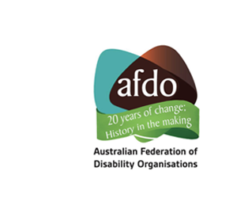
Report Card on the Final Recommendations from the Royal Commission into Violence, Abuse, Neglect, and Exploitation of People with Disability

November 2023

About AFDO

The Australian Federation of Disability Organisations (AFDO) Vision and Mission is that; “All people with disabilities must be involved equally in all aspects of social, economic, political and cultural life."
For over twenty years AFDO, a Disabled Peoples Organisation (DPO), has been the recognised national peak, along with its disability specific and population-based member organisations, representing all people with disability.
We have an impressive and increasing reach currently connecting with over 16% of the total population or over 4 million Australians through our own and via our thirty-eight member organisations.
AFDO provides a strong, trusted, independent voice for the disability sector on national policy, inquiries, submissions, systemic advocacy and advisory on government initiatives across Federal, State, Territory and Local governments.

Our Members

Full Members of AFDO
Advocacy for Inclusion | Arts Access Australia
Autism Aspergers Advocacy Australia | Blind Citizens Australia
Brain Injury Australia | Deaf Australia
Deafblind Australia | Deafness Forum Australia
Disability Advocacy Network Australia | Disability Justice Australia
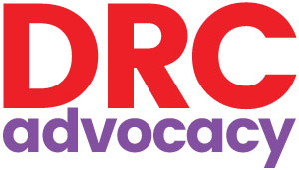  Disability Resources Centre | Down Syndrome Australia
Enhanced Lifestyles | National Mental Health  Consumer & Carer Forum
People with Disabilities WA | Physical Disability Australia
Polio Australia | 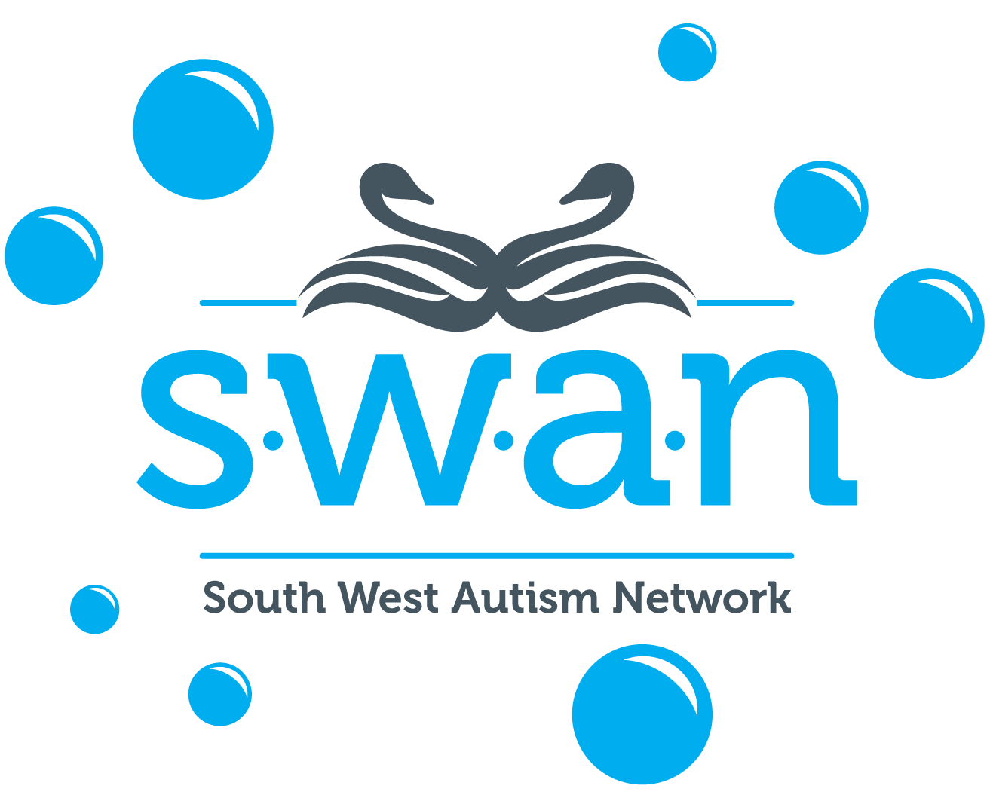  Southwest Autism Network
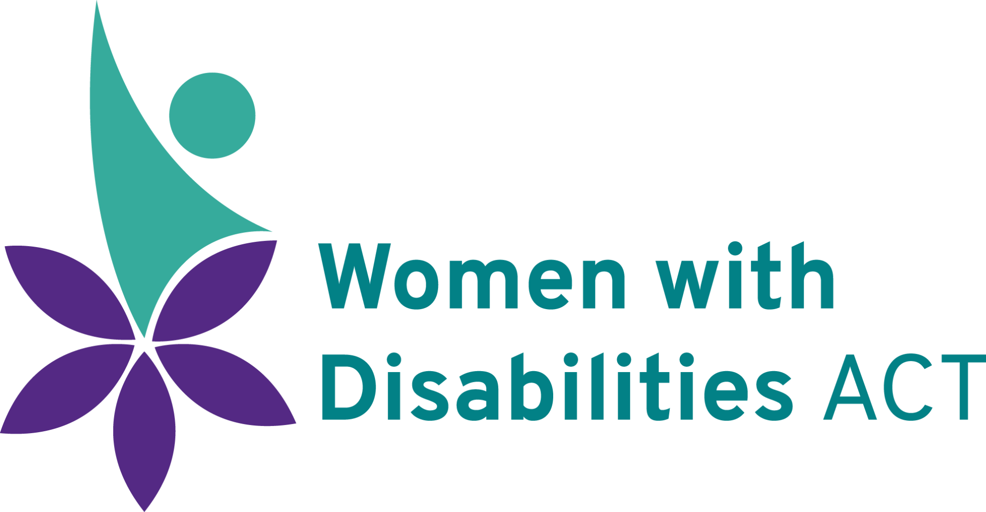  Women with Disabilities ACT | Women with Disabilities Victoria

Associate Members of AFDO
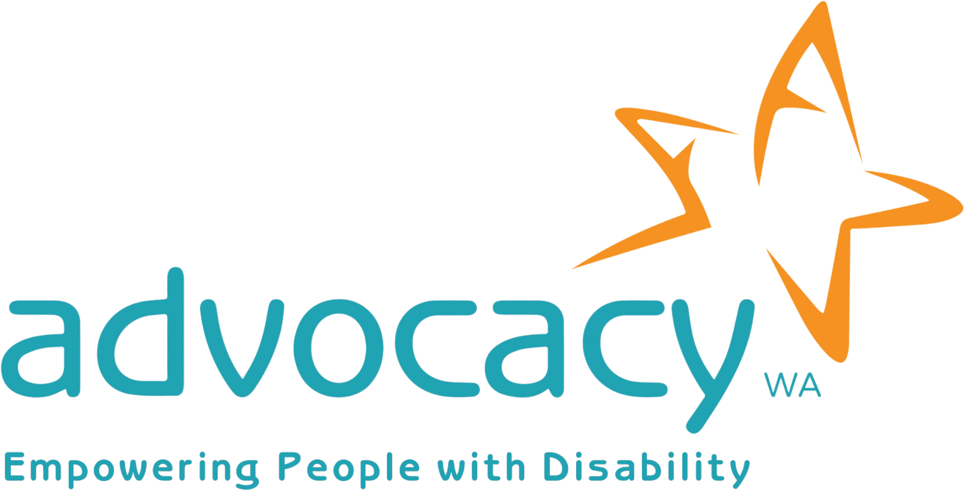  Advocacy WA | AED Legal Centre
All Means All | 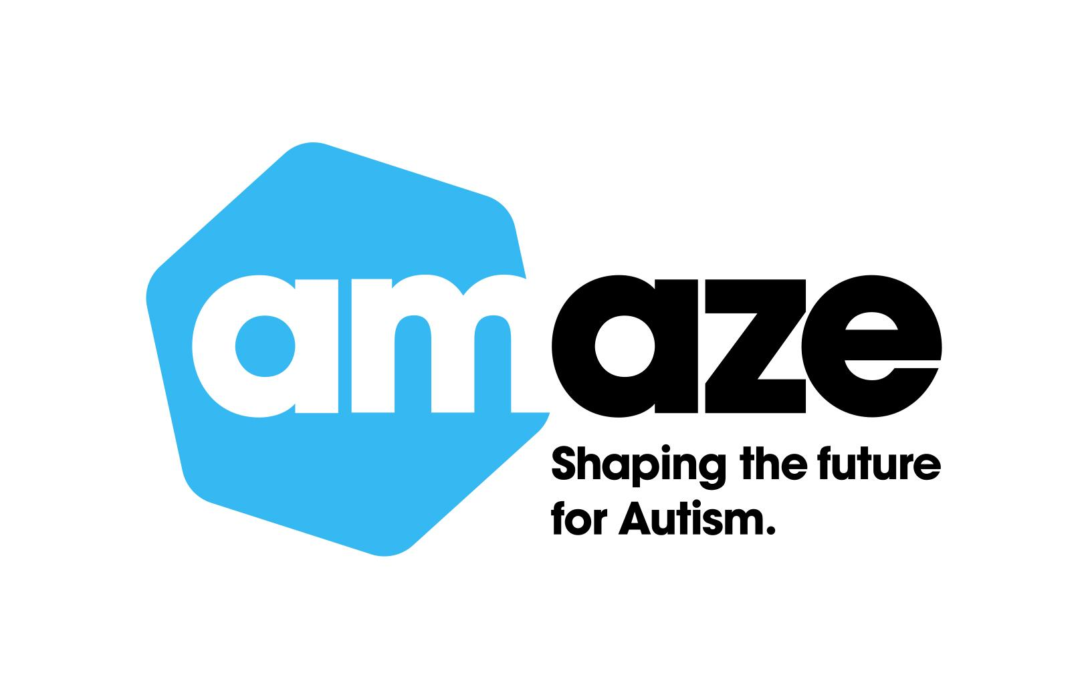  Amaze
Aspergers Victoria | Disability Advocacy and Complaints Service of South Australia
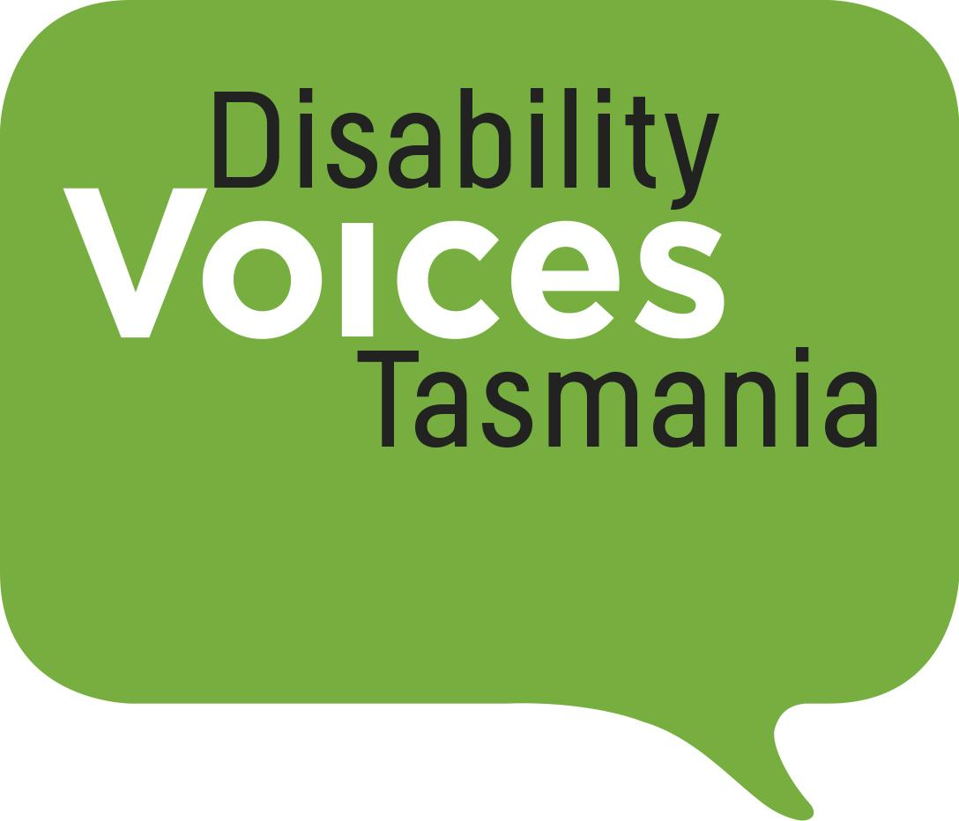  Disability Voices Tasmania | Explorability Inc
Leadership Plus | Multiple Sclerosis Australia
National Organisation for Fetal  Alcohol Spectrum Disorder | National Union of Students -  Disabilities Department
Star Victoria | TASC National Limited
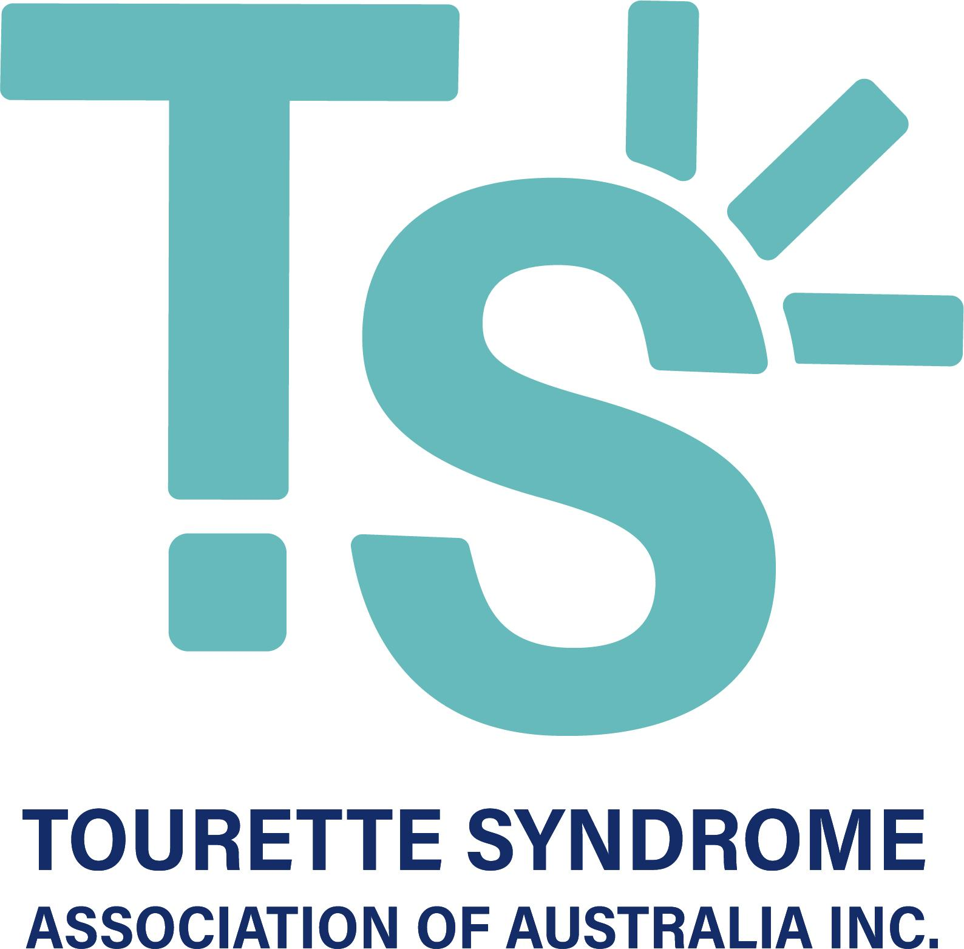  Tourette’s Syndrome Association of Australia | Youth Disability Advocacy Service

Background
The final report from the Royal Commission into Violence, Abuse, Neglect and Exploitation of people with disability was tabled in Parliament on 29 September 2023. It is spread across 12 volumes and includes 222 recommendations. These recommendations are aimed at improving laws, policies, systems, and processes to ensure a society that properly supports the independence of people with disability and their right to live free from violence, abuse, neglect, and exploitation.
The conclusion of the Royal Commission marks the end of a critical moment in time for Australian disability policy. It is the culmination of many years of blood, sweat, and tears on the part of people with disability, their families, supporters, and representative organisations. And while the Royal Commission has come to an end, for the team at AFDO, the real work is only just beginning.
We must hold Government and other decision-makers accountable by driving the implementation of key recommendations from the final report. We will undertake this work alongside our members as we work towards a more inclusive society that adequately safeguards people with disability from violence, abuse, neglect, and exploitation.
This report card represents our initial analysis of the 222 recommendations from the final report. We have developed this document in close consultation with our 36 member organisations and have incorporated their feedback throughout.
We would like to thank all members who contributed to this document for their subject matter expertise and the spirit of collaboration in which they have approached this work.

Changes and Member Sovereignty
· This document may be subject to change as we undertake further consultation with our members around specific recommendations.

· We have undertaken this work to ensure the perspectives and views of all members are incorporated into this document. We acknowledge, however, that each of our member organisations reserves the right to express a different view on any of the Royal Commission’s recommendations.

So, what did we think about the recommendations included in the final report? Let us tell you!

Note
· We recommend you have AFDO’s Consolidated DRC Recommendations document open alongside this document, which contains all of the Royal Commission’s recommendations in full. We were unable to include the recommendations themselves in this document as it would not have been possible to keep the document within a manageable length.
· All recommendations have been clearly labelled throughout this report card to assist you to work between the two documents.
· We have developed a second document that outlines the various policy issues that were either absent from, or not adequately covered, in the final report from the Royal Commission. We encourage you to refer to this document as well, as it is critical that these issues remain on the Government’s agenda

This report card uses the following key:
Support – We agree with this recommendation.

Support in principle – We would like Government to consider some additional factors as it approaches the implementation of this recommendation.

Further information/consultation needed – We do not have enough detail to support this recommendation in full.

Do not support – This recommendation includes one or more issues of concern that we are unable to support.

Realising the human rights of people with disability (Volume 4)

Recommendation 4.1 Establish a Disability Rights Act
Support in principle

Greater clarity is needed to determine how this Act would interact with the Disability Discrimination Act 1992 (Cth) and the national Charter of Rights that has been proposed by the Australian Human Rights Commission. In any case, we have developed a position statement outlining the specific provisions that must be included under a new federal human rights instrument. We look forward to working with Government to progress the implementation of this recommendation.

Recommendation 4.2 Objects of the Disability Rights Act
Support in principle

There could be a lot of potential overlap between the proposed Disability Rights Act, our existing federal Disability Discrimination Act and the new Disability Services and Inclusion Act. Greater clarity is needed to determine how these three pieces of legislation will interact with one another.

Recommendation 4.3 Principles in the Disability Rights Act
Support in principle

The new Act, including its objects and principles, must be developed in close consultation with people with disability and their representative organisations. We would expect, however, that the principles of the Act would reflect those outlined under the Convention on the Rights of Persons with Disabilities.

Recommendation 4.4 Future review of the Disability Rights Act
Do not support

This recommendation states:

“The Australian Government should ensure that a review of the Disability Rights Act is undertaken in consultation with people with disability within five years of the commencement of the Act.”

We feel this is too long and would like to see Government commit to undertaking a review three years from the commencement of the Act.

Recommendation 4.5 The right to non-discrimination and equality before the law
Support in principle

We are supportive of any steps taken to uphold and promote the right to non-discrimination and equality before the law. These measures will, however, have a significant level of crossover with our federal Disability Discrimination Act. We need more detail about how these two pieces of legislation will interact with one another.

Recommendation 4.6 The right to equal recognition before the law
Support

Recommendation 4.7 The right to live free from exploitation, violence and abuse
Support in principle

We would also like to see an acknowledgement of the fact that people with disability have the right to access redress on an equitable basis with others (in circumstances where there is a redress scheme available).

Recommendation 4.8 The right to liberty and security of person
Support in principle

This recommendation states that:

“no person with disability may be arbitrarily arrested or detained. No person with disability may be deprived of liberty, except on the grounds and in accordance with the procedures established by law.”

Current legal and procedural arrangements make it acceptable to indefinitely detain people with disability and deprive them of liberty without a criminal conviction. The efficacy of this recommendation is therefore heavily reliant on the successful implementation of recommendation 8.12, which relates to repealing laws that allow for the indefinite detention of people with disability.

Recommendation 4.9 The right to equitable access to health services
Support in principle

We would like to see an acknowledgement of the fact that all people with disability have a right to be treated with dignity and respect in their interactions with the health care system. People with disability also have a right to access services from staff who are properly trained and disability-aware.

Recommendation 4.10 Public authority conduct
Support in principle

We will need to undertake further research to determine whether the definition of a “public authority” that has been proposed for the new Disability Rights Act is sufficiently exhaustive.

Recommendation 4.11 Consultation with people with disability
Support in principle

Greater clarity is needed to determine:

· Exactly how this duty will be captured under the new Disability Rights Act, and the extent to which the requirement outlined in the Act aligns with the provision set out in General Comment 7, published by the Committee on the Rights of Persons with Disabilities in 2018;
· How Government will effectively resource organisations undertaking systemic advocacy to contribute to this work;
· How Government consultations will be effectively coordinated across Departments to avoid short consultation timeframes and consultation fatigue; and
· What measures will be put in place to provide transparency and accountability, e.g., how will we know that feedback is being properly considered and incorporated and that Government entities are not undertaking consultation in a tokenistic manner.

Recommendation 4.12 Positive duty to promote disability equality and inclusion
Support in principle

We would like to see this expanded to include similar measures required to be implemented at the state/territory and local Government level.

Recommendation 4.13 The duty to provide an interpreter
Support in principle

We note that this duty cannot be upheld without the effective implementation of recommendation 6.2, which is aimed at increasing the workforce of Auslan interpreters. Addressing existing workforce gaps is not only critical to the effective implementation of this recommendation, but to the majority of recommendations included in the report.

Recommendation 4.14 The duty to provide accessible information
Further information/consultation needed

This recommendation states:
“The Disability Rights Act should provide that a Commonwealth entity must ensure that its communications are provided in at least two formats accessible to people with disability…”
This wording is very vague and makes it appear as though many people with disability will still not be able to access information in a format that is appropriate to their needs. Commonwealth entities must ensure their communications are provided in a range of accessible formats, such as Easy Read, Auslan, audio, large print, e-text, and braille. There should also be consistent guidelines in place to determine how Commonwealth entities should respond to requests for information in alternative formats. It is also critical that all apps and websites fully comply with the Web Content Accessibility Guidelines 2.1.

Recommendation 4.15 Duties supporting compliance with the Disability Rights Act
Further information/consultation needed

We are unsure about the efficacy of agencies undertaking self-assessment audits for disability inclusion. Instead, we believe periodic audits for disability inclusion should fall within the jurisdiction of the newly established National Disability Commission.

Recommendation 4.16 Interpretation of the Disability Rights Act consistently with international human rights
Support

Recommendation 4.17 Limitations on rights
Support in principle

This recommendation states:

“The Disability Rights Act should make clear that the right to recognition before the law (see Recommendation 4.6), as an absolute right under international law, is not subject to any limitations.”

The right to recognition before the law is not the only right that is not subject to limitations. As such, we would like to see the new Disability Rights Act:
· Clearly articulate and differentiate between absolute rights and those that are subject to permissible limitations; and
· Clearly reference the international human rights treaties in which the above provisions can be found.

Recommendation 4.18 Functions of the National Disability Commission to support compliance with the Disability Rights Act
Support in principle

Many of the functions listed overlap with those of the Commonwealth Disability Discrimination Commissioner. Greater clarity is needed around the separation between these two roles.

Recommendation 4.19 Co-design a new complaints mechanism for people with disability
Support in principle

We are concerned that the proposed arrangements for dealing with complaints under the proposed Disability Rights Act and the Disability Discrimination Act may be more confusing for some people with disability to navigate. We look forward to working with Government to ensure new complaints arrangements are intuitive, accessible, and responsive to the needs of people with disability. We also note that the efficacy of this recommendation relies heavily on the successful enactment of a Disability Rights Act.

The most frustrating aspect of the complaint process that exists under current legislation is the fact that the Australian Human Rights Commission cannot compel the respondent to participate in conciliation. Nor can they issue infringement notices or order sanctions for non-compliance. A new complaints mechanism must therefore have the right legal backing in order to be effective.

Recommendation 4.20 Enabling remedies through the courts
Support

Recommendation 4.21 Strengthening awareness and understanding of disability rights

Support in principle

Many of the functions listed overlap with those of the Australian Human Rights Commission. Further clarity is needed to determine how the Australian Human Rights Commission and the new National Disability Commission will approach this work. Greater clarity around roles and responsibilities will enable agencies to avoid duplication and maximise resources.

Recommendation 4.22 Strengthening disability rights protection in state and territory laws

Support in principle

We would like to see proactive measures aimed at compelling State and Territory Governments to enact their own state-based Disability Rights Acts. We would also like to see a commitment to collaboration and information sharing across jurisdictions to drive consistency in the implementation of state-based legislation. All state-based disability rights Acts should include a provision requiring the relevant Government to periodically table disability rights reports in Parliament.

Recommendation 4.23 Burden of proof in direct discrimination
Support

Recommendation 4.24 Reforming indirect discrimination
Further information/consultation needed

We will need to undertake further consultation with our members and obtain legal advice to better understand the appropriateness of this recommendation.

Recommendation 4.25 Adjustments
Support

Recommendation 4.26 Standalone duty to make adjustments
Support

Recommendation 4.27 Positive duty to eliminate disability discrimination
Support

Recommendation 4.28 Systemic discrimination
Support

Recommendation 4.29 Offensive behaviour
Support in principle

This recommendation states;

“public place includes any place to which the public have access as of right or by invitation, whether express or implied and whether or not a charge is made.”

While we understand social media and public online spaces may be included under this definition, this must be explicitly stated and expanded in the Government’s response to avoid any confusion.

Recommendation 4.30 Vilification because of disability
Support in principle

Government must ensure social media and public online spaces are included under the definition of a “public space” when approaching the implementation of this recommendation.

Recommendation 4.31 Disability discrimination and migration law

Support

Recommendation 4.32 Unjustifiable hardship
Support

Recommendation 4.33 Reference to the Convention on the Rights of Persons with Disabilities
Support in principle

This recommendation states:

“The Disability Discrimination Act 1992 (Cth) should be amended to insert a new subsection 3(d) as follows:

(d) to give effect to Australia’s obligations under the Disabilities Convention.”

While we support the Convention being referred to in the Act, the full, true, and correct title of the instrument must be included in the Act to avoid any confusion.

Recommendation 4.34 Interpretation of the Disability Discrimination Act 1992

Support in principle

This recommendation states:

“The Disability Discrimination Act 1992 (Cth) should be amended by inserting a new subsection 4(3):
(3) This Act must be interpreted in a way that is beneficial to a person or persons with disability, to the extent it is possible to do so consistently with—
(a) the objects of this Act
(b) the Convention
(c) the Covenant on Civil and Political Rights
(d) the Disabilities Convention
(e) the International Covenant on Economic, Social and Cultural Rights.”

We are unsure what is meant by the terms “The Convention” and “the Disabilities Convention,” as both of these terms can be used to refer to the Convention on the Rights of Persons with Disabilities. It is critical that the full and correct names of instruments are included in the Act to avoid confusion and facilitate the effective interpretation of the Act.

Governing for inclusion
(Volume 5)

Recommendation 5.1 Development of a National Disability Agreement
Support in principle

We would like an assurance that this agreement will apply to all people with disability, irrespective of age or eligibility for, or participation in, the NDIS.

Recommendation 5.2 Review and update of Australia’s Disability Strategy
Support in principle

We would also like to see the 2019 concluding observations handed down by the United Nations Committee on the Rights of Persons with Disabilities reflected in the updated strategy and implementation and reporting framework.

Recommendation 5.3 Review and update of disability strategies and plans
Support in principle

While we are supportive of the proposal for State and Territory Governments to update their disability plans by mid-2025, this work must not commence until such time as Australia’s Disability Strategy 2021-2031 has been reviewed and updated. Historically, there have been instances where State and Territory Governments have been developing their plans prior to the new national plan being finalised. This results in a fragmented approach to policy in which the relationship between the national and state/territory plans is unclear and ineffective.

Recommendation 5.4 Review of national agreements, strategies and plans
Support in principle

We would also like to see consideration given to the concluding observations handed down by the United Nations Committee on the Rights of Persons with Disabilities in 2019 as national agreements, plans, and strategies are being reviewed and updated.

Recommendation 5.5 Establishment of a National Disability Commission
Support in principle

We note that there may be some overlap between the role of the new National Disability Commission and the Australian Human Rights Commission.
Greater clarity is needed to determine how these two entities will complement each other’s work, and whether it might be more feasible for the Disability Discrimination Commissioner and the National Disability Commissioner to undertake joint reporting.

Recommendation 5.6 New governance arrangements for disability
Support

Recommendation 5.7 Focal points across jurisdictions to implement the CRPD
Support

Accessible information and communications
(Volume 6)

Recommendation 6.1 A national plan to promote accessible information and communications
Support in principle

It is critical that the Government’s response to this recommendation clearly identifies audio description as a vehicle for providing access to information and communications technology and identifies strategies for improving the availability of audio description over time.
Auslan interpreters should ALWAYS be at every governmental announcement and emergency services broadcasting. Captioning alone is insufficient. Emergency broadcasts and Government announcements on television must be Auslan interpreted as well as captioned. Captions and Auslan interpreting must be a permanent feature of a broadcast or recorded video, meaning they appear in replays, on catch-up TV services, secondary channels, and on social media.
The proposed plan should also outline parameters aimed at meeting the needs of people with disability from culturally and linguistically diverse backgrounds.
To ensure the proposed plan is fully aligned with the expectations set out under the CRPD, it is critical for Government to review the following three documents as it approaches the implementation of this recommendation:
· General Comment 2 on accessibility, published by the United Nations Committee on the Rights of Persons with Disabilities in 2014, and
· The Committee’s 2019 concluding observations on the combined second and third periodic reviews of Australia.
· The UN Resolution on Easy to Understand Communications, published in 2023.

Recommendation 6.2 Increase the number of Auslan interpreters
Support in principle

It is critical that AFDO and its members Deaf Australia and Deafblind Australia are actively involved in the development, implementation, and evaluation of this strategy.

Recommendation 6.3 Access to appropriately skilled and qualified interpreters
Further information/consultation needed

This recommendation appears to focus exclusively on participants within the NDIS ecosystem. While we support all measures outlined in this recommendation, Government must also outline how they will ensure older people with disability, including those who do not meet the age eligibility requirements for the NDIS, have equitable access to appropriately skilled and qualified interpreters.

Recommendation 6.4 Terms and definitions in guardianship and administration
Support

Recommendation 6.5 Objects of guardianship and administration legislation
Support in principle

Governments should also be required to consider General Comment 1 on Equal recognition before the law, published by the Committee on the Rights of Persons with Disabilities in 2014, when reviewing their guardianship and administration laws.

Recommendation 6.6 Supported decision-making principles
Support

Recommendation 6.7 Decision-making ability
Support in principle

We will need to undertake further research to determine whether the proposed measures are both appropriate and sufficiently extensive.

Recommendation 6.8 Formal supporters
Support in principle

We are broadly supportive of this recommendation but have some reservations about appropriate safeguards being put in place. We look forward to being involved in further discussions in relation to this recommendation.

Recommendation 6.9 Representatives as a last resort
Further information/consultation needed

Further research is required to determine the efficacy of the proposed approach.

Recommendation 6.10 Decision-making process
Support in principle

We have some reservations about appropriate safeguards being put in place. We look forward to being involved in further discussions in relation to this recommendation.

Recommendation 6.11 Guidelines on maximising participation
Support

Recommendation 6.12 Public disclosure and confidentiality restrictions
Support

Recommendation 6.13 Information and education on supported decision-making
Support

Recommendation 6.14 Systemic advocacy to promote supported decision-making.
Support in principle

We are supportive of the proposal for state and territory governments to appoint a statutory body to undertake systemic advocacy to promote supported decision-making. We would, however, like to see a commitment to information-sharing and collaboration across jurisdictions to improve practice nationally.

Recommendation 6.15 Updating the national standards for public advocates, public guardians and public trustees.
Support

Recommendation 6.16 Financial skills development programs
Support

Recommendation 6.17 Transparency of public trustee fees and charges
Support in principle

Public trustees in each state and territory must undertake this work in consultation with people with disability and their representative organisations to ensure information is accessible and intuitive to navigate.

Recommendation 6.18 Review of public trustees’ fees and charges

Support in principle

We would like to see Governments commit to a timeframe to undertake this work.

Recommendation 6.19 Data collection on support and representation arrangements
Support

Recommendation 6.20 Interpretative declaration
Support in principle

We are broadly supportive of this recommendation, despite the fact that it was only agreed to by four out of the seven Commissioners. We were, however, very disappointed to note that there was no mention of Australia’s interpretive declarations on Articles 17 and 18 – despite the fact that the United Nations Committee on the Rights of Persons with Disabilities has already instructed the Australian Government to withdraw these declarations.

Recommendation 6.21 Additional funding for advocacy programs
Support in principle

The value of individual advocacy and self-advocacy is recognised and acknowledged. However, this recommendation does not include any reference to securing greater funding for systemic advocacy.
For national disabled peoples organisations and representative organisations undertaking systemic advocacy, the real work around the Royal Commission is only just beginning. Over the coming months and years, AFDO and its members will be approached to provide input on various aspects of the Royal Commission’s recommendations. We will also be undertaking our own proactive advocacy around those recommendations which are of greatest importance to our members. This work will be significant in magnitude and will take many years to complete. As such, Governments must ensure improved funding for, and the continued operation of, systemic advocacy as a vital aspect of civil society.

Recommendation 6.22 Improved data collection and reporting on met and unmet demand for disability advocacy
Support in principle

This recommendation states that data should:
“include demographic indicators that show geographic location, First Nations and culturally and linguistically diverse status”
We would like to see age added to this list of demographic indicators.

This recommendation also states that data must:
“identify, where possible, whether a request for disability advocacy is from or concerns a person with disability who lives in supported accommodation or is in prison or juvenile detention.”
We do not believe this approach is extensive enough. Data should identify, where possible, whether a request for disability advocacy is from or concerns a person who lives in a setting that meets the definition of an “institution” outlined in the United Nations Guidelines on Deinstitutionalization. These metrics should also be incorporated into the National Disability Data Asset.

Recommendation 6.23 Culturally safe disability advocacy
Support in principle

We are broadly supportive of this recommendation but acknowledge that we are not experts on matters affecting people with disability from culturally and linguistically diverse backgrounds or LGBTIQA+ people with disability. As such, we look forward to supporting fellow disability advocates with expertise in these areas as we progress the implementation of this recommendation.

Recommendation 6.24 Improve implementation planning and coordination for the cognitive disability health capability framework
Further information/consultation needed

We are confused about the reference to a Cognitive Disability Health Capability Framework, as to our knowledge no such framework currently exists. There is, however, an Intellectual Disability Health Capability Framework which is one aspect of the National Roadmap for Improving the Health of People with Intellectual Disability. AFDO member organisation, Down Syndrome Australia, has been involved in consultation surrounding the framework and are confident in its implementation.
In any case, we will need to undertake further consultation with our members to determine the appropriateness of the measures outlined in this recommendation.

Recommendation 6.25 Expand the scope of health workforce capability development to include all forms of cognitive disability at all stages of education and training
Support

We would like to have seen additional recommendations aimed at improving education and training around other types of disability, particularly as several of our members representing other disability groups submitted evidence around the same issues.
We would also like to see Government prioritise the development of a separate autism healthcare capability framework that includes clear targets, outcomes, and measures for accountability. This framework should be reviewed every three years.

Recommendation 6.26 Expand the role of the Health Ministers Meeting to monitor health workforce capability development
Support

We note that the efficacy of this recommendation will be heavily dependent on the successful implementation of recommendation 6.25.

Recommendation 6.27 Establish regular progress reporting by accreditation authorities
Support in principle

We are supportive of all initiatives that improve health outcomes for people with cognitive disability. We question, however, why other disability groups have been excluded from this recommendation when we know many individuals and organisations made submissions in relation to this topic.
We would like to see accreditation authorities for registered health professions and peak professional bodies for non-registered health professions update their accreditation standards and evidence requirements to include competencies around disability awareness more broadly.

Recommendation 6.28 Improve access to clinical placements in disability health
Support in principle

We question why this recommendation only refers to cognitive disability and excludes other people with disability.

Recommendation 6.29 Improve specialist training and continuing professional development in cognitive disability health care
Support in principle

We question why this recommendation only refers to cognitive disability and excludes other people with disability.

Recommendation 6.30 Expand the scope of the National Centre of Excellence in Intellectual Disability Health
Do not support

AFDO strongly opposes this recommendation after receiving guidance from member organisation, Down Syndrome Australia. The health and communication needs of these cohorts vary greatly. If the Centre was expanded, it is very likely that the impact and outcomes for people with intellectual disability would be diluted.

We acknowledge the work that is being undertaken to develop a National Roadmap to Improve the Health and Mental Health of Autistic People. This Roadmap should be the precursor to the establishment of a separate National Centre of Excellence in autism; drawing on the structure, functions and strengths of the National Centre of Excellence for Intellectual Disability.

Recommendation 6.31 Embed the right to equitable access to health services in key policy instruments
Support in principle

We would like more clarity around how these proposed policy and legislative changes will interact with, and strengthen the provisions of, the federal Disability Discrimination Act.

Recommendation 6.32 Increase capacity to provide supports and adaptations through improved guidance, funding and accessible information
Support in principle

This recommendation states:

“The Australian Government and state and territory governments, in consultation with people with disability, should:
identify and publish a list of frequently needed adaptations and supports (including communication supports) to enable people with disability to receive high-quality health care in all publicly funded settings.”

Consultation should be undertaken with people with disability and their representative organisations. It is also imperative that the list of supports being proposed is accompanied by information that helps practitioners to understand their legal obligations around the provision of supports and adjustments.

The need to balance the tension between remaining person centred and providing prescriptive guidance for practitioners is common across the health and disability service sectors. As such, there needs to be greater collaboration across sectors to ensure that the information in question is delivered, updated, and managed in ways that make it accessible and easily actionable for frontline staff.

Recommendation 6.33 Develop specialised health and mental health services for people with cognitive disability
Support in principle

We note that there are other cohorts who would also benefit from this specialised approach. As an example, the Deaf community are at severe risk of deteriorating mental health due to unsafe language/cultural barriers and the lack of Auslan interpreters.

Recommendation 6.34 Introduce disability health navigators to support navigation of health care for people with disability
Support in principle

We are very supportive of the proposal to fund a national workforce of ‘disability health navigators.’ This recommendation states, however, that this service is only intended to be available to:
“…people with cognitive disability and complex health needs”.
We look forward to working with Government as it approaches the implementation of this recommendation - noting that the service being proposed would be beneficial for many people with disability and not just those with cognitive impairment.

Recommendation 6.35 Legal frameworks for the authorisation, review and oversight of restrictive practices
Support in principle

All recommendations relating to restrictive practices will need significant Lived Experience input to strengthen their implementation in the context of mental health and suicide prevention. We recommend:
· All mental health treatment programs operate from a strengths-based perspective to provide recovery-oriented, person-centred, trauma-informed, and human rights-based practice.
· Government undertake a comprehensive review of the difference between ‘medication’ and ‘restraint’, with a view towards eliminating chemical restraint.
· Lived Experience and peer support workers be included in seclusion incident reviews.
· Family, carers, and kin be adequately resourced to provide support.
· Peer support workers be employed to support early intervention and prevention efforts in clinical and community settings.
· The use of restrictive interventions in Emergency Departments be clearly documented using a standardised national tool.

Recommendation 6.36 Immediate action to provide that certain restrictive practices must not be used
Further information/consultation needed

This recommendation includes a different list of prohibited forms of restrictive practices for health and mental health settings than other service settings. We will need to undertake further consultation with our members to determine the appropriateness of these arrangements.

Recommendation 6.37 Data collection and public reporting on psychotropic medication
Support

Recommendation 6.38 Strengthening the evidence base on reducing and eliminating restrictive practices
Support in principle

We are supportive of the proposal to undertake a longitudinal study of the impact of positive behaviour support and other strategies to reduce and eliminate restrictive practices. This recommendation states that the study should:
· “be co-designed with people with disability and relevant experts and professionals from the disability, health, education and justice sectors, to ensure the findings are relevant across a range of settings
· include the experiences and identify the intersecting needs of a broad range of people with disability, such as First Nations people with disability, LGBTIQA+ people with disability, and culturally and linguistically diverse people with disability.”

This study must include and extend to all people with disability in aged care settings.

Recommendation 6.39 Improving collection and reporting of restrictive practices data
Support

Recommendation 6.40 Targets and performance indicators to drive the reduction and elimination of restrictive practices
Support in principle

We support the proposal for the Commonwealth and State and Territory Governments to establish sector-specific targets and performance indicators to drive the reduction and elimination of restrictive practices over time.
We encourage the Department of Social Services to liaise with the Department of Health and Aged Care when approaching the implementation of this recommendation. They are already working through similar recommendations that arose out of the Royal Commission into Aged Care Quality and Safety and there needs to be consistency across service settings.

Recommendation 6.41 Legislative prohibition of non-therapeutic sterilisation

Support in principle

We also wanted to see the inclusion of recommendations aimed at improving access to reproductive rights. We urge Government to consider this as it considers its response to each of the Royal Commission’s recommendations.

Inclusive education
(Volume 7)

Recommendation 7.1 Provide equal access to mainstream education and enrolment
Support in principle

We would like to see annual reports on progress tabled in Parliament at both a Federal and State/Territory level. Reports should also be made publicly available as a means of assisting civil society to monitor progress.

Recommendation 7.2 Prevent the inappropriate use of exclusionary discipline against students with disability
Support in principle

We would also like to see a positive duty for educational institutions to provide information about advocacy support to any child with disability (as well as their family and supporters) who may be subject to exclusionary discipline.

Recommendation 7.3 Improve policies and procedures on the provision of reasonable adjustments to students with disability
Support in principle

We believe Educators should be trained on how to apply reasonable adjustments before they move into the workforce. As such, we would also like to see all relevant university and VET accredited courses updated to include this content.

Recommendation 7.4 Participation in school communities
Support in principle

While we agree with the intended outcomes, this recommendation will be difficult to implement, measure, and report on. More clarity and detail are needed. We also stress the importance of children with disability having access to peer support opportunities to normalise their experience and help them develop disability-specific tips, tricks, and strategies.

Recommendation 7.5 Careers guidance and transition support services
Support in principle

We are supportive of the proposal to introduce a careers guidance and transition support service for students with disability in each state and territory. In order for us to fully support this recommendation, however, we need an assurance that this program will:
· Be developed and led by people with disability and their representative organisations.
· Take an individualised approach, and not automatically place participants in a group learning environment which we know doesn’t work for many young people with disability.
· Be subject to rigorous evaluation.
· Be subject to public annual reporting on engagement and participant evaluation.

Recommendation 7.6 Student and parental communication and relationships
Support

Recommendation 7.7 Inclusive education units and First Nations expertise
Support in principle

We are supportive of the proposal for state and territory education authorities to introduce inclusive education units. We would, however, like to see a commitment to information-sharing and collaboration across jurisdictions to improve practice nationally.

Recommendation 7.8 Workforce capabilities, expertise and development
Support in principle

All courses and training materials aimed at embedding a human-rights-based approach to inclusive education must be developed in collaboration with people with disability and their representative organisations. Our members are also concerned that this shift might prevent people from developing a deeper understanding and specialisation in a particular area, such as Deafness or Deafblindness.

Recommendation 7.9 Data, evidence and building best practice
Support

Recommendation 7.10 Complaint management
Support in principle

We will need to undertake further consultation with our members to determine how this recommendation could be strengthened, and the complaints process improved for students with disability and their families.

Recommendation 7.11 Stronger oversight and enforcement of school duties
Support

Recommendation 7.12 Improving funding
Further information/consultation needed

We would like to see disability loading settings and total funding for adjustments reviewed every three years rather than every five years. We would also like to see a requirement for schools to demonstrate that disability allowances have been dedicated to the correct activities and have not been diverted to general expenditure.

Recommendation 7.13 National Roadmap to Inclusive Education
Support in principle

We will need to undertake further consultation with our members to determine the milestones, key performance indicators, and deliverables they would like to see included in a national road map.

Recommendation 7.14 Phasing out and ending special/segregated education
Support in principle

We note that this recommendation caused division amongst Commissioners. It was supported by three Commissioners: Bennett, Galbally, and McEwin.
This recommendation does, however, align with Article 24 of the CRPD, general comment no.4 issued by the Committee on the Rights of Persons with Disabilities, and the roadmap that has been published by the Australian Coalition for Inclusive Education. At a minimum, the time frame must be changed from 2054 to 2035. We will need to undertake further consultation to ensure members are satisfied with the final position we adopt on this issue. Some of our members are very concerned about ensuring no child is left behind on the road to achieving safe and high-quality inclusive education.

Recommendation 7.15 An alternative approach
Further information/consultation needed

This recommendation is still supportive of segregated educational settings and was agreed to by three Commissioners: The Chair and Commissioners Mason and Ryan. This recommendation includes some valuable aspects which should feature in any future roadmap to inclusive education. As such, we can only support this recommendation as it relates to the implementation of recommendation 7.14. Again, this will be subject to further consultation, discussion, and input from our members.

Inclusive employment
(Volume 7)

Recommendation 7.16 Priorities for inclusion in the new Disability Employment Services model
Support in principle

The new Disability Employment Services model must be co-designed with people with a diverse range of disabilities who may typically experience greater, or different, barriers to employment e.g., people with intellectual disability, people who are Deaf and Deafblind, people with autism, people with brain injury, and people with hearing loss.
We would also like to see:
· A firm commitment to removing the requirement for a person to have a minimum future work capacity of eight hours per week to be eligible to access the Disability Employment Services program, as this presents a barrier for many people with disability seeking employment.
· The successful attainment of employment introduced as a metric against which providers are assessed.

Recommendation 7.17 Develop education and training resources for Disability Employment Services staff
Support in principle

This training must also cover issues relating to intersectionality. Providers must be required to demonstrate their commitment to ongoing professional development and upskilling in relation to disability awareness to maintain access to funding. We would also like to see a greater uptake of disability awareness training across private employment providers.

Recommendation 7.18 Establish specific and disaggregated targets for disability employment in the public sector
Support in principle

We would also like to see:
· An interjurisdictional agreement that establishes consistent targets across each state and territory.
· Specific targets set for cohorts who experience the worst employment rates and outcomes, including people with intellectual disability and people with autism.

Recommendation 7.19 Establish specific disability employment targets for new public service hires in agencies and departments
Support in principle

As with the previous recommendation, we would like to see a consistent approach to the establishment of targets across jurisdictions. Targets need to apply to all levels of the staff hierarchy, including leadership positions.

Recommendation 7.20 Clarify the application of the merit principle in public sector recruitment
Support

Recommendation 7.21 Introduce consistent adjustment principles and adjustment passports
Support in principle

This work must be undertaken in close consultation with public sector employees with disability and their representative organisations.
This recommendation must also be clearly articulated and reported against under the APS Disability Employment Strategy 2020-2025.

Recommendation 7.22 Public reporting on public sector disability employment
Support

Recommendation 7.23 Strengthen disability employment procurement policies
Support

Recommendation 7.24 Convene a Disability Employment Rights Council
Further information/consultation needed

The wording of this recommendation is quite vague and lacks clarity. Further information and detail are required.

Recommendation 7.25 Amend the Fair Work Act 2009 (Cth)
Support

Recommendation 7.26 Amend the Disability Discrimination Act 1992 (Cth)
Support

Recommendation 7.27 Enable a Fair Work Ombudsman referral mechanism
Support in principle

The measures outlined in this recommendation must be accompanied by disability awareness training for staff working at the Fair Work Ombudsman. This will be critical to creating an environment that is culturally safe for people with disability.

Recommendation 7.28 Improve information about wages and the Disability Support Pension
Support in principle

Funding for these initiatives must be awarded in an open and transparent manner via public requests for tender.

Recommendation 7.29 Embed an ‘open employment first’ approach in the NDIS Participant Employment Strategy
Support in principle

We would like to see this recommendation implemented in collaboration with cohorts who typically experience poorer employment outcomes, such as people with intellectual disability, people with autism, women with disability, and people with disability from culturally and linguistically diverse backgrounds.

Recommendation 7.30 Support the transition to inclusive employment
Support in principle

We are broadly supportive of this recommendation but are continuing to work with our members to clarify our position on supported employment and Australian Disability Enterprises (ADEs) – also known as “sheltered workshops”.

Recommendation 7.31 Raise subminimum wages
Support in principle

We are not convinced that this recommendation is sufficient to address the level of exploitation experienced by many people with disability who are still on sub-minimum wages.
We are continuing to work with our members to clarify our position on supported employment and Australian Disability Enterprises (ADEs).

Recommendation 7.32 End segregated employment by 2034
Support in principle

We note that this recommendation was supported by four Commissioners: Bennett, Galbally, Mason, and McEwin. We are broadly supportive of the proposal to develop a roadmap to inclusive employment. We will, however, need to undertake further consultation with our members to determine the milestones, key performance indicators, and deliverables they would like to see included in a national road map.

Inclusive housing
(Volume 7)

Recommendation 7.33 Prioritise people with disability in key national housing and homelessness approaches
Support

Recommendation 7.34 Include homelessness in Australia’s Disability Strategy
Support in principle

We would like to see further consultation with people with disability and their representative organisations prior to the strategy and outcomes framework being updated.

Recommendation 7.35 Increase the availability and supply of accessible and adaptive housing for people with disability through the National Construction Code
Support

Recommendation 7.36 Improve social housing operational policy and processes
Support in principle

We are broadly supportive of the measures outlined in this recommendation, however, we stress that they must be implemented in close consultation with people with disability and their representative organisations.

Recommendation 7.37 Increase tenancy and occupancy protections for people with disability
Support

Recommendation 7.38 Minimum service standards and monitoring and oversight of supported residential services and their equivalents
Support in principle

This recommendation states:
“States and territories should consider whether these recommendations should be implemented in relation to other forms of marginal accommodation for people with disability, including general boarding houses and caravan parks”.

We would like to see a greater onus placed on State and Territory Governments to explore these options as we do not feel the wording of this recommendation is strong enough.

Recommendation 7.39 Preventing homelessness when people with disability transition from service or institutional settings

Support in principle

We urge Government to consult people with disability who have been homeless, or at risk of homelessness, and their representative organisations when approaching the implementation of this recommendation.

Recommendation 7.40 Address homelessness for people with disability in the National Housing and Homelessness Plan
Support in principle

We urge Government to explore the feasibility of developing a separate strategy to understand and prevent homelessness among people with intellectual or cognitive impairment, as well as autistic people.

Recommendation 7.41 Group home reform
Support in principle

We are supportive of the recommendation to transition away from allowing the same provider to provide Supported Independent Living and Specialist Disability Accommodation services. We require further member input and advice on the other measures outlined in this recommendation.

Recommendation 7.42 Improve access to alternative housing options.
Support

Recommendation 7.43 A roadmap to phase out group homes within 15 years
Support in principle

We note that this recommendation was supported by four of the Commissioners: Bennett, Galbally, Mason, and McEwin. While we are broadly supportive of this recommendation, we feel that 15 years is too long and would seek a shorter phase out period, with alternative accommodation and supports identified, funded, and provided, and all group homes ceased.

Recommendation 7.44 A roadmap to phase out group homes over a generational timeframe
Do not support

We note that this recommendation was only supported by one of seven Commissioners. AFDO does not support this recommendation, as per our response to recommendation 7.43.

Criminal justice and people with disability
(Volume 8)

Recommendation 8.1 Conditions in custody for people with disability
Support in principle

We would like to see the term “so far as feasible” clarified, and guidelines developed to outline how decisions around the feasibility of applying disability supports to people in custody will be made.

Recommendation 8.2 Disability awareness in OPCAT monitoring
Support

Recommendation 8.3 Prohibiting solitary confinement in youth detention
Further information/consultation needed

While we are supportive of the majority of measures outlined in this recommendation, it compels state and territory Governments to:
“introduce legislation to prohibit solitary confinement in youth justice settings (being the enforced isolation or segregation for any purpose of a child or young person for 22 or more hours in any day)”
We understand that 22 hours is the same time frame that is generally applied to adult prisoners and would reject that this is appropriate in the context of children.

Recommendation 8.4 Screening and assessment for disability in youth detention
Further information/consultation needed

We do not understand why screening and assessment should be limited to people with cognitive disability. All children and young people should be subject to proper screening and assessment to ensure any disability-related needs are identified and adjustments put in place.

Recommendation 8.5 Disability training for staff in youth detention
Support

Recommendation 8.6 Western Australia youth detention staff retention
Support

Recommendation 8.7 Western Australia youth detention operating philosophy
Support

Recommendation 8.8 Inspector of Custodial Services Act 2003 (WA)
Support

Recommendation 8.9 Use of seclusion in New South Wales Justice Health and Forensic Mental Health Network
Support

Recommendation 8.10 Transition from custodial supervision in the Northern Territory
Support in principle

We would like to see the term “supported step-down accommodation” clearly defined.

Recommendation 8.11 Information for courts and legal practitioners
Support in principle

Greater clarity is needed to determine how this work would be coordinated between the Commonwealth and State and Territory Governments to ensure a consistent and uniform approach.

Recommendation 8.12 Implementation of the National Principles
Support in principle

We do not believe this recommendation is strong enough. Indefinitely detaining people is a clear violation of international human rights principles, which is unacceptable.

Recommendation 8.13 Data about people detained in forensic systems
Support in principle

This recommendation encourages Governments to collect data on:
“the number of people under orders for detention by sex, disability, disability type and First Nations status”
We would like to see multiple impairments and age also added to this list of indicators.

Recommendation 8.14 National practice guidelines for screening in custody
Support in principle

We support the proposal to develop national practice guidelines and policies relating to screening for disability and identification of support needs in custodial settings. This recommendation states that these guidelines should:
· “encourage the development and use of culturally safe disability screening tools that address the particular needs of First Nations people with disability
· encourage the development and use of disability screening tools that are culturally appropriate for people with disability from culturally and linguistically diverse communities”
We do not believe this wording is strong enough, particularly given culturally appropriate screening tools will be critical to the successful implementation of this recommendation. As such, we would like to see the Commonwealth take a stronger approach to compelling State and Territory Governments to develop and implement culturally safe disability screening tools.
It is also critical that appropriate supports are put in place to facilitate the screening process itself. For example, the provision of Deaf and hearing Auslan interpreters when encountering children with deafness upon screening, assessing, and identifying disability in custody.

Recommendation 8.15 Policies and practices on screening, identifying and diagnosing disability in custody
Support

Recommendation 8.16 Support by First Nations organisations to people in custody
Support in principle

We support the proposal to engage First Nations organisations, including Aboriginal Community Controlled Health Organisations, to provide culturally safe disability screening and assessment services for First Nations prisoners and detainees. We stress, however, that these organisations must be adequately resourced to take on this additional workload.

Recommendation 8.17 NDIS Applied Principles and Tables of Support concerning the justice system
Support

Recommendation 8.18 Timing of NDIA-funded transition supports
Support in principle

We question what arrangements will be put in place for prisoners with disability who are ineligible for the NDIS and must access their supports under other service systems. It is imperative that Government considers this as it responds to each of the recommendations.

Recommendation 8.19 Amendment of the Disability Discrimination Act 1992 (Cth) to cover police provision of ‘services’
Support

Recommendation 8.20 Improving police responses to people with disability
Support in principle

We support the proposal for Governments to collaborate with people with disability in the co-design, implementation, and evaluation of strategies to improve police responses to people with disability. We would, however, like to see a commitment to information-sharing and collaboration across jurisdictions to drive consistency and share models of best practice.

Recommendation 8.21 Diversion of people with cognitive disability from criminal proceedings
Support in principle

We support most of the measures outlined in this recommendation. We note, however, that it instructs Governments to ensure their diversionary programs:
“provide support for defendants to access the National Disability Insurance Scheme (NDIS)”
Given the NDIS only provides individualised funding to around 10% of people with disability, it is critical that there are diversionary procedures in place to provide an equitable level of support to people with cognitive impairment who are not eligible for the NDIS.
We would also like to see an element of collaboration and information sharing between Governments as they approach the implementation of the measures outlined in this recommendation.

Recommendation 8.22 Age of criminal responsibility
Support in principle

We do not believe this recommendation provides a great enough sense of urgency. We would like to see a timeframe allocated to this recommendation to make things clearer for governments.

Recommendation 8.23 Action plan to end violence against women and children
Support

Recommendation 8.24 Disability-inclusive definition of family and domestic violence
Support

First Nations people with disability
(Volume 9)

· Recommendation 9.1 Culturally appropriate parenting capacity assessments
· Recommendation 9.2 Ages and Stages Questionnaire-Talking about Raising Aboriginal Kids (ASQ-TRAK)
· Recommendation 9.3 Cultural safety of First Nations people in criminal justice settings
· Recommendation 9.4 Expand community connector programs
· Recommendation 9.5 Block funding the community-controlled sector
· Recommendation 9.6 National Disability Insurance Agency Board
· Recommendation 9.7 Participation in cultural life
· Recommendation 9.8 Return to Country
· Recommendation 9.9 Criteria for funding family supports
· Recommendation 9.10 First Nations Disability Forum
· Recommendation 9.11 Building on the Disability Sector Strengthening Plan
· Recommendation 9.12 Disability-inclusive cultural safety standards
· Recommendation 9.13 Remote workforce development

We welcome many of the initiatives included throughout this section. As a non-indigenous organisation, we stand in solidarity with our First Nations colleagues and support them in their response to these recommendations.
We recognise the First Peoples Disability Network as sector experts on all matters pertaining to First Nations people with disability and trust that they will be properly consulted in relation to recommendations 9.1 – 9.13 from the final report.
We will be guided by the expertise and lived experience of First Nations representative organisations in our responses to these areas.

Disability services
(Volume 10)

Note: Our response to Recommendations relating to the NDIS are subject to further consideration and review following the release of the final report from the NDIS Independent Review Panel.

Recommendation 10.1 Embedding human rights
Support

Recommendation 10.2 Independent support coordination
Support in principle

It is critical that people with disability and their representative organisations are adequately consulted around specific exemptions that must be put in place. As an example, AFDO member Deafblind Australia is currently battling to have the persistent thin markets of support for Deafblind people recognised as “exceptional circumstances” under the NDIS operational guidelines.
Until current workforce challenges are addressed, however, the only suitable person that may be available to undertake support coordination for a participant who is Deafblind may also be from the only provider that provides communication guide support. Workforce challenges should not prevent a person who is Deafblind from accessing either service.

Recommendation 10.3 Adequate support coordination
Support in principle

Greater clarity is required to determine how the NDIA will identify which participants are at heightened risk of violence, abuse, neglect, and exploitation.

Recommendation 10.4 Quality of support coordination
Support in principle

We would also like to see people over the age of 65 who are ageing in the NDIS added to the list of cohorts to be examined.

Recommendation 10.5 Advocacy
Support

Recommendation 10.6 Supported decision-making in disability services
Support

Recommendation 10.7 Practical guidance on supported decision-making
Support

Recommendation 10.8 A national disability support worker registration scheme
Support in principle

We question whether 2028 is a reasonable target for implementation. We would like to see action on this matter much sooner and support the consultation and engagement of all those outlined in the recommendation to ensure that this considers choice and control for people with disability in their access to services and supports.

Recommendation 10.9 The Social, Community, Home Care and Disability Services Industry Award
Support in principle

This requires further research and advice.

Recommendation 10.10 Provider of last resort
Support in principle

We urge Government to ensure this provider of last resort scheme also explores the service requirements of people whose needs cannot be adequately met by other service systems, including people with disability who are over the age of 65.

Recommendation 10.11 Internal procedures for monitoring reportable incidents
Support in principle

We suggest an independent body be commissioned to undertake an audit and suggest improvements to processes for monitoring reportable incidents within the NDIS Quality and Safeguards Commission.

Recommendation 10.12 Introduction of class or kind determinations
Further information/consultation needed

This recommendation is lacking in detail. Additional information is needed.

Recommendation 10.13 Creating an independent investigators panel
Support in principle

We would like to see care taken to prioritise the appointment of Independent Investigators with lived experience of disability.

Recommendation 10.14 Developing model policies and procedures
Support

Recommendation 10.15 Complaint handling and investigative practice guideline
Support

Recommendation 10.16 Requirement to consider redress
Support in principle

Further clarity is needed to determine how providers will be encouraged to consider redress:
“…in instances where the NDIS Quality and Safeguards Commission (NDIS Commission) forms the view that the service provider bears responsibility for the violence, abuse, neglect or exploitation experienced by the NDIS participant.”
We also question whether this recommendation goes far enough. We feel it should be up to the NDIS Quality and Safeguards Commission to determine whether redress should be available in a particular case and compel the respondent to act accordingly. They should be able to do more than simply “encourage” providers to consider redress. We look forward to working with Government as it approaches the implementation of this recommendation.

Recommendation 10.17 Access to safeguarding indicators and expertise
Support

Recommendation 10.18 Improved complaint handling procedures and responses
Support

Recommendation 10.19 Requirement to investigate certain complaints
Support

Recommendation 10.20 Making complaint processes accessible
Support

Recommendation 10.21 Registration and audit process
Support

Recommendation 10.22 Strengthened regulatory requirements
Support

Recommendation 10.23 Publishing data about the unregistered provider market
Support

Recommendation 10.24 Improved access to behaviour support practitioners
Support

Recommendation 10.25 Strengthened monitoring, compliance and enforcement.
Support in principle

We would like further clarity around how the NDIS Quality and Safeguards Commission will determine which participants are at greater risk of experiencing violence, abuse, neglect, and exploitation. We look forward to working with Government as it approaches the implementation of this recommendation.

Recommendation 10.26 Expanded data reporting and publication
Support

Recommendation 10.27 Strengthened intelligence capacity
Support in principle

We are broadly supportive of the proposal to establish a central intelligence unit within the NDIA. We would, however, like to see this work undertaken in close consultation with people with disability and their representative organisations, to ensure the unit’s investigative practices and procedures are trauma-informed and culturally appropriate for people with disability.

Recommendation 10.28 Information sharing between prescribed bodies
Support

Recommendation 10.29 Establishing a First Nations Unit
Support in principle

We are broadly supportive of the proposal to establish a First Nations Unit within the NDIA. We would, however, like to see care taken to appoint First Nations people with lived experience of disability to these roles wherever possible.

Recommendation 10.30 Engagement and capacity building activities
Support in principle

We would like to see training in relation to fulfilling obligations to recognise, report, and investigate incidents and deal appropriately with complaints mandated for all new providers.

Recommendation 10.31 Continuous monitoring of criminal charges
Support in principle

We would like to see findings shared with workers undertaking independent disability advocacy as well.

Recommendation 10.32 Operational framework to guide worker screening
Support

Recommendation 10.33 Reviewing information sharing arrangements
Support

Independent oversight and complaint mechanisms
(Volume 11)

Recommendation 11.1 Nationally consistent adult safeguarding functions
Support

Recommendation 11.2 An integrated national adult safeguarding framework
Support

Recommendation 11.3 ‘One-stop shop’ complaint reporting, referral and support
Support in principle

We would like to see a set of national guidelines established to ensure each state and territory approaches the “…establishment or maintenance of an independent ‘one-stop shop’ complaint reporting, referral and support mechanism” in a consistent and uniform manner.

Recommendation 11.4 Creating accessible complaint pathways
Support in principle

It is important that the national 1800 number, website, and other accessible reporting tools, once implemented, are properly integrated with the National Disability Gateway (if the Gateway is to remain funded in the future).

Recommendation 11.5 Complaint handling and investigative practice guidelines
Support in principle

We stress that these guidelines must be co-designed with people with lived experience of disability and their representative organisations.

Recommendation 11.6 Enshrining key provisions of OPCAT in legislation
Support

Recommendation 11.7 Resourcing and wider definition of places of detention
Support in principle

We would like to see Governments follow the guidance provided in:
· The Australian Human Rights Commission’s Road Map to OPCAT Compliance, and
· DPO (Disabled Persons Organisations) Australia’s position paper on a disability-inclusive National Preventative Mechanism (NPM).

Recommendation 11.8 Legislating National Preventive Mechanisms
Support

Recommendation 11.9 Designating National Preventive Mechanism bodies
Support

Recommendation 11.10 Improved consistency and coordination
Support in principle

We would like to see nationally consistent collection and reporting of data about monitoring places of detention. This information must be made publicly available.

Recommendation 11.11 Disability inclusive approach to implementing OPCAT
Support

Recommendation 11.12 Nationally consistent community visitor schemes
Support

Recommendation 11.13 Integration of community visitor schemes with the NDIS
Support in principle

We would like to see this work undertaken in close consultation with the Department of Health and Aged Care. They are currently working through recommendations relating to community visitor schemes that arose out of the Royal Commission into Aged Care Quality and Safety. It would be beneficial to have greater alignment across service systems wherever possible.

Recommendation 11.14 Establishing disability death review schemes

Support in principle

We would like to see a set of national guidelines established to ensure each government approaches the establishment of a disability death review scheme in a consistent manner.

Recommendation 11.15 Disability death review scheme requirements
Support in principle

Legislation should specify that the death of a person with disability who lives in any of the settings outlined in the United Nations Guidelines on Deinstitutionalization should be subject to a mandatory notification.

Recommendation 11.16 National agreement on disability death reviews
Support in principle

This recommendation urges Federal, State and Territory governments to enter into a national agreement that articulates the relationship between the functions of the disability death review schemes and the NDIS Commission. It does not, however, include any reference to the Aged Care Quality and Safety Commission. Greater clarity is needed to determine how the proposed disability death review schemes will capture data relating to people with disability who are not participants of the NDIS.

Recommendation 11.17 Nationally consistent reportable conduct schemes
Support

Recommendation 11.18 Dual oversight of reportable conduct and incidents
Support

Government responses to Final report recommendations (Volume 12)

Recommendation 12.1 Government responses to the Final report
Support in principle

We would like to see all Governments follow a consistent reporting template to make information easier to analyse.
Governments must also ensure their responses to the Royal Commission’s recommendations are available in accessible formats.

Recommendation 12.2 Implementation of the Final report recommendations
Support

Recommendation 12.3 Progress reporting on implementation of recommendations
Support in principle

We would also like to see the National Disability Commission tasked with developing a progress report to inform the combined fourth and fifth periodic reviews of Australia’s performance under the Convention on the Rights of Persons with Disabilities in 2026.

Recommendation 12.4 Evaluation of effectiveness in improving outcomes
Support in principle

We would like to see reporting of outcomes in relation to people with disability who are under, as well as over, 65 years of age.

Recommendation 12.5 A nationally consistent approach to data collection
Support

Recommendation 12.6 Disability flags in data collection for mainstream services
Support in principle

Greater clarity is needed. It is, however, critical that this work be undertaken in close consultation with disability representative organisations.

Recommendation 12.7 Improving disability data collection
Support in principle

We would like to see this work undertaken in close consultation with people with disability and their representative organisations. We would also like to see the suggested areas for intersectional analysis expanded to include older people with disability.

Recommendation 12.8 Long-term support for the National Disability Data Asset
Support in principle

We would like to see the implementation of recommendation 73 from the Royal Commission into Aged Care Quality and Safety incorporated into this work. Recommendation 73 states:
“By 1 July 2024, the Disability Discrimination Commissioner and the Age Discrimination Commissioner should be required, as part of the new National Disability Strategy, to report annually to the Parliament on the number of people receiving aged care with disability who are aged 65 years or older and their ability to access daily living supports and outcomes (including assistive technologies, aids and equipment) equivalent to those available under the National Disability Insurance Scheme.”

