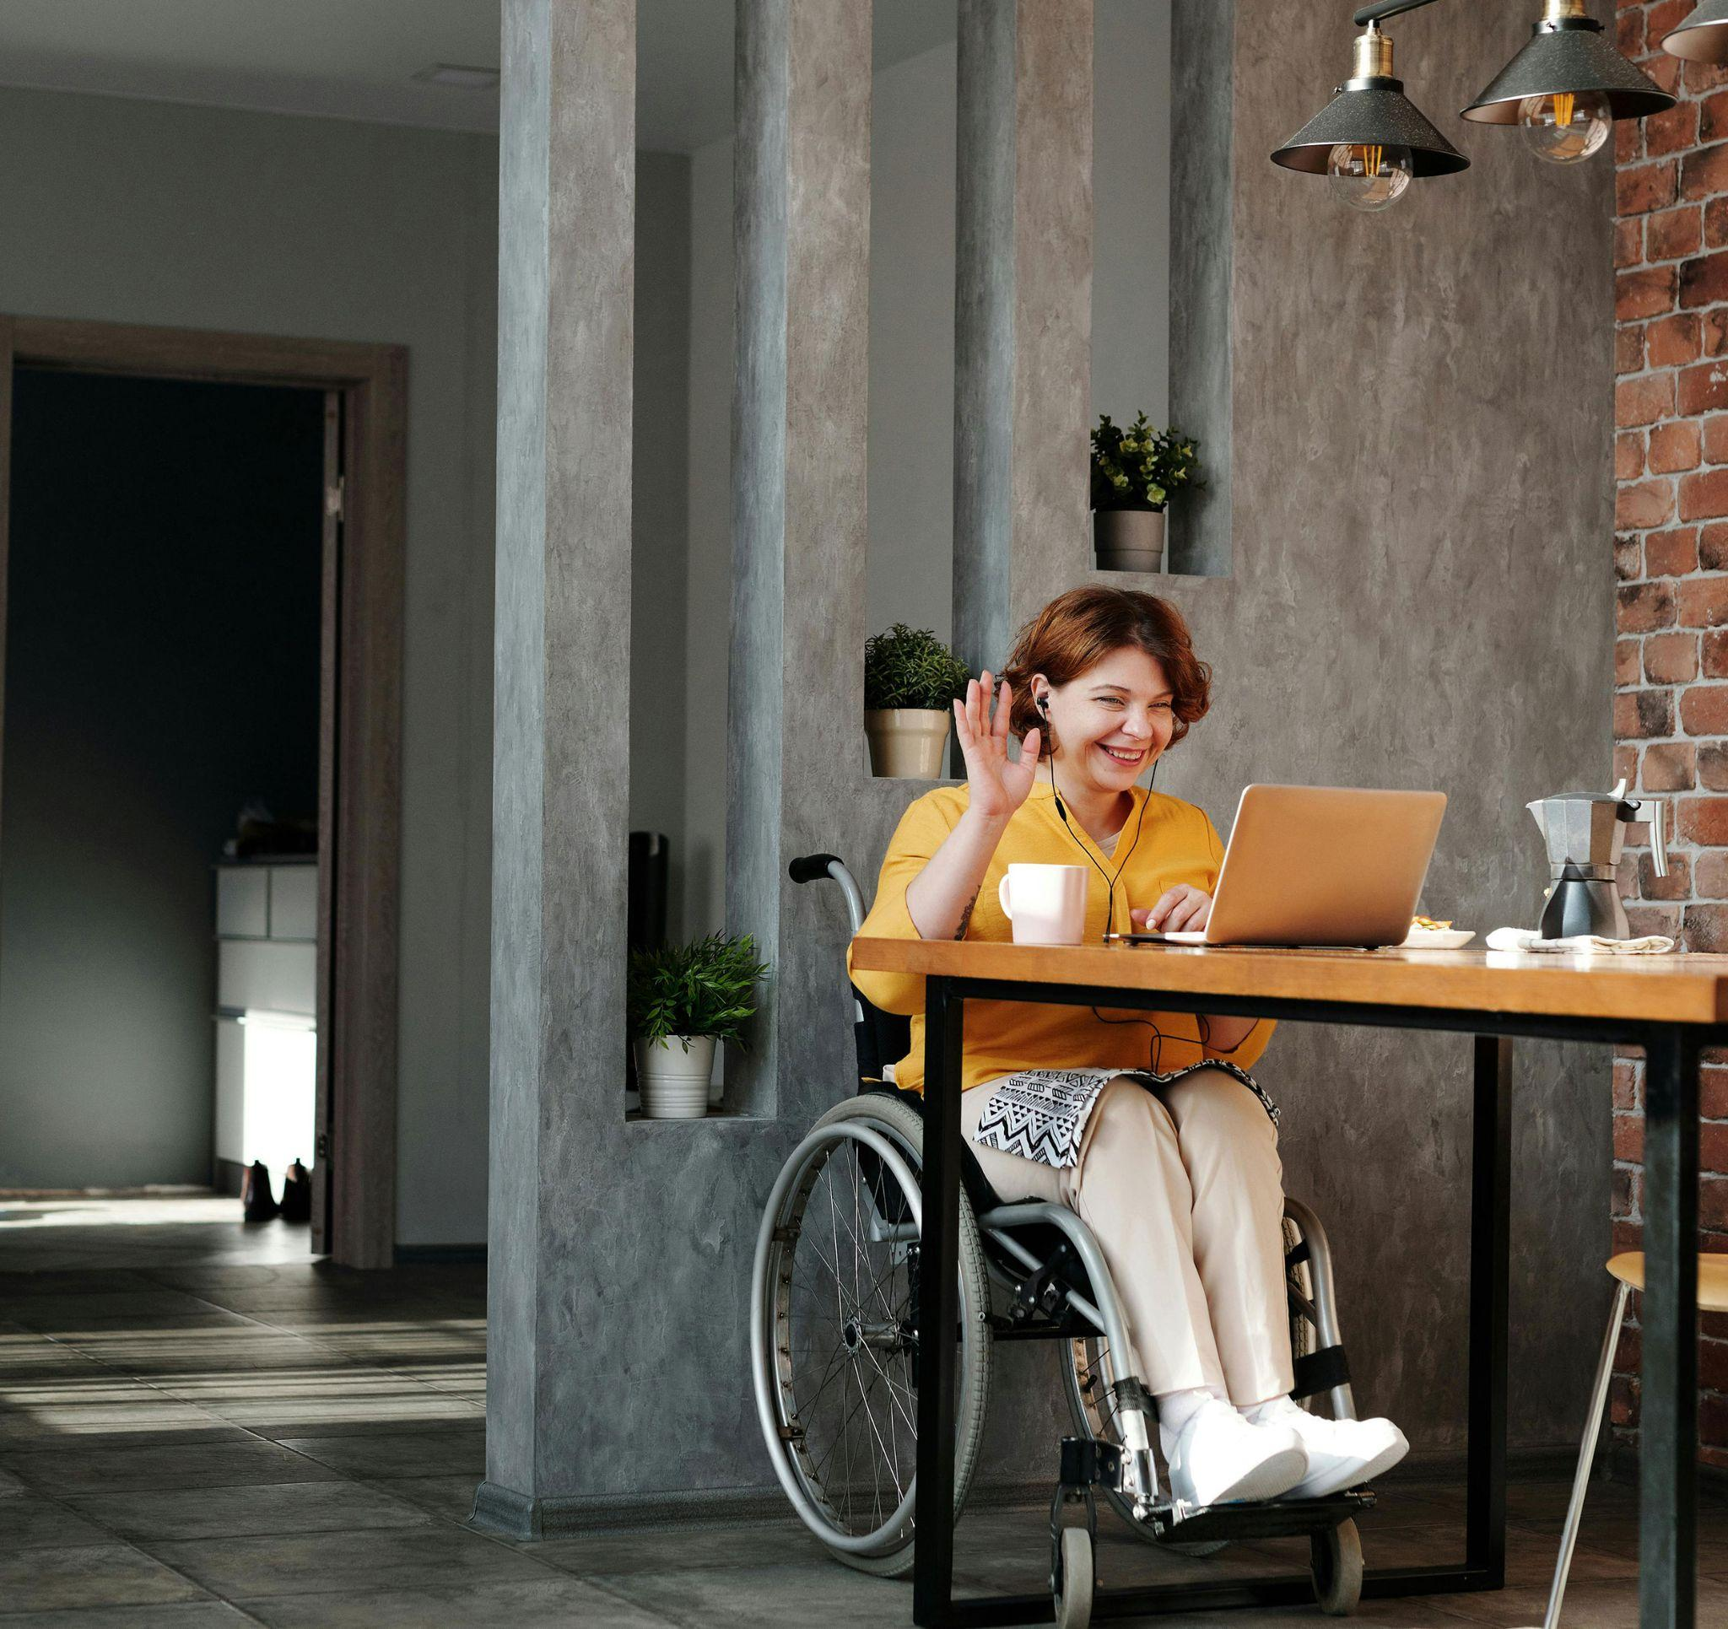

What’s missing from the Disability
Royal Commission’s recommendations?

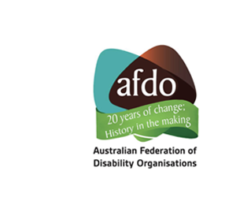

Table of Contents
About AFDO…………………………………………………………………… | 2
Our members………………………………………………………………….. | 3
Introduction…………………………………………………………………….. | 5
Capacity building to help people with disability recognise  and respond to violence, abuse, neglect, and exploitation……………….. | 6
Digital inclusion………………………………………………………………... | 7
Emergency preparedness and response…………………………………… | 7
Transport……………………………………………………………………….. | 8
Income support………………………………………………………………... | 8
Health…………………………………………………………………………... | 9
Older people with disability…………………………………………………... | 10
Day programs………………………………………………………………….. | 11
Women and girls with disability……………………………………………… | 11
People with psychosocial disability………………………………………….. | 12
People with autism……………………………………………………………. | 12
Disability awareness training………………………………………………… | 13

About AFDO

The Australian Federation of Disability Organisations (AFDO) Vision and Mission is that;"All people with disabilities must be involved equally in all aspects of social, economic, political and cultural life."
For over twenty years AFDO, a Disabled Peoples Organisation (DPO), has been the recognised national peak, along with its disability specific and population based member organisations, representing all people with disability.
We have an impressive and increasing reach currently connecting with over 16% of the total population or over 4 Million Australians through our own and via our thirty-eight member organisations.
AFDO provides a strong, trusted, independent voice for the disability sector on national policy, inquiries, submissions, systemic advocacy and advisory on government initiatives across Federal, State, Territory and Local governments.

Our members

Full Members of AFDO
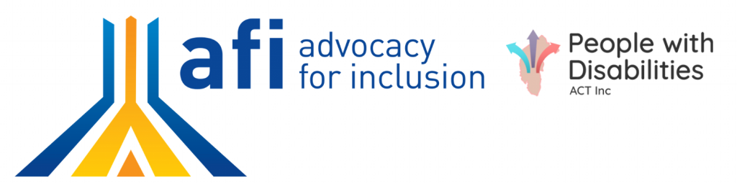  Advocacy for Inclusion | Arts Access Australia
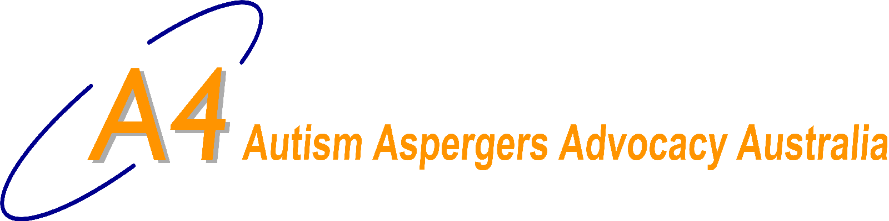  Autism Aspergers Advocacy Australia | 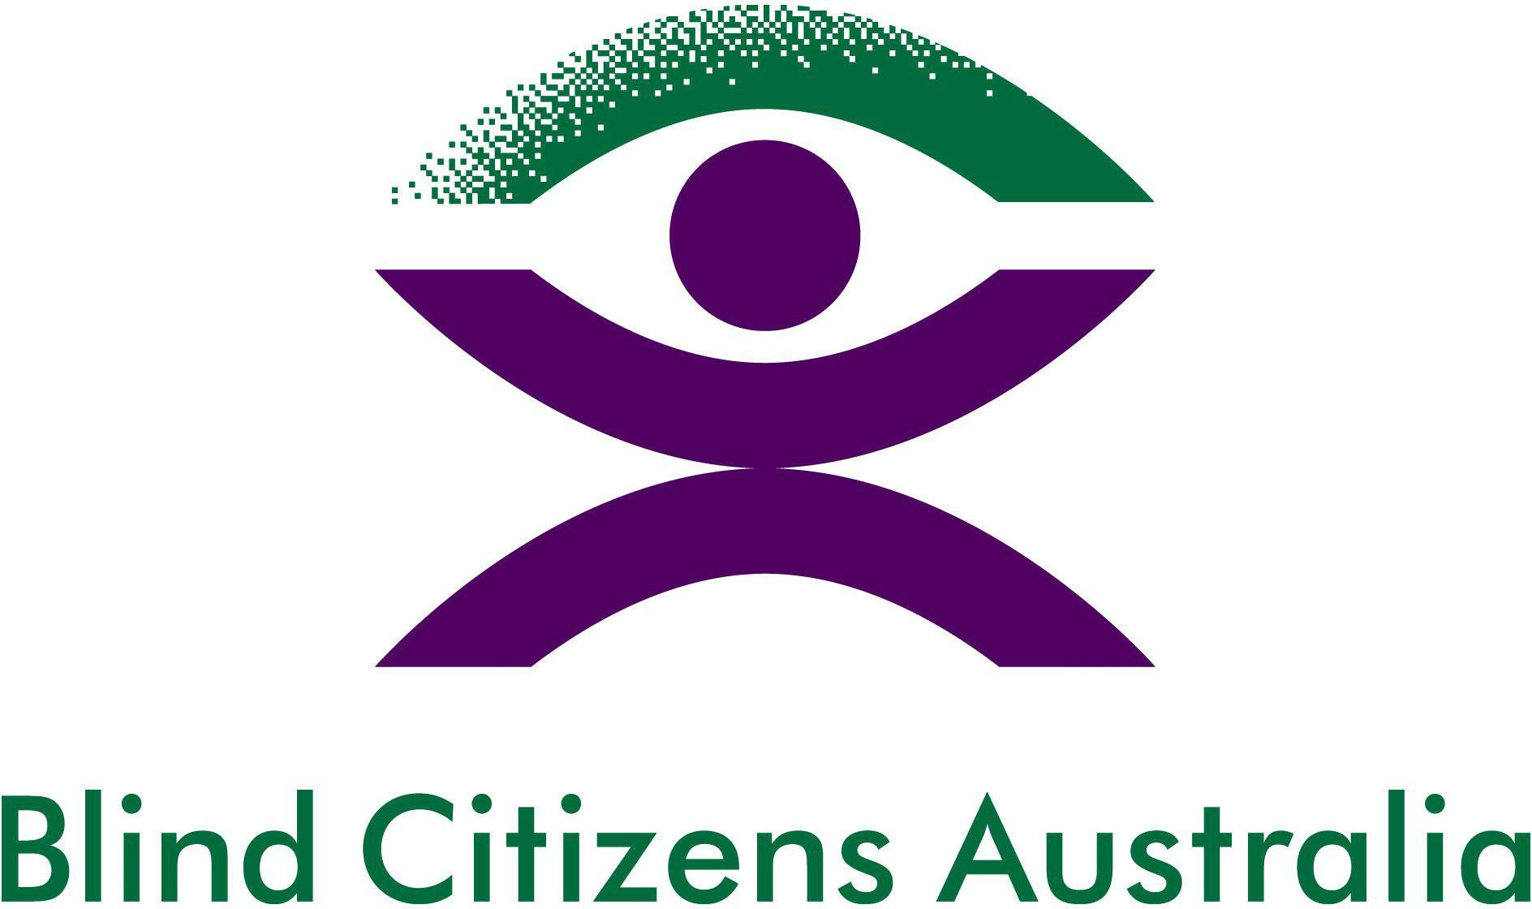  Blind Citizens Australia
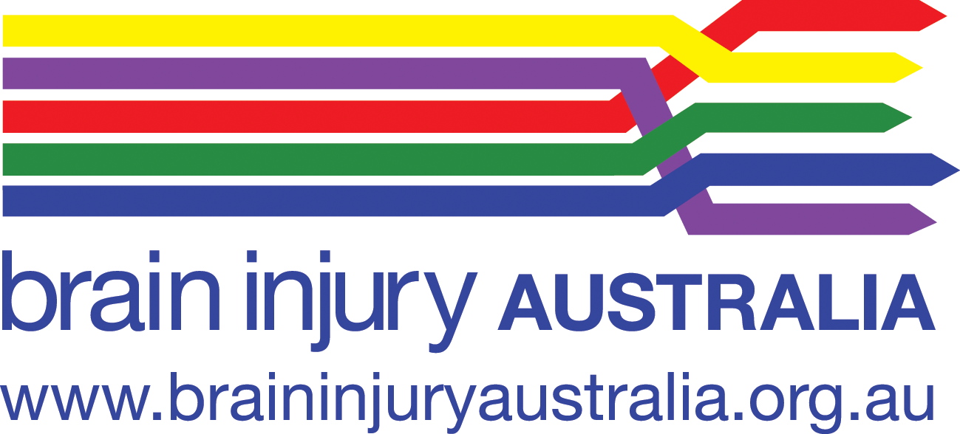  Brain Injury Australia | 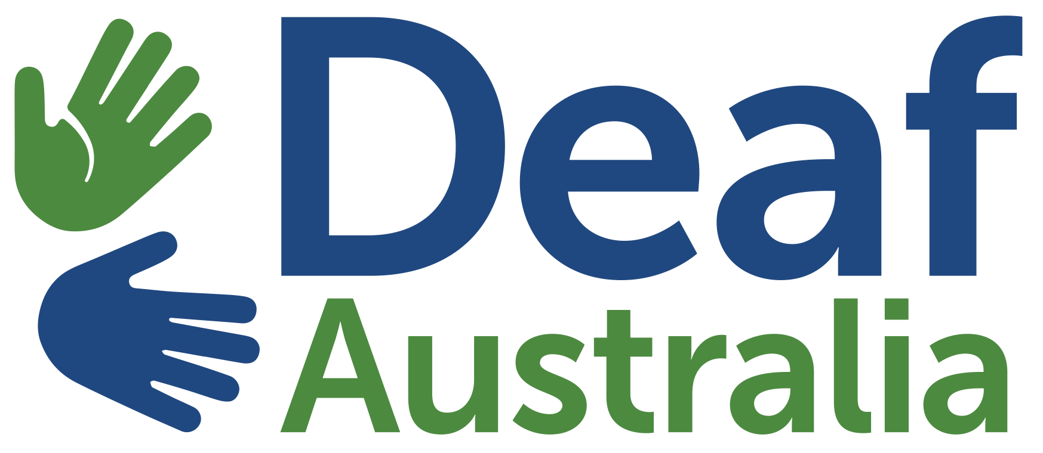  Deaf Australia
Deafblind Australia | 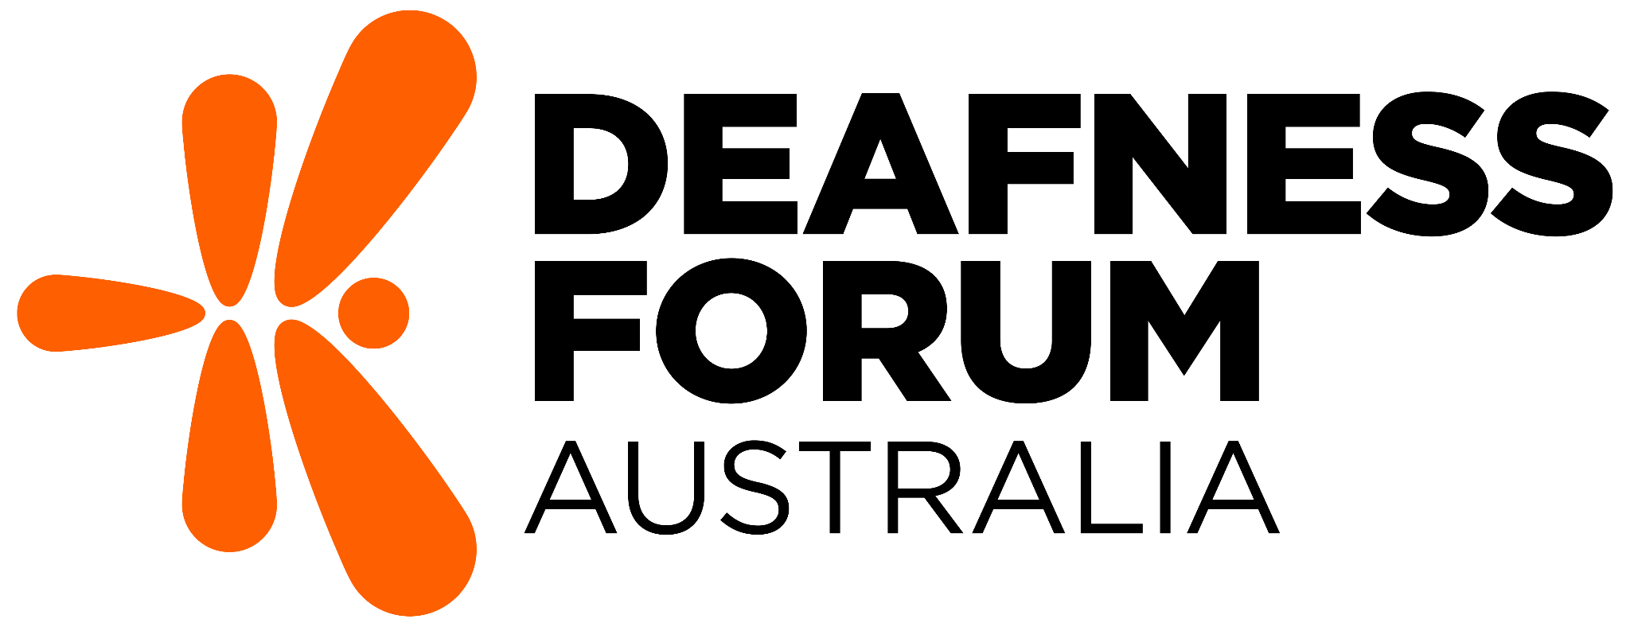  Deafness Forum Australia
Disability Advocacy Network Australia | 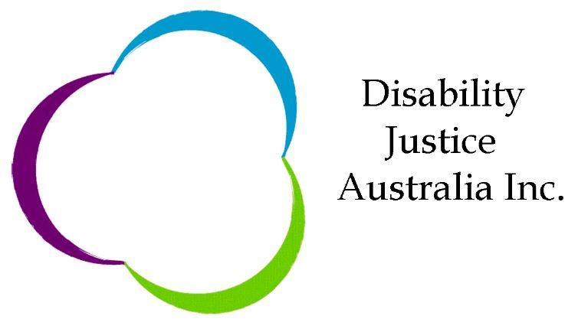  Disability Justice Australia
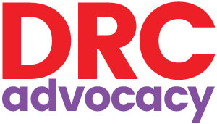  Disability Resources Centre | Down Syndrome Australia
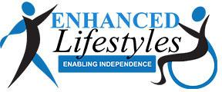  Enhanced Lifestyles | National Mental Health  Consumer & Carer Forum
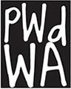  People with Disabilities WA | 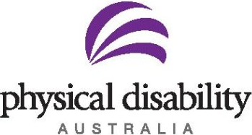  Physical Disability Australia
Polio Australia | 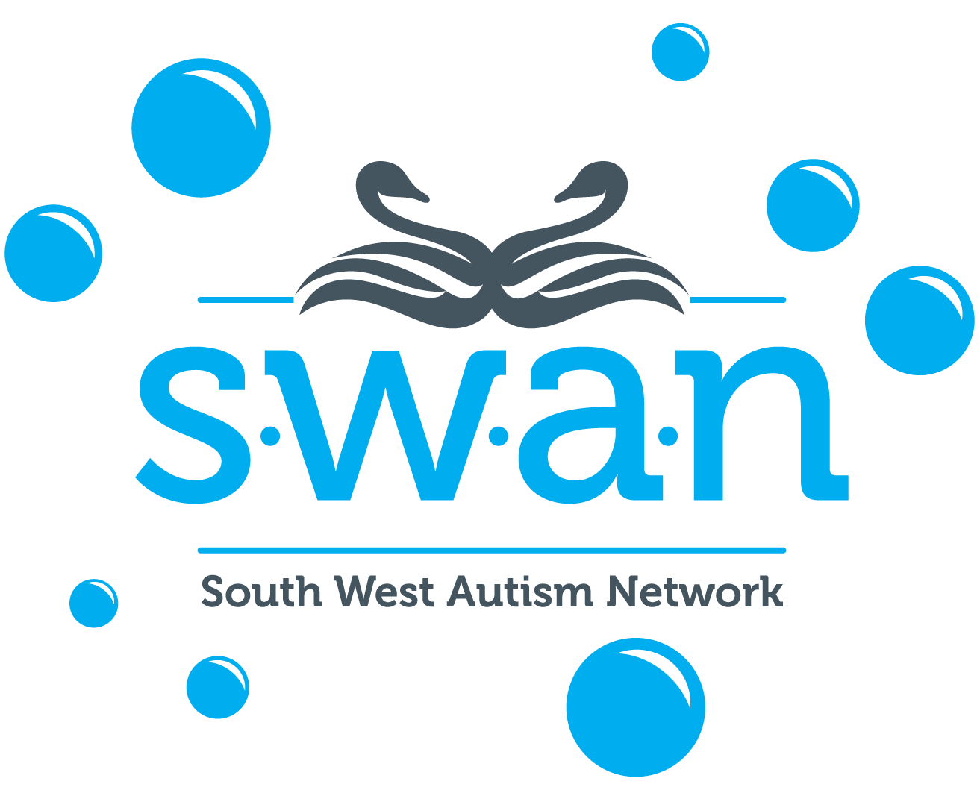  Southwest Autism Network
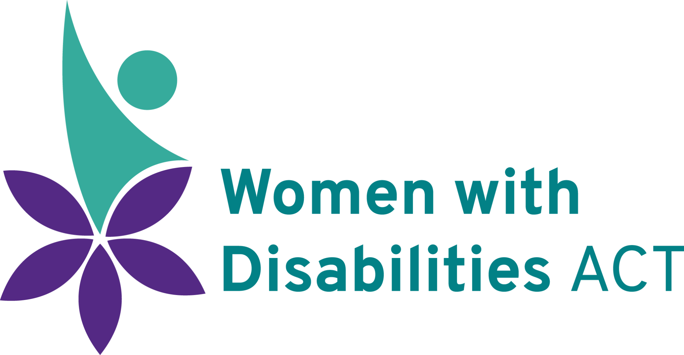  Women with Disabilities ACT | Women with Disabilities Victoria

Associate Members of AFDO
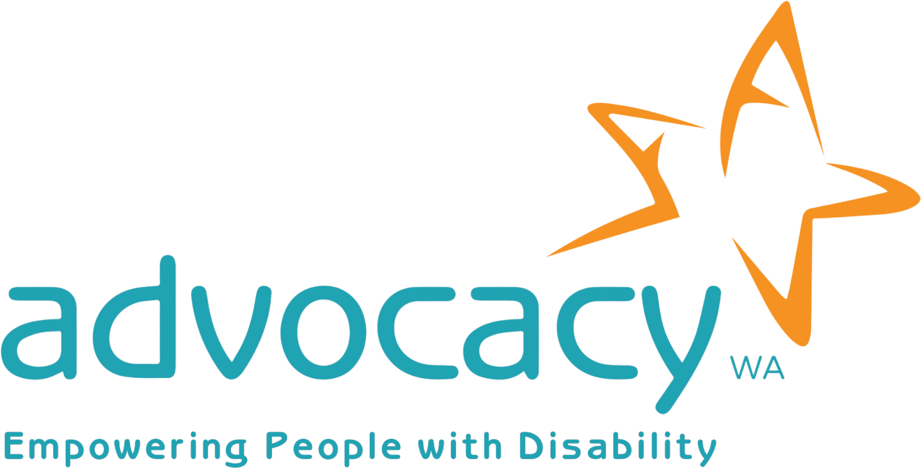  Advocacy WA | 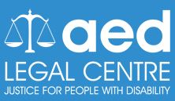  AED Legal Centre
All Means All | 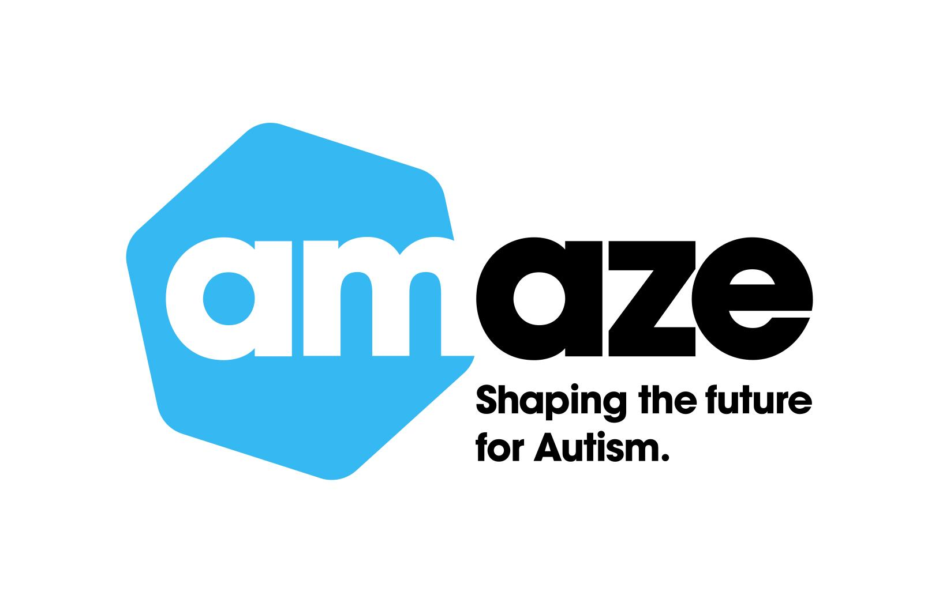  Amaze
Aspergers Victoria | Disability Advocacy and Complaints Service of South Australia
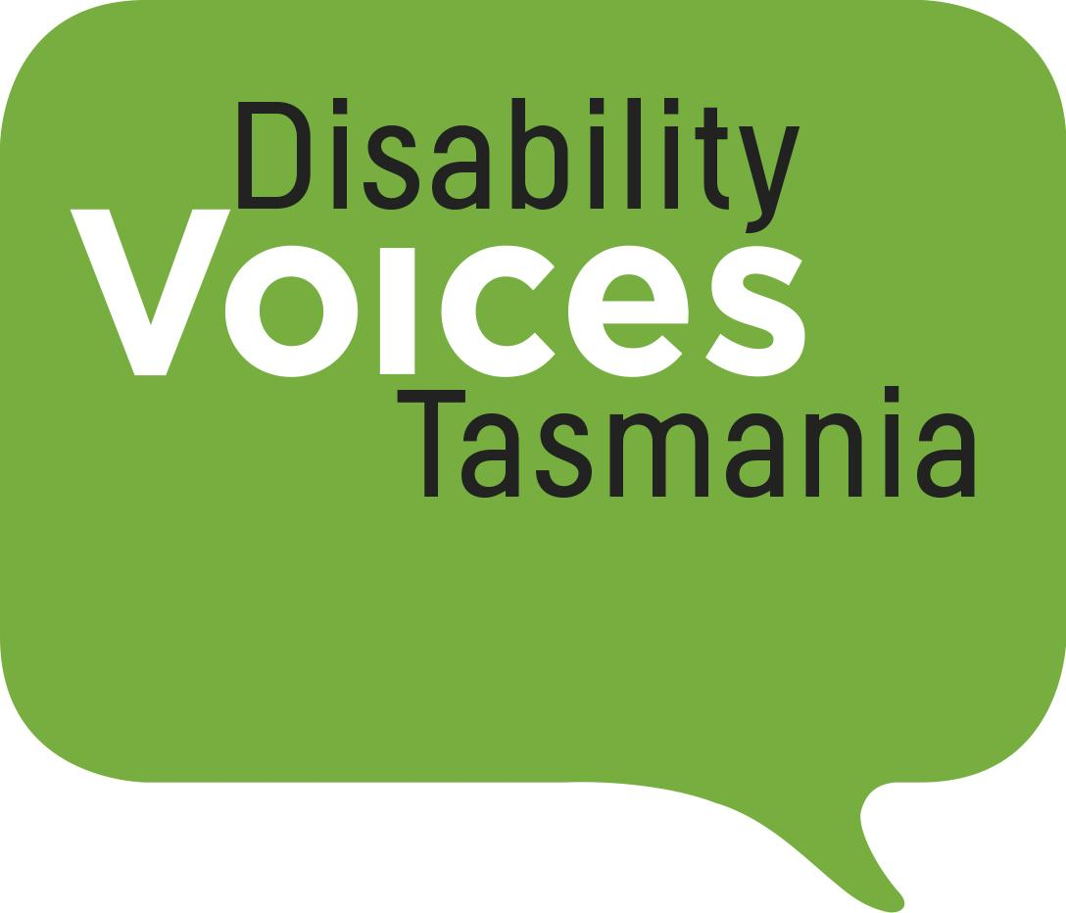  Disability Voices Tasmania | Explorability Inc
Leadership Plus | Multiple Sclerosis Australia
National Organisation for Fetal  Alcohol Spectrum Disorder | National Union of Students -  Disabilities Department
Star Victoria | 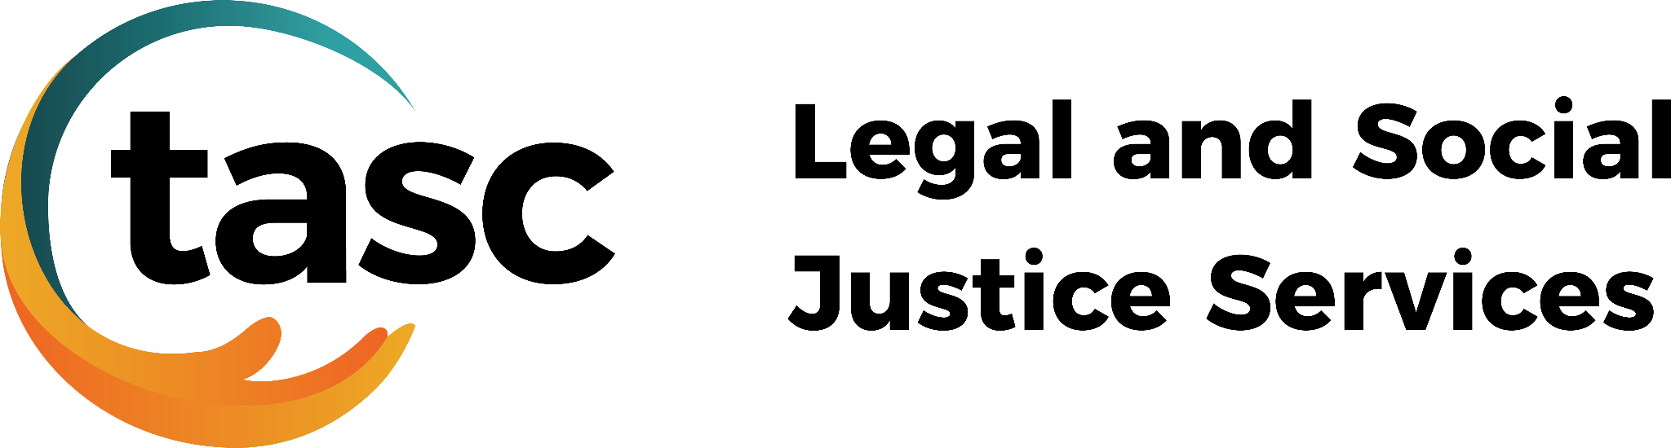  TASC National Limited
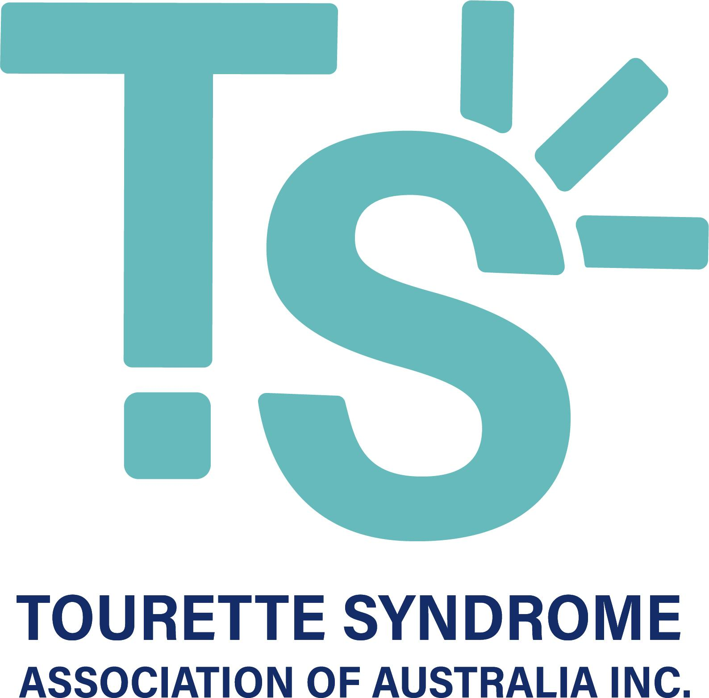  Tourette’s Syndrome Association of Australia | 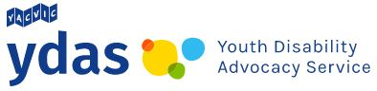  Youth Disability Advocacy Service

Introduction

The 12 volumes and 222 recommendations that make up the final report from the Disability Royal Commission cover a multitude of issues. We were, however, very disappointed to see that a number of big-ticket items had been excluded. So, which issues were not adequately covered in the final report?
To answer this question, we consulted with our 36 member organisations representing disability-specific and population-based communities across Australia. This document reflects our collective views on some of the key items we believe were “missing in action”.

Capacity building to help people with disability recognise and respond to violence, abuse, neglect, and exploitation

The final report does not include any recommendations relating to building the awareness of people with disability to recognise and understand their right to live free from violence and abuse. We should be taking a proactive approach to building the capacity of people with disability in relation to:
· Self-advocacy.
· Accessing support for decision-making.
· Understanding consent.
· Understanding how to seek help and/or report things that don’t feel right.
This education must happen throughout the entire life course and must begin in early childhood.

Digital inclusion

The final report did not include any recommendations aimed at increasing the digital inclusion of people with disability, despite the recorded fact that Australians with disability are still less digitally included than the general population. We would like to have seen additional recommendations aimed at addressing the many barriers to digital inclusion that are experienced by people with disability, including:
· Access to the internet being cost-prohibitive.
· Lack of funding for assistive technology.
· Inaccessible apps and websites.
· Low levels of digital literacy.
· Increased risk of people with disability experiencing safety issues, such as cyberbullying.

Emergency preparedness and response

While there are passing references to emergency preparedness in recommendations 5.4 and 6.1, the final report offers little in this area.
This is a stark oversight when we consider that people with physical disability are between two and four times more likely to be killed or injured during a natural disaster. We would like to see Government draw on the disability sector’s feedback on the 11 specific questions set out in the Royal Commission's Emergency Planning and Response Issues Paper to implement additional measures in this area.

Transport

We know social isolation and loneliness are major drivers of violence, abuse, neglect, and exploitation. That is why we were disappointed to find that the Royal Commission had not made any recommendations aimed at improving access to transport for people with disability. We prepared a comprehensive submission to the Royal Commission on this topic, which included 16 recommendations. We will continue to auspice and work with the National Inclusive Transport Advocacy Network (NITAN) as a means of driving Government to implement these recommendations and other changes that are required.

Income support

Poverty is a known primary driver of violence, abuse, neglect, and exploitation, and people with disability are at significantly higher risk of falling into poverty. Despite these facts, the Royal Commission failed to explore the adequacy of Australia’s income support system for people with disability in any great detail. We found this oversight particularly disappointing, having prepared a submission to the Royal Commission establishing the Disability Support Pension as an example of systemic neglect. As such, we would like to see the recommendations from the Inquiry into the Purpose, Intent and Adequacy of the Disability Support Pension implemented as a matter of urgency.

Health

There are a range of recommendations that relate to improving the accessibility of health services. Regrettably, these recommendations mostly relate to improving outcomes for people with cognitive disability only. While we acknowledge that people with cognitive disability are disproportionately affected by many of the issues outlined in the report, we do not feel the Royal Commission’s recommendations go far enough towards improving health outcomes for other people with disability.
We were also disappointed that the Royal Commission did not investigate the issue of prenatal screening. Many prospective parents do not receive accurate or objective information before prenatal screening, or upon receiving a high chance result or diagnosis. The Department of Health and Aged Care has produced guidelines on prenatal screening. Regrettably, there is no coordinated approach or training to support their implementation. We would like to see the Department work with Primary Health Networks, professional colleges and universities, and disability representative organisations such as Down Syndrome Australia to ensure the guidelines are properly implemented. This will help ensure accurate, evidence-based information about Down syndrome is available to parents during pre and post-natal periods.
We were equally disappointed not to see any recommendations around improving access to reproductive rights, including:
· Abortion rights and access.
· The right to not be subjected to forced contraception.
· The right to parent.
· The right to sexual expression and self-determination.

Older people with disability

Dependency is a known risk factor for abuse. This is a problem for many older people with disability who do not meet the age eligibility requirements for the NDIS, and also cannot access the supports they need under other service systems. The Royal Commission’s investigations focused primarily on the experiences of people with disability under the age of 65 and disregarded the experiences of those aged 65 years and over.
We have recently partnered with the Older Persons Advocacy Network (OPAN) to develop a joint discussion paper which explores the many policy gaps that exist in relation to supports for older people with disability.
We would like to see a targeted action plan developed under Australia’s Disability Strategy 2021-2031 to outline how the Federal Government and State and Territory Governments intend to fill these gaps.
It is also worth considering the extent to which disability is included under the National Plan to Respond to the Abuse of Older Australians. People with disability are significantly more likely to experience elder abuse than people without disability. Elder abuse also differs from other forms of family violence in that it is not gendered and requires a more nuanced approach.

Finally, there are a range of recommendations included in the final report that have a high level of crossover with work that is already being undertaken in the aged care sector. These are recommendations that deal with:
· Training.
· National worker registration.
· Adequacy of the SCHCDS Industry Award.
· Supported decision-making.
· Community visitor schemes.
· Reportable incidents and complaints.
· Restrictive practices.
· Data collection.

Day programs

Day programs appear to be largely absent from the report, despite the fact that these are segregated settings where people with disability are at greater risk of violence, abuse, neglect, and exploitation. We would like to see Government take proactive steps to:
· Ensure people with disability accessing day programs are adequately safeguarded.
· Ensure people with disability accessing day programs are provided with a range of other service options.

Women and girls with disability

Women with disability experience all types of violence at higher rates and with increased severity compared to men and people without disability. Although this was explained at length in Volume 3 of the final report, only five of the Royal Commission’s recommendations included explicit reference to women and girls. We would like to have seen a stronger focus on intersectionality generally; in recognition of the fact that violence, abuse, and neglect is compounded by intersectional forms of power working against women, girls, and non-binary people with disability. It is therefore critical that all the Royal Commission’s recommendations are implemented with an intersectional approach.

People with psychosocial disability

Psychosocial disability is not mentioned in any of the Royal Commission’s recommendations. This seems like a significant oversight when considering people with a primary diagnosis of psychosocial disability make up 10% of NDIS participants. We would like to see the following measures implemented to better serve the needs of this cohort:
· Increased funding for community supports and evidence-based models of practice.
· The establishment of peer support networks.
· Training for the clinical workforce around trauma-informed practice and the needs of people with psychosocial disability.
· Removal of barriers that prevent people with psychosocial disability from accessing the Disability Support Pension and the NDIS.

People with autism

There were only two autism-related recommendations included in the final report. This is despite the fact that people with autism:
· Continue to experience some of the worst education and employment outcomes.
· Are at increased risk of violence, abuse, neglect, and exploitation.
· Are overrepresented in the criminal justice system.
Some of the recommendations relating to people with cognitive and intellectual disability may be of some relevance to people with autism. It is important to recognise, however, that only some autistic people have cognitive impairment and/or intellectual disability. Many autistic people experience a range of other comorbidities and varying levels of intersectionality. It is critical that an autism lens is applied to all the Royal Commission’s recommendations to ensure the specific needs of autistic people are recognised and met through any future reforms.

Disability awareness training

While the final report includes recommendations around disability awareness training for a range of professions, we do not believe this will not go far enough towards improving community attitudes or avoiding indirect discrimination. We need people to undertake disability awareness training that is tailored to their industry while they are still in higher education, and before they move into the workforce. As such, we would like to see the following recommendation from our December 2022 submission to the Royal Commission investigated in greater detail:
“The Minister for Employment must be directed to work with the Australian Curriculum, Assessment and Reporting Authority, the Tertiary Education Quality and Standards Agency and the new independent Training Package Assurance function within the Department of Employment and Workplace Relations to ensure modules on disability awareness, accessibility and inclusive design are built into:
· The Australian school curriculum.
· Relevant VET accredited courses.
· Relevant university courses.”

