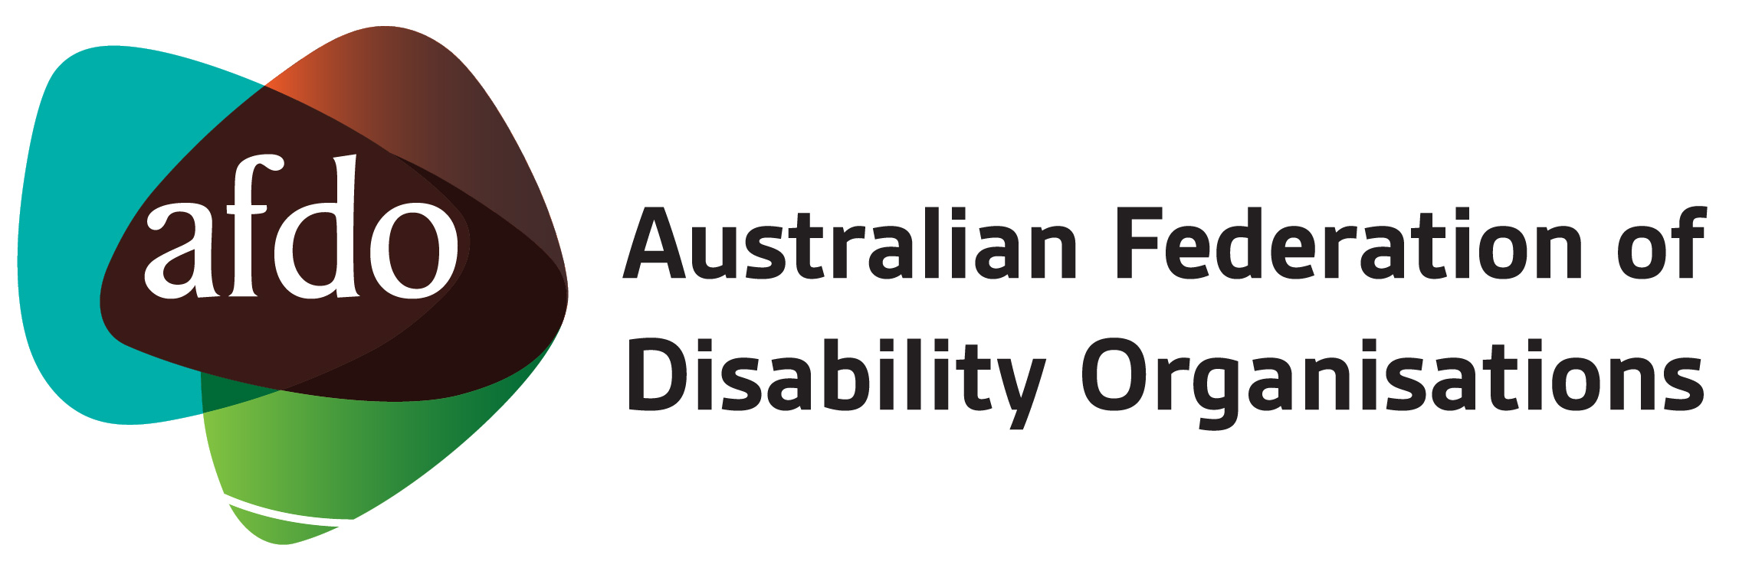

AFDO Membership Application Form (Full Member)

Organisation:

ABN:

Contact Person:

Position:

Email:

Address:

Please tick boxes as appropriate, to indicate yes, next to the seven statements below:

- ☐ We are a Not-for-Profit Disability organisation, whose members are:
- people with disability, and/or
- organisations of people with disability, and/or
- organisations for people with disability.
Please indicate the number of members your organisation has: Insert number here
- ☐ We are governed by a Board where at least 50% of Board members are people with disability.
- ☐ We are a national disability organisation representing the lived experience of advocating for a family member with disability, such as:
☐ a) Children with disabilities, or
☐ b) People with Intellectual disability, or
☐ c) Carers and family members.

- ☐ We are an Incorporated Association.
- ☐ We are a Company Limited by Guarantee.
- ☐ Our prime role is to advocate for the rights and wellbeing of people with disability.
- ☐ We exist to support people with disability, and we do not have any purposes contrary to the purposes of the AFDO.

Signed:

Name:

Title:

On approval of your Full membership application, AFDO will forward you an invoice for $100 plus GST. Please provide your accounts department email address below.

Accounts contact email:

Please attach your latest Constitution and Annual Report with your application.

Applications for membership should be sent to the CEO & Company Secretary at ceo@afdo.org.au

For further information about membership, please contact the AFDO office on (03) 9662 3324 or by email to office@afdo.org.au or visit the AFDO website.

The Board of AFDO considers all membership applications and will notify you within 60 days if your application is successful. All decisions made by the AFDO Board on membership applications are final.

Australian Federation of Disability Organisations
ABN 25 105 510 898

