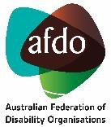

The Hon Mark Dreyfus KC Attorney-General
Email: attorney@ag.gov.au 18 January 2024
Dear Attorney-General,

Urgent meeting request re: the Administrative Review Tribunal Bill 2023

We seek an urgent meeting to discuss the implicationsof the Administrative Review Tribunal Bill 2023 (ART Bill) and the Administrative Review Tribunal (Consequential and Transitional Provisions No.1) Bill 2023 (Consequential and Transitional Bill).
Although these bills incorporate various welcome measures designed to enhance access to external review, we believe these will be counteracted by the critical impact of the abolition of the two-tier system currently in place for certain jurisdictions. Abolition of the lower tier is a retrograde measure, undermining the intention to effect structural reform to ensure that the administrative review system is accessible and fair.
During the numerous consultations on the bills and the new Administrative Review Tribunal model, we strongly argued that the new tribunal should retain a two-tier structure for designated jurisdictions, replicate thisapproach for NDIS appeals, and ensure the first tier continues to be inquisitorial, non-adversarial and as informal and accessible as possible. Under the proposed single tier model, we believe the following issues will arise:

Reduced access to justice

Given the powers of the Tribunal and the nature ofits jurisdiction, Tribunal processes frequently determine individuals’ access to legal and human rights, with Tribunal decisions having a profound impact on people’s lives.
The model proposed under the ART Bill reduces accessibility, particularly for Applicants who are vulnerable and/or self-represented. Applicants will only have one real opportunity to have their case reviewed by the Tribunal, but given the complexity of matters and pressures on the limited resources of Community Legal Centres (CLCs) and Legal Aid, most Applicants are unlikely to have the benefit of legal advice or representation, particularly if Commonwealth funding of legal services remains at current levels. This has the potential to result in unjust, life changing decisionswith no guaranteed right to further review – even where the person may have been able to have the decision in question set aside had they understood the need to present specific evidence. This fundamentally undermines access to justice.

To be more specific, you are likely aware that Services Australia staff are currently making review decisionswhile struggling to address chronic understaffing. This has reduced the quality and amount of detail provided to Centrelink recipients through internal review. As a result, it is not uncommon for social security appeal Applicants to first comprehend the reasons for Services Australia’s decisions, and what they need to provide in support of their appeal, at the Tier 1 (Social Security and Child Support Division – SSCSD) hearing. Currently, a person with grounds to have a large debt cancelled or reduced who fails at Tier 1 can appeal to the General Division – armed with what they nowknowis essential evidence. Abolition of the SSCSD removes this step, which would result in the person being permanently lumbered with a debt, with no further appeal rights regarding the debt quantum, and waiver unlikely given the Secretary’s general deference to the Tribunal’s affirmation of the debt.
Further, regarding NDIS Appeals matters, the Federal Government recently trialled an Independent Expert Review (IER) panel, like Tier 1 arrangements, to address the appeal backlog. This approach was evaluated, with the evaluation finding that the IER panel provided greater client satisfaction in terms of process and consideration of the issues and was an efficient approach in terms of both resourcing and timeframes.

Loss of efficient and just resolution for Applicants

Under the current model, a significant portion of Tier 1 matters are resolved. According to the AAT Annual Report 2022-2023, of 8,890 Centrelink appeals finalised by the SSCSD, only 13% of matters were finalised at Tier 2. The proposed restructure reduces this opportunity for an efficient resolution.
It is not uncommon for a client to be unsuccessful at Tier 1 but with the Tribunal’s reasoning different from that of the previous decision-maker. Such clarification makes it much more straightforward for solicitors to provide advice on meritsof appeal and the evidence or reports required for their client to effectively make their case. It is also not uncommon for matters to be settled after being lodged for Tier 2 review, both parties drawing on the discussion of fact and evidence undertaken during the Tier 1 hearing.
AAT Tier 1 is a space where CLC and Legal Aid lawyers can provide advice and assistance to individuals to self-represent, and also employ advocates who may not be legally trained but are experts in the relevant division. Removing Tier 1 excludes these advo cates from assisting vulnerable people who are unable to effectively self-represent and are consequently at risk of losing their appeal or withdrawing from the process as they are too intimidated to proceed. Abolishing the first tier will mean that vulnerable Applicants will be less able to self-represent and will reduce the capacity of CLCs and Legal Aid to assist with the significant number of matters before the Tribunal.

Reduced efficiency and increased costs for stakeholders managing ART matters

In addition to the impact on efficient and just resolution for Applicants, the abolition of Tier 1 may contribute to additional costs for the ART in managing matters if all matters involve more formal and expensive procedures. This could also contribute to ongoing pressure in managing applications which has implications for backlogging of ART matters.

The proposed changes may also contribute to increased costs and resourcing for government agencies such as Services Australia and the National Disability Insurance Agency in responding to matters, as current Tier 1 hearings occur without respondent input and presence.

Reduced accountability mechanisms on primary administrative decision -making

In the absence of clear explanations or reviews by primary decision-makers, Tier 1 of the AAT is often the only mechanism for an Applicant to obtain the reason for a decision. Losing this level of review is not only detrimental to individuals but also reduces accountability mechanisms for government agency decisions, as well as oversight of primary decision making. In the case of social security, this is clearly contrary to several recommendations of the Robodebt Royal Commission (particularly recommendations 20.1 and 20.3), and hard to reconcile with the Government’s overriding commitment to address systemic administrative barriers to the social security safety net.
We ask that the Bill be amended to provide that the ART incorporate a two-tier structure for Social Security, Child Support and NDIS appeal matters, with the first Tier effectively being a continuation of the SSCSD.
As you will understand, this is an urgent matter. We would like to meet with you as soon as possible, and prior to this Bill being further debated within the Parliament. We look forward to hearing from you.
Yours sincerely,

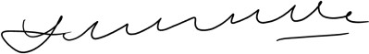  Louise Glanville  Chair | Tim Leach  Chief Executive Officer
National Legal Aid | Community Legal Centres Australia
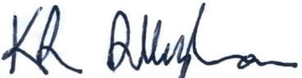 | 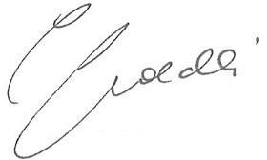
Kate Allingham  Chief Executive Officer | Cassandra Goldie  Chief Executive Officer
Economic Justice Australia | Australian Council of Social Services
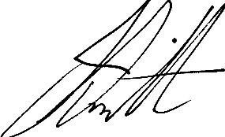 | 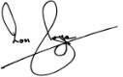
Jeff Smith  Chief Executive Officer | Ross Joyce  Chief Executive Officer
Disability Advocacy Network Australia | Australian Federation of Disability  Organisations

