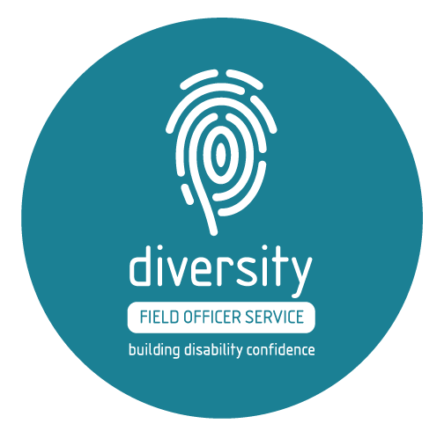
Supporting businesses to become more welcoming, confident and accessible – free spaces available in 2017
Empathy. Perseverance. Resilience.
While these skills are regularly bandied as skillsets of the future, they remain largely nebulous, with very few businesses giving thought to the role life experience has in strengthening these skills or the strategies needed to introduce these skills within the workplace. Even less businesses give thought to people with a disability. These two elements aren’t mutually exclusive, with people with disability often demonstrating these very same skills to navigate what is often an inaccessible society and one that is less welcoming than it could be.
Employment and retention of people with a disability is often seen as a goodwill gesture rather than an advantageous business decision. Businesses are largely unaware of the benefits of becoming more welcoming and inclusive of people with disability in operations and customer service, including positive return on investment (ROI).
But some businesses are becoming more aware. Working with 50 workplaces, across 15 industries in just 12 months, the Diversity Field Officer Service, an initiative of the Australian Federation of Disability Organisations and Deakin University, is turning the conversation on its head.
Piloted in 2016, the service has worked with small and medium sized businesses, including the Geelong Chamber of Commerce, to build the disability confidence of leadership teams to become more welcoming, confident and accessible. So what exactly does that mean?
“It’s about opening up the thinking of businesses of how genuinely welcoming they are. This isn’t just about ramps: it’s about your workplace culture, what you think you know about people with disability, how you recruit and what you are doing that is unintentionally telling people that they are not welcome, either as employees or customers”, says Jessica Zammit, Program Manager of the Diversity Field Officer Service.
“Disability is far more common that people think. Most disability is acquired or arises later in life. We often ask businesses leaders: if you were to acquire a disability tomorrow, how ready would your workplace be? Do you know what to do or where to go? When you think about your customer strategy, how inclusive is it really?”.
“It raised our awareness more than I imagined”, says Bernadette Uzelac, CEO of the Geelong Chamber of Commerce.
“The Diversity Field Officer Service’s passion to engage with the Geelong business community has helped raise the issue of diversity, get businesses to identify barriers to hiring people with a disability and encouraged businesses to think much more broadly, including about customer needs.
From a Chamber point of view, the expertise helped us to identify ways we could provide a meaningful position within our organisation and we’re delighted to have appointed someone to a part-time administration support role”.
These comments are consistent with the findings of the pilot evaluation, with businesses reporting increased knowledge and awareness of disability and diversity, changes to recruitment processes, exploration of new opportunities to bring in talent and increased confidence. 97% of businesses reported that the service significantly met their expectations, with over 95% reporting a ‘high’ satisfaction rating.
The Diversity Field Officer Service will continue in 2017, welcoming new businesses to the fold. The service will be free of charge until 30 June 2017. Check out www.diversityfieldofficer.com.au for details of the service offering and participating businesses.
“We want to work with businesses who are genuinely open to the opportunity to think more strategically and to untapped opportunities in recruitment, retention and customer service. If you think this is your business, we’d love to have a chat”, Ms Zammit said.
The Diversity Field Officer Service is kindly supported by Worksafe Victoria, AMP Foundation and the Australian Federation of Disability Organisations.

