Australian Federation of Disability Organisations
Medicare Levy Amendment (National Disability Insurance Scheme Funding) Bill 2017 and 10 related bills
September 2017
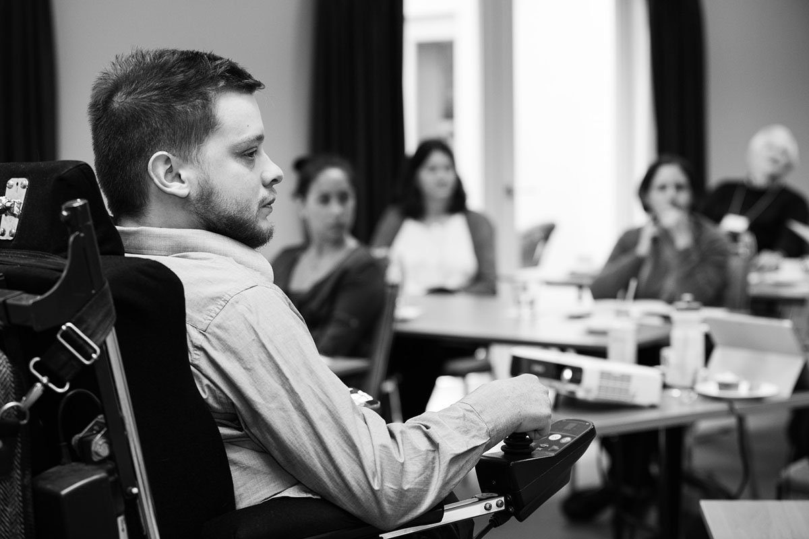

Table of Contents
Who is AFDO? 3
The Benefits of the NDIS 4
The Impact of Uncertainty on the Future Costs of the NDIS 6
Increasing the Medicare Levy 7

Who is AFDO?
The Australian Federation of Disability Organisations (AFDO) is the peak organisation in the disability sector representing people with lived experience of disability. AFDO and its member organisations are run by and for people with lived experience of disability.
AFDO’s mission is to champion the rights of people with disability in Australia and support them to participate fully in Australian life. AFDO has strong relationships not just with its member organisations, but across the disability sector including peaks representing service providers as well as those representing families and carers.
As a founding member of the National Disability and Carer Alliance, AFDO played a key role in the campaign for the introduction of the National Disability Insurance Scheme (NDIS). As the NDIS has moved through the trial phase and begun the transition to full scheme, AFDO and its members have continued to work constructively with the National Disability Insurance Agency (NDIA), as well as Commonwealth and State and Territory governments to provide critical feedback and address implementation issues as they arise.
AFDO’s members include:

Blind Citizens Australia
Brain Injury Australia
Deaf Australia
Deafblind Australia
Autism Aspergers Advocacy Australia
Down Syndrome Australia
Physical Disability Australia
Disability Advocacy Network Australia
Disability Justice Advocacy
Disability Resources Centre
People with Disability ACT
Enhanced Lifestyles
People with Disability WA
Deafness Forum of Australia

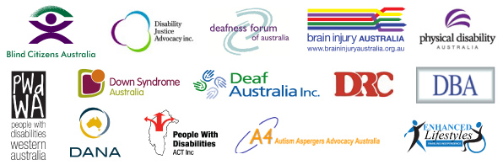

The Benefits of the NDIS
AFDO welcomes the Federal Governments commitment to fund the NDIS fully; it is proposing to do this via an increase to the Medicare Levy.
AFDO would like to begin this Submission by noting that to date, the National Disability Insurance Scheme has been delivered on time and within the given funding envelope. This cannot be said for other large government initiatives. Given the size and complexity of the NDIS, this fact should not be overlooked.

The National Disability Insurance Scheme is the most comprehensive social policy reform since the introduction of Medicare. For the first time in Australia’s history, the National Disability Insurance Scheme provides people with disability with the opportunity to participate as equal citizens in Australian Society. The NDIS is the mechanism by which people with disability to able to exercise not only their civil and political rights but also their economic, social and cultural rights.

Since the beginning of the NDIS journey, the premise that this insurance model was the most economically sustainable system of providing people with disability with the same opportunities as the rest of the community, continues to hold currency. It is clear that continuing to do nothing and underinvest in both people with disability as citizens and in the sector that supports them simply costs more in the long run.
People with disability, their families as well as the organisations that support them are vitally interested in the sustainability of the NDIS. AFDO want the NDIS to support generations of Australians to come. AFDO understand that cost overruns jeopardise public and political support for any government initiated scheme. AFDO is therefore interested in the effective and efficient administration of the NDIS to ensure its ongoing support throughout the wider community.
Government initiatives can be well managed and still not achieve intended outcomes. The scheme should be judged not only by how it manages costs but what outcomes are achieved. It is also true that the good outcomes delivered by the NDIS are often hard to capture and quantify. It is even more difficult to assign value in economic terms and measure return on investment. Some economic outcomes are easily captured and quantified – investment in capacity building or home modifications or equipment can reduce support costs in the long term. If a NDIS participant is supported to move into employment, or a family carer re-enters the workforce, the economic impact of that change can be measured.
There are other, just as important outcomes that are not only more difficult to capture; they are more difficult to assign value. What value can we assign, for example, to increased inclusion? To an increased independence? To increased dignity? Through the development of an outcomes framework, the NDIA has begun the work of attempting to capture and document these outcomes. Because of their vital importance in assessing the full impact of the scheme on the lives of people with disability, we believe this work warrants further attention and promotion.
Its still early days for the NDIS and many of the outcomes that can be expected from such a significant social reform are yet to be realised. AFDO would argue strongly for patience in examining outcomes from the scheme and expect that return on investment will take some time to be realised.
This is particularly true because the previous system was under-resourced and highly rationed, with the result that many people with disability have arrived at the door of the NDIS with high and complex needs. AFDO would expect this to reduce over time as people receive more timely and appropriate supports through the NDIS.
This is not the time for governments to lose their confidence in the scheme. The insurance principles which underpin the NDIS mean the scheme takes a lifetime view of an individual. Governments must also take a long-term view regarding the implementation of the scheme in viewing its results and achievements for people with disability. This is particularly difficult in the current political climate but essential to good governance and operation of the scheme.

The Impact of Uncertainty on the Future Costs of the NDIS
The National Disability Services, the peak body for non-government services, has indicated that disability providers across the country are struggling to remain viable. Ken Baker, Chief Executive of the NDS, said: “two-thirds of disability service providers had reported to the commission that they were very worried about their capacity to provide services at current NDIS prices.”

One of the key impacts of the uncertainty of the future costs of the NDIS is erosion in confidence in the promised outcomes of the NDIS for people with disability. The history of people with disability in relation to inclusion in the community has been one of ongoing isolation and a lack of opportunity. People with disability were repeatedly promised better support, better housing, better services, employment opportunities, but nothing seemed to change. People with disability were promised that they would now have the opportunity to participate in the benefits available to the rest of the community.

Access to the same positive experiences of inclusion in the life of the community that other Australians enjoy has never occurred for people with disability. Maintaining the confidence of people with disability is central to ensuring the people with disability will seek out NDIS eligibility, participate in the eligibility process and utilise the benefits of a single nationally consistent disability system. If people with disability lack confidence in the NDIS then they are unlikely to seek to become eligible. This will place further strain on those disability services still operating at the state level and skew the data needed to help us understand the shape of the NDIS that will be needed into the future.

The provision of services to people with disability under the NDIS is costed according to an insurance model of decreasing costs over time. If people with disability do not have confidence in the NDIS and do not sign up for the NDIS, this will impact upon the Scheme’s financial viability and sustainability in the long run as well as whether the NDIS will be able to provide inclusion to all people with disability.
Not only will some people with disability miss out on access to the NDIS but the cost of providing services to those people who do have access to the NDIS will likely increase. Any cost increase in the provision of services will be felt across the board but will be more acutely felt in regional rural and remote areas, in the provision of specialist disability services and too hard to reach populations.

Increasing the Medicare Levy
The Federal Government proposes to do this via an increase to the Medicare Levy. This method of raising revenue for securing the NDIS gives people confidence that the NDIS will be supported into the future. AFDO also welcomes the Government’s shift from funding essential universal services such as the NDIS, by cuts to benefits and services as proposed in its 2016 Budget. The 2017 Budget proposes an increase in the universally applied Medicare Levy, which is based on gross earnings and capacity to pay rather than a flat tax regime.

On a wider note, the best way to fund increases in the cost of essential universal services such as NDIS and health and aged care (which will inevitably grow as a share of GDP) is through the tax system. The alternatives - service rationing and user charges - lead to greater inequality, and two-tier systems where the service people receive depends on their income, not their needs. People on lower incomes are hit harder by fixed out-of-pocket expenses. We all benefit from essential services and should contribute through the tax system to the extent that we can afford to do so.

It makes sense from an equitable position, as the NDIS is available to all Australians who have or may acquire a lifelong disability, that the costs of the NDIS are shared by all via revenue raised through a universal tax system. The application of this needs which takes into account capacity of individuals to pay according to their earnings.
A strong, well-funded NDIS will be of benefit to our community as people with disability are supported to participate economically and socially, delivering on the promised outcomes from its inception

AFDO welcomes the Federal Government’s commitment to fully funding the NDIS and has a preference for this to be via the taxation system rather than funds coming from a decrease in welfare or other support funding.

