Australian Federation of Disability Organisations: 2nd Progress Report on the National Disability Strategy
August 2017
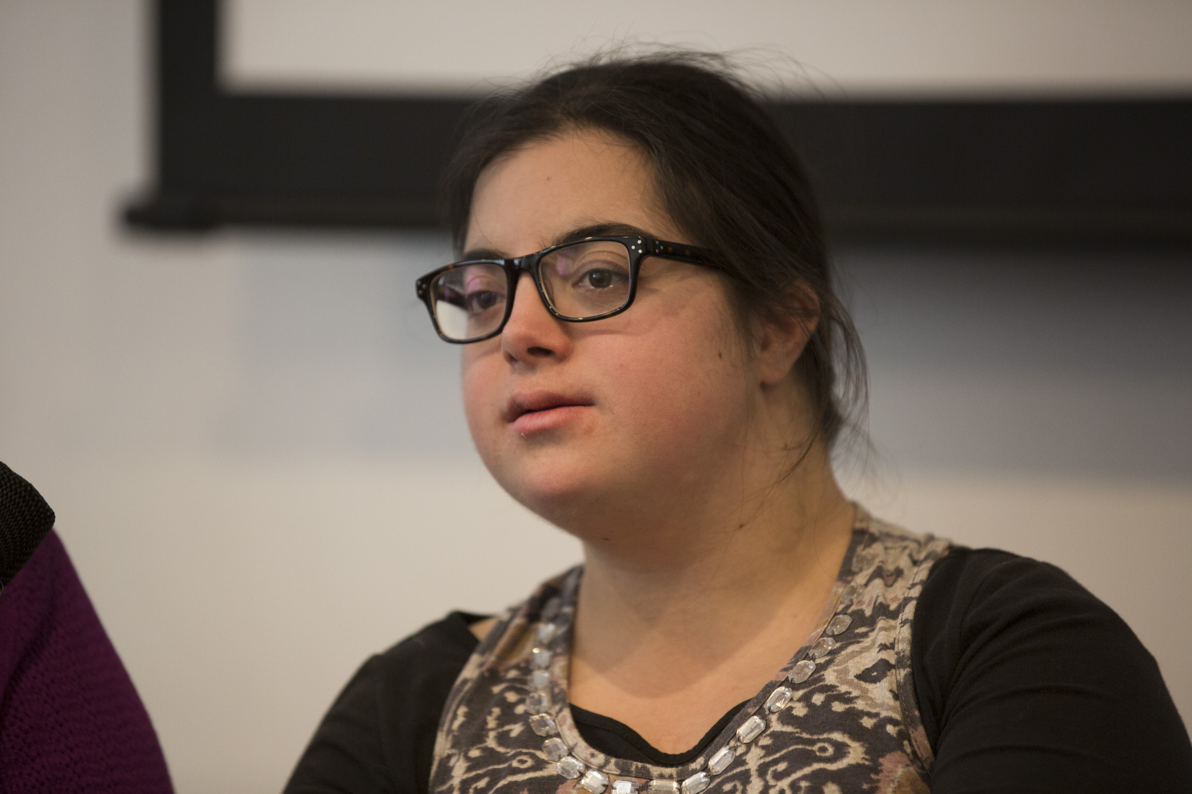

Table of Contents
Who is AFDO? 3
Introduction 4
Outcome 1 – Inclusive and accessible communities 5
Outcome 2 – Rights protection, justice and legislation 7
Outcome 3 – Economic security 9
Outcome 5 – Learning and skills 12
Outcome 6 – Health and wellbeing 13

Who is AFDO?
The Australian Federation of Disability Organisations (AFDO) is the peak organisation in the disability sector representing people with lived experience of disability. AFDO and its member organisations are run by and for people with lived experience of disability.
AFDO’s mission is to champion the rights of people with disability in Australia and support them to participate fully in Australian life. AFDO has strong relationships not just with its member organisations, but across the disability sector including peaks representing service providers as well as those representing families and carers.
As a founding member of the National Disability and Carer Alliance, AFDO played a key role in the campaign for the introduction of the National Disability Insurance Scheme (NDIS). As the NDIS has moved through the trial phase and begun the transition to the full scheme, AFDO and its members have continued to work constructively with the National Disability Insurance Agency (NDIA) as well as Commonwealth and State and Territory governments to provide critical feedback and address implementation issues as they arise.
AFDO’s members include:

Blind Citizens Australia
Brain Injury Australia
Deaf Australia
Deafblind Australia
Autism Aspergers Advocacy Australia
Down Syndrome Australia
Physical Disability Australia
Disability Advocacy Network Australia
Disability Justice Advocacy
Disability Resources Centre
People with Disability ACT
Enhanced Lifestyles
People with Disability WA
Deafness Forum of Australia

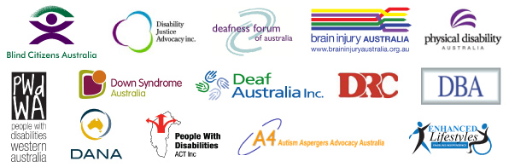

Introduction
AFDO welcomes the opportunity to examine progress made towards the goals outlined in the National Disability Strategy through contributing to the 2nd Progress Report for the National Disability Strategy.
AFDO and its members played an important role in the consultations which informed the development of the National Disability Strategy, and have continued to watch progress in implementation over the last seven years. Undoubtedly the most significant achievement is the introduction and roll out of the National Disability Insurance Scheme (NDIS). AFDO and its members are unwavering in their support for the NDIS.
We regularly hear from people with disability and their families about the difference the scheme is making to their lives. People who now have the dignity of appropriate and timely support, the opportunity to be more involved in their communities, the chance to move out of home, the economic freedom of a new job. These are the kinds of differences the scheme has already made in a short period of time.
The NDIS has undoubtedly already made a contribution to increasing the social and economic participation of people with disability in Australia. But as important as the scheme it, it alone cannot achieve the kind of change we want and expect to see for people with disability. Closing the gap in life outcomes between people with disability and those without can only be achieved through progress in all six areas identified in the National Disability Strategy.
Unfortunately, this is where we feel little progress has been made.
Lack of access to mainstream services, poor service response and failure of communities to address issues of inclusion not only contributes to poor life outcomes for people with disability but also poses a significant risk to the sustainability of the NDIS. Without progress in these areas, the risk of cost-shifting remains, as people with disability seek individual funding for supports that should be provided by the mainstream.
While we have seen some improvements in the lives of people with disability during the last seven years, there remain many significant barriers which require strong, effective and urgent systemic reform and action. AFDO made a lengthy submission to the review of the NDS in 2015. Unfortunately, many of the observations we made in our report remain true.
AFDO and its members believe the lack of an operational plan with matched funding has fundamentally compromised efforts to ensure the National Disability Strategy moves from words on a page to action.
While we welcome the release of the second implementation plan late last year and are supportive of its target areas of action, we regret that it remains a high-level plan that does not contain specific actions or measurable indicators of success. A high-level plan requires and produces only high-level reporting. We note that regular reporting to COAG has proved an ineffective mechanism to ensure either action or accountability.
This is not a problem unique to disability but experienced in other areas of public policy where high-level strategies fail to drive change. Nevertheless, after seven years, it is unacceptable to see such little change beyond the introduction of the NDIS.

Outcome 1 – Inclusive and accessible communities
Progress made against this outcome
- AFDO Disability Loop Project (2014 – 2016)
(Disability Loop Project finished in 2016 but was extended via Victorian Government Funding to end of the financial year 2016 under the Transition Support Package)

Outline the activity’s progress/outcomes/achievements
Department of Social Security Sector Development Fund project supported AFDO to design, develop and deliver the Understanding the NDIS series of workshops
Gap Analysis - The gap analysis found that the NDIS improves lives, often dramatically, but that a rapid expansion of specialist disability services with often poor practice models of old fashioned closed systems, has been allowed to establish.
AFDO Disability Loop includes an accessible website in line with W3C Web Content Accessibility Guidelines (WCAG), an e-newsletter and online resources that explain the NDIS and NDIS news specifically for people with disability, families and grassroots community and advocacy organisations. It also includes social media channels as well as face-to-face workshops and training.
A range of plain language resources has been developed; fact sheets, PowerPoint presentations, captioned YouTube videos, Auslan videos and a plain language Guide to Reasonable and Necessary.
6 x 3-hour workshops included information on: How does the NDIS work? Understanding the principles of reasonable and necessary, The NDIS planning process, How to put your plan into action, What is plan management, and Is self-management for me? Delivered 36 workshops to 306 people with disability and their families.
Additionally, with the aid of the Victorian Transition Support Package (TSP) funding, we delivered 48 Understanding the NDIS workshops to a further 634 people with disability and their families in 7 locations throughout Victoria.
Designed, developed and delivered 4 x 3 hour Opportunities for community organisations series of workshops, including topics on changes a market environment will bring to your organisation and the associated opportunities and challenges, the impact of independence on sustainability, implications of becoming a registered provider of supports in the NDIS, impact of change from block funding to unit price/funding, becoming ILC ready, the NDIS Price Guide in detail, NDIS Support Categories/Support Clusters, and a checklist for ILC readiness
Delivered the Disability Loop website (130,000 hits) with 3,300 Subscribers and released 38 editions of enews. AFDO Disability Loop selected 30 people with disability to become NDIS Champions
Who has this measure impacted? (include data if available)
People with disabilities their carers and families
Are there success factors to consider for future NDS implementation?
AFDO Disability Loop's commitment to co-design ensured that each element of the project was developed from the perspective of people with disability
An open and flexible approach to accessibility ensured the full contribution of people with disability to the success of the project.
Peer based information sharing and learning underpinned every project element, culminating with the popular NDIS Champions program.
AFDO Disability Loop’s commitment to universal design and plain language has been critical to the successful engagement of people with disability.
AFDO Disability Loop has sought to provide influential leadership, especially in accessible information. The project helped to change minds, shape opinions, and move others to act.
People with disability have felt safe to engage in AFDO Disability Loop’s consistent, predictable and respectful environments.
- Deafness Forum of Australia – an AFDO Member Organisation
Working with Service NSW, Deafness Forum of Australia facilitated the introduction of hearing loops, on-demand captions and Auslan interpreting services of the government shopfronts, progressively rolling out across the state in 2016-18. This program provides access to deaf and hearing impaired members of the community to essential government services.
Hearing Awareness Week in August each year involves a range of activities by volunteer organisations and businesses throughout the country, including ‘silent’ sports events, public exhibitions on hearing technologies, and hearing safety training by employers. The purpose of the Week is to alert people to ways to protect their hearing and to the assistance services that are available.
Development of a free national program in 2014 and to the present to facilitate hearing assistance skills for nurses, staff, carers and volunteers in hospitals and aged care settings. Teaching/learning modules, good practice guide, fact sheets and posters have been endorsed and promoted by the Australian Aged Care Quality Agency, Hearing CRC and Australian Midwifery and Nursing Federation. The program contributes to the goal that age care service providers and hospitals have the knowledge to ensure that the seven in 10 older Australians in their care who are living with hearing loss can continue to participate in their community.
Office of Hearing Services and the Department of Social Services consultations on the interface between the NDIS and the Hearing Services Program, from May 2015. Through specialist advice given by Deafness Forum, the NDIS was able to identify interface issues for the systems and to plan for their integration in 2019, ensuring a smooth transition of eligible Program clients to the NDIS.

Outcome 2 – Rights protection, justice and legislation
Progress made against this outcome
- Australians for Disability Justice -
This advocacy work regarding people with disabilities in the criminal justice system is the work of Australians for Disability Justice who work in collaboration with the Australian Federation of Disability Organisations.
The advocacy work targets people with cognitive impairments and mental health issues who are vulnerable to recurrent and indefinite detention in jails and forensic disability and mental health facilities in Australia
Activities
2016 Findings from a complaint the United Nations Committee on the Convention on the Rights of People with Disabilities Regarding Mr Marlon Noble alleging arbitrary detention.“The Committee, acting under article 5 of the Optional Protocol to the Convention, is the view that the State party has failed to fulfil its obligations under articles 5(1) and (2), 12 (2) and (3), 13(1), 14(1)(b) and 15 of the Convention and therefore makes the following recommendations to the State party:
- Article 5 - Equality and non-discrimination
- Article 12 - Equal recognition before the law
- Article 13 - Access to justice
- Article 14 - Liberty and security of the person
- Article 15 - Freedom from torture or cruel, inhuman or degrading treatment or punishment
2016 Commitment by Australia in response to the Universal Periodic Review to develop a National set of Principles relating to People with Cognitive Impairments in the Criminal Justice System – Excerpt of Letter from Andrew Walter Assistant Secretary Civil Law Unit Attorney-General Department
“In November 2015, the Law, Crime and Community Safety Council (LCCSC) established a cross-jurisdictional working group to collate existing data across jurisdictions and develop resources for national use in the treatment of people with mental and/or cognitive disability unfit to plead or found not guilty by reason of mental impairment.
At Australia's Universal Periodic Review appearance before the Human Rights Council in November 2015, Australia announced a commitment to improving the way the criminal justice system treats people with cognitive disability who are unfit to plead or found not guilty by reason of mental impairment, in light of the establishment of this Working Group.
The Working Group has been drafting a National Statement of Principles Relating to Persons Unfit to Plead or Found Not Guilty by Reason of Cognitive or Mental Health Impairment (National Principles). These seek to identify safeguards throughout legal processes and during the period in which a person who is unfit to plead or not guilty by reason of cognitive or mental health impairment, is subject to orders. The Working Group presented a draft of the National Principles when it reported back to LCCSC at its meeting on 21 October 2016
Attorneys-General noted progress on the National Principles and noted work to collect and collate existing data on fitness to stand trial, the defence of mental impairment and interstate forensic transfers. Existing gaps, or unavailability of data, have made it challenging to assess the current situation in Australia regarding the experience of people with a cognitive disability or mental health impairment in the criminal justice system to date. Attorneys-General agreed that the Working Group continue to analyse that data and report back to LCCSC at its first meeting of 2017 with any subsequent proposals to improve data collection frameworks and forensic transfer processes. At that meeting, LCCSC will also consider whether to endorse the National Principles.
These principles and data collection resources have not been released publicly by the Law Crime and Community Safety Council
2016 Inquiry Report by the Federal Government Community Affairs Reference Committee on the Indefinite Detention of People with Cognitive and Psychiatric Impairment
http://www.aph.gov.au/Parliamentary_Business/Committees/Senate/Community_Affairs/IndefiniteDetention45/Report/c09
Are there success factors to consider for future NDS implementation?
Advocacy work involves creating a network of people to develop shared understanding and activity. Australians for Disability Justice (formerly the Aboriginal Disability Justice Campaign) has been successful in building a national network of disability advocates, legal advocates, human rights advocates, academics working in the field and clinicians to build the case for changes to legislation, policy and programs that recurrently or indefinitely detain people with disabilities in jails and forensic facilities.
- Deafness Forum of Australia – an AFDO Member Organisation

2016 - Deafness Forum of Australia’s Signage Guide for Hearing Augmentation Systems (first published 2013, updated in 2016) promotes the use of hearing augmentation systems in rooms used for judicial purposes and all places where sound amplification is provided or public announcements are made, for example: boardrooms, class/lecture rooms, assembly halls, cinemas, theatres and auditoriums. It underpins more widespread provision of hearing augmentation systems that allow equal communication access rights to people with hearing disability

Outcome 3 – Economic Security
Progress made against this outcome
- Deafness Forum Australia – an AFDO Member Organisation

2014-2015 - Creation of an online Work Centre to provide a source of information to the hearing disability sector on various government employment assistance programs, including the DES. It provided the Department of Employment with access to a new audience of individuals that was outside its communication networks.

- AFDO Diversity Field Officer
2014 to present - a Pilot program created to identify good practice to support small and medium sized enterprises to increase confidence and in turn, action to employ people with disability; over 90% of businesses are SMEs in Australia. The pilot informed from a domestic and international literature review conducted by Deakin University.
The pilot subsequently developed to support 50 small to medium size businesses in the Geelong, Victoria region to become more welcoming, confident and accessible of people with disability. The pilot had a particular focus on recruitment, retention and customer service. The evaluation was undertaken by Deakin University completed in early 2017.
The DFOS included:
- business analysis
- ‘disability friendly checks’ regarding physical access and inclusive culture o attention to disability awareness and unconscious bias o a customised ‘road map’ with practical recommendations to build more confidence and inclusion and o warm connections with peer businesses, employment service providers and disability focused/aligned organisations that could assist businesses to implement their objectives. The interest, intent, and action of recommendations and activities by businesses were recorded to track progress and confidence
36 workplaces participated in both the pre and post evaluation; a response rate of 82%. A small number of participating businesses managed more than one workplace. Evaluation included survey data and qualitative interviews.
Who has the measure impacted? Include data if available.
Sixty-two percent (62%) of businesses who participated in the pilot employed 6-50 employees, with 30% of businesses with 51 or more employees.
The DFOS predominantly engaged with business owners or at a CEO/General Manager level (40%), with 32% of engagement with HR and 26% with a senior manager or member of the leadership team. The level of influence of the ‘drivers’ the DFOS worked with was a critical element identified in the findings.
While directed towards owners and CEOs, the impact of the pilot often extended to other parts of the business, with presentations made to senior leadership teams of businesses, other business managers and partners and senior staff, leading to changes in some of all of the following: employment practices, recruitment, retention and/or improvements to customer service.
Over 20 local, state and national stakeholders provided in-kind support, including connection to programs for students with a disability, work experience, disability employment service providers etc. Guidance and support also provided by industry representative bodies.
New jobs were created for people with disability; interview processes became more accessible in a number of workplaces, confidence to retain staff who might acquire a disability increased. Work experience and mock interview opportunities were also created. The findings are detailed below;
- The businesses who participated grew markedly in ‘disability confidence’ and awareness (10%) especially given the short duration of engagement with businesses (for some this was just a few months) and already high levels of confidence (over 70%) prior to engagement with the Diversity Field Officer Service.
- Businesses viewed the service highly, with 97% of businesses indicating that their expectations were fully met or mostly met. Businesses also ranked capacity building exercises consistently high (90% or more).
- Irrespective of the short time frame, 75% of businesses were employing people with disability at the end of the pilot, as compared to 39% of businesses at pilot commencement, with 86% indicating that there might be an opportunity to employ people with disability in the next 12 months, as compared to 58% at the start of the pilot.
- 79% are actively implementing or planning to include welcoming wording for people with disability in job advertisements/descriptions • 42% are actively implementing or intending to implement job carving (creation of a specific role or identification of tasks that can be performed by a person with disability
- 36% are actively implementing or planning to implement guaranteed interview for people with disability who meet the key selection criteria • 36% are implementing or planning to implement work experience
- 30% are implementing or planning to implement graduate opportunities or internships
- 64% are examining mental health related initiatives in the workplace as well as • Improved accessibility of workplaces, including physical access and workplace flexibility.
Are there success factors to consider for future NDS implementation?
Good understanding of small business practice and business challenges, not just knowledge of disability – demand led focus. The professional skills, knowledge, and disability expertise of the Diversity Field Officers were seen to be the most important attributes, highlighting that the model’s unique point of view. It’s independence – as a non-government program – and its customisation to the needs of businesses resonated with small businesses . The ongoing connection was identified by businesses as important as a ‘conduit’ to other services and support and as a contact point for information. To improve the effectiveness of the DFOS, senior leadership, and ideally the CEO or owner, need to be engaged from the outset to ensure organisational buy in and commitment.
The success of the DFOS is largely dependent on the quality and breadth of existing services and government programs – the service is only able to refer small and medium businesses to ‘who is there’, who may or may not be able to address what businesses actually require to employ and retain staff with a disability. This highlights the need for additional programs and investment.
Challenges included: The specific support that could be offered by services or programs, including what could be contractually delivered due to government or operational requirements, did not always align with business needs; o Limitations of existing government programs such as JobAccess and the Employment Assistance Fund (EAF), i.e. counselling support to staff working with an employee with autism demonstrating challenging behaviour could not be funded by the EAF. Programs or services often focus on building general awareness of disability, rather than provide specific advice.
Despite the number of businesses reporting disadvantages or challenges to employing people with disability reducing four fold during the service, just over half the businesses still reported some challenges. These were principally regarding; additional costs of employing people with disability o additional time required, and training challenges o accessibility o OHS concerns and o questions around people with disability’s ability and performance, or anticipated issues with reactions from other staff in the business.
What Stakeholder Engagement and/or Engagement Activities Were Undertaken
Multiple individual meetings with businesses x 50 Development of a collaborative network of stakeholders, including disability employment services, to identify mechanisms to best support local employers in a less competitive, cross collaborative way.
Key Dates for the Activity
Sep 2015- Dec 2016. Refined model will continue in the Geelong, Victoria region during 2017 with views to expand delivery. Evaluation by Deakin University completed early 2017.

Outcome 5 – Learning and skills
Progress made against this outcome
- Down Syndrome Australia – an AFDO Member Organisation
Members of the Down Syndrome Federation have provided training to schools to assist with the inclusion of people with Down Syndrome with mainstream education. This has occurred both within schools that have a child with down syndrome attending as well as other schools who are looking to upskill their teaching staff
Down Syndrome Northern Territory runs skills based program to assist young adults who have left school to refine their skills to support them to find employment
Key Dates for the Activities
Jan 2015 - Dec 2016

Outcome 6 – Health and wellbeing
Progress made against this outcome
- Deafness Forum Australia – man AFDO Member Organisation
Development of a free national program in 2014 and to the present to develop hearing assistance skills for nurses, staff, carers and volunteers in hospitals and aged care settings. Teaching/learning modules, good practice guide, fact sheets and posters have been endorsed and promoted by the Australian Aged Care Quality Agency, Hearing CRC and Australian Midwifery and Nursing Federation. The program contributes to the goal that age care service providers and hospitals have the knowledge to ensure the health and well-being of the seven in 10 older Australians in their care who are living with hearing loss.
The Australasian Newborn Hearing Screening Committee – a committee of Deafness Forum of Australia – is the group that caused the introduction of universal newborn screening for babies with hearing loss. Through its biennial practice conferences, public communications and deep connections with state health systems, it maintains a program that ensures hearing loss is identified at the earliest possible time, and that immediate and appropriate support is available for all parents of children identified with permanent hearing impairment in Australia. This ongoing work is crucial to minimising the effects of hearing disability on the individual, family and the community.
Deafness Forum of Australia made a successful case in 2015 against a proposed change to the Australian Building Codes with the aim of reducing false alarms resulting in unnecessary Fire Brigade attendances. Collaborating with AFAC representing the various Fire Brigades, the Australian Protection Association of Australia and Standards Australia proved that changing the Building Code to install smoke alarms in place of smoke detectors the proposal to change the Building Code of Australia to install smoke alarms in place of smoke detectors would be outweighed by dangers to personal safety.
Deafness Forum of Australia’s Safe and Accessible Accommodation Guide provides hotels, motels, and serviced apartments with reference to ensuring that all guests and staff with hearing disability will be alerted to any danger, and to any drill or system test. It aims to avoid situations where deaf persons could be overcome by smoke and fumes before the heat detector or the sprinkler system were activated.
Deafness Forum’s membership of the Health Department’s Audiology Expert Reference Group in 2016 assisted in the development of national practice standards in Audiology. The objective is for the voluntary standards to reflect nationally agreed practice expectations of those working in the hearing services sector, to protect the consumer and ensure they receive quality and best value audiology services.
Active participation in the Government’s Scoping Study into future ownership options for Australian Hearing from May 2015 to March 2017 provided consumer and service provider advice on risks and strategies to mitigate risk in the event the Australian Government proceeded with the option to sell the asset. The Finance Department project team benefitted from these inputs, which ultimately protected the high standard of hearing care provided to the community.
Key Dates for the Activities
2014 - Dec 2016 plus ongoing

